Supplementary figures.

Figure S1 Cohort 1 all samples. Boxplots of the clinical parameters. (a) Body mass weight (BW), (b) body mass index (BMI), (c) fasting plasma glucose (FPG), (d) hemoglobin A1C (HbA1C), (e) plasma insulin, and (f) HOMAR-IR (the product of insulin and FPG), and (g) c-reactive protein (CRP). Lean controls (ctrl in grey), individual observation before (B), and after bariatric surgery (A), of nonD (blue) and T2D (pink), which refer to the initial T2D status before the bariatric surgery.

Figure S2 Cohort 2. Boxplots of clinical parameters for nonD (blue) and T2D (pink). (a) Body mass index (BMI), (b) hemoglobin A1C (HbA1C), (c) fasting plasma glucose (FPG), (d) serum insulin, and (e) HOMAR-IR (product of insulin and FPG).
Figure S3 Cohort 3. (a-h) Boxplots of clinical parameters for nonD (blue) and T2D (pink); (a) body mass index (BMI), (b) hemoglobin A1C (HbA1C), (c) fasting plasma glucose (FPG), (d) serum insulin, (e) HOMAR-IR (product of plasma insulin and FPG), (f) serum interleukin 6.

Figure S4. Cohort 2. Pre-analyses by Principal Component analyses discovered batch effects. (a) PCA scores of the individuals with T2D (red), and nonD (blue) from batch 1 (open circles) and batch 2 (closed circles). Two groups were identified by PCA which was found to reflect two different batches. GEM was applied to omit the batch effects, by a model with batch and the targeted disease (T2D) as two design variables, and the interacting term, and the transcriptome data as responses. This GEM analyses omits the batch effects and the ER values of T2D was applied throughout the publication.

Figure S5. Cohort 1 and 2. GEM were used to combine cohort 1 and 2 (see method description), and GEM-PLS are applied for an overview of (a) the main effects of T2D, (b) the main effects of cohort identity, and (c) their interaction. For cohort 2, the ER values of T2D was used, where the batch effect was omitted. This GEM analyses omits the differences between the cohorts and the ER values of T2D for cohort 1 and 2 was applied throughout the publication.

Figure S6 Cohorts 1,2 and 3 SAT. PCA of the 128 genes significant for T2D in the multivariate data analysis of the cross-cohort dataset of cohort 1 and 2 and in the multivariate analysis of cohort 3, analysed by PCA on the combined data across all cohorts. (a) Score plots of the samples. (b) Loading plot of the genes.

Figure S7 Cohort 1 and 2. Validation by univariate analyses displaying raw p-values, and p-values adjusted for false discovery rate (FDR) using rotation test, Benjamin Hochberg’s test, and Bonferroni correction. (a-c) SAT in cohort 1: two-way factorial ANOVA of the effects of bariatric surgery, effects of the initial T2D status before the surgery, and the interaction term, (d) SAT in cohort 1: one-way ANOVA of fold change data after/before bariatric surgery for initial T2D status, (e-g) SAT in the cross-cohort data of cohort 1 and 2: two-way factorial ANOVA of the effects of cohort affiliation, initial T2D status, and their interaction.

.
Figure S8 Cohort 1 SAT all samples. GEM-PLS of Cohort 1 with the design variables initial T2D status, bariatric surgery (BS) and their interaction, where PLS is applied on the ER values of one of these design factors at the time. (a-c) PLS of BS, (d-f) PLS of the nonD versus T2D group (“T2D” refers to the initial T2D status before the BS), (g-i) PLS of the ER values of the interaction term. (a,d,g) Score plots of the individuals, (b,e,h) corresponding loading plots of the genes, (c,f,i) error rate. All gene probes were included in the analyses, but only those significant by Jackknife are displayed in the loading plots.

Figure S9 Cohort 1 SAT all samples. Boxplot of some genes whose expression levels were significantly elevated in the obese condition before bariatric surgery as a main effect of bariatric surgery and normalised reduced by the surgery. Lean controls (grey), observations before the bariatric surgery (B), and after bariatric surgery (A), of the nonD group (‘n’, blue) and the T2D group (‘d’, pink), which refer to the initial T2D status before the bariatric surgery. The plots are means of gene probes for the same gene.

Figure S10 Cohort 1 SAT all samples. Boxplot of some of the genes downregulated in T2D across all cohorts and reversed by the bariatric surgery as observed in cohort 1. Lean controls (grey), observation before the bariatric surgery (B), and after bariatric surgery (A), of nonD (‘n’, blue) and T2D (‘d’, pink), which refer to the initial T2D status before the bariatric surgery. The plots are means of gene probes for the same gene.

Figure S11 Cohort 1 SAT all samples. Boxplot of some of the genes upregulated in T2D across all cohorts and reversed by the bariatric surgery as observed in cohort 1. Lean controls (grey), observation before the bariatric surgery (B), and after bariatric surgery (A), of nonD (‘n’, blue) and T2D (‘d’, pink), which refer to the initial T2D status before the bariatric surgery. The plots are means of gene probes for the same gene.

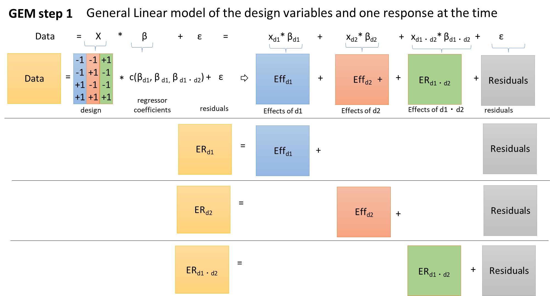

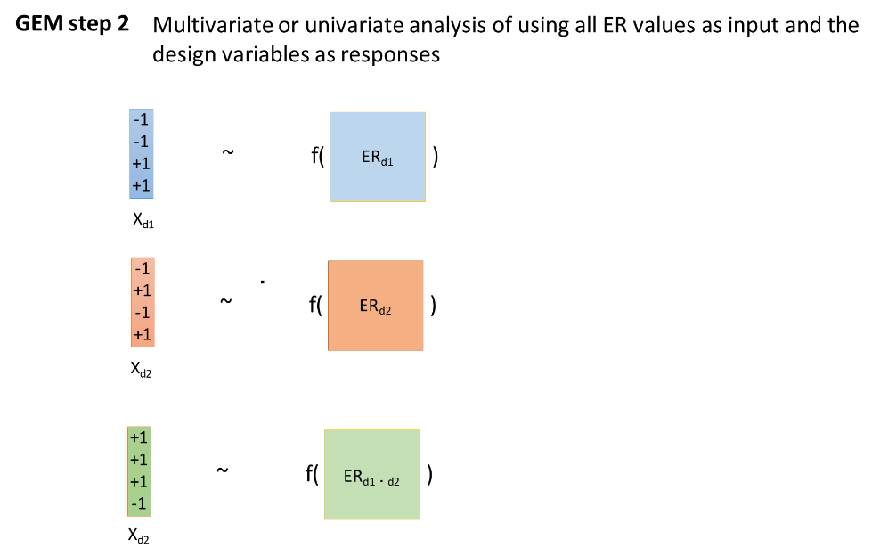

Figure 12. Schematic illustration of GEM.

