Supplementary tables and figures
Fig. S1 Mean annual precipitation and mean annual temperature of the study site (climatology based on measurements over 14 years from 2004 to 2017)
Fig. S2 Basal area increment (a) and annual basal area increment (b) from 1992-2003 to 2004-2017 in different N treatments. * P＜0.05.

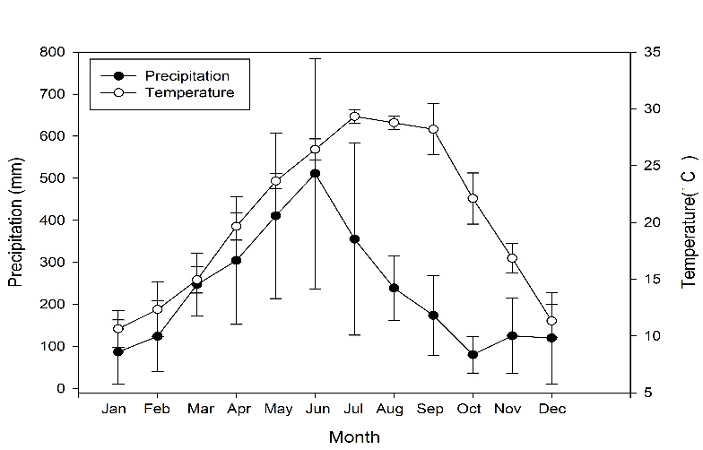
Fig.S1 Mean annual precipitation and mean annual temperature of the study site (climatology based on measurements over 14 years from 2004 to 2017)

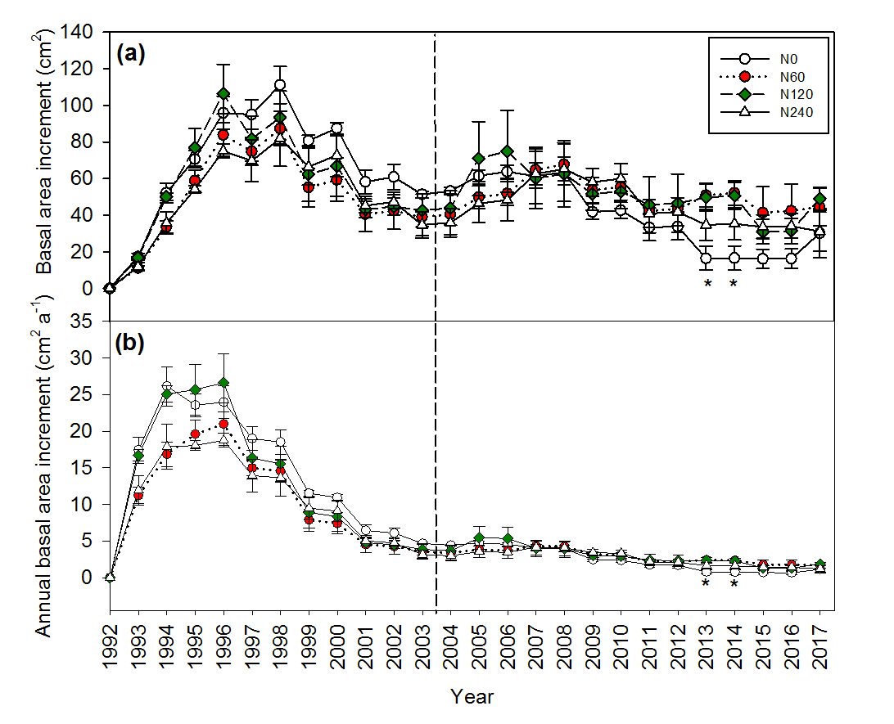
Fig. S2 Basal area increment (a) and annual basal area increment (b) from 1992--2017 in different N treatments. * P＜0.05

Table S1 Dry mass and N content of Chinese fir plant organs under different N fertilizer treatments in 2003. Values are means±SEs (n=3).
Component | Dry mass ( t hm⁻²) |  |  |  |  | N content (g kg⁻¹)
Component | N0 | N60 | N120 | N240 |  | N0 | N60 | N120 | N240
Leaf | 12.28 | 14.02 | 13.52 | 11.96 |  | 14.10 | 15.30 | 14.40 | 14.50
Branch | 19.57 | 11.92 | 14.68 | 18.21 |  | 5.09 | 5.22 | 6.55 | 5.68
Stem | 81.93 | 84.95 | 86.82 | 77.30 |  | 2.62 | 2.42 | 2.83 | 2.28
Bark | 9.13 | 9.63 | 10.00 | 8.95 |  | 6.97 | 5.27 | 7.00 | 7.13
Coarse root | 21.25 | 25.81 | 22.21 | 19.28 |  | 0.65 | 0.72 | 0.74 | 0.76
2-5 mm | 0.27 | 0.31 | 0.53 | 0.27 |  | 0.71 | 0.72 | 0.72 | 0.79
<2 mm | 0.18 | 0.26 | 0.30 | 0.17 |  | 0.68 | 0.70 | 0.74 | 0.76
Subtotal | 144.61 | 146.91 | 148.07 | 136.13
Note: Coarse root N content was estimated by the mean value of branch and stem due to high destructive.

