Supplementary figures

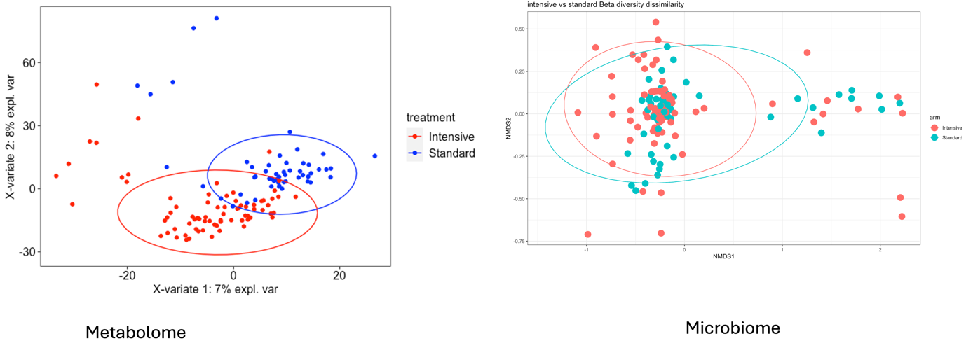
Supplementaty 1: Comparison of metabolome and microbiome of participants living in rural community. (A) PLSDA plot comparison of metabolomes between intensive and standard antihelminthic treatment. (B) PcoA plot showing beta diversity (using Bray-Curtis distance) comparison between intensive and standard antihelminthic treatment.

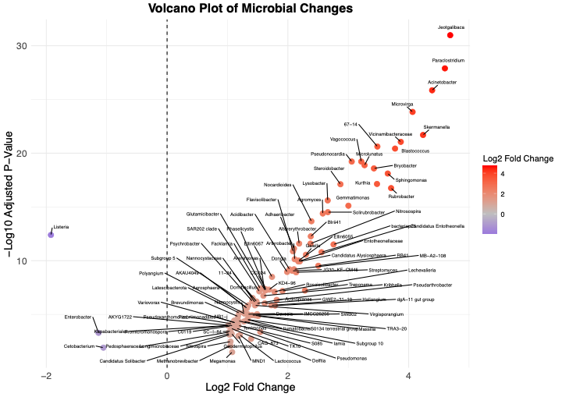
Supplementary 2: Differential abundance analysis. Volcano plot showing the log₂ fold change in abundance (x-axis) versus the –log₁₀ adjusted p-value (y-axis) for microbial taxa differentially abundant between S. mansoni-infected and -uninfected individuals. Each point represents a microbial taxon. Taxa to the right of the vertical dashed line are enriched in S. mansoni-infected individuals, while those to the left are depleted. Points are colored by their log₂ fold change, with red indicating higher abundance and blue indicating lower abundance in S. mansoni-infected. Labels highlight All taxa with statistically significant differences (FDR-adjusted p < 0.05). Also, coloured taxa denoted by triangular dots are both significantly enriched in S. mansoni partipants and also asociated with CVD risk. Those taxa shown by circular dots are significantly impacted by S. mansoni infection but are not associated with CVD risk.

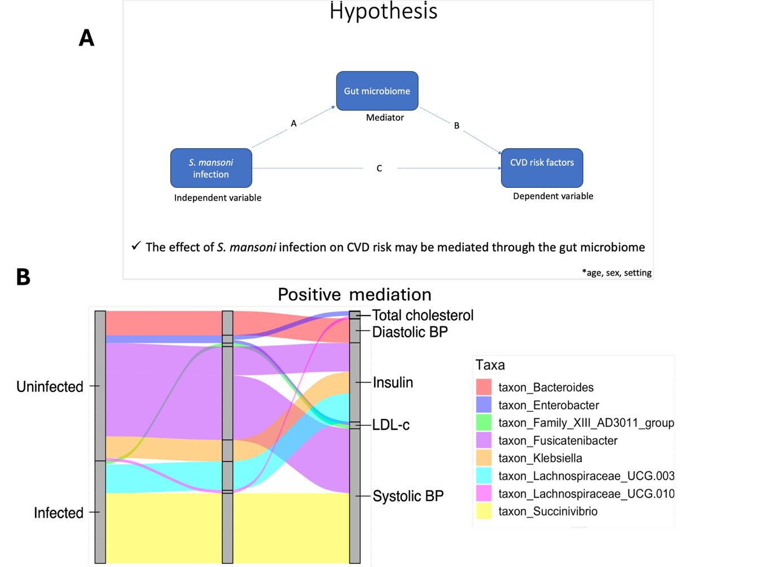
Supplementary 3: Positive mediation by microbes
(A) Visualisation of the mediation analysis model showing hypothesis underlying the link between microbes, S. mansoni infection and CVD risk. (B) Mediation analysis illustrating the mediatory role of microbes in S.mansoni-driven CVD risk resolution. An alluvial plot showing microbes through which helminths may alter one’s CVD risk. Results from mediation analysis using bias-correct non-parametric bootstrap method in the pingouin.mediation analysis package in R. Microbial taxa shown were differentially abundant (p=0.05) in either the S.m+ and S.m- groups (shown the Y-axis). All the microbes above had a significant positive mediation effect (p<0.05, 97.5% CI) on CVD risk factors shown.

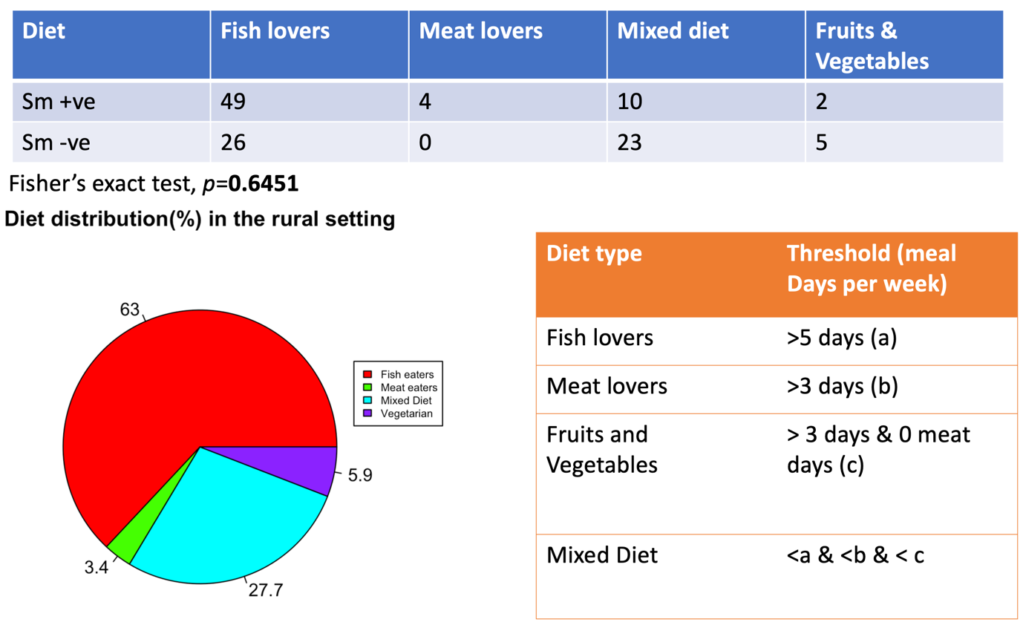
Supplementary 4: Diet distribution for the rural population
(A) Distribution table showing the number of S. mansoni-infected and uninfected participants predominantly consuming each dietary pattern, including fish-based, meat-based, mixed, and fruit/vegetable-rich diets.
(B) Pie chart depicting the overall distribution of dietary patterns across all participants, presented as percentages.
(C) Schematic illustrating the algorithm used to classify participants into dietary categories, based on self-reported frequency (number of days per week) of consuming specific food types

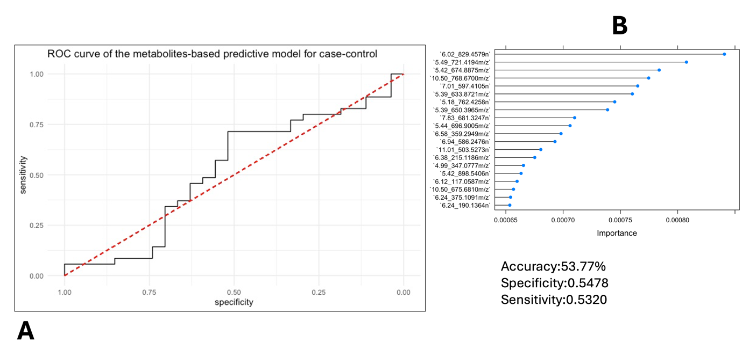
Supplementary 5: Prediction of infection status using the metabolite profile
(A) Receiver operating characteristic (ROC) curve illustrating the performance of a metabolite-based classification model generated using partial least squares discriminant analysis (PLS-DA) to distinguish between groups. The model achieved an accuracy of 53.77%, with a specificity of 54.78% and a sensitivity of 53.20%.
(B) Variable importance in projection (VIP) plot highlighting the top contributing metabolites (based on m/z ratios) driving the model’s classification. Metabolites with the highest VIP scores were considered the most influential in separating the groups and may reflect biologically relevant signatures.

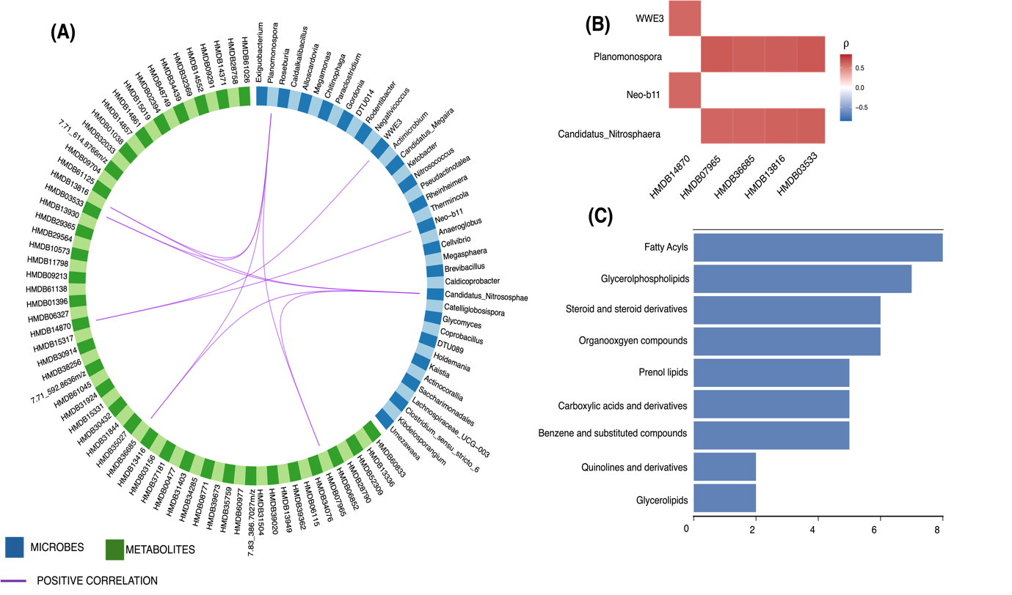
Supplementary 6: Insulin_associated microbes interaction with metabolites
A Circos plot plot showing the top most correlations between variables of microbiome (blue blocks) and metabolome (green blocks) data that were significantly associated with insulin resistance following association analysis described in Figure 3 where factors such as age, sex, BMI were adjusted for , and setting included as interaction term in our model. The correlation cut-off for this circos plot is r ≥ 0.65. B After extracting only those microbes and metabolites shown to interact in A, a heatmap was used to clearly show the most significant correlations between the microbiota and metabolites that were significantly associated withinsulin resistance. Correlation strength (spearmans correlation coefficient, r, value) is shown by the depth of the red colour (the deepest red indicates the strongest correlation positive correlation, and blue shows negative correlation). C Annotation of metabolites into classes. Going beyong individual metabolites, this annotation was done using the CLASSYFIRE to show the classes they fall under. The blue horizontal bars represent the number of metabolites matching with x-axes. The vertical axis represents the annotated classes of metabolites, and the graph shows the number of metabolites annotated to a class.

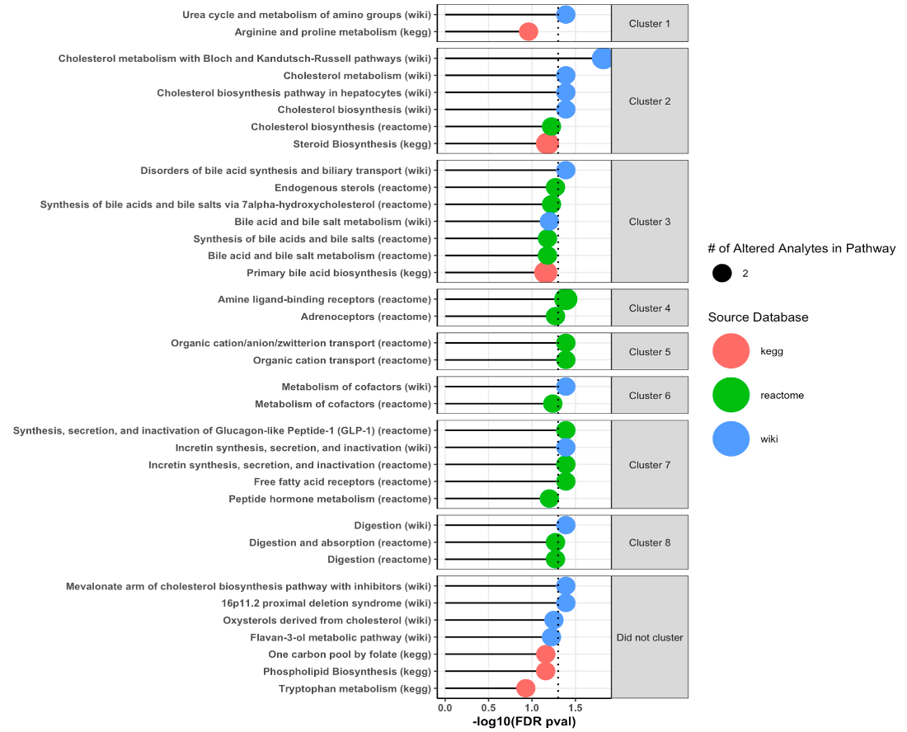
Supplementary 7: Total cholesterol-associated metabolic pathways.
Lollipop plot summarizing pathway enrichment results for metabolites associated with total cholesterol. A pathway redundancy clustering algorithm, implemented via the RaMP R package, was used to group highly overlapping pathways and identify functional redundancies. The vertical axis displays the names of enriched pathways, along with their assigned clusters (if applicable), the source database, the number of altered analytes per pathway, and the Fisher’s exact test p-values corrected for multiple testing. Among 36 enriched pathways, 27 were grouped into 8 distinct clusters, reflecting shared biological functions or metabolite overlap.

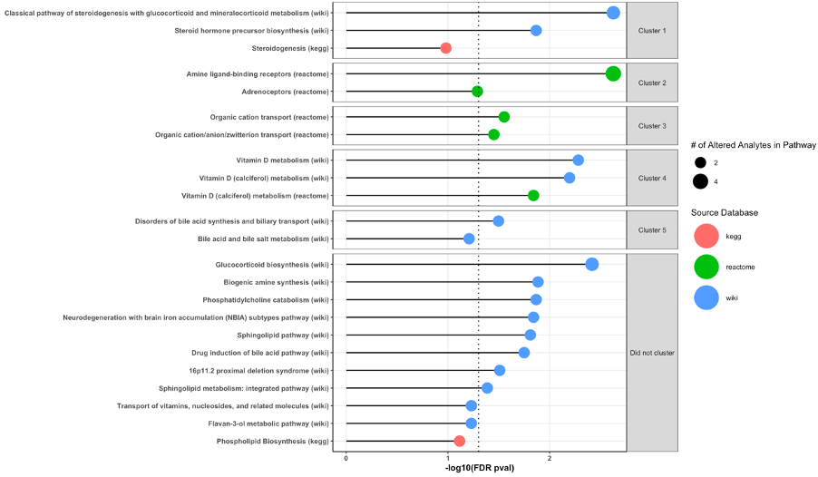
Supplementary 8: Diastolic blood pressure-associated metabolic pathways.
Lollipop plot displaying enriched metabolic pathways associated with diastolic blood pressure. A pathway redundancy clustering algorithm, implemented in the RaMP-DB package, was used to group highly overlapping pathways and identify functional redundancies within the enrichment results. The vertical axis indicates the names of enriched pathways, the cluster to which each pathway was assigned (if applicable), the source database, the number of altered analytes contributing to enrichment, and the Fisher’s exact test p-values adjusted for multiple testing. Of the pathways identified, 12 were grouped into 4 distinct clusters, while the remaining pathways could not be clustered due to lack of overlap

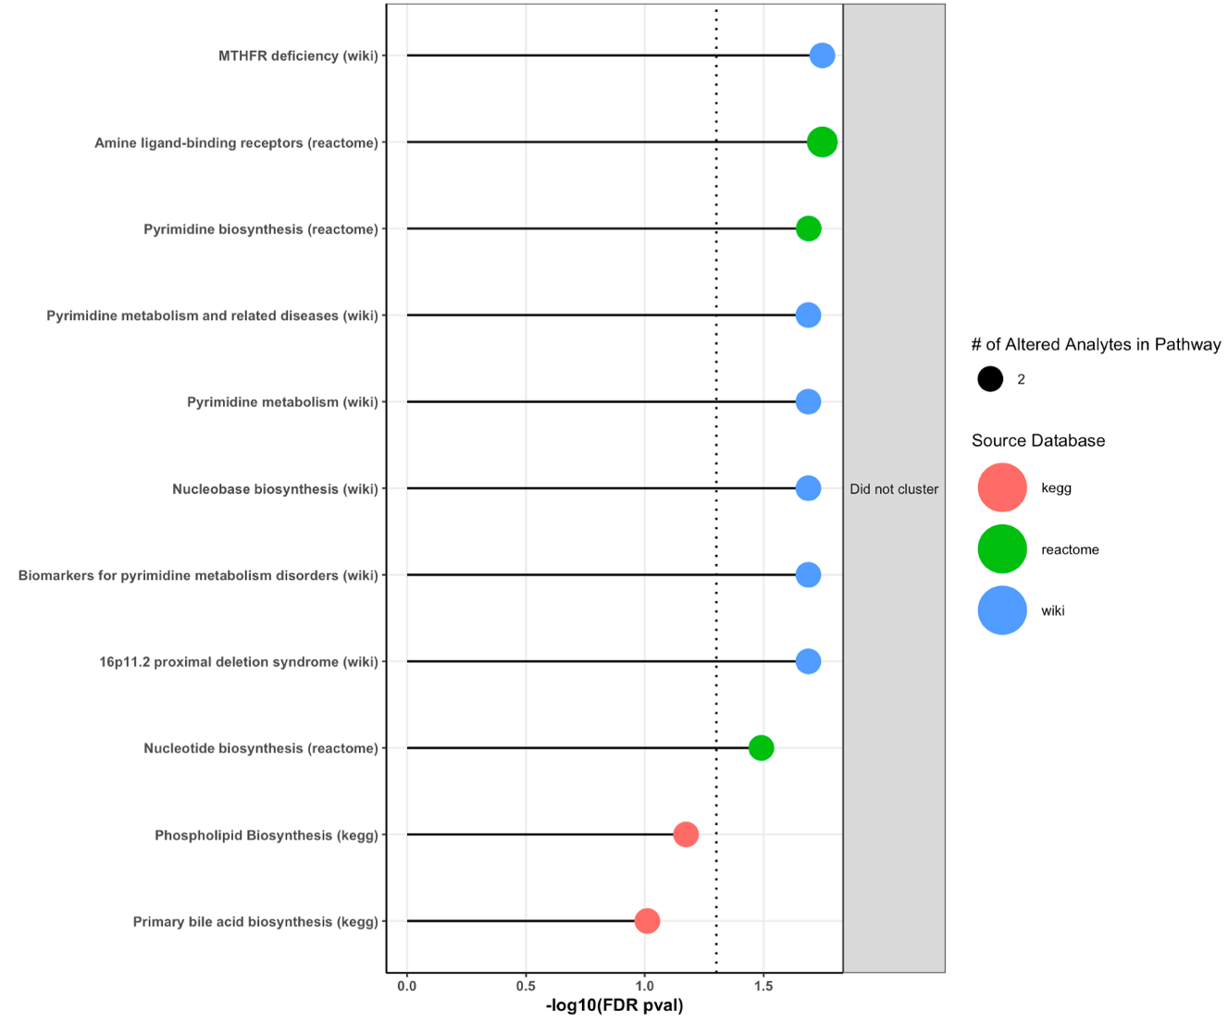
Supplementary 9 : Insulin resistance-associated metabolic pathways.
Lollipop plot illustrating metabolic pathways enriched by metabolites associated with insulin resistance. A pathway redundancy clustering algorithm, implemented in the RaMP-DB package, was applied to group highly overlapping pathways and identify functional redundancies in the enrichment results. The vertical axis displays the names of enriched pathways, their corresponding clusters (if assigned), the source database, the number of altered analytes per pathway, and the Fisher’s exact test p-values adjusted for multiple comparisons. In this analysis, 11 pathways were identified, none of which clustered due to limited overlap, indicating distinct biological processes.

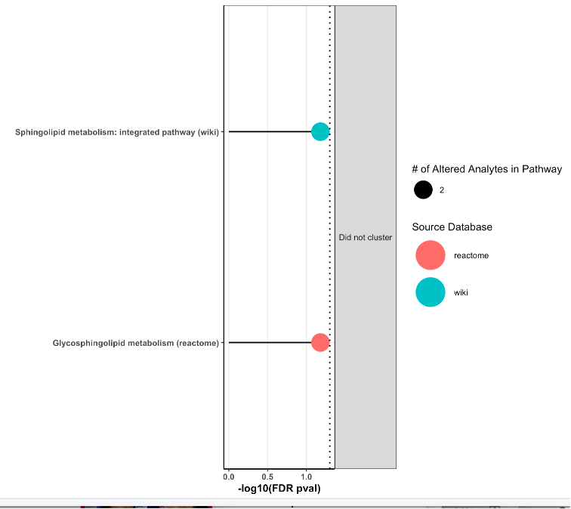
Supplementary 10: Systolic blood pressure-associated metabolic pathways.
Lollipop plot showing metabolic pathways enriched by metabolites associated with systolic blood pressure. A pathway redundancy clustering algorithm, implemented in the RaMP R package, was used to group highly overlapping pathways and identify functional redundancies in the enrichment results. The vertical axis presents the names of enriched pathways, their assigned clusters (if any), the source database, the number of altered analytes contributing to each pathway, and Fisher’s exact test p-values corrected for multiple testing. The two enriched pathways identified did not cluster, suggesting limited overlap and distinct biological roles

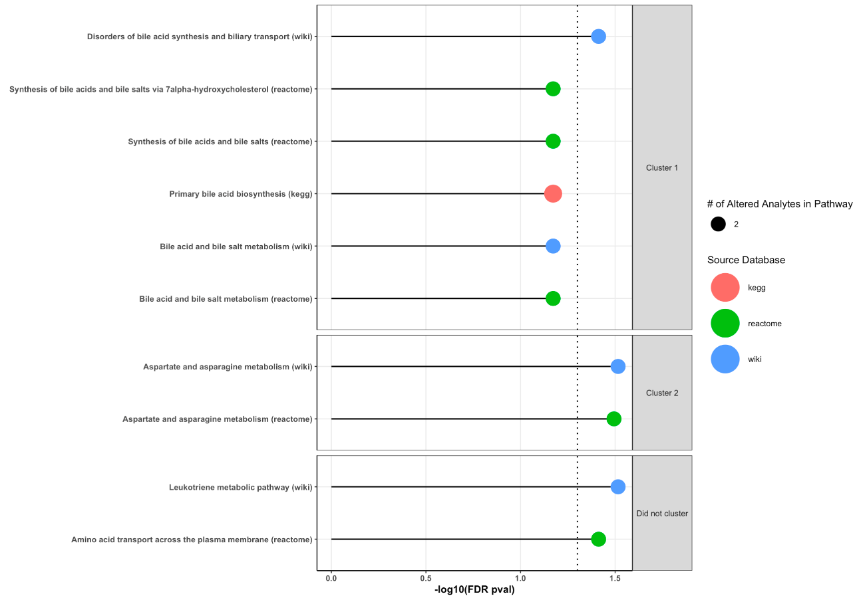
Supplementary 11: Glucose intolerance-associated metabolic pathways.
Lollipop plot illustrating metabolic pathways enriched by metabolites associated with glucose intolerance. A pathway redundancy clustering algorithm, implemented in the RaMP-DB package, was used to group highly overlapping pathways and identify functional redundancies in the enrichment results. The vertical axis displays the names of enriched pathways, their corresponding clusters (if assigned), the source database, the number of altered analytes per pathway, and the Fisher’s exact test p-values adjusted for multiple testing. Of the 10 enriched pathways, 8 were grouped into two distinct clusters, while the remaining two pathways did not cluster due to limited overlap.

