Supplementary information
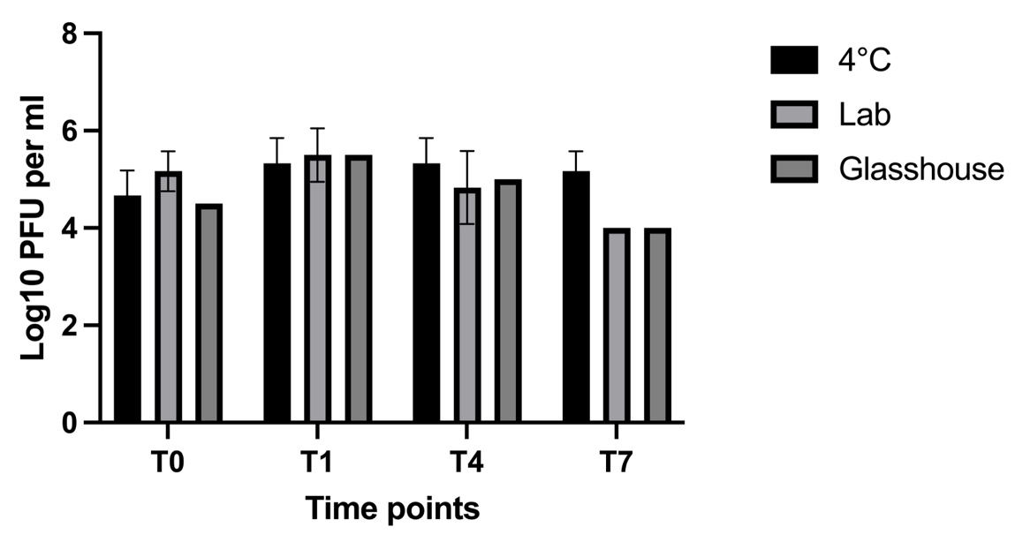
Figure S1. Detection and titre of phage in artificial bee feed (n=6) at T0 (immediately after inoculation), T1 (1-day post-inoculation), T4 (4 -day post-inoculation), and T7 (7-day post-inoculation), under 4ºC, lab and glasshouse conditions (20±2ºC) after spiking with phage powder. Bars show the median PFU ml⁻¹ and error bars represent the interquartile range.

