SUPPLENTARY INFORMATION

Sensitivity of larval and juvenile fish with different swim bladder morphology to barotrauma with a special focus on Cypriniformes

Andreas Zitek^{1,*}, Wolfgang Gessl², Peter Mehlmauer³, Clemens Ratschan⁴, Martin Schletterer^{5,6} and Josef Schneider⁷
¹EcoScience, Vienna, 1140, Austria
²University of Graz, Institute of Biology, Graz, 8010, Austria
³Self-employed, Graz, 8020, Austria
⁴Consulting Office for Applied Hydrobiology, Fisheries and Hydro-Engineering, Zauner GmbH, Engelhartszell,
4090, Austria
⁵ TIWAG -Tiroler Wasserkraft AG, Department of Hydropower Engineering, Eduard-Wallnöfer-Platz 2, 6020 Innsbruck, Austria
⁶ BOKU University, Institute of Hydrobiology and Aquatic Ecosystem Management, Department of Ecosystem Management, Climate and Biodiversity, Vienna, 1180, Austria
⁷Graz University of Technology, Institute of Hydraulic Engineering and Water Resources Management, Graz, 8010, Austria
*andreas.zitek@ecoscience.at
Species /Life stage | Anaesthetized |  | Not Anaesthetized |  | Statistics
Species /Life stage | % M | Nadir, RPC | % M | Nadir, RPC | Fisher's exact test
E. perch L1/L2 | 41 | 18, 5.62 | 41 | 21, 4.82 | P=0.568, n.s.
E. perch L4 | 70 | 19, 5.33 | 79 | 16, 6.33 | P=0.167, n.s
 | 16 | 51, 1.98 | 13 | 53, 1.91 | P=0.378, n.s.
 | 11* | control | 6* | control | P=0.183, n.s.
E. perch 0+ | 63 | 15, 6.75 | 59 | 16, 6.33 | P=0.365, n.s.
 | 4 | 48, 2.11 | 3 | 47, 2.16 | P=0.500, n.s.
 | 0 | control | 0 | control | P=1, n.s.
E. grayling L1/L2 | 0 | 17, 5.96 | 3 | 19, 5.33 | P=0.248, n.s.
 | 1.5 | 50, 2.03 | 0 | 65, 1.56 | P=0.500, n.s.
 | 0 | control | 0 | control | P=1, n.s.
E. grayling 0+ | 4 | 17, 5.96 | 1.4 | 17, 5.96 | P=0.500, n.s.
 | 0 | 55, 1.84 | 0 | 71, 1.43 | P=1, n.s.
 | 0 | control | 0 | control | P=1, n.s.
Roach 0+ | 45 | 17, 5.96 | 54 | 19, 5.33 | P=0.247, n.s
 | 0 | 51, 1.99 | 0 | 65, 1.56 | P=1, n.s.
 | 0 | control | 0 | control | P_{einseitig}=1, n.s.
*mortalities caused by methodological issues related to the net cage.
Supplementary Table 1: Percentages of mortally injured individuals from pre-experiments in anesthetized and not anesthetized fish (n=70 per experiment) at target nadirs 15 kPa and 50 kPa and control without pressure treatment, with experimentally achieved nadirs and ratios of pressure changes (RPC) and statistical significance according to Fisher’s exact test; note that E. perch at developmental stage L4 were only available for pre-experiments.
 | RoR-HPP 1, Drava |  | RoR-HPP 2, Mur
Nadir | FL | PL | FL | PL
[kPa] | [%] | [%] | [%] | [%]
101 | 49.72 | 8.62 | 98.92 | 88.03
80 | 31.94 | 5.36 | 74.23 | 36.03
60 | 18.55 | 2.69 | 32.61 | 5.64
50 | 12.72 | 1.44 | 16.78 | 1.49
40 | 8.01 | 0.49 | 6.54 | 1.23
30 | 4.37 | 0.04 | 2.51 | 0.93
15 | 1.17 | 0.02 | 1.02 | 0.84
Supplementary Table 2: Summary of lowest nadirs in percent modelled by CFD along n=5000 particle traces at full load (FL) and partial load (PL).
Species | Stage | Tested concentrations mg l⁻¹ | Final concentration  mg l⁻¹ | Description
E. grayling | L1 | 30 | 30 mg/l | no abnormalities
E. grayling | 0+ | 50 | 50 mg/l | no abnormalities
Nase | L1 | 20 | 20 mg/l | no abnormalities
Nase | 0+ | 50, 30, 40, 45, 40 | 40 mg/l | different depths of anesthesia, depending on the different sizes of the fish.
E. perch | L1/L2 | 30, 20, 5 | 5 mg/l | fish still mobile, but at 30 or 20 mg/L, all dead after 11 minutes (3 + 8 minutes).
E. perch | L4 | 50, 25, 40, 35, 30 | 30 mg/l | no abnormalities
E. perch | L6/J1 | 50, 40 | 40 mg/l | no abnormalities
E. perch | 0+ | 90 | 90 mg/l | no abnormalities
Roach | L6/J1 | 50 | 50 mg/l | no abnormalities
Roach | 0+ | 75, 65 | 65 mg/l | no abnormalities
Supplementary Table 3: Determination of the MS222 concentration needed for anesthetizing the different life stages of the investigated species as determined by two replicates with n=5.
Species / Life stage | Pre-experiments | Atmospheric pressure trials | Acclimatization trials
E. grayling L1 | 2*70 fish at target nadir 15  2*70 fish at target nadir 50  2*70 fish for control | 3*10 fish at target nadir 15  3*10 fish at target nadir 30  3*10 fish at target nadir 40  4*10 fish at target nadir 60  3*10 fish for control | -
Nase L1 | - | 4*10 fish at target nadir 15  3*10 fish at target nadir 30  3*10 fish at target nadir 40  3*10 fish at target nadir 60  3*10 fish for control | -
E. perch L1 | 2*70 fish at target nadir 15 | 3*10 fish at target nadir 15  3*10 fish at target nadir 30  3*10 fish at target nadir 40  3*10 fish at target nadir 60  3*10 fish for control | -
E. perch L4 | 2*70 fish at target nadir 15  2*70 fish at target nadir 50  1*68 fish at target nadir 50  2*70 fish for control | - | -
E. perch L6/J1 | - | 3*10 fish at target nadir 15  3*10 fish at target nadir 30  3*10 fish at target nadir 40  3*10 fish at target nadir 60  3*10 fish for control | -
Roach L6/J1 | - | 3*10 fish at target nadir 15  3*10 fish at target nadir 30  2*10 fish at target nadir 40  None at target nadir 60  2*10 fish for control | -
Roach 0+ | 2*70 fish at target nadir 15  2*70 fish at target nadir 50  2*70 fish for control | 3*10 fish at target nadir 15  3*10 fish at target nadir 30  3*10 fish at target nadir 40  3*10 fish at target nadir 60  3*10 fish for control | 1*70 slow from 251 kPa to 101.3 kPa  1*70 fast from 251 kPa to 44 kPa
Nase 0+ | - | 3*10 fish at target nadir 15  3*10 fish at target nadir 30  3*10 fish at target nadir 40  3*10 fish at target nadir 60  3*10 fish for control | 1*70 slow from 251 kPa to 101.3 kPa  1*70 fast from 251 kPa to 29 kPa
E. grayling 0+ | 2*70 fish at target nadir 15  2*70 fish at target nadir 50  2*70 fish for control | 3*10 fish at target nadir 15  3*10 fish at target nadir 30  3*10 fish at target nadir 40  3*10 fish at target nadir 60  3*10 fish for control | 1*70 slow from 251 kPa to 101.3 kPa  1*70 fast from 251 kPa to 44 kPa  1*70 fast from 251 kPa to 42 kPa*
E. perch 0+ | 2*70 fish at target nadir 15  2*70 fish at target nadir 50  2*70 fish for control | 3*10 fish at target nadir 15  3*10 fish at target nadir 30  3*10 fish at target nadir 40  3*10 fish at target nadir 60  3*10 fish for control | 1*70 slow from 251 kPa to 101.3 kPa  1*70 fast from 251 kPa to 15 kPa
Supplementary Table 4: Overview on the number of fish used for different types of experiments; all experiments were run with anaesthetized fish, except for one experiment of acclimatized E. grayling 0+ (*), where the experiment was repeated without anesthetization to exclude a potential effect of the anaesthetic on the unexpected results.

Parameter | RoR-HPP 1, river Drava (MAF = 195 m3/s) | RoR-HPP 2, river Mur (MAF = 117 m3/s)
Turbine Type | Kaplan 5100 (n=2), vertical | Kaplan RT 3850 (n=2), horizontal with 10° inclination
Maximum Flow Rate per Turbine (m³/s) | 275 | 104
Average Turbine Flow Rate (m³/s) | 230 | 58
Number of Blades | 5 | 4
Flow Rate at Best Efficiency (m³/s) | 170 | 71
Turbine Runner Diameter (mm) | 5100 | 3850
Maximum Turbine Efficiency (%) | 94.6 | 88.7
RPM (Rotations per Minute) | 142.9 | 125
Head Difference (Upper-Lower Water) (m) | 25.2 | 7.36
Reservoir Depth (m) | 25–30 | 7
Clear Width of Trash Rack (mm) | 140 | 100
Supplementary Table 5: Parameters of two studied Kaplan turbines typical for Run-Of-River Hydropower Plants (RoR-HPP) at medium sized rivers (MAF = mean annual flow).

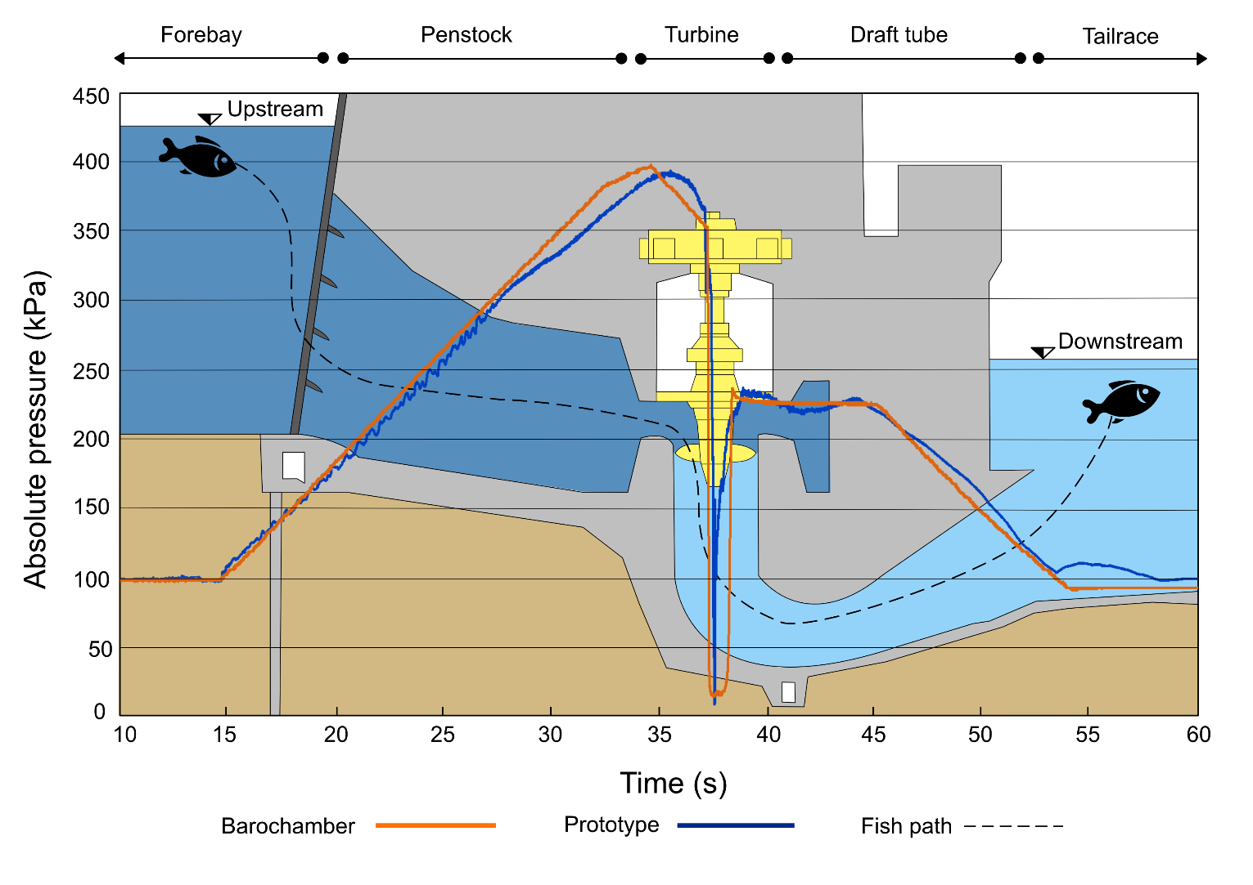
Supplementary Figure 1: Section trough a typical Run-Of-River Hydropower-Plant (RoR-HPP) with a vertical Kaplan turbine, and example of a pressure curve experienced by a fish passing through (dotted black line), a sensor-measured pressure curve (blue line) and a pressure curve simulated by the barotrauma chamber (orange line) (Schneider et al., accepted).

