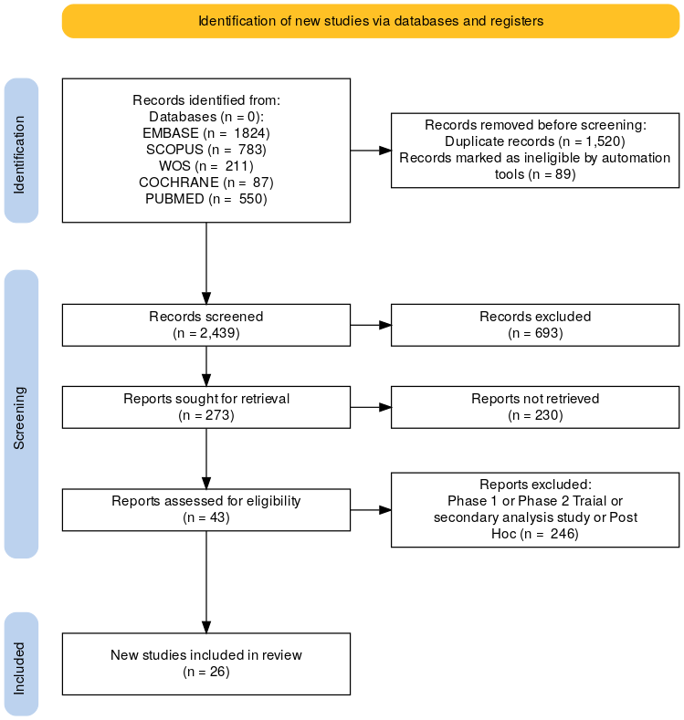
Supplementary Figure 1: PRISMA flow chart of the screening process

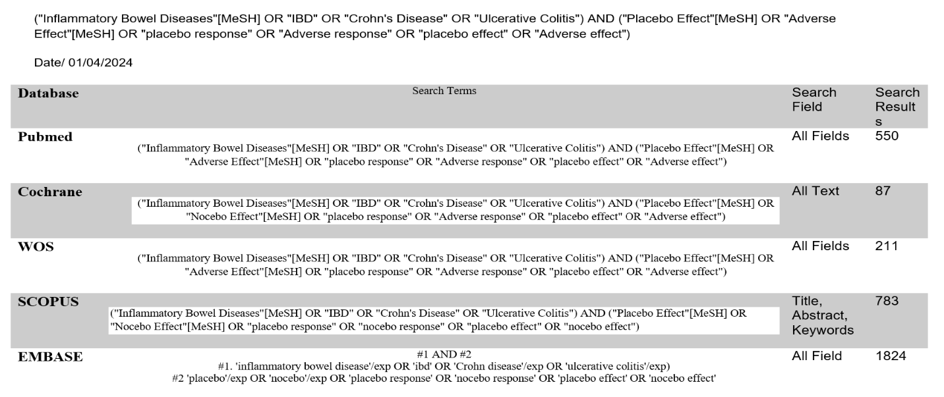
Supplementary Table 1: Search Strategy

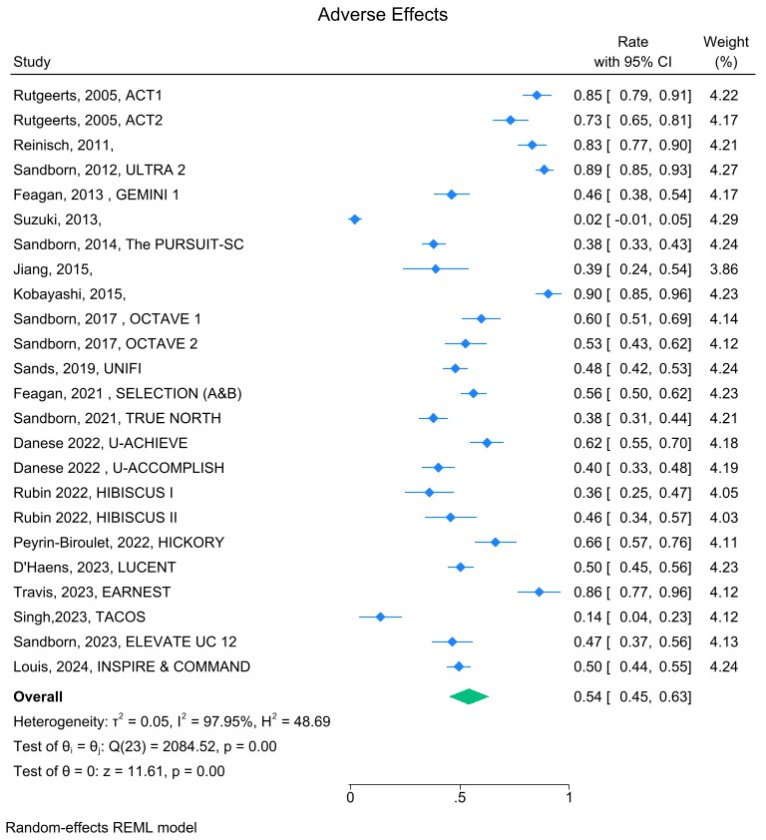
Supplementary Figure 2: Pooled Adverse Events among Published RCTs, CI: confidence interval
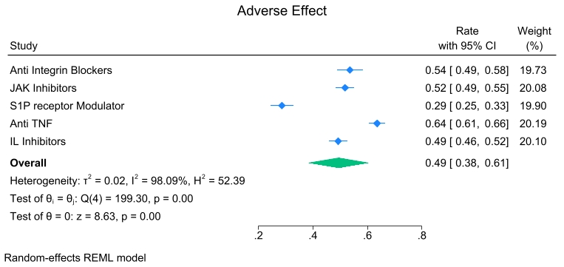
Supplementary Figure 3: Pooled Adverse Events among therapeutic class subgroup analysis: confidence interval

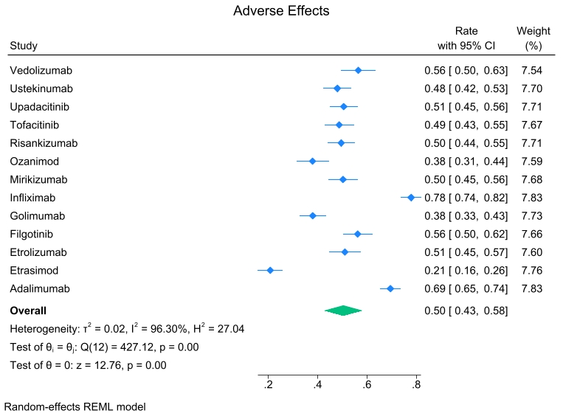
Supplementary Figure 4: Pooled Adverse Events based on drug class subgroup analysis: confidence interval

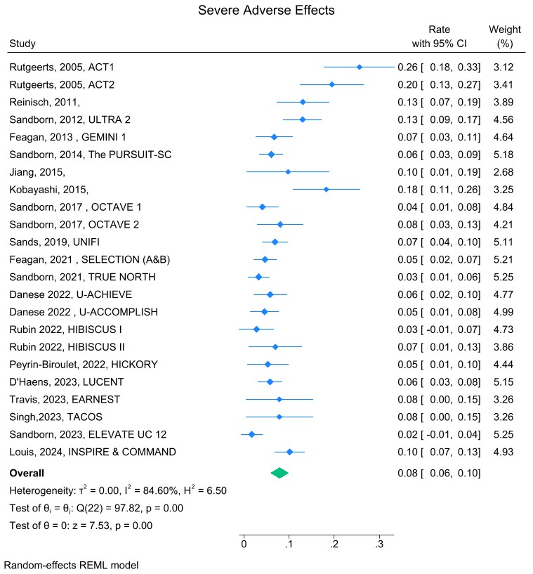
Supplementary Figure 5: Pooled Severe Adverse Events among Published RCTs, CI: confidence interval

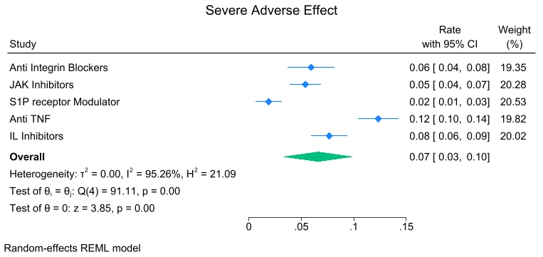
Supplementary Figure 6: Pooled Severe Adverse Events among therapeutic class subgroup analysis,, CI: confidence interval

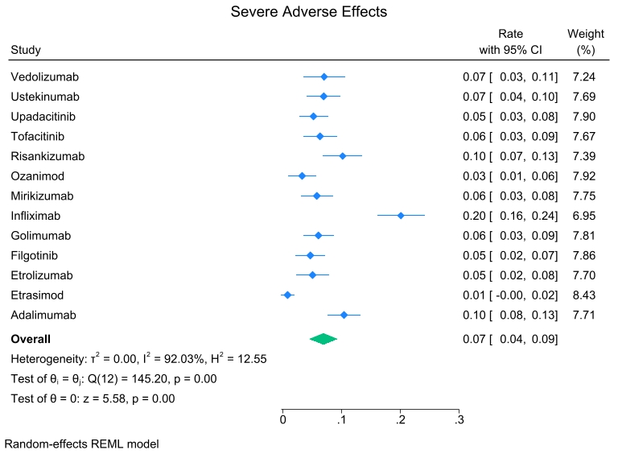
Supplementary Figure 7: Pooled Severe Adverse Events based on drug class subgroup analysis, CI: confidence interval

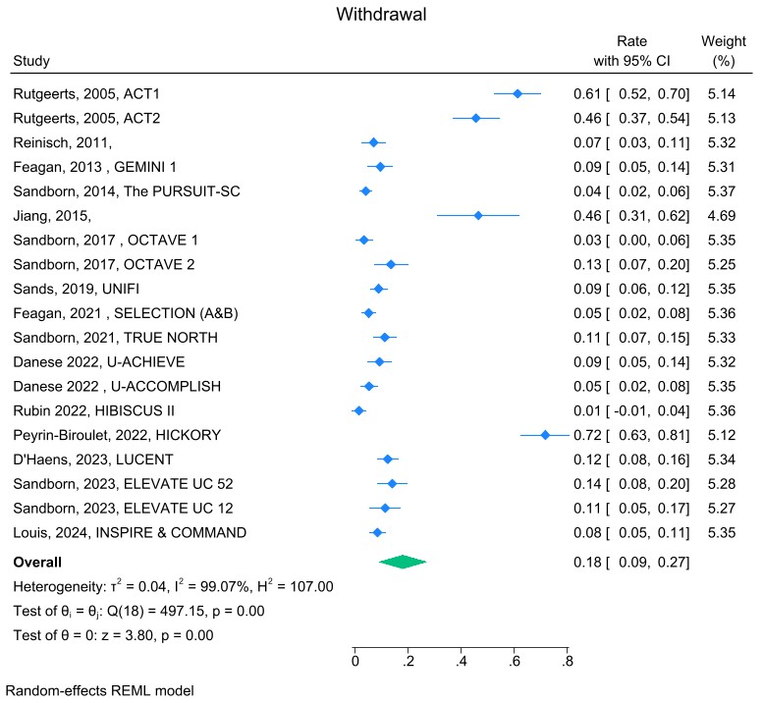
Supplementary Figure 8: Pooled Withdrawal among Published RCTs, CI: confidence interval

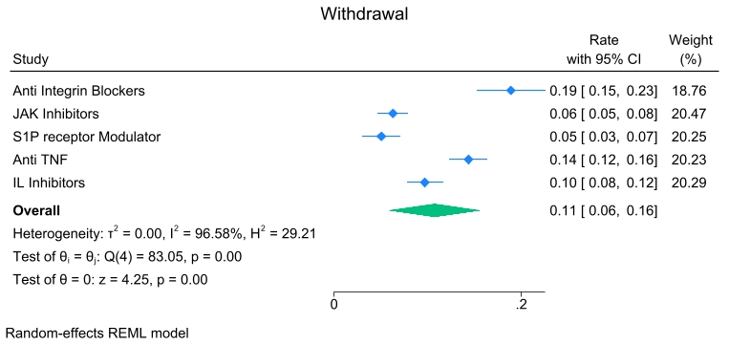
Supplementary Figure 9: Pooled Withdrawal among therapeutic class subgroup analysis,, CI: confidence interval

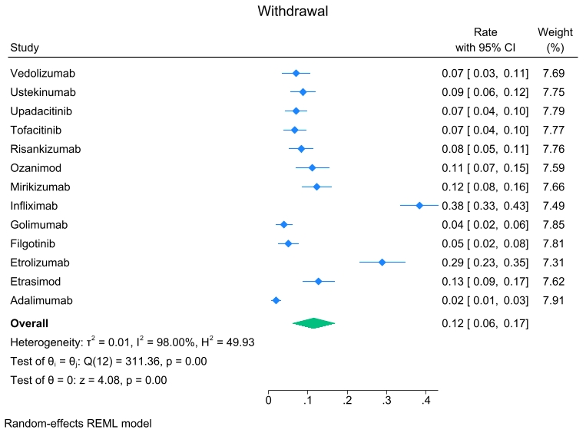
Supplementary Figure 10: Pooled Withdrawal based on drug class subgroup analysis, CI: confidence interval

Clinical Remission Predictors
Study Characteristics | Odd Ratio | P Value | [95% conf. interval]
Year of Publication | 0.999 | 0.641 | 0.996 | 1.002
Sample Size | 0.999 | 0.115 | <0.999 | >1.000
Gender Ratio (M/F) | 1.032 | 0.220 | 0.981 | 1.085
Mean Age (Y) | 0.996 | 0.225 | 0.989 | 1.003
Follow-up Duration (Weeks) | 1.002 | 0.001 | 1.001 | 1.003
Duration Disease (Weeks) | 0.992 | 0.137 | 0.982 | 1.002
Previous TNF Exposure | 0.970 | 0.083 | 0.938 | 1.004
Supplementary Table 2: Multivariate Meta-Regression Analysis of Study Characteristics for Predicting Clinical Remission

Endoscopic Response Predictors
Study Characteristics | Odd Ratio | P Value | [95% conf. interval]
Year of Publication | 0.986 | 0.001 | 0.977 | 0.994
Sample Size | 0.999 | 0.064 | <0.999 | >1.000
Gender Ratio (M/F) | 1.020 | 0.684 | 0.926 | 1.124
Mean Age (Y) | 0.978 | 0.000 | 0.966 | 0.990
Follow-up Duration (Weeks) | 1.004 | 0.042 | 1.000 | 1.007
Duration Disease (Weeks) | 0.987 | 0.452 | 0.954 | 1.021
Previous TNF Exposure | 0.873 | 0.000 | 0.814 | 0.936
Supplementary Table 3: Multivariate Meta-Regression Analysis of Study Characteristics for Predicting Endoscopic Response

Endoscopic Remission Predictors
Study Characteristics | Odd Ratio | P Value | [95% conf. interval]
Year of Publication | 0.985 | 0.000 | 0.979 | 0.991
Sample Size | 0.999 | 0.454 | <0.999 | >1.000
Gender Ratio (M/F) | 0.943 | 0.578 | 0.765 | 1.161
Mean Age (Y) | 0.997 | 0.788 | 0.975 | 1.019
Follow-up Duration (Weeks) | 1.006 | 0.002 | 1.002 | 1.010
Duration Disease (Weeks) | 1.007 | 0.688 | 0.972 | 1.043
Previous TNF Exposure | 0.931 | 0.223 | 0.829 | 1.045
Supplementary Table 4: Multivariate Meta-Regression Analysis of Study Characteristics for Predicting Endoscopic Remission

Predictors of Adverse Effect
Study Characteristics | Odd Ratio | P Value | [95% conf. interval]
Year of Publication | 0.986 | 0.089 | 0.970 | 1.002
Sample Size | 0.999 | 0.671 | <0.999 | >1.000
Gender Ratio (M/F) | 0.865 | 0.299 | 0.658 | 1.137
Mean Age (Y) | 1.008 | 0.689 | 0.971 | 1.046
Follow-up Duration (Weeks) | 1.002 | 0.571 | 0.995 | 1.009
Duration Disease (Weeks) | 1.008 | 0.770 | 0.955 | 1.064
Previous TNF Exposure | 0.889 | 0.246 | 0.728 | 1.085
Supplementary Table 5: Multivariate Meta-Regression Analysis of Study Characteristics for Predicting Adverse Effect Rate

Predictors of Severe Adverse Effect
Study Characteristics | Odd Ratio | P Value | [95% conf. interval]
Year of Publication | 0.993 | 0.000 | 0.990 | 0.996
Sample Size | 0.999 | 0.286 | <0.999 | >1.000
Gender Ratio (M/F) | 0.998 | 0.970 | 0.916 | 1.088
Mean Age (Y) | 0.999 | 0.998 | 0.991 | 1.009
Follow-up Duration (Weeks) | 1.003 | 0.000 | 1.002 | 1.005
Duration Disease (Weeks) | 1.005 | 0.395 | 0.993 | 1.018
Previous TNF Exposure | 0.951 | 0.014 | 0.914 | 0.990
Supplementary Table 6: Multivariate Meta-Regression Analysis of Study Characteristics for Predicting Severe Adverse Effect Rate

Withdrawal Rate
Study Characteristics | Odd Ratio | P Value | [95% conf. interval]
Year of Publication | 0.983 | 0.026 | 0.968 | 0.998
Sample Size | 1.000 | 0.070 | <0.999 | >1.000
Gender Ratio (M/F) | 0.888 | 0.551 | 0.602 | 1.312
Mean Age (Y) | 0.962 | 0.045 | 0.927 | 0.999
Follow-up Duration (Weeks) | 1.013 | 0.001 | 1.008 | 1.019
Duration Disease (Weeks) | 1.007 | 0.868 | 0.923 | 1.100
Previous TNF Exposure | 0.880 | 0.239 | 0.712 | 1.088
Supplementary Table 7: Multivariate Meta-Regression Analysis of Study Characteristics for Predicting Withdrawal

RCT | Clinical Response | Clinical Remission | Endoscopic Response | Endoscopic Remission
Rutgeerts, 2005 (2005 ACT 1 & 2 ) | Mayo score decrease ≥3 and ≥30% + rectal bleeding decrease ≥1 or subscore 0–1 | Mayo score ≤2 with no subscore >1 | Not Assessed | Endoscopic subscore ≤1
Reinisch, 2011 | Mayo decrease ≥3 and ≥30% + rectal bleeding subscore drop ≥1 or to 0–1 | Mayo score ≤2 and no subscore >1 | Not detailed | Not Assessed
Sandborn, 2012 | Mayo decrease ≥3 and ≥30% + rectal bleeding subscore drop ≥1 or to 0–1 | Mayo score ≤2 and no subscore >1 | Not Assessed | Not Assessed
Suzuki, 2013 | ≥3 point improvement | Mayo score ≤2 | Endoscopic subscore drop ≥2 from baseline | Not Assessed
Feagan, 2013 (GEMENI I) | Mayo decrease ≥3 and ≥30% + rectal bleeding subscore drop ≥1 or to 0–1 | Mayo score ≤2, no subscore >1 | Not Assessed | Not Assessed
Sandborn, 2014 (Pursuit-Sc) | ≥3 point improvement | Mayo score ≤2 with no subscore >1 | Endoscopic subscore drop ≥2 from baseline | Not Assessed
Jiang, 2015 | Mayo decrease ≥3 and ≥30%, rectal bleeding drop ≥1 or to 0–1 | Not clearly defined | Not Assessed | Not Assessed
Kobayashi, 2015 | Mayo decrease ≥3 and ≥30% + rectal bleeding subscore drop ≥1 or to 0–1; mPDAI decrease ≥2 points | Mayo score ≤2 with no subscore >1; CAI remission score of 4 or less | Endoscopic subscore drop ≥2 from baseline | Not Assessed
Sandborn, 2017 (Octave 1 & 2) | Mayo decrease ≥3 and ≥30%, rectal bleeding drop ≥1 or to 0–1 | Mayo score ≤2 with no subscore >1 | Endoscopic subscore ≤1 | Endoscopic subscore = 0
Sands, 2019 (Unifi) | Mayo decrease ≥3 and ≥30%, rectal bleeding drop ≥1 or to 0–1 | Mayo score ≤2 and no subscore >1 | Endoscopic subscore ≥2 at baseline | Endoscopic subscore ≤1
Feagan, 2021 (Selection A & B ) | Not Assessed | Mayo score ≤2, no subscore >1, rectal bleeding subscore = 0 | Not Assessed | Endoscopic subscore ≤1
Sandborn, 2021 (True North) | Mayo decrease ≥3 and ≥30%, rectal bleeding drop ≥1 or to 0–1 | Mayo score ≤2, no subscore >1, rectal bleeding subscore = 0 | Endoscopic subscore drop ≥2 from baseline | Endoscopic subscore ≤1
Peyrin-Biroulet, 2022 (HICKORY) | MCS decrease ≥3 points & ≥30% + rectal bleeding subscore drop ≥1 or to 0–1 | MCS ≤2, all subscores ≤1, rectal bleeding subscore = 0 | Endoscopic subscore drop ≥2 from baseline | Endoscopic subscore ≤1
Rubin 2022 (HIBISCUS I & II) | ≥3-point decrease and ≥30% reduction + rectal bleeding subscore drop ≥1 or to 0–1 | MCS ≤2, all subscores ≤1, rectal bleeding = 0 | Endoscopic subscore drop ≥2 from baseline | Endoscopic subscore ≤1
Danese 2022 ( ^{U-ACHIEVE & U-ACCOMPLISH)} | ≥2-point and ≥30% drop in Mayo, rectal bleeding subscore drop ≥1 or = 0–1 | Mayo score ≤2, no subscore >1 | Endoscopic subscore 2–3 baseline | Endoscopic subscore ≤1
Travis, 2023 (EARNEST) | mPDAI decrease ≥2 points | mPDAI ≤4 and ≥2 point drop | Not Assessed | Not Assessed
Sandborn, 2023 (ELEVATE I & II) | ≥2-point and ≥30% drop in Mayo, rectal bleeding subscore drop ≥1 or = 0–1 | Mayo score ≤2, no subscore >1, rectal bleeding subscore = 0 | Endoscopic subscore drop ≥2 from baseline | Endoscopic subscore ≤1
D'Haens, 2023 (LUCENT) | ≥2-point and ≥30% drop in Mayo, rectal bleeding subscore drop ≥1 or = 0–1 | Mayo score ≤2, no subscore >1 | Subscore ≤1 | Endoscopic Subscore = 0
Singh, 2023 (TACOS) | Lichtiger index drop >3 and score <10 for 2 days without rescue | Not assessed | Not assessed | Not Assessed
Loius, 2023 (INSPIRE & COMMAND) | Mayo score decrease ≥30% + rectal bleeding decrease ≥1 or to ≤1 | Stool frequency ≤1, rectal bleeding = 0, endoscopy ≤1 without friability | Endoscopic subscore drop ≥2 from baseline | Endoscopic subscore ≤1, no friability
Supplementary Table 8: Outcome Definition in Ulcerative Colitis RCTs

