Appendix 1 Primer information used in this article
Primer | Primer sequence
CAD-F | ATGGGAAGCCTTGATACCGAGAGA
CAD-R | CTACGGATCAAGTTTGCTT
D-ZX-F | GACCTCGAGGGGGGGCCCGGTACCATGGGAAGCCTTGATACCGAGAGA
D-ZX-R | CTACGGATCAAGTTTGCTT
D-FX-F | GCCACCGCGGTGGAGCTCGGTACCATGGGAAGCCTTGATACCGAGAGA
D-FX-R | CTACGGATCAAGTTTGCTT
D-PDK-F | CGGAAGCAAACTTGATCCGTAGGTAAGGAAATAATTATTTTCTTT
D-PDK-R | CGGAAGCAAACTTGATCCGTAGCTGTAATCAATCCAAATGTAAGAT
PH-F | GGTAACATGATAGATCATGTCATTGTG
PH-R | TACAACGTGCACAACAGA
01yz-F | TGTTTGAACGATCTGCAGCCCGGG
01yz-R | GGGGGACTCTAGTTTATCAAGC
BGD-F | GAGCTCGGTACCCGGGGATCCATGGGAAGCCTTGATACCGAG
BGD-R | CAGGTCGACTCTAGAGGATCCCTACGGATCAAGTTTGCTTCCG
yz-F | TCCGGTATTTTTACAACAATACC
yz-R | CAATCTTAAGAAACTTTATTGCC
D-XbalF | ATACACCAAATCGACTCTAGAATGGGAAGCCTTGATACCGAG
D-KpnIR | GCCCTTGATCACCATGGTACCCGGATCAAGTTTGCTTCCGG
1300yz-F | GACGCCATTTCGCCTTTTC
1300yz-R | GCCGTCCAGCTCGACCAG
kana300F | CACAGTCGATGAATCCAGAA
kana300R | CCGAGAAAGTATCCATCATG
kana270R | CTCGGCAGGAGCAAGGTGAGATGAC
kana270F | CGGCTATGACTGGGCACAACAGACAAT
hyg560-F | GCTGCATCATCGAAATTGCC
hyg501-R | CAAGACCTGCCTGAAACCGA
hyg359-F | GCCTCGCTCCAGTCAATGAC
hyg501-R | CAAGACCTGCCTGAAACCGA
C4H-F | CGCTCAGCAAAAGGGTGAAA
C4H-R | AAAGAAAAGACAAAGGTACCGGC
C3H-F | GCAGGAGCGATATGACCTTAGTG
C3H-R | CTGTCAGTACGCGATTGGTGC
4CL-F | TTTCACGGATTCAATTCCAAAAG
4CL-R | GTTAGGCATAGAACCAGCGGC
HCT-F | ACCTGGGCAAGTATTGCTCG
HCT-R | AATTATTCAGAAAAGGAGGAGGGTC
F3H-F | CCCTAGACCCAAGTTTCGTTCG
F3H-R | TCACTCCTTTTGCCATCAACTTC
F3M-F | TTCATCTTTTCTCCGGCAAGG
F3M-R | TGAGCTAAGTTCACTGGCTCCC
F35H-F | GTCGATTTCTTGGTTGGATTTACA
F35H-R | GCTCCTCAATCATCTTCGTTAACA
PAL-F | TGTCAAGGCCAGCAGTGATT
PAL-R | TTCTCCGATGAGAAGTGGCG
qCAD-F | CTGGTAAATCCCTCGGGGTG
qCAD-R | TGACACGCAATCCAAAAGCC
Actin-F | GCTGATGATGCGGATTGGG
Actin-R | AGCTGTGCTTCGATGTCTTTGA
JMCAD-F | CCGCTGCAGGTCGACGGATCCATGGGAAGCCTTGATACCGAG
JMCAD-R | ATGGCCATGGAGGCCGAATTCCTACGGATCAAGTTTGCTTCCG
pyz-F | GACCTGCATATGGCCATG
pyz-R | CTAGTTATGCGGCCGCTG

Appendix 2 Diagram of recombinant plasmid construction
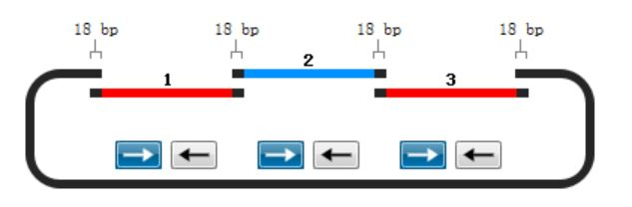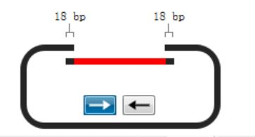
A
B
C
D
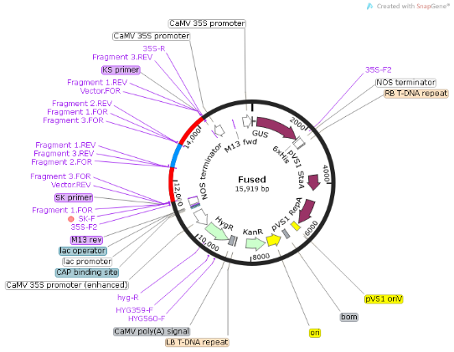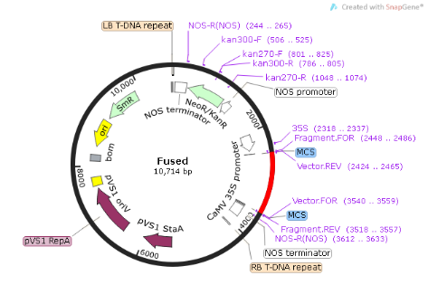
Diagram of recombinant plasmid construction
Figure A is a schematic diagram of multi-fragment homologous recombination; figure B is a schematic diagram of single-fragment homologous recombination; the C diagram is a ZaCAD-RNAi diagram; D diagram is ZaCAD-overexpression diagram.

