Mitochondrial Transplantation Ameliorates the Development and Progression of Osteoarthritis
A Ram Lee^{1, 2, *}, Jin Seok Woo^{1, *}, Seon-Yeong Lee^{1, *}, Hyun Sik Na^{1, 2}, Keun-Hyung Cho^{1, 2}, Yeon Su Lee^{1,2}, Jeong Su Lee^{1,2}, Seon Ae Kim³, Sung-Hwan Park⁴, Seok Jung Kim^{3, #}, Mi-La Cho^{1, 5, #}
¹ Rheumatism Research Center, College of Medicine, Catholic Research Institute of Medical Science, The Catholic University of Korea, Seoul 06591, Republic of Korea
² Department of Biomedicine & Health Sciences, College of Medicine, The Catholic University of Korea, Seoul 06591, Republic of Korea
³ Department of Orthopedic Surgery, Uijeongbu St. Mary's Hospital, College of Medicine, Catholic University of Korea, Seoul 06591, Republic of Korea
⁴ Division of Rheumatology, Department of Internal Medicine, Seoul St. Mary's Hospital, College of Medicine, Catholic University of Korea, Seoul 06591, Republic of Korea
⁵ Department of Medical Lifescience, College of Medicine, Catholic University of Korea, Seoul 06591, Republic of Korea
* These authors contributed equally to this work.
# Authors to whom correspondence should be addressed.
SUPPLEMENTAL INFORMATION
Supplementary Table
Supplementary Table 1. List of primers for real-time PCR in this study
Gene name | Forward Primer | Reverse Primer
β-actin | GGA CTT CGA GCA AGA GAT GG | TGT GTT GGG GTA CAG GTC TTT
NDUFB5 | GCC ATG AGT TTG TTG CGG C | CCT TCG GAA AGC CAC GAG T
UQCRB | GGATGT TTC GCATTA AGA GGG C | TGG TCC ACT GCT CTT TAG GC
COX5B | AGT CCC CTC CAT CTC CAA CA | CTG GGG CAC CAG CTT GTA AT
ATP5O | GAG AGG TTC TCT CCC CTC ACT | CAA GGTACC TCT CCG CGA TG
MMP-1 | CTG AAG GTG ATG AAG CAG CC | AGT CCA AGA GAA TGG CCG AG
MMP-3 | CTC ACA GAC CTG ACT CGG TT | CAC GCC TGA AGG AAG AGA TG
MMP-13 | CTA TGG TCC AGG AGA TGA AG | CTA TGG TCC AGG AGA TGA AG
COL2A1 | TCT ACC CCA ATC CAG CAA AC | GTT GGG AGC CAG ATT GTC AT

Supplementary Figure and FigureLegends:
Supplementary Figure 1. Mitochondrial transplantation suppressed inflammatory mediators in the MIA-induced model. OA rats were sacrificed at day 29 after induction and joint tissues were stained with indicated antibodies (N = 5 animals per group). (a) The expression of pro-inflammatory cytokines (IL-1β, TNF-α), MCP-1, catabolic factor (MMP-13), and necroptosis marker (p-MLKL) was determined immunohistochemically in the synovium of MIA-induced OA rats. (b) Bar graphs show the percentage of positive cells for each antibody. The data are expressed as the mean±S.E.M. (*p< 0.05).
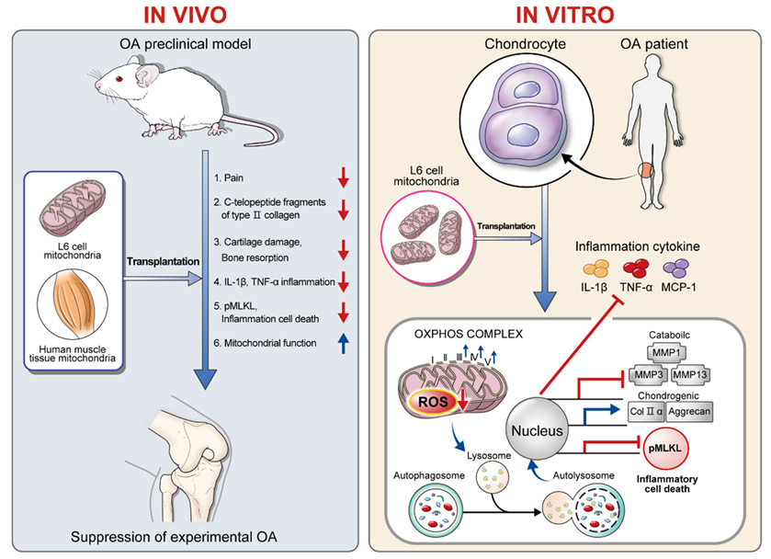
Supplementary Figure 2. Mitochondrial transplantation ameliorates the development and progression of osteoarthritis.

