Virtual Reality vs Traditional Videogames: Which is More Effective at Enhancing Adolescent Intentions and Attitudes Towards Sport?

Supplementary Materials

Gameplay Images
- Totally Baseball! on Meta Quest VR
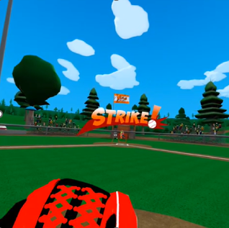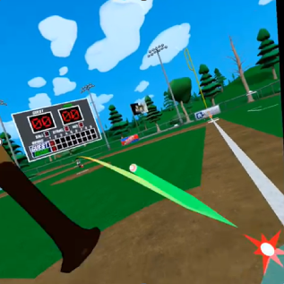

- Golf+ on Meta Quest VR
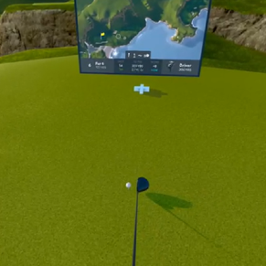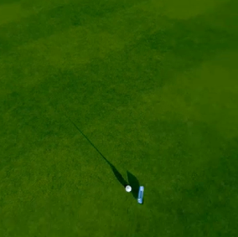

- First Person Tennis on Meta Quest VR
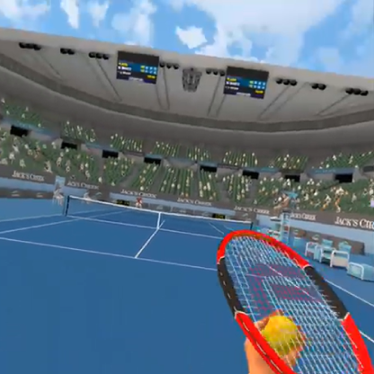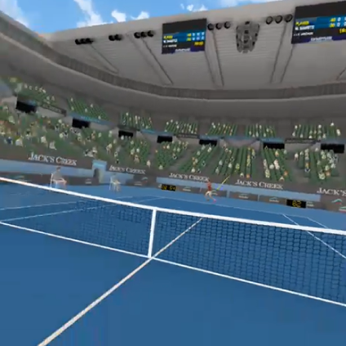

- Fruit Ninja 2 on Meta Quest VR
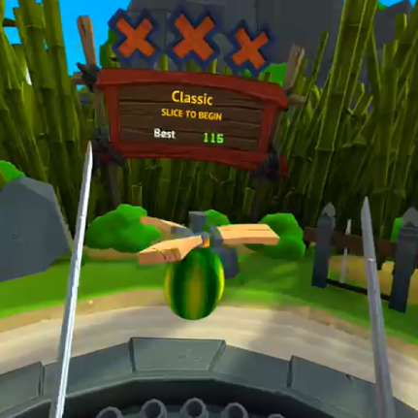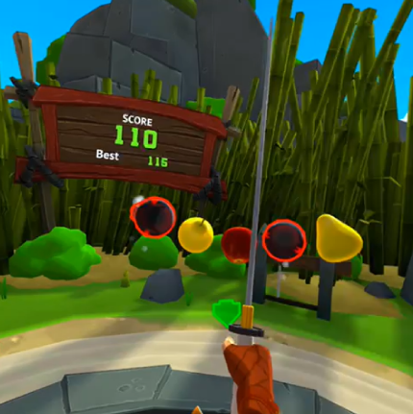

- PGA Tour 2k23 on PlayStation 5
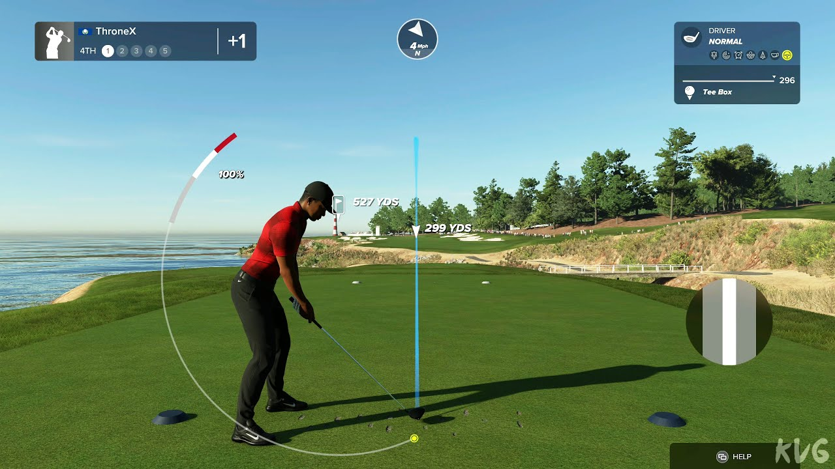

- Tennis World Tour 2 on PlayStation 5
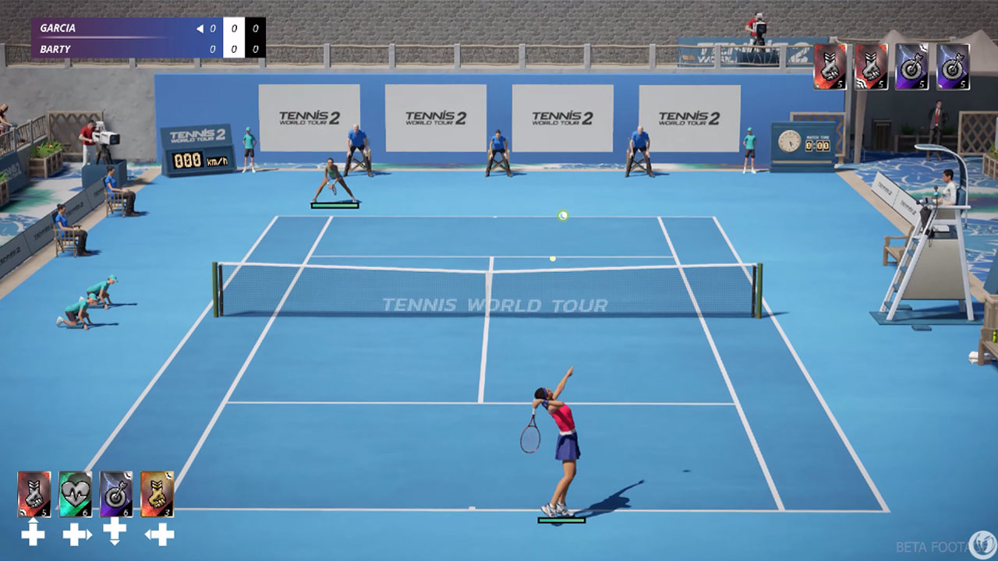

- MLB The Show 23 on PlayStation 5
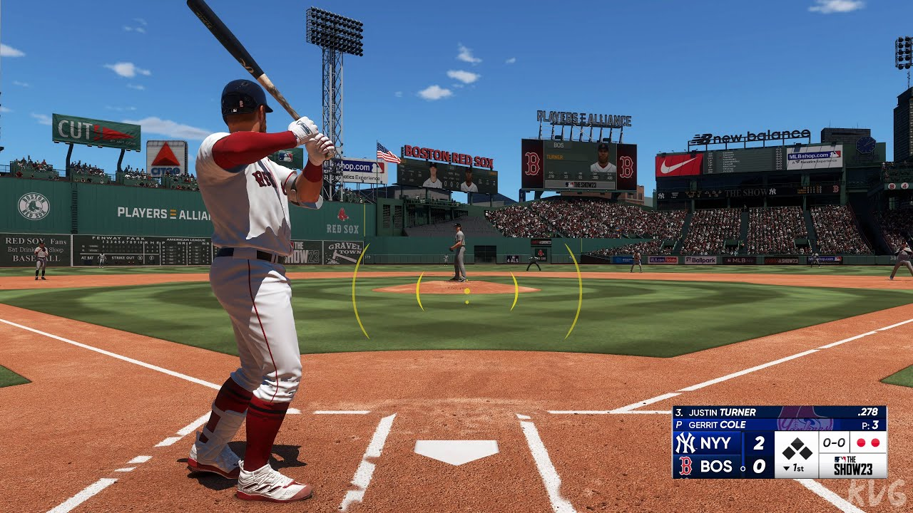

Full Questionnaire

First Name: ___________________________________________________________

Last Name: ___________________________________________________________

How old are you now? ___________________

How do you identify? (please circle)
Boy
Girl
I prefer to self-describe as ___________________________________________________________

Part 1

“Sport” is an activity that is organised by a club and includes playing within a team (e.g., football or netball) or playing individually (e.g., club tennis or swimming squad)

Favourite Sport (NOT including baseball, golf, or tennis): ________________________________________

- How many times did you play sport last week?
None | 1-2 | 3-4 | 5-6 | 7+

- How many times did you do training sessions for your sport last week?
None | 1-2 | 3-4 | 5-6 | 7+

- For each sport you played last week, what age group or level did you play in? Remember, this does NOT include activities you do with friends at school, in the yard, or in the park.
Sport | Age group or level (e.g., Under 13s)
1
2
3
4
5

- How many times in the past week did you practice/play sport just for fun?
At a park: | None | 1-2 | 3-4 | 4+
In your backyard or another person’s backyard: | None | 1-2 | 3-4 | 4+
At school (recess/lunchtime): | None | 1-2 | 3-4 | 4+
Other location: | None | 1-2 | 3-4 | 4+

For questions 5 to 8, if you play more than one sport, please think about the sport that you play the most

5. What sport do you play the most? _________________________________________________

6. How long have you been playing sport? If you play more than one sport, just think about the sport you play the most. Please circle ONE box only.
Less than a year | 5 years
1 year | 6 years
2 years | 7 years
3 years | 8 years
4 years | More than 8 years

7. How much do you like playing sport? Again, if you play more than one sport, think about the sport you play the most. Please circle ONE box only.
I like it a lot
I like it a little bit
I don’t know
I don’t like it that much
I don’t like it at all

8. Why do you play sport? Again, if you play more than one sport, think about the sport you play the most. MORE than one box can be circled.
I enjoy playing it | My friends play it
I am good at it | It’s a safe sport to play
My parents encourage me to play it | I like being part of a team
Where I play is close to home | Playing it runs in my family
I like playing competitive games | I like watching it on TV
I want to play for Australia one day | I like using the gear
Other reason. Please explain:
________________________________________________________________

________________________________________________________________

9. Have you played any other sports over the past year that you don’t play at the moment? For example, other sports you did not put down in question 3. This does NOT include activities you do with friends at school, in the yard, or in the park.

YES (go to question 10 below) NO (go to question 14)

10. What were the other sports you played over the past year? (please list)

11. Will you play the sports you listed in question 10 again next year?

NO (go to question 12 below) YES (go to question 14)

12. Which of the sports that you listed in question 10 do you think you will STOP playing? (please list)

13. Why will you stop playing the sport(s) next year? MORE than one box can be circled.
I don’t like it anymore | My parents told me to stop
I got hurt/injured while playing it | My friends stopped playing
I live too far away to play | The sport is too dangerous
I don’t have anyone to take me to games | I don’t like the training
The sport costs too much money to play | I found a better sport
I have too much homework | I have a job after school
Other reason. Please explain: ________________________________________________________________

________________________________________________________________

14. Think about your usual SCHOOL WEEK (i.e., NOT during the term breaks or summer holidays), then please answer the questions below.
On a typical MONDAY, how many hours/minutes do you spend participating in sport, physical activity, or active play? | __________ hours __________ minutes
On a typical TUESDAY, how many hours/minutes do you spend participating in sport, physical activity, or active play? | __________ hours __________ minutes
On a typical WEDNESDAY, how many hours/minutes do you spend participating in sport, physical activity, or active play? | __________ hours __________ minutes
On a typical THURSDAY, how many hours/minutes do you spend participating in sport, physical activity, or active play? | __________ hours __________ minutes
On a typical FRIDAY, how many hours/minutes do you spend participating in sport, physical activity, or active play? | __________ hours __________ minutes
On a typical SATURDAY, how many hours/minutes do you spend participating in sport, physical activity, or active play? | __________ hours __________ minutes
On a typical SUNDAY, how many hours/minutes do you spend participating in sport, physical activity, or active play? | __________ hours __________ minutes

15. Think about your usual SCHOOL WEEK (i.e., NOT during the term breaks or summer holidays), then please answer the questions below.
On a typical MONDAY, how many hours/minutes do you spend watching television, playing electronic games, or using the computer (other than for homework)? | __________ hours __________ minutes
On a typical TUESDAY, how many hours/minutes do you spend watching television, playing electronic games, or using the computer (other than for homework)? | __________ hours __________ minutes
On a typical WEDNESDAY, how many hours/minutes do you spend watching television, playing electronic games, or using the computer (other than for homework)? | __________ hours __________ minutes
On a typical THURSDAY, how many hours/minutes do you spend watching television, playing electronic games, or using the computer (other than for homework)? | __________ hours __________ minutes
On a typical FRIDAY, how many hours/minutes do you spend watching television, playing electronic games, or using the computer (other than for homework)? | __________ hours __________ minutes
On a typical SATURDAY, how many hours/minutes do you spend watching television, playing electronic games, or using the computer (other than for homework)? | __________ hours __________ minutes
On a typical SUNDAY, how many hours/minutes do you spend watching television, playing electronic games, or using the computer (other than for homework)? | __________ hours __________ minutes

Part 2
Do you own a VR headset?
Yes | No

If yes, how often do you use your VR headset?
5 or more times per week | 3-4 times per week | 1-2 times per week | Less than once a week

Have you ever used a VR headset before?
Yes | No

If yes, how many times have you used a VR headset?
Once or twice | 3-5 times | 6-10 times | Over 10 times

Have you ever played a sports game in VR before?
Yes | No

How many times have you played a sports game in VR before?
Once or twice | 3-5 times | 6-10 times | Over 10 times

Have you ever played a game of baseball, golf, or tennis in VR before?
Baseball: | Yes | No
Golf: | Yes | No
Tennis: | Yes | No

How many times have you played a game of baseball, golf, or tennis in VR before?
Baseball: | Once or twice | 3-5 times | 6-10 times | Over 10 times
Golf: | Once or twice | 3-5 times | 6-10 times | Over 10 times
Tennis: | Once or twice | 3-5 times | 6-10 times | Over 10 times

Part 3
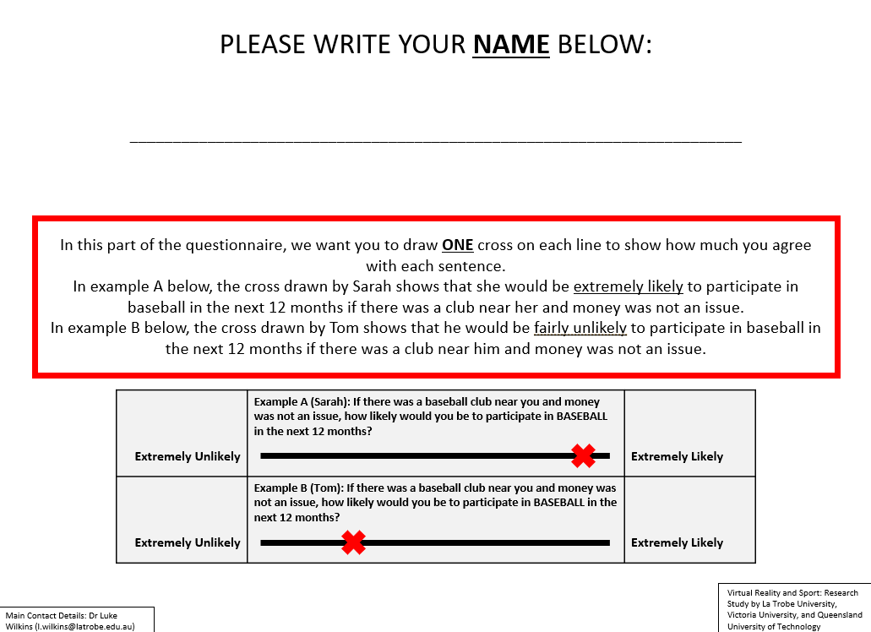
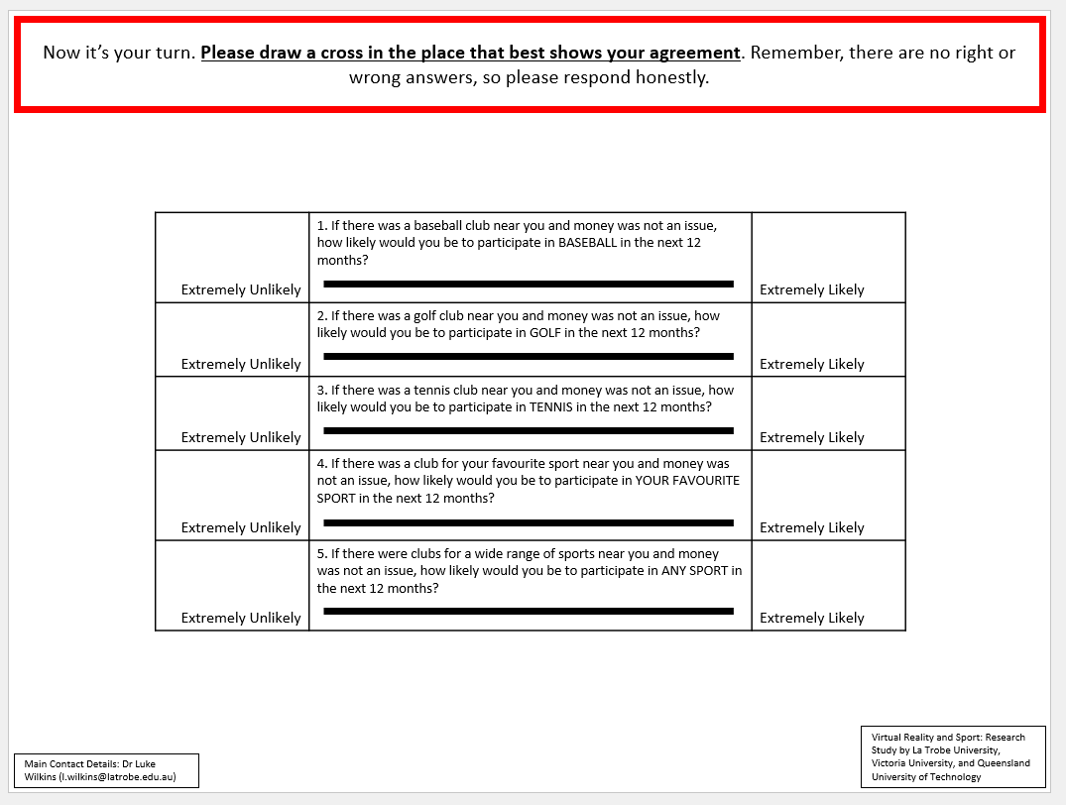
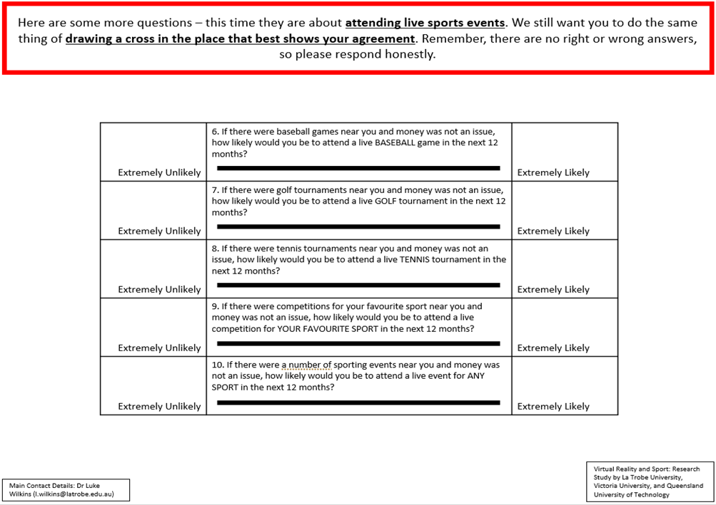
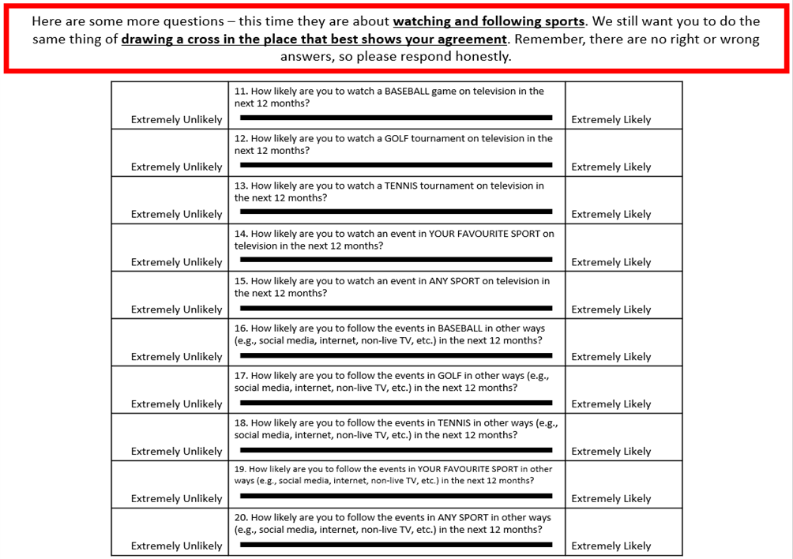

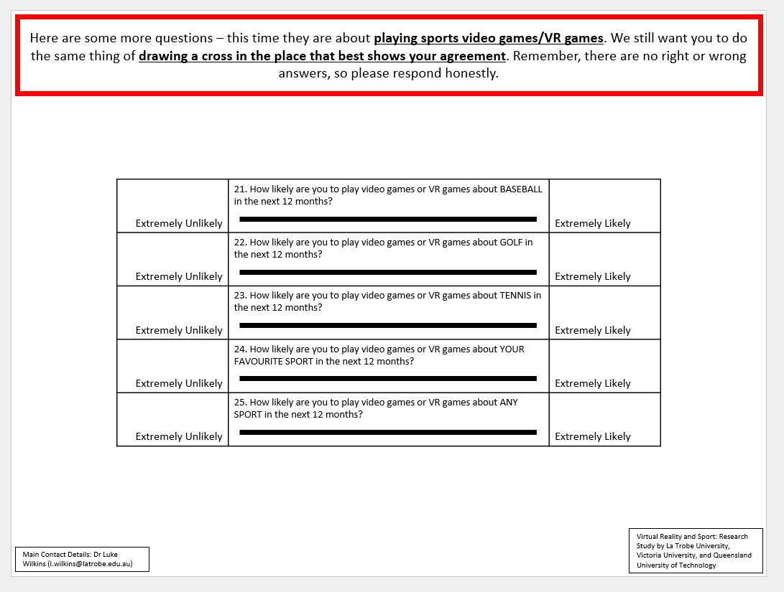
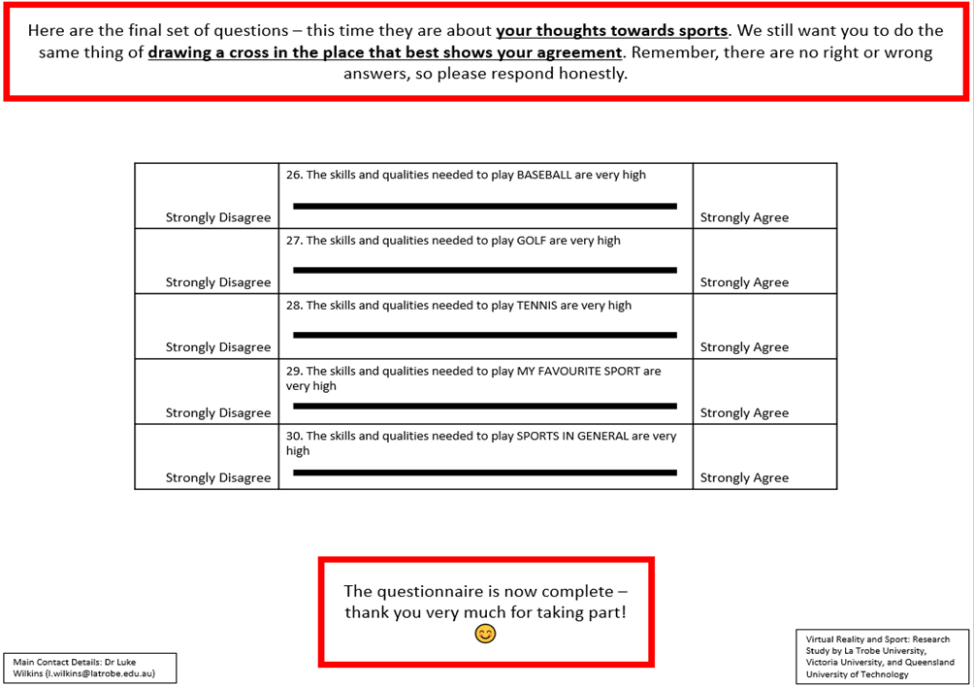

(Post-Intervention Only)
