Article title: Serum Interleukin-4 and Ascitic CD206 Predicts Mortality in Acute Cirrhosis Decompensation and Acute-on-Chronic Liver Failure.
Journal name: Indian Journal of Gastroenterology.
Author names: Sameh A. Lashen , Perihan Salem, Esraa Ibrahim, DaliaAbd Elmoaty, Walid I. Yousif.
*Corresponding author:
Sameh A. Lashen (MD), [ORCID: 0000-0002-8599-1338], Assistant professor, Internal Medicine Department (Hepatology & Gastroenterology Division), Faculty of Medicine, Alexandria University, Champollion Street, El-Khartoum Square, Azarita, Alexandria, 21521, Egypt. Contact: sameh.lashen@alexmed.edu.eg, telephone: (+20)127 4117 543.

Supplementary figure legends:
Supplementary Fig. 1: Study flow chart. Ascitic AD: Acute decompensation, ascitic ACLF: Acute –on chronic liver failure, HCC: Hepatocellular carcinoma.
Supplementary Fig. 2: The overall mortality over six months among patients with acute decompensation (AD), patients with acute-on-chronic liver failure (ACLF), and the control group.

Suppl. Table 1:
Supplementary table 2: comparison between patients with and without sepsis as regards serum IL-4 and ascitic sCD206:
 | All patients  (n = 90) |  | Acute decompensation  (n = 30) |  | Acute on chronic liver failure  (n = 30)
Sepsis | Yes (n = 18) | No (n = 72) | Yes (n = 8) | No (n = 22) | Yes (n = 10 | No (n = 20)
Serum IL-4 #  (pg/ml) | 0.21 – 11.58 (4.49) | 0.06 – 16.82  (1.14) | 0.21 – 11.28  (1.08) | 0.29 – 6.52  (0.98) | 5.28 – 11.58  (10.09) | 1.03 – 16.82  (13.27)
P* | 0.21 |  | 0.57 |  | 0.17
Ascitic sCD206 #  (ng/ml) | 2.99 – 54.22 (16.35) | 0.20 – 59.70 (11.20) | 2.99 – 49.77  (14.22) | 1.40 – 33.47  (13.80) | 24.0 – 54.22  (37.28) | 4.23 – 59.70  (33.90)
P* | 0.14 |  | 0.88 |  | 0.42
* P for Mann-Whitney test
# Data expressed as minimum – maximum (median)

Supplementary table 2: Univariate analysis for predictors for in-hospital mortality and 3 months mortality among AD+ACLF patients: (n = 60)
 | One month mortality |  |  |  | 3 months mortality
Baseline parameters | Died  n = 28 | Alive  n = 32 | P* | 95% CI | Died  n = 36 | Alive  n = 24 | P* | 95% CI
Age | 59.45±13.62 | 56.74±17.29 | 0.50 | -5.30 – 10.72 | 60.08±12.45 | 55.00±19.30 | 0.25 | -3.78 – 14.21
Male gender | 14 (50) | 14 (43.75) | 0.63 ª | - | 18 (50) | 10 (41.7) | 0.61 ª | -
CTP score | 11.92±1.68 | 10.66±1.17 | 0.002 | 0.51 – 2.04 | 11.75±1.59 | 10.50±1.18 | 0.002 | 0.48 – 2.01
MELD-Na | 34.42±8.95 | 24.84±6.90 | <0.001 | 5.40 – 13.80 | 32.72±8.89 | 24.21±7.23 | <0.001 | 4.15 – 12.88
Cr | 3.75±2.53 | 1.72±1.16 | <0.001 | 1.03 – 3.02 | 3.39±2.37 | 1.60±1.18 | <0.001 | 0.86 – 2.72
MAP | 82.3±12.78 | 83.60±12.24 | 0.68 | -7.80 – 5.14 | 82.03±13.33 | 84.37±11.00 | 0.48 | -8.90 – 4.24
Platelets x10^{3 b} | 14 – 551 (96) | 26 – 478 (93) | 0.11^{c} | 0.10-0.12 | 14 – 551 (96) | 26 – 478 (91) | 0.29 ^{c} | 0.28 – 0.31
Albumen | 2.52±0.53 | 2.75±0.55 | 0.10 | -0.51 – 0.05 | 2.55±0.56 | 2.78±0.51 | 0.11 | -0.50 – 0.05
Bilirubin ^{b} | 1.8 – 35.1 (9.85) | 0.6 – 2.4 (3.90) | <0.001^{c} | - | 1.7 – 35.1 (9.45) | 0.6 – 2.4 (2.85) | <0.001 | -
INR | 2.28±0.87 | 1.72±0.37 | 0.003 | 0.21 – 0.93 | 2.15±0.83 | 1.72±0.36 | 0.01 | 0.11 – 0.74
Serum IL-4 ^{b} | 2.74 – 16.82 (11.43) | 0.21 – 14.10 (1.10) | <0.001 ^{c} | - | 2.74 – 16.82 (10.33) | 0.21 – 13.27 (0.86) | <0.001 | -
Ascitic CD206 ^{b} | 14.22 – 59.70 (39.70) | 1.40 – 37.28 (11.91) | <0.001^{c} | - | 11.6 – 59.7 (33.35) | 1.40 – 19.24 (8.65) | <0.001 | -
CI: Confidence interval; CTP: Child-Turcotte-Pugh; Cr: Creatinine; INR: International normalization ratio; IL-4: Interleukin -4; MAP: Mean arterial pressure; MELD: Model of end-stage liver disease; OR: Odd’s ratio.
*P for independent sample t-test
a: chi-square test
b: data expressed as minimum-maximum (median)
c: Mann-Whitney test

Supplementary Fig. 1
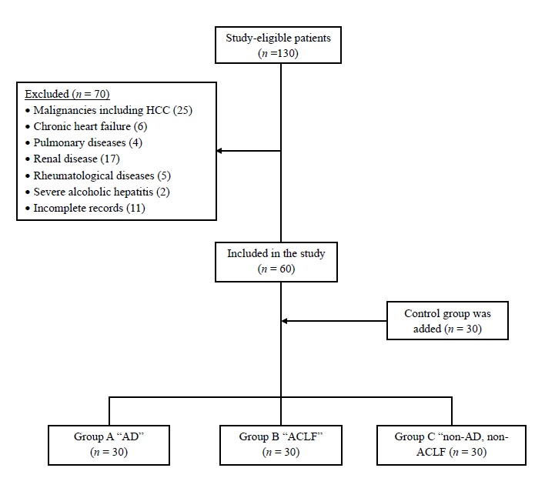

Supplementary fig.2

