Appendices

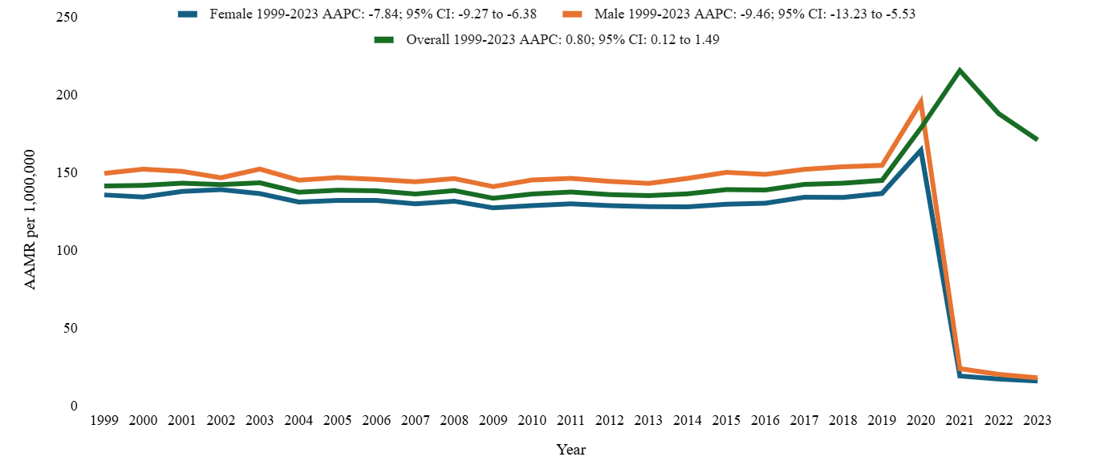
Figure 1: Overall and sex-stratified pulmonary embolism-related age adjusted mortality rates per 1,000,000 in the United States from 1999-2023

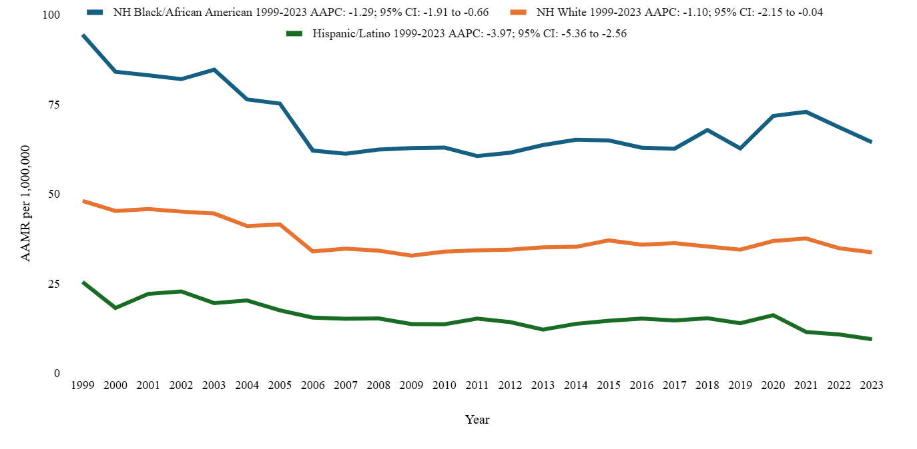
Figure 2: Pulmonary embolism-related age adjusted mortality rates (AAMRs) per 1,000,000 individuals stratified by race in the United States, 1999-2023
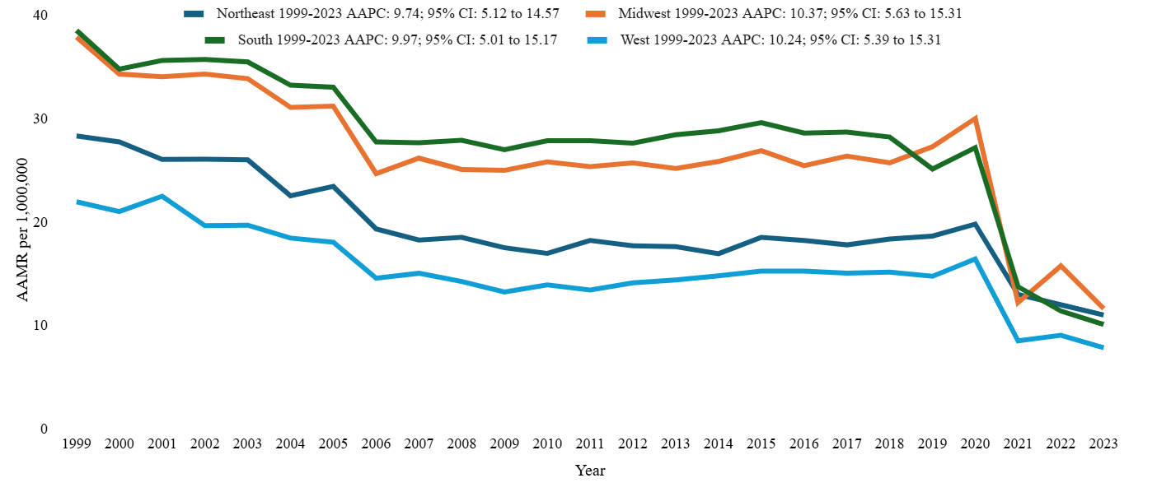
Figure 3: Pulmonary embolism-related age adjusted mortality rates (AAMRs) per 1,000,000 individuals stratified by region in the United States, 1999-2023

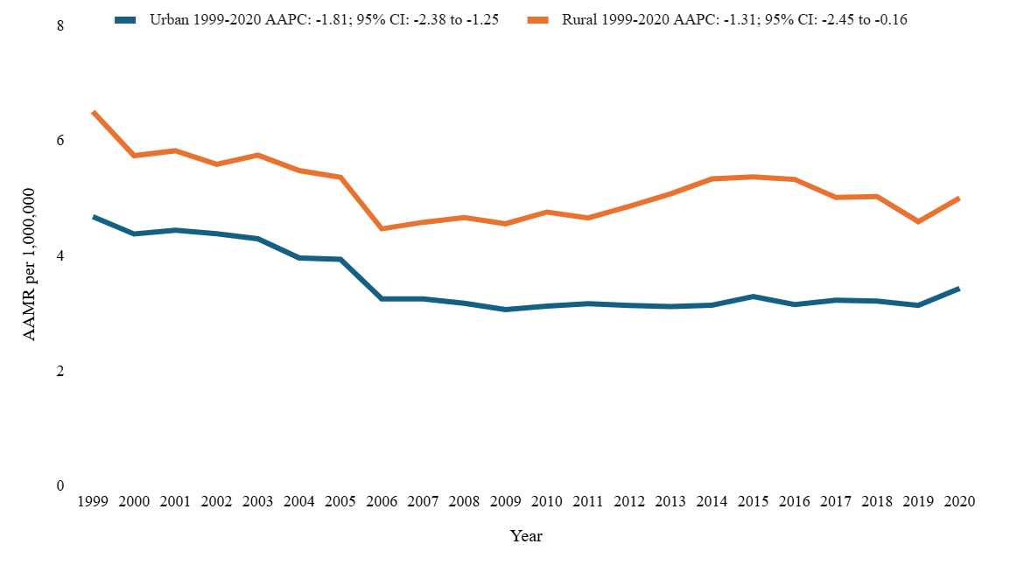
Figure 4: Pulmonary embolism-related age adjusted mortality rates (AAMRs) per 1,000,000 individuals stratified by urbanization in the United States, 1999-2020 *data from urbanization AAMRs was unavailable for 2021-2023*
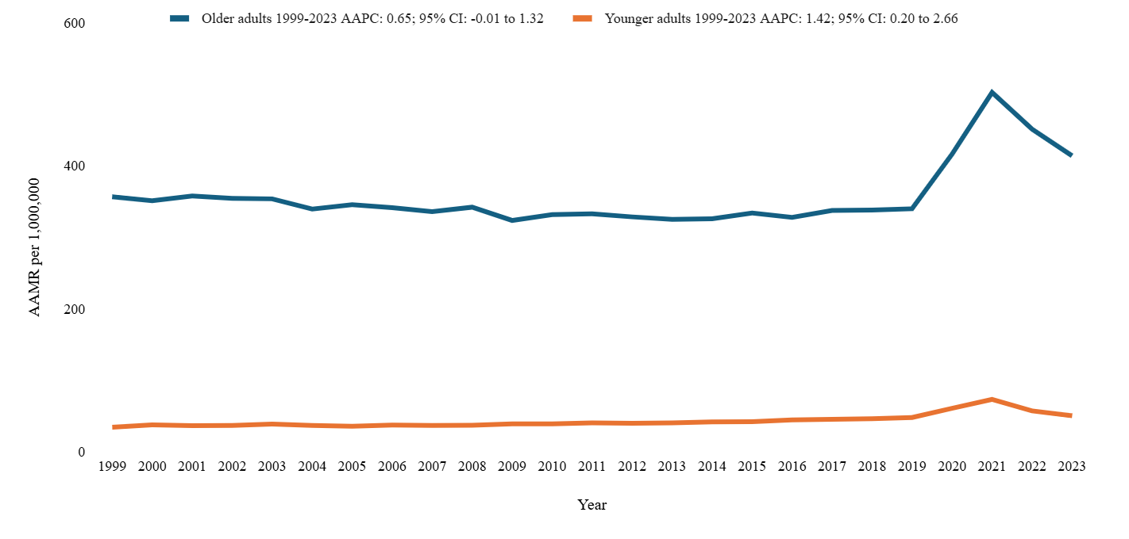
Figure 5: Pulmonary embolism-related age adjusted mortality rates (AAMRs) per 1,000,000 individuals stratified by age in the United States, 1999-2023

