Supplementary Table 1: Deaths per 1,000,000 in the United States, 1999 to 2023
Year | Female | Male | NH White | NH Black or African American | Hispanic or Latino
1999 | 14083 | 10993 | 7054 | 1509 | 241
2000 | 14063 | 11387 | 6677 | 1367 | 190
2001 | 14631 | 11534 | 6830 | 1388 | 236
2002 | 14937 | 11462 | 6798 | 1386 | 256
2003 | 14886 | 12155 | 6794 | 1469 | 231
2004 | 14490 | 11815 | 6323 | 1346 | 253
2005 | 14860 | 12196 | 6480 | 1358 | 227
2006 | 15093 | 12420 | 5374 | 1162 | 221
2007 | 15066 | 12531 | 5553 | 1152 | 231
2008 | 15574 | 13027 | 5538 | 1209 | 235
2009 | 15216 | 12929 | 5341 | 1270 | 236
2010 | 15616 | 13519 | 5609 | 1289 | 234
2011 | 16066 | 14037 | 5762 | 1302 | 280
2012 | 16200 | 14253 | 5864 | 1345 | 279
2013 | 16391 | 14499 | 6042 | 1412 | 260
2014 | 16657 | 15187 | 6145 | 1501 | 296
2015 | 17199 | 16039 | 6553 | 1552 | 337
2016 | 17485 | 16217 | 6370 | 1534 | 363
2017 | 18354 | 16992 | 6529 | 1563 | 379
2018 | 18674 | 17555 | 6443 | 1719 | 412
2019 | 19287 | 18001 | 6338 | 1648 | 383
2020 | 23494 | 23165 | 6711 | 1931 | 477
2021 | 27119 | 28547 | 7216 | 1944 | 528
2022 | 25565 | 24745 | 6988 | 1852 | 513
2023 | 23803 | 22468 | 6703 | 1798 | 453

Supplementary Table 2: Overall Age-Adjusted Mortality Rates per 1,000,000 in the United States, 1999 to 2023
Age Adjusted Rate (95% CI) OVERALL
Year | Age Adjusted Rate | Age Adjusted Rate Lower 95% Confidence Interval | Age Adjusted Rate Upper 95% Confidence Interval
1999 | 141.6646 | 139.9108 | 143.4183
2000 | 142.0208 | 140.2758 | 143.7658
2001 | 143.5371 | 141.7976 | 145.2766
2002 | 142.5398 | 140.8194 | 144.2602
2003 | 143.6976 | 141.983 | 145.4121
2004 | 137.6547 | 135.9884 | 139.321
2005 | 138.989 | 137.3287 | 140.6493
2006 | 138.5802 | 136.9371 | 140.2234
2007 | 136.5792 | 134.9605 | 138.1979
2008 | 138.6718 | 137.0557 | 140.2878
2009 | 133.8621 | 132.2865 | 135.4376
2010 | 136.5469 | 134.9655 | 138.1284
2011 | 137.831 | 136.2567 | 139.4052
2012 | 136.1377 | 134.5897 | 137.6856
2013 | 135.4177 | 133.8865 | 136.9489
2014 | 136.5879 | 135.0642 | 138.1116
2015 | 139.3143 | 137.7914 | 140.8371
2016 | 139.0791 | 137.5667 | 140.5916
2017 | 142.7657 | 141.2489 | 144.2825
2018 | 143.4361 | 141.9304 | 144.9418
2019 | 145.2252 | 143.7213 | 146.729
2020 | 179.0354 | 177.3759 | 180.6948
2021 | 215.9562 | 214.1232 | 217.7892
2022 | 188.221 | 186.544 | 189.898
2023 | 171.3555 | 169.764 | 172.9469

Supplemental Table 3: Sex‐Stratified Age-Adjusted Mortality Rates per 1,000,000 in the United States, 1999 to 2023
Age Adjusted Rate (95% CI) Females
Year | Age Adjusted Rate | Age Adjusted Rate Lower 95% Confidence Interval | Age Adjusted Rate Upper 95% Confidence Interval
1999 | 135.9336 | 133.6751 | 138.1921
2000 | 134.5719 | 132.3341 | 136.8098
2001 | 138.1897 | 135.9371 | 140.4424
2002 | 139.2868 | 137.04 | 141.5335
2003 | 136.8195 | 134.6071 | 139.0318
2004 | 131.405 | 129.2508 | 133.5592
2005 | 132.4453 | 130.2988 | 134.5918
2006 | 132.3675 | 130.2363 | 134.4988
2007 | 130.1389 | 128.039 | 132.2387
2008 | 131.9193 | 129.8232 | 134.0154
2009 | 127.5665 | 125.5117 | 129.6213
2010 | 129.0497 | 126.9948 | 131.1045
2011 | 130.1644 | 128.1142 | 132.2146
2012 | 129.0066 | 126.9794 | 131.0338
2013 | 128.3774 | 126.3694 | 130.3854
2014 | 128.3195 | 126.3251 | 130.314
2015 | 129.9677 | 127.9772 | 131.9581
2016 | 130.6331 | 128.6456 | 132.6207
2017 | 134.4099 | 132.4122 | 136.4076
2018 | 134.3125 | 132.3316 | 136.2933
2019 | 136.855 | 134.8668 | 138.8432
2020 | 164.6932 | 162.5227 | 166.8638
2021 | 193.8794 | 191.51 | 196.2487
2022 | 174.9405 | 172.7336 | 177.1473
2023 | 161.3782 | 159.2756 | 163.4807

Age Adjusted Rate (95% CI) Males
Year | Age Adjusted Rate | Age Adjusted Rate Lower 95% Confidence Interval | Age Adjusted Rate Upper 95% Confidence Interval
1999 | 149.8033 | 146.9472 | 152.6594
2000 | 152.5351 | 149.6799 | 155.3904
2001 | 151.0945 | 148.2864 | 153.9025
2002 | 146.9663 | 144.2256 | 149.707
2003 | 152.6113 | 149.8494 | 155.3732
2004 | 145.4732 | 142.8026 | 148.1438
2005 | 147.1389 | 144.4819 | 149.7959
2006 | 145.9187 | 143.309 | 148.5284
2007 | 144.3426 | 141.7732 | 146.9119
2008 | 146.3975 | 143.8417 | 148.9534
2009 | 141.2629 | 138.7849 | 143.7408
2010 | 145.5372 | 143.0402 | 148.0342
2011 | 146.5067 | 144.0388 | 148.9745
2012 | 144.6108 | 142.1925 | 147.0292
2013 | 143.3724 | 140.9934 | 145.7514
2014 | 146.5602 | 144.183 | 148.9375
2015 | 150.4414 | 148.0645 | 152.8184
2016 | 149.0979 | 146.7532 | 151.4427
2017 | 152.3848 | 150.044 | 154.7256
2018 | 154.0236 | 151.6976 | 156.3496
2019 | 154.9166 | 152.6063 | 157.2268
2020 | 195.735 | 193.1599 | 198.3101
2021 | 241.425 | 238.5483 | 244.3017
2022 | 204.206 | 201.6032 | 206.8088
2023 | 182.5886 | 180.1457 | 185.0315

Supplementary Table 4: Race‐Stratified Age-Adjusted Mortality Rates per 1,000,000 in the United States, 1999 to 2023
Age Adjusted Rate (95% CI) BLACK OR AFRICAN AMERICAN
Year | Age Adjusted Rate | Age Adjusted Rate Lower 95% Confidence Interval | Age Adjusted Rate Upper 95% Confidence Interval
1999 | 94.6208 | 89.7572 | 99.4845
2000 | 84.2653 | 79.7096 | 88.8209
2001 | 83.2644 | 78.7893 | 87.7394
2002 | 82.1945 | 77.7708 | 86.6182
2003 | 84.8435 | 80.4033 | 89.2836
2004 | 76.5525 | 72.3601 | 80.7449
2005 | 75.363 | 71.2506 | 79.4755
2006 | 62.2484 | 58.5703 | 65.9266
2007 | 61.389 | 57.7449 | 65.0331
2008 | 62.537 | 58.9107 | 66.1633
2009 | 62.9476 | 59.3812 | 66.514
2010 | 63.0967 | 59.5509 | 66.6426
2011 | 60.7308 | 57.3339 | 64.1277
2012 | 61.6631 | 58.2753 | 65.0509
2013 | 63.8026 | 60.3799 | 67.2252
2014 | 65.2856 | 61.8917 | 68.6795
2015 | 65.0865 | 61.76 | 68.4129
2016 | 63.0583 | 59.8149 | 66.3016
2017 | 62.7755 | 59.5818 | 65.9692
2018 | 67.9976 | 64.7018 | 71.2933
2019 | 62.8334 | 59.7237 | 65.9431
2020 | 71.9164 | 68.6332 | 75.1996
2021 | 70.11 | 66.9031 | 66.9031
2022 | 66.1602 | 63.0721 | 63.0721
2023 | 62.2836 | 59.3306 | 59.3306

Age Adjusted Rate (95% CI) WHITE
Year | Age Adjusted Rate | Age Adjusted Rate Lower 95% Confidence Interval | Age Adjusted Rate Upper 95% Confidence Interval
1999 | 48.178 | 47.052 | 49.3041
2000 | 45.3831 | 44.2926 | 46.4736
2001 | 45.9096 | 44.8185 | 47.0007
2002 | 45.2121 | 44.1344 | 46.2899
2003 | 44.6626 | 43.5964 | 45.7289
2004 | 41.1762 | 40.1562 | 42.1962
2005 | 41.6027 | 40.5834 | 42.622
2006 | 34.1146 | 33.1947 | 35.0345
2007 | 34.853 | 33.9267 | 35.7794
2008 | 34.311 | 33.3953 | 35.2266
2009 | 32.9339 | 32.0355 | 33.8324
2010 | 34.0284 | 33.1212 | 34.9356
2011 | 34.3793 | 33.4713 | 35.2873
2012 | 34.6026 | 33.6946 | 35.5106
2013 | 35.2231 | 34.3099 | 36.1363
2014 | 35.3589 | 34.4466 | 36.2712
2015 | 37.1612 | 36.2309 | 38.0915
2016 | 35.9734 | 35.0557 | 36.8912
2017 | 36.4122 | 35.4931 | 37.3312
2018 | 35.4527 | 34.5499 | 36.3554
2019 | 34.5984 | 33.7086 | 35.4882
2020 | 37.008 | 36.0777 | 37.9384
2021 | 35.0918 | 34.2588 | 35.9248
2022 | 32.6775 | 31.8888 | 33.4662
2023 | 31.1862 | 30.4183 | 31.954

Age Adjusted Rate (95% CI) HISPANICS OR LATINO
Year | Age Adjusted Rate | Age Adjusted Rate Lower 95% Confidence Interval | Age Adjusted Rate Upper 95% Confidence Interval
1999 | 25.543 | 22.0769 | 29.009
2000 | 18.2841 | 15.4936 | 21.0746
2001 | 22.2499 | 19.2064 | 25.2934
2002 | 22.9256 | 19.9036 | 25.9476
2003 | 19.6763 | 16.9429 | 22.4097
2004 | 20.4022 | 17.6832 | 23.1211
2005 | 17.6374 | 15.1861 | 20.0886
2006 | 15.6303 | 13.4188 | 17.8418
2007 | 15.2899 | 13.1789 | 17.4009
2008 | 15.384 | 13.2795 | 17.4885
2009 | 13.7917 | 11.9182 | 15.6652
2010 | 13.7384 | 11.859 | 15.6178
2011 | 15.3321 | 13.4287 | 17.2356
2012 | 14.366 | 12.5877 | 16.1443
2013 | 12.2634 | 10.6843 | 13.8424
2014 | 13.8726 | 12.2125 | 15.5326
2015 | 14.7431 | 13.0907 | 16.3956
2016 | 15.3254 | 13.6708 | 16.9801
2017 | 14.8396 | 13.2733 | 16.4059
2018 | 15.4056 | 13.8542 | 16.9569
2019 | 14.0546 | 12.5913 | 15.518
2020 | 16.2788 | 14.7659 | 17.7918
2021 | 17.7124 | 16.1337 | 19.2911
2022 | 16.7794 | 15.2739 | 18.285
2023 | 14.7072 | 13.2997 | 16.1147

Supplementary Table 5: Region‐Stratified Age-Adjusted Mortality Rates per 1,000,000 in the United States, 1999 to 2023
Age Adjusted Rate (95% CI) NORTHEAST
Year | Age Adjusted Rate | Age Adjusted Rate Lower 95% Confidence Interval | Age Adjusted Rate Upper 95% Confidence Interval
1999 | 28.3608 | 26.9777 | 29.7439
2000 | 27.7804 | 26.4193 | 29.1415
2001 | 26.0902 | 24.7763 | 27.4042
2002 | 26.0993 | 24.7938 | 27.4048
2003 | 26.041 | 24.7437 | 27.3383
2004 | 22.5722 | 21.3684 | 23.776
2005 | 23.4788 | 22.2551 | 24.7026
2006 | 19.3666 | 18.2601 | 20.473
2007 | 18.2918 | 17.2158 | 19.3678
2008 | 18.541 | 17.4652 | 19.6168
2009 | 17.5401 | 16.498 | 18.5822
2010 | 17.0015 | 15.9775 | 18.0256
2011 | 18.2402 | 17.1851 | 19.2954
2012 | 17.733 | 16.6956 | 18.7704
2013 | 17.6486 | 16.6248 | 18.6724
2014 | 16.9638 | 15.9628 | 17.9647
2015 | 18.5525 | 17.5149 | 19.5901
2016 | 18.2567 | 17.226 | 19.2874
2017 | 17.8229 | 16.8088 | 18.837
2018 | 18.3948 | 17.3701 | 19.4194
2019 | 18.6722 | 17.6487 | 19.6957
2020 | 19.8243 | 18.7625 | 20.8861
2021 | 13.0201 | 10.3999 | 16.0996
2022 | 12.0252 | 9.5497 | 14.9463
2023 | 11.0389 | 8.6975 | 13.8169

Age Adjusted Rate (95% CI) MIDWEST
Year | Age Adjusted Rate | Age Adjusted Rate Lower 95% Confidence Interval | Age Adjusted Rate Upper 95% Confidence Interval
1999 | 37.9055 | 36.4074 | 39.4036
2000 | 34.341 | 32.9203 | 35.7618
2001 | 34.0934 | 32.6854 | 35.5014
2002 | 34.3383 | 32.9318 | 35.7448
2003 | 33.8973 | 32.5076 | 35.2871
2004 | 31.1143 | 29.7883 | 32.4404
2005 | 31.2309 | 29.9104 | 32.5514
2006 | 24.7101 | 23.5428 | 25.8773
2007 | 26.2088 | 25.0126 | 27.4049
2008 | 25.1141 | 23.948 | 26.2802
2009 | 25.0276 | 23.8675 | 26.1877
2010 | 25.8486 | 24.6727 | 27.0244
2011 | 25.3945 | 24.2379 | 26.5511
2012 | 25.7444 | 24.5841 | 26.9048
2013 | 25.2143 | 24.0711 | 26.3575
2014 | 25.8871 | 24.7358 | 27.0385
2015 | 26.9392 | 25.7709 | 28.1075
2016 | 25.4785 | 24.3373 | 26.6198
2017 | 26.401 | 25.2471 | 27.5549
2018 | 25.7655 | 24.6359 | 26.895
2019 | 27.3186 | 26.1593 | 28.4779
2020 | 30.0453 | 28.8249 | 31.2657
2021 | 12.2324 | 8.7782 | 16.5946
2022 | 15.7881 | 11.6409 | 20.9327
2023 | 11.6495 | 8.3599 | 15.8039

Age Adjusted Rate (95% CI) SOUTH
Year | Age Adjusted Rate | Age Adjusted Rate Lower 95% Confidence Interval | Age Adjusted Rate Upper 95% Confidence Interval
1999 | 38.555 | 37.3139 | 39.7962
2000 | 34.8294 | 33.6587 | 36.0001
2001 | 35.6632 | 34.4901 | 36.8363
2002 | 35.7666 | 34.6001 | 36.9332
2003 | 35.518 | 34.3648 | 36.6712
2004 | 33.2664 | 32.1599 | 34.373
2005 | 33.0722 | 31.9794 | 34.1649
2006 | 27.776 | 26.7853 | 28.7668
2007 | 27.7004 | 26.7204 | 28.6805
2008 | 27.9355 | 26.9631 | 28.9078
2009 | 27.0189 | 26.0699 | 27.9679
2010 | 27.8975 | 26.9423 | 28.8526
2011 | 27.9004 | 26.9566 | 28.8442
2012 | 27.6617 | 26.7312 | 28.5922
2013 | 28.4726 | 27.5369 | 29.4083
2014 | 28.8537 | 27.9241 | 29.7834
2015 | 29.6449 | 28.7113 | 30.5786
2016 | 28.6434 | 27.7334 | 29.5534
2017 | 28.7414 | 27.8383 | 29.6446
2018 | 28.2547 | 27.3701 | 29.1393
2019 | 25.1549 | 24.3264 | 25.9833
2020 | 27.2259 | 26.3641 | 28.0878
2021 | 13.7734 | 11.9933 | 15.5535
2022 | 11.4234 | 9.867 | 12.9799
2023 | 10.121 | 8.6419 | 11.6002

Age Adjusted Rate (95% CI) WEST
Year | Age Adjusted Rate | Age Adjusted Rate Lower 95% Confidence Interval | Age Adjusted Rate Upper 95% Confidence Interval
1999 | 21.9904 | 20.7501 | 23.2307
2000 | 21.0408 | 19.8393 | 22.2423
2001 | 22.525 | 21.2965 | 23.7535
2002 | 19.6752 | 18.5414 | 20.809
2003 | 19.7302 | 18.6082 | 20.8522
2004 | 18.4791 | 17.4018 | 19.5564
2005 | 18.0872 | 17.0377 | 19.1368
2006 | 14.5977 | 13.6643 | 15.5311
2007 | 15.0744 | 14.1368 | 16.0121
2008 | 14.2776 | 13.3762 | 15.179
2009 | 13.266 | 12.4097 | 14.1222
2010 | 13.9489 | 13.0751 | 14.8228
2011 | 13.4626 | 12.6166 | 14.3087
2012 | 14.1493 | 13.2938 | 15.0049
2013 | 14.4307 | 13.5776 | 15.2838
2014 | 14.8344 | 13.974 | 15.6948
2015 | 15.2942 | 14.4348 | 16.1537
2016 | 15.2941 | 14.4433 | 16.145
2017 | 15.0775 | 14.2435 | 15.9115
2018 | 15.1873 | 14.3544 | 16.0202
2019 | 14.7849 | 13.9741 | 15.5956
2020 | 16.4566 | 15.6014 | 17.3117
2021 | 8.5371 | 7.1005 | 9.9737
2022 | 9.0688 | 7.597 | 10.5405
2023 | 7.8766 | 6.5 | 9.2532

Age Adjusted Rate (95% CI) STATES 1999-2020
State | Age Adjusted Rate | Age Adjusted Rate Lower 95% Confidence Interval | Age Adjusted Rate Upper 95% Confidence Interval
Alabama | 164.9035 | 161.9523 | 167.8548
Alaska | 118.2895 | 109.7879 | 126.791
Arizona | 115.5883 | 113.4458 | 117.7307
Arkansas | 181.7945 | 177.864 | 185.725
California | 118.0381 | 117.1004 | 118.9758
Colorado | 178.8429 | 175.6179 | 182.0678
Connecticut | 123.8629 | 121.0318 | 126.6941
Delaware | 153.0593 | 146.6178 | 159.5007
District of Columbia | 248.9538 | 238.3181 | 259.5894
Florida | 107.7942 | 106.6915 | 108.8969
Georgia | 142.1921 | 140.0783 | 144.3059
Hawaii | 73.0012 | 69.443 | 76.5594
Idaho | 155.0854 | 149.8909 | 160.2798
Illinois | 147.0801 | 145.3575 | 148.8027
Indiana | 164.7035 | 162.1509 | 167.2561
Iowa | 151.4639 | 148.0836 | 154.8441
Kansas | 150.9349 | 147.295 | 154.5749
Kentucky | 168.6166 | 165.4676 | 171.7655
Louisiana | 154.089 | 151.0771 | 157.1008
Maine | 112.951 | 108.6464 | 117.2557
Maryland | 174.3322 | 171.5149 | 177.1496
Massachusetts | 119.7724 | 117.7057 | 121.839
Michigan | 147.8064 | 145.8996 | 149.7131
Minnesota | 136.7746 | 134.2349 | 139.3144
Mississippi | 190.3144 | 186.1864 | 194.4424
Missouri | 154.1298 | 151.6231 | 156.6364
Montana | 135.7104 | 130.083 | 141.3378
Nebraska | 171.604 | 166.8127 | 176.3953
Nevada | 123.7499 | 120.1013 | 127.3985
New Hampshire | 127.6282 | 122.8125 | 132.4438
New Jersey | 123.1973 | 121.356 | 125.0385
New Mexico | 127.3213 | 123.2764 | 131.3661
New York | 114.4784 | 113.2788 | 115.6779
North Carolina | 161.3268 | 159.2207 | 163.4329
North Dakota | 145.4859 | 138.3955 | 152.5763
Ohio | 157.3283 | 155.5203 | 159.1364
Oklahoma | 147.0566 | 143.889 | 150.2243
Oregon | 125.4948 | 122.7017 | 128.288
Pennsylvania | 144.9214 | 143.3295 | 146.5132
Rhode Island | 131.5949 | 126.2906 | 136.8992
South Carolina | 188.0585 | 184.8336 | 191.2835
South Dakota | 159.43 | 152.6563 | 166.2038
Tennessee | 181.7659 | 179.0589 | 184.473
Texas | 164.5022 | 163.0769 | 165.9275
Utah | 165.6849 | 161.0578 | 170.312
Vermont | 157.4076 | 149.7832 | 165.032
Virginia | 138.7401 | 136.5786 | 140.9015
Washington | 149.9476 | 147.531 | 152.3642
West Virginia | 161.1623 | 156.7438 | 165.5809
Wisconsin | 153.0171 | 150.4724 | 155.5617
Wyoming | 195.5615 | 185.9226 | 205.2004

Age Adjusted Rate (95% CI) STATES 2018-2023
State | Age Adjusted Rate | Age Adjusted Rate Lower 95% Confidence Interval | Age Adjusted Rate Upper 95% Confidence Interval
Alabama | 196.4125 | 188.2961 | 204.5288
Alaska | 167.5119 | 144.9663 | 190.0576
Arizona | 167.9324 | 161.8192 | 174.0455
Arkansas | 240.7869 | 229.1268 | 252.4471
California | 148.6636 | 146.0848 | 151.2424
Colorado | 310.8887 | 300.9803 | 320.7971
Connecticut | 150.8142 | 142.7613 | 158.867
Delaware | 215.891 | 197.3484 | 234.4335
District of Columbia | 319.2429 | 288.5322 | 349.9537
Florida | 158.0902 | 154.8514 | 161.329
Georgia | 198.067 | 192.2275 | 203.9064
Hawaii | 100.388 | 90.1338 | 110.6422
Idaho | 242.0717 | 227.0998 | 257.0436
Illinois | 160.7966 | 156.1856 | 165.4077
Indiana | 233.1851 | 225.5047 | 240.8655
Iowa | 201.8334 | 191.5539 | 212.1129
Kansas | 202.1512 | 191.184 | 213.1183
Kentucky | 258.1233 | 248.2541 | 267.9926
Louisiana | 169.7251 | 161.5822 | 177.868
Maine | 74.914 | 65.686 | 84.1421
Maryland | 275.3886 | 266.7712 | 284.006
Massachusetts | 161.3957 | 155.3543 | 167.437
Michigan | 206.26 | 200.4798 | 212.0401
Minnesota | 243.995 | 235.6273 | 252.3628
Mississippi | 269.578 | 256.9324 | 282.2235
Missouri | 207.1717 | 199.7036 | 214.6397
Montana | 217.7591 | 200.0677 | 235.4505
Nebraska | 241.5793 | 227.0382 | 256.1205
Nevada | 177.2605 | 167.3622 | 187.1587
New Hampshire | 188.7113 | 174.2457 | 203.1769
New Jersey | 144.5821 | 139.5616 | 149.6025
New Mexico | 149.805 | 138.8884 | 160.7216
New York | 153.3667 | 149.8454 | 156.888
North Carolina | 206.9814 | 201.2374 | 212.7254
North Dakota | 179.3948 | 159.2627 | 199.5268
Ohio | 211.7562 | 206.3042 | 217.2082
Oklahoma | 208.5735 | 198.9678 | 218.1791
Oregon | 219.574 | 210.505 | 228.6429
Pennsylvania | 207.7002 | 202.7271 | 212.6732
Rhode Island | 174.0741 | 158.4539 | 189.6943
South Carolina | 259.5768 | 250.5548 | 268.5987
South Dakota | 239.4214 | 218.1887 | 260.6541
Tennessee | 232.2865 | 224.7629 | 239.8102
Texas | 205.4514 | 201.7287 | 209.1741
Utah | 224.8647 | 212.4119 | 237.3174
Vermont | 211.1642 | 189.0567 | 233.2716
Virginia | 171.2801 | 165.4957 | 177.0646
Washington | 220.1767 | 213.193 | 227.1605
West Virginia | 228.3146 | 214.1537 | 242.4755
Wisconsin | 220.4313 | 212.6471 | 228.2154
Wyoming | 292.3983 | 263.6397 | 321.1568

Supplementary Table 6: Age group‐Stratified Age-Adjusted Mortality Rates per 1,000,000 in the United States, 1999 to 2023
Age Adjusted Rate (95% CI) OLDER ADULTS
Year | Age Adjusted Rate | Age Adjusted Rate Lower 95% Confidence Interval | Age Adjusted Rate Upper 95% Confidence Interval
1999 | 357.6422 | 352.7896 | 362.4949
2000 | 352.0801 | 347.2931 | 356.8671
2001 | 358.5576 | 353.7647 | 363.3504
2002 | 355.3193 | 350.59 | 360.0487
2003 | 354.6292 | 349.9443 | 359.3141
2004 | 340.4563 | 335.9004 | 345.0122
2005 | 346.3888 | 341.837 | 350.9405
2006 | 342.1722 | 337.6925 | 346.6519
2007 | 336.832 | 332.4291 | 341.235
2008 | 342.9403 | 338.5463 | 347.3344
2009 | 324.3082 | 320.0795 | 328.5369
2010 | 332.5648 | 328.3144 | 336.8152
2011 | 333.7856 | 329.5855 | 337.9857
2012 | 329.4094 | 325.2964 | 333.5224
2013 | 325.9808 | 321.9372 | 330.0244
2014 | 326.7382 | 322.7457 | 330.7306
2015 | 334.6668 | 330.6759 | 338.6578
2016 | 328.7478 | 324.8398 | 332.6559
2017 | 338.4638 | 334.5508 | 342.3769
2018 | 338.9329 | 335.0768 | 342.7891
2019 | 340.7375 | 336.919 | 344.5561
2020 | 417.0347 | 412.857 | 421.2123
2021 | 503.5934 | 498.9492 | 508.2375
2022 | 452.1402 | 447.837 | 456.4433
2023 | 414.8671 | 410.7601 | 418.974

Age Adjusted Rate (95% CI) YOUNGER ADULTS
Year | Age Adjusted Rate | Age Adjusted Rate Lower 95% Confidence Interval | Age Adjusted Rate Upper 95% Confidence Interval
1999 | 35.1112 | 34.0495 | 36.1729
2000 | 38.3872 | 37.2858 | 39.4887
2001 | 37.4559 | 36.3804 | 38.5315
2002 | 37.5642 | 36.4888 | 38.6396
2003 | 39.6337 | 38.5321 | 40.7353
2004 | 37.6018 | 36.5341 | 38.6695
2005 | 36.6676 | 35.6166 | 37.7185
2006 | 38.1374 | 37.0712 | 39.2035
2007 | 37.7837 | 36.7233 | 38.8441
2008 | 37.8951 | 36.8345 | 38.9557
2009 | 39.9048 | 38.8168 | 40.9927
2010 | 39.8408 | 38.7545 | 40.9271
2011 | 41.156 | 40.0456 | 42.2664
2012 | 40.7864 | 39.679 | 41.8937
2013 | 41.4027 | 40.2852 | 42.5202
2014 | 42.7765 | 41.6374 | 43.9157
2015 | 42.9364 | 41.7982 | 44.0745
2016 | 45.5054 | 44.3289 | 46.6818
2017 | 46.2173 | 45.0324 | 47.4021
2018 | 46.987 | 45.7884 | 48.1855
2019 | 48.7684 | 47.546 | 49.9909
2020 | 61.6176 | 60.2416 | 62.9935
2021 | 74.0494 | 72.5517 | 75.5471
2022 | 58.0156 | 56.6871 | 59.344
2023 | 51.2181 | 49.9761 | 52.4602

Supplementary Table 7: Age group‐Stratified Crude Rates per 1,000,000 in the United States, 1999 to 2023
Crude Rates (95% CI) OLDER ADULTS
Year | Crude Rate | Crude Adjusted Rate Lower 95% Confidence Interval | Crude Adjusted Rate Upper 95% Confidence Interval
1999 | 356.3071 | 351.4731 | 361.1412
2000 | 350.6538 | 345.8863 | 355.4213
2001 | 356.036 | 351.2771 | 360.7948
2002 | 348.8278 | 344.1872 | 353.4685
2003 | 345.3131 | 340.7558 | 349.8703
2004 | 328.5369 | 324.1476 | 332.9262
2005 | 332.1826 | 327.8279 | 336.5374
2006 | 326.5396 | 322.2787 | 330.8005
2007 | 319.5444 | 315.385 | 323.7038
2008 | 324.0982 | 319.9665 | 328.2299
2009 | 305.2429 | 301.2895 | 309.1962
2010 | 311.2153 | 307.2685 | 315.1622
2011 | 311.3159 | 307.4362 | 315.1955
2012 | 307.8003 | 303.9967 | 311.6039
2013 | 303.9377 | 300.2099 | 307.6655
2014 | 305.2104 | 301.5248 | 308.8959
2015 | 312.437 | 308.7572 | 316.1168
2016 | 307.2849 | 303.6775 | 310.8924
2017 | 316.9157 | 313.2947 | 320.5367
2018 | 319.5225 | 315.9223 | 323.1226
2019 | 322.454 | 318.8713 | 326.0367
2020 | 396.6122 | 392.6705 | 400.5539
2021 | 468.5507 | 464.2791 | 472.8222
2022 | 429.9847 | 425.918 | 434.0514
2023 | 392.7687 | 388.9055 | 396.6318

Crude Rates (95% CI) YOUNGER ADULTS
Year | Crude Rate | Crude Adjusted Rate Lower 95% Confidence Interval | Crude Adjusted Rate Upper 95% Confidence Interval
1999 | 27.4751 | 26.6642 | 28.286
2000 | 30.0367 | 29.1925 | 30.8809
2001 | 29.7155 | 28.8815 | 30.5495
2002 | 29.6961 | 28.8642 | 30.528
2003 | 31.4057 | 30.5522 | 32.2592
2004 | 29.8899 | 29.0598 | 30.72
2005 | 29.2833 | 28.4643 | 30.1024
2006 | 30.5921 | 29.7576 | 31.4266
2007 | 30.1895 | 29.3625 | 31.0164
2008 | 30.4314 | 29.6027 | 31.26
2009 | 32.0412 | 31.1919 | 32.8905
2010 | 32.026 | 31.1772 | 32.8748
2011 | 32.6909 | 31.8337 | 33.548
2012 | 32.1975 | 31.3471 | 33.0478
2013 | 32.4934 | 31.6391 | 33.3478
2014 | 33.3764 | 32.5117 | 34.2412
2015 | 33.6044 | 32.7374 | 34.4713
2016 | 35.4108 | 34.52 | 36.3015
2017 | 35.7186 | 34.825 | 36.6122
2018 | 36.1818 | 35.2817 | 37.0818
2019 | 37.4791 | 36.562 | 38.3963
2020 | 47.2571 | 46.2271 | 48.2871
2021 | 72.8697 | 71.4 | 74.3395
2022 | 56.8009 | 55.5034 | 58.0983
2023 | 50.304 | 49.0868 | 51.5212

Supplementary Table 8: Annual percent change (APC) of mortality rates per 1,000,000 in the United States, 1999 to 2023
Year Interval | APC (95% CI)
Overall
1999-2018 | 0.1768 (-0.3486 to -0.0048)
2018-2021 | 15.3917 (9.8245 to 21.2410)
2021-2023 | -9.7509 (-13.7901 to -5.5225)
Male
1999-2020 | -0.881 (-1.065 to –0.695)
Female
1999-2020 | 0.374 (0.24 to 0.50)
NH White
1999-2003 | -1.4321 (-4.6678 to 1.9133)
2003-2007 | -6.4210 (-11.6714 to -0.8586)
2007-2023 | 0.3548 (-0.0931 to 0.8047)
NH Black or African American
1999-2008 | -4.6462 (-6.0212 to -3.2510)
2008-2023 | 0.7817 (0.1552 to 1.4121)
Hispanic or Latino
1999-2009 | -5.4351 (-7.3274 to -3.5041)
2009-2020 | 0.6145 (-1.0753 to 2.3332)
2020-2023 | -14.8255 (-21.8245 to -7.1998)
Older Adults
1999-2018 | -0.5071 (-0.6745 to -0.3395)
2018-2021 | 14.8418 (9.4966 to 20.4480)
2021-2023 | -7.8161 (-11.7441 to -3.7134)
Younger Adults
1999-2018 | 1.1865 (0.8891 to 1.4847)
2018-2021 | 17.1958 (7.5877 to 27.6620)
2021-2023 | -16.4995 (-23.3028 to -9.0928)
Female
1999-2016 | 0.0862 (-0.3824 to 0.5569)
2016-2019 | -53.5151 (-58.9392 to -47.3744)
2019-2023 | 8.4286 (4.7487 to 12.2378)
Male
1999-2019 | 0.4866 (-2.1545 to 3.1989)
2019-2023 | -46.2604 (-57.5807 to -31.9192)
Northeast
1999-2019 | -2.3890 (-4.3628 to -0.3745)
2019-2023 | 97.1669 (52.7379 to 154.5165)
Midwest
1999-2019 | -1.6515 (-3.7185 to 0.4599)
2019-2023 | 96.4269 (51.6048 to 154.5008)
South
1999-2019 | -1.5170 (-3.7251 to 0.7417)
2019-2023 | 90.9536 (45.4187 to 150.7470)
West
1999-2019 | -1.9392 (-4.1769 to 0.3506)
2019-2023 | 97.9808 (52.1903 to 157.5486)

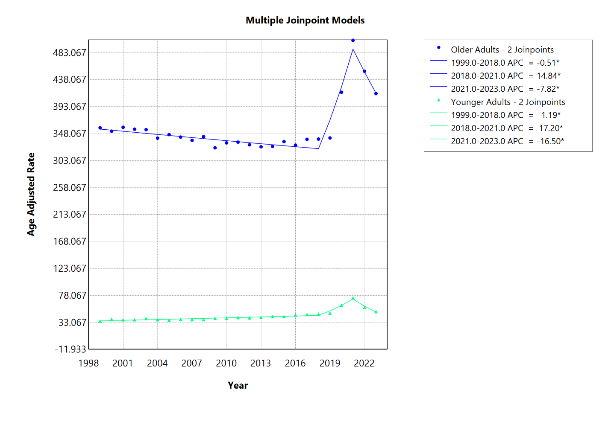
Figure 1: Age Groups

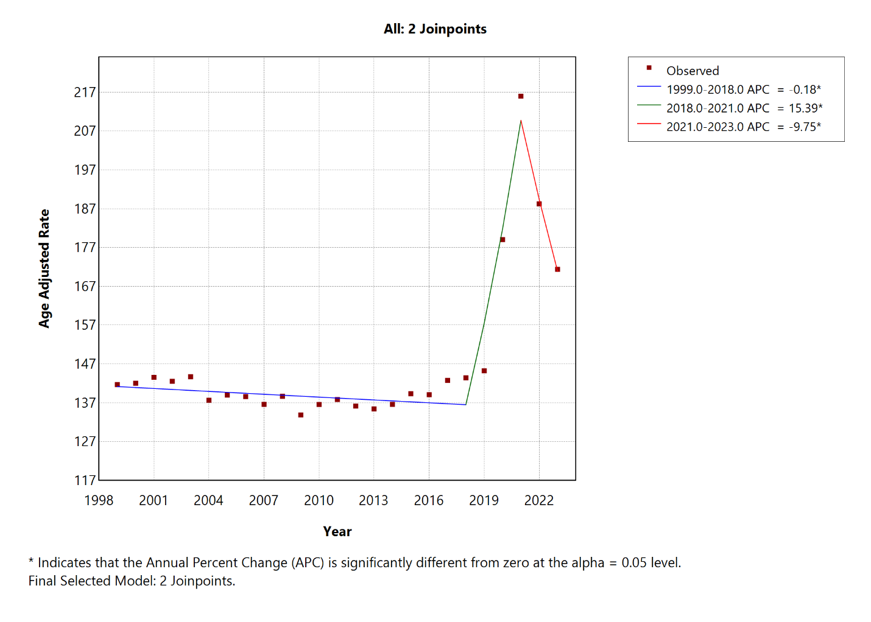
Figure 2: Overall
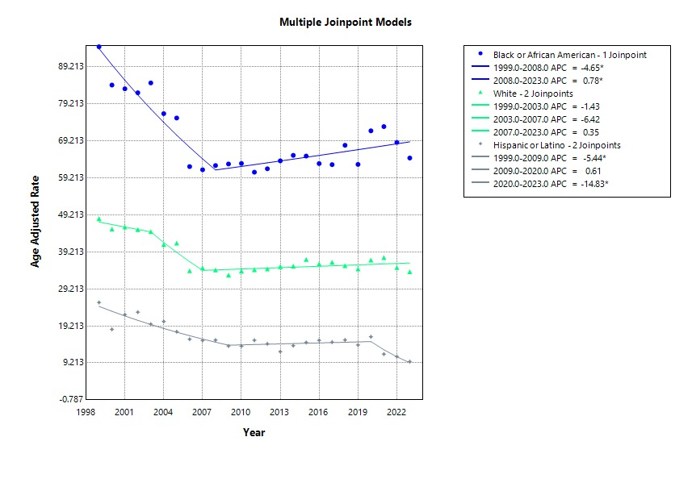
Figure 3: Race
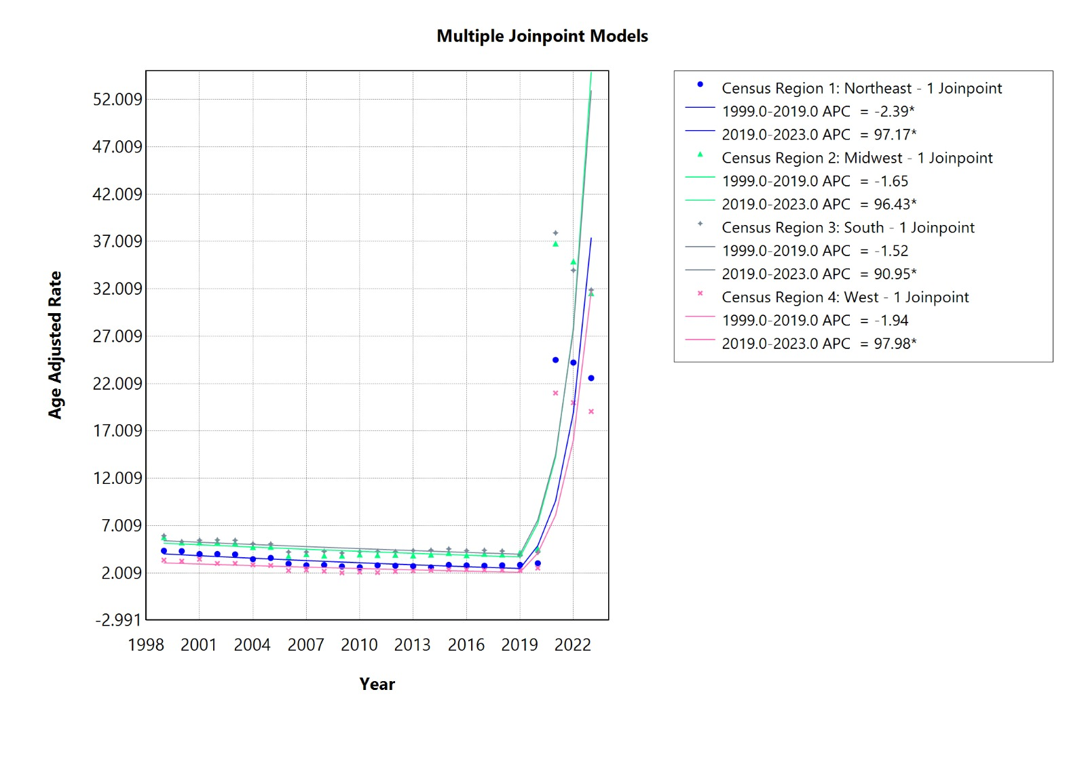
Figure 4: Region
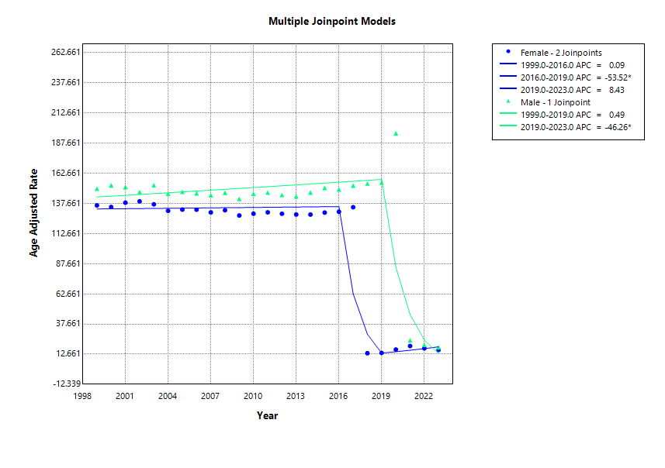
Figure 5: Sex
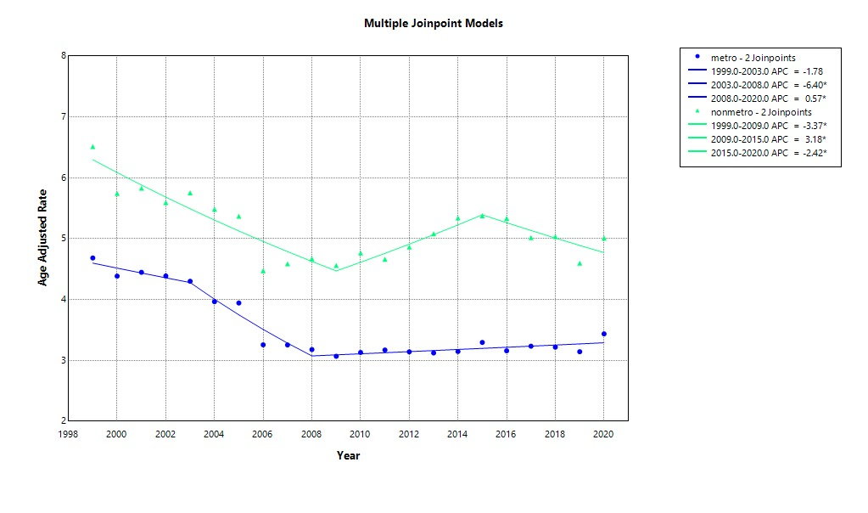
Figure 6: Urbanization

