Table S1. Climate description of the study area during the period 1996 – 2021.
Month | T.avg. [°C] | T.min [°C] | T.max [°C] | Radiation [MJ/m2] | Prec [mm] | PET_{P-M} [mm] | CWB_{P-M} [mm]
I | 3.7 | -3.8 | 10.1 | 6.06 | 47.36 | 26 | 21.36
II | 5.2 | -4.4 | 15.2 | 9.93 | 26.75 | 40.54 | -13.79
III | 8.1 | -0.7 | 20.4 | 15.1 | 34.5 | 78.49 | -44
IV | 10.5 | 1.4 | 21.1 | 18.74 | 47.12 | 95.19 | -48.07
V | 14.3 | 3.8 | 24.2 | 23.4 | 45.03 | 129.15 | -84.12
VI | 19.1 | 8.2 | 30.7 | 26.37 | 27.4 | 168.06 | -140.66
VII | 21.6 | 10 | 32.5 | 27.56 | 18.13 | 193.85 | -175.72
VII | 21.3 | 10.2 | 32.9 | 24.28 | 20 | 176.59 | -156.59
IX | 17.5 | 7 | 29.4 | 18.3 | 26.19 | 118.26 | -92.06
X | 12.6 | 3.3 | 24.1 | 12.13 | 53.74 | 67.41 | -13.67
XI | 7.0 | -1.6 | 15.3 | 7.08 | 48.78 | 34.08 | 14.7
XII | 4.2 | -3.8 | 11.8 | 5.4 | 49.19 | 21.16 | 28.03
PET_{P-M} stands for potential evapotranspiration calculated by Penman – Monteith method. CWB is the climatic water balance, as a result of subtraction Precipitation – PET_{P-M}. T.avg, T.min and T.max refer to average, average minimal and average maximal monthly temperature.

Table S2. Climate description of the study area during the analysed years 2022 - 2024.
Season | Year | T.avg [°C] | Prec [mm] | CWB [mm]
Spring  (III-V) | 2022 | 11.5 | 110 | -198
Spring  (III-V) | 2023 | 12.4 | 45 | -303
Spring  (III-V) | 2024 | 11.0 | 136 | -168
Summer  (VI-VIII) | 2022 | 23.0 | 53 | -473
Summer  (VI-VIII) | 2023 | 21.7 | 48 | -437
Summer  (VI-VIII) | 2024 | 21.8 | 78 | -412
Autumn  (IX-XI) | 2022 | 13.7 | 142 | -57
Autumn  (IX-XI) | 2023 | 13.9 | 254 | 68
Autumn  (IX-XI) | 2024 | 14.1 | 113 | -118
Winter  (XII pr. yr. - II) | 2022 | 4.8 | 55 | -43
Winter  (XII pr. yr. - II) | 2023 | 5.0 | 157 | 72
Winter  (XII pr. yr. - II) | 2024 | 5.4 | 144 | 66

Table S3. Dendrometric characteristics of the sample plots and number of dendrometers installed on each of them.
Plot (total area) | Type | Species | N [stems] | N [stems ha⁻¹] | DBH [cm] | Height [m] | G [m² ha⁻¹] | BAI [cm² year⁻¹]
Plot 1 (0.30 ha) | Mixed | Jt | 47 | 157 (36%) | 13.2 (±5.1) | 6.2 (±1.6) | 2.27 (17%) | 4.8 (±2.7)
Plot 1 (0.30 ha) | Mixed | Pp | 25 | 83 (19%) | 38.3 (±10.1) | 10.4 (±1.7) | 10.22 (74%) | 23.7 (±8.6)
Plot 1 (0.30 ha) | Mixed | Qi | 60 | 200 (46%) | 10.1 (±1.9) | 5.1 (±0.9) | 1.31 (9%) | 1.7 (±0.6)
Plot 2 (0.30 ha) | Mixed | Jt | 83 | 277 (46%) | 7.6 (±2.2) | 4.8 (±1.0) | 1.01 (5%) | 3.3 (±1.8)
Plot 2 (0.30 ha) | Mixed | Pp | 42 | 140 (24%) | 38.8 (±10.0) | 10.5 (±1.8) | 17.18 (93%) | 13.2 (±5.9)
Plot 2 (0.30 ha) | Mixed | Qi | 54 | 180 (30%) | 6.3 (±1.0) | 3.8 (±0.6) | 0.3 (2%) | 0.6 (±0.0)
Plot 3 (0.48 ha) | Mixed | Pp | 62 | 129 (30%) | 30.2 (±13.6) | 11.0 (±3.4) | 10.59 (45%) | 22.6 (±16.6)
Plot 3 (0.48 ha) | Mixed | Pt | 79 | 165 (38%) | 28.4 (±10.2) | 11.8 (±2.7) | 11.72 (50%) | 13.9 (±11.6)
Plot 3 (0.48 ha) | Mixed | Qi | 69 | 144 (32%) | 9.0 (±3.3) | 5.2 (±2.3) | 1.03 (5%) | -
Plot 4 (0.36 ha) | Pure | Pp | 78 | 217 (95%) | 29.3 (±10.9) | 9.5 (±2.0) | 16.23 (99%) | 21.3 (±9.5)
Plot 4 (0.36 ha) | Pure | Qi | 4 | 11 (5%) | 7.3 (±2.4) | 3.2 (±0.9) | 0.05 (<1%) | -
Plot 5(0.30 ha) | Pure | Pp | 7 | 23 (9%) | 36.4 (±11.0) | 10.5 (±1.6) | 2.62 (15%) | -
Plot 5(0.30 ha) | Pure | Pt | 54 | 180 (73%) | 31.7 (±5.7) | 12.2 (±1.7) | 14.7 (83%) | 15.1 (±5.9)
Plot 5(0.30 ha) | Pure | Qi | 13 | 43 (17%) | 11.0 (±3.1) | 5.3 (±1.1) | 0.44 (3%) | -
Plot 6 (0.16 ha) | Pure | Qi | 232 | 1450 (100%) | 8.9 (±3.3) | 4.5 (±1.4) | 10.15 (100%) | 1.3 (±0.9)
Plot 7 (0.15 ha) | Pure | Jt | 67 | 457 (89%) | 11.7 (±3.9) | 5.6 (±0.9) | 5.41 (60%) | 2.4 (±1.1)
Plot 7 (0.15 ha) | Pure | Pp | 6 | 41 (8%) | 31.1 (±13.1) | 7.9 (±1.2) | 3.56 (39%) | -
Plot 7 (0.15 ha) | Pure | Qi | 2 | 14 (3%) | 7.9 (±0.7) | 4.0 (±0.1) | 0.07 (<1%) | -
N: total number of stems (share in %). G [m² ha⁻¹]: total basal area (share in %); BAI [cm² year⁻¹]: annual basal area increment, given for the cored trees only.
Table S4. Characteristics of trees with the dendrometers installed. Standard errors (± SE) of continuous variables are shown.
Species | Stand Type | DBH class [cm] | N dendrometers | DBH [cm] | Height [m] | HGCI | CI.inter
Juniperus  thurifera | Mixed | 5 - 10 | 7 | 8.04 (± 0.67) | 4.9 (± 0.4) | 5.44 (± 1.79) | 0.81 (± 0.07)
Juniperus  thurifera | Mixed | 10 - 15 | 7 | 12.29 (± 1.69) | 6.13 (± 1.6) | 4.16 (± 1.48) | 0.78 (± 0.16)
Juniperus  thurifera | Mixed | > 15 | 6 | 19.33 (± 4.13) | 7.68 (± 1.5) | 2.14 (± 0.88) | 0.71 (± 0.12)
Juniperus  thurifera | Pure | 5 - 10 | 6 | 8.08 (± 1.56) | 5.2 (± 0.79) | 4.17 (± 1.61) | 0.09 (± 0.09)
Juniperus  thurifera | Pure | 10 - 15 | 5 | 12.12 (± 1.33) | 6.3 (± 0.57) | 3.01 (± 1.75) | 0.14 (± 0.13)
Juniperus  thurifera | Pure | > 15 | 4 | 18.13 (± 2.84) | 6.83 (± 0.47) | 1.02 (± 0.07) | 0.34 (± 0.22)
Pinus pinea | Mixed | 7 - 20 | 7 | 12.07 (± 4.22) | 7.67 (± 3.58) | 5.64 (± 3.3) | 0.33 (± 0.18)
Pinus pinea | Mixed | 20 - 35 | 12 | 28.87 (± 4.62) | 9.87 (± 2.31) | 3.13 (± 1.86) | 0.41 (± 0.13)
Pinus pinea | Mixed | > 35 | 16 | 44.05 (± 6.03) | 12.04 (± 1.64) | 2.39 (± 1.16) | 0.44 (± 0.2)
Pinus pinea | Pure | 7 - 20 | 2 | 17.45 (± 0.92) | 7.9 (± 0.57) | 2.81 (± 0.32) | 0.01 (± 0.02)
Pinus pinea | Pure | 20 - 35 | 6 | 27.08 (± 5.14) | 9.32 (± 1.04) | 2.13 (± 0.72) | 0.02 (± 0.03)
Pinus pinea | Pure | > 35 | 7 | 45.61 (± 5.96) | 11.89 (± 0.87) | 1.25 (± 0.51) | 0.05 (± 0.06)
Pinus pinaster | Mixed | 7 - 20 | 4 | 15.55 (± 3.06) | 9.45 (± 0.49) | 5.74 (± 0.12) | 0.47 (± 0.19)
Pinus pinaster | Mixed | 20 - 35 | 6 | 26.88 (± 4.49) | 11.7 (± 1.67) | 4.53 (± 0.34) | 0.49 (± 0.18)
Pinus pinaster | Mixed | > 35 | 5 | 41.32 (± 5.07) | 13.7 (± 1.01) | 1.99 (± 1.08) | 0.5 (± 0.2)
Pinus pinaster | Pure | 20 - 35 | 8 | 27.51 (± 4.69) | 11.34 (± 1.84) | 2.16 (± 0.57) | 0.25 (± 0.18)
Pinus pinaster | Pure | > 35 | 7 | 37.97 (± 2.37) | 12.79 (± 1.23) | 1.93 (± 0.5) | 0.11 (± 0.08)
Quercus ilex | Mixed | 5 - 10 | 13 | 8.44 (± 0.91) | 4.65 (± 0.98) | 6.79 (± 2.11) | 0.76 (± 0.13)
Quercus ilex | Mixed | 10 - 15 | 11 | 11.8 (± 1.53) | 5.25 (± 0.96) | 5.77 (± 2.81) | 0.63 (± 0.22)
Quercus ilex | Pure | 5 - 10 | 6 | 12.24 (± 1.75) | 6.84 (± 3.04) | 6.82 (± 4.31) | 0 (± 0)
Quercus ilex | Pure | 10 - 15 | 7 | 8.32 (± 0.9) | 4.52 (± 1.1) | 8.46 (± 2.85) | 0 (± 0)
Quercus ilex | Pure | > 15 | 2 | 20.15 (± 4.03) | 6.75 (± 1.2) | 3.75 (± 1.43) | 0 (± 0)

Table S5. Number of observations (proportion) used in modelling of every response variable considered in the study and number of observations (proportion) excluded.
Response variable (model) | Years considered | Total nr of tree × year  units (100%) | Observations excluded (%) | Observations included (%)
PE₁ (Spring onset) | 2023 – 2024 | 308 | 24 (8%) | 284 (92%)
PE₂ (Summer cessation) | 2023 – 2024 | 308 | 41 (15%) | 261 (85%)
PE₃ (Autumn onset) | 2022 – 2023 | 308 | 78 (25%) | 230 (75%)
PE₄ (Year cessation) | 2022 – 2023 | 308 | 74 (24%) | 234 (76%)
PE₅ (Spring growth duration)¹ | 2023 – 2024 | 308 | 23 (7%) | 285 (93%)
PE₆ (Summer cessation duration) | 2023 | 154 | 12 (8%) | 142 (92%)
PE₇ (Autumn growth duration) | 2023 – 2024 | 308 | 78 (25%) | 230 (75%)
ΔCBA Spring | 2023 – 2024 | 308 | 24 (8%) | 284 (92%)
ΔCBA Autumn | 2022 – 2023 | 308 | 78 (25%) | 230 (75%)
ΔCBA Year | 2023 | 154 | 10 (7%) | 144 (93%)
TWD% | 2022 – 2023 | 308 | 76 (25%) | 232 (75%)
¹In 2024 year, when the summer cessation moment was not apparent (the CBA curve had a positive slope until the last measurement date), the spring season was considered until the last measurement date.
Table S6. Significance of the model terms, tested using a type III Wald χ² test (α = 0.05), within the framework of Hypothesis I. The significance levels marked as follows:
***p.val. ≤ 0.001; **p.val ≤ 0.01; *p.val ≤ 0.05; (.)p.val. ≤ 0.10; (–) included, not significant; (X) excluded from final model (lowest AIC); NA = not applicable.
Terms  Models | Main effects |  |  |  |  | Interactions effects
Terms  Models | Species | StandType | Year | DBH | HGCI | Species×  StandType | Species×  Year | Species×  DBH | Species×  HGCI | StandType×  Year | StandType×  DBH | StandType×  HGCI | Year×  DBH | Year×  HGCI
PE₁ (Spring onset) | *** | ** | *** | – | – | *** | *** | X | X | X | X | X | X | X
PE₂ (Summer cessation) | ** | – | *** | – | – | ** | *** | X | X | X | X | X | X | X
PE₃ (Autumn onset) | *** | – | *** | *** | – | X | *** | * | X | (.) | X | X | X | X
PE₄ (Year cessation) | *** | – | *** | – | – | X | *** | X | X | X | * | X | X | (.)
SG (Spring growth duration) | *** | – | *** | – | – | (.) | *** | X | X | X | X | X | X | X
SC (Summer cessation duration) | *** | – | NA | ** | – | *** | NA | X | ** | NA | X | X | NA | NA
AG (Autumn growth duration) | * | – | *** | – | – | X | ** | X | X | X | X | (.) | X | (.)

Table S7. Significance of the model terms, tested using a type II Wald χ² test (α = 0.05), within the framework of Hypothesis II & III. The significance levels marked as follows:
***p.val. ≤ 0.001; **p.val ≤ 0.01; *p.val ≤ 0.05; (.)p.val. ≤ 0.10; (–) included, not significant; (X) excluded from final model (lowest AIC); NA = not applicable.
Terms  Models | Main effects |  |  |  |  | Interactions effects
Terms  Models | Species | Year | DBH | HGCI | CIinter% | Species ×  Year | Species ×  DBH | Species ×  HGCI | Species ×  CIinter% | Year ×  DBH | Year ×  HGCI | Year ×  CIinter%
ΔCBA Spring | *** | – | *** | – | ** | *** | *** | * | – | X | X | *
ΔCBA Autumn | *** | ** | *** | – | (.) | ** | * | *** | ** | X | – | –
ΔCBA Year | *** | NA | *** | – | ** | NA | ** | X | – | NA | NA | NA
TWD | * | *** | – | – | * | *** | X | X | * | * | X | X

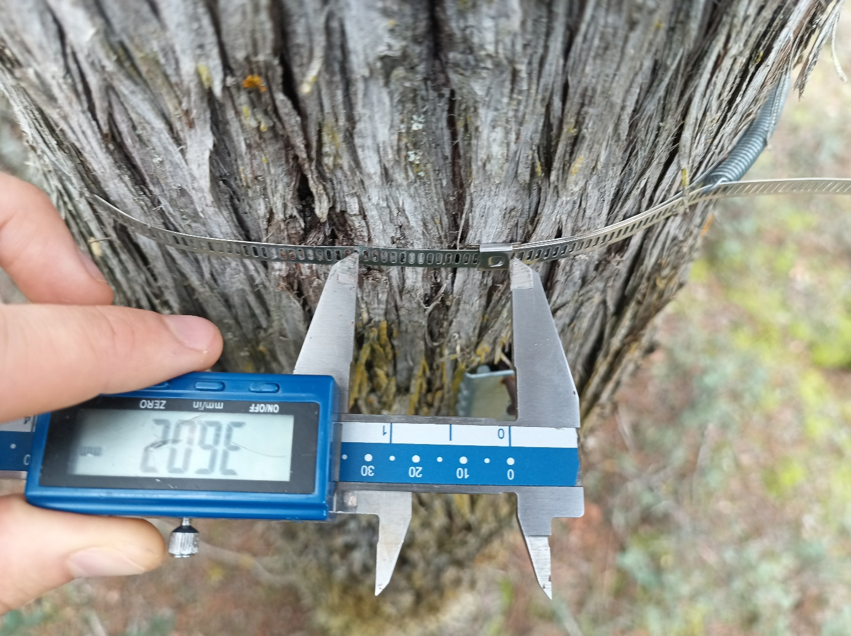Figure S1. Change of circumference recording, using an electronic calliper.

Data preparation
Cumulative daily basal area increment (CBA; mm²) was derived from raw girth increment measurements recorded on dendrometers. CBA curves of each tree served as the basis for calculating all response variables (variables of interest) analysed in the hypotheses we proposed. The following steps describe the calculation process in detail:
- Initial girth calculation. The diameter at breast height (DBH_{ij,k=0}; cm) of tree i in plot j at the initial measurement time (k = 0) was converted into initial girth (IG_{ij,k=0}; mm) using the formula:
${IG}_{ij,k=0}=2×π×\left({{DBH}_{ij,k=0}}/2\right)×10$
Here, the multiplication by 10 converts DBH from centimetres to millimetres.
- Girth Increment Variation. Girth increment measurements (GI_{ijky}; mm) taken at consecutive time points (k and k-1) during year y were used to calculate the girth increment variation (GIV_{ijky}; mm):
${GIV}_{ijky}={GI}_{ijky}- {GI}_{ijy,k-1}$
- Girth at Each Measurement. The cumulative sum of girth increment variation (GIV_{ijky}) was added to the initial girth (IG_{ij,k=0}) to calculate the girth (G_{ijky}; mm) at each measurement k during year y:
$G_{ijky}={IG}_{ijy,k=0}+ \sum_{k=1}^{k}{{GIV}_{ijky}}$
- Radius calculation. The radius (R_{ijky} ; mm) at each measurement k was derived from the girth:
$R_{ijky}={G_{ijky}}/{2×π}$
- Basal Area calculation. The basal area (BA_{ijky}; mm²) at each measurement was then derived from the radius:
${BA}_{ijky}=π×{\left(R_{ijky}\right)}^{2}$
- Basal Area Increment. The basal area increment (BAI_{ijky}; mm²) between two consecutive measurements (k-1, k) was calculated by subtracting the basal area of the previous measurement from the current one:
${BAI}_{ijky}={BA}_{ijky}- {BA}_{ijy,k-1}$
This reflects the change in basal area from one measurement to the next.

Daily Basal Area Increment. The daily basal area increment (DBI_{ijy,DOY} ; mm²×day⁻¹) was obtained by dividing the basal area increment (BAI_{ijky}) by the number of days (n_{k}) between two adjacent measurements:
${DBI}_{ijy,DOY}= {{BAI}_{ijky}}/{n_{ k}}$
This measures the basal area variation per day.
- Cumulative Basal Area Increment. The cumulative basal area increment (CBA_{ijy,DOY} ; mm²) for each tree (i) in plot (j) at any day of year (DOY) was calculated by summing the daily basal area increments (DBI_{ijy,DOY}) across the year:
${CBA}_{ijy,DOY}=\sum_{DOY=1}^{DOY}{{DBI}_{ijy,DOY}}$
In the formulas above, we use the term “increment” to describe variation of tree size recorded between two consecutive measurements. We are aware, that this variation is not equal to the real (net) growth a given tree attained in this time due to cambium cells division. The data obtained from manually measured band dendrometers does not allow for discerning between the net growth and hydration fluctuations, etc.

