Supporting Information
Does Turnover Number Represent a Single Value or a Distribution?

Miguel Orozco, Joseph Gott, Eric Liu, Arda Genc, Lior Sepunaru

Table of Contents
Platinum nanoparticle characterization 4
Figure S1: Platinum nanoparticle size distribution using a transmission electron microscope (TEM) 4
Figure S2: High-resolution transmission electron microscopy of the mesoporous 30 nm platinum 4
Figure S3: Hydrodynamic diameter distribution over time obtained using dynamic light scattering 5
Figure S4: Pt nanoparticle zeta-potential after degassing 6
Particle impact frequencies 7
Table S1: Calculated theoretical impact frequencies of PtNPs after dilution. 7
Carbon fiber microelectrode characterization 8
Figure S5: Cyclic voltammogram (CV) of the hydrogen evolution reaction using different electrode materials 8
Figure S6: Carbon microelectrode image before nanoimpacts. 8
Figure S7: Carbon microelectrode image after nanoimpacts. 9
Calculating the catalytic charge and statistical analysis 10
Figure S8: Example i-t traces of impacts from multiple experiments. 10
Figure S9: Fitting the catalytic charge distribution. 11
Figure S10: Bootstrap distributions (1,000 replicates) of the median, mean, skewness, and upper-tail percentiles (90th, 95th, and 99th). 12
Table S2: Bootstrap-derived estimates and confidence intervals for catalytic charge 12
Figure S11: Bootstrap resampled histogram compared to the original data histogram. 13
Calculating the number of active sites 14
Figure S12: A CV of a platinum microelectrode (d ≈ 10 μm) at 50 mV/s in Ar-saturated 1 mM HClO₄. 14
Figure S13: Charge for H_{ads} distribution from nanoimpacts at -300 mV vs. SCE. 15
Figure S14: Charge for H_{ads} distribution from nanoimpacts at -450 mV vs. SCE. 15
Figure S15: Charge for H_{ads} distribution is potential dependent 16
Figure S16: Charge for H_{ads} distribution is size dependent 17
Table S3: The average Q_{ads} needed to scale each spike-decay curve. 17
Figure S17: Charge for H_{ads} normalized by distribution at -300 mV vs. SCE. 18
Calculating turnover number 19
Calculating electroactive surface area (EASA) and roughness factor for PtNPs 21
Table S4: Summary of Surface area, EASA, and roughness factor 21
The current density of a microelectrode vs. nanoparticles 22
Deactivation mechanism 23
Figure S18: 30 nm PtNP nanoimpacts after spiking with 10 μm of known HER inhibitors. 23
Figure S19: CV of platinum microelectrode deactivation. 23
Figure S20: SEM image of Pt microelectrode and EDS before and after deactivation. 24
Figure S21: Chronoamperogram of 30 nm PtNP nanoimpacts at -0.9 V vs. SCE. 25
Figure S22: Outer-sphere electron transfer is not affected by Pt HER deactivation and CO poisoning. 25
Figure S23: Platinum microelectrode CV in H₂ environment. 26
Figure S24: Pt microelectrode LSV stripping after deactivation. 27
Electrochemical correlative microscopy 28
Figure S25: SECCM of PtNPs drop-cast on the glassy carbon substrate. 28
Figure S26: SECCM of 70 nm PtNPs drop-cast on TEM grid. 29
Figure S27: EDS of 70 nm Pt nanoparticles before and after catalysis 30
Figure S28: EDS of 70 nm Pt nanoparticles comparison. 31
References 32

Platinum nanoparticle characterization

Figure S1: Platinum nanoparticle size distribution using a transmission electron microscope (TEM)
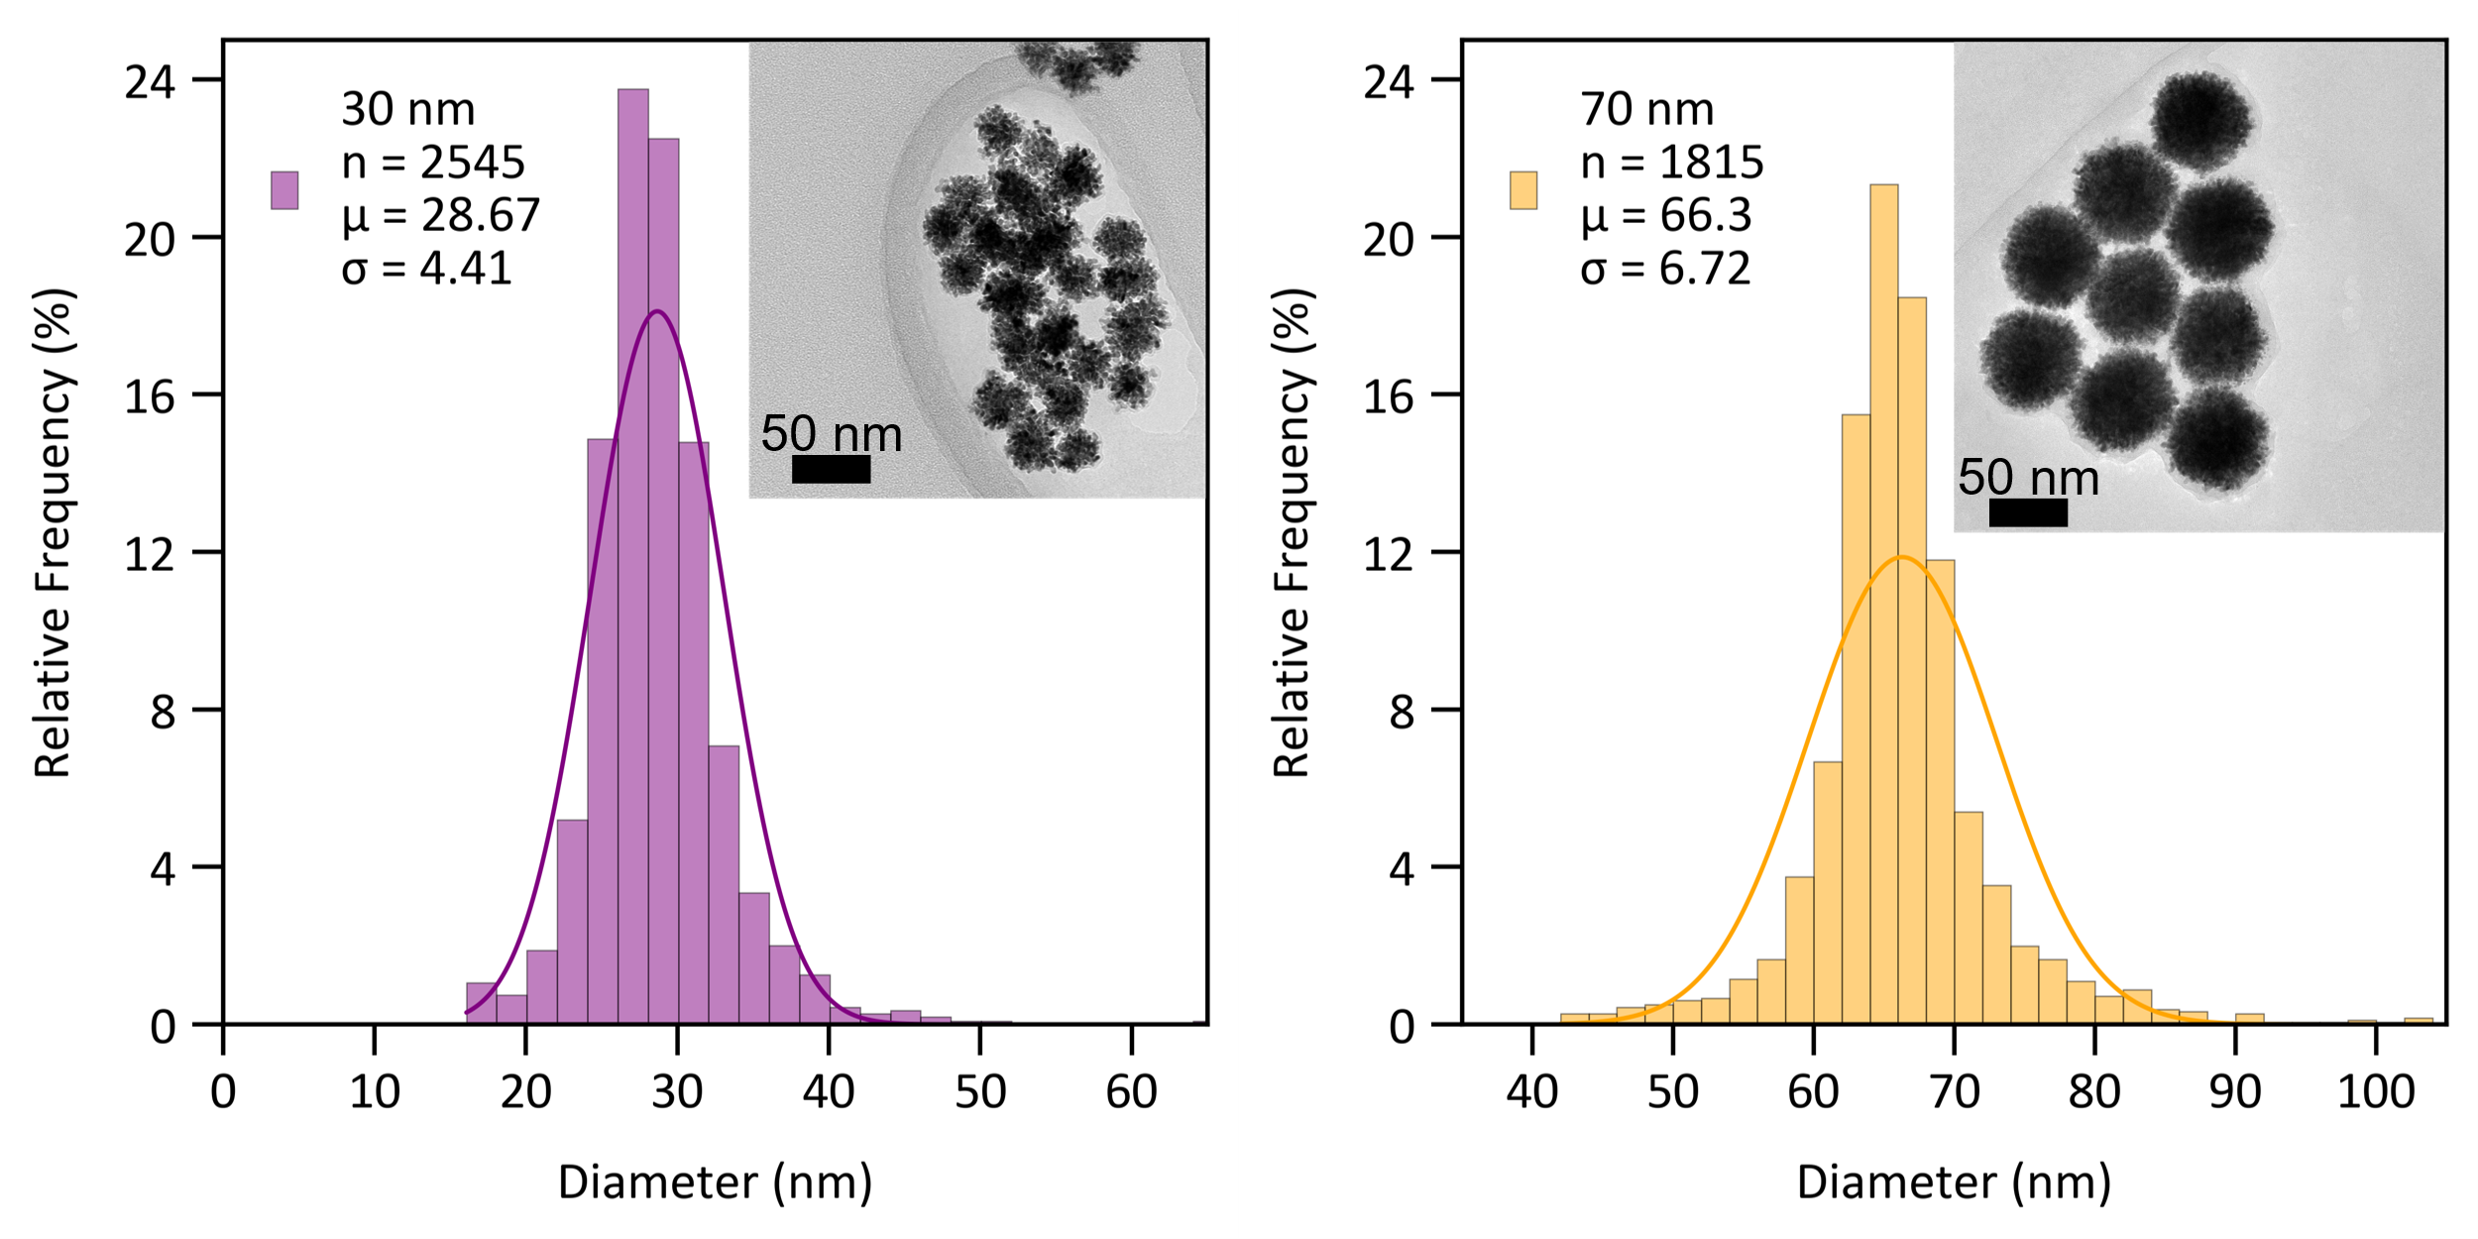
AI-enhanced nanoparticle analysis was used to obtain the size distribution for two samples of PtNPs.^{1,2}

Figure S2: High-resolution transmission electron microscopy of the mesoporous 30 nm platinum
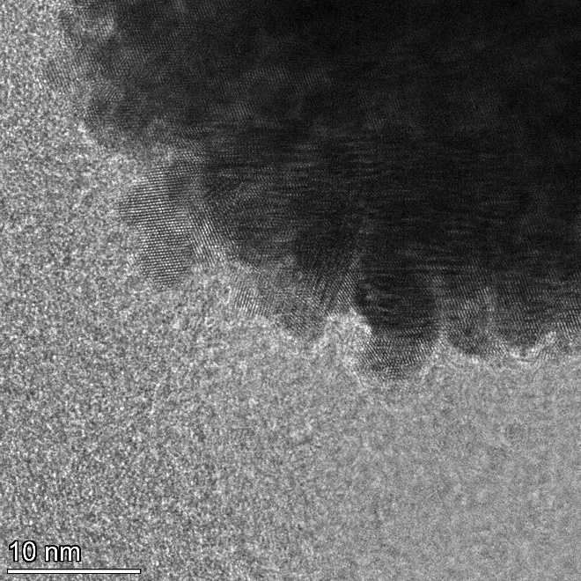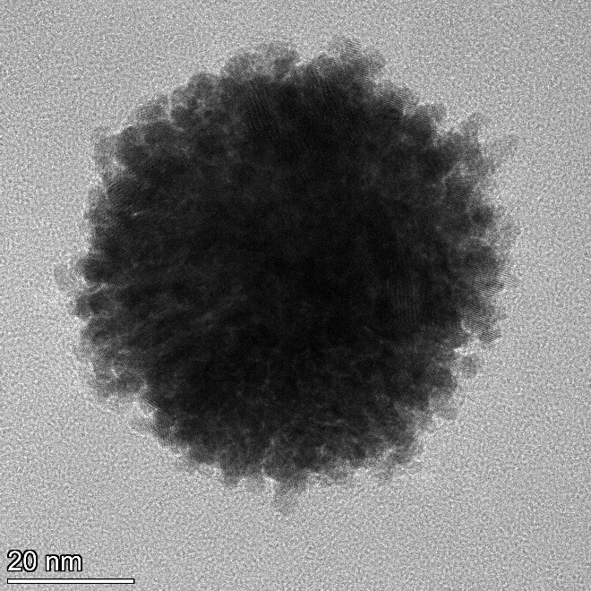
An atomic scale image showing a nanoparticle comprises smaller 2-3 nm Pt particles that comprise the whole.

Figure S3: Hydrodynamic diameter distribution over time obtained using dynamic light scattering
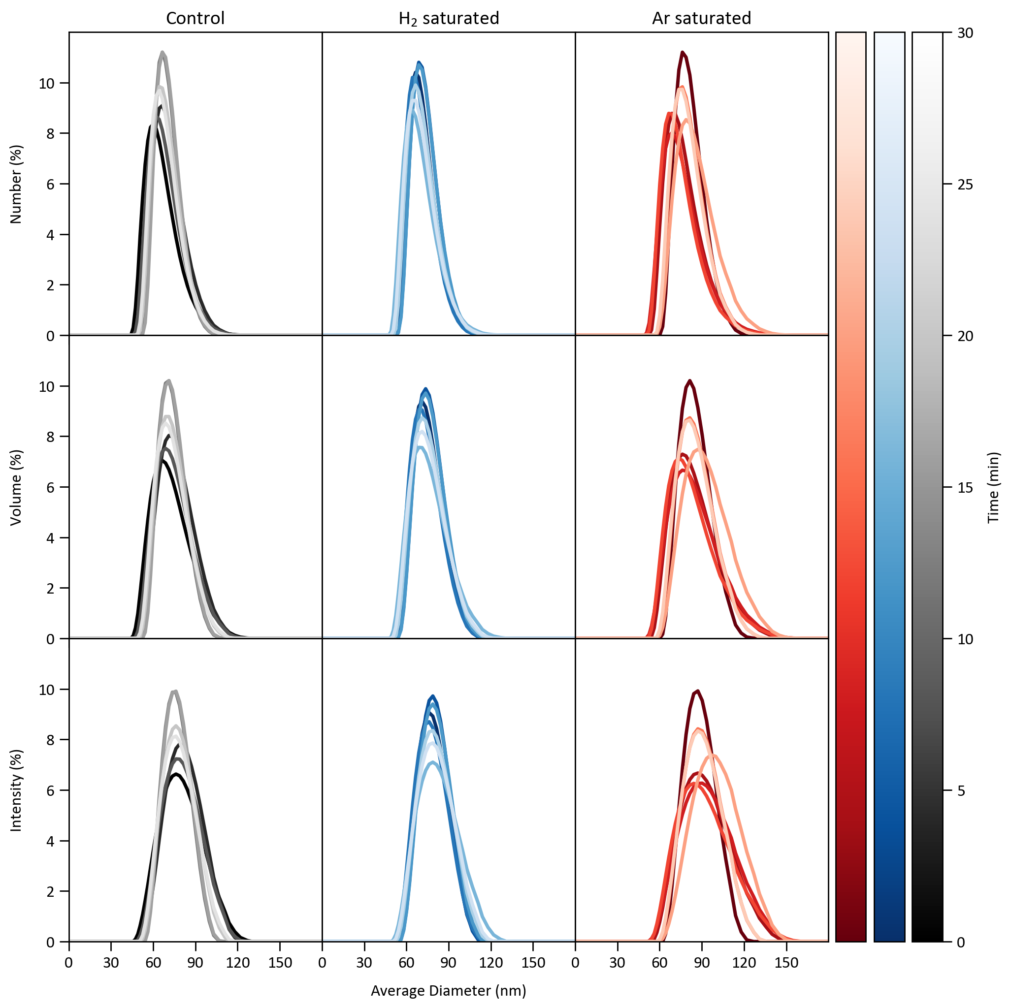

The stability of the 70 nm PtNPs (1.44 pM PtNPs and 1 mM HClO₄) under different conditions was tested, including degassing with H₂, Ar, or atmospheric conditions. H₂ and Ar gases were degassed for 20 min while particles were in solution, then immediately sized by DLS. Minimal to no change in particle diameter was observed over 30 min (the duration of the chronoamperometry experiment) for the control, Argon, and H₂ samples.

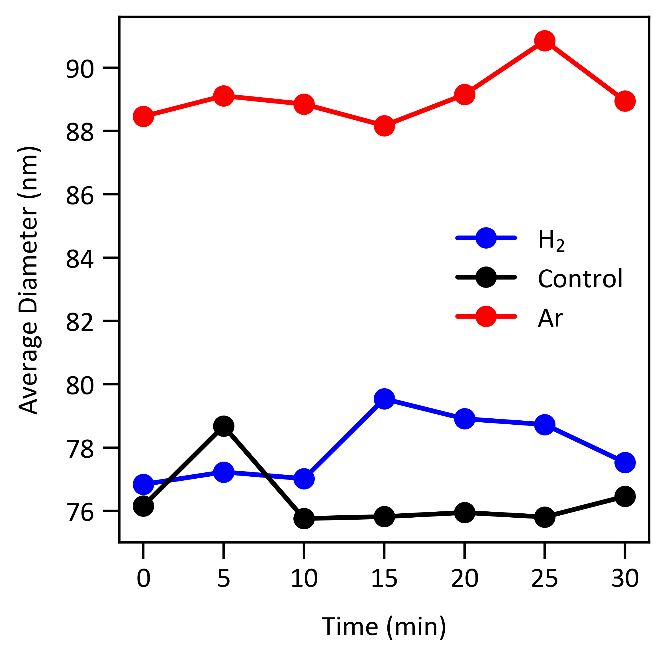
Platinum nanoparticles are stable during the experimental timescale. Their observed average hydrodynamic diameter per run increases by approximately 10 nm when degassed with Ar, but remains stable throughout the experiment.

Figure S4: Pt nanoparticle zeta-potential after degassing
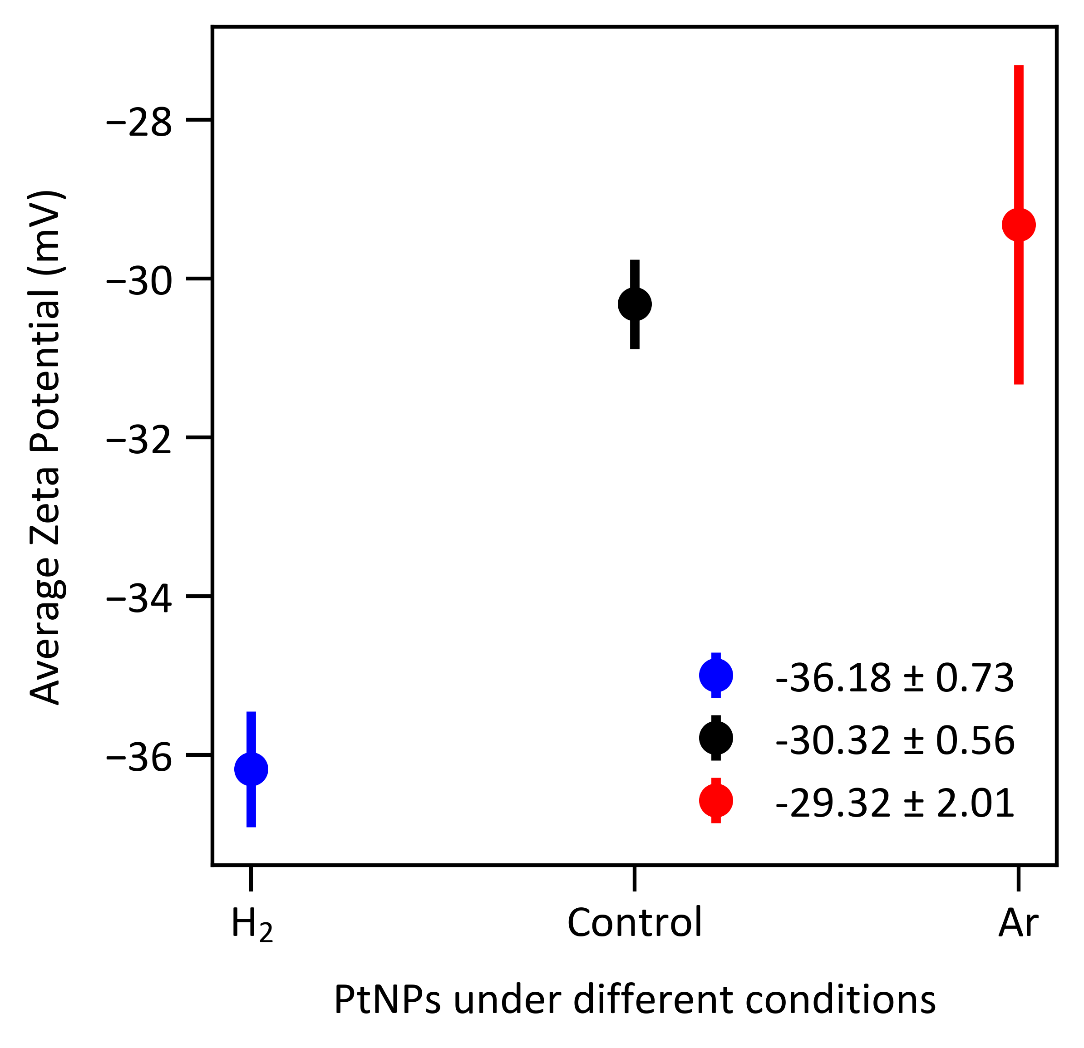
The Zeta Potential was plotted under different degassing conditions. It was measured five times to yield an average with the corresponding standard deviation.

Particle impact frequencies
The theoretical impact event frequency can be calculated by assuming purely Brownian motion and using the theory developed by the Compton group.³

The diffusion coefficient for the two different nanoparticles is first calculated using the Stokes-Einstein equation, taking the dynamic viscosity of water as 8.9 × 10⁻⁴ Pa s at 25 ℃:

$$D=\frac{k_{B}T}{6πηr_{NP}}$$
, where k_{B} is the Boltzmann constant, T is the temperature, η is the dynamic viscosity, and r_{NP} is the radius of a single nanoparticle.

We calculated the particle impact frequencies for the Pt nanoparticles landing on the 33 μm diameter microelectrode using the equation below:

$$N_{impacts}\left(t\right)=c^{*}r_{d}^{3}\left(τ+1.437\sqrt{τ}+6.567×{10}^{-2}\ln\left(τ\right)+\frac{3.425×{10}^{-2}}{\sqrt{τ}}-\frac{3.349×{10}^{-3}}{τ}\right)$$
, where r_{d} is the disc radius, c* is the particle number concentration in units of particles m⁻³, and τ is a dimensionless time parameter. The impact frequency based on the size and volume added to the cell is summarized in the table below.

Table S1: Calculated theoretical impact frequencies of PtNPs after dilution.
Radius of  nanoparticle (nm) | Concentration of Pt  (particles/m³) | N_{impacts} s⁻¹
14.335 | 1.972 x 10¹⁵ | 7.8
33.15 | 8.667 x 10¹⁴ | 1.7

We calculate the probability of two impacts occurring simultaneously. We assume that impacts follow a Poisson process with a time resolution of 0.01 seconds and an experimental average of 100 impacts in 30 minutes or ~ 0.06 impacts per second for the 30 nm PtNPs.

Use the Poisson distribution, where t is the time resolution, λ_{t} is events in a given interval of t seconds, and k is the probability of events in the same interval:

$$P\left(k\right)=\frac{{\left(λ_{t}\right)}^{k}e^{-λ_{t}}}{k!}$$
$$λ_{0.01}=λ×0.01=\left(\frac{100}{1800}\right)×0.01$$
$$λ_{0.01}=\frac{100}{180000}≈0.00055 impacts per 0.01 sec$$
$$P\left(2\right)=\frac{{\left(λ_{0.01}\right)}^{2}e^{-λ_{0.01}}}{2!}=\frac{{\left(0.00055\right)}^{2}e^{-0.00055}}{2!}≈1.542×{10}^{-7}$$
The experimental probability of two impacts occurring simultaneously is 0.000015% vs 0.0135% when using the theoretical impact frequency in Table S1.

Carbon fiber microelectrode characterization

Figure S5: Cyclic voltammogram (CV) of the hydrogen evolution reaction using different electrode materials
A cyclic voltammogram overlay at 50 mV/s comparing different microelectrodes' electrocatalytic activity in reducing H₃O⁺ to H₂ gas in Ar-saturated 1 mM HClO₄. Carbon showed no catalytic activity, gold was capable of hydrogen evolution at a higher potential, and platinum was the most effective catalyst, exhibiting the highest activity at the lowest potential onset.

Figure S6: Carbon microelectrode image before nanoimpacts.
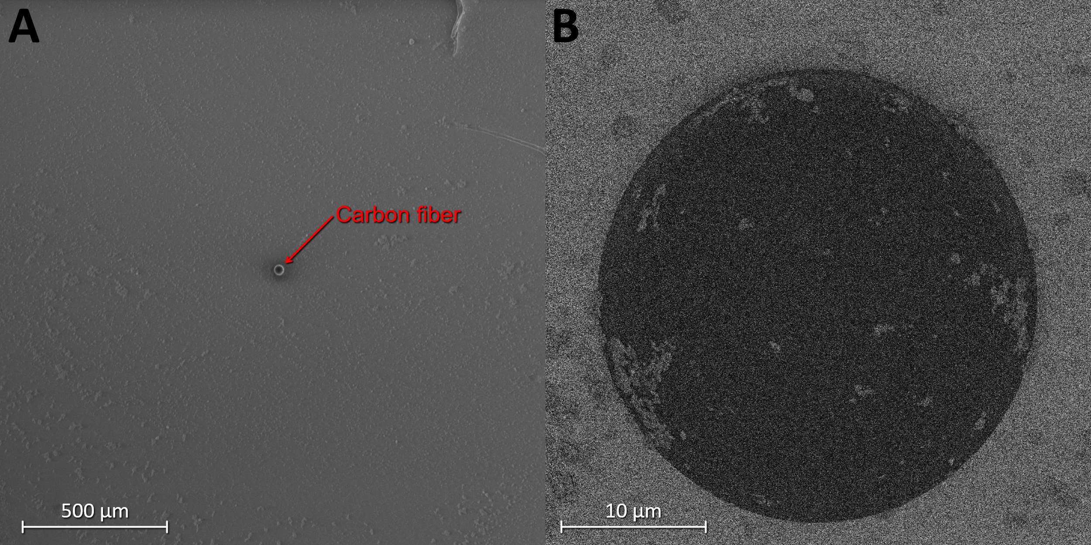
A) SEM image of carbon fiber microelectrode (d ≈ 33 μm) using the Everhart-Thornley Detector (ETD) at 1 kV and 50 pA. B) Magnified SEM image of the carbon fiber using T1 in-lens backscattering detector at 5.00 kV and 50 pA. The control image shows no Pt nanoparticles adhered to the carbon fiber before nanoimpacts.

Figure S7: Carbon microelectrode image after nanoimpacts.
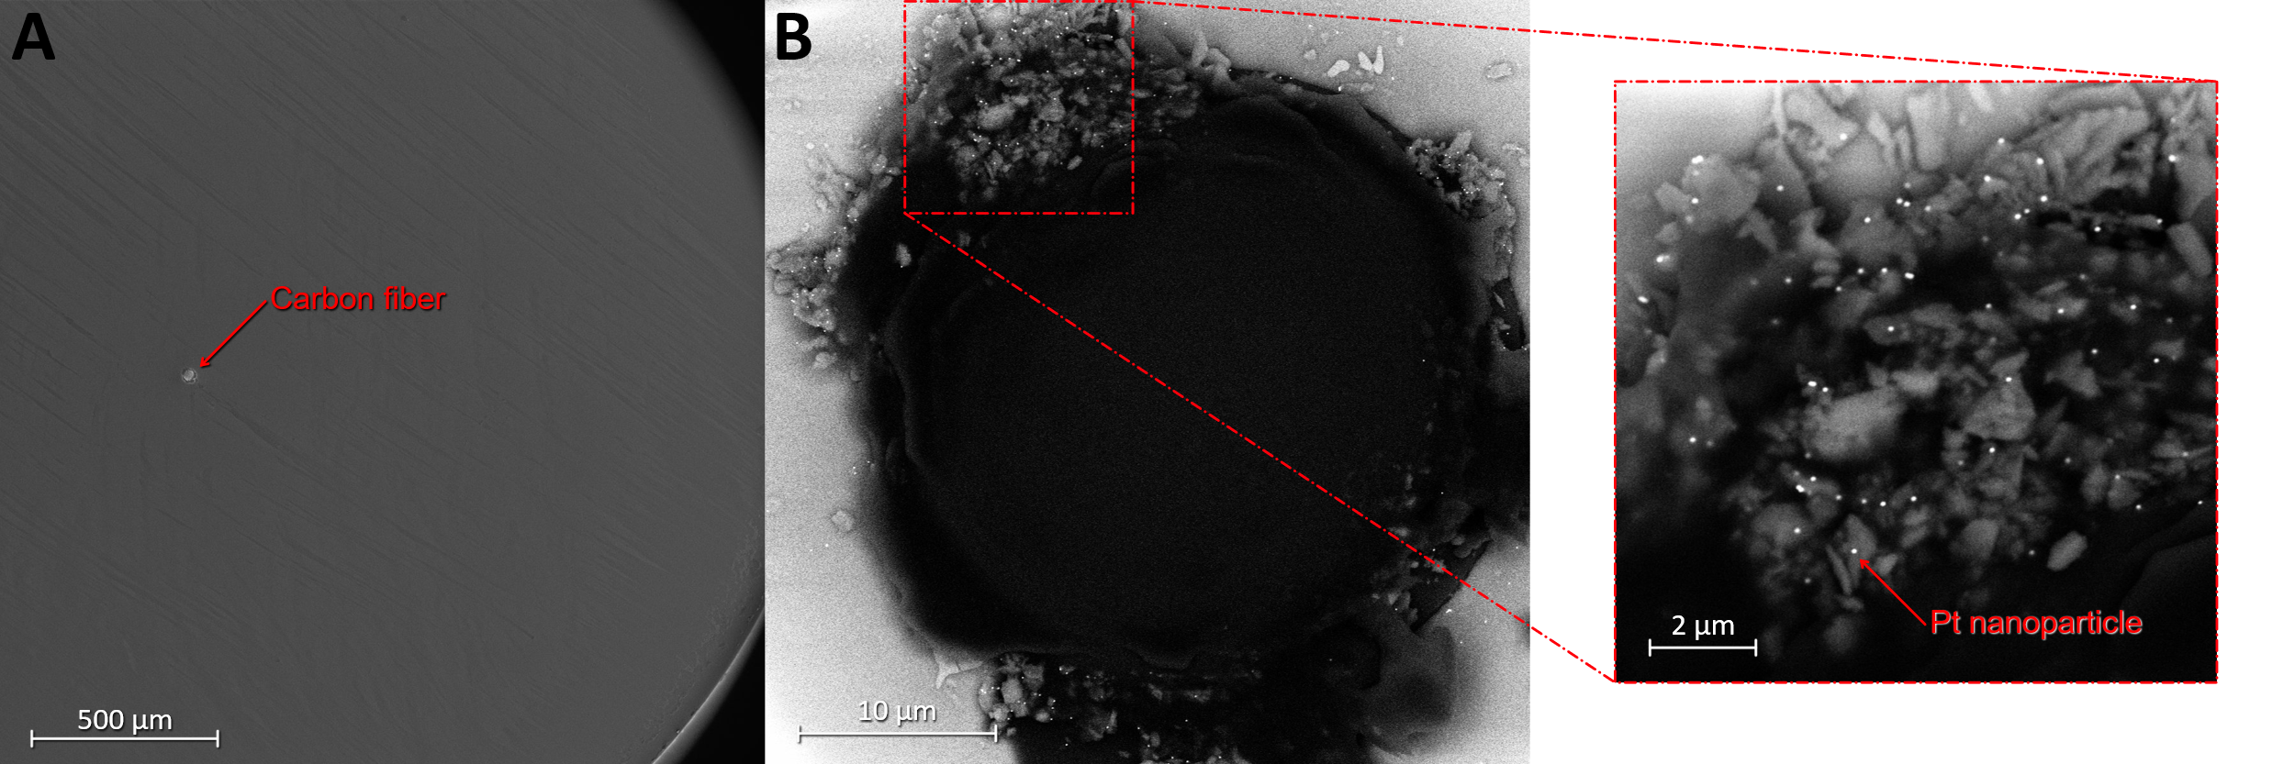
A) SEM image of carbon fiber microelectrode (d ≈ 33 μm) using the Everhart-Thornley Detector (ETD) at 1 kV and 25 pA. B) Magnified SEM image of the carbon fiber using T1 in-lens backscattering detector at 10.00 kV and 0.40 nA. Pt nanoparticles are adhered to the carbon fiber after nanoimpacts.

Calculating the catalytic charge and statistical analysis
Particle impacts were recorded in the HER regime at an applied overpotential of -31 mV vs. RHE (-400 mV vs. SCE), gathering statistical data (n = 587) across multiple experiments.

Figure S8: Example i-t traces of impacts from multiple experiments.
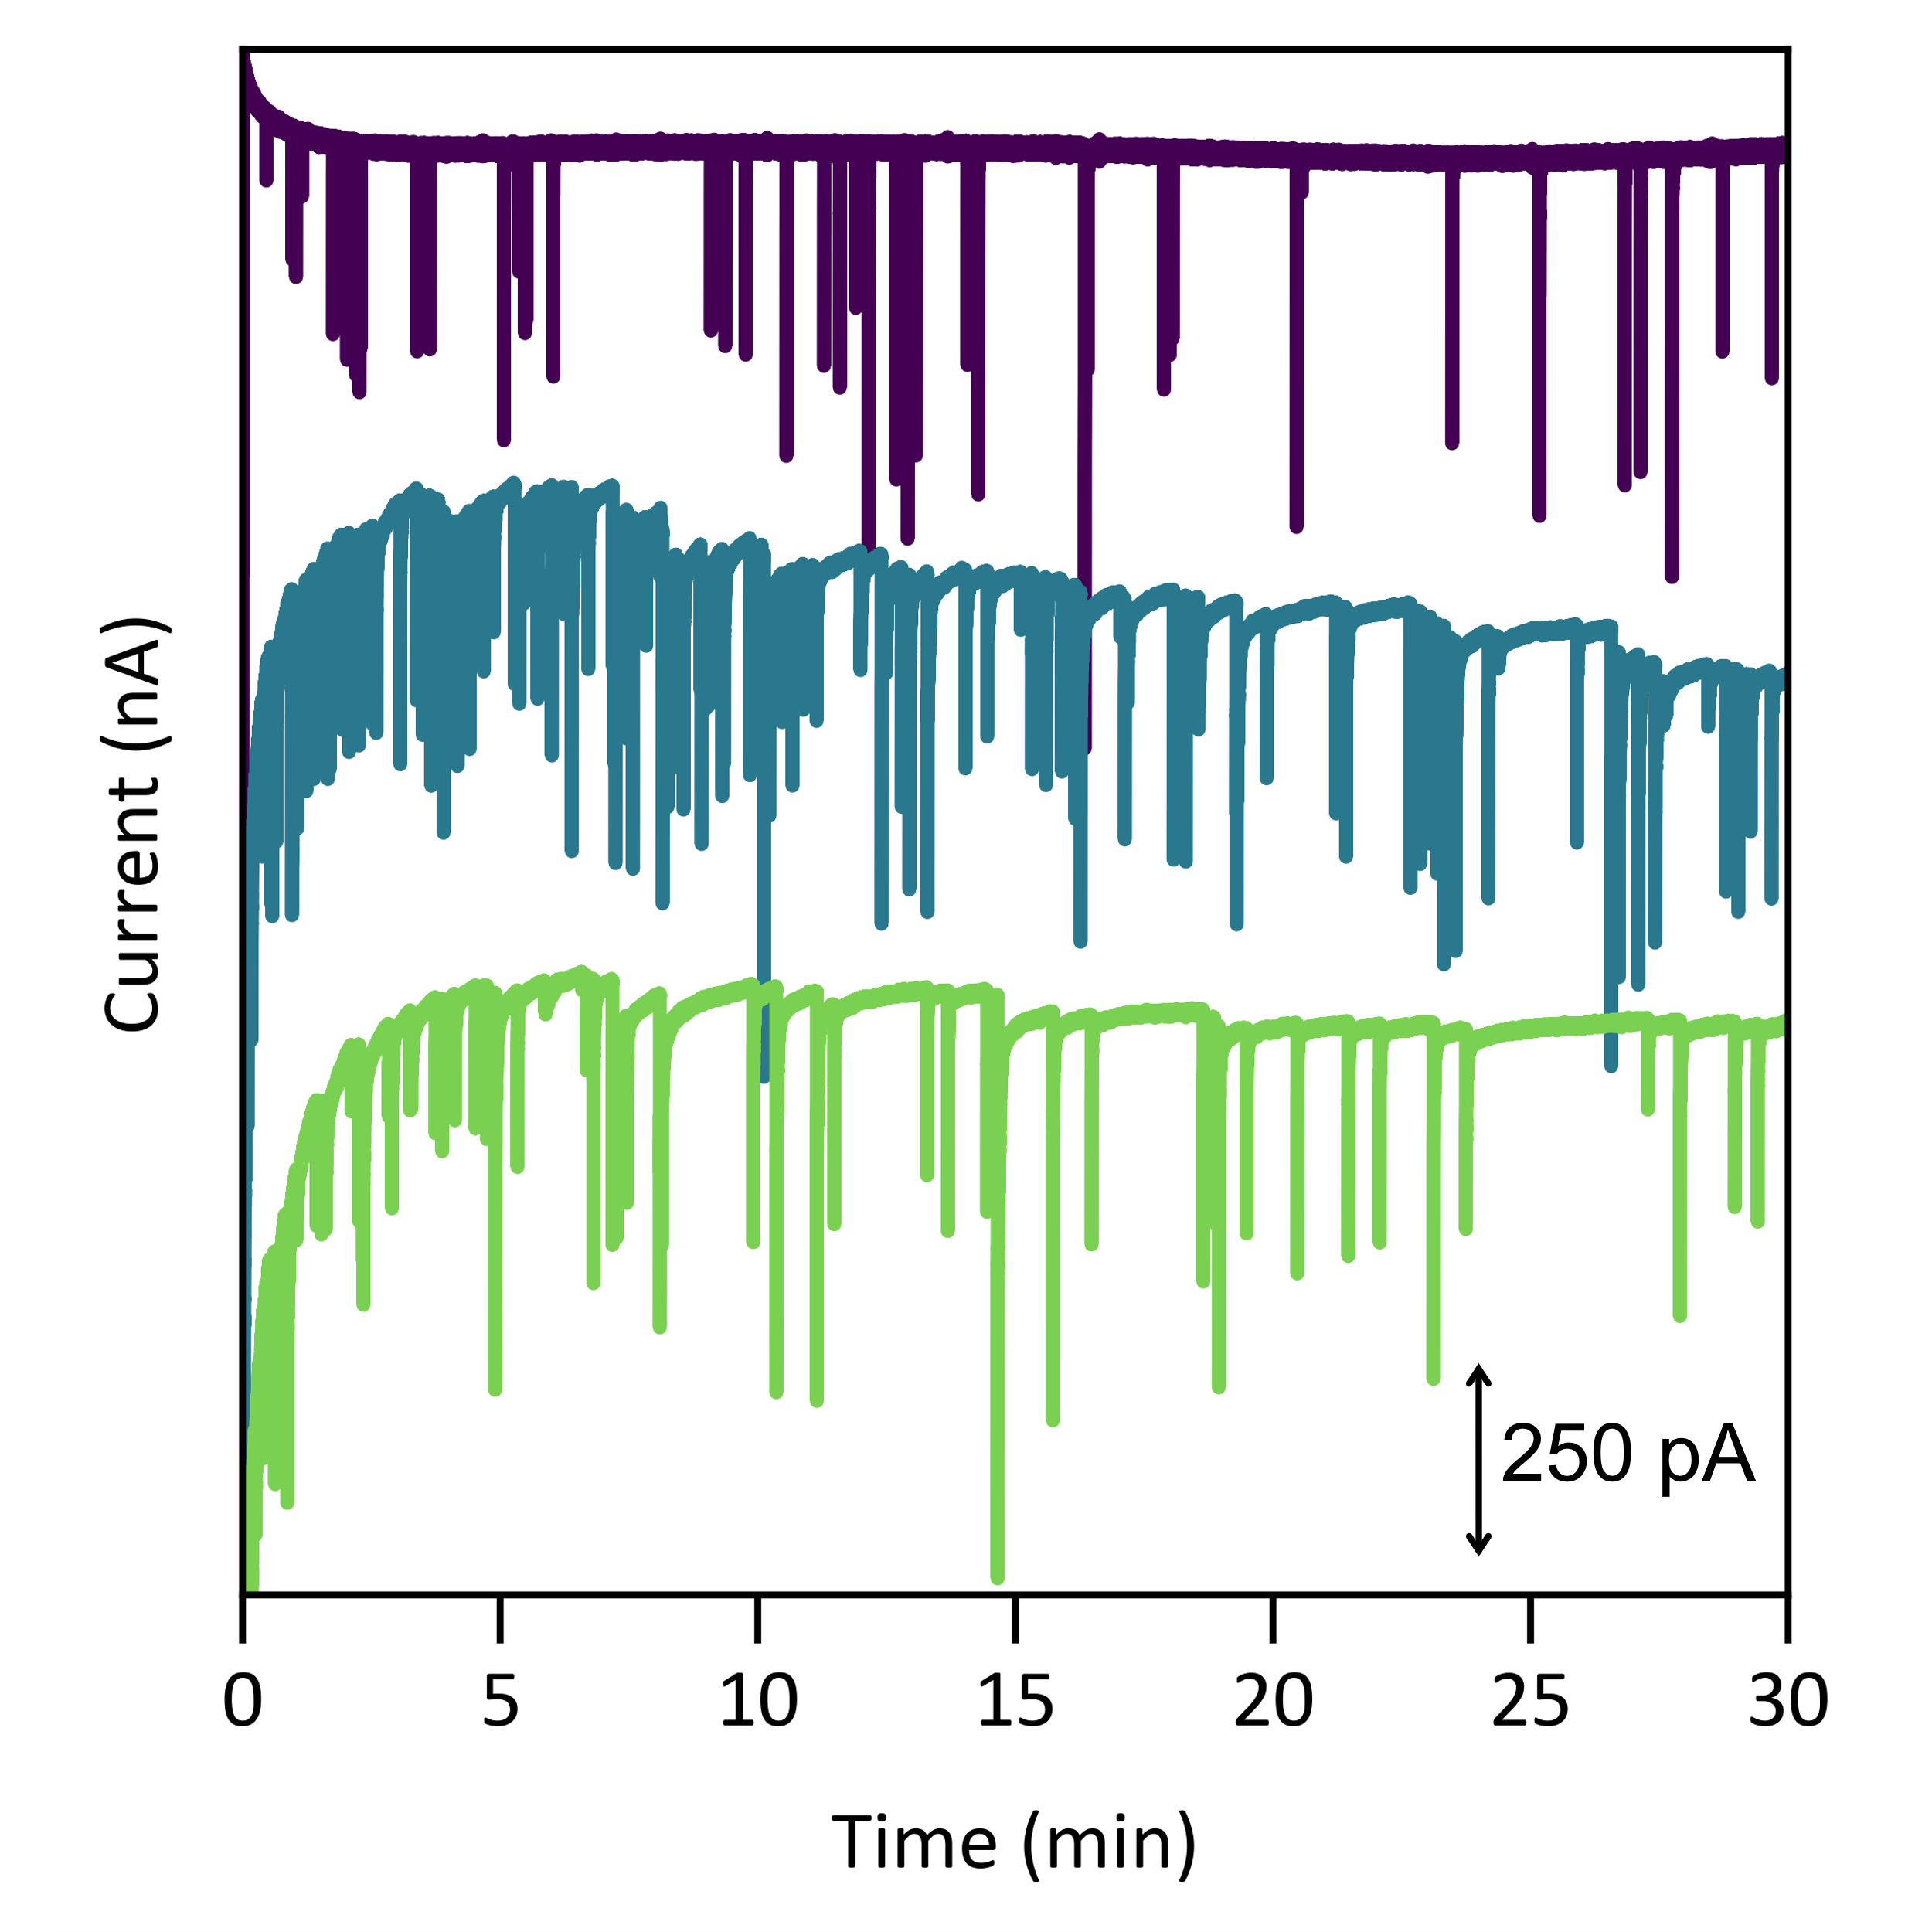
The catalytic area/charge (Q_{HER}) was integrated for each spike. An example spike-decay was integrated from the start of the transient spike until the current reached back to the baseline (below).
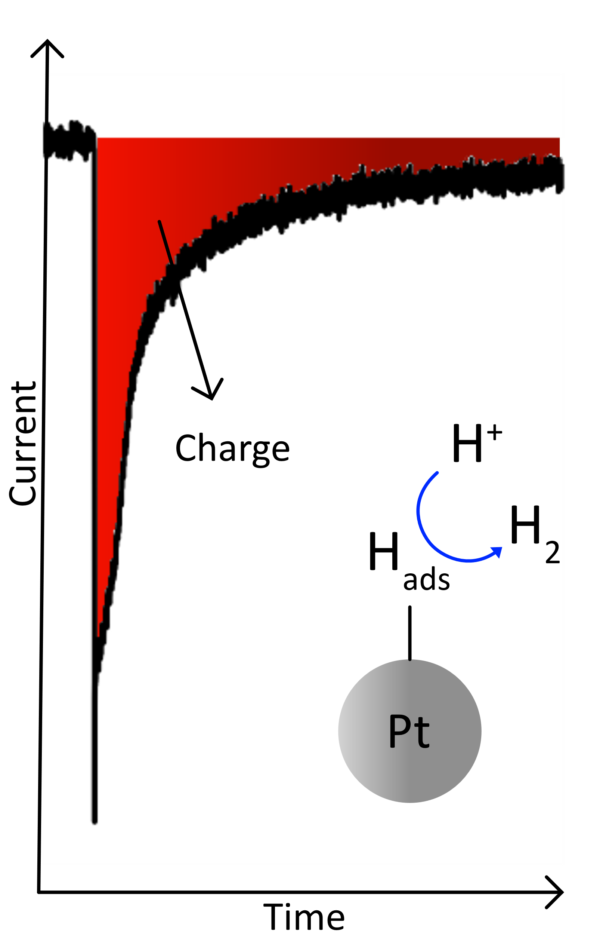

We analyzed catalytic charge data from 587 impact events, with a mean of 8.0 pC and a standard deviation of 11.1 pC. The initial inspection of the histogram revealed a pronounced right skew, characteristic of distributions such as the Gumbel, lognormal, gamma, Lévy, Fréchet, and chi-squared distributions.

Figure S9: Fitting the catalytic charge distribution.
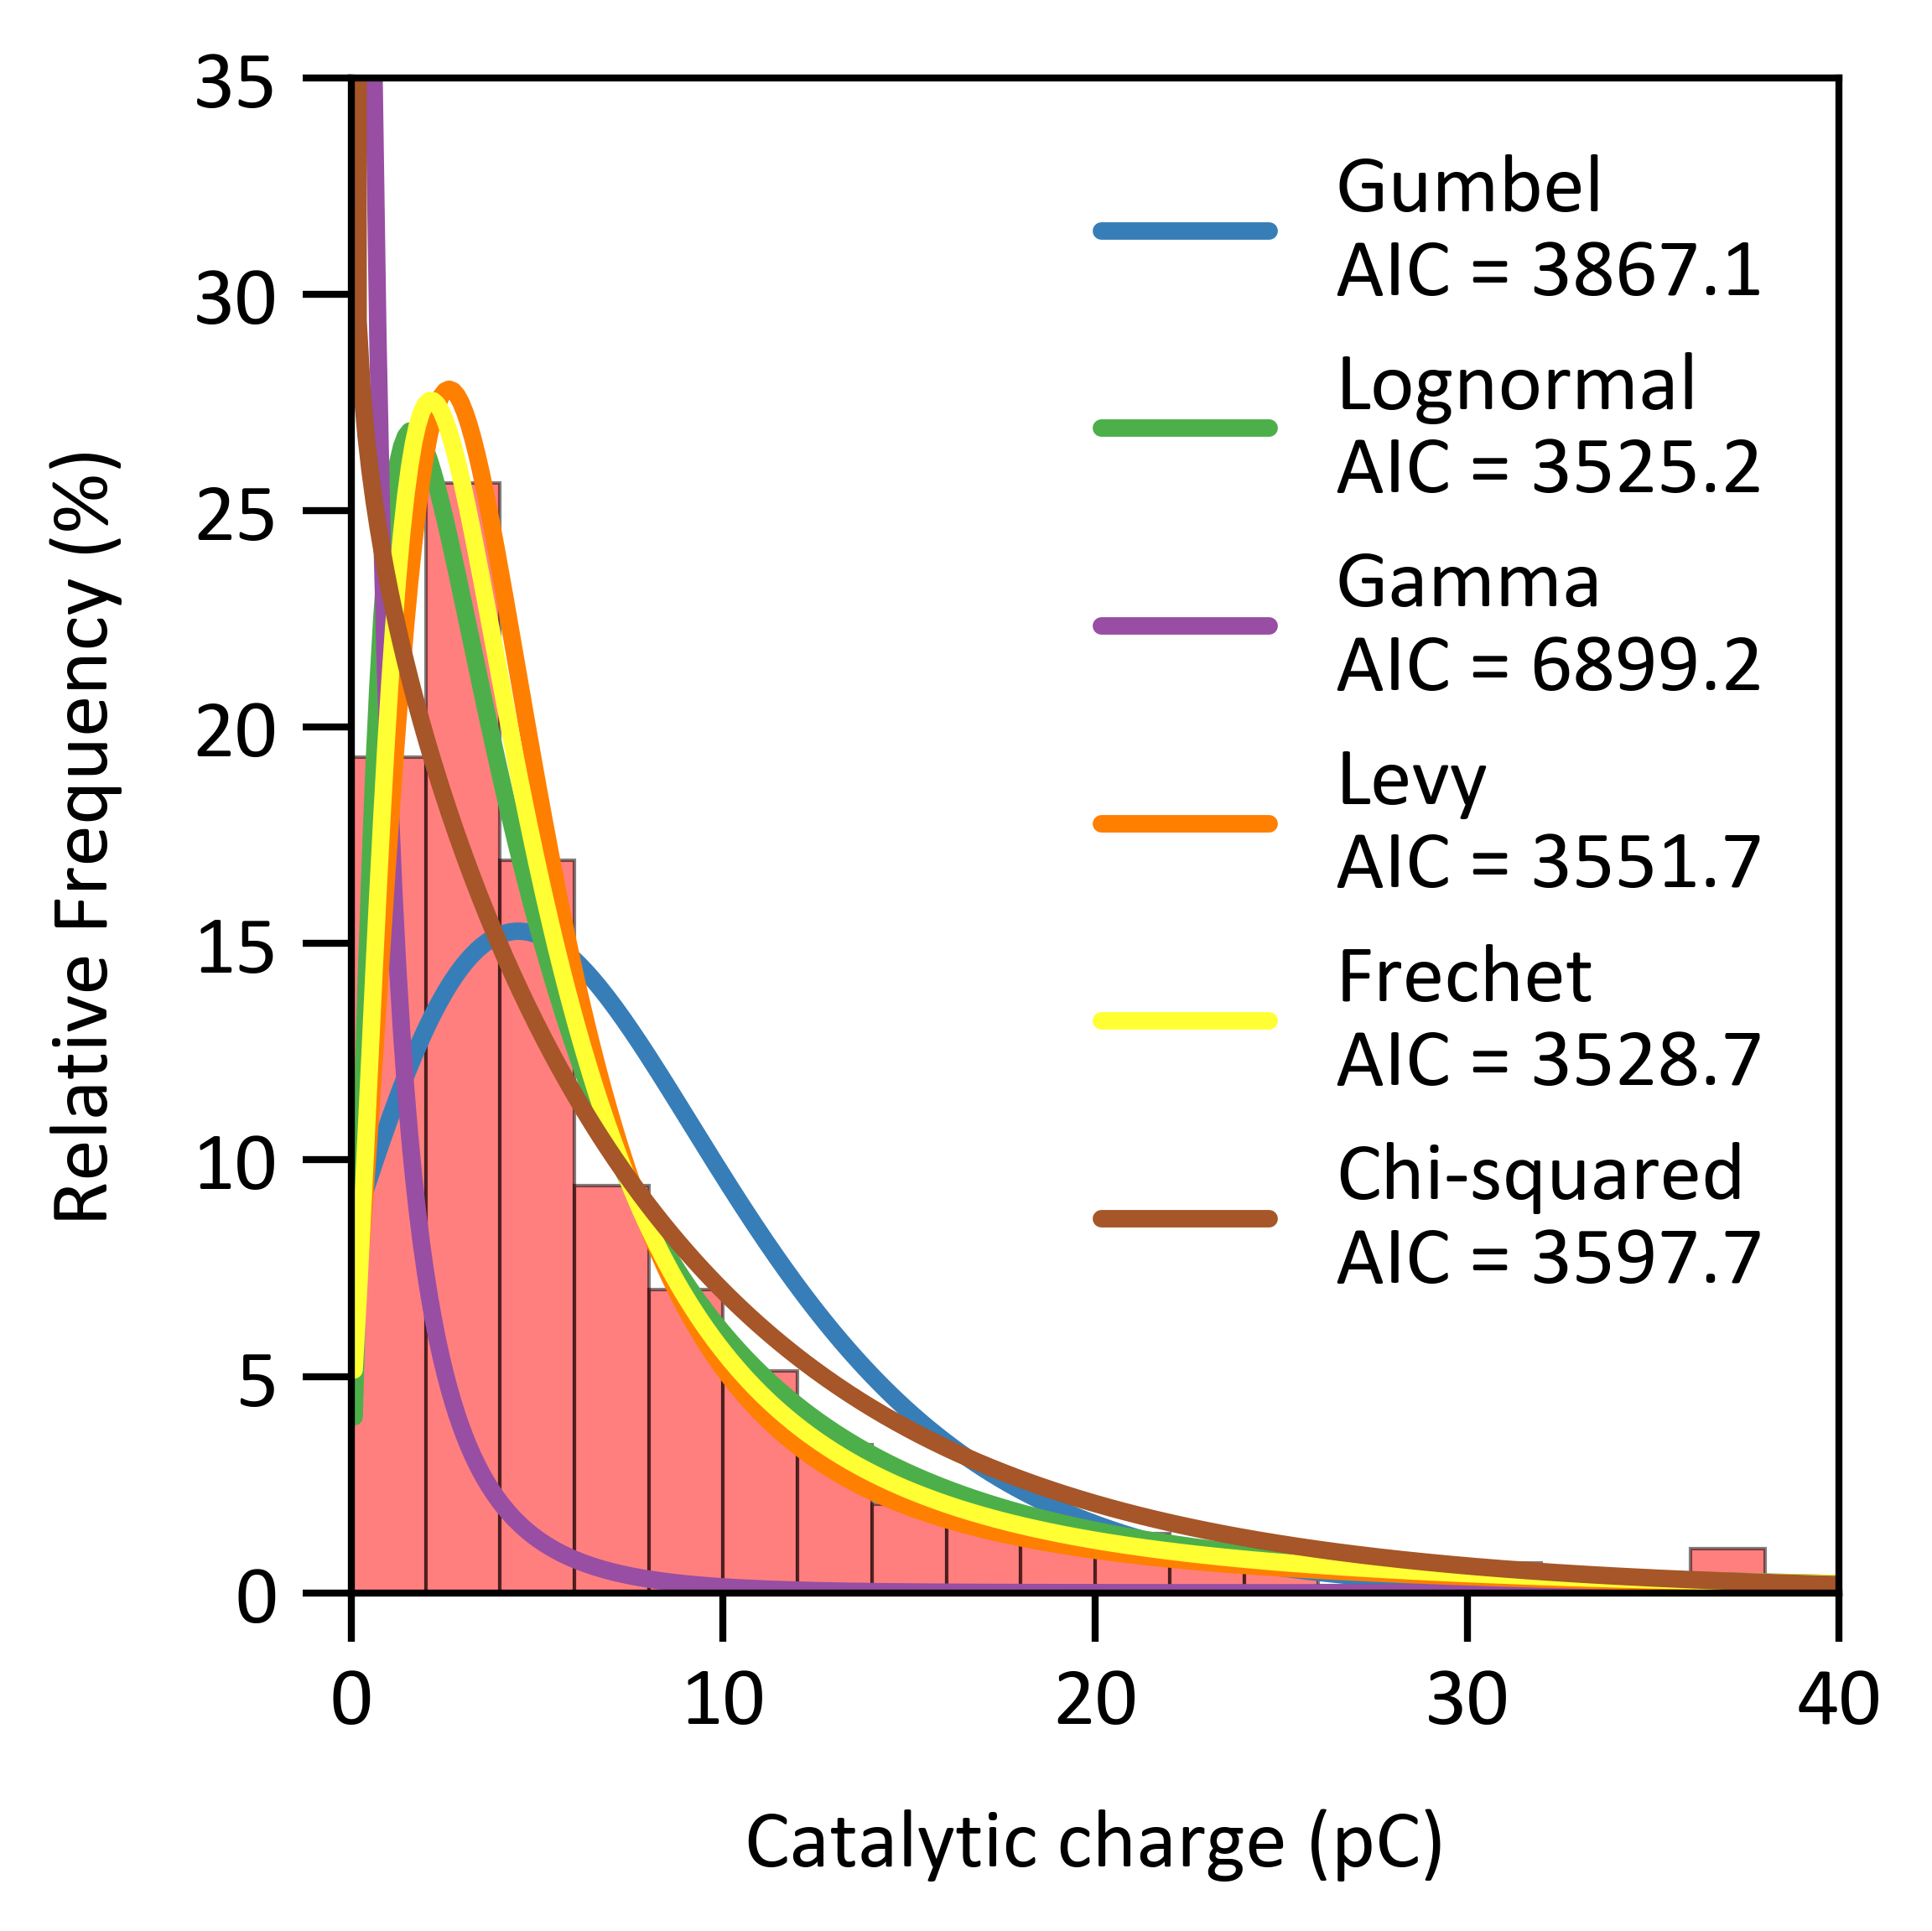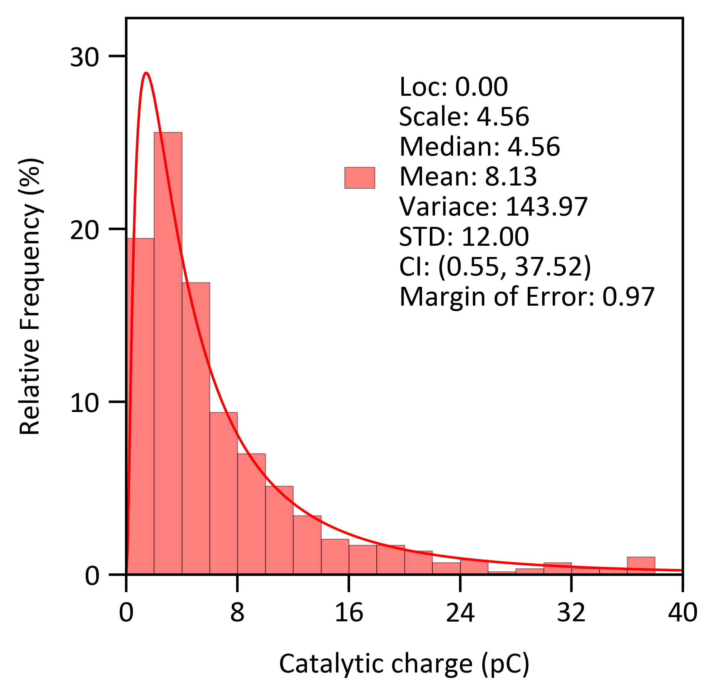
The catalytic charge histogram was fit using these six statistical models, and the Akaike information criterion (AIC) was calculated for each (left). The lognormal, Lévy, and Fréchet distributions have lower AIC values than the others, with lognormal being the best fit. The lognormal distribution, fitted with the corresponding parameters, was plotted (right). All future histograms were fit using a lognormal distribution.

The catalytic charge data were analyzed using parametric and nonparametric statistical approaches. From these parameters, the calculated median was 4.55 pC, which was substantially lower than the arithmetic mean, reflecting the influence of the heavy right tail.

To assess the adequacy of the sample size, we computed the standard error of the mean and constructed approximate 95% confidence intervals assuming asymptotic normality. Because the distribution was skewed, we additionally applied a nonparametric bootstrap resampling procedure with 1,000 replicates to estimate empirical confidence intervals for the median, mean, skewness, and upper-tail quantiles (90th, 95th, and 99th percentiles), as shown in Figure S10. Histograms of the resampled distributions were visually inspected to assess stability and variability across bootstrap samples.

Figure S10: Bootstrap distributions (1,000 replicates) of the median, mean, skewness, and upper-tail percentiles (90th, 95th, and 99th).
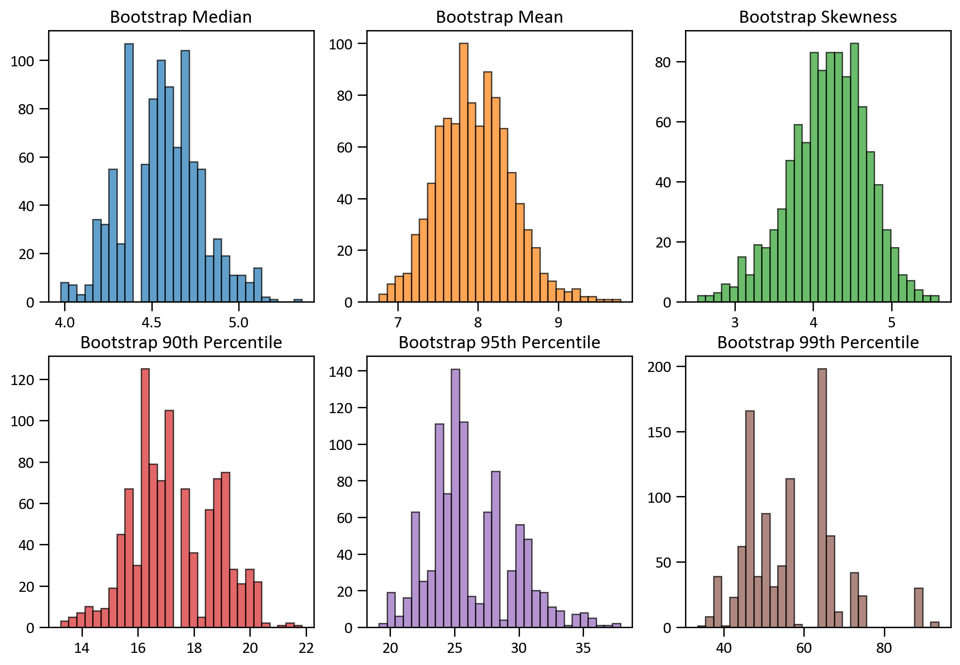

Table S2: Bootstrap-derived estimates and confidence intervals for catalytic charge
Statistic | Mean | 95% CI  (Lower, Upper) | Std Error
Median | 4.554 | (4.172, 5.022) | 0.215
Mean | 7.964 | (7.084, 8.938) | 0.464
Skewness | 4.189 | (3.191, 5.087) | 0.476
90th Percentile | 17.231 | (14.504,20.049) | 1.548
95th Percentile | 26.112 | (20.994,33.608) | 3.388
99th Percentile | 56.943 | (38.710,88.536) | 11.283

Figure S11: Bootstrap resampled histogram compared to the original data histogram.
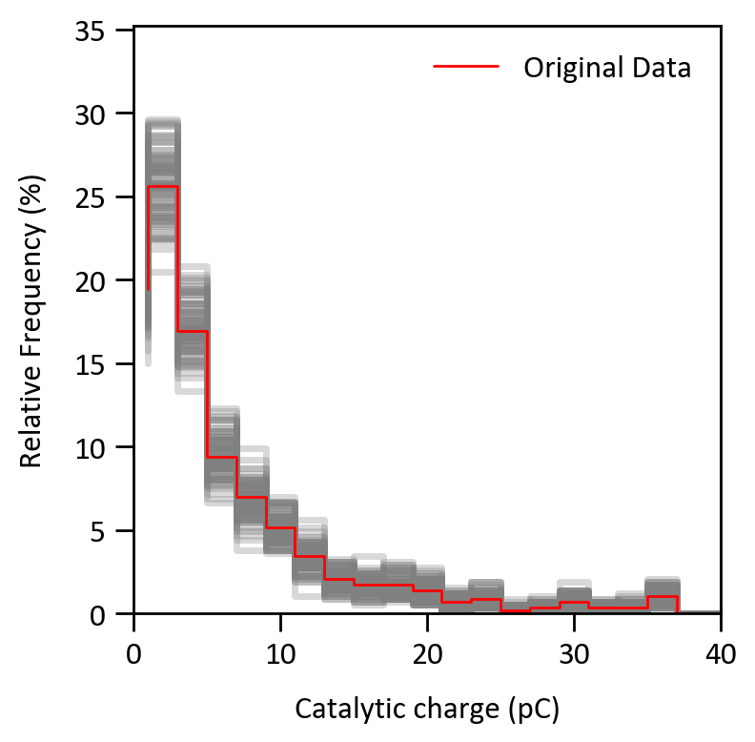
Every 10th bootstrap resampled histogram was overlayed to compare to the original data histogram (red), illustrating the variability in distribution shape across resamples. These visualizations highlight the stability of central tendency measures (median, mean) in this dataset.

Calculating the number of active sites

Figure S12: A CV of a platinum microelectrode (d ≈ 10 μm) at 50 mV/s in Ar-saturated 1 mM HClO₄.
Vertical dashed lines indicate the four potentials used to collect nanoimpacts: -0.30 V for the Hads regime, -0.45 V (E_{1/4}), -0.50 V (E_{1/2}), and -0.70 V for the diffusion-limited potential. Each potential was converted to RHE in the main text using the equation below, where R is the gas constant, T is the temperature, and F is Faraday’s constant.

$$E_{RHE}=E_{SCE}-0.2412-\frac{RT}{F}\ln\left(10\right)∙pH$$

Saturated Calomel Electrode  (SCE) potential | Reversible Hydrogen electrode  (RHE) potential
-300 mV | 119 mV
-450 mV | -31 mV
-500 mV | -81 mV
-700 mV | -281 mV

Figure S13: Charge for H_{ads} distribution from nanoimpacts at -300 mV vs. SCE.
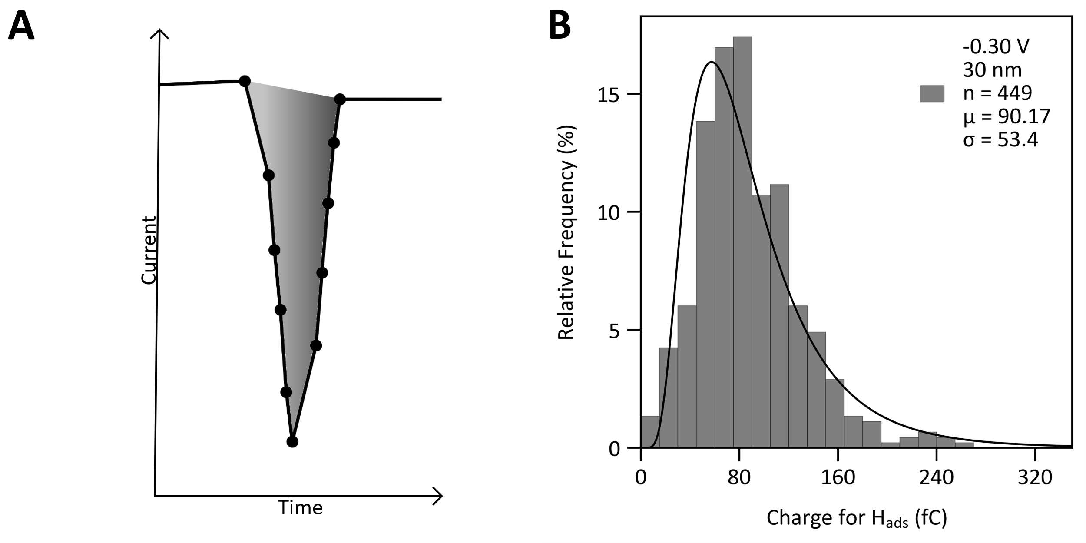
A) An example spike for 30 nm PtNP is shown, where the charge of H_{ads} spikes (Q_{ads}) was integrated (gray) to calculate the number of active sites. B) Corresponding histogram of Q_{ads} (n = 449) as a function of relative frequency with an average of 90.17 ± 53.4 fC.

Figure S14: Charge for H_{ads} distribution from nanoimpacts at -450 mV vs. SCE.
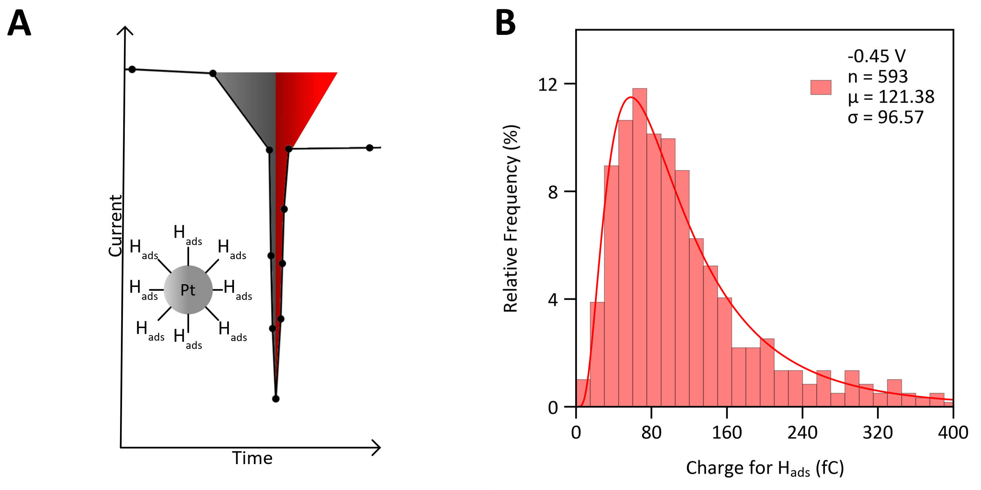
A) An example spike-decay with proton reduction (gray area) was integrated from the onset of the spike to the minimum point to deconvolute as much as possible from the charge associated with hydrogen evolution. The area was multiplied by two for symmetry (red area) and then compared to Figure S13. B) Corresponding histogram of Q_{ads} for 593 impact events for 30 nm PtNPs at the potential of -450 mV vs. SCE. The average was 121.38 ± 96.57 fC, significantly higher than the average at -300 mV vs. SCE.

Figure S15: Charge for H_{ads} distribution is potential dependent
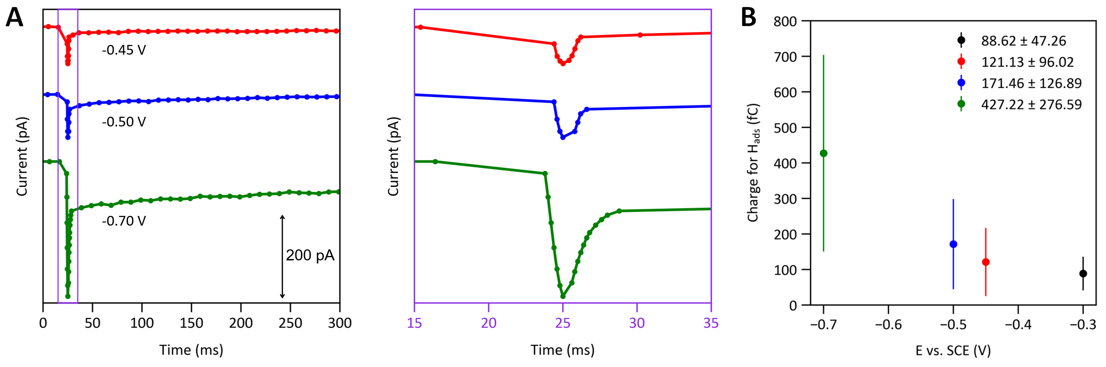

A) Example spikes-decay curves at three different potentials (-0.45, -0.50, and -0.70 V vs. SCE) and magnified view of spike in the middle panel. The variable sampling rate can be seen in the magnified i-t trace (100 Hz or a change in I > 15 pA) was first met. This allowed the measurement to limit the peak-to-peak noise but still collect enough data points when an impact occurred. B) The average Q_{ads} is potential-dependent and increases as potential increases, and is quantified in Table S3. It increases as more unattainable active sites at higher overpotentials are activated, and some current contribution comes from hydrogen evolution occurring at the initial spike.

The rest of the Q_{ads} histograms for other potentials and sizes are below.
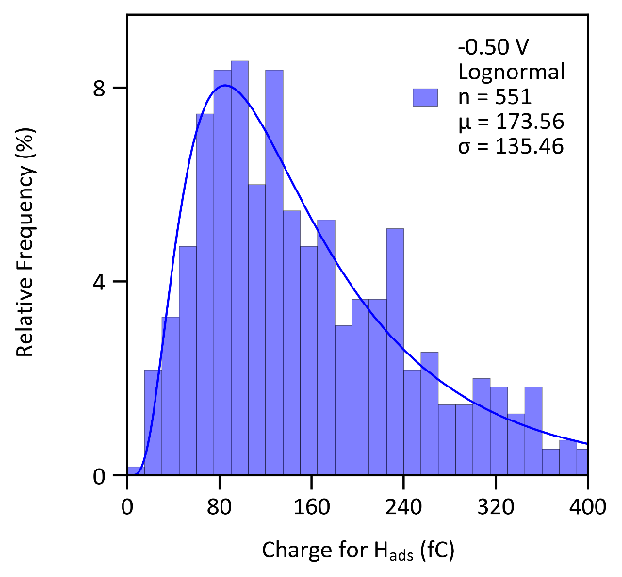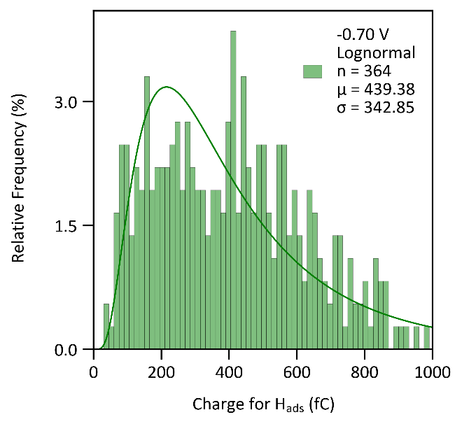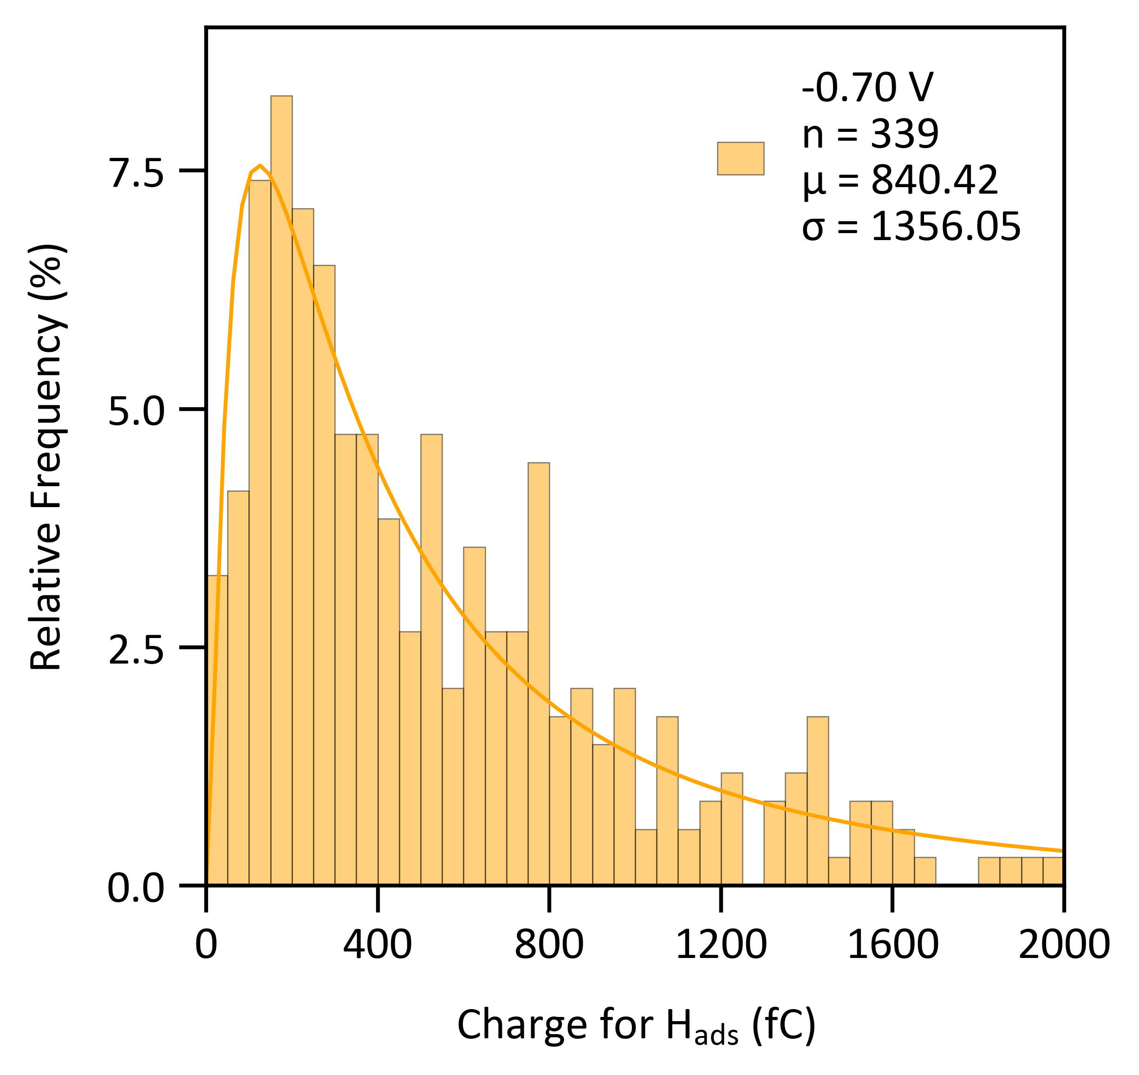

Figure S16: Charge for H_{ads} distribution is size dependent
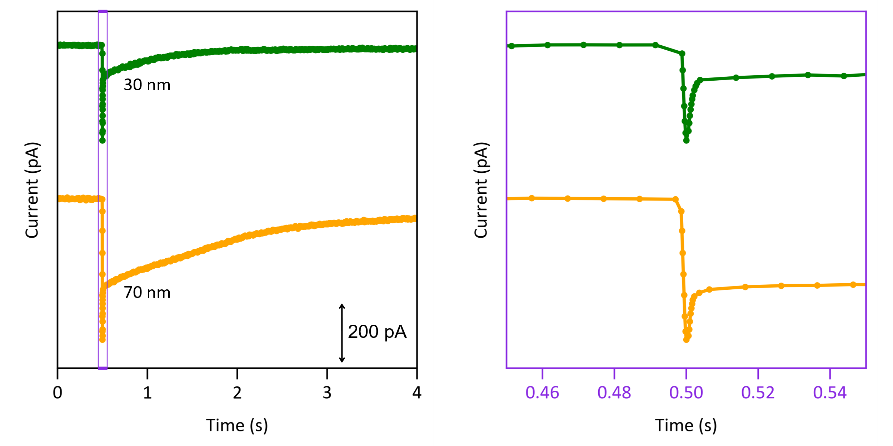
Example spikes-decay curves for 30 and 70 nm PtNPs showing the size dependence of Q_{ads} (left). A magnified view of the initial spike shows a larger area and is quantified in Table S3 (right).

Table S3: The average Q_{ads} needed to scale each spike-decay curve.
Potential  (V vs. SCE) | Size of platinum  nanoparticle (nm) | Average Q_{ads} (C) | Ratio
-0.30 | 30 | 8.802 x 10⁻¹⁴ | 1
-0.30 | 70 | 2.642 x 10⁻¹³ | 1
-0.45 | 30 | 1.211 x 10⁻¹³ | 0.7266
-0.50 | 30 | 1.715 x 10⁻¹³ | 0.5134
-0.70 | 30 | 4.272 x 10⁻¹³ | 0.2060
-0.70 | 70 | 9.184 x 10⁻¹³ | 0.2877

The Q_{ads} are scaled to match the average at -0.30 V vs. SCE, where there is just proton reduction. Table S3 summarizes the ratio used to scale all the Q_{ads} charges by taking the average Q_{ads} for all the spikes and then dividing by the average Q_{ads} at -0.3 V with a size of 30 nm. The standard deviation (σ) and lognormal distribution are within the same order of magnitude. This suggests that the scaling gives a reasonable estimate of the total active sites per PtNP in Figure S17.

Figure S17: Charge for H_{ads} normalized by distribution at -300 mV vs. SCE.
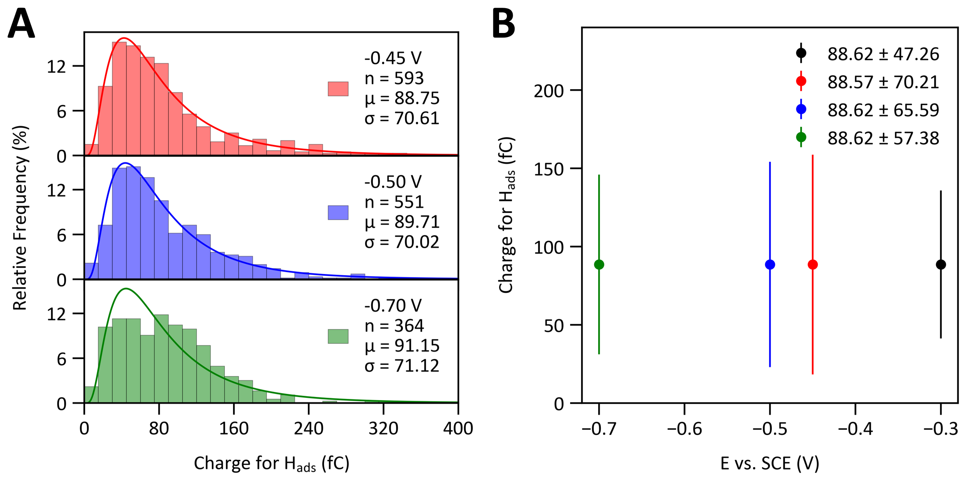
A) Stacked histograms were plotted after normalization of Q_{ads} by the ratio in Table S3 for 30 nm PtNPs. B) Mean plot of Q_{ads} vs. applied potential after scaling.

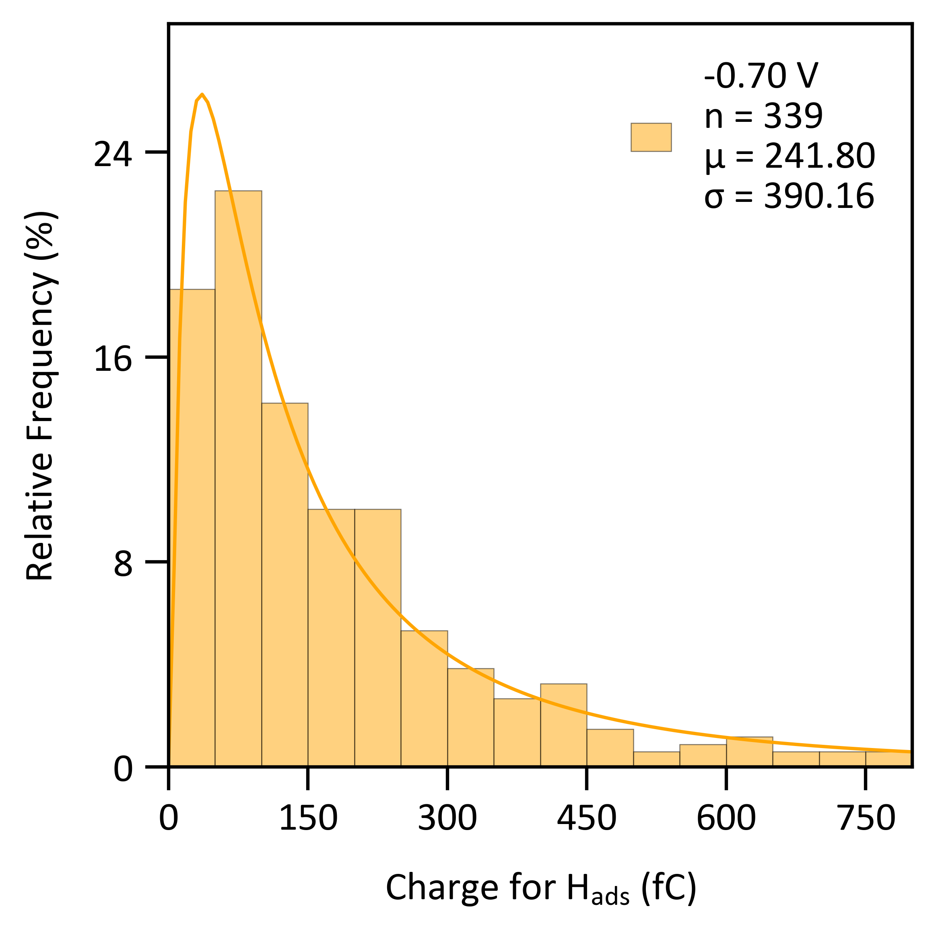

Assuming a one-electron process, the area in Coulombs (C) is converted to the number of active sites.
Volmer step: $H^{+}+e^{-}→H_{ads}$
$$Q_{ads} C×\frac{1{ e}^{-}}{1.602×{10}^{-19} C}×\frac{1 H_{ads}}{1{ e}^{-}}×\frac{1 active site}{1 H_{ads}}$$

Calculating turnover number
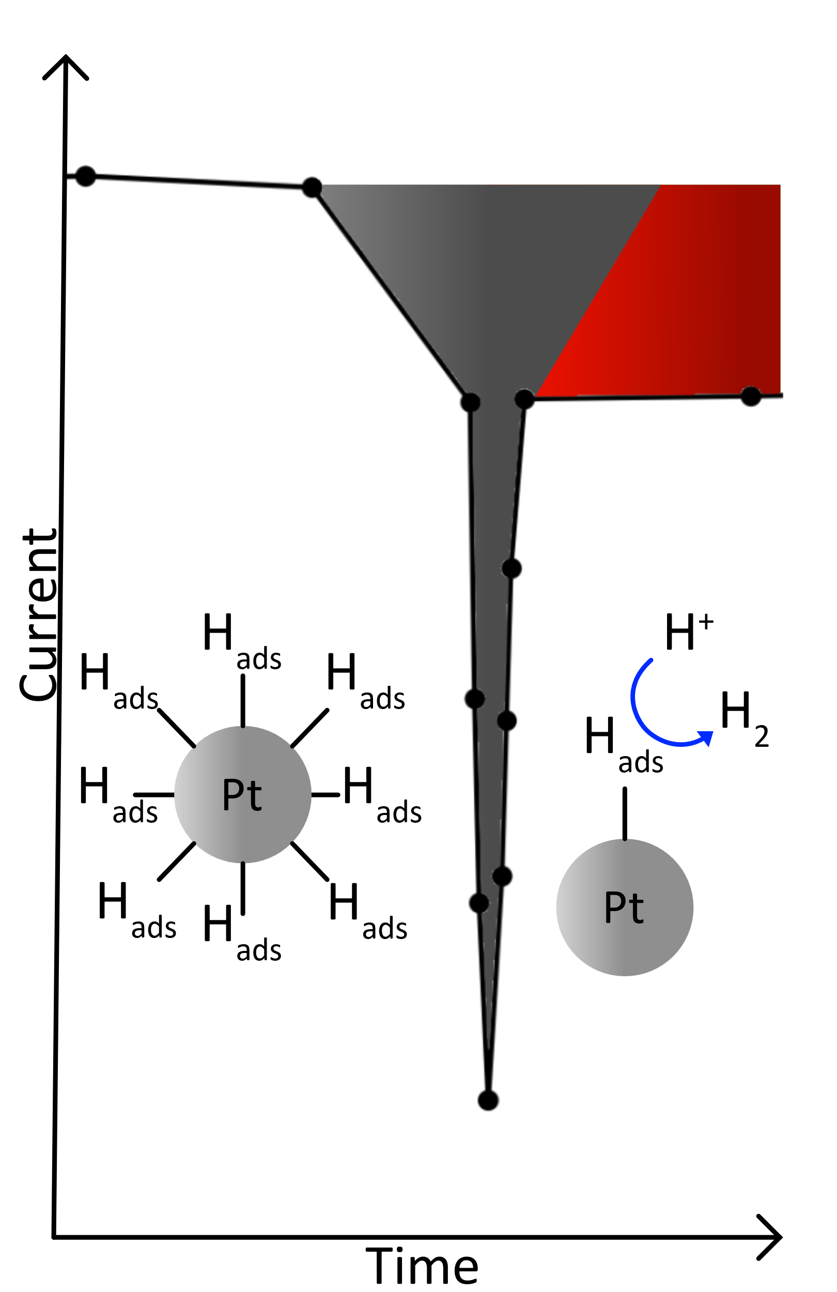
An example zoomed-in spike-decay to show that the full integration above was subtracted by the Q_{ads} spike (gray) for each impact after multiplying by two for symmetry and scaling (previous section).

The rest of the Q_{HER} histograms for other potentials are below.
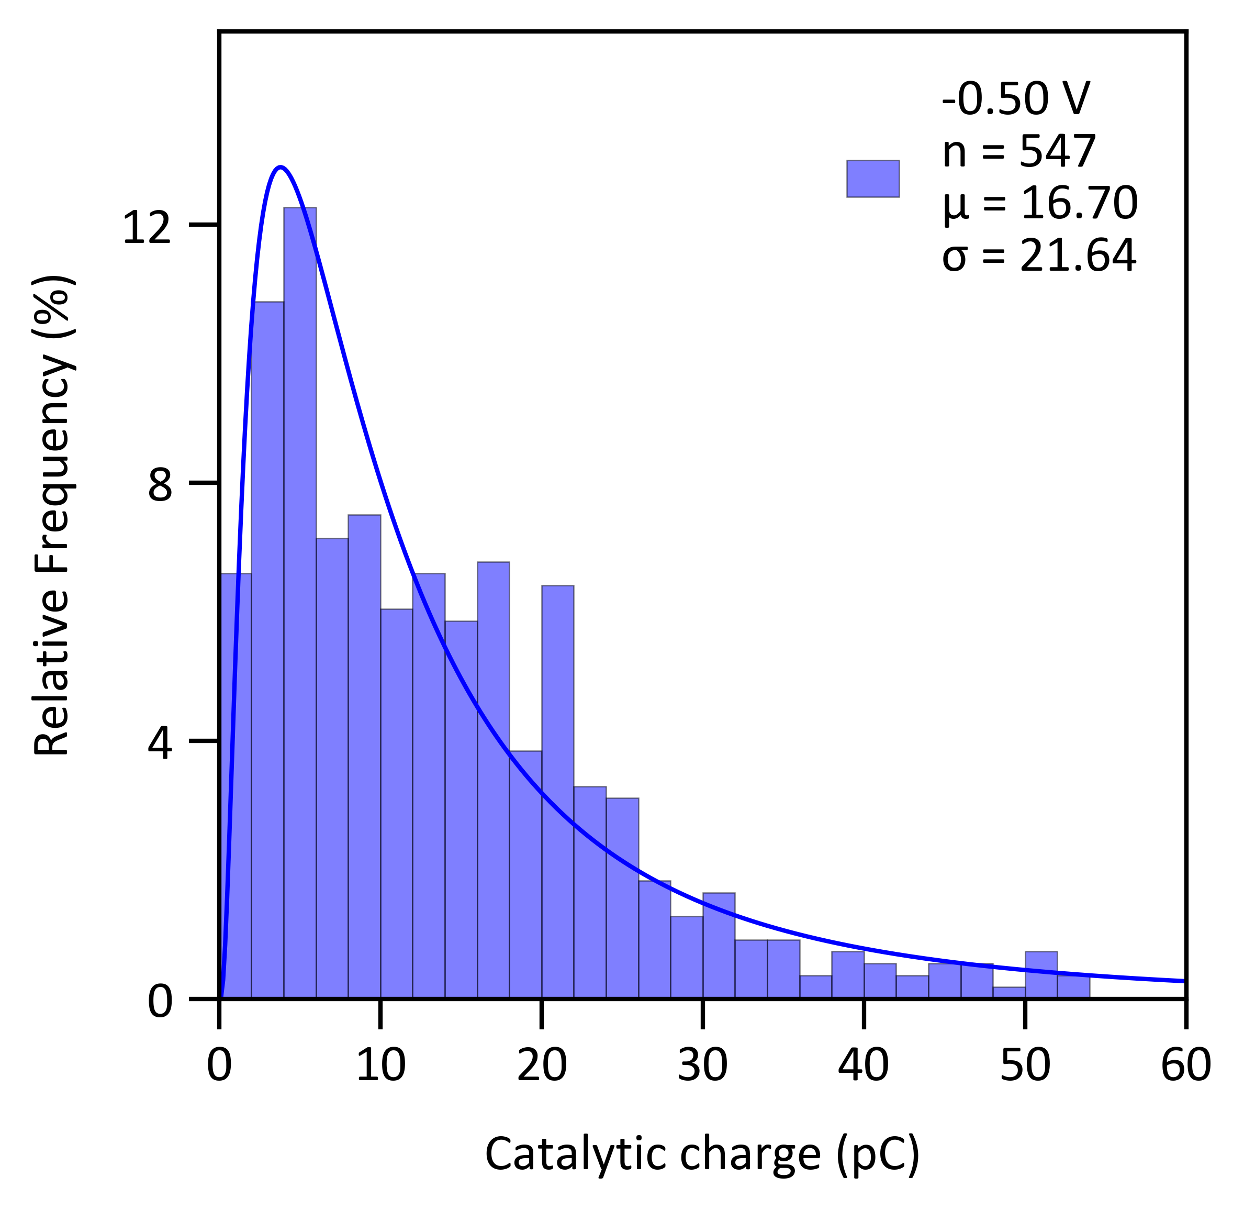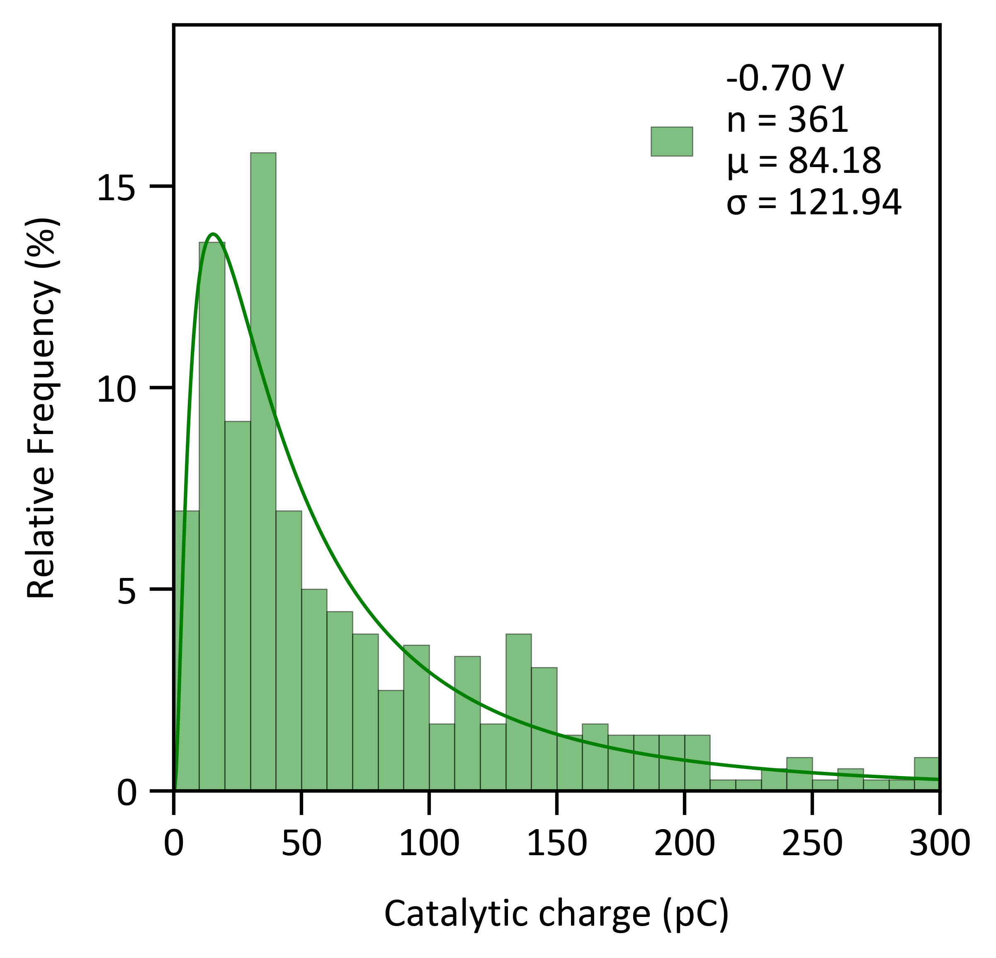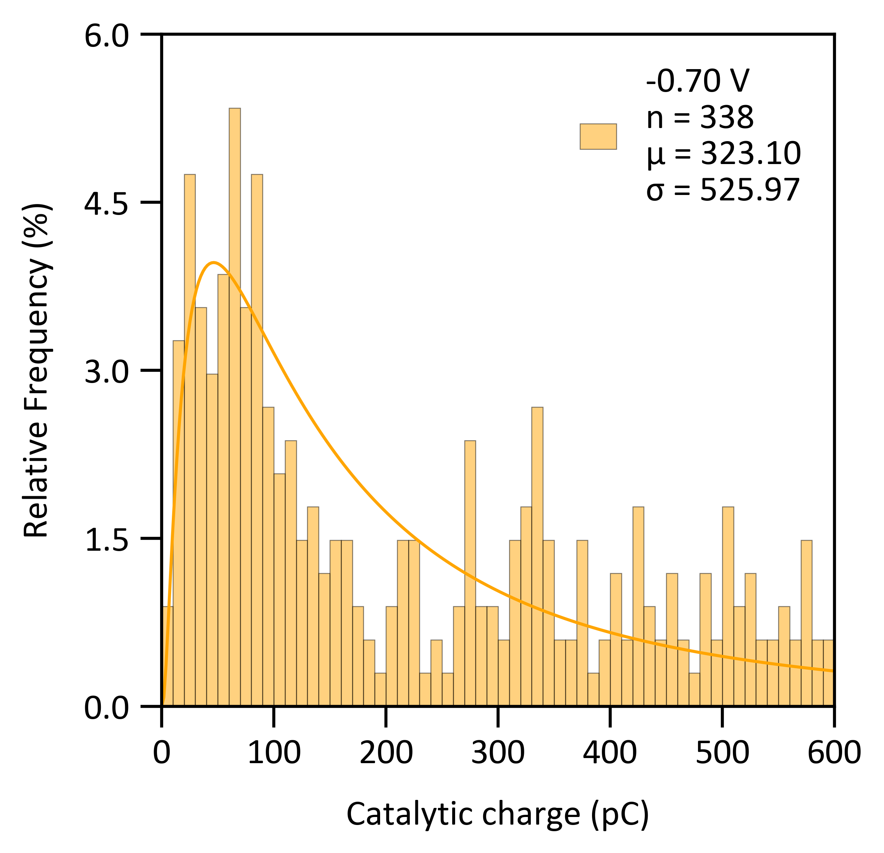

Catalytic charge and charge for H_{ads} distribution
$$Q_{ads}∝EASA or active sites$$
$$Q_{HER}∝turnovers$$
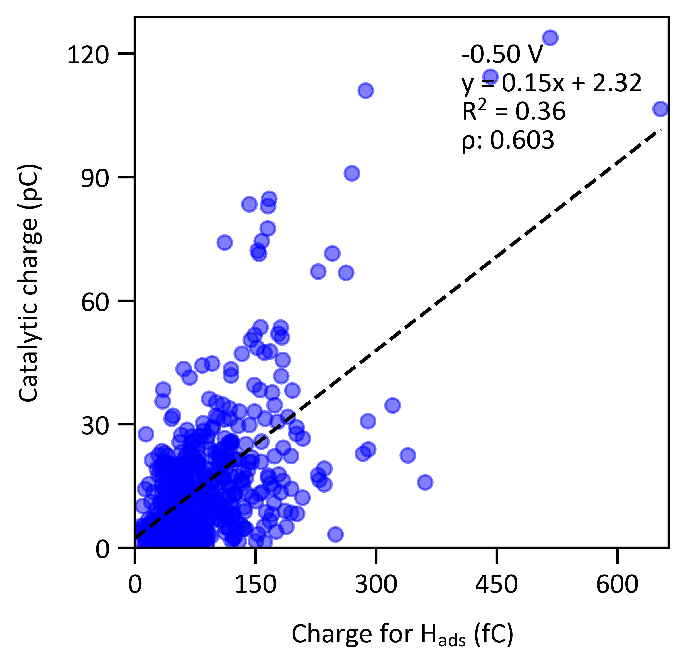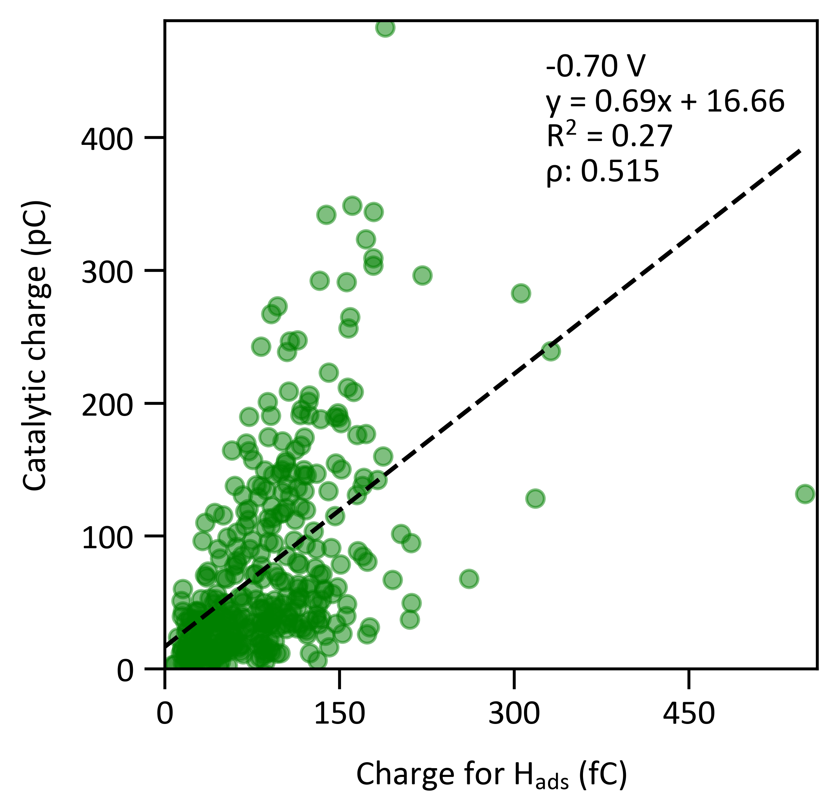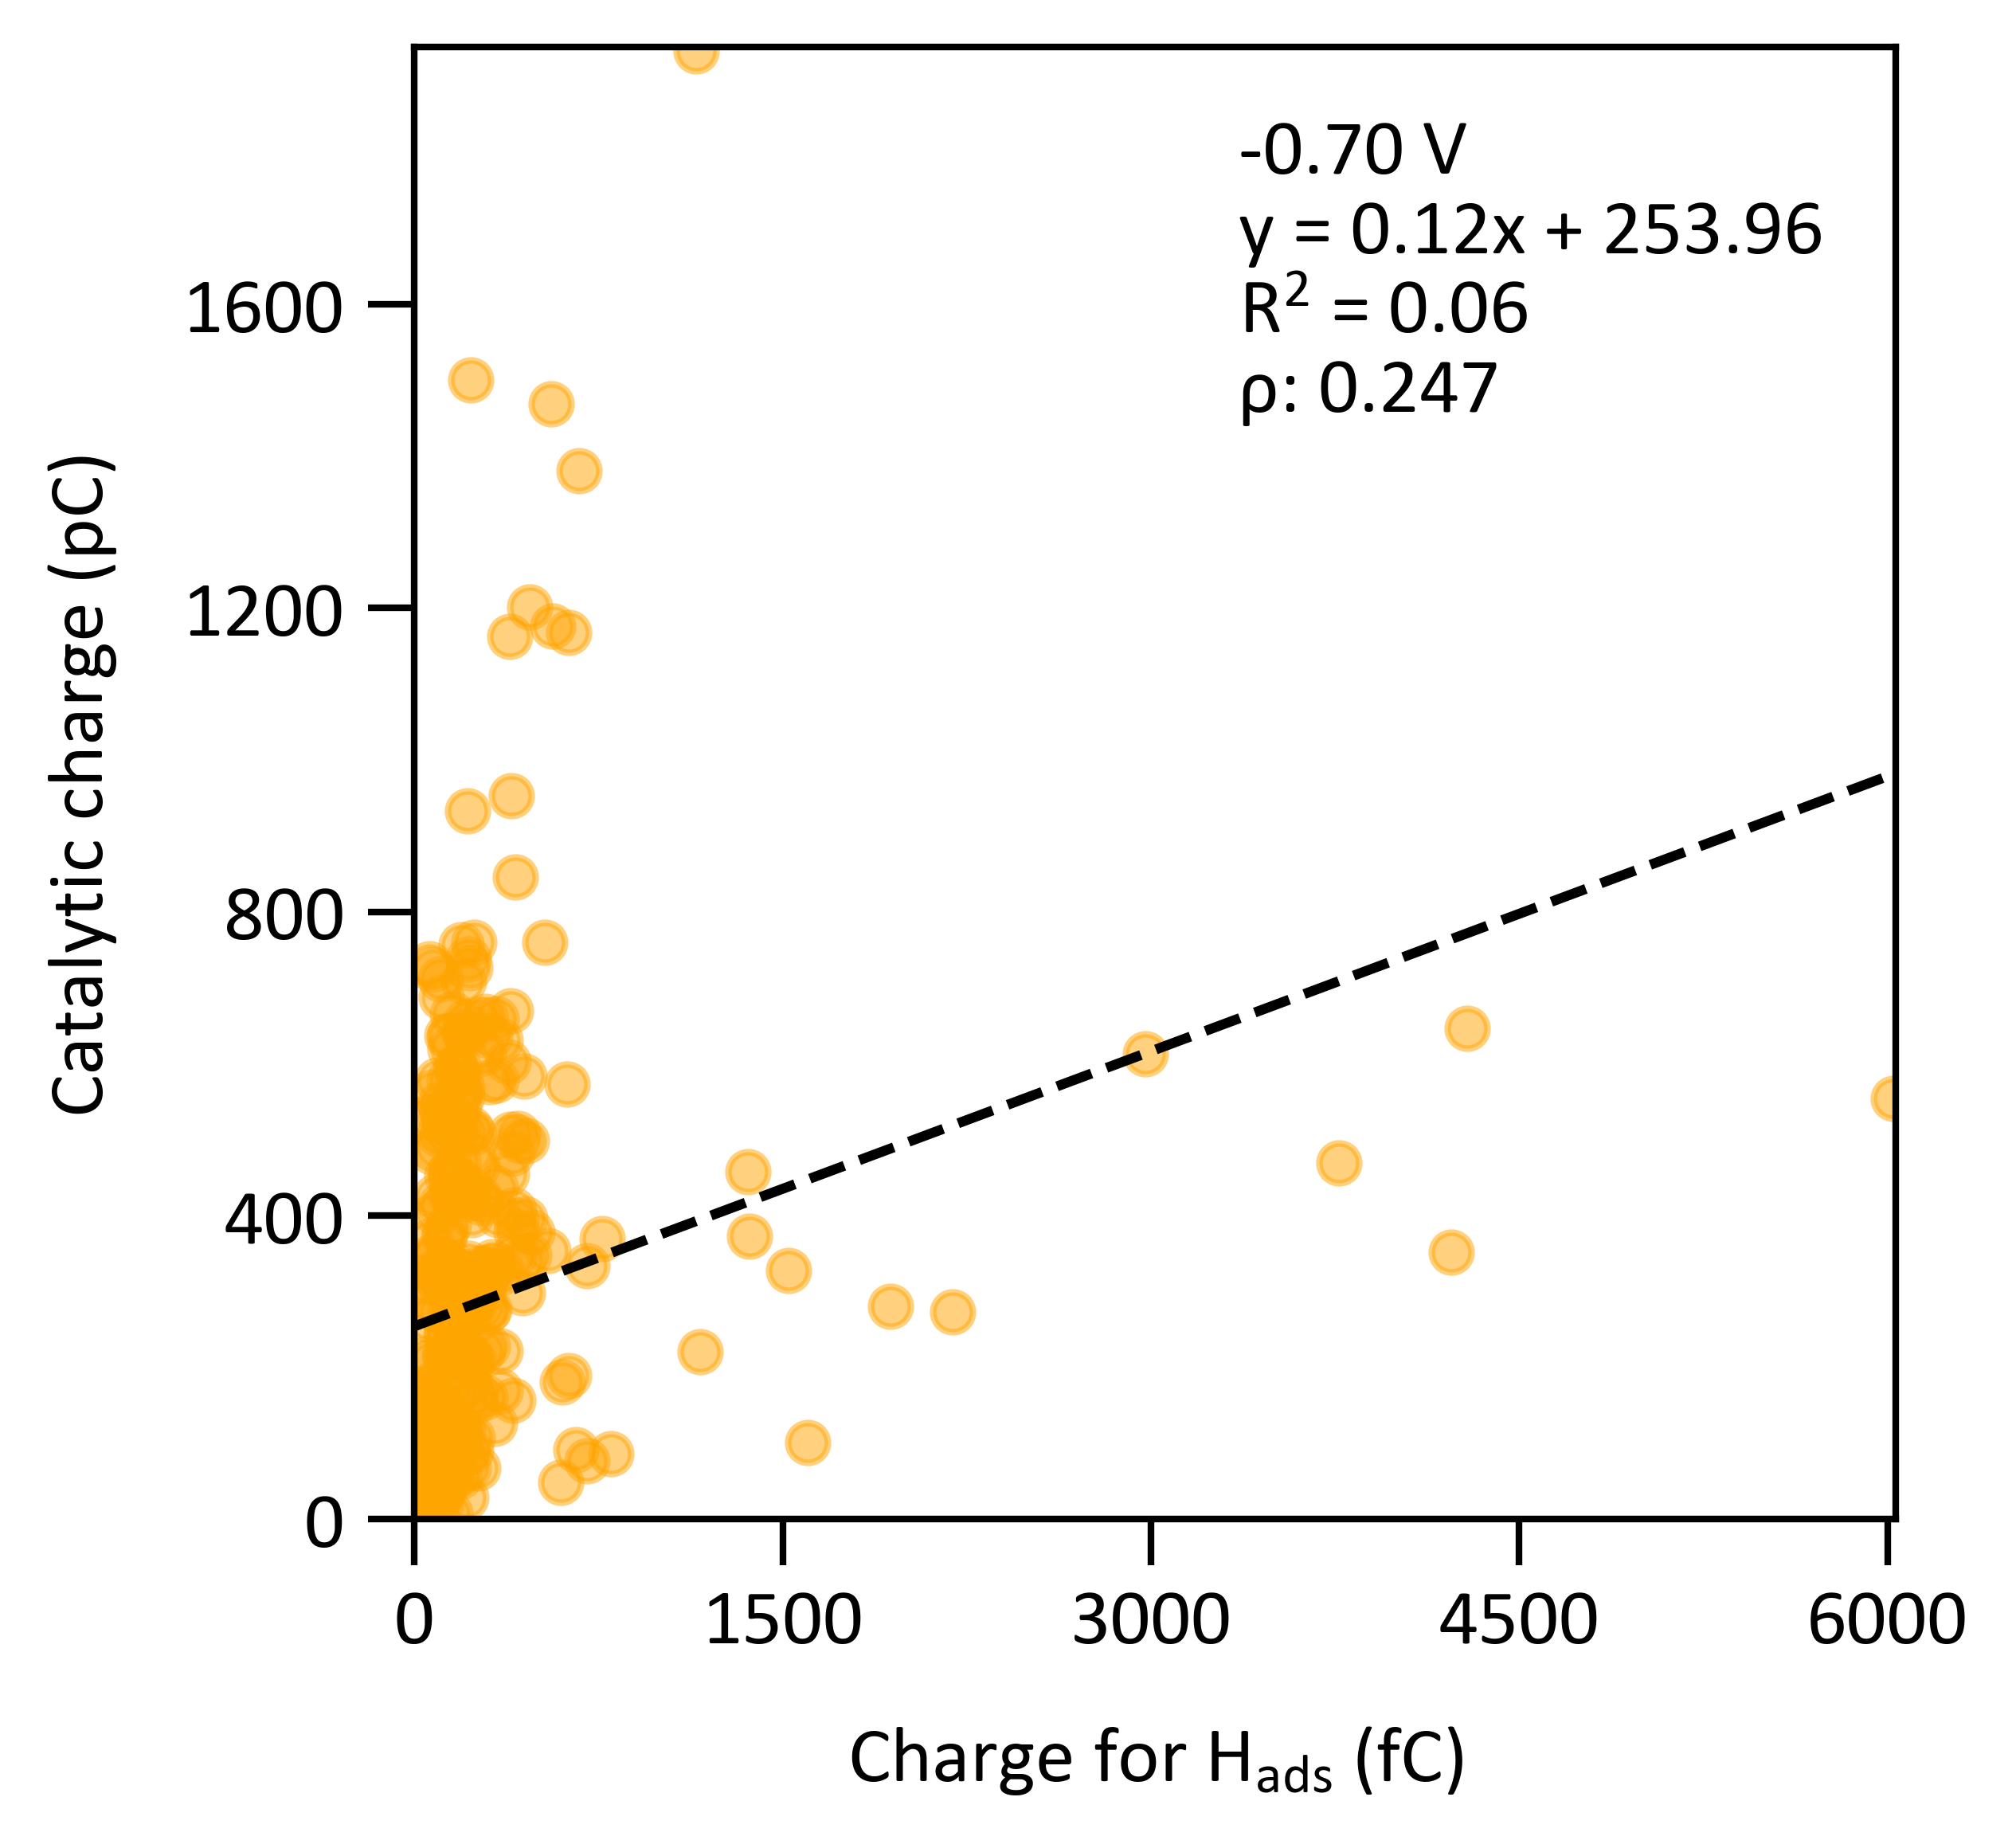
There is a moderate positive correlation between the number of active sites and turnovers for all three potentials using the 30 nm PtNPs, compared to a low positive correlation for the 70 nm PtNPs.

The amount of H₂ produced was calculated based on the overall reaction
Overall reaction: $2H^{+}+2e^{-}→H_{2}$
$$Q_{HER} C×\frac{1 electron}{1.602×{10}^{-19} C}×\frac{1 H_{2}}{2 electrons}$$

or

$$Q_{HER} C×\frac{1 mol electron}{96485.33 C}×\frac{1 mol H_{2}}{2 mol electrons}$$

Corresponding histograms of relative frequency versus the number of cycles in units of 10⁶ H₂ produced per particle.
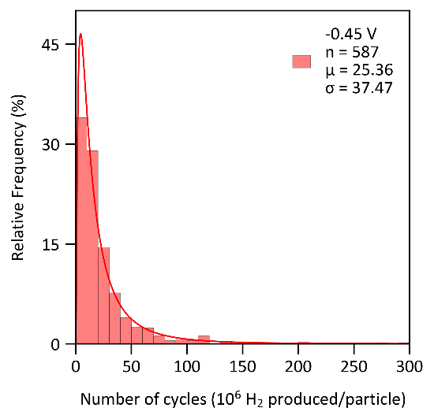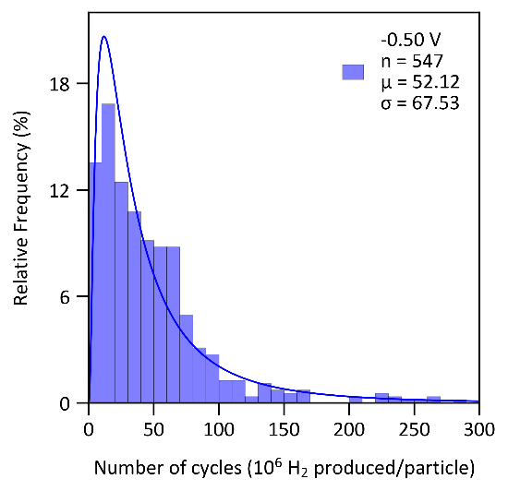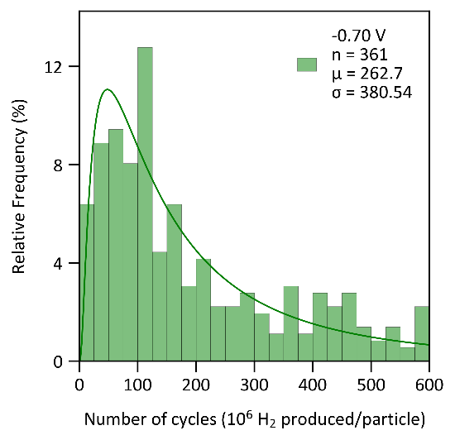
The TON was calculated by dividing the molecules of H₂ produced per particle by the number of active sites from the same nanoparticle impact. The complete TON equation is below.

$$\frac{Q_{HER} C×\frac{1{ e}^{-}}{1.602×{10}^{-19} C}×\frac{1 H_{2}}{2{ e}^{-}}}{Q_{ads} C×\frac{1{ e}^{-}}{1.602×{10}^{-19} C}×\frac{1 H_{ads}}{1{ e}^{-}}×\frac{1 active site}{1 H_{ads}}}=\frac{H_{2} produced}{active site}$$
$$TON=\frac{Q_{HER}}{{2Q}_{ads}}$$

Calculating electroactive surface area (EASA) and roughness factor for PtNPs
Surface area of a perfect spherical nanoparticle$=4πr^{2}$
$$=4π{(14.335 nm)}^{2}≈2582.3 nm^{2}$$
$$=4π{(33.15 nm)}^{2}≈13809.5 nm^{2}$$

There is 5.3 times more surface area in the larger 70 nm in diameter PtNPs, assuming they are perfect spheres.

From the spikes attributed to the Volmer step, we assume a monolayer of hydrogen forms on impacting particles. The accepted value for the surface charge for an ideal monolayer of H on polycrystalline platinum is 210 μC/cm² or 2.1x10⁻¹⁸ C/nm². Since platinum nanoparticles are used, there is a possibility of underestimating the actual surface area because the role of corner and edge atoms in hydrogen adsorption is not sufficiently understood. At potentials just before the onset of HER, the surface coverage is 77% of the total sites.⁴ The average charge of H_{ads} at -0.3 V vs. SCE was obtained from Table 1 and used to calculate the average EASA.

$$EASA \left(nm^{2}\right)=\frac{Q_{ads}\left(C\right)}{Surface coverage ×Surface charge (C nm^{-2})}=54807.19 nm^{2}$$

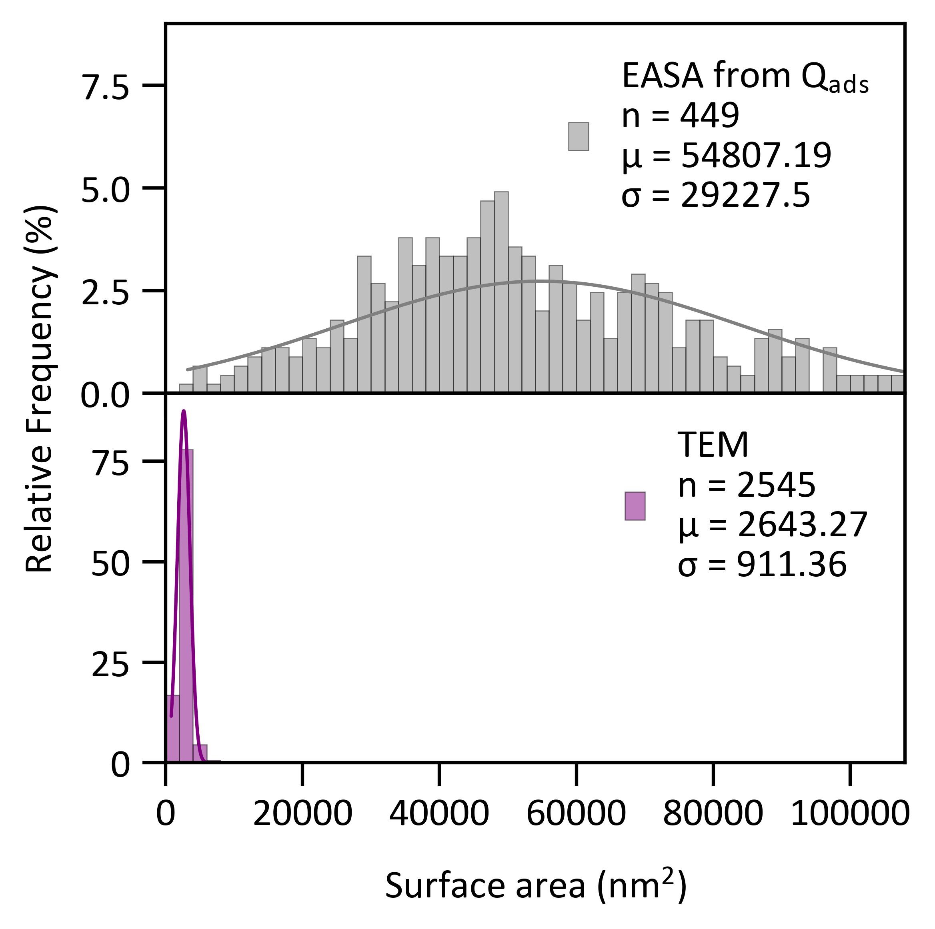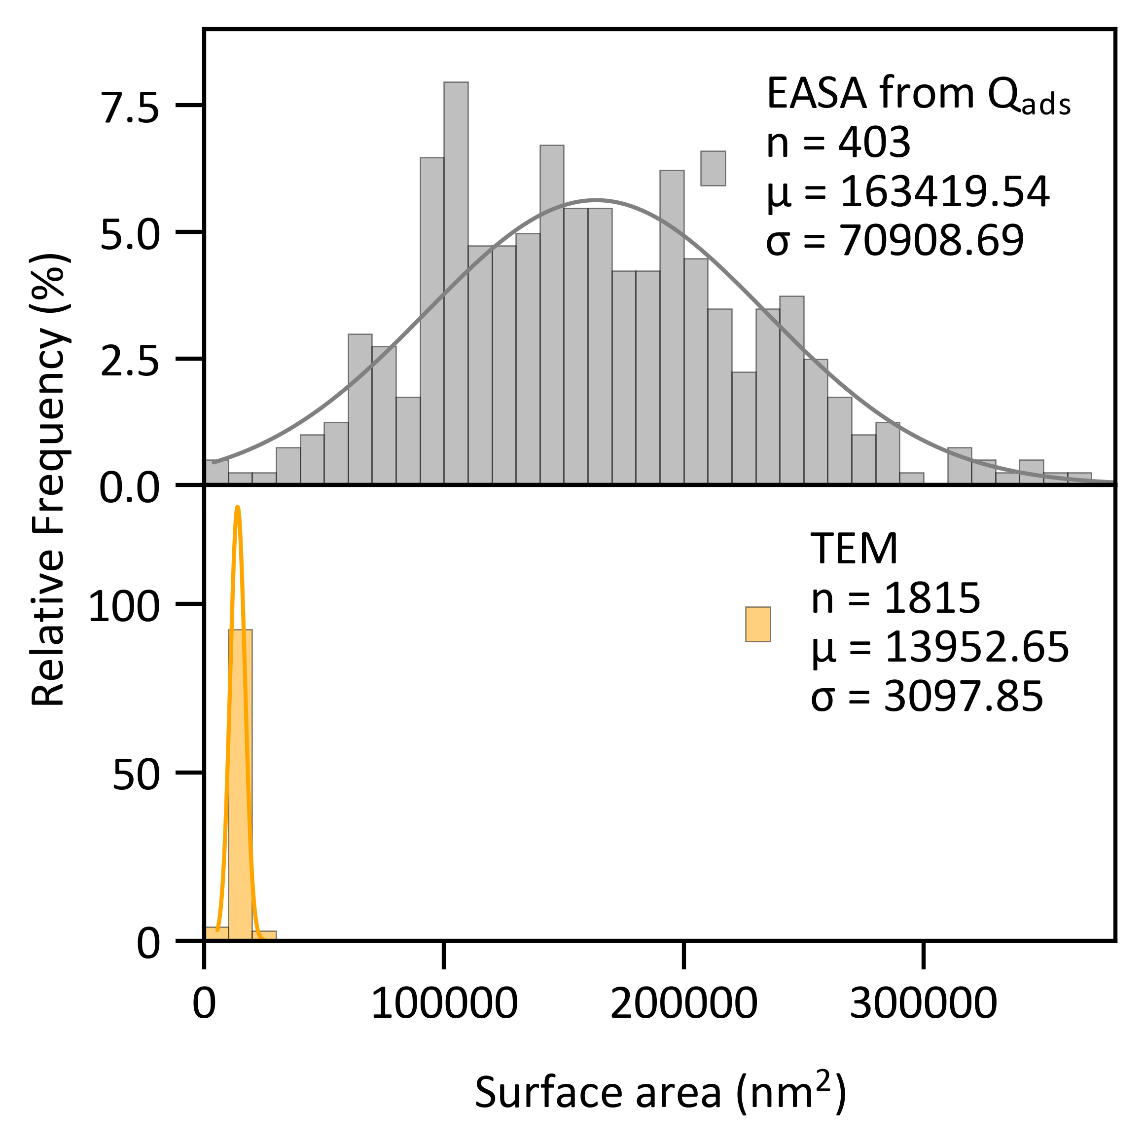
Using the experimental EASA, the roughness factor can be calculated by assuming the electroactive surface area of a smooth, 14.335 nm (left) and 33.15 nm (right) radius sphere (Figure S1).

$$R_{f}=\frac{EASA_{measured}}{EASA_{theoretical}}$$

Table S4: Summary of Surface area, EASA, and roughness factor
PtNP radius  (nm) | Perfect sphere surface area/  EASA_{theoretical} (nm²) | EASA_{measuresd} from  Q_{ads} (nm²) | Roughness  factor – R_{f}
14.335 | 2582.3 | 54807.2 | 21.22
33.15 | 13809.5 | 163419.5 | 11.83

The current density of a microelectrode vs. nanoparticles
A 10 μm diameter microelectrode has a diffusion rate equivalent to an RDE with a diameter of 1 cm at 5000 rpm. The microelectrode operates at very high current densities (up to 2 A cm⁻²) without nucleation of bubbles on the surface.⁵ The experimental current density of the platinum microelectrode for 1 mM HClO₄ and assuming a perfect spherical disk is around 0.018 A cm⁻² (Figure S5). Nanoparticles that impact an electrode can operate at even higher current densities at the same pH.

The equation below was used to get the expected current for a nanoparticle on a microelectrode.

$$I = 4π(ln 2)nFDCr$$

, where I is the amplitude of the current, n is the number of electrons, F is Faraday’s constant, D is the diffusion coefficient of reactants at concentration C, and r is the radius of the single-metal NP.⁶ Assume the diffusion coefficient for H⁺ is 9.8x10⁻⁵ cm²/s.⁷ The theoretical current we should expect is 236.13 pA. Dividing by the EASA yields a value of 0.4309 A cm⁻², approximately 24 times more current density than a platinum microelectrode.
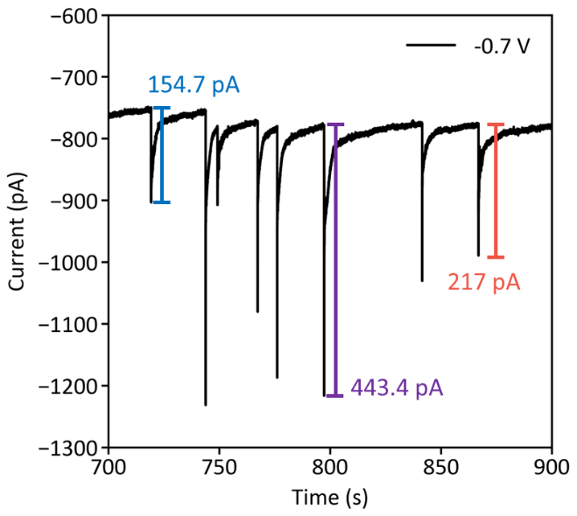
Experimentally, the three sample spike currents (154.7, 443.4, and 217 pA) were divided by the EASA to yield values of 0.282, 0.809, and 0.396 A cm⁻², respectively. These values are within the same order of magnitude as the expected theoretical current density.

Deactivation mechanism

Figure S18: 30 nm PtNP nanoimpacts after spiking with 10 μm of known HER inhibitors.
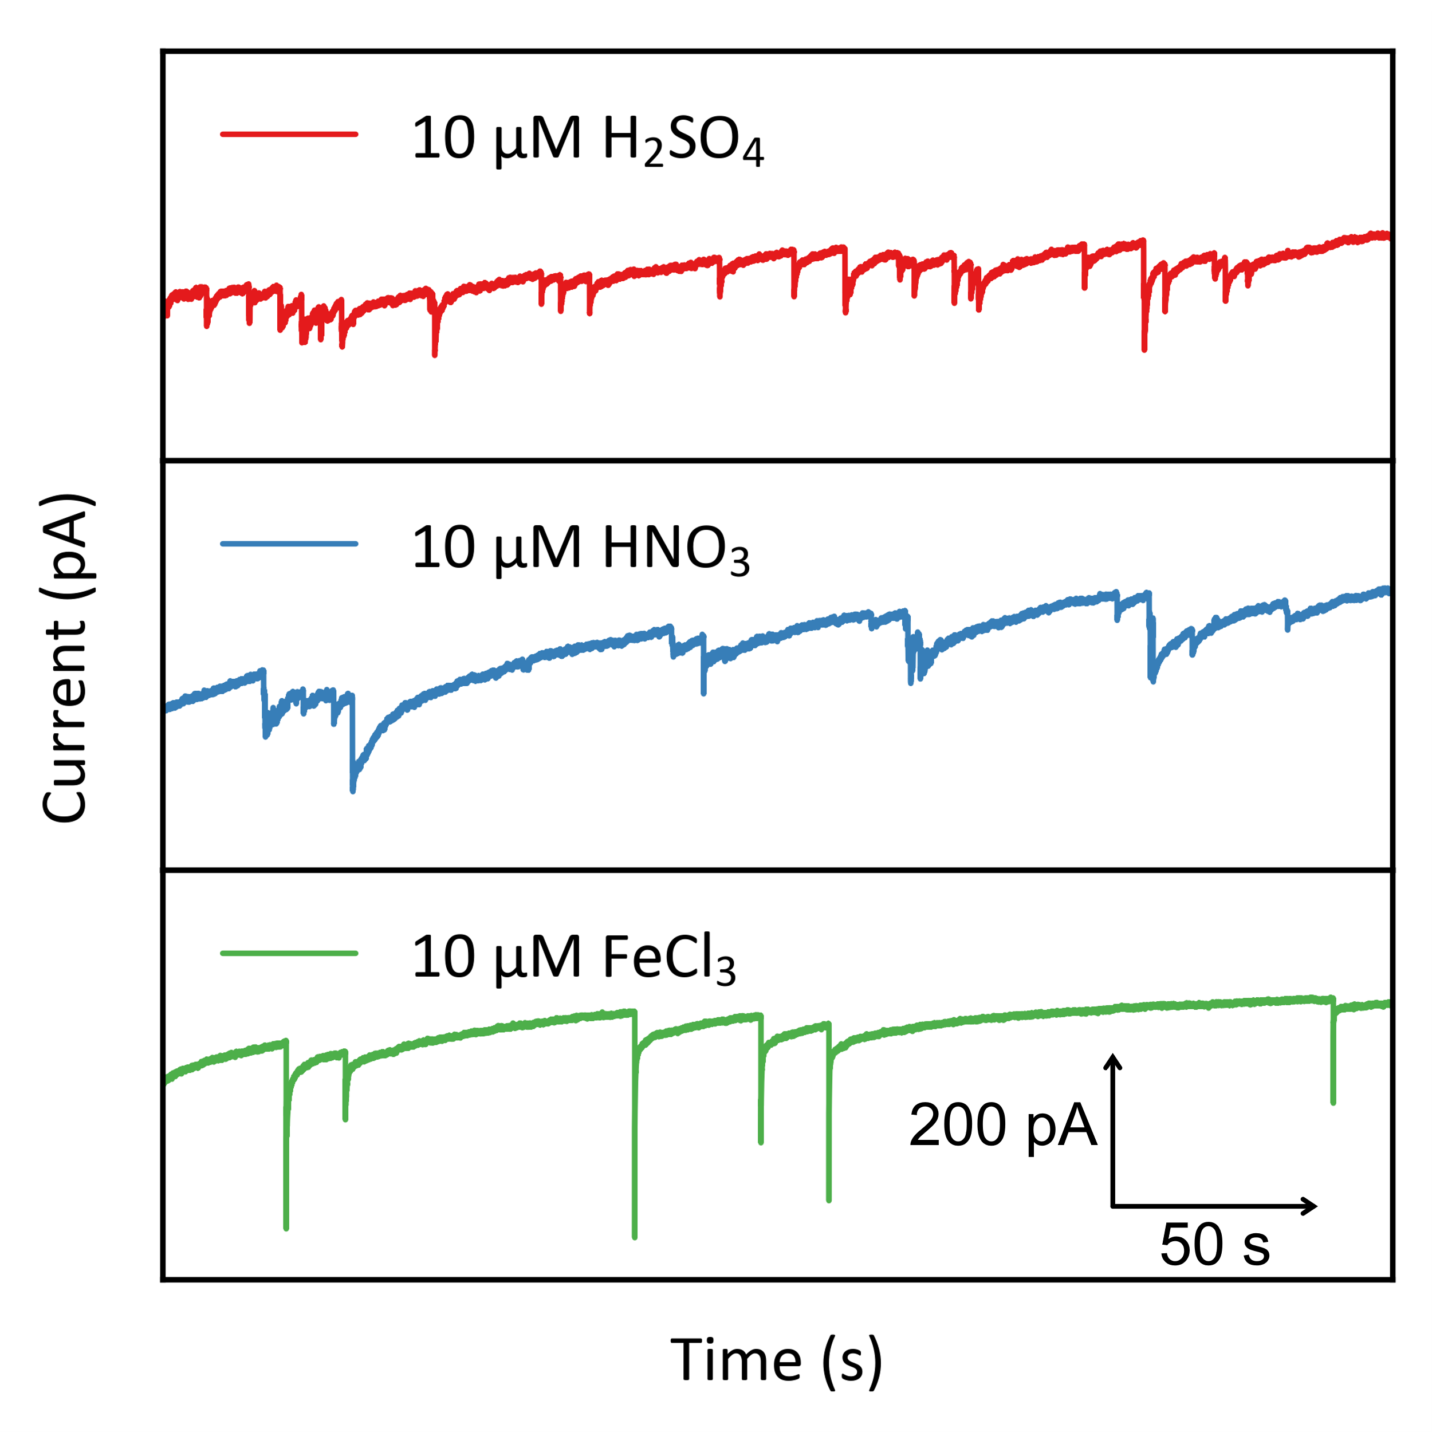
A nanoimpact experiment (1 mM HClO₄ and 3.27 pM PtNPs) was intentionally spiked with 10 μM of known HER inhibitors.

Figure S19: CV of platinum microelectrode deactivation.
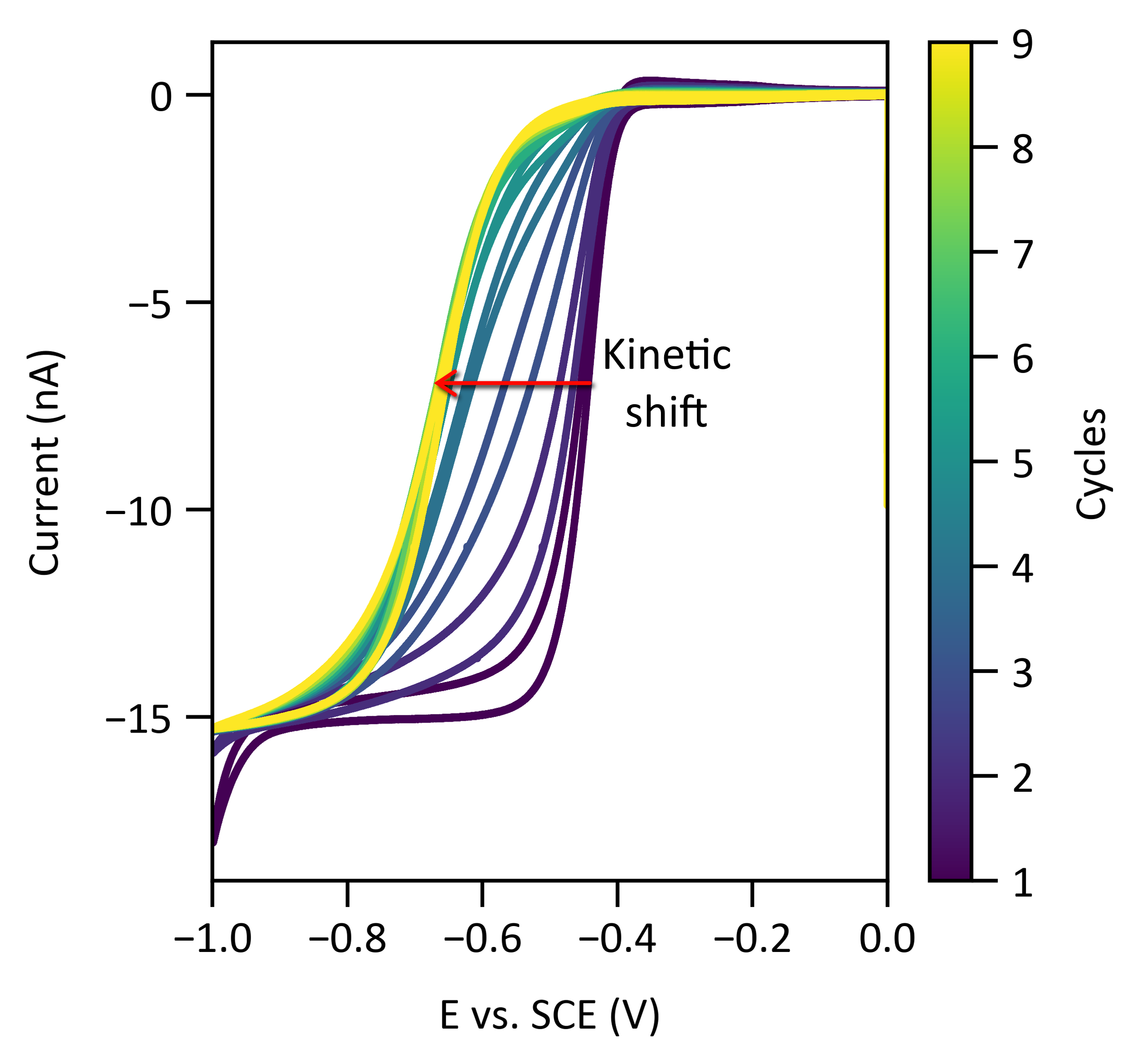
Wider window multiple-cycle cyclic voltammogram at 50 mV/s with open circuit potential for 2 min in between cycles in 1 mM HClO₄. Over multiple cycles, a kinetic shift is observed, as indicated by the red arrow.

Figure S20: SEM image of Pt microelectrode and EDS before and after deactivation.
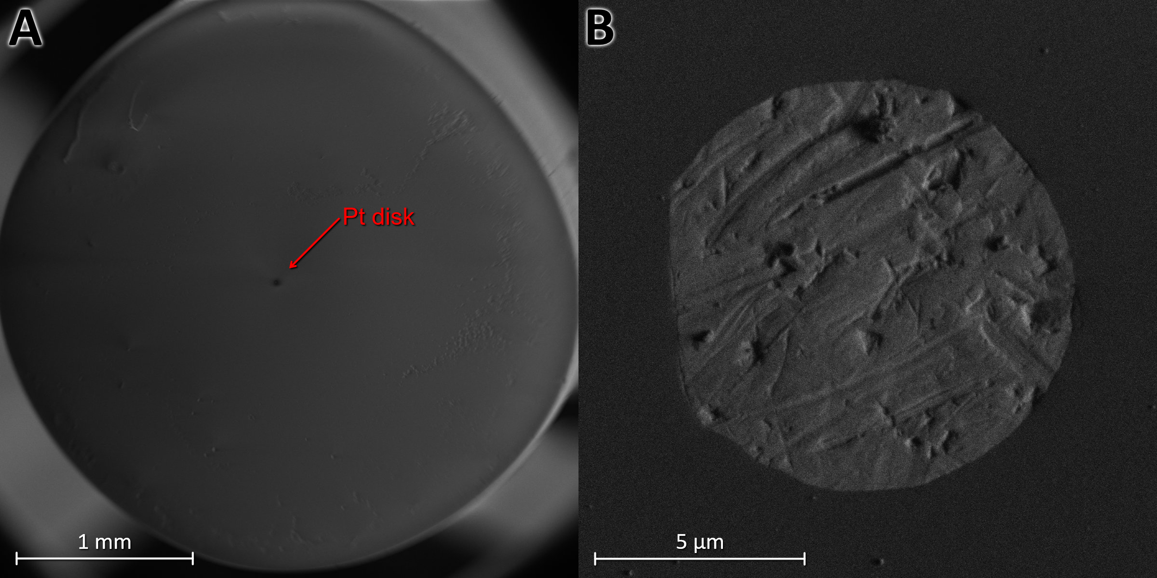
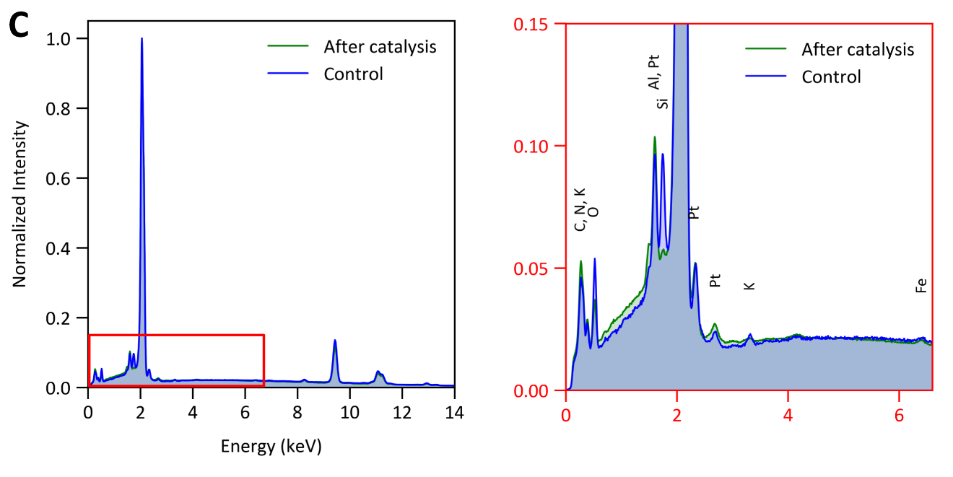
A) SEM image of the Pt microelectrode. B) Zoom in on the rough surface of the Pt disk. C) Energy-dispersive X-ray spectroscopy (EDS) spectra were collected using the SEM, showing no noticeable changes after catalysis and deactivation. The Pt peak at 2.013 keV was normalized to 1 for comparison between the two experiments. Notably, the peak associated with Si in the zoomed-in region was larger before deactivation due to drift during the spectral collection, which originates from the insulating glass surrounding the Pt disk.

Figure S21: Chronoamperogram of 30 nm PtNP nanoimpacts at -0.9 V vs. SCE.
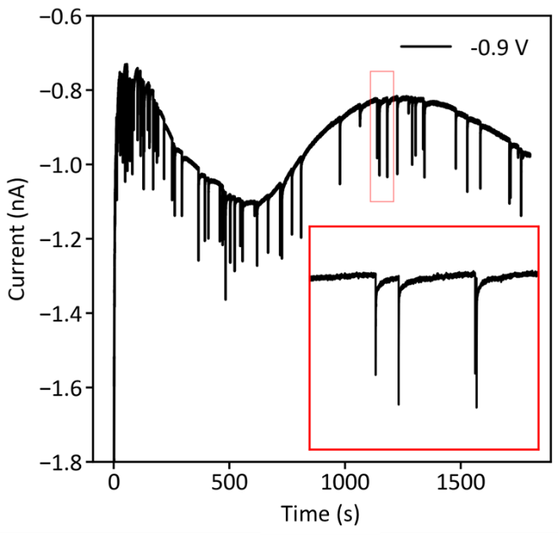
Chronoamperogram of 30 nm PtNPs impacting the carbon fiber microelectrode at -0.9 V vs. SCE, showing spike-decay curves.

Figure S22: Outer-sphere electron transfer is not affected by Pt HER deactivation and CO poisoning.
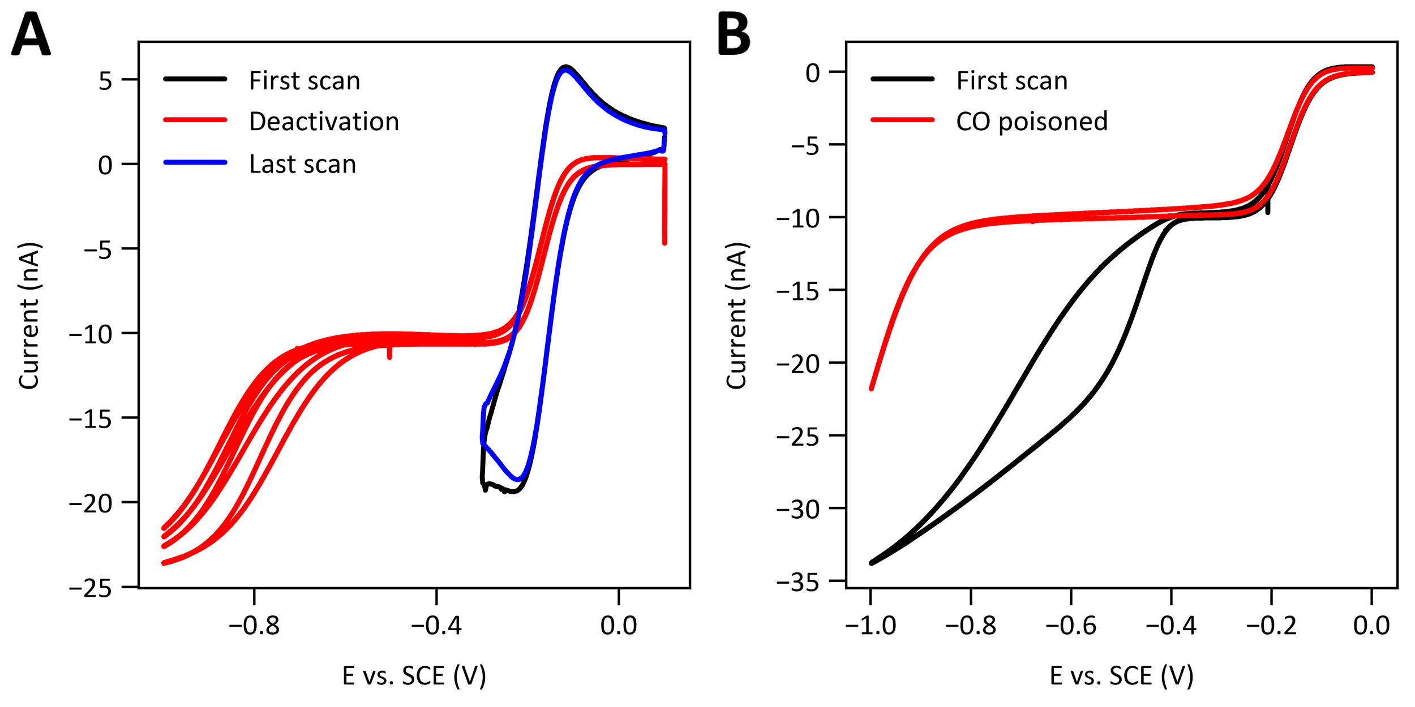
A) A solution of 5 mM hexaammineruthenium(III) chloride (Ruhex) and 1 mM HClO4 was made to investigate the CV response of the Pt microelectrode after deactivation. The first scan (black) was run at 5 V/s to study the electron transfer kinetics after deactivation. The second CV (red) at 50 mV/s was pushed to -1 V vs. SCE with open circuit potential for 2 min (same experiment as Figure S19) to deactivate the Pt microelectrode. The last scan (blue) was repeated at 5V/s, with the peak potential remaining constant and no increased separation. B) The same solution was prepared, and a CV scan at 50 mV/s was performed before saturating the Pt microelectrode with CO gas. Running the CV after poisoning with CO showed a complete shutdown of the HER, but no change in the Ruhex steady-state current.

Figure S23: Platinum microelectrode CV in H₂ environment.
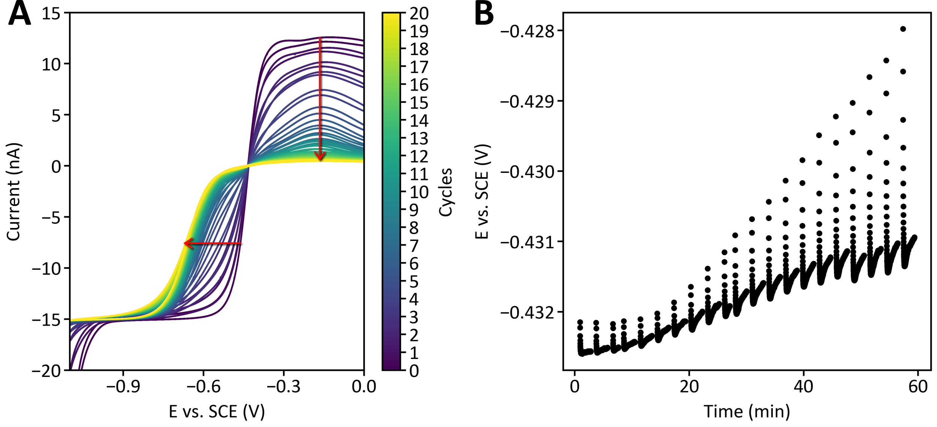
A) Multiple-cycle cyclic voltammogram at 50 mV/s with open circuit potential for 2 min in between cycles in 1 mM HClO₄ and H₂ environment. Over multiple cycles, a kinetic shift occurs for HER, accompanied by the complete deactivation of HOR, as indicated by the red arrows. B) Corresponding open-circuit potential plot showing stability after 2 minutes.

Figure S24: Pt microelectrode LSV stripping after deactivation.
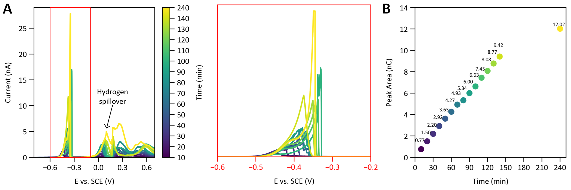
A) A platinum microelectrode was held at -0.8 V vs. SCE for different times, as shown by the color-bar, then a linear sweep (LSV) from -0.8 V to 0.7 V vs. SCE was done to strip any surface-bound species. The red box shows the zoomed-in view of the first stripping peak associated with H₂ bubble oxidation. The stripping peak around 0 V vs. SCE is associated with Hydrogen spillover from the Pt microelectrode.⁸ B) Integrated area of zoomed-in stripping peak of H₂ on the surface vs deactivation/catalysis time.

The theoretical charge for stripping off one monolayer of H_{ads} on a polycrystalline Pt microelectrode (d ≈ 10 μm) with a charge density of 210 μC cm⁻² and a surface coverage of 77% is calculated below.

Charge = (210 μC cm⁻²)(25π x 10⁻⁸ cm²) = 1.64x10⁻⁴ μC = 165 pC

This value is much less than the integrated charge in Figure S26B, providing evidence that this charge is associated with H₂ oxidation from H₂ microbubble formation.

Electrochemical correlative microscopy
Scanning electrochemical cell microscopy (SECCM)
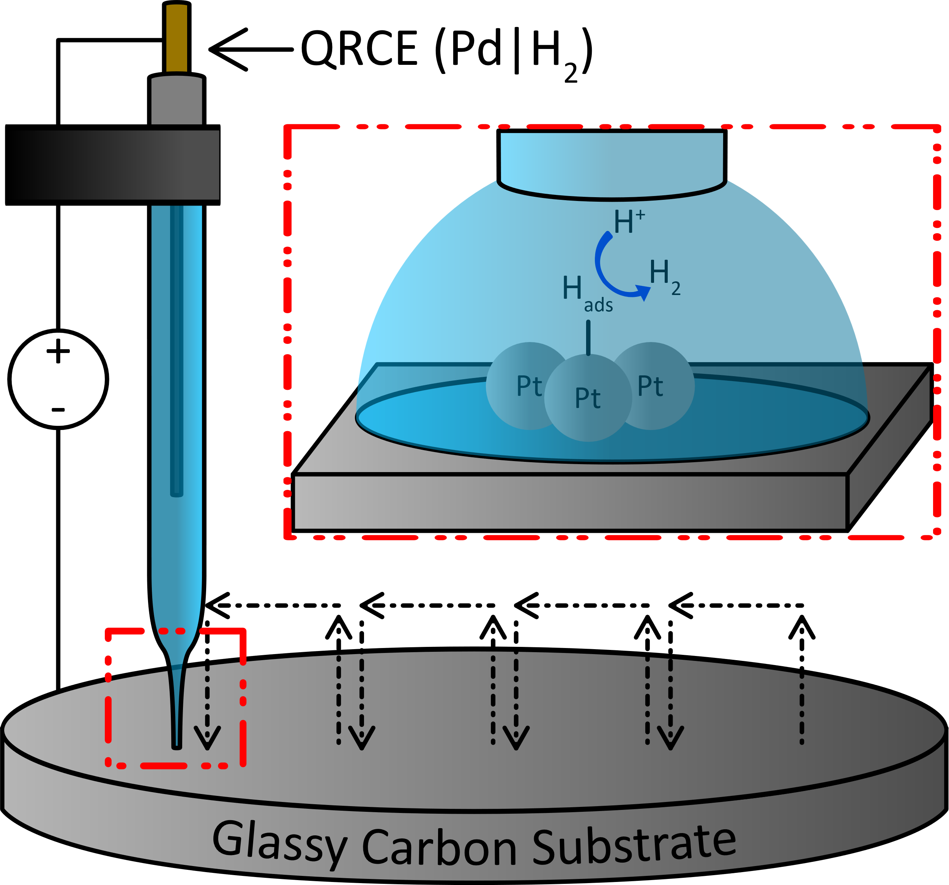

Figure S25: SECCM of PtNPs drop-cast on the glassy carbon substrate.
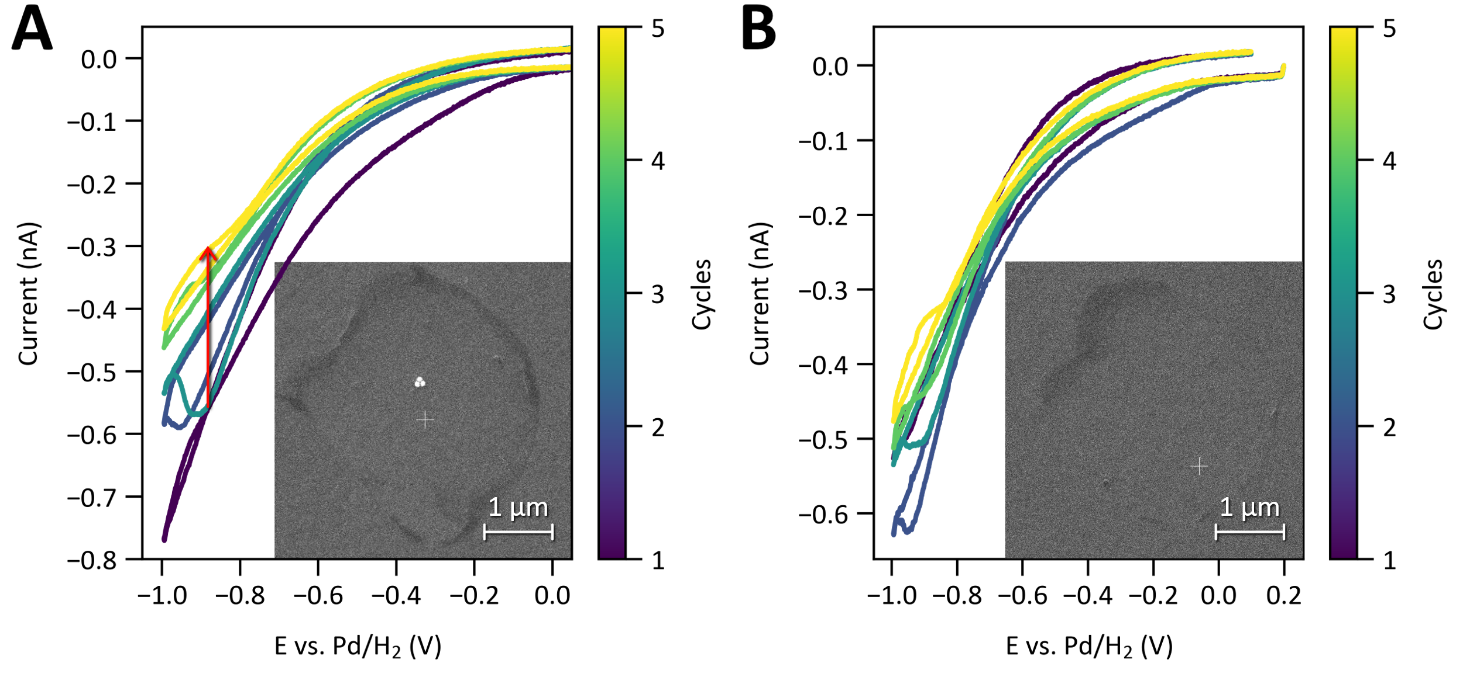
SECCM experiment, where Pt nanoparticles were drop-cast on a glassy carbon substrate and probed using a 2–3 μm micropipette filled with 1 mM HClO₄. The probe contains a Pd/H₂ QRCE, enabling localized voltammetry at the nanoscale. A) A multicycle CV at 1 V/s was collected at a cluster of three PtNPs in the center of the droplet footprint, as shown in the inset of the SEM image. B) A multicycle CV at 1 V/s was collected at a PtNP-free location within the droplet footprint, as shown in the inset of the SEM image.

Schematic of scanning electrochemical cell microscopy on a TEM grid.
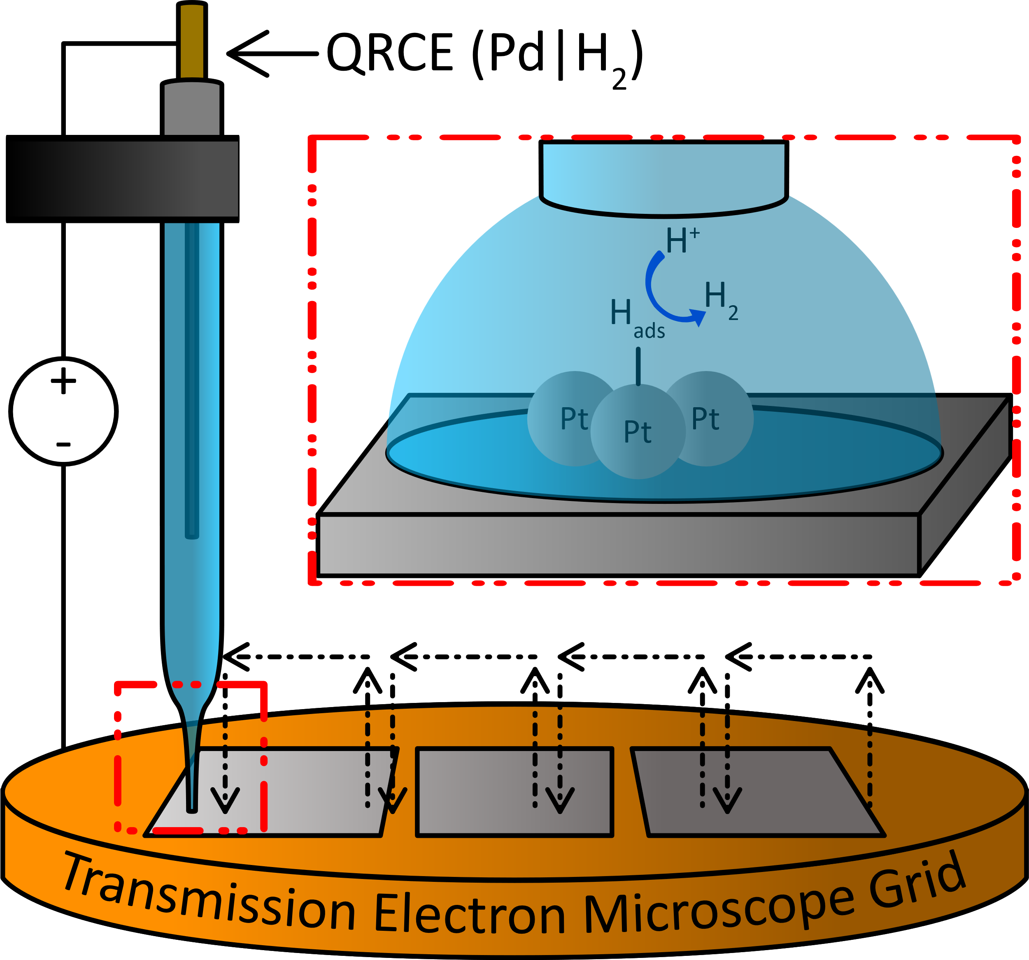

Figure S26: SECCM of 70 nm PtNPs drop-cast on TEM grid.
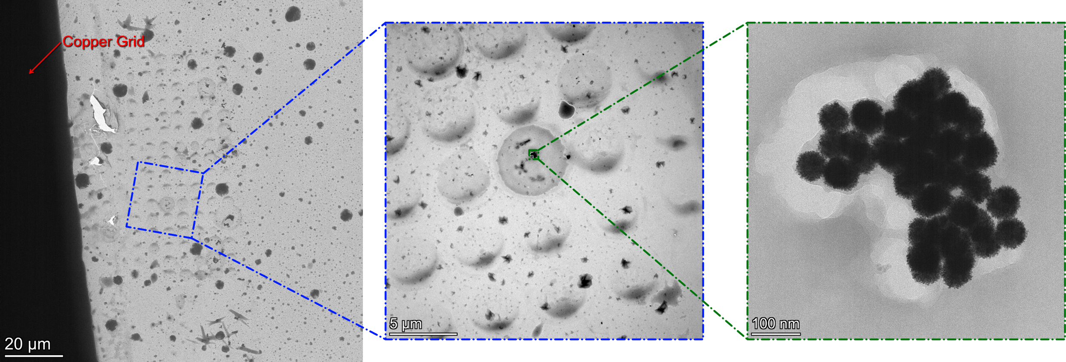
SECCM was performed on a triple-slot copper grid with drop-cast 70 nm PtNP solution. TEM images showed no structural changes after using the SECCM on a TEM grid after catalysis.

Figure S27: EDS of 70 nm Pt nanoparticles before and after catalysis
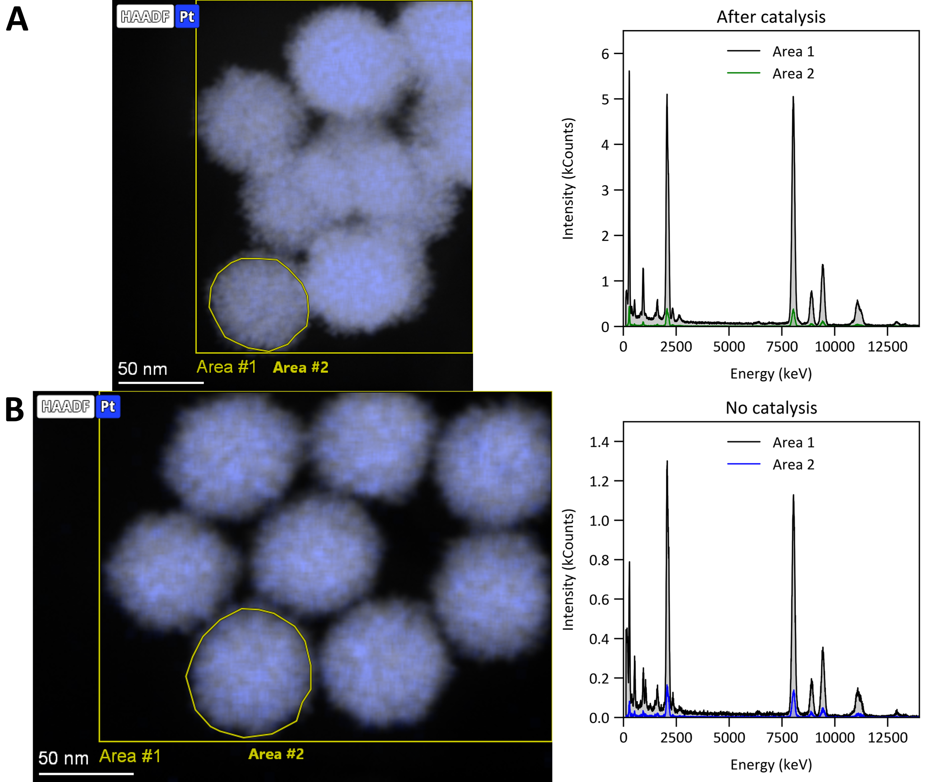
EDS spectra were collected using a TEM in two different locations. A) The EDS spectrum corresponds to the top-left cluster of PtNPs in Figure S28. Two different areas are shown to see the intensity contribution from one PtNP and the whole cluster. B) The stage was relocated to a different position of the TEM grid, away from the SECCM experiment, to collect the control spectra.

Figure S28: EDS of 70 nm Pt nanoparticles comparison.
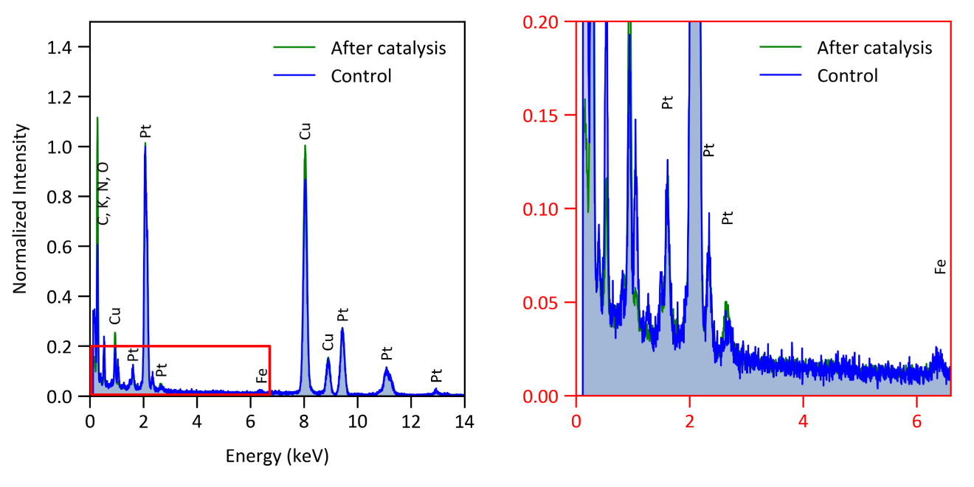
The EDS spectra from Figure S29 was normalized by the Pt peak at 2.013 keV to 1 for comparison between the two experiments. The spectra show no noticeable peak differences after catalysis and deactivation.

References
1. Genc, A., Marlowe, J., Finzel, J. & Christopher, P. AI-Enhanced Nanoparticle Analysis: Integrating Single-Shot Object Detection and Vision Transformer for Rapid and Accurate Characterization. Microscopy and Microanalysis 30, ozae044.196 (2024).
2. Genc, A., Marlowe, J., Jalil, A., Kovarik, L. & Christopher, P. A versatile machine learning workflow for high-throughput analysis of supported metal catalyst particles. Ultramicroscopy 271, 114116 (2025).
3. Sokolov, S. V, Eloul, S., Kätelhön, E., Batchelor-McAuley, C. & Compton, R. G. Electrode–particle impacts: a users guide. Physical Chemistry Chemical Physics 19, 28–43 (2017).
4. Łukaszewski, M., Soszko, M. & Czerwiński, A. Electrochemical methods of real surface area determination of noble metal electrodes–an overview. Int J Electrochem Sci 11, 4442–4469 (2016).
5. Tavares, M. C., Machado, S. A. S. & Mazo, L. H. Study of hydrogen evolution reaction in acid medium on Pt microelectrodes. Electrochim Acta 46, 4359–4369 (2001).
6. Compton, R. G. & Banks, C. E. Understanding Voltammetry. (World Scientific, 2018).
7. Wiberg, G. K. H. & Arenz, M. On the influence of hydronium and hydroxide ion diffusion on the hydrogen and oxygen evolution reactions in aqueous media. Electrochim Acta 158, 13–17 (2015).
8. Dongping, Z., Velmurugan, J. & Mirkin, M. V. Adsorption/desorption of hydrogen on Pt nanoelectrodes: Evidence of surface diffusion and spillover. J Am Chem Soc 131, 14756–14760 (2009).

