Extended data figures and tables
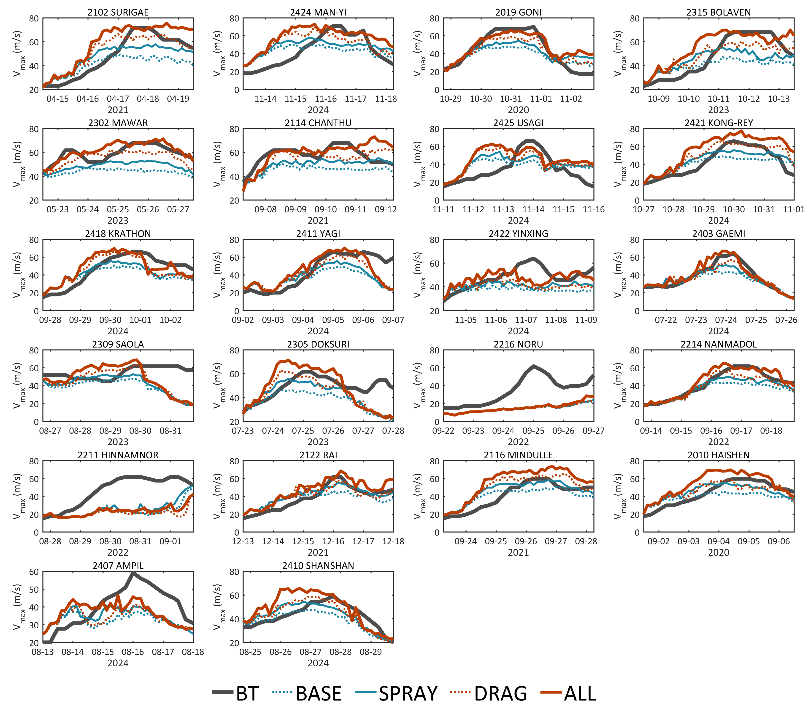
Extended Data Fig.1 | Time series of the maximum wind speeds at 10 m above the sea surface for the 22 TCs. Forecasts started 72-hour before the TCs reached their peak intensities. Black lines show the results of the best track observations. Dashed blue, dashed red, solid blue, and solid red lines show reforecasts with BASE, DRAG, SPRAY, and ALL configurations, respectively.

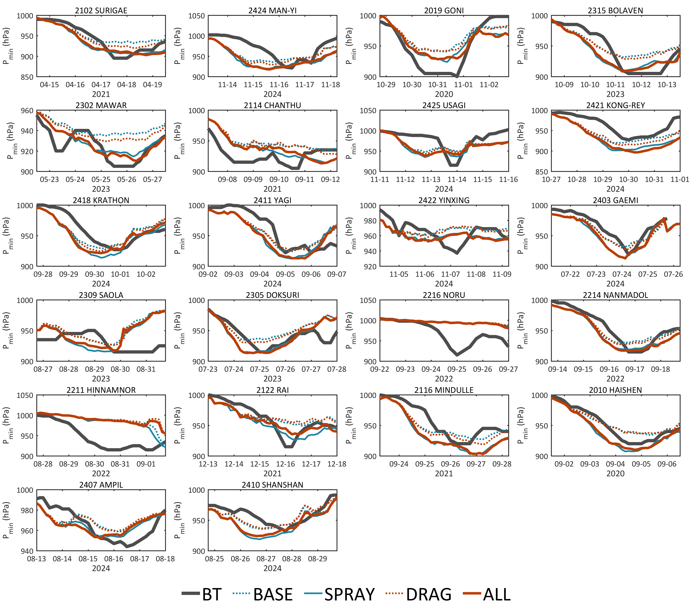
Extended Data Fig.2 | Time series of the minimum central pressure at the sea surface for the 22 TCs. Forecasts started 72-hour before the TCs reached their peak intensities. Black lines show the results of the best track observations. Dashed blue, dashed red, solid blue, and solid red lines show reforecasts with BASE, DRAG, SPRAY, and ALL configurations, respectively.

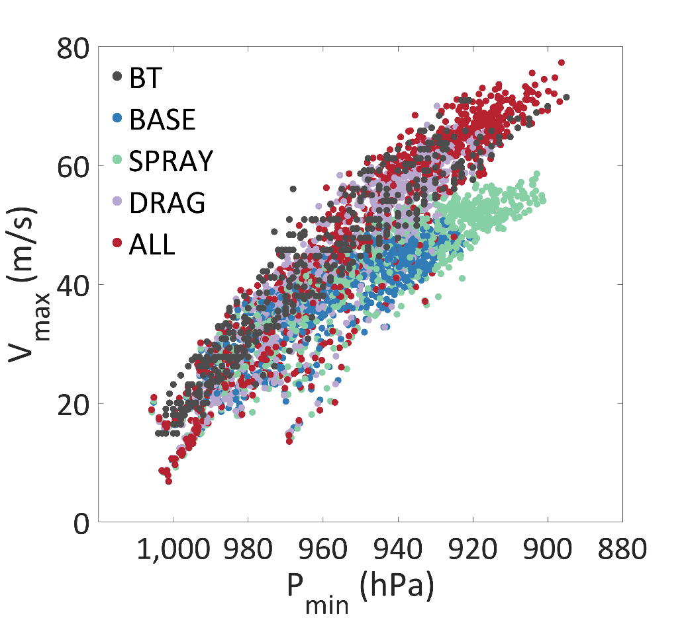
Extended Data Fig.3 | Wind-pressure relationship. Relationship between maximum 10 m wind speed and minimum surface central pressure for 22 TCs.

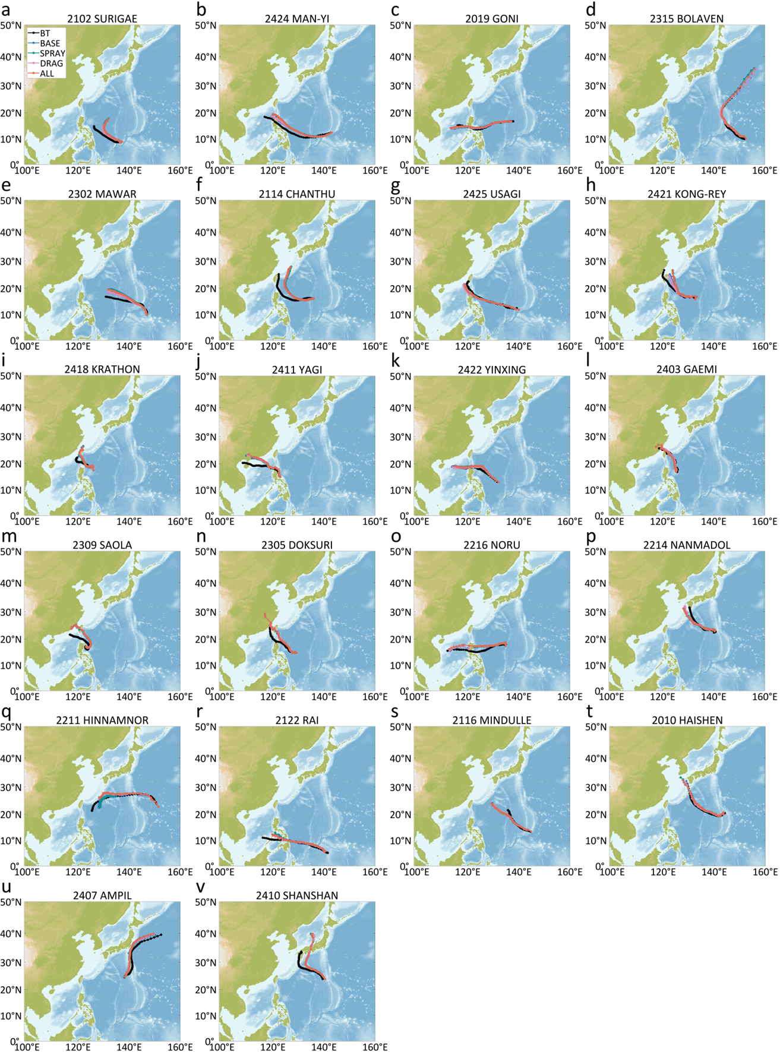
Extended Data Fig.4 | TCs tracks within 120 hours. Forecasts started 72-hour before the TCs reached their peak intensities.

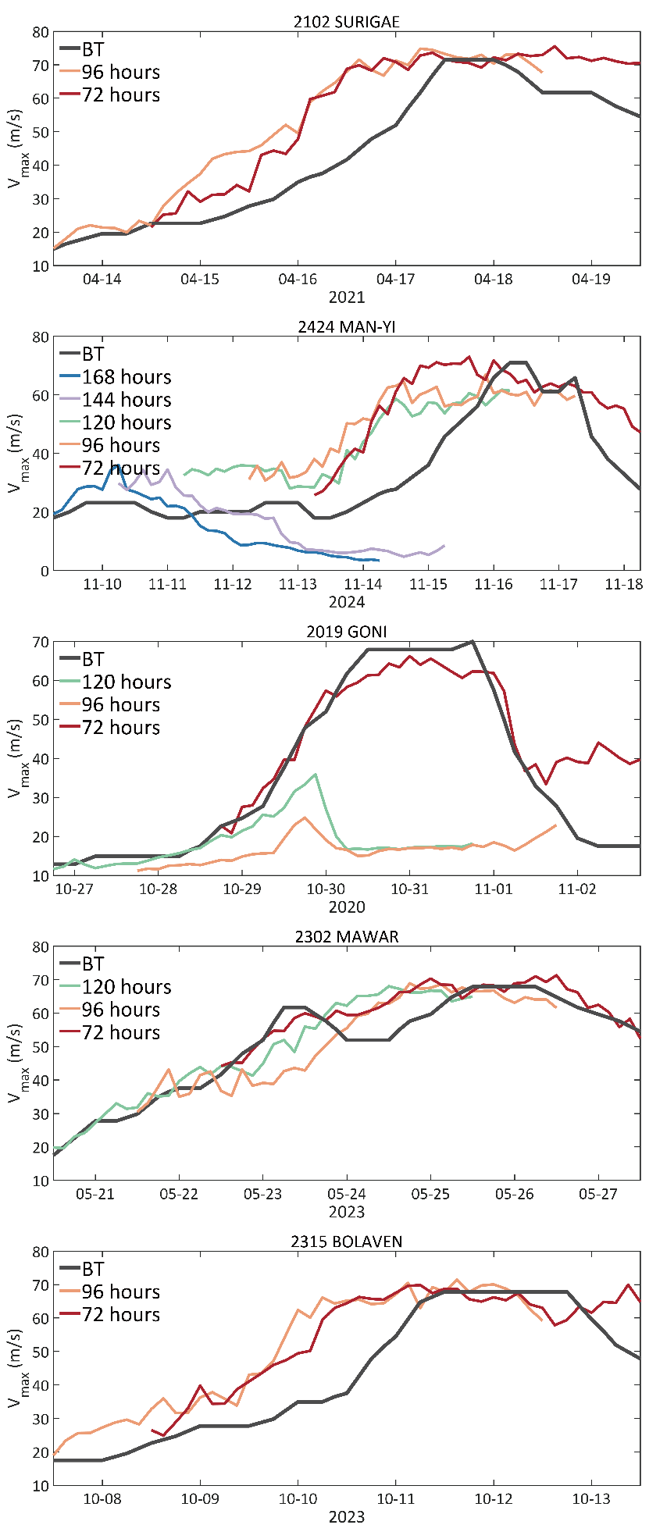
Extended Data Fig.5 | Time series of maximum wind speed at 10 m above the sea surface with different lead-time for the 5 strongest TCs during 2020-2024.
Extended Data Table 1 | Information about the strongest 22 TCs in the Northwest Pacific during 2020-2024
Number | Name | Peak intensity Date | Peak intensity | Classification
1 | 2102 SURIGAE | 2021-04-17 12:00 | 139 knots | CAT-5
2 | 2424 MAN-YI | 2024-11-16 06:00 | 138 knots | CAT-5
3 | 2019 GONI | 2020-10-31 18:00 | 136 knots | CAT-4
4 | 2315 BOLAVEN | 2023-10-11 12:00 | 132 knots | CAT-4
5 | 2303 MAWAR | 2023-05-25 12:00 | 132 knots | CAT-4
6 | 2114 CHANTHU | 2021-09-10 06:00 | 132 knots | CAT-4
7 | 2425 USAGI | 2024-11-13 18:00 | 128 knots | CAT-4
8 | 2421 KONG-REY | 2024-10-30 00:00 | 128 knots | CAT-4
9 | 2418 KRATHON | 2024-09-30 18:00 | 128 knots | CAT-4
10 | 2411 YAGI | 2024-09-05 00:00 | 128 knots | CAT-4
11 | 2422 YINXING | 2024-11-07 06:00 | 124 knots | CAT-4
12 | 2403 GAEMI | 2024-07-24 06:00 | 124 knots | CAT-4
13 | 2309 SAOLA | 2023-08-29 18:00 | 120 knots | CAT-4
14 | 2305 DOKSURI | 2023-07-25 00:00 | 120 knots | CAT-4
15 | 2216 NORU | 2022-09-25 00:00 | 120 knots | CAT-4
16 | 2214 NANMADOL | 2022-09-16 18:00 | 120 knots | CAT-4
17 | 2211 HINNAMNOR | 2022-08-30 12:00 | 120 knots | CAT-4
18 | 2122 RAI | 2021-12-16 00:00 | 120 knots | CAT-4
19 | 2116 MINDULLE | 2021-09-26 06:00 | 116 knots | CAT-4
20 | 2010 HAISHEN | 2020-09-04 12:00 | 116 knots | CAT-4
21 | 2407 AMPIL | 2024-08-16 00:00 | 115 knots | CAT-4
22 | 2410 SHANSHAN | 2024-08-27 18:00 | 115 knots | CAT-4

Extended Data Table 2 | Reforecast errors of peak intensity, RI and track for all the 22 strongest TCs with different configurations
Configurations | BASE | SPRAY | DRAG | ALL
$V_{max}$ (ms^{–1}) | –18.4±6.0 | –12.1±7.2 | –6.4±9.3 | 0.7±10.9
$P_{min}$ (hPa) | 20.4±16.9 | 4.0±19.3 | 18.7±18.1 | 6.3±20.5
$∆V_{24}$ (ms^{–1}) | –9.3±6.1 | –6.5±6.6 | –2.2±7.8 | 2.3±8.5
72-hour track errors (km) | 101.4±43.1 | 101.7±41.9 | 102.6±41.6 | 103.4±41.8

Extended Data Table 3 | Reforecast mean absolute errors of peak intensity and RI for all the 22 strong TCs with different configurations
Configurations | BASE | SPRAY | DRAG | ALL
$V_{max}$ (ms^{–1}) | 18.4 | 12.1 | 7.3 | 8.0
$P_{min}$ (hPa) | 21.1 | 13.3 | 20.2 | 14.6
$∆V_{24}$ (ms^{–1}) | 9.3 | 7.0 | 5.5 | 6.7

Extended Data Table 4 | Surface wave related processes in different configurations.
Configurations | BASE | SPRAY | DRAG | ALL
Sea spray enthalpy flux | × | √ | × | √
Air-sea momentum flux correction | × | × | √ | √
Surface wave-induced vertical mixing | √ | √ | √ | √

