Supplementary Tables
Supp. Table 1. List of 176 targets included in mNGS assay and their associated category (see Excel file).
Supp. Table 2. Reference and discrepancy testing of clinical samples by DHM and Microba.
 | Seegene PCR Assay
 | GI-Bacteria (I) | GI-Bacteria (II) | H. pylori | GI-Helminth | GI-Parasite | GI-Virus | MCS | MALDI-TOF | Antigen
DHM | 480 | 0 | 0 | 0 | 0 | 162 | 468 | 468 | 136
Microba | 476 | 468 | 51 | 47 | 470 | 55 | 0 | 0 | 0

Supp. Table 3. mNGS species or target names comprising comparison reference targets along with Seegene PCR assays and C_{t} thresholds.
Reference Target | Seegene PCR Assay | C_{t} threshold | mNGS Assay Equivalent Targets
Aeromonas spp. | GI-Bacteria (I) | ≤45 | A. caviae, A. dhakensis, A. hydrophila, A. veronii
Campylobacter spp. | GI-Bacteria (I) | ≤45 | C. coli, C. jejuni
Edwardsiella tarda | - | - | E. tarda
Helicobacter pylori | H. pylori & ClariR | ≤50 | H. pylori
Plesiomonas shigelloides | - | - | P. shigelloides
Salmonella spp. | GI-Bacteria (I) | ≤45 | S. bongori, S. enterica
Vibrio spp. | GI-Bacteria (I) | ≤45 | V. cholerae, V. parahaemolyticus, V. vulnificus
Yersinia enterocolitica | GI-Bacteria (I) | ≤45 | Y. enterocolitica
Cryptosporidium spp. | GI-Parasite | ≤43 | C. felis, C. meleagridis, C. muris, C. ubiquitum, C. viatorum, C. hominis/parvum/cuniculus/tyzzeri complex
Cyclospora cayetanensis | GI-Parasite | ≤43 | C. cayetanensis
Entamoeba histolytica | GI-Parasite | ≤43 | E. histolytica
Enterobius vermicularis | GI-Helminth (I) | ≤45 | E. vermicularis
Giardia lamblia | GI-Parasite | ≤43 | G. intestinalis
Strongyloides stercoralis | GI-Helminth (I) | ≤45 | S. stercoralis
Taenia spp. | GI-Helminth (I) | ≤45 | T. saginata, T. solium
C. difficile Toxin B | GI-Bacteria (I) | ≤45 | C. difficile toxin A/B
EAEC virulence factors | GI-Bacteria (II) | ≤43 | EAEC virulence factors
Shigella spp. / EIEC virulence factors | GI-Bacteria (I) | ≤45 | EIEC invasion plasmid antigen
EPEC virulence factors | GI-Bacteria (II) | ≤43 | EPEC virulence factors
ETEC heat labile/stable toxins | GI-Bacteria (II) | ≤43 | ETEC heat labile and heat stable toxins
STEC Shiga toxin | GI-Bacteria (II) | ≤43 | STEC Shiga toxin
Adenovirus F | GI-Virus | ≤40 | Adenovirus F (serotype 40/41)

Supp. Table 4. Number of samples with conventional test results for each clinical target.
Target Name | Target Type | No. Samples
Aeromonas spp. | Bacterial | 497
Campylobacter spp. | Bacterial | 497
Cryptosporidium spp. | Eukaryotic | 490
Cyclospora cayetanensis | Eukaryotic | 496
Edwardsiella tarda | Bacterial | 468
Entamoeba histolytica | Eukaryotic | 497
Enterobius vermicularis | Eukaryotic | 468
Giardia intestinalis | Eukaryotic | 497
Helicobacter pylori | Bacterial | 61
Plesiomonas shigelloides | Bacterial | 464
Salmonella spp. | Bacterial | 497
Strongyloides stercoralis | Eukaryotic | 468
Taenia spp. | Eukaryotic | 468
Vibrio spp. | Bacterial | 497
Yersinia enterocolitica | Bacterial | 497
Adenovirus F (serotype 40/41) | Viral | 193
C. difficile Toxin B | Virulence Factor | 497
EAEC virulence factors | Virulence Factor | 468
EIEC virulence factors | Virulence Factor | 497
EPEC virulence factors | Virulence Factor | 468
ETEC heat labile/stable toxins | Virulence Factor | 468
STEC Shiga toxin | Virulence Factor | 468

Supp. Table 5. Simulated faecal spike-in samples were generated for increasing numbers of read pairs. Pathogen targets were generated at a fixed number of read pairs whereas read pairs for gene targets were generated to achieve a fixed depth of coverage. Estimated biomass is given for a faecal sample with 6.23 x 10¹⁰ equ. orgs/g faeces assuming 3.9 Mb organisms and 1000 bp genes. Numbers in parentheses indicate the percentage of reads from a target in a standard mNGS assay sample of 16 million read pairs and considering length for the gene targets.
Depth | Pathogen Target | Pathogen Biomass  (equ. orgs/g) | Gene Target | Gene Biomass  (equ. orgs/g)
Ultra-low | 16 (0.0001) | 6.23×10⁴ | 0.5 (6.25×10⁻⁶ to 8.75×10⁻⁵; mean = 1.16×10⁻⁵) | 1.52×10⁷ to 2.13×10⁸
Low | 160 (0.001) | 6.23×10⁵ | 1.0 (6.25×10⁻⁶ to 1.69×10⁻⁴; mean = 2.11×10⁻⁵) | 1.52×10⁷ to 4.11×10⁸
Medium | 1,600 (0.01) | 6.23×10⁶ | 2.5 (1.25×10⁻⁵ to 4.25×10⁻⁴; mean = 5.75×10⁻⁵) | 3.04×10⁷ to 1.03×10⁹
High | 16,000 (0.1) | 6.23×10⁷ | 5.0 (2.50×10⁻⁵ to 8.50×10⁻⁴; mean = 1.16×10⁻⁴) | 6.07×10⁷ to 2.07×10⁹

Supp. Table 6. Targets identified by mNGS assay in faecal samples used to generate simulated communities with spiked-in targets.
Sample ID | Targets Identified by mNGS Assay
BBW5020 | Campylobacter concisus
BBW5021 | Clostridium perfringens
BBW5022 | blaACT, blaCMY_Group2, blaSHV, Salmonella enterica, Campylobacter concisus

Supp. Table 7. List of mNGS assay targets in each of the 22 groups used to generate in silico faecal spike-in samples (see Excel file).

Supp. Table 8. Diagnostic test results for each of the 510 DHM clinical samples (see Excel file).

Supp. Table 9. Outcome of mNGS assay for each target in the DHM data set.
Bacteria | TP | FP | TN | FN | Prevalence (%)
Aeromonas spp. | 30 | 2 | 450 | 15 | 9.05
Campylobacter spp. | 41 | 1 | 451 | 4 | 9.05
Edwardsiella tarda | 3 | 0 | 465 | 0 | 0.64
Helicobacter pylori | 1 | 0 | 40 | 20 | 34.43
Plesiomonas shigelloides | 23 | 0 | 441 | 0 | 4.96
Salmonella spp. | 31 | 1 | 456 | 9 | 8.05
Vibrio spp. | 16 | 2 | 474 | 5 | 4.23
Yersinia enterocolitica | 30 | 1 | 463 | 3 | 6.64
Total | 175 | 7 | 3240 | 56

Eukaryotes | TP | FP | TN | FN | Prevalence (%)
Cryptosporidium spp. | 36 | 2 | 452 | 0 | 7.35
Cyclospora cayetanensis | 16 | 0 | 480 | 0 | 3.23
Entamoeba histolytica | 2 | 0 | 492 | 3 | 1.01
Enterobius vermicularis | 9 | 0 | 459 | 0 | 1.92
Giardia intestinalis | 26 | 0 | 466 | 5 | 6.24
Strongyloides stercoralis | 1 | 0 | 467 | 0 | 0.21
Taenia spp. | 1 | 0 | 467 | 0 | 0.21
Total | 91 | 2 | 3283 | 8

Viruses | TP | FP | TN | FN | Prevalence (%)
Adenovirus F (serotype 40/41) | 41 | 4 | 120 | 28 | 35.75

Virulence factors | TP | FP | TN | FN | Prevalence (%)
C. difficile toxin A/B | 34 | 0 | 444 | 19 | 10.66
EAEC virulence factors | 56 | 1 | 393 | 18 | 15.81
EIEC virulence factors | 38 | 0 | 434 | 25 | 12.68
EPEC virulence factors | 29 | 0 | 372 | 67 | 20.51
ETEC heat labile/stable toxins | 16 | 0 | 440 | 12 | 5.98
STEC Shiga toxin | 1 | 0 | 466 | 1 | 0.43
Total | 174 | 1 | 2549 | 142

All targets | TP | FP | TN | FN
Total | 481 | 14 | 9192 | 234

Supp. Table 10. Additional targets identified by the mNGS assay compared to current standard-of-care diagnostic testing performed by DHM (see Excel file).
Supp. Table 11. Performance of the mNGS assay compared to PCR reference testing (see Excel file).
Supp. Table 12. Sensitivity of mNGS assay on samples with Seegene PCR results stratified by C_{t} values greater or less than 35 (see Excel file).
Supp. Table 13. Reproducibility of mNGS targets across biological replicates (see Excel file).
Supp. Table 14. Performance of each target in the mNGS assay on the in silico faecal spike-in samples (see Excel file).
Supp. Table 15. Exploration of FP predictions for the in silico faecal samples (see Excel file).

Supplementary Figures
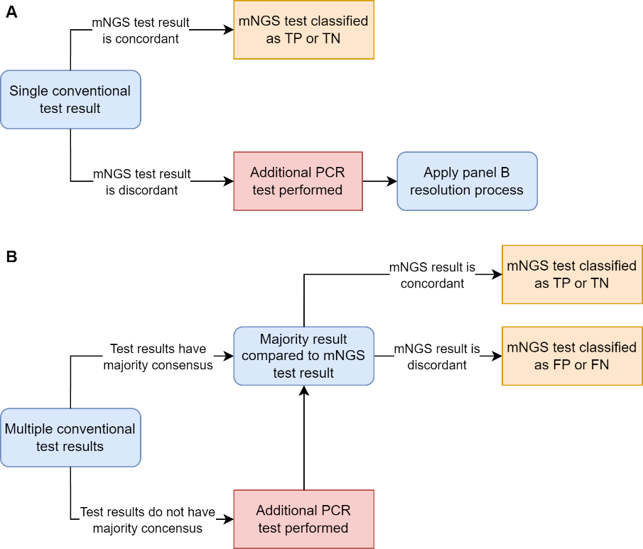
Supp. Figure 1. Decision trees for resolving discordant conventional and mNGS assay test results. Samples with a single conventional test result are either i) concordant with the mNGS assay and classified as a TP or TN, ii) discordant with the mNGS assay and subjected to an additional independent PCR test (Supp. Figure 1A). A majority vote (>50% consensus) was used to establish the expected result for samples provided with multiple conventional test results or where a single discordant test result prompted application of an additional independent PCR test (B). Samples where conventional tests had a majority result were used to evaluate the mNGS assay, whereas samples without a majority result (i.e. equal number of conventional tests indicating the absence or presence of a target) were subjected to additional PCR testing in order to establish a consensus point of truth.

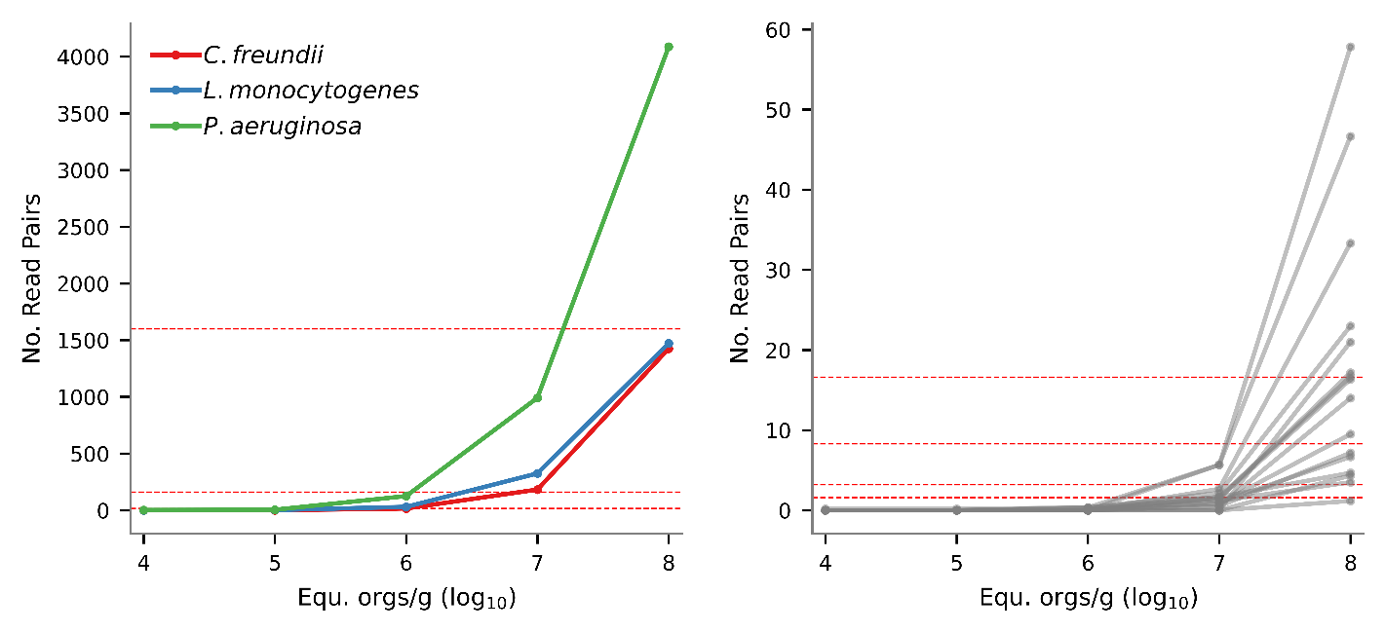
Supp. Figure 2. Number of identified reads for mNGS targets with increasing concentration in a standard faecal sample for pathogen (A) and gene (B) targets. For pathogen targets, the red dotted lines indicate the ultra-low (16 read pairs), low (160 read pairs), and medium (1,600 read pairs) read depths used for the in silico samples. Identification of pathogen targets required 10⁵ to 10⁶ equ. orgs/g faeces where the number of identified reads fall between the ultra-low and low read depths. For gene targets, the red dotted lines indicate the ultra-low (0.5x coverage; 1.6 read pairs), low (1x coverage; 3.2 read pairs), medium (2.5x coverage; 8.3 read pairs), and high (5x coverage; 16.6 read pairs) read depths used for the in silico samples assuming an average gene length of 1,000 bp. Robust identification of gene targets required ≥10⁸ equ. orgs/g faeces where the majority of targets are at or above the low in silico read depth.

Supplementary Notes
Supp. Note 1. Simulated samples were used to determine the limit of detection of the mNGS assay by spiking in isolate cells at decreasing equ. orgs/g faeces into a homologous faecal matrix (see Analytical Performance on Simulated Samples). The faecal matrix was determined to have a biomass of 4.19 to 8.67 x 10¹⁰ equ. orgs/g in a faecal sample. Sensitivity reached 100% for all mNGS assay target pathogens at 10⁶ equ. orgs/g (Table 2). This corresponds to a relative abundance of 0.00115% (100% x 10⁶ / 8.67 x 10¹⁰) to 0.00239% (100% x 10⁶ / 4.19 x 10¹⁰). For an mNGS assay operating at 16 million read pairs this corresponds to 184 to 382 read pairs from each species, assuming a genome size equal to the mean genome size of all organisms in the sample. The low depth in silico faecal samples were set at 160 read pairs (0.001% relative read abundance) to correspond with the expected limit of detection of a target requiring approximately 10⁶ equ. orgs/g (Supp. Table 5). Similarly, ultra-low depth was set at 16 read pairs (0.0001% relative read abundance) to simulate targets detectable at 10⁵ equ. orgs/g.
AMR and VF genes are ~1,000 bp and thus expected to have an mNGS assay limit of detection that is 3900 time lower than for a bacterial pathogen (3.9 Mb / 1000 bp). This is 3 orders of magnitude smaller which is in good agreement with the analytical results where bacterial pathogens have 100% sensitivity at 10⁶ equ. orgs/g and only a subset of AMR and VF genes reach 100% sensitivity at 10⁸ equ. orgs/g (i.e. indicating 10⁹ equ. orgs/g or greater is required before all gene targets reach 100% sensitivity). Read pairs from AMR and VF gene targets were simulated to achieve a fixed depth of coverage between 0.5x and 2.0x as this corresponds to an expected biomass between 1.52 x 10⁷ to 2.07 x 10⁹ equ. orgs/g (Supp. Table 5) which is around the limit of detection established for AMR and VF genes using simulated samples.

Supp. Note 2. The mNGS assay demonstrates excellent specificity and PPV across all targets as a result of few FP predictions. The limited number of FPs that occurred were investigated to establish factors resulting in incorrect predictions (126 FPs compared to 8,558 TPs and 126,635 TNs; Supp. Table 14). Notably, FP predictions only occurred for 9 of 176 (5.1%) targets. The only two pathogens to result in FPs were Helicobacter cinaedi and H. fennelliae and these were the results of the in silico samples containing the other Helicobacter species (i.e. Helicobacter cinaedi being identified in samples with H. fennelliae, and vice versa). There were 3 AMR, 1 VF, and 3 VF with host targets resulting in FPs. Similar, to the Helicobacter FPs, the FP for CTX-M-G8 is the result of the in silico sample contain the closely related genes CTX-M-G1 and CTX-M-G9. The cause of the other FP AMR and VF gene predictions is less clear though may be the result of interaction with DNA in the faecal background or other targets spiked into the sample (e.g. identification of the Shiga toxin in a sample that contains stx1A as a spike in and identified to contain a Shigella/E. coli species in the faecal background).

