Supplementary Figures
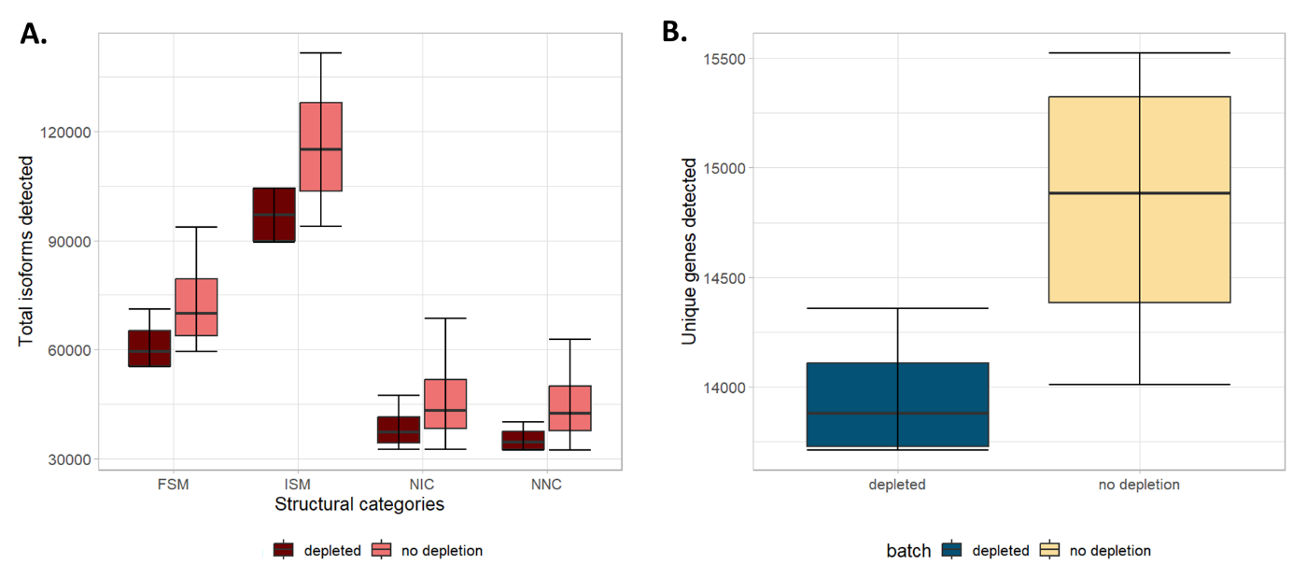
Supplementary figure 1. Detection of isoform diversity in goblin depleted (n=4) vs undepleted (n=4) samples. A. Total number of isoforms detected across four different structural categories. FSM: Full splice match; ISM: Incomplete splice match; NIC: Novel in catalogue; NNC: Novel not in catalogue. B. Number of unique genes detected in depleted samples vs undepleted. These only include full splice and incomplete splice matches. The depleted and undepleted samples are biological replicates.
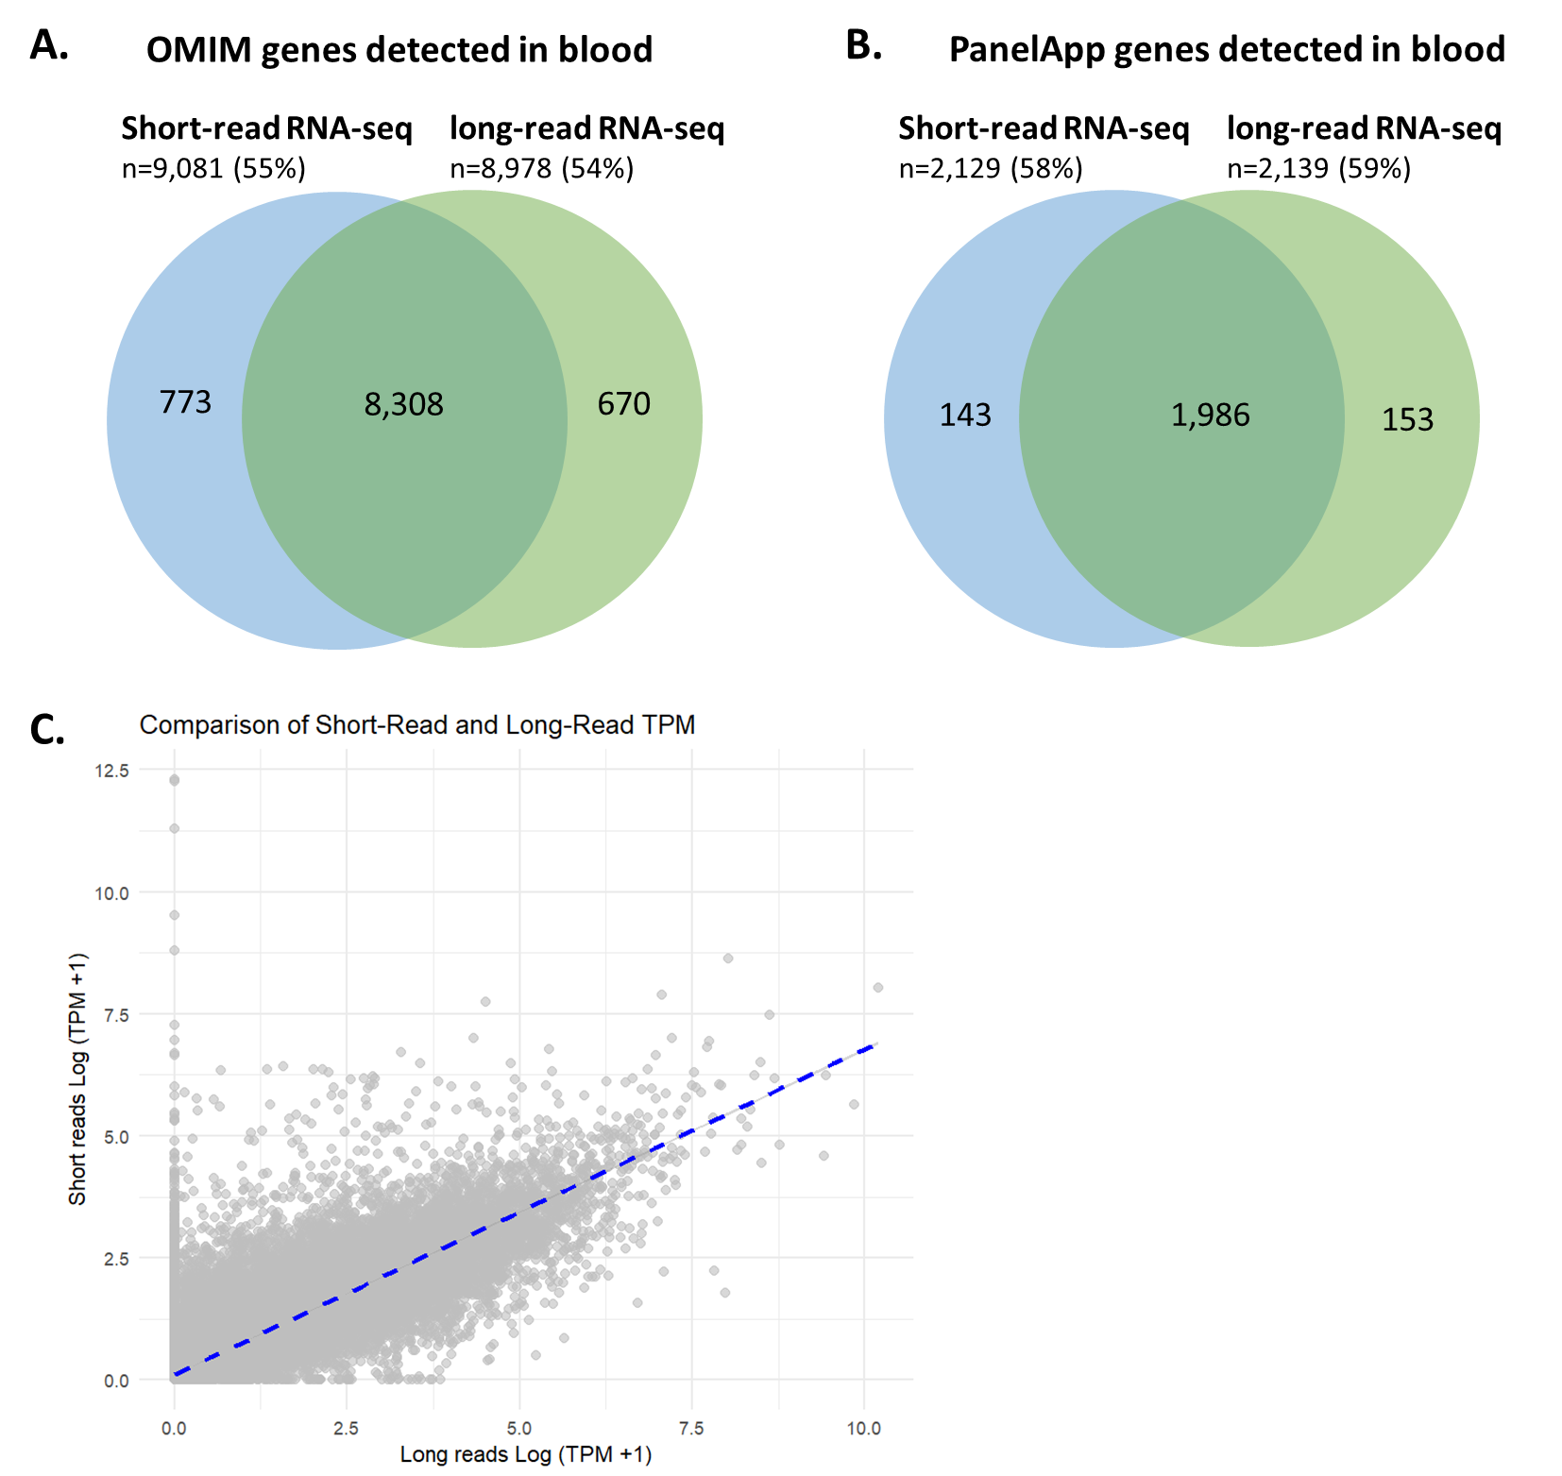
Supplementary figure 2. Gene detection rate in short versus long read RNA-seq in blood. A. Overlap of OMIM genes detected in short read RNA-seq (n =88) versus long read RNA-seq (n=4). B. Overlap of PanelApp genes detected in short read RNA-seq (n=88) versus long read RNA-seq (n=4). C. Correlation of transcripts per million (TPM) in long versus short read RNA-seq.
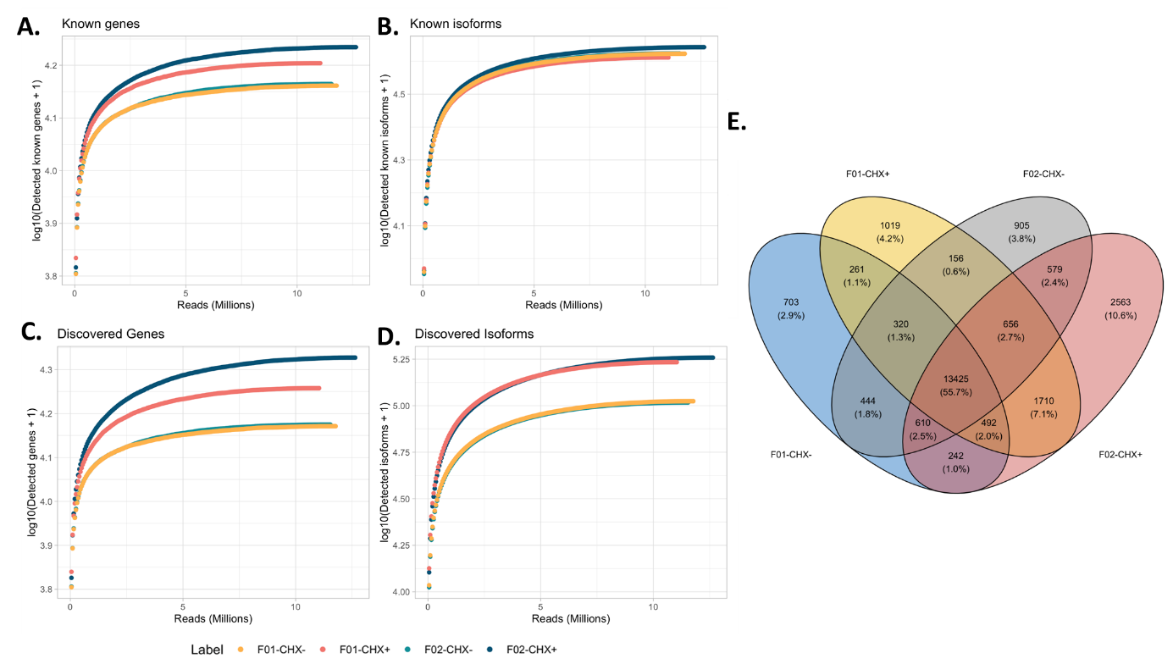
Supplementary figure 3. Gene and isoform detection rates in fibroblast cell lines. A-B. Saturation curves showing the number of detected genes and transcripts present in the annotation catalogue in the fibroblast cell lines at different numbers of down sampled sequencing reads. C-D. Saturation curves for genes and transcripts estimated from sequencing data by Iso-Seq pigeon at different numbers of down sampled sequencing reads. E. Venn diagram showing the overlap in expressed genes across the fibroblast lines. F01, F02 represent the two fibroblast lines; CHX- specifies lines not treated with cycloheximide, while CHX+ indicates cycloheximide-treated lines.

