Emergence and spread of Japanese encephalitis virus genotype IV in a novel ecosystem
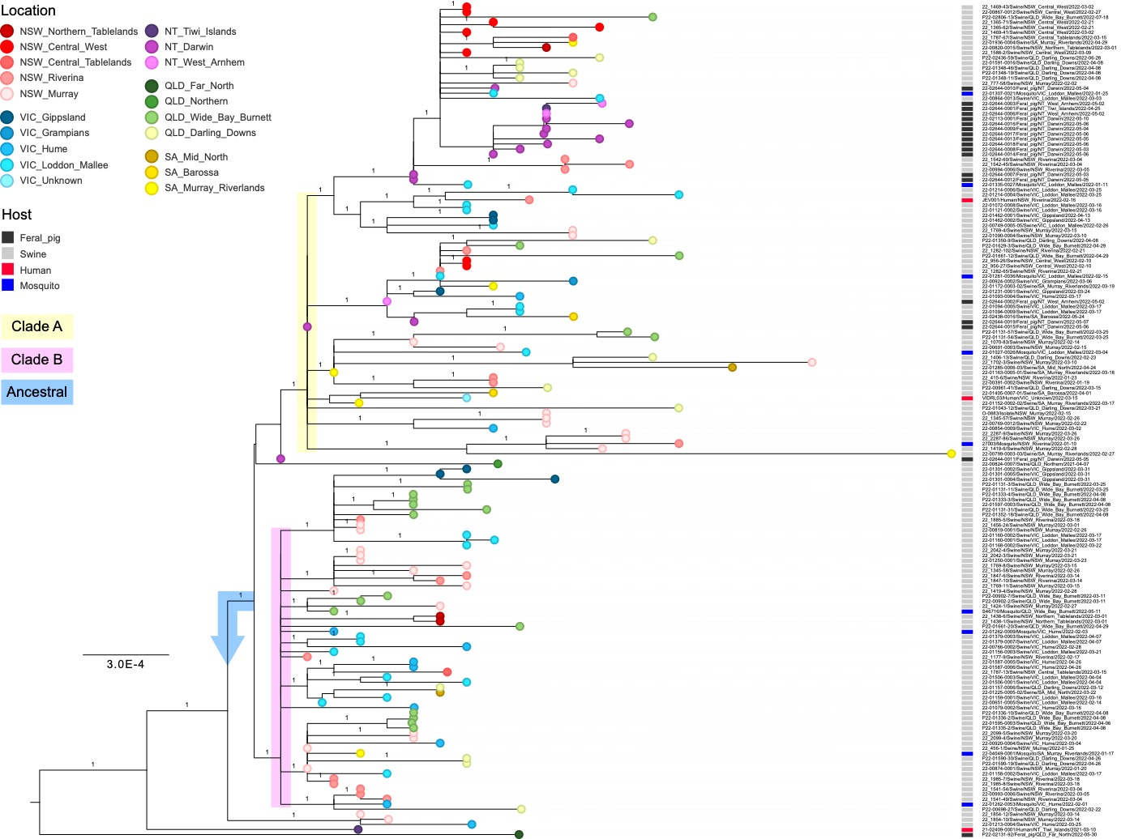

Supplementary Figure 1 – Maximum likelihood genome phylogeny of GIV Australia 2021-22 lineage. Full length genomes from the Australian JEV GIV outbreak were aligned before a phylogenetic tree was estimated using PhyML. The phylogeny was rooted using the Indonesian strain JEV/Swine/Bali-93/2017 (GenBank accession number LC461961). Colored circles at tips indicate the sampling location with colored boxes next to sequence labels show host species as per the legends provided. The two major clades A & B have been highlighted, as well as the putative ancestral group that sit in basal positions. The scale bar is proportional to the number of substitutions per site. Shimodaira–Hasegawa approximate likelihood-based measures of branch support are provided at nodes.

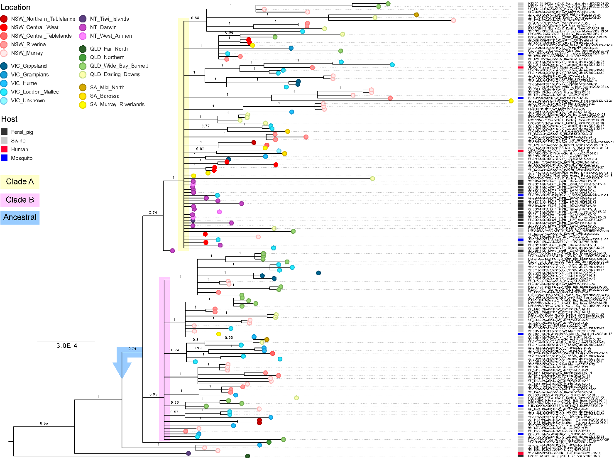

Supplementary Figure 2 – Bayesian genome phylogeny of GIV Australia 2021-22 lineage. Full length genomes from the Australian JEV GIV outbreak were aligned before a phylogenetic tree was estimated using MrBayes. The phylogeny was rooted using the Indonesian strain JEV/Swine/Bali-93/2017 (GenBank accession number LC461961). Colored circles at tips indicate the sampling location with colored boxes next to sequence labels show host species as per the legends provided. The two major clades A & B have been highlighted, as well as the putative ancestral group that sit in basal positions. The scale bar is proportional to the number of substitutions per site. Posterior probability branch support values are provided at nodes.

Supplementary Figure 3 – Unrooted maximum likelihood genome phylogeny of GIV Australia 2021-22 lineage showing informative sites. The same data and phylogeny from Supp Figure 1, displayed unrooted to demonstrate the star-like pattern and three main informative sites at positions 539, 5537 & 7241 (relative to GenBank accession number LC461961) that largely define the backbone of the phylogeny. The base composition of each clade and other intermediate variants are shown in the key provided and with colored tip circles. The scale bar is proportional to the number of substitutions per site.
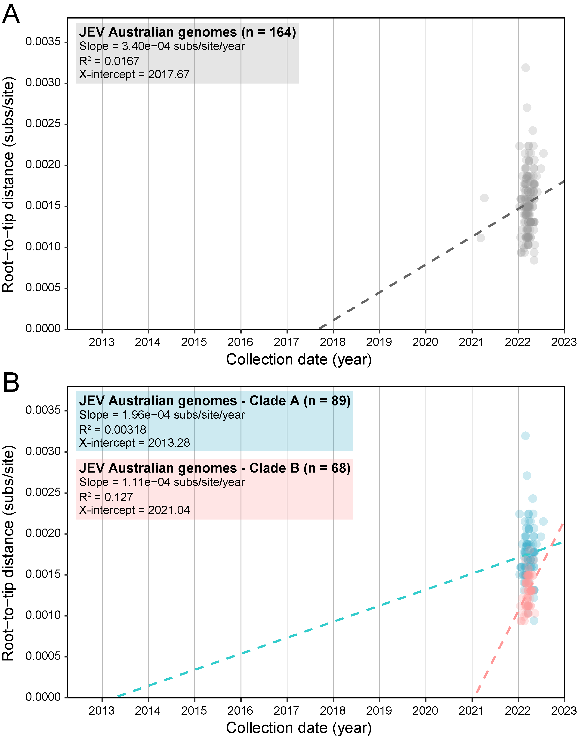
Supplementary Figure 4 – Lack of temporal structure in JEV GIV Australia 2021-22 outbreak. Linear regression of root-to-tip genetic distance on the maximum likelihood genome phylogeny of GIV Australia 2021-22 lineage viruses against time of sampling. (a) All JEV GIV genomes from the Australian outbreak (b) same JEV genomes partitioned into individual clades A (blue) and B (red).

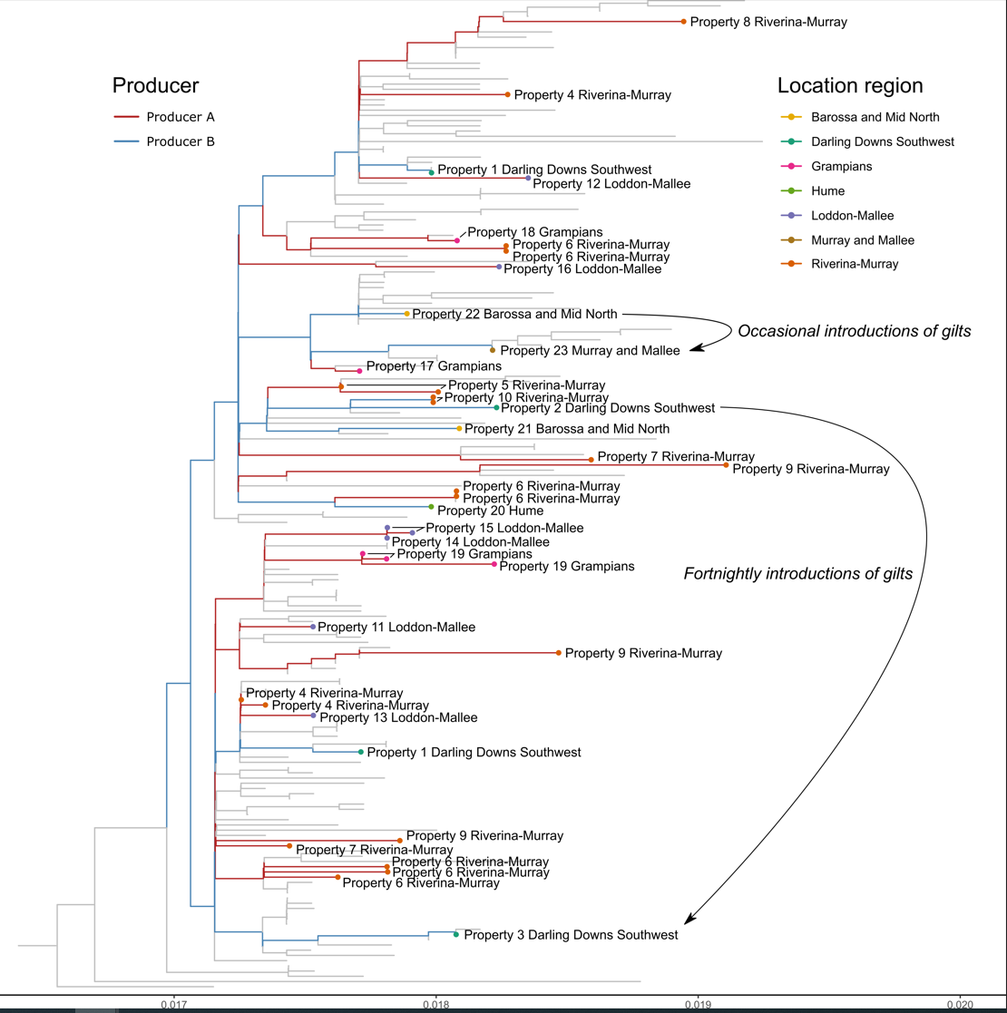

Supplementary Figure 5 – JEV belonging to both virus clades were detected within individual porcine production units from Queensland, New South Wales, South Australia and Victoria. An alignment of full-length genomes from Australian GIV outbreak viruses were used to generate a phylogenetic tree estimated using IQ-TREE. The phylogeny was rooted using the Indonesian strain JEV/Swine/Bali-93/2017 (GenBank Acc. No. LC461961). Colored branches indicate samples that came from different porcine producers and arrows at the tips indicate known movements of animals
.

Supplementary Table 1 – Collection details of mosquito samples yielding positive JEV detections. Morphological identification of mosquito samples was undertaken prior to homogenisation, JEV RT-qPCR screening and whole genome sequencing.

Sample identification number | Region or nearest town | Date of collection | Grouped location | Number of mosquitoes in pool tested | Mosquito species composition
27003 | Wagga Wagga | 10/01/2022 | NSW_Riverina | 282 | 198 Culex annulirostris  50 Aedes notoscriptus  27 Cx. australicus  4 Cx. quinquefasciatus  2 Anopheles annulipes  1 Ae. alboannulatus
27075 | Forbes | 17/01/2022 | NSW_Central_West | 8,248 | 5594 Ae. theobaldi  1900 Cx. annulirostris  392 Ae. vittiger  196 Ae. alternans  75 Cx. australicus  45 Ae. sagax  45 An. annulipes
27163 | Forbes | 24/01/2022 | NSW_Central_West | 2,121 | 1340 Cx. annulirostris  658 Ae. theobaldi  99 Ae. vittiger  8 Ae. alternans  8 Cx. australicus  8 Tripteroides atripes
22-01027-0026 | Gannawarra | 4/03/2022 | VIC_Loddon_Mallee | 195 | 168 Cx. annulirostris  10 Cx. australicus  6 Mansonia uniformis  5 Cx. molestus  2 An. annulipes  2 Coquillettidia linealis  2 Cx. cylindricus
22-01261-0036 | Mildura | 15/02/2022 | VIC_Loddon_Mallee | 842 | 820 Cx. annulirostris  9 An. annulipes  4 Cx. australicus  4 Ae. theobaldi  3 Cx. quinquefasciatus  1 Ae. notoscriptus  1 Ae. vittiger
22-01262-0009 | Wodonga | 3/02/2022 | VIC_Hume | 317 | 212 Cx. annulirostris  84 Ae. notoscriptus  8 Cx. australicus  4 An. annulipes  4 Ae. bancroftianus  4 Cx. cylindricus  1 Ae. alternans
22-01262-0053 | Moira | 1/02/2022 | VIC_Hume | 182 | 171 Cx. annulirostris  6 Cx. australicus  3 Cx. quinquefasciatus  1 An. annulipes  1 Ae. notoscriptus
22-01307-0021 | Campaspe | 25/01/2022 | VIC_Loddon_Mallee | 107 | 76 Cx. annulirostris  15 Cx. quinquefasciatus  6 Cx. australicus  3 Cx. molestus  2 Ae. notoscriptus  2 Ae. sagax  1 Ae. theobaldi  1 Ae. vittiger  1 An. annulipes
22-01335-0027 | Campaspe | 11/01/2022 | VIC_Loddon_Mallee | 186 | 162 Cx. annulirostris  16 An. annulipes  6 Cx. australicus  1 Ae. theobaldi  1 Cq. linealis
22-01335-0070 | Shepparton | 30/12/2021 | VIC_Hume | 271 | 216 Cx. annulirostris  21 An. annulipes  15 Ae. theobaldi  9 Ae. notoscriptus  9 Cx. australicus  1 Ae. vittiger
S46716 | Mundubbera | 15/3/2022 | QLD_Wide_Bay_Burnett | 50 | 373 Ae. vittigerª  2 An. annulipes  2 An. bancrofti  28 Cx. annulirostris  3 Cx. gelidus  5 Cq. xanthogaster
22-04049-0001/27080 | Swan Reach | 17/01/2022 | SA_Murray_Riverlands | 8 | 3 Ae. camptorhynchus  1 Cq. linealis  4 Cx. annulirostris

ªThe number of mosquitoes of each species presented here is for an entire trap collection of 418 mosquitoes from which 9 pools were processed. The pool which yielded the sequence was a pool of 50 mosquitoes from this trap and is comprised of mixed species, which may have contained some or all the species listed (Pyke et al., 2024).
Supplementary Table 2. Details of infected commercial piggeries included in an analysis of the potential role of pig movements in the 2022 outbreak in south-eastern Australia.
De-identified infected property No. | Location state | Location region | Clade | No. of sequences from property | Notes on operations
1 | Queensland | Darling Downs Southwest | A, B | 1 | Semi-closed to live introductions. Gilts leave the site to an acclimatisation facility and return, all on the same property. Semen 2x weekly from non-infected property#.
2 | Queensland | Darling Downs Southwest | A | 1 | Has 5-weekly introductions of gilts from a non-infected property. Semen 2x weekly from non-infected property#.
3 | Queensland | Darling Downs Southwest | B | 1 | Fortnightly introductions of gilts from property #2. Semen 2x weekly from non-infected property#.
4 | New South Wales | Riverina-Murray | A, B | 3 | Multi-unit farm. Closed since week 51, 2021 when had intakes of gilts from piggeries in Loddon-Mallee and Grampians. Semen daily from property concurrently confirmed infected.
5 | New South Wales | Riverina-Murray | A | 2
6 | New South Wales | Riverina-Murray | A, B | 5
7 | New South Wales | Riverina-Murray | A, B | 2 | Closed farm. Semen 2-3x weekly from property concurrently confirmed infected.
8 | New South Wales |  | A | 1 | Closed farm. Semen daily from property concurrently confirmed infected.
9 | New South Wales |  | A, B | 3 | Semi-closed to live animals and self-replaces. Sends replacement gilts to grow out at a separate property. Semen 2-3x weekly from property concurrently confirmed infected.
10 | New South Wales |  | A | 1 | Closed farm. No external semen.
11 | Victoria | Loddon-Mallee | B | 1 | Closed farm. Semen 2-3x weekly from property concurrently confirmed infected.
12 | Victoria | Loddon-Mallee | A | 1 | Closed farm. Semen 2-3x weekly from property concurrently confirmed infected.
13 | Victoria | Loddon-Mallee | B | 1 | Closed farm. Semen 2-3x weekly from property concurrently confirmed infected.
14 | Victoria | Loddon-Mallee | B | 1 | Closed farm. Semen 2-3x weekly from property concurrently confirmed infected.
15 | Victoria | Loddon-Mallee | B | 2 | Closed farm. Semen 2-3x weekly from property concurrently confirmed infected.
16 | Victoria | Loddon-Mallee | A | 1 | Boar stud
17 | Victoria | Grampians | A | 1 | Multi-unit farm. Semi-closed to live animals and self-replaces. Sends replacement gilts to grow out at a separate property. Semen 2-3x weekly from property concurrently confirmed infected.
18 | Victoria | Grampians | A | 2
19 | Victoria | Grampians | B | 3
20 | Victoria | Hume | A | 1 | Fortnightly introduction of gilts from separate non-infected property. Semen 2x weekly from non-infected property*.
21 | South Australia | Barossa and Mid North | A | 1 | Closed farm. Semen 2x weekly from non-infected property*.
22 | South Australia | Barossa and Mid North | A | 1 | Fortnightly introduction of gilts from separate non-infected property. Semen 2x weekly from non-infected property*.
23 | South Australia | Murray and Mallee | A | 1 | Occasional introduction of gilts from property #22 and a non-infected property. Semen 2x weekly from non-infected property*.

# Non-infected property supplying semen also supplied semen to properties that were infected.
* Non-infected property supplying semen different to property supplying 1, 2 and 3, and property also supplied semen to properties that were infected.

Supplementary Table 3. Details of primers used for whole genome sequencing at the Biosecurity Sciences Laboratory, Queensland Government.

Name | Pool | Sequence (5’ 3’)
JEV_1F | 1 | TTAGTATTGTTGAGGAGAATCGAGAGA
JEV_1R | 1 | TGTTCCTCCATTTCCTCCTCTTT
JEV_3F | 1 | TGGCAATGACCCAGAGGATGT
JEV_3R | 1 | CTCCTTCTAGCACCAAGTCCAC
JEV_5F | 1 | GGATGTGGACTTTTTGGAAAAGGA
JEV_5R | 1 | TCTCTGTTTCTCCATGCAGTGT
JEV_7F | 1 | GTTTGCAAAGAATCCAGCGGAC
JEV_7R | 1 | GAACGGCCTTCCCAATGGAA
JEV_9F | 1 | CATCTTTGTGCACAACGACGTG
JEV_9R | 1 | TTGCATGCTATTCCAGGCTCTG
JEV_11F | 1 | CAGAAACACACACTCTCTGGGG
JEV_11R | 1 | GGGTCAATCATCTCACCACTGA
JEV_13F | 1 | CAAAATTCAGCCGGCATTCCTG
JEV_13R | 1 | TGTGGTAGGTGAAAACCAACCA
JEV_15F | 1 | GATATCAGCTGGGAGATGGACG
JEV_15R | 1 | CACTCATTATTGCGGCCCCT
JEV_17F | 1 | TGGCTCACCCATCCTGGATT
JEV_17R | 1 | CATCAGTCTGTGGGTCAAGGTG
JEV_19F | 1 | AATGGATCACAGAGTACGCAGG
JEV_19R | 1 | TGCTATCATCTTCACTGGTGGC
JEV_21F | 1 | GACAGAAAGTGGTGCTTTGACG
JEV_21R | 1 | CGTTGCATCATGAGCAGAAAGA
JEV_23F | 1 | CAGCGAATGAGTACGGGATGTT
JEV_23R | 1 | CTTAGTGCCTCAGCTTGCCATC
JEV_25F | 1 | ACCCTATGGGATAATGGAGCCA
JEV_25R | 1 | TCCACGTCCACATCCTAGGT
JEV_27F | 1 | GAAGAACAACGAACCCTGCGAG
JEV_27R | 1 | ATGTCGTGGCGAATTCCTCTTT
JEV_29F | 1 | AAGGAAGTGCTCAACGAAACCA
JEV_29R | 1 | ACCTGAGTTCCTCCGGCTTA
JEV_31F | 1 | AAAGTCATGAGGCCCTCGACAG
JEV_31R | 1 | CCTGGAAATGGTTAGAGCAAAAAGG
JEV_33F | 1 | CCACAGGCAGAACATCTTGGTC
JEV_33R | 1 | TGGCCTGACTCCATATGTACAC
JEV_2F | 2 | TAGCTTCAAACGGGAACTTGGG
JEV_2R | 2 | GAGTGTCTGGTTCTTGTGCACC
JEV_4F | 2 | TCCGGCATACAGTTTCAATTGC
JEV_4R | 2 | TTTCTGGCTGAATCGTCTTCCC
JEV_6F | 2 | TGGGCTCAAAGTCATTCTTGGT
JEV_6R | 2 | GGCCACTGAGACAATTGGGATT
JEV_8F | 2 | GATTGGCAGCGTTGGGAGATAC
JEV_8R | 2 | GCGCTTTGTGGACAATTTTTGC
JEV_10F | 2 | TTTTTGCTCCAGAGTTGGCCAA
JEV_10R | 2 | CCTGTTGTGTTTGCTTTTGGGT
JEV_12F | 2 | GCTGCTGGTATGGAATGGAAGT
JEV_12R | 2 | TGCTCCGAGAACCAGAACTACA
JEV_14F | 2 | CTGTTGCAGGAGAGAAGGAGGA
JEV_14R | 2 | GAAGTCTCCATCATCGTCCAGC
JEV_16F | 2 | AAGCCGGTGTTGGAGTCATGTA
JEV_16R | 2 | CACGATGGCGCTGACATATGA
JEV_18F | 2 | CAAACTTCAGCAGTGCAAAGGG
JEV_18R | 2 | CTCTCTGGAGGCAAACAGCAAT
JEV_20F | 2 | GAGAGGTAGGGTGGGTAGGAAT
JEV_20R | 2 | TCCTCTCACCCATTCTTGTGAC
JEV_22F | 2 | TACCAGACGCATTGGAGACCAT
JEV_22R | 2 | AGGCAGTCCAGTCATTCCTGA
JEV_24F | 2 | ATCACTCTCACGACCTTCCTGA
JEV_24R | 2 | CCAGCCAAGTAACTGCCTCTCA
JEV_26F | 2 | GTTTCGCGAGGTTCAGCAAAAC
JEV_26R | 2 | CATGTAAGGGCAGAGCACCTTT
JEV_28F | 2 | TAGGGAAGGGAGAAGTCCACAG
JEV_28R | 2 | AACTCTTCCTTCGTGCACAAGC
JEV_30F | 2 | TTTGGTTCATGTGGCTAGGAGC
JEV_30R | 2 | AGAGCATAGGTGACCACTTGC
JEV_32F | 2 | CGAAGGTCAGGAAAGACATCCA
JEV_32R | 2 | CTCTGTTCCAAACCTGCAGCAT
JEV_34F | 2 | ACGAGGATGTCTTGATCCAGGA
JEV_34R | 2 | AGTCCTTACATCTCGTCCATTGC

Supplementary Table 4. Details of primers used for whole genome sequencing at the Westmead Institute for Medical Research. Primer sets of JEV-SW-500 and JEV-G4-800 for whole genome sequencing are shown.

Name | Pool | Sequence (5' 3')
JEV-SW-500_1_LEFT | 1 | TGACTTAGTATTGTTGAGGAGAATCGA
JEV-SW-500_1_RIGHT | 1 | TCCGCAATGTCCGTATTGTTGA
JEV-SW-500_3_LEFT | 1 | CGGTATCTCATGAAAACTGAAAATTGG
JEV-SW-500_3_RIGHT | 1 | TGCTAGTGCAGGAGAACTTAGC
JEV-SW-500_5_LEFT | 1 | GACGTCCTCTTCAAACACTGCA
JEV-SW-500_5_RIGHT | 1 | TTGTGCCAATGGTGGTTGATCT
JEV-SW-500_7_LEFT | 1 | CGCTGATACTGGCTGTGCTATT
JEV-SW-500_7_RIGHT | 1 | ATCTTTAACCACACCCGGGTTG
JEV-SW-500_9_LEFT | 1 | CGAAGATGGCATCGTCTTAGACT
JEV-SW-500_9_RIGHT | 1 | CAGGAATGCCGGCTGAATTTTG
JEV-SW-500_11_LEFT | 1 | CGAAAAAGAAAGGAGCCGTGCT
JEV-SW-500_11_RIGHT | 1 | GTCCCAAAACACACCTCCTCTT
JEV-SW-500_13_LEFT | 1 | GACGAAGCCGGGAGTGTTTT
JEV-SW-500_13_RIGHT | 1 | CCTGTTCGGTGACATCAGTCTG
JEV-SW-500_15_LEFT | 1 | GGGGAAAAGGGTCATTCAGCTC
JEV-SW-500_15_RIGHT | 1 | TCAGCAGTCCTAAGCAGCTCTA
JEV-SW-500_17_LEFT | 1 | CAATGTACCTGGTCGCTACAGC
JEV-SW-500_17_RIGHT | 1 | CTACCTCCATACAATGCCCAGG
JEV-SW-500_19_LEFT | 1 | ACCGATGTGCCTGAATTGGAAA
JEV-SW-500_19_RIGHT | 1 | CGAATCCTTTTTCCACGAGCCA
JEV-SW-500_21_LEFT | 1 | CTTCTGACTGGTTGCACAGAGG
JEV-SW-500_21_RIGHT | 1 | CATCCCAGGGCTTGCTCATTAG
JEV-SW-500_23_LEFT | 1 | GACGTGGAGAGGGAAAACCATC
JEV-SW-500_23_RIGHT | 1 | TGCCTCTCTGGTCTTCTCTTGA
JEV-SW-500_25_LEFT | 1 | TTGGCAGCAAGTTCCTTTTTGC
JEV-SW-500_25_RIGHT | 1 | GCTCTCACCTGATTTATTGCTGCA
JEV-SW-500_27_LEFT | 1 | AGGAGGACTGGGTTAACAAATCTG
JEV-SW-500_27_RIGHT | 1 | CACATACTTCGGCGCTCTGT
JEV-SW-500_2_LEFT | 2 | GCTTGACAATTGCTGCAGTCAG
JEV-SW-500_2_RIGHT | 2 | CATGCGCTGGCCACTATTACT
JEV-SW-500_4_LEFT | 2 | ATGTTTGCAAGCAAGGCTTCAC
JEV-SW-500_4_RIGHT | 2 | TTCTTGTGACCCGAGGGCAA
JEV-SW-500_6_LEFT | 2 | GTCTTGGTTGAGATGGAACCCC
JEV-SW-500_6_RIGHT | 2 | TACCTATCCACCCAAGCTTCCA
JEV-SW-500_8_LEFT | 2 | AAAGAATGCCCCGATGAACACA
JEV-SW-500_8_RIGHT | 2 | TCAGTGGTGGTTCTGACTGAGG
JEV-SW-500_10_LEFT | 2 | GCCGCTTTTGCAGAAGCTAAT
JEV-SW-500_10_RIGHT | 2 | CTTCTTGTTTGGGTTGCAGACC
JEV-SW-500_12_LEFT | 2 | CATGTCTTGCATTGGCCTAGC
JEV-SW-500_12_RIGHT | 2 | AGGATGGGTGAGCCAGATGTTC
JEV-SW-500_14_LEFT | 2 | CAAACTTCAGCAGTGCAAAGGG
JEV-SW-500_14_RIGHT | 2 | GATGACAAAGTCCCAGTCTCCG
JEV-SW-500_16_LEFT | 2 | ACCTGAGAGGGAAAAGGCTTTC
JEV-SW-500_16_RIGHT | 2 | GCGATGGCTACAATGAGTGTGA
JEV-SW-500_18_LEFT | 2 | AAAAGCATGTTTGGCGGGAAAG
JEV-SW-500_18_RIGHT | 2 | AGGAATGCTGCCACACTAACTC
JEV-SW-500_20_LEFT | 2 | AGGGAAGCCATAACCGAGGT
JEV-SW-500_20_RIGHT | 2 | CTGCAGCACTTCCATCTTCTCT
JEV-SW-500_22_LEFT | 2 | CCGTATCGCACTTGGACATACC
JEV-SW-500_22_RIGHT | 2 | GCTTTTCCGAACTCTCCAGGTT
JEV-SW-500_24_LEFT | 2 | ACATACAAACACAAAGTAGTCAAAGTCA
JEV-SW-500_24_RIGHT | 2 | ATTAGCTCATCCTGGCCCCTAC
JEV-SW-500_26_LEFT | 2 | CGTGGGAAAACGTGAGGACATT
JEV-SW-500_26_RIGHT | 2 | ATCCTAGACGAGACTTGGGCTG

NAME | POOL | SEQUENCE (5' - 3')
JEV-G4-800_1_LEFT | 1 | TTAGTATTGTTGAGGAGAATCGAGAGA
JEV-G4-800_1_RIGHT_alt | 1 | TTTTCATRAGATACCGGGTGGC
JEV-G4-800_3_LEFT | 1 | CGGAACCACGACCTCAGAAAAT
JEV-G4-800_3_RIGHT | 1 | CCCAATGTGCTTCCAGGTTTGT
JEV-G4-800_5_LEFT | 1 | GCGTAGTAGTCAACAAGCCTGT
JEV-G4-800_5_RIGHT_alt | 1 | CATCTCACCACTGAARGCATCG
JEV-G4-800_7_LEFT | 1 | CCATGGCGAAAAAGAAAGGAGC
JEV-G4-800_7_RIGHT_alt | 1 | CTTTCCTGGTTCCACYACGATC
JEV-G4-800_9_LEFT | 1 | GCGGGGTTACATTGCAACAAAA
JEV-G4-800_9_RIGHT | 1 | CGTCAAAGCACCACTTTCTGTC
JEV-G4-800_11_LEFT | 1 | TCATCTGTGTCCTGACTGTGGT
JEV-G4-800_11_RIGHT_alt | 1 | CCCCCAGGYCTTCCTCTCTTTA
JEV-G4-800_13_LEFT_alt | 1 | CATAAAGGTGCTCTGCCCYTAC
JEV-G4-800_13_RIGHT_alt | 1 | ATTCTCCTCGCAGRTGGTTTTC
JEV-G4-800_15_LEFT_alt | 1 | ACATGTGGAACAATTGCCTAGG
JEV-G4-800_15_RIGHT | 1 | TGACCCTGTCTTCCTGGATCAA
JEV-G4-800_2_LEFT_alt | 2 | AGAGAAGYAGGAGATCCGTGTC
JEV-G4-800_2_RIGHT | 2 | TCGCCAAGCTTCAGGGTTATTG
JEV-G4-800_4_LEFT | 2 | AGGTCTTGGTTGAGATGGAACC
JEV-G4-800_4_RIGHT | 2 | TTGGCCAACTCTGGAGCAAAAA
JEV-G4-800_6_LEFT | 2 | ACAGGAAGTGGCTGCTGGTAT
JEV-G4-800_6_RIGHT | 2 | TAGCAGGCCATCCTCTCTTCTT
JEV-G4-800_8_LEFT | 2 | TGACTCCATACTGGGGAAGTGT
JEV-G4-800_8_RIGHT_alt | 2 | TGGAGCGTTTGAGTCAGGRAAG
JEV-G4-800_10_LEFT | 2 | TCAGAGGTGAGGAGAAAAAGAATTTC
JEV-G4-800_10_RIGHT_alt | 2 | CATGCCAGGCARTCCAGTCATT
JEV-G4-800_12_LEFT | 2 | GCTCTGCCATGTTATGAGAGGC
JEV-G4-800_12_RIGHT | 2 | CATTACCAGCTGCTCCGCTAAC
JEV-G4-800_14_LEFT_alt | 2 | GAAAGTCAATAGYAACGCGGC
JEV-G4-800_14_RIGHT | 2 | CAACACAGTCATCTCCGCTGAT
JEV-G4-800_16_LEFT | 2 | ATGCTGCAGGTTTGGAACAGAG
JEV-G4-800_16_RIGHT | 2 | ACCTCTAGTCCTTCCACCTCTTC

Supplementary Table 5. Details of JEV whole genome sequences generated from samples collected in 2021 to 2022 in Australia used for the phylogenetic analyses conducted for this study.

Sample Identifier | Collection Date | Host | Location | GenBank
21-02409-0001 | 2021-03-10 | Human | NT_Tiwi_Islands | OM867669
O-0883 | 2022-02 | Isolate | NSW_Murray | OP904182
S46716 | 2022-05-11 | Mosquito | QLD_Wide_Bay_Burnett | OR965960
27003 | 2022-01-10 | Mosquito | NSW_Riverina | PV666440
22-00391-0002 | 2022-01-19 | Swine | NSW_Riverina | PV666441
22-00651-0005 | 2022-02-14 | Swine | VIC_Loddon_Mallee | PV666442
22-00691-0003 | 2022-02-15 | Swine | NSW_Murray | PV666443
22-00749-0005-05 | 2022-02-26 | Swine | VIC_Loddon_Mallee | PV666444
22-00766-0002 | 2022-02-28 | Swine | VIC_Hume | PV666445
22-00769-0012 | 2022-02-22 | Swine | NSW_Murray | PV666446
22-00799-0003-03 | 2022-02-27 | Swine | SA_Murray_Riverlands | PV666447
22-00819-0001 | 2022-02-26 | Swine | NSW_Murray | PV666448
22-00820-0015 | 2022-03-01 | Swine | NSW_Northern_Tablelands | PV666449
22-00824-0007 | 2021-04-07 | Swine | QLD_Northern | PV666450
22-00854-0009 | 2022-03-02 | Swine | VIC_Hume | PV666451
22-00855-0006 | 2022-03-02 | Swine | VIC_Loddon_Mallee | PV666452
22-00864-0013 | 2022-03-03 | Swine | VIC_Loddon_Mallee | PV666453
22-00867-0012 | 2022-02-27 | Swine | NSW_Central_West | PV666454
22-00874-0001 | 2022-01-20 | Swine | NSW_Murray | PV666455
22-00920-0004 | 2022-03-04 | Swine | VIC_Hume | PV666456
22-00924-0002 | 2022-03-06 | Swine | VIC_Grampians | PV666457
22-00993-0006 | 2022-03-05 | Swine | NSW_Riverina | PV666458
22-00994-0006 | 2022-03-05 | Swine | NSW_Riverina | PV666459
22-01027-0026 | 2022-03-04 | Mosquito | VIC_Loddon_Mallee | PV666460
22-01072-0008 | 2022-03-16 | Swine | VIC_Loddon_Mallee | PV666461
22-01079-0002 | 2022-03-16 | Swine | VIC_Hume | PV666462
22-01090-0004 | 2022-03-10 | Swine | NSW_Murray | PV666463
22-01093-0004 | 2022-03-17 | Swine | VIC_Hume | PV666464
22-01094-0005 | 2022-03-17 | Swine | VIC_Loddon_Mallee | PV666465
22-01094-0009 | 2022-03-17 | Swine | VIC_Loddon_Mallee | PV666466
22-01121-0002 | 2022-03-16 | Swine | VIC_Loddon_Mallee | PV666467
22-01152-0002-02 | 2022-03-17 | Swine | SA_Murray_Riverlands | PV666468
22-01156-0003 | 2022-03-21 | Swine | VIC_Loddon_Mallee | PV666469
22-01157-0006 | 2022-03-12 | Swine | QLD_Darling_Downs | PV666470
22-01158-0002 | 2022-03-17 | Swine | VIC_Loddon_Mallee | PV666471
22-01159-0001 | 2022-03-16 | Swine | VIC_Loddon_Mallee | PV666472
22-01160-0001 | 2022-03-17 | Swine | VIC_Loddon_Mallee | PV666473
22-01160-0002 | 2022-03-17 | Swine | VIC_Loddon_Mallee | PV666474
22-01163-0005-01 | 2022-03-18 | Swine | SA_Murray_Riverlands | PV666475
22-01168-0002 | 2022-03-22 | Swine | VIC_Loddon_Mallee | PV666476
22-01172-0003-02 | 2022-03-19 | Swine | SA_Murray_Riverlands | PV666477
22-01213-0004 | 2022-03-25 | Swine | VIC_Hume | PV666478
22-01214-0004 | 2022-03-25 | Swine | VIC_Loddon_Mallee | PV666479
22-01214-0006 | 2022-03-25 | Swine | VIC_Loddon_Mallee | PV666480
22-01225-0005-02 | 2022-03-22 | Swine | SA_Mid_North | PV666481
22-01231-0001 | 2022-03-24 | Swine | VIC_Gippsland | PV666482
22-01250-0001 | 2022-03-23 | Swine | NSW_Murray | PV666483
22-01261-0036 | 2022-02-15 | Mosquito | VIC_Loddon_Mallee | PV666484
22-01262-0009 | 2022-02-03 | Mosquito | VIC_Hume | PV666485
22-01262-0053 | 2022-02-01 | Mosquito | VIC_Hume | PV666486
22-01285-0006-03 | 2022-04-24 | Swine | SA_Mid_North | PV666487
22-01301-0002 | 2022-03-31 | Swine | VIC_Gippsland | PV666488
22-01301-0004 | 2022-03-31 | Swine | VIC_Gippsland | PV666489
22-01301-0005 | 2022-03-31 | Swine | VIC_Gippsland | PV666490
22-01307-0021 | 2022-01-25 | Mosquito | VIC_Loddon_Mallee | PV666491
22-01335-0027 | 2022-01-11 | Mosquito | VIC_Loddon_Mallee | PV666492
22-01379-0003 | 2022-04-07 | Swine | VIC_Loddon_Mallee | PV666493
22-01379-0007 | 2022-04-07 | Swine | VIC_Loddon_Mallee | PV666494
22-01405-0007-01 | 2022-04-01 | Swine | SA_Barossa | PV666495
22-01462-0001 | 2022-04-13 | Swine | VIC_Gippsland | PV666496
22-01462-0002 | 2022-04-13 | Swine | VIC_Gippsland | PV666497
22-01506-0001 | 2022-04-04 | Swine | VIC_Loddon_Mallee | PV666498
22-01506-0003 | 2022-04-04 | Swine | VIC_Loddon_Mallee | PV666499
22-01587-0005 | 2022-04-26 | Swine | VIC_Hume | PV666500
22-01587-0006 | 2022-04-26 | Swine | VIC_Hume | PV666501
22-01591-0016 | 2022-04-08 | Swine | QLD_Darling_Downs | PV666502
22-01595-0003 | 2022-04-06 | Swine | QLD_Wide_Bay_Burnett | PV666503
22-01596-0002 | 2022-04-08 | Swine | QLD_Wide_Bay_Burnett | PV666504
22-01597-0003 | 2022-04-08 | Swine | QLD_Wide_Bay_Burnett | PV666505
22-01936-0004 | 2022-04-29 | Swine | SA_Murray_Riverlands | PV666506
22-02018-0010 | 2022-04-26 | Swine | QLD_Darling_Downs | PV666507
22-02113-0001 | 2022-05-10 | Feral_pig | NT_Darwin | PV666508
22-02438-0016 | 2022-05-24 | Swine | SA_Barossa | PV666509
22-02644-0001 | 2022-04-25 | Feral_pig | NT_Tiwi_Islands | PV666510
22-02644-0002 | 2022-05-02 | Feral_pig | NT_West_Arnhem | PV666511
22-02644-0003 | 2022-05-02 | Feral_pig | NT_West_Arnhem | PV666512
22-02644-0006 | 2022-05-02 | Feral_pig | NT_West_Arnhem | PV666513
22-02644-0007 | 2022-05-03 | Feral_pig | NT_Darwin | PV666514
22-02644-0008 | 2022-05-03 | Feral_pig | NT_Darwin | PV666515
22-02644-0009 | 2022-05-04 | Feral_pig | NT_Darwin | PV666516
22-02644-0010 | 2022-05-04 | Feral_pig | NT_Darwin | PV666517
22-02644-0011 | 2022-05-05 | Feral_pig | NT_Darwin | PV666518
22-02644-0012 | 2022-05-05 | Feral_pig | NT_Darwin | PV666519
22-02644-0013 | 2022-05-05 | Feral_pig | NT_Darwin | PV666520
22-02644-0014 | 2022-05-06 | Feral_pig | NT_Darwin | PV666521
22-02644-0015 | 2022-05-06 | Feral_pig | NT_Darwin | PV666522
22-02644-0016 | 2022-05-06 | Feral_pig | NT_Darwin | PV666523
22-02644-0017 | 2022-05-06 | Feral_pig | NT_Darwin | PV666524
22-02644-0018 | 2022-05-06 | Feral_pig | NT_Darwin | PV666525
22-02644-0019 | 2022-05-07 | Feral_pig | NT_Darwin | PV666526
22-04049-0001 | 2022-01-17 | Mosquito | SA_Murray_Riverlands | PV666527
EMAI01 | 2022-01-23 | Swine | NSW_Riverina | PV666528
EMAI02 | 2022-01-25 | Swine | NSW_Murray | PV666529
EMAI03 | 2022-02-02 | Swine | NSW_Murray | PV666530
EMAI04 | 2022-02-10 | Swine | NSW_Central_West | PV666531
EMAI05 | 2022-02-10 | Swine | NSW_Central_West | PV666532
EMAI06 | 2022-02-14 | Swine | NSW_Murray | PV666533
EMAI07 | 2022-02-17 | Swine | NSW_Riverina | PV666534
EMAI09 | 2022-02-21 | Swine | NSW_Riverina | PV666535
EMAI10 | 2022-02-21 | Swine | NSW_Riverina | PV666536
EMAI11 | 2022-02-26 | Swine | NSW_Murray | PV666537
EMAI12 | 2022-02-26 | Swine | NSW_Murray | PV666538
EMAI13 | 2022-02-21 | Swine | NSW_Central_West | PV666539
EMAI14 | 2022-02-21 | Swine | NSW_Central_West | PV666540
EMAI15 | 2022-02-23 | Swine | QLD_Darling_Downs | PV666541
EMAI17 | 2022-02-28 | Swine | NSW_Murray | PV666542
EMAI18 | 2022-02-28 | Swine | NSW_Murray | PV666543
EMAI19 | 2022-02-27 | Swine | NSW_Murray | PV666544
EMAI21 | 2022-03-01 | Swine | NSW_Northern_Tablelands | PV666545
EMAI22 | 2022-03-01 | Swine | NSW_Northern_Tablelands | PV666546
EMAI24 | 2022-03-01 | Swine | NSW_Murray | PV666547
EMAI25 | 2022-03-02 | Swine | NSW_Central_West | PV666548
EMAI26 | 2022-03-02 | Swine | NSW_Central_West | PV666549
EMAI27 | 2022-03-04 | Swine | NSW_Riverina | PV666550
EMAI28 | 2022-03-04 | Swine | NSW_Riverina | PV666551
EMAI29 | 2022-03-04 | Swine | NSW_Riverina | PV666552
EMAI30 | 2022-03-04 | Swine | NSW_Riverina | PV666553
EMAI31 | 2022-03-09 | Swine | NSW_Central_West | PV666554
EMAI34 | 2022-03-10 | Swine | NSW_Murray | PV666555
EMAI36 | 2022-03-15 | Swine | NSW_Murray | PV666556
EMAI37 | 2022-03-15 | Swine | NSW_Murray | PV666557
EMAI38 | 2022-03-15 | Swine | NSW_Murray | PV666558
EMAI39 | 2022-03-15 | Swine | NSW_Central_Tablelands | PV666559
EMAI40 | 2022-03-15 | Swine | NSW_Central_Tablelands | PV666560
EMAI41 | 2022-03-14 | Swine | NSW_Riverina | PV666561
EMAI42 | 2022-03-14 | Swine | NSW_Riverina | PV666562
EMAI43 | 2022-03-14 | Swine | NSW_Murray | PV666563
EMAI44 | 2022-03-14 | Swine | NSW_Murray | PV666564
EMAI45 | 2022-03-18 | Swine | NSW_Riverina | PV666565
EMAI47 | 2022-03-18 | Swine | NSW_Riverina | PV666566
EMAI48 | 2022-03-18 | Swine | NSW_Riverina | PV666567
EMAI51 | 2022-03-21 | Swine | NSW_Murray | PV666568
EMAI52 | 2022-03-21 | Swine | NSW_Murray | PV666569
EMAI53 | 2022-03-20 | Swine | NSW_Murray | PV666570
EMAI54 | 2022-03-20 | Swine | NSW_Murray | PV666571
EMAI56 | 2022-03-26 | Swine | NSW_Murray | PV666572
EMAI57 | 2022-03-26 | Swine | NSW_Murray | PV666573
JEV001 | 2022-02-16 | Human | NSW_Riverina | PV666574
P22-00698-27 | 2022-02-22 | Swine | QLD_Darling_Downs | PV666575
P22-00902-2 | 2022-03-11 | Swine | QLD_Wide_Bay_Burnett | PV666576
P22-00902-7 | 2022-03-11 | Swine | QLD_Wide_Bay_Burnett | PV666577
P22-00961-41 | 2022-03-15 | Swine | QLD_Darling_Downs | PV666578
P22-01043-12 | 2022-03-21 | Swine | QLD_Darling_Downs | PV666579
P22-01131-3 | 2022-03-25 | Swine | QLD_Wide_Bay_Burnett | PV666580
P22-01131-11 | 2022-03-25 | Swine | QLD_Wide_Bay_Burnett | PV666581
P22-01131-31 | 2022-03-25 | Swine | QLD_Wide_Bay_Burnett | PV666582
P22-01131-54 | 2022-03-25 | Swine | QLD_Wide_Bay_Burnett | PV666583
P22-01131-57 | 2022-03-25 | Swine | QLD_Wide_Bay_Burnett | PV666584
P22-01333-3 | 2022-04-08 | Swine | QLD_Wide_Bay_Burnett | PV666585
P22-01333-4 | 2022-04-08 | Swine | QLD_Wide_Bay_Burnett | PV666586
P22-01335-2 | 2022-04-08 | Swine | QLD_Wide_Bay_Burnett | PV666587
P22-01336-2 | 2022-04-08 | Swine | QLD_Wide_Bay_Burnett | PV666588
P22-01336-10 | 2022-04-08 | Swine | QLD_Wide_Bay_Burnett | PV666589
P22-01348-11 | 2022-04-08 | Swine | QLD_Darling_Downs | PV666590
P22-01348-19 | 2022-04-08 | Swine | QLD_Darling_Downs | PV666591
P22-01348-46 | 2022-04-08 | Swine | QLD_Darling_Downs | PV666592
P22-01350-9 | 2022-04-08 | Swine | QLD_Darling_Downs | PV666593
P22-01352-18 | 2022-04-08 | Swine | QLD_Wide_Bay_Burnett | PV666594
P22-01590-19 | 2022-04-26 | Swine | QLD_Darling_Downs | PV666595
P22-01590-30 | 2022-04-26 | Swine | QLD_Darling_Downs | PV666596
P22-01629-3 | 2022-04-29 | Swine | QLD_Wide_Bay_Burnett | PV666597
P22-01661-12 | 2022-04-29 | Swine | QLD_Wide_Bay_Burnett | PV666598
P22-01661-20 | 2022-04-29 | Swine | QLD_Wide_Bay_Burnett | PV666599
P22-02131-92 | 2022-05-30 | Feral_pig | QLD_Far_North | PV666600
P22-02436-59 | 2022-06-28 | Swine | QLD_Darling_Downs | PV666601
P22-02806-13 | 2022-07-18 | Swine | QLD_Wide_Bay_Burnett | PV666602
VIDRL03 | 2022-03 | Human | VIC_Unknown | PV666603

References

Pyke, A.T. et al. (2024) ‘First Isolation of Japanese Encephalitis Virus Genotype IV from Mosquitoes in Australia’, Vector-Borne and Zoonotic Diseases, 24(7), pp. 439-442. Available at: https//doi.org.10.1089/vbz.2024.0017

