Supporting information for Magneto-photoelectrochemical 2D heterojunction platform for biosensing detection
Tao Wang^{1#}, Nan Zhang^{1#*}, Hongjie Huang⁴, Yunhe An², Yunyun Dai⁵, Yongrui Li¹, Nan Yang², Chaojie Yang², Xinran Zhou², Yucheng Zhu⁴, Yingshan Ma⁵, Lingling Huang^{1*}, Yongtian Wang¹, Yang Liu^{3*}, Zhiyong Yan^{2*}
¹Beijing Engineering Research Center of Mixed Reality and Advanced Display, School of Optics and Photonics, Beijing Institute of Technology, Beijing, 100081, China.
²Institute of Analysis and Testing, Beijing Academy of Science and Technology (Beijing Center for Physical and Chemical Analysis), Beijing, 100089, China.
³Department of Chemistry, Kay Lab of Bioorganic Phosphorus Chemistry and Chemical Biology of Ministry of Education, Beijing Key Laboratory for Analytical Methods and Instrumentation, Tsinghua University, Beijing, 100084, China.
⁴Department of Sports Medicine Peking University Third Hospital, Institute of Sports Medicine of Peking University, Beijing Key Laboratory of Sports Injuries, Engineering Research Center of Sports Trauma Treatment Technology and Devices Ministry of Education, Beijing, 100191, China.
⁵School of Integrated Circuits and Electronics, Beijing Institute of Technology, Beijing, 100081 China.
#These authors contributed equally: Tao Wang, Nan Zhang
*Corresponding Authors e-mail: nanzhang@bit.edu.cn; huanglingling@bit.edu.cn; liu-yang@mail.tsinghua.edu.cn; yanzhiyong@bcpca.ac.cn

This file includes:
Supplementary Note 1: Formulas for calculating conduction band potentials and valence band potentials
Supplementary Note 2: Computational details
Fig. S1 SEM image of the MXenes film.
Fig. S2 AFM image of the Co-TiO₂ Nanosheet.
Fig. S3 EDX mapping of the elemental composition of MXenes.
Fig. S4 EDX mapping of the elemental composition of Co-TiO₂.
Fig. S5 XPS spectra of MXenes powder.
Fig. S6 Preparation process of biosensor.
Fig. S7 The photocurrent response diagram corresponding to progressively modified electrodes.
Fig. S8 PL spectra of Co-TiO₂ with MF and without MF conditions.
Fig. S9 The intensity of the photocurrent signal changes with different kempatide concentrations.
Fig. S10 The linear relationship between the intensity of the photocurrent changes and the PKA concentration without magnetic field.
Fig. S11 The detection of PKA concentration in the synovial fluid (diluted 500 times) of normal individuals and osteoarthritis patients using an Elisa kit.
Fig. S12 8-cycle response curve of the PEC biosensor.
Table 1 Comparison of various methods for PKA activity assay
Supplementary Note 1: Formulas for calculating conduction band potentials and valence band potentials.
The conversion equation normal hydrogen electrode potential (NHE) and Ag/AgCl electrode potential¹：
$$E_{CB}(V vs Ag/AgCl)=E_{fb}(V vs Ag/AgCl)-0.2 V$$
$$E_{CB}(V vs NHE)=E_{CB}(V vs Ag/AgCl)+0.24 V$$
$$E_{VB}(V vs NHE)=E_{g}(eV)+E_{CB}(V vs Ag/AgCl)$$
Supplementary Note 2: Computational details.
All the calculations were carried out using the GGA-PBE functional implemented in the Vienna ab initio Simulation Package (VASP)². We used the generalized gradient approximation (GGA) with the Pedrew-Burke-Ernzerhof (PBE) function³ and Hubbard U corrections (3.32 eV for treating Co 3d orbitals) were introduced to consider the self-interaction error of transition metals. The cut-off energy for plane wave is set to 500 eV. The energy criterion is set to 10-5 eV in iterative solution of the Kohn-Sham equation. The Brillouin zone integration is performed using a 3x3x1 k-mesh. All the structures are relaxed until the residual forces on the atoms have declined to less than 0.01 eV/Å.
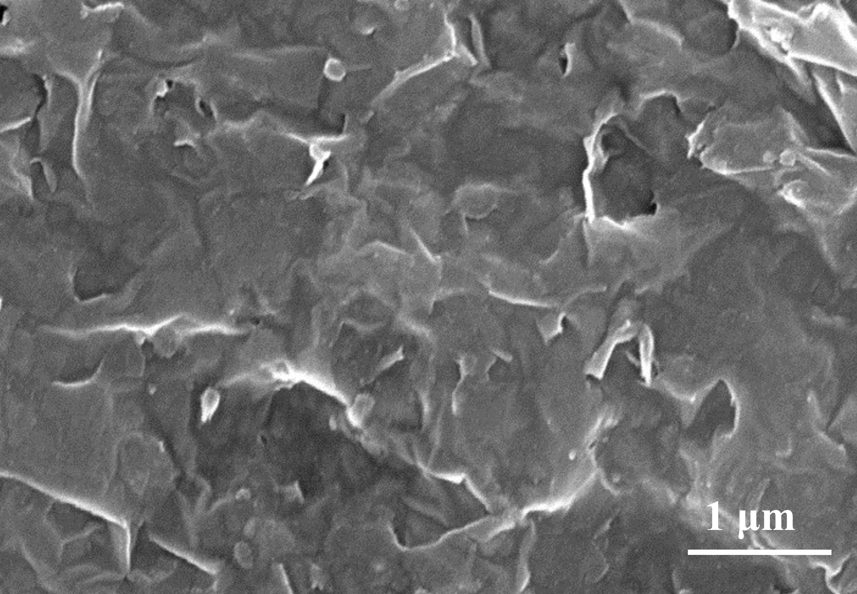
Fig. S1 SEM image of the MXenes film.
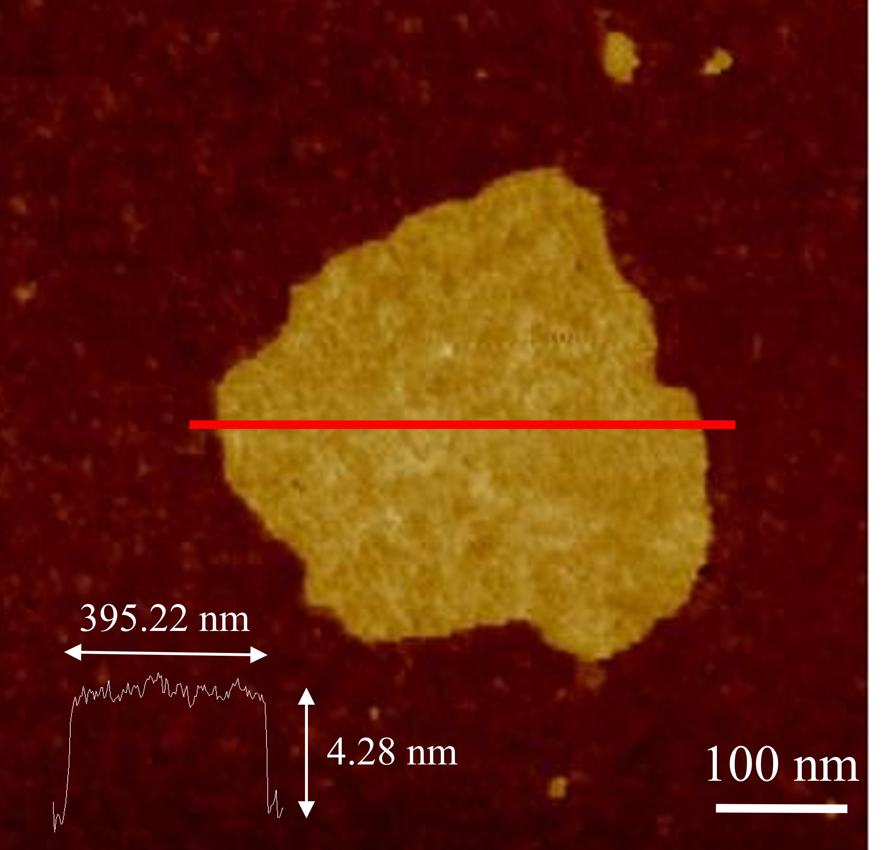
Fig. S2 AFM image of the Co-TiO₂ Nanosheet. The Co-TiO₂ Nanosheet showed a thickness of 4.28 nm and a lateral size of 395.22 nm.
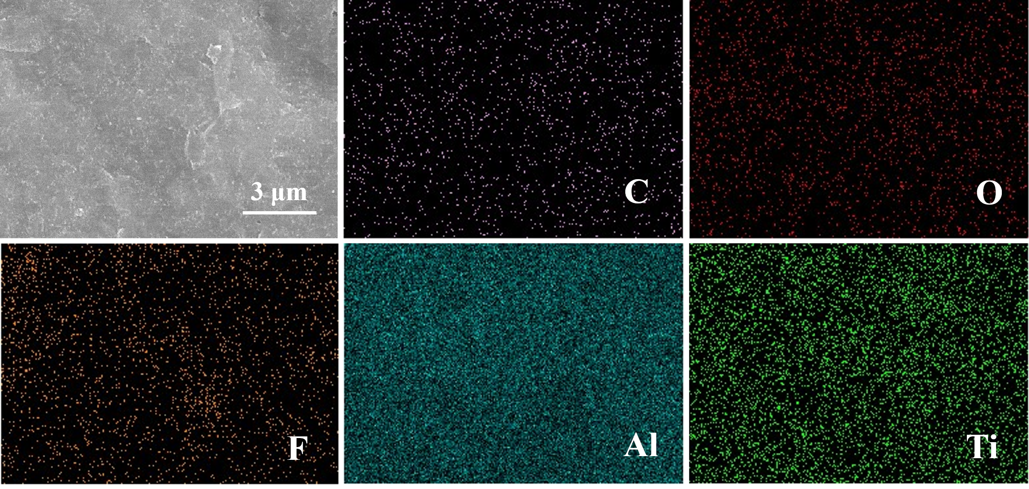
Fig. S3 EDX mapping of the elemental composition of MXenes. MXenes contained C, O, F, Al and Ti elements.
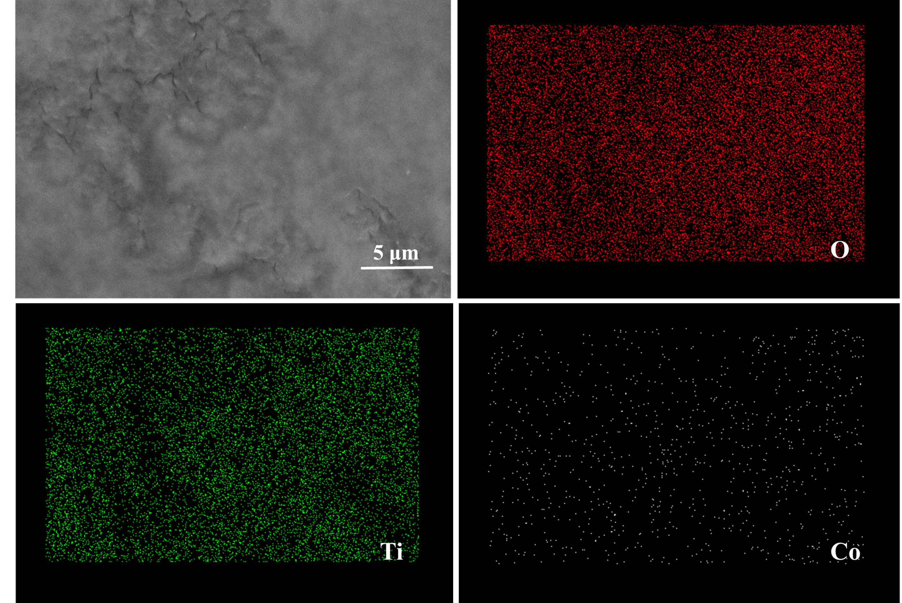
Fig. S4 EDX mapping of the elemental composition of Co-TiO₂. Co-TiO₂ contained O, Ti and Co elements.
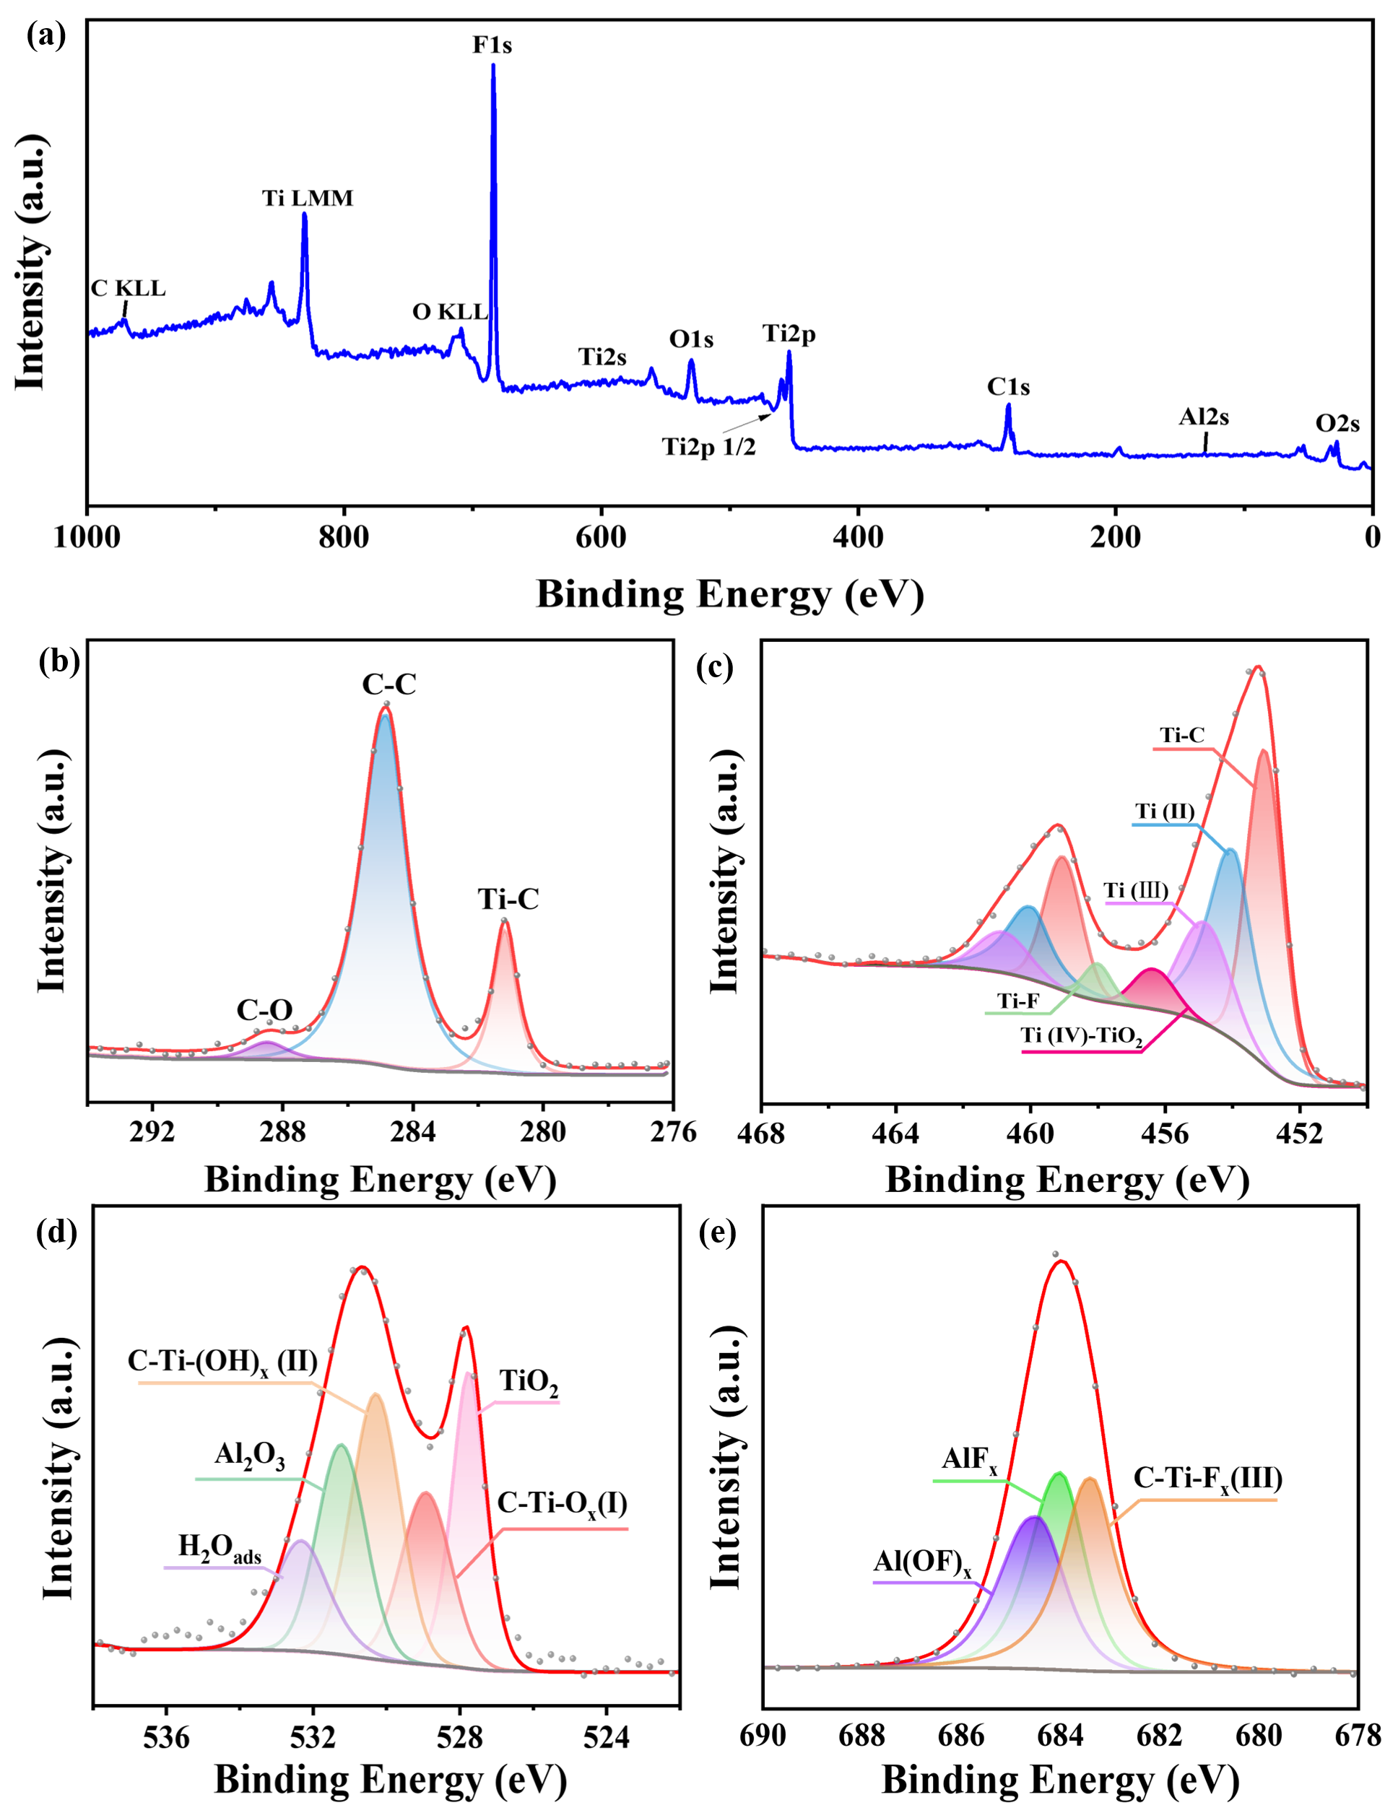
Fig. S5 XPS spectra of MXenes powder. (a) survey, (b–e) high resolution spectra of C1s, Ti 2p, O 1s, and F1s regions, respectively.
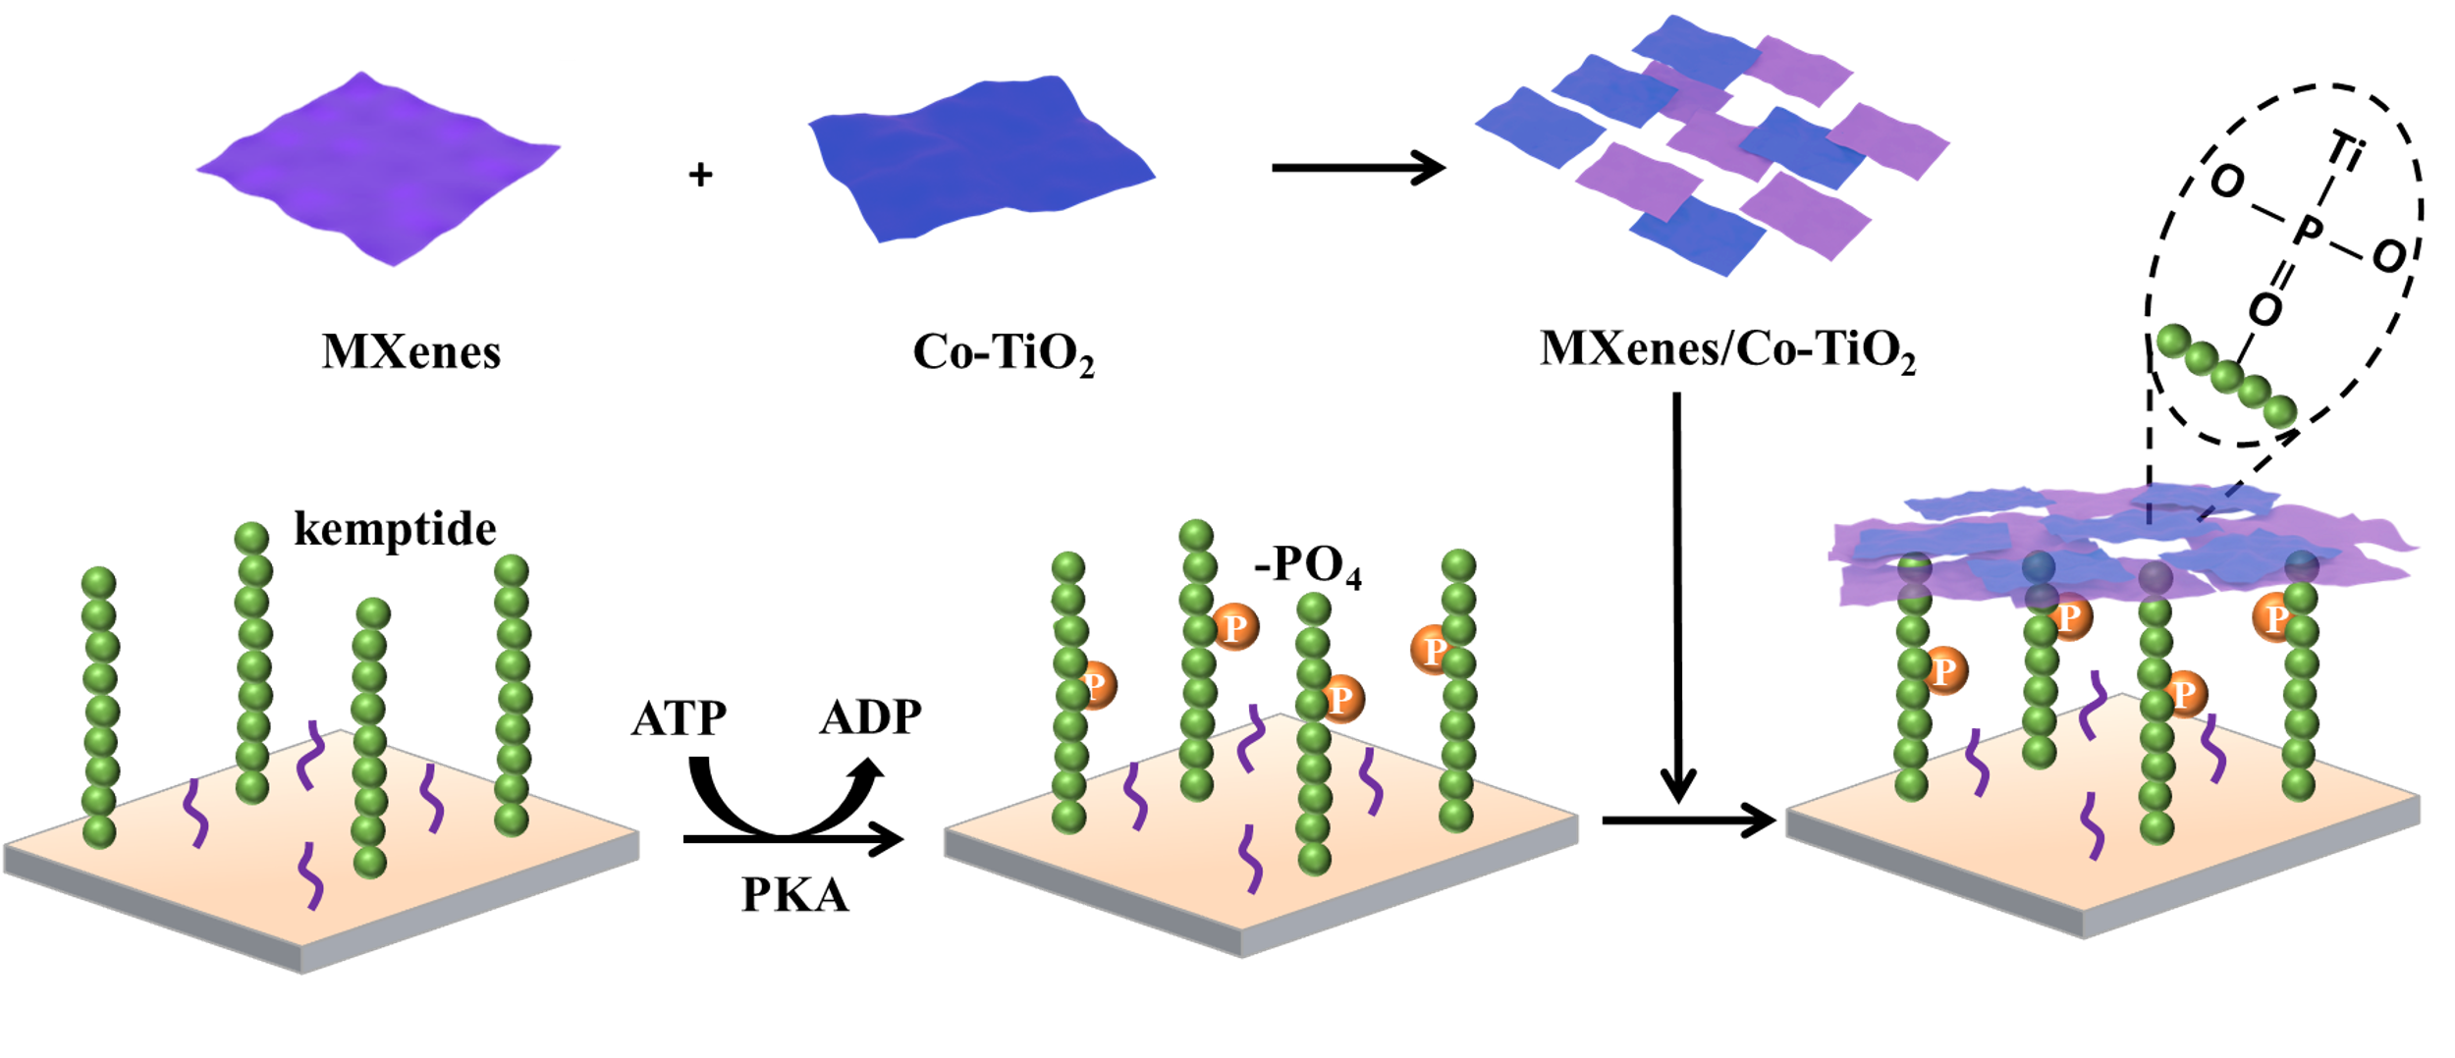
Fig. S6 Preparation process of biosensor. In brief, Ti⁴⁺ sites within the MXenes/Co-TiO₂ composite selectively recognize phosphate groups on the kinase phosphorylation substrate (kemptide) via coordination interactions. Detailed descriptions are provided in the main text.
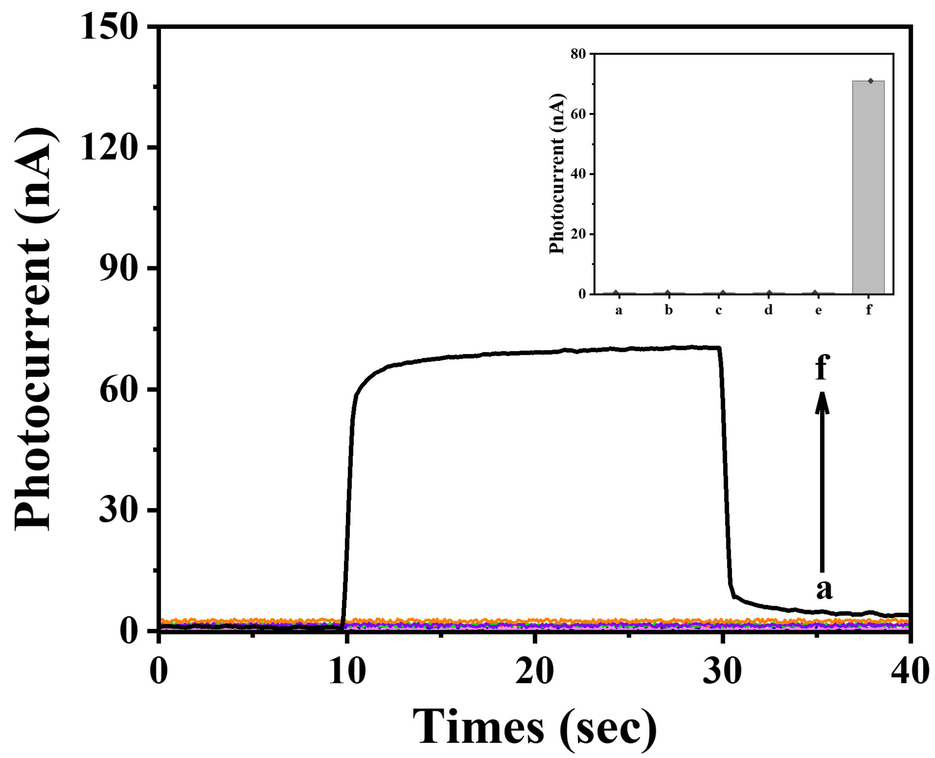
Fig. S7 The photocurrent response diagram corresponding to progressively modified electrodes. (a) bare ITO, (b) chitosan-modified ITO, (c) glutaraldehyde/chitosan/ITO, (d) kemptide/glutaraldehyde/chitosan/ITO, (e) phosphorylated kemptide/glutaraldehyde/chitosan/ITO, and (f) MXenes/Co-TiO₂ probe-functionalized electrode.
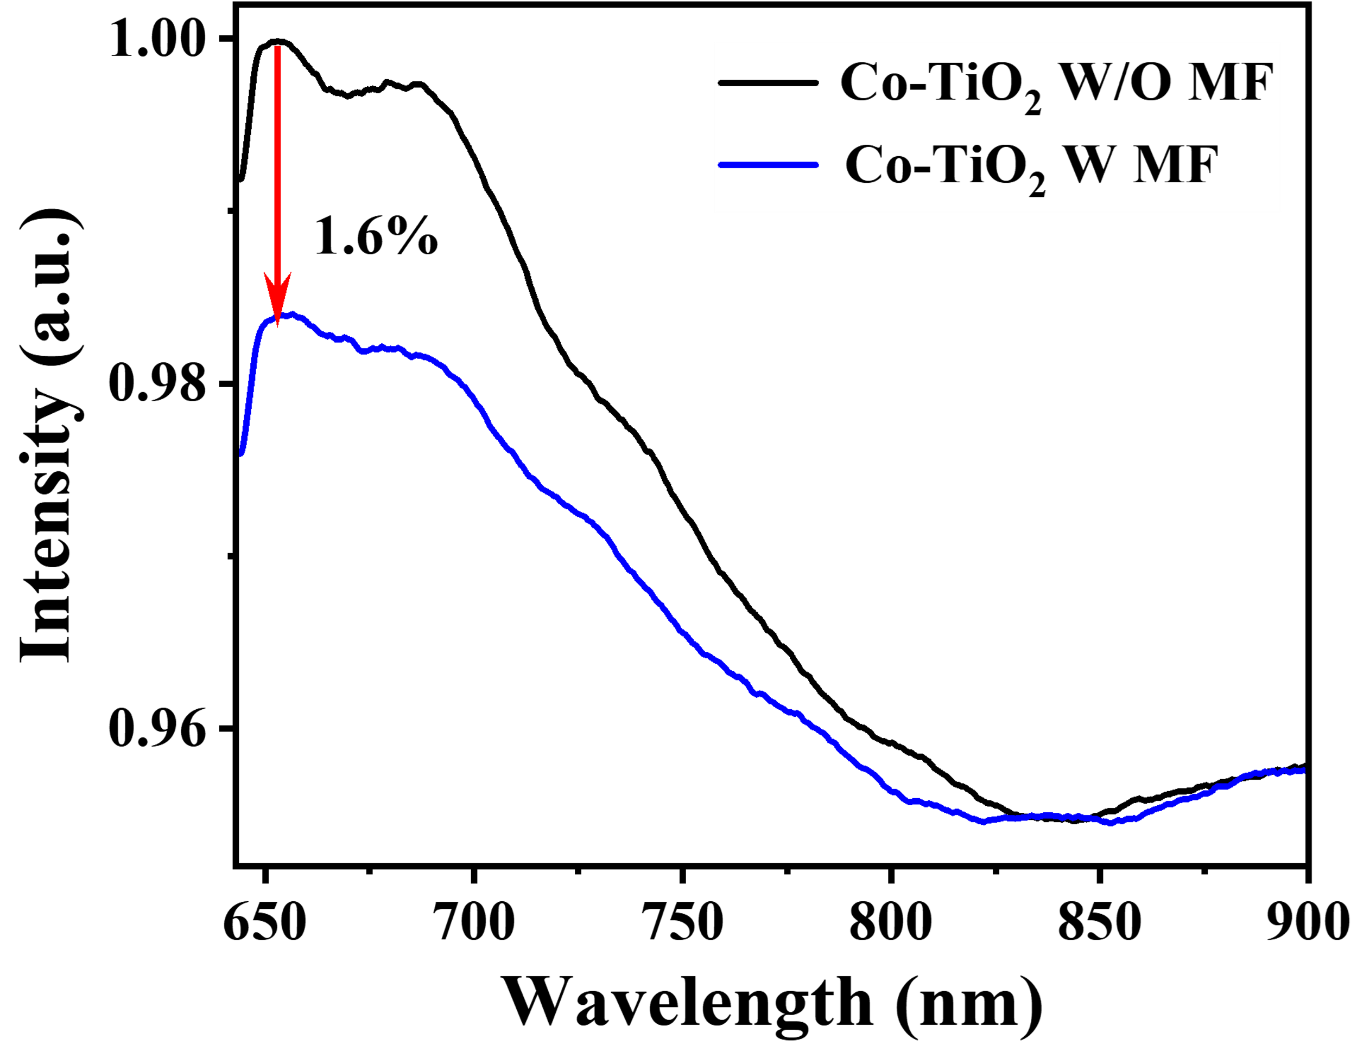
Fig. S8 PL spectra of Co-TiO₂ with MF and without MF conditions. Under 532 nm laser excitation, the PL intensity of Co-TiO₂ at 650 nm decreased by 1.6% under MF.
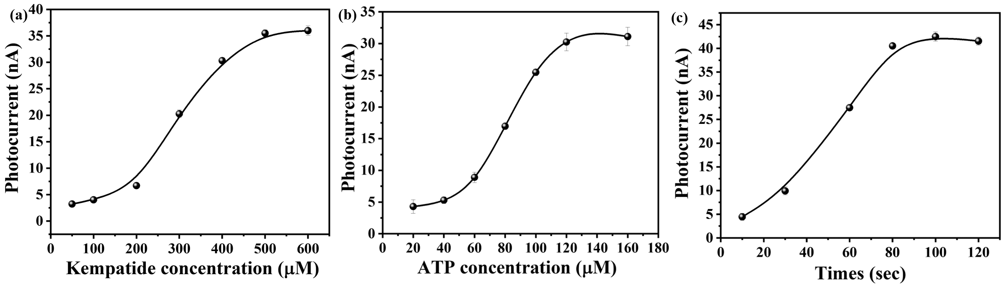
Fig. S9 The intensity of the photocurrent signal changes with different kempatide concentrations. (a) kempatide concentration, (b) ATP concentrationsand and (c) phosphorylation timesc. The light power density was 190 mW cm⁻², electrode area was 0.5 cm².
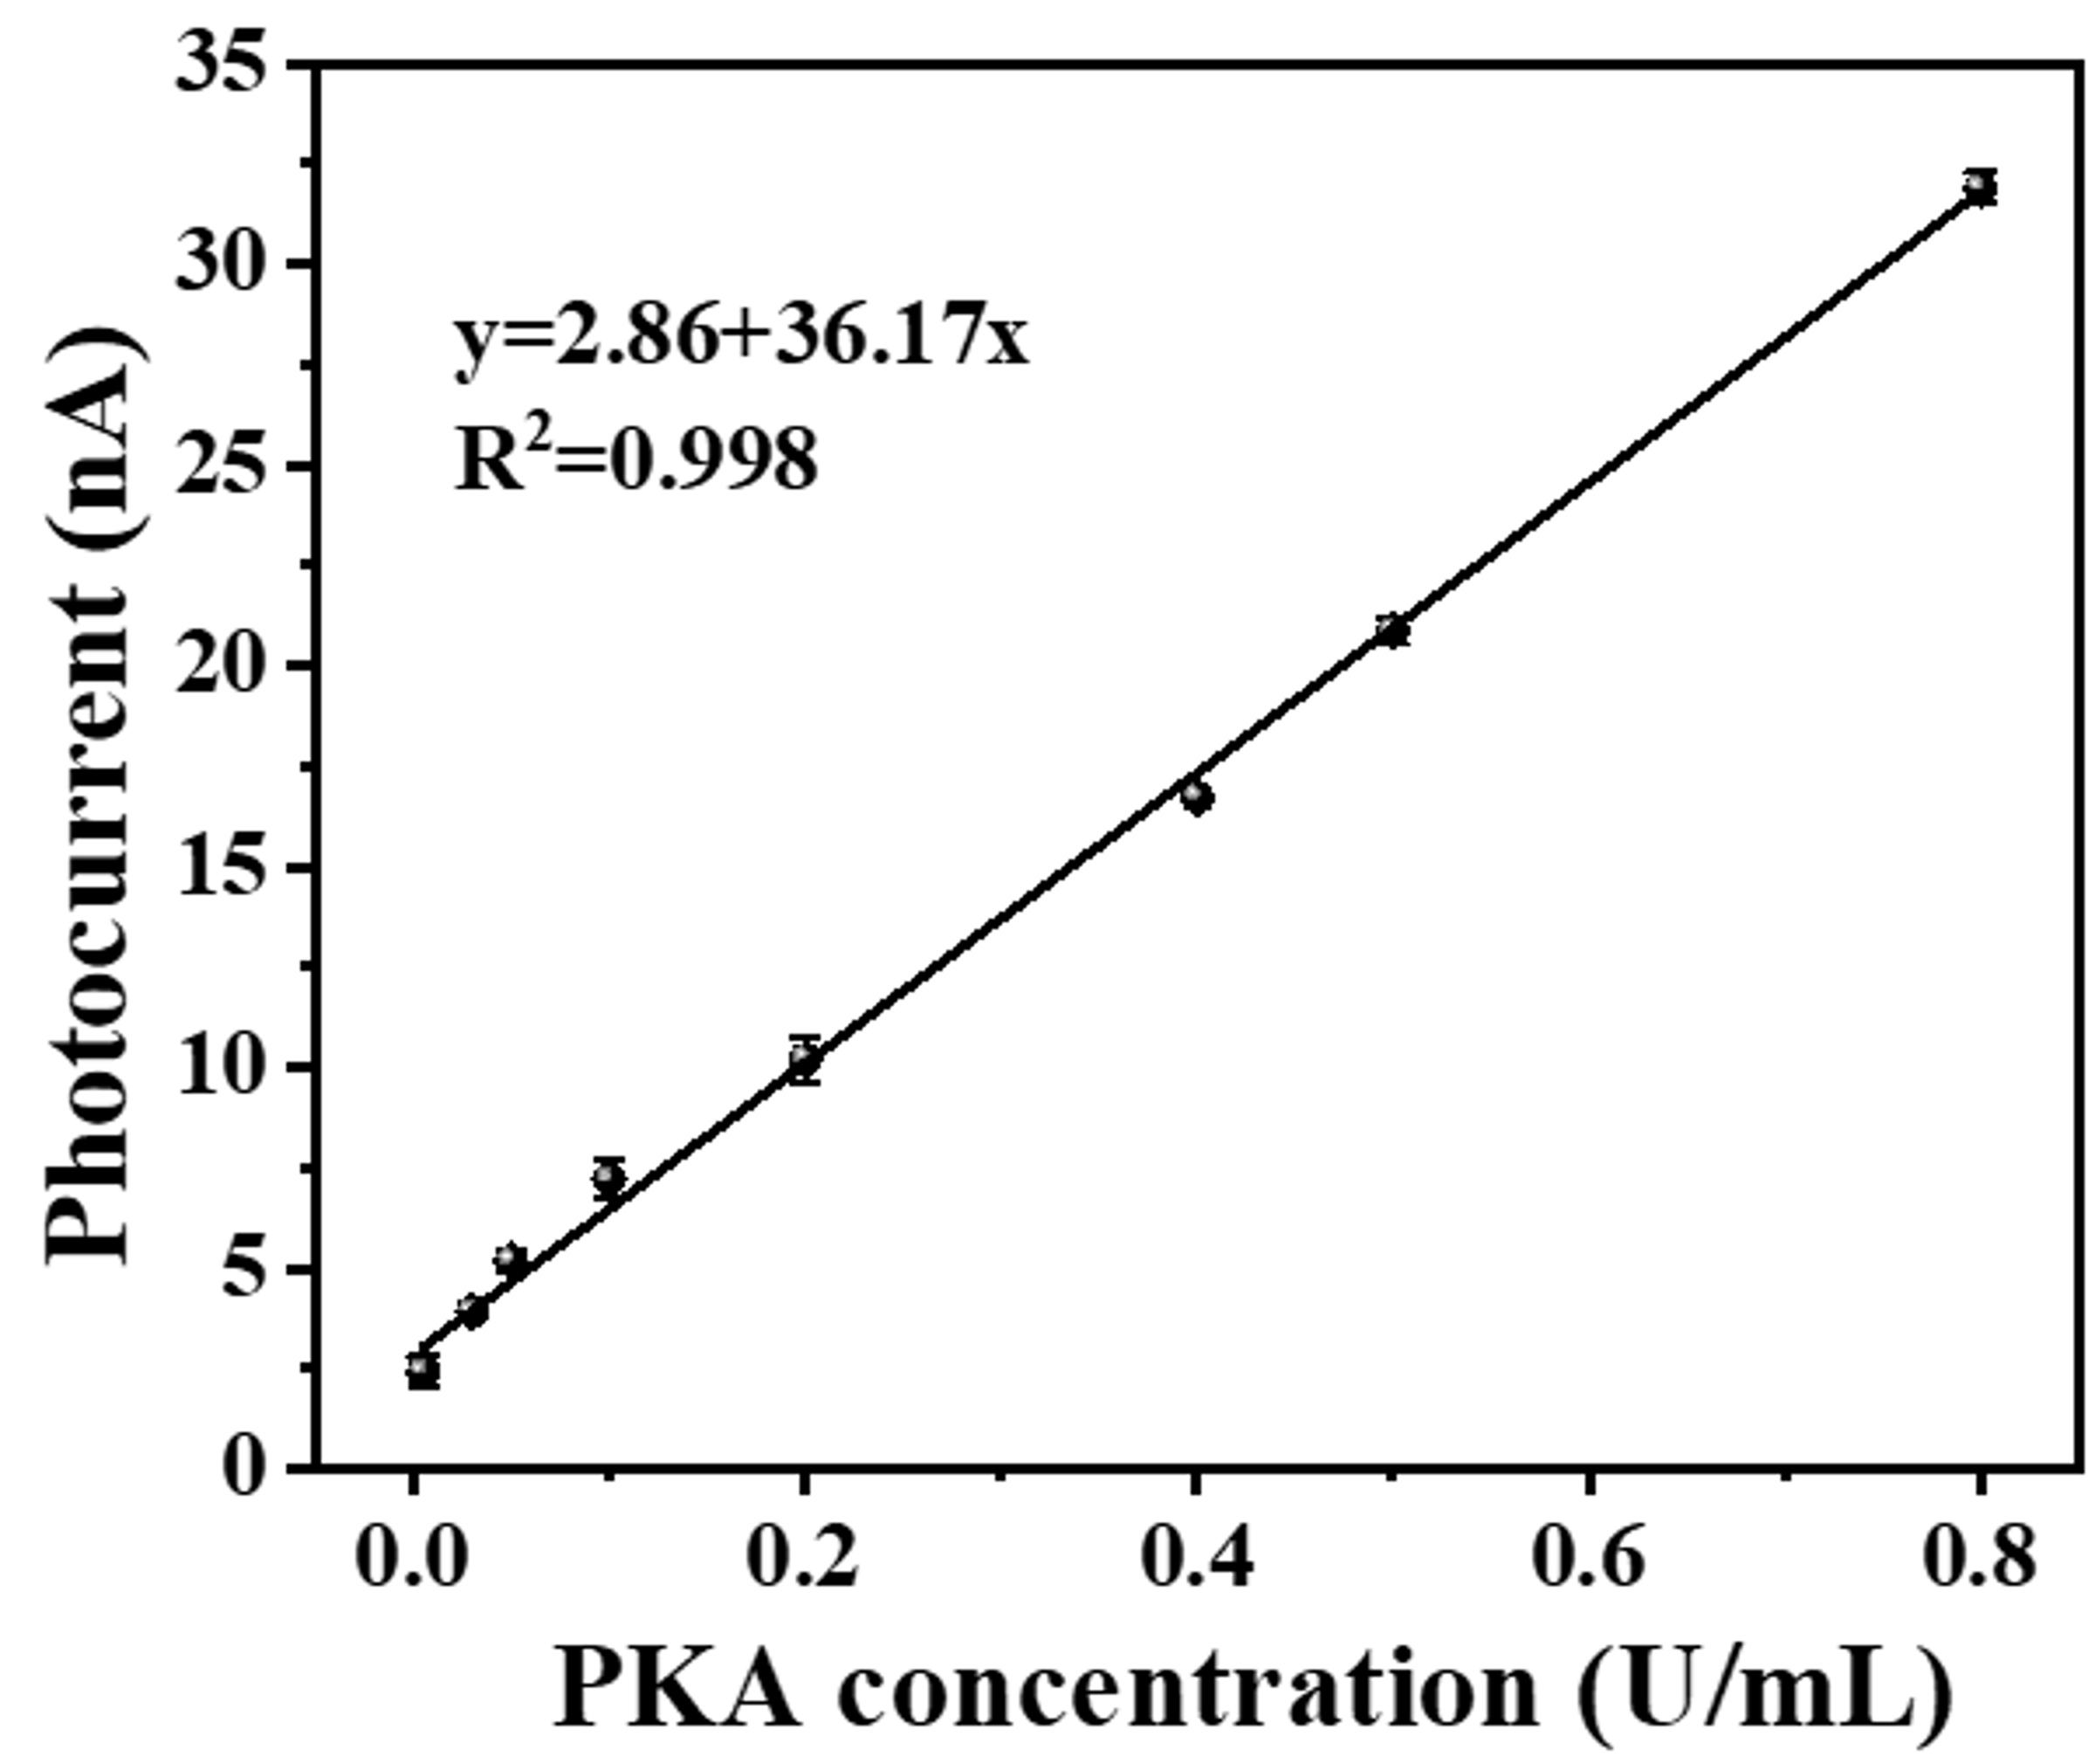
Fig. S10 The linear relationship between the intensity of the photocurrent changes and the PKA concentration without magnetic field. The PKA concentration within the range of 0.005 to 1 U/mL had a linear fitting function of y = 2.86 + 36.17x (where y represents photocurrent intensity and x represents PKA concentration), with a correlation coefficient of R² = 0.998.
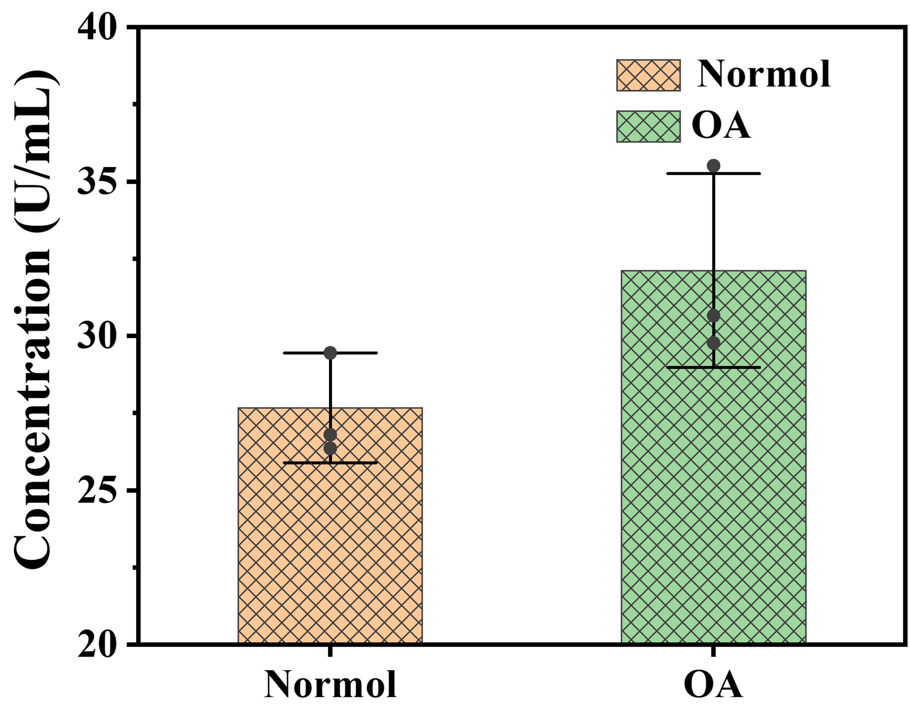
Fig. S11 The detection of PKA concentration in the synovial fluid (diluted 500 times) of normal individuals and osteoarthritis patients using an Elisa kit. The results indicated that the biological activity of PKA in the synovial fluid of osteoarthritis patients is significantly increased
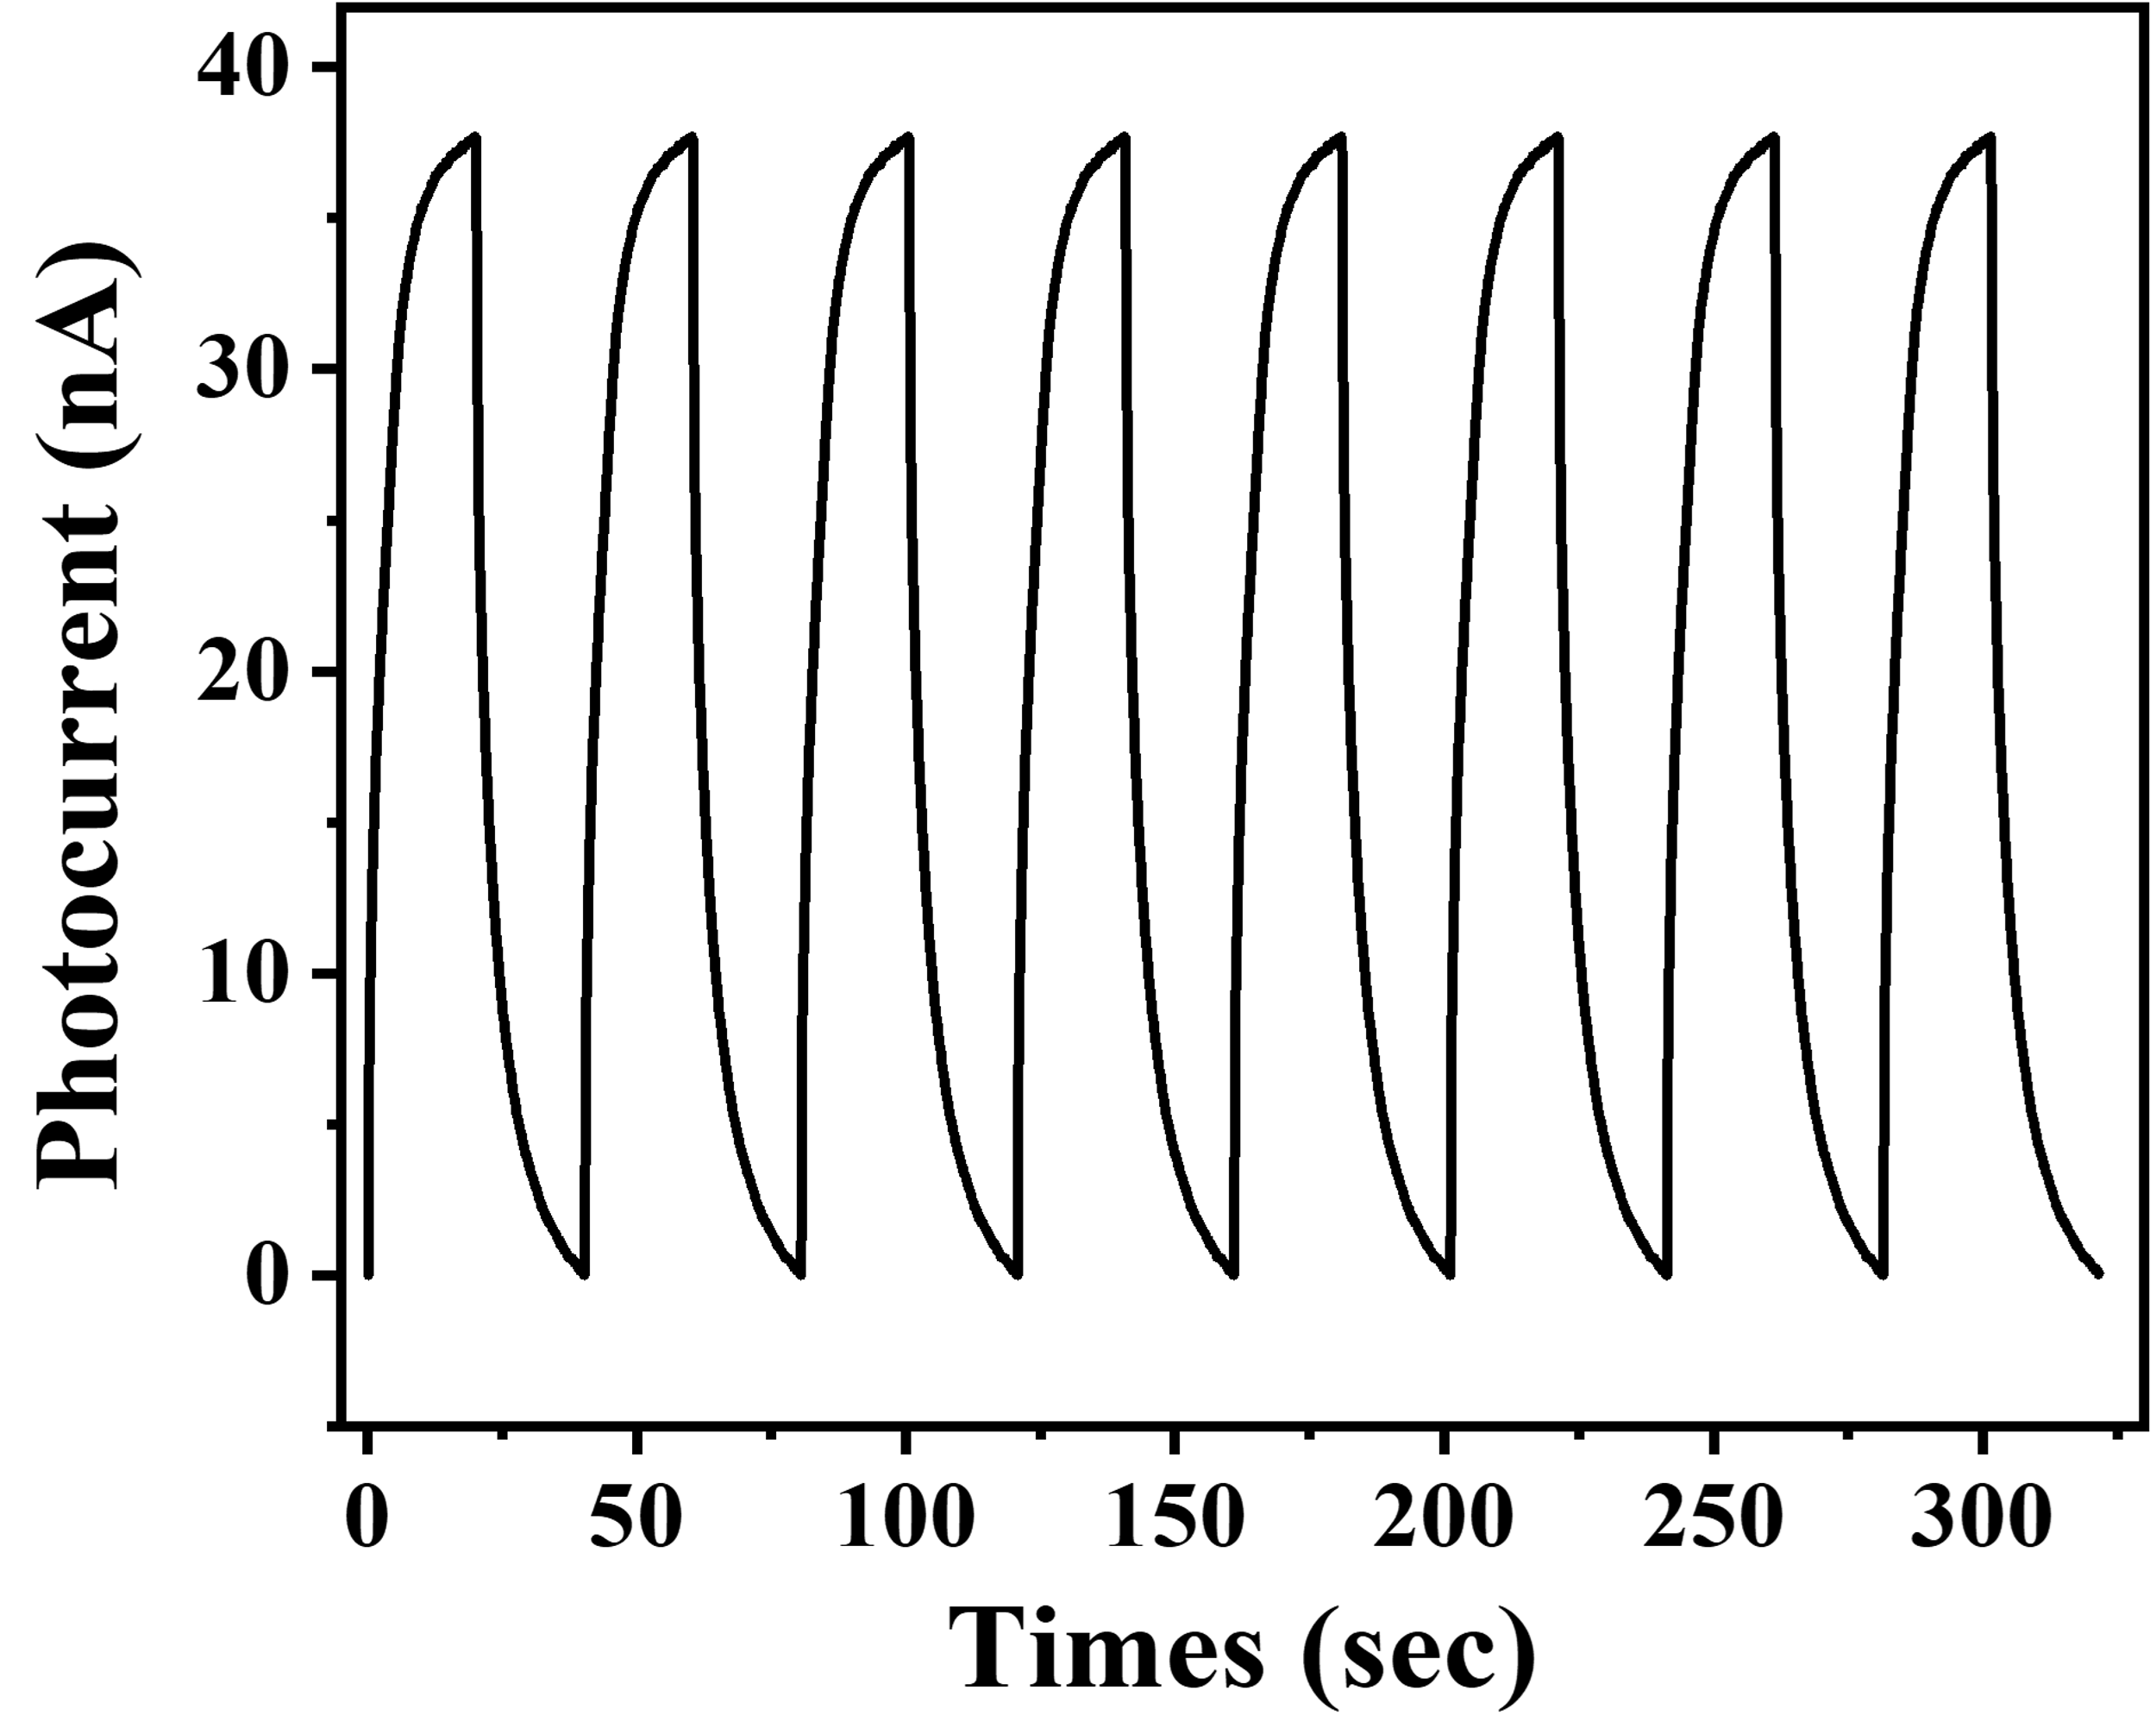
Fig. S12 8-cycle response curve of the PEC biosensor. The PKA concentration was 0.5 U/mL. The results showed a low relative standard deviation (RSD) of 0.33%.
Table 1 Comparison of various methods for PKA activity assay
Method | Linear range (U/mL) | Detection limit (U/mL) | Reference
Colorimetry | 0-0.5 | 0.0375 | ⁴
Fluorescence | 0-1000 | 0.5 | ⁵
Fluorescence | 0-800 | 0.5 | ⁶
Electrochemiluminescence | 0.07-32 | 0.07 | ⁷
Quartz crystal microbalance | 0.64-22.33 | 0.061 | ⁸
Electrochemistry | 0.05-100 | 0.014 | ⁹
Electrochemistry | 0.005-50 | 0.002 | ¹⁰
PEC method | 0.005-0.0625 | 0.0049 | ¹¹
PEC method | 0.05-100 | 0.048 | ¹²
PEC method | 0.05-50 | 0.017 | ¹³
PEC method | 0.001-100 | 0.00035 | ¹⁴
PEC method | 0.008-80 | 0.005 | ¹⁵
PEC method | 0.005-50 | 0.0049 | ¹⁶
PEC method | 0.015-60 | 0.009 | ¹⁷
PEC method | 0.004-90 | 0.0026 | ¹⁸
This work | 0.005-80 | 0.00027 | without MF
This work | 0.005-80 | 0.00016 | With MF

References
1. Li, M. et al. Enhanced Salinity Gradient Energy Conversion by Photodegradable MXene/TiO₂ Membrane Utilizing Saline Dye Wastewater. Adv. Funct. Mater. 35, 2414342 (2025).
2. Perdew, J. P., Burke, K. & Ernzerhof, M. Generalized Gradient Approximation Made Simple. Phys. Rev. Lett. 77, 3865–3868 (1996).
3. Kresse, G. & Joubert, D. From ultrasoft pseudopotentials to the projector augmented wave method. Phys. Rev. B 59, 1758–1775 (1999).
4. Shen, C. et al. Colorimetric and electrochemical determination of the activity of protein kinase based on retarded particle growth due to binding of phosphorylated peptides to DNA – capped silver nanoclusters. Microchim. Acta 183, 2933–2939 (2016).
5. Lu, G. et al. Fluorescent detection of protein kinase based on positively charged gold nanoparticles. Talanta 128, 360–365 (2014).
6. Tan, P. et al. Fluorescent detection of protein kinase based on zirconium ions immobilized magnetic nanoparticles. Anal. Chim. Acta 780, 89–94 (2013).
7. Xu, S., Liu, Y., Wang, T. & Li, J. Highly Sensitive Electrogenerated Chemiluminescence Biosensor in Profiling Protein Kinase Activity and Inhibition Using Gold Nanoparticle as Signal Transduction Probes. Anal. Chem. 82, 9566–9572 (2010).
8. Xu, X. et al. Aptameric Peptide for One-Step Detection of Protein Kinase. Anal. Chem. 84, 4746–4753 (2012).
9. Zhou, Y. et al. Electrochemical biosensor for protein kinase A activity assay based on gold nanoparticles-carbon nanospheres, phos-tag-biotin and β-galactosidase. Biosens. Bioelectron. 86, 508–515 (2016).
10. Shen, C. et al. A single electrochemical biosensor for detecting the activity and inhibition of both protein kinase and alkaline phosphatase based on phosphate ions induced deposition of redox precipitates. Biosens. Bioelectron. 85, 220–225 (2016).
11. Wang, Z. et al. Highly sensitive photoelectrochemical biosensor for kinase activity detection and inhibition based on the surface defect recognition and multiple signal amplification of metal-organic frameworks. Biosens. Bioelectron. 97, 107–114 (2017).
12. Li, X., Zhu, L., Zhou, Y., Yin, H. & Ai, S. Enhanced Photoelectrochemical Method for Sensitive Detection of Protein Kinase A Activity Using TiO₂/g-C₃N₄, PAMAM Dendrimer, and Alkaline Phosphatase. Anal. Chem. 89, 2369–2376 (2017).
13. Sui, C. et al. Photoelectrochemical determination of the activity of protein kinase A by using g-C₃N₄ and CdS quantum dots. Microchim. Acta 185, 541 (2018).
14. Xiao, K. et al. A label-free photoelectrochemical biosensor with near-zero-background noise for protein kinase A activity assay based on porous ZrO₂/CdS octahedra. Sens. Actuators B Chem. 328, 129096 (2021).
15. Yan, Z., Wang, Z., Miao, Z. & Liu, Y. Dye-Sensitized and Localized Surface Plasmon Resonance Enhanced Visible-Light Photoelectrochemical Biosensors for Highly Sensitive Analysis of Protein Kinase Activity. Anal. Chem. 88, 922–929 (2016).
16. Wang, Z. Highly sensitive photoelectrochemical biosensor for kinase activity detection and inhibition based on the surface defect recognition and multiple signal amplification of metal-organic frameworks. Biosens. Bioelectron. 97, 107–114 (2017).
17. Yan, Z. Sensitive electrogenerated chemiluminescence biosensors for protein kinase activity analysis based on bimetallic catalysis signal amplification and recognition of Au and Pt loaded metal-organic frameworks nanocomposites. Biosens. Bioelectron. 109, 132–138 (2018).
18. Yan, Z. et al. Sensitive photoelectrochemical biosensors based on AuNPs/MXenes electrode coupled with light-harvesting UiO-66-NH₂ probes for protein kinase detection. Biosens. Bioelectron. X 11, 100204 (2022).

