Supplementary Materials for

Somatostatin neurons in the medial amygdala orchestrate flexible, sex-specific social behavior in male mice

Aroa Mañas-Ojeda et al.

*Corresponding author. Esther Castillo-Gómez. Email: escastil@uji.es

This PDF file includes:

Figs. S1 to S3

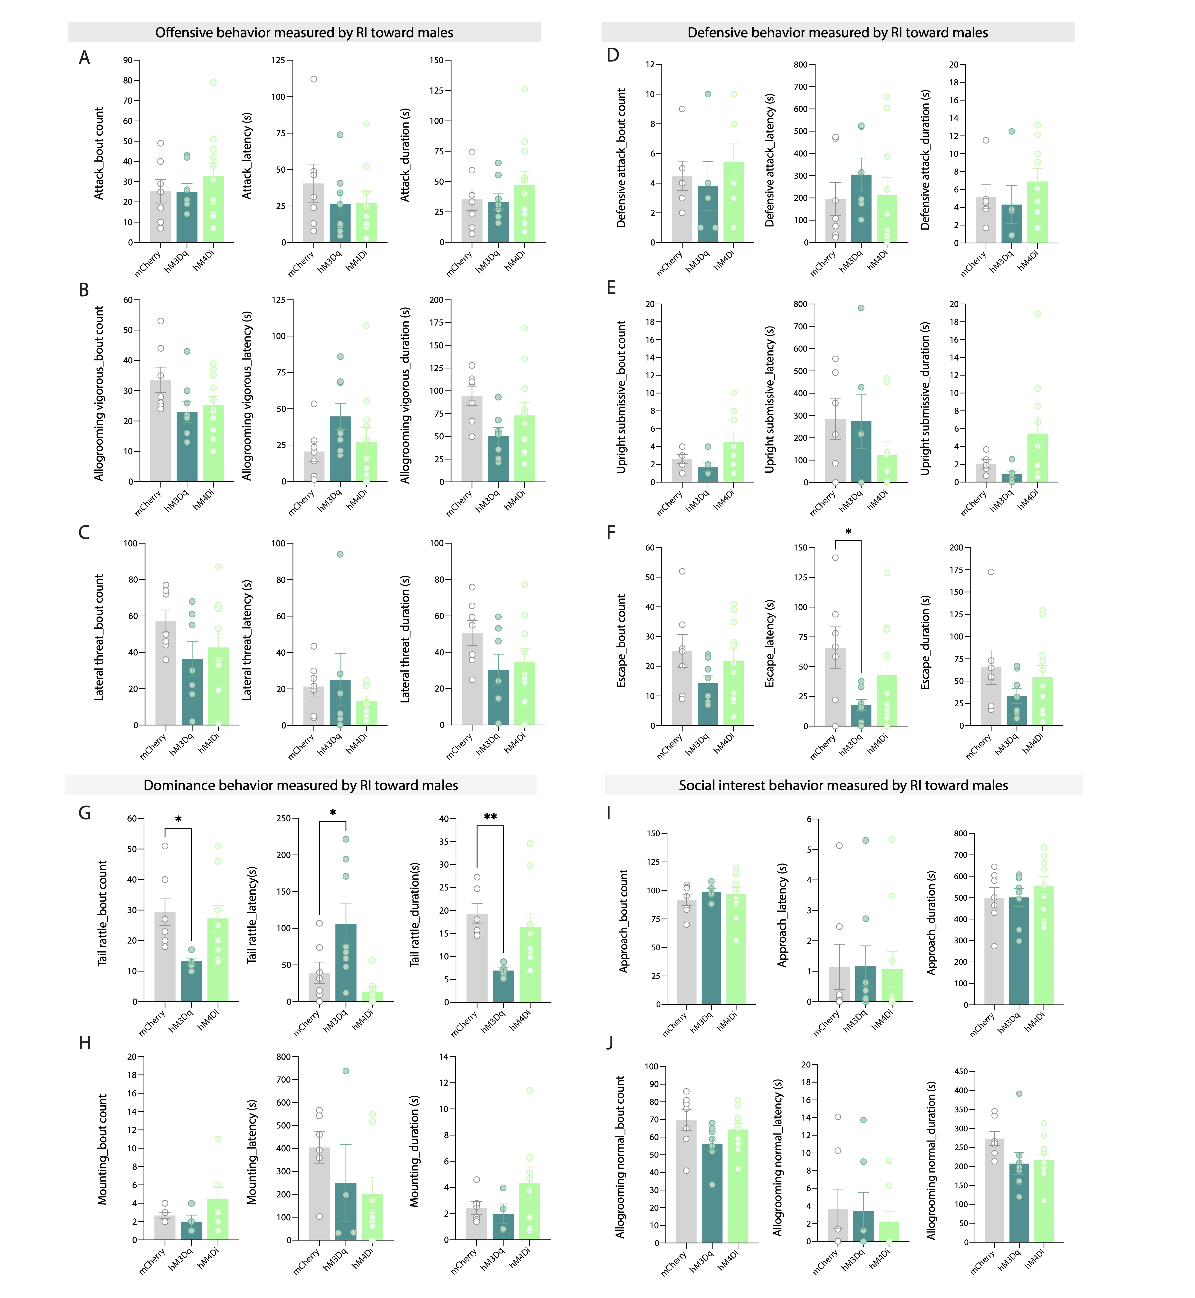

Fig. S1. Detailed results of each classifier considered in the analyses of the resident intruder toward males measuring bout counts, latency to first event and duration parameters.
A-C Offensive behaviour includes A attacks, B allogrooming vigorous, and C lateral threat; D-F Defensive behavior includes D defensive attack, E upright submission, and F escapes; G-H Social dominance includes G tail rattling, and H mounting; and I-J Social interest behavior includes I approach, and J allogrooming normal. Each data point is an individual animal. Data in graph are presented as mean ± SEM (n=7-9/group), one-way analyses of variance (ANOVA), post hoc Bonferroni test; *p<0.05; **<p<0.01.

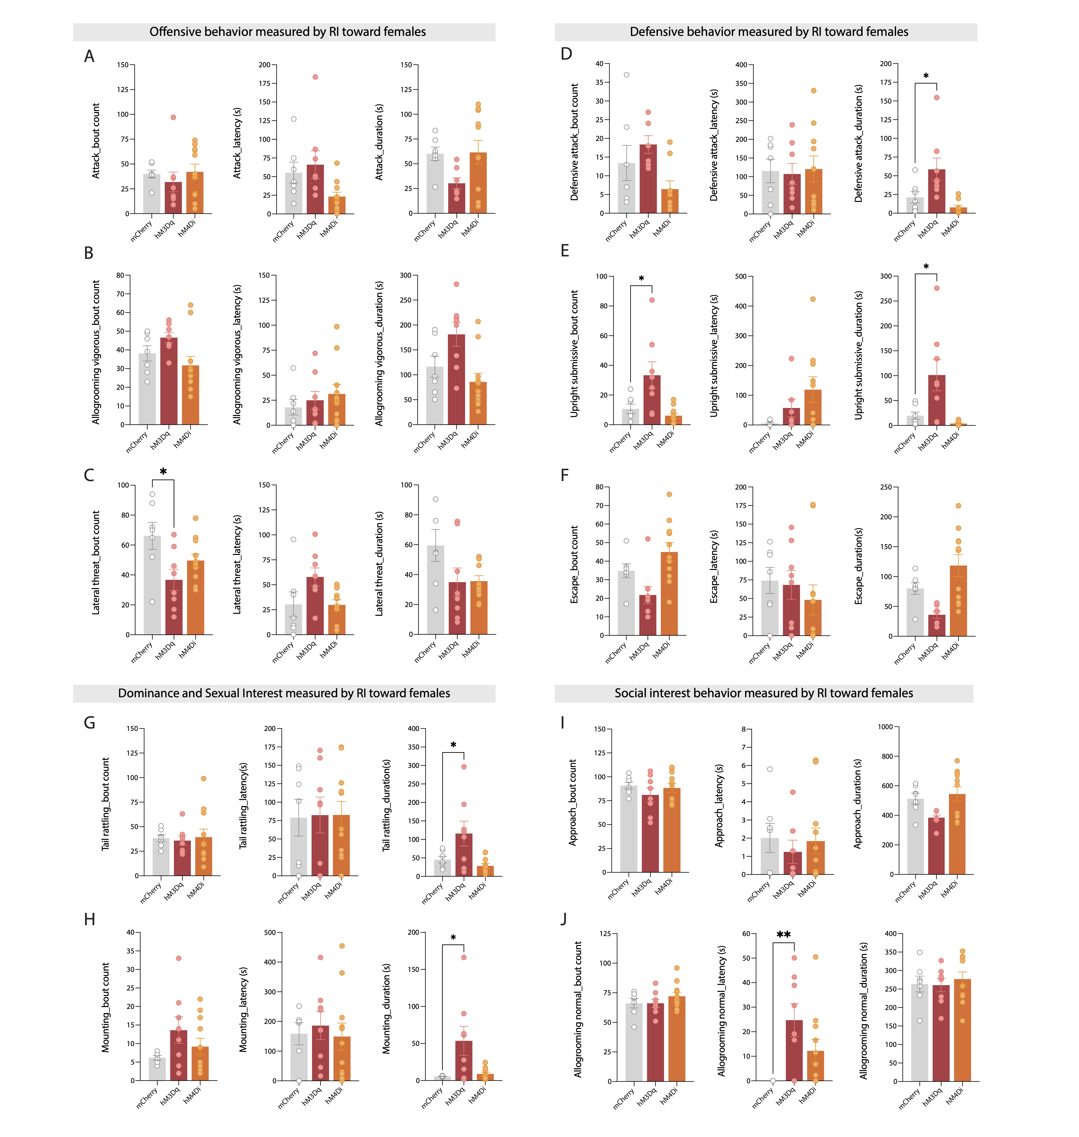

Fig. S2. Detailed results of each classifier considered in the analyses of the resident intruder toward females measuring bout counts, latency to first event and duration parameters.
A-C Offensive behaviour includes A attacks, B allogrooming vigorous, and C lateral threat; D-F Defensive behavior includes D defensive attack, E upright submission, and F escapes; G-H Dominance and sexual interest includes G tail rattling, and H mounting; and I-J Social interest behavior includes I approach, and J allogrooming normal. Each data point is an individual animal. Data in graph are presented as mean ± SEM (n=7-9/group), one-way analyses of variance (ANOVA), post hoc Bonferroni test; *p<0.05; **<p<0.01.

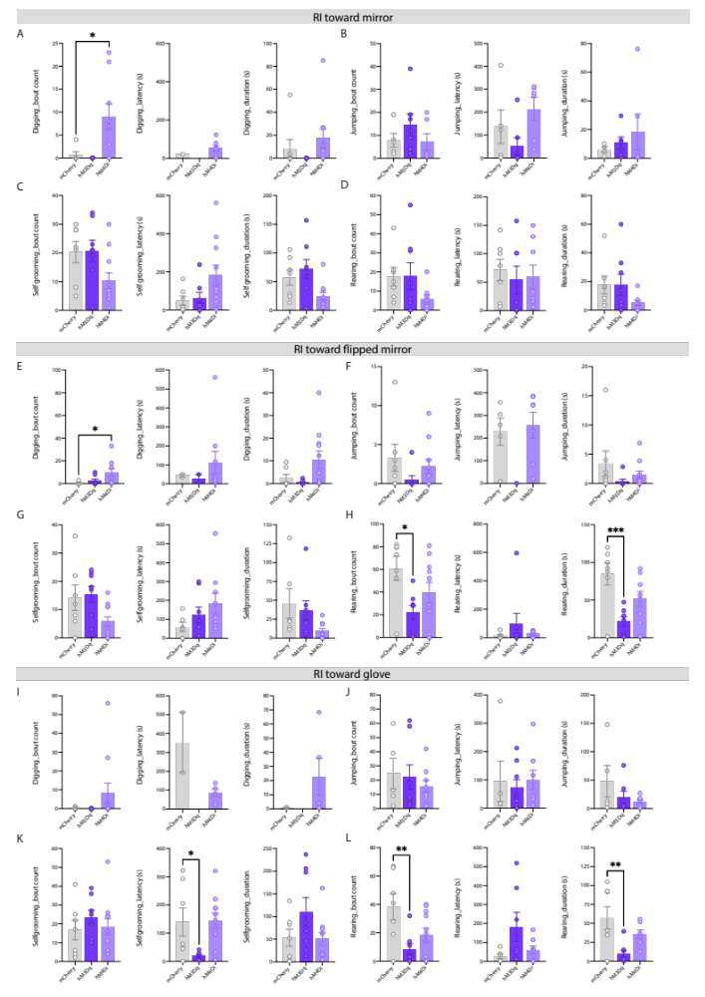
Fig. S3. Resident intruder toward inanimate objects-extended classifiers.
A-L Bar graphs with dots showing different classifiers considered in the analyses of the RI in non-social contexts with bout counts, latency to first event and duration as parameters measured. A-D RI toward mirror classifiers: A digging, B jumping, C self-grooming, D rearing. E-H RI toward flipped mirror classifiers: E digging, F jumping, G self-grooming, H rearing. I-L RI toward glove classifiers: I digging, J jumping, K self-grooming, L rearing. Each data point is an individual animal. Data in graph are presented as mean ± SEM (n=7-9/group), one-way analyses of variance (ANOVA), post hoc Bonferroni test; *p<

