Supplementary Material
EDRs were obtained using a publicly available repository (https://github.com/rmabreu/Respiratory_Signal_Estimation) which includes methods from 7 categories: ECG envelope (ENV), heart-rate variability (HRV), amplitude modulation (AM), QRS-area modulation (QRS-AM), principal component analysis (PCA), kernel PCA (kPCA), and empirical mode decomposition (EMD), previously described in the work by Abreu et al. (2017). For each category, we identified the EDR method that achieved the highest correlation with the respiratory signal (Resp) using the optimal lag for each task. The final method selected for each category was determined by majority vote across the three tasks. The maximum correlation values for all EDR methods regarding each task are shown in Figures S1-S3.
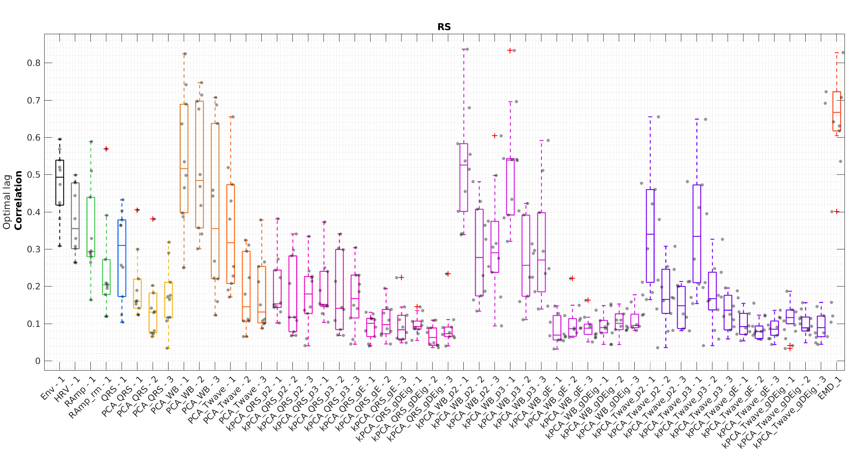

Figure S1 – RS: Distribution of maximum correlation values between each ECG-derived respiration (EDR) method and the recorded respiratory signal, calculated using the optimal lag within a range of –5 to 5 seconds for each subject. AMP methods are labeled based on whether an ECG baseline removal step is applied: RAmp without baseline removal and RAmp_rm with baseline removal. PCA- and kPCA-based methods are labeled according to the part of the heartbeat used: QRS (QRS complex), WB (whole beat), and Twave (T wave). For these two methods, numbers 1–3 indicate the first three extracted components. In the case of kPCA, p2 and p3 denote the use of second-order and third-order polynomial kernels, respectively; gE denotes the maximum entropy approach, and gDEig indicates computations based on eigenvalues.
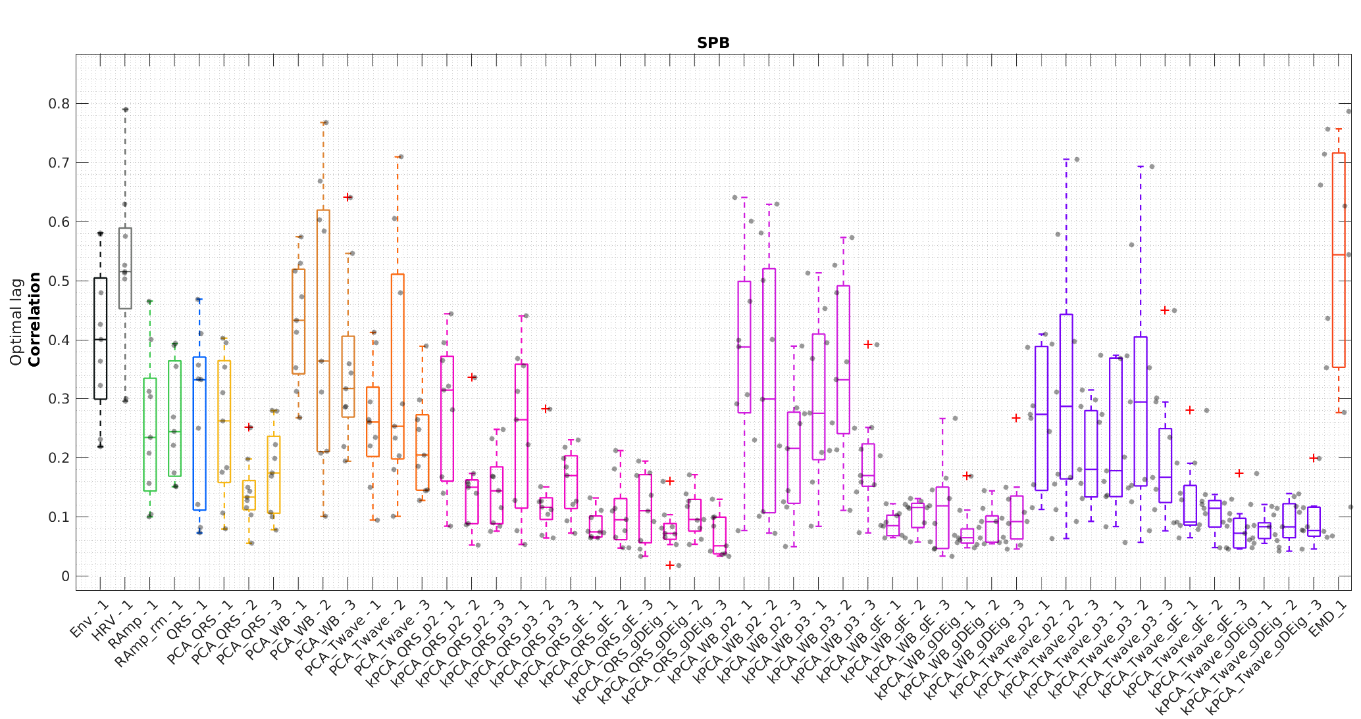

Figure S2 – SPB: Distribution of maximum correlation values between each ECG-derived respiration (EDR) method and the recorded respiratory signal, calculated using the optimal lag within a range of –5 to 5 seconds for each subject. AMP methods are labeled based on whether an ECG baseline removal step is applied: RAmp without baseline removal and RAmp_rm with baseline removal. PCA- and kPCA-based methods are labeled according to the part of the heartbeat used: QRS (QRS complex), WB (whole beat), and Twave (T wave). For these two methods, numbers 1–3 indicate the first three extracted components. In the case of kPCA, p2 and p3 denote the use of second-order and third-order polynomial kernels, respectively; gE denotes the maximum entropy approach, and gDEig indicates computations based on eigenvalues.

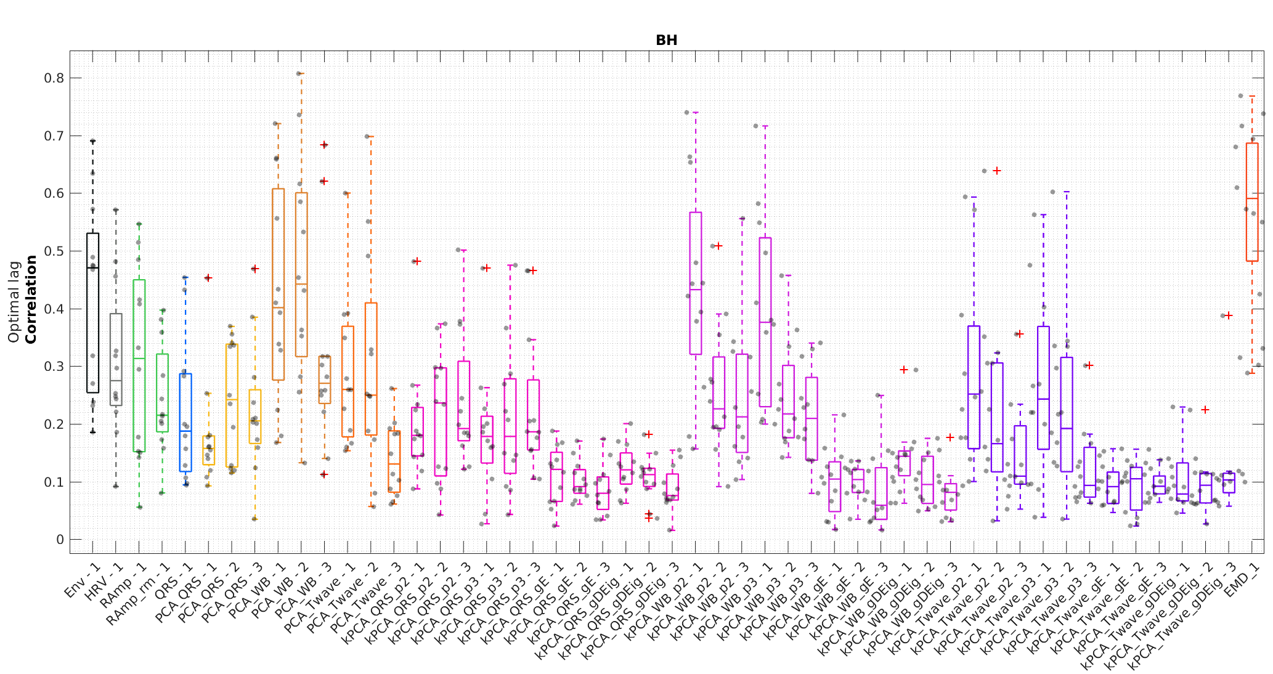
Figure S3 – BH: Distribution of maximum correlation values between each ECG-derived respiration (EDR) method and the recorded respiratory signal, calculated using the optimal lag within a range of –5 to 5 seconds for each subject. AMP methods are labeled based on whether an ECG baseline removal step is applied: RAmp without baseline removal and RAmp_rm with baseline removal. PCA- and kPCA-based methods are labeled according to the part of the heartbeat used: QRS (QRS complex), WB (whole beat), and Twave (T wave). For these two methods, numbers 1–3 indicate the first three extracted components. In the case of kPCA, p2 and p3 denote the use of second-order and third-order polynomial kernels, respectively; gE denotes the maximum entropy approach, and gDEig indicates computations based on eigenvalues.

