### Supplementary Information ###
The ligand–protein RMSD plots and interaction timelines from MD simulation replicates #2 and #3.
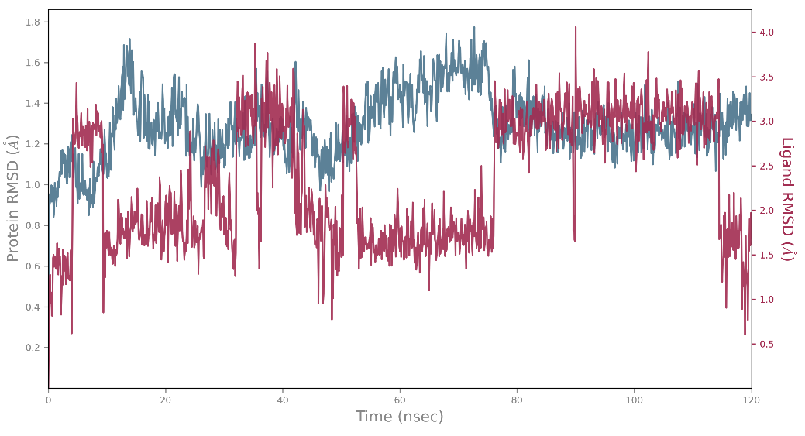
Figure S1. Protein and ligand RMSD values over the 120 ns MD simulation (replicate #2) of the CAS-AKR1C3 complex.
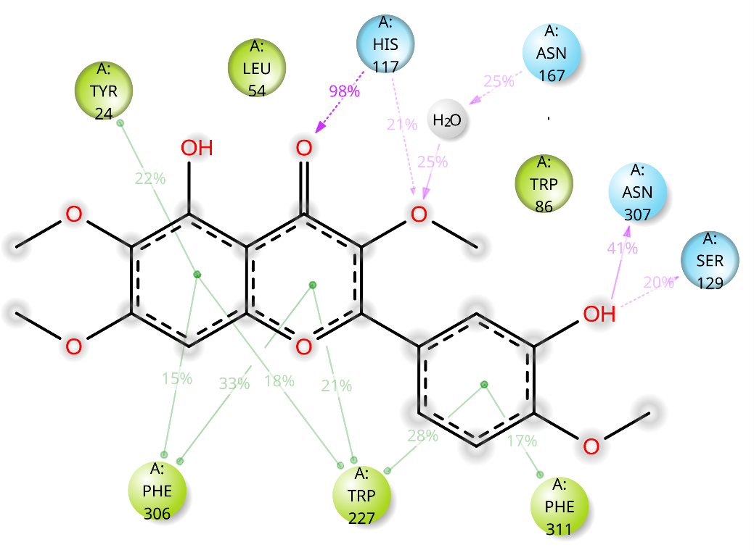

Figure S2. Interaction timeline for the 120 ns MD simulation (replicate #2) of the CAS-AKR1C3 complex.
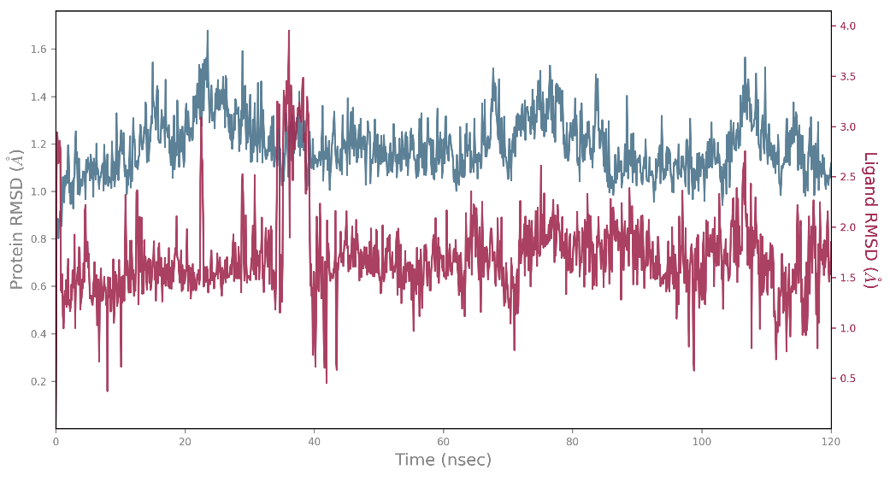
Figure S3. Protein and ligand RMSD values over the 120 ns MD simulation (replicate #3) of the CAS-AKR1C3 complex.
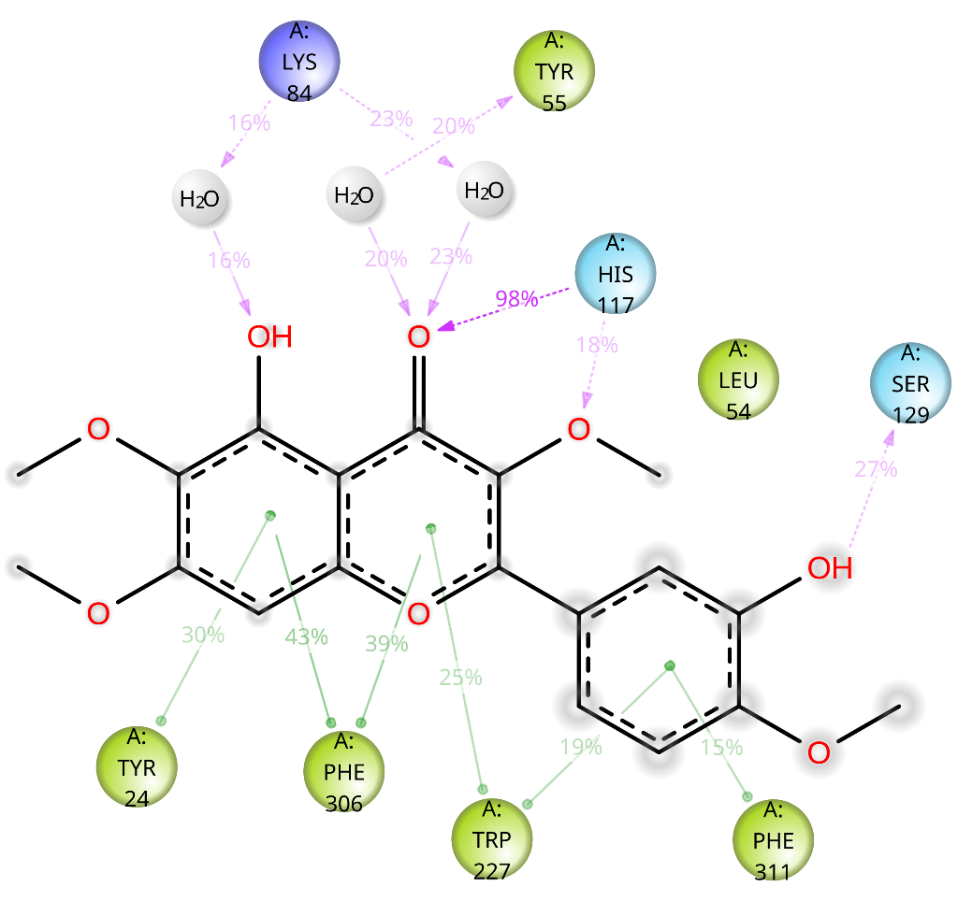
Figure S4. Interaction timeline for the 120 ns MD simulation (replicate #3) of the CAS-AKR1C3 complex.

