Title: Benchmarking model-based design of experiment approaches with a pharmaceutical crystallisation emulator
Journal: “Self-Driving Laboratories for Chemistry and Materials Science” collection in npj Computational Materials
Authors: Thomas Picklesª, Kakasaheb Nandiwale^{b}, Bhavik A. Mehta^{c}, Sammy Sambu^{d}, Jonathan Mooresª, Alastair J. Florence^{a, e}, Cameron J. Brown^{a, e*}
Affiliations: ª Strathclyde Institute of Pharmacy and Biomedical Sciences, University of Strathclyde, Glasgow G4 0RE, UK, ^{b} Chemical Research and Development, Pfizer Worldwide Research and Development, Groton, Connecticut 06340, USA, ^{c} Siemens Industry Software Limited, Process Automation Software, 26-28 Hammersmith Grove, London, U.K, ^{d} UCB Biopharma SRL, Allée de la Recherche 60, B – 1070 Brussels, Belgium, ^{e} EPSRC MediForge Hub, CMAC, University of Strathclyde, Glasgow, G1 1RD, UK.
Email: *cameron.brown.100@strath.ac.uk

1. Introduction
Nothing to add to ESI.

2. Methods

2.1. Self-Driving Crystallisation Lab
A Latin hypercube sampling (LHS) plan was used with ordinal values for most of the input parameters so that the bounds would be selected rather than a continuous value within the range. This helps with parameter estimation in predicted high growth and high nucleation dominating areas. Parameters from the plan are listed in Table 1 along with ‘real terms’ values i.e., a parameter that can be controlled directly via the Scale-up CMC DataFactory™ for example seed SS is linked to seed temperature.

Table 1. LHS design of experiments plan for the 16 experiments.
Exp Num | Exp Name | Mass lovastatin (g) | Mass acetone (g) | Volume acetone (mL) | Mass of water (g) | Volume water (mL) | Conc-init (g/kg solvent) | Cooling Rate (°C/min) | Seed Mass (%) | Seed Mass (g) | Seed Size | Seed SS | Seed Temp (°C) | Antisolvent Flow Rate (mL/min) | Mass of antisolvent (g) | Volume of antisolvent (mL)
1 | PICKL71 | 52.5 | 225 | 287 | 25 | 25 | 210 | 0 | 0 | 0 | small | 1.2 | 40 | 0 | 0 | 0
2 | PICKL77 | 52.5 | 225 | 287 | 25 | 25 | 210 | 0.25 | 1 | 0.525 | big | 1.22 | 40 | 6 | 250 | 251
3 | PICKL78 | 52.5 | 225 | 287 | 25 | 25 | 210 | 0.5 | 5 | 2.625 | small | 1.24 | 39 | 10 | 250 | 251
4 | PICKL86 | 52.5 | 225 | 287 | 25 | 25 | 210 | 0.25 | 5 | 2.625 | big | 1.26 | 39 | 3 | 250 | 251
5 | PICKL80 | 52.5 | 225 | 287 | 25 | 25 | 210 | 0.5 | 0 | 0 | small | 1.912251 | 27.5* | 6 | 250 | 251
6 | PICKL72 | 52.5 | 225 | 287 | 25 | 25 | 210 | 0 | 1 | 0.525 | big | 1.3 | 38 | 0 | 0 | 0
7 | PICKL87 | 52.5 | 225 | 287 | 25 | 25 | 210 | 0.25 | 1 | 0.525 | small | 1.32 | 37 | 3 | 250 | 251
8 | PICKL73 | 52.5 | 225 | 287 | 25 | 25 | 210 | 0 | 5 | 2.625 | big | 1.34 | 37 | 0 | 0 | 0
9 | PICKL83 | 52.5 | 225 | 287 | 25 | 25 | 210 | 0.5 | 0 | 0 | small | 1.447779 | 35* | 10 | 250 | 251
10 | PICKL74 | 52.5 | 225 | 287 | 25 | 25 | 210 | 0 | 1 | 0.525 | small | 1.38 | 36 | 0 | 0 | 0
11 | PICKL89 | 52.5 | 225 | 287 | 25 | 25 | 210 | 0.5 | 5 | 2.625 | small | 1.4 | 36 | 3 | 250 | 251
12 | PICKL85 | 52.5 | 225 | 287 | 25 | 25 | 210 | 0.25 | 0 | 0 | big | 1.94084 | 27.1* | 10 | 250 | 251
13 | PICKL75 | 52.5 | 225 | 287 | 25 | 25 | 210 | 0 | 5 | 2.625 | small | 1.44 | 35 | 0 | 0 | 0
14 | PICKL84 | 52.5 | 225 | 287 | 25 | 25 | 210 | 0.25 | 0 | 0 | big | 1.447779 | 35* | 6 | 250 | 251
15 | PICKL90 | 52.5 | 225 | 287 | 25 | 25 | 210 | 0.5 | 1 | 0.525 | small | 1.48 | 34 | 3 | 250 | 251
16 | PICKL76 | 52.5 | 225 | 287 | 25 | 25 | 210 | 0 | 1 | 0.525 | big | 1.5 | 34 | 0 | 0 | 0
*Unseeded therefore seed temperature was extracted from result (not the LHS planned temperature)

2.2. Population Balance Model (gPROMS) & Simulation
Nothing to add to ESI.

2.3. Benchmark Function
Nothing to add to ESI.

2.4. Experimental Design & Optimisation
Nothing to add to ESI.

3. Results

3.1. Population Balance Model & Simulation
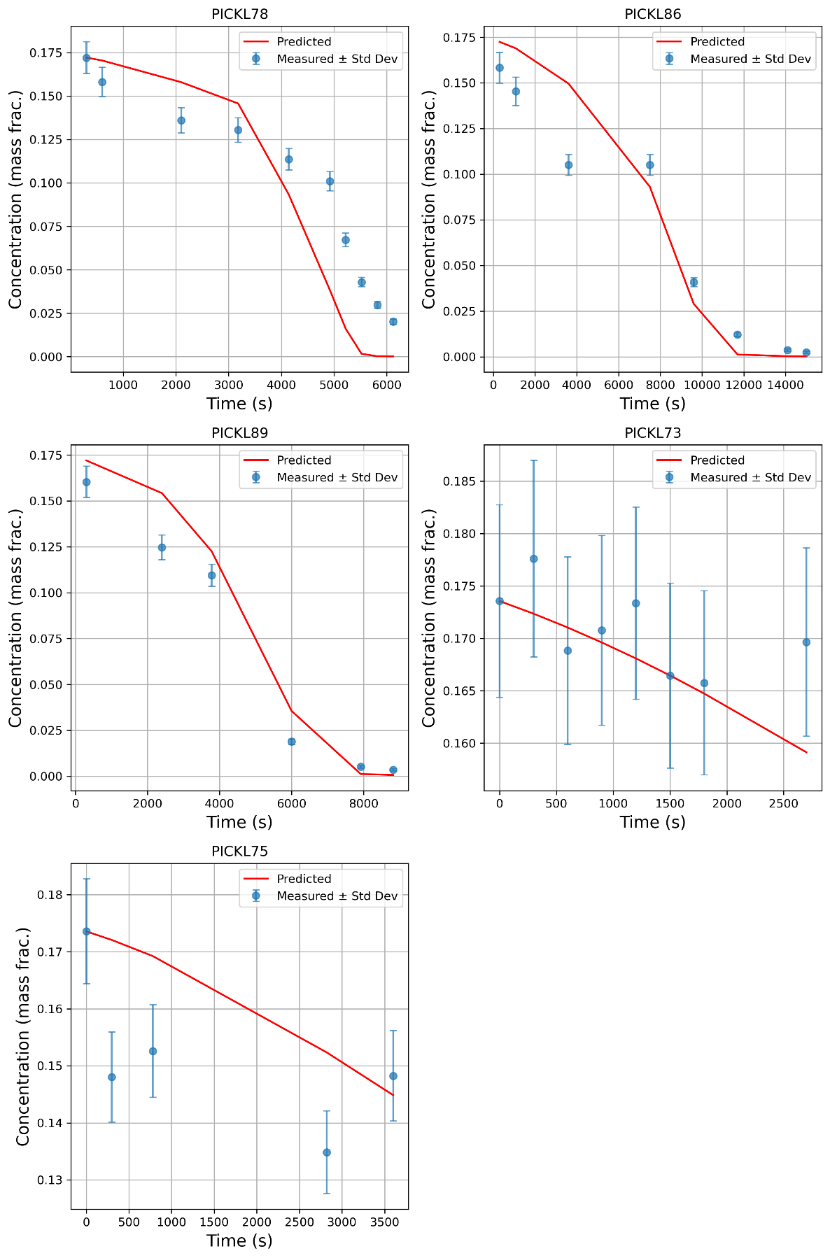
Figure 1. Measured and best fit predicted concentration trends for experiments with high seed loading to calibrate growth model parameters.
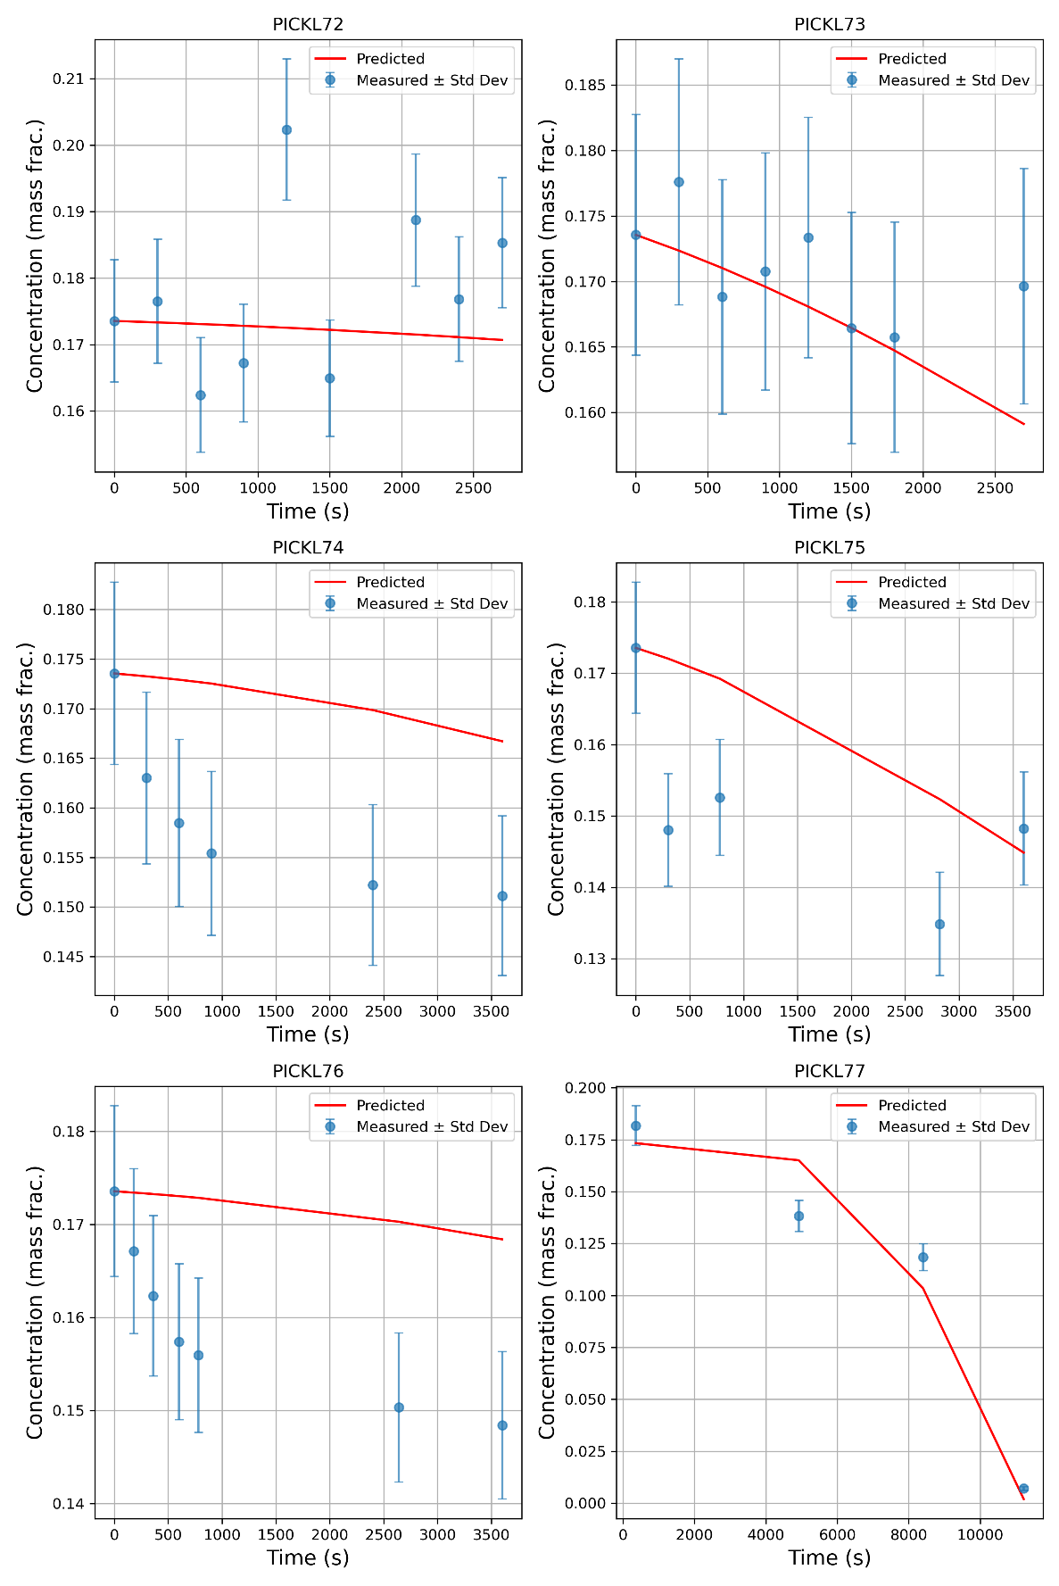
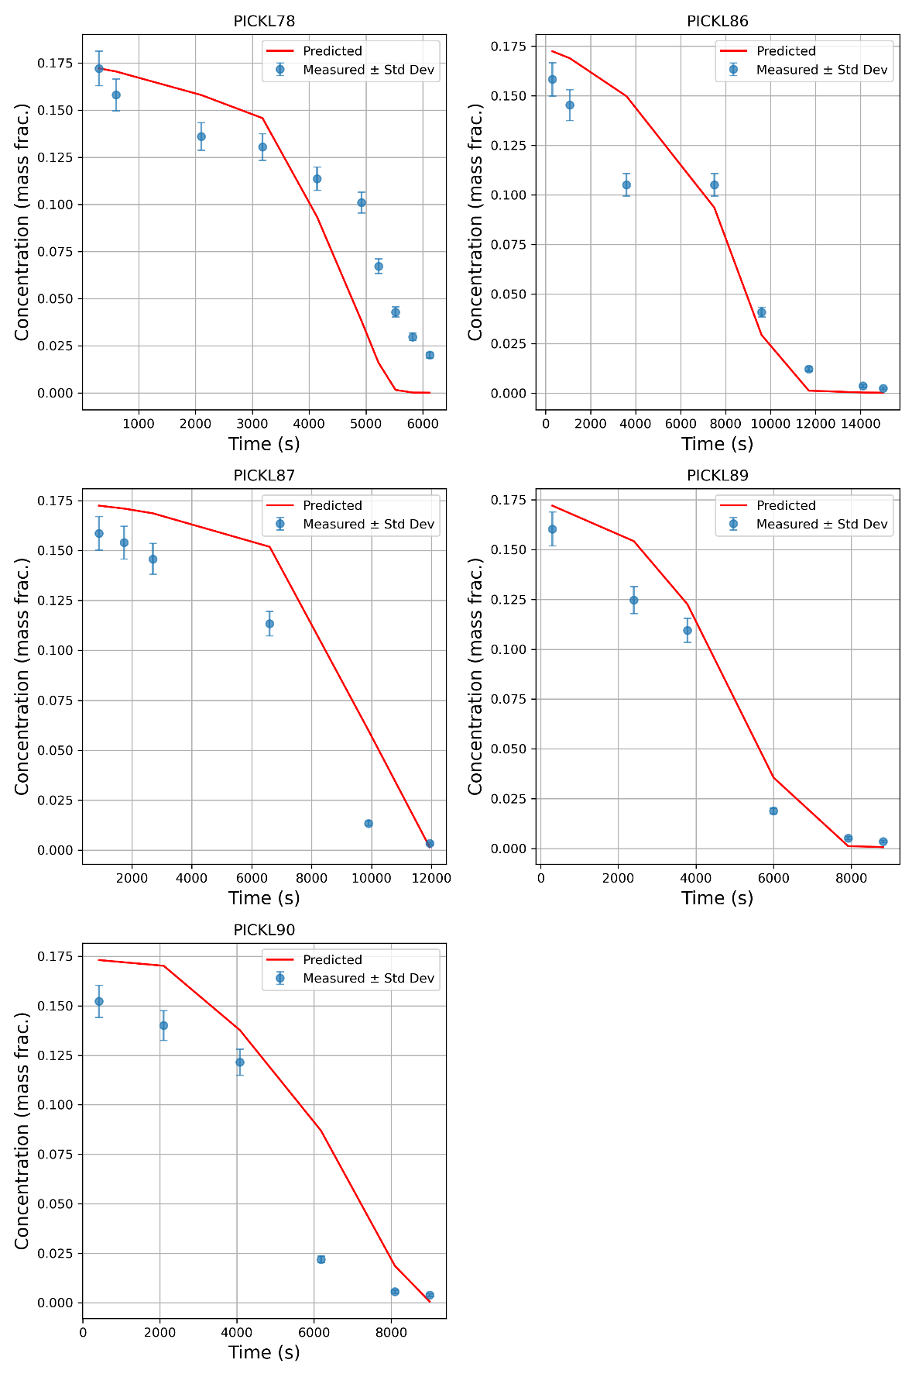
Figure 2. Measured and predicted concentration trends for low seed loading experiments assuming a growth only model.

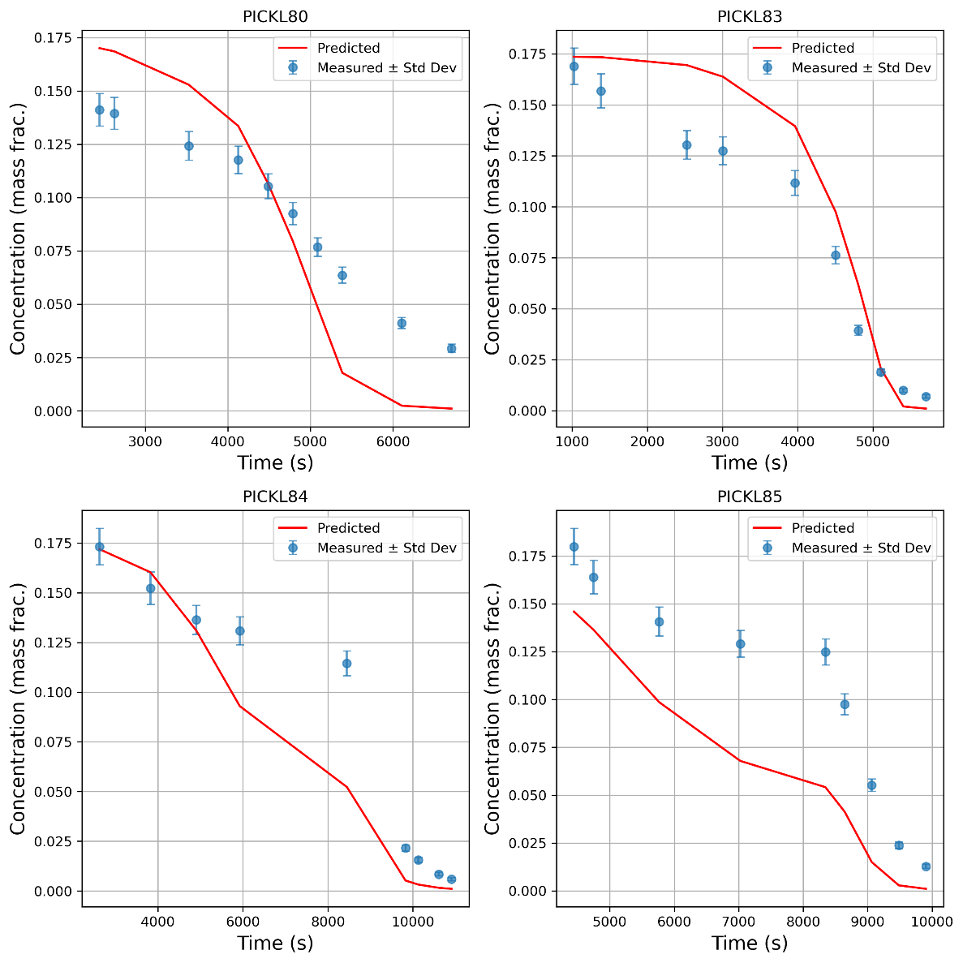
Figure 3. Measured and best fit predicted concentration trends for unseeded experiments to calibrate primary nucleation model parameters.

3.2. Benchmark Function – Random Forest
Nothing to add to ESI.

3.3. Experimental Design & Optimisation
Nothing to add to ESI.

4. Discussion
Nothing to add to ESI.

