Electronic Supplementary Information

The turn-on type fluorescent photochromism of diarylmaleimide-S,S,S’,S’-tetraoxide

Kai Nishikawa¹ and Takashi Ubukata^{2,3}*

¹Department of Chemistry and Life Science, Graduate School of Engineering Science,
Yokohama National University,
79-5, Tokiwadai, Hodogaya-ku, Yokohama 240-8501 Japan.
²Faculity of Engineering, Yokohama National University,
79-5, Tokiwadai, Hodogaya, Yokohama, Kanagawa 240-8501 Japan.
³Typhoon Science and Technology Research Center (TRC),
Institute for Multidisciplinary Sciences (IMS), Yokohama National University,
79-5, Tokiwadai, Hodogaya, Yokohama, Kanagawa 240-8501 Japan.

E-mail: ubukata-takashi-wy@ynu.ac.jp

Contents

1. Experimental details S-2
2. Synthesis procedure of 1o and 2o S-3
3. ¹H NMR and ¹³C NMR spectra S-7
4. APCI-TOF Mass spectra S-11
5. Absorption spectral change of 1o upon 436-nm light irradiation in each solvent S-12
6. Absorption spectral change of PSS₄₃₆ of 1 upon 550-nm light irradiation in each solvent S-13
7. Absorption spectral change of 2o upon 365-nm light irradiation in each solvent S-13
8. Absorption spectral change of PSS₃₆₅ of 2 upon 436-nm light irradiation in ethanol S-14
9. Fluorescence spectral change of 1o upon 436-nm light irradiation in toluene S-14
10. Fluorescence spectral change of 2o upon 365-nm light irradiation in each solvent S-14
11. Excitation spectral change of 1o upon 436-nm light irradiation in toluene S-15
12. Excitation spectrum of 2o upon 365-nm light irradiation in toluene S-15
13. HPLC chromatogram change of 2 in each solvent S-15
14. Calculation of the quantum yields S-16
15. Results of DFT calculations of 1 and 2 S-17

1. Experimental details
General. All chemical reactions were carried out under a dry argon or nitrogen atmosphere. Solvents were used as received, except for toluene, which was distilled to remove water and oxygen. Flash column chromatography was performed on 5-μm silica gel using toluene or 17% hexane / DCM as eluents. Analytical thin-layer chromatography (TLC) was conducted on the pre-coated silica gel plates (190-290 μm thickness). ¹H NMR and ¹³C NMR spectra were recorded on Bruker DRX500 (500 MHz) or Bruker AVANCE NEO 600 (600 MHz) spectrometers. Chemical shifts in CDCl₃ were referenced to tetramethylsilane (TMS) as an internal standard. The J values are expressed in Hz and quoted chemical shifts are in ppm. Splitting patterns are indicated as s, singlet; t, triplet; h, sextet; m, multiplet. APCI-TOF-mass spectra were obtained using a Hitachi High-Tech Nano Frontier LD. HPLC chromatograms were recorded using a JASCO X-LC system.

Optical measurements. Absorption spectra were recorded using a JASCO V-750 spectrophotometer, and fluorescence spectra were obtained with a JASCO FP-8300 spectrophotometer. Fluorescence quantum yields of 2o were determined using a JASCO FP-8500 spectrophotometer. Photochemical reactions were conducted in a quartz cuvette with a 10-mm path length. Photoirradiation at 365 and 436 nm was performed using a 250-W ultra-high-pressure mercury lamp (Asahi spectra REX-250) equipped with a cold mirror, separated by a glass filter (Asahi spectra LX0365 or LX0436). Photoirradiation at 550 nm was carried out using a 300-W xenon lamp (Asahi spectra MAX-303) equipped with a mirror module (UV-VIS), separated by a glass filter (Asahi spectra IAD MC 550). Photocyclization quantum yield upon irradiation with 365- and 436-nm light and photocycloreversion quantum yield upon irradiation with 436- and 550-nm light were determined with the procedures described elsewhere [1]. Light intensity was measured using a power meter (Newport, 843-R, 918D-UV-OD3R).

Computational details. For structure optimization, density functional theory (DFT) calculations of 1o, 1c, 2o and 2c were carried out with Spartan’24 (Wavefunction Inc.) at ωB97X-D/6-31G* level. Before structure optimization, conformer distribution search was carried out with Spartan’24 (Wavefunction Inc.) by MMFF method.

2. Synthesis procedure of 1o and 2o.
The syntheses of 1o and 2o were carried out according to the following scheme.

Synthesis of 3,4-dibromo-N-methyl maleimide (3) [2]
To a mixture of 3,4-dibromomaleimide (499.5 mg, 1.96 mmol, 1.00 eq) and K₂CO₃ (309.7 mg, 2.24 mmol, 1.14 eq) in dehydrated acetone (15 mL) was added dropwise Me₂SO₄ (0.20 mL, 2.11 mmol, 1.08 eq) in a two-necked flask equipped with a Liebig condenser connected with three-way stopcock with a balloon. The reaction mixture was stirred and refluxed at 60℃ for 45 min. After completion, water was added and the organic components were extracted with diethyl ether three times. The combined organic extracts were dried over anhydrous MgSO₄, filtered, and the solvent evaporated under reduced pressure to afford 3 (288.7 mg, 42%) as yellow needle crystals.
¹H NMR (500 MHz, 20℃, CDCl₃, TMS): δ/ppm = 3.14 (3H, s). (Fig. S1c)
¹³C NMR (126 MHz, 20℃, CDCl₃, TMS): δ/ppm = 25.44 (CH₃), 129.43 (C-Br), 163.98 (C=O). (Fig. S1c)

Synthesis of 2,4-dimethyl-5-phenyl-3-tributylstanylthiophene (4) [3]
To a solution of 3-bromo-2,4-dimethyl-5-phenylthiophene (1.99 g, 7.46 mmol, 1.00 eq) in dehydrated THF (32 mL) in a two-necked flask equipped with three-way stopcock with a balloon was added dropwise n-butyllithium in hexane (1.6 M, 4.9 mL, 7.84 mmol, 1.05 eq) for 20 min with cooling at -78℃, and the resulting solution was stirred at -78℃ for 30 min. To the mixture was added dropwise tributyltin chloride (2.0 mL, 7.37 mmol, 0.99 eq) for 15 min with cooling at -78℃, and the resulting mixture was stirred at -78℃ for 20 min. The mixture was then allowed warm to room temperature and stirred for 1.5 h. After completion, water and hexane were added, and the combined organic layer was washed with water three times. The organic layer was dried over anhydrous MgSO₄, filtered, and concentrated under reduced pressure. The crude product was purified by distillation using a glass-tube oven and Kugelrohr apparatus, to give 4 (1.94 g, 55%) as yellow-brownish oil.
¹H NMR (600 MHz, 20℃, CDCl₃, TMS): δ/ppm = 0.90 (9H, t, J/Hz = 7.3), 1.09-1.12 (6H, m), 1.35 (6H, h, J/Hz = 7.3), 1.51-1.56 (6H, m), 2.26 (3H, s), 2.49 (3H, s), 7.26-7.42 (5H, m). (Fig. S1d)
¹³C NMR (151 MHz, 20℃, CDCl₃, TMS): δ/ppm = 10.89 (CH₃), 13.65 (CH₂), 17.15 (CH₃), 17.42 (CH₃), 27.39 (CH₂), 29.17 (CH₂), 126.67 (CH), 128.27 (CH), 129.42 (CH), 135.28 (C), 135.54 (C), 139.00 (C), 139.78 (C), 143. 86 (C). (Fig. S1d)
HRMS (APCI-TOF) m/z = 421.1008 ([M-R₁]⁺), 291.1120 ([M-R₂]⁺), 235.0493 ([M-R₃+H]⁺) (R₁ = C₄H₉, R₂ = C₁₂H₁₁S, R₃ = C₁₆H₂₀S), exact mass calculated for [M-R₁]⁺ 421.1007, [M-R₂]⁺ 291.1129, [M-R₃+H]⁺ 235.0503. (Fig. S2c)

Synthesis of 1o [3]
To a mixture of 3 (118.9 mg, 0.442 mmol, 1.00 eq), Pd(PPh₃)₄ (51.8 mg, 0.045 mmol, 0.10 eq), and CuI (9.1 mg, 0.048 mmol, 0.11 eq) in dehydrated toluene was added 4 (434.2 mg, 0.910 mmol, 2.06 eq) in three-necked flask equipped with a Dimroth condenser connected with three-way stopcock with a balloon, and the resulting mixture was stirred and refluxed at 110℃ overnight. After cooling to room temperature, diethyl ether and aq. KF were added, and the mixture was stirred for 1 h. The resulting precipitated organotin byproducts were filtered off, and the remaining organic material was extracted with diethyl ether. The combined organic layer was washed with water three times, dried over anhydrous MgSO₄, filtered, and concentrated under reduced pressure. The crude product was purified by silica gel column chromatography (toluene as the eluent) to give 1o (75.0 mg, 35%) as yellowish crystals.
Since 1o is C2 symmetric, only two methyl group peaks of the thiophene ring should be observed in ¹H NMR spectrum if there is only one conformer, but four methyl group peaks were actually observed. Therefore, the possibility of multiple conformers was suggested, and this hypothesis was examined by DFT calculations. As a result, three possible conformers of the o-form—photoactive anti-parallel- (ap-) form, photoinactive ap-form, and parallel- (p-) form— were identified when helicity was not considered. (Table S2) Based on the predicted ¹H NMR spectra by DFT calculations, it was revealed that the chemical shift values of the methyl groups on the thiophene rings differ depending on the three conformers. Among these, two ap-forms can interconvert easily, and thus only two kinds of peaks of methyl groups are expected to be observed in the ¹H NMR spectrum due to their indistinguishability on the NMR time scale. For that reason, in ¹³C NMR spectrum, almost carbon peaks were observed as twin peaks except for the peaks of 134.29 and 136.19 ppm. The ratio of ap-form and p-form was 1 : 1.
¹H NMR (600 MHz, 20℃, CDCl₃, TMS): δ/ppm = 1.94 (6H, s, ap or p), 2.05 (6H, s, ap or p), 2.08 (6H, s, ap or p), 2.20 (6H, s, ap or p), 3.18 (3H, s, ap or p), 3.19 (3H, s, ap or p), 7.29-7.40 (10H, m). (Fig. S1a)
¹³C NMR (151 MHz, 20℃, CDCl₃, TMS): δ/ppm = 14.39, 14.51 (CH₃), 14.71, 14.85 (CH₃), 24.45, 24.48 (CH₃), 127.32, 127.33 (CH), 128.48, 128.58 (C), 128.51, 128.53 (CH), 129.18, 129.20 (CH), 131.87, 132.09 (C), 134.29 (C), 136.19 (C), 137.16, 137.35 (C), 139.06, 139.27 (C), 170.23, 170.28 (C=O). (Fig. S1a)
HRMS (APCI-TOF) m/z = 484.1379 ([M+H]⁺), exact mass calculated for [M+H]⁺ 484.1400. (Fig. S2a)

Synthesis of 2o [4]
To a solution of 1o (50.1 mg, 0.104 mmol, 1.00 eq) in DCM (15 mL) was added 69-75% m-CPBA (151.5 mg) in a two-necked flask, and the resulting solution was stirred at room temperature for 65 h. After completion, sat. aq. NaHCO₃ and DCM were added to the mixture. The combined organic layer was washed with brine three times, dried over anhydrous MgSO₄, filtered, and concentrated under reduced pressure. The crude product was purified by silica gel column chromatography (17% hexane / DCM as the eluent) to give 2o (34.7 mg, 61%) as pale yellow powder.
Since 2o is also C2 symmetric, if there is only one conformer, only two peaks of the methyl group of the thiophene ring should be observed in the ¹H NMR. This suggested the possibility of the existence of multiple conformers, and we verified this hypothesis by DFT calculations. As a result, three possible conformers of the o-form—photoactive ap-form, photoinactive ap-form, and p-form— were identified when helicity was not considered. (Table S2) Based on the predicted ¹H NMR spectra by DFT calculations, it was revealed that the chemical shift values of the methyl groups on the thiophene rings differ depending on the three conformers. Among these, two ap-forms can interconvert easily, and thus only two kinds of peaks of methyl groups are expected to be observed in the ¹H NMR spectrum due to their indistinguishability on the NMR time scale. For that reason, in ¹³C NMR spectrum, almost carbon peaks were observed as twin peaks except for the peak of 133.68 ppm. The ratio of ap-form and p-form was 2 : 1.
¹H NMR (600 MHz, 20℃, CDCl₃, TMS): δ/ppm = 1.97 (6H, s, ap form), 2.02 (6H, s, p form), 2.12 (6H, s, ap form) 2.12 (6H, s, p form), 3.21 (3H, s, p form), 3.21 (3H, s, ap form), 7.46-7.50, 7.58-7.62 (10H, m). (Fig. S1b)
¹³C NMR (151 MHz, 20℃, CDCl₃, TMS): δ/ppm = 9.17, 9.14 (CH₃), 14.23, 14.84 (CH₃), 25.04, 25.10 (CH₃), 126.45, 126.48 (CH), 126.76, 126.91 (C), 129.13, 129.17 (CH), 129.20, 130.16 (CH), 132.29, 132.78 (C), 133.68 (C), 136.37, 136.78 (C), 136.81, 137.09 (C), 141.28, 142.37 (C), 167.22, 167.64 (C=O). (Fig. S1b)
HRMS (APCI-TOF) m/z = 548.1195 ([M+H]⁺), exact mass calculated for [M+H]⁺ 548.1196. (Fig. S2b)

References
1. Nakagawa, T., Kato, R., Iiyoshi, Y., Furuya, M., Kitano, T., Nakamura, R., Yokoyama, Y., & Ubukata, T. (2024). A chiral photoswitch based on enantiospecific interconversion between binaphthyl and helicenoid skeletons. Chemical Communications, 60(39), 5149-5152. https://doi.org/10.1039/d4cc00364k
2. Štrbac, P., & Margetić, D. (2022). Complementarity of solution and solid state mechanochemical reaction conditions demonstrated by 1,2-debromination of tricyclic imides. Beilstein Journal of Organic Chemistry, 18, 746-753. https://doi.org/10.3762/bjoc.18.75
3. Deng, X., & Liebeskind, L. S. (2001). A Contribution to the Design of Molecular Switches: Novel Acid-Mediated Ring-Closing-Photochemical Ring-Opening of 2,3-Bis(heteroaryl)quinones (Heteroaryl = Thienyl, Furanyl, Pyrrolyl). Journal of the American Chemical Society, 123(31), 7703-7704. https://doi.org/10.1021/ja0106220
4. Jeong, Y.-C., Han, J. P., Kim, Y., Kim, E., Yang, S. I., & Ahn, K.-H. (2007). Characterization and photophysical properties of sulfur-oxidized diarylethenes. Tetrahedron, 63(15), 3173-3182. https://doi.org/10.1016/j.tet.2007.02.007

3. ¹H NMR and ¹³C NMR spectra
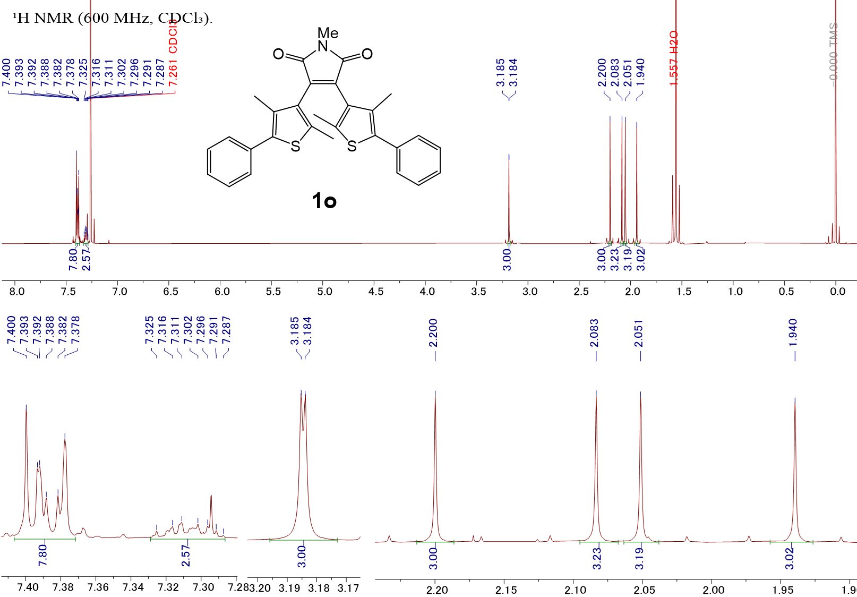
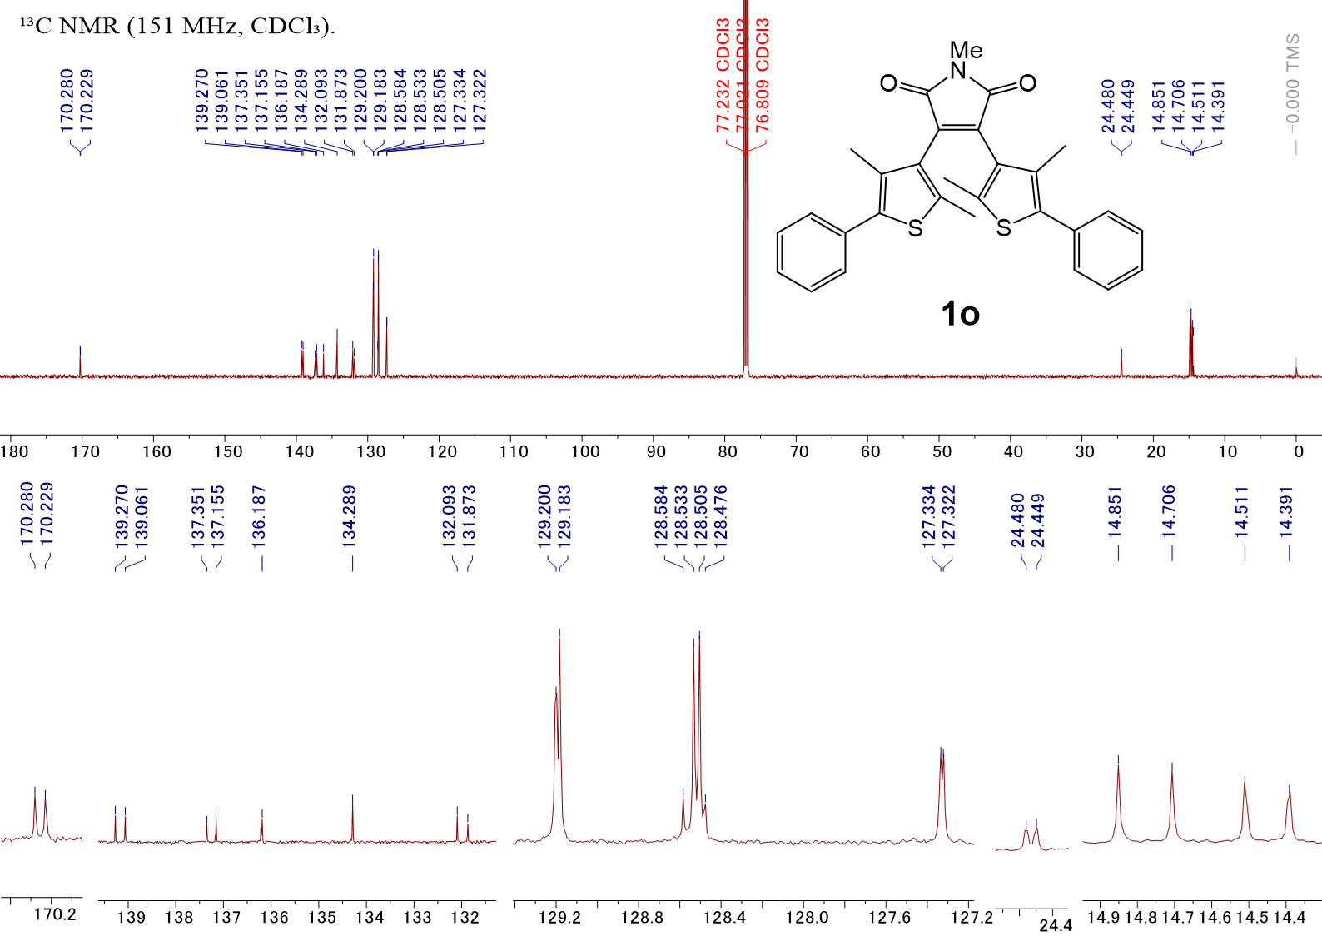
Fig. S1a NMR spectra of 1o.
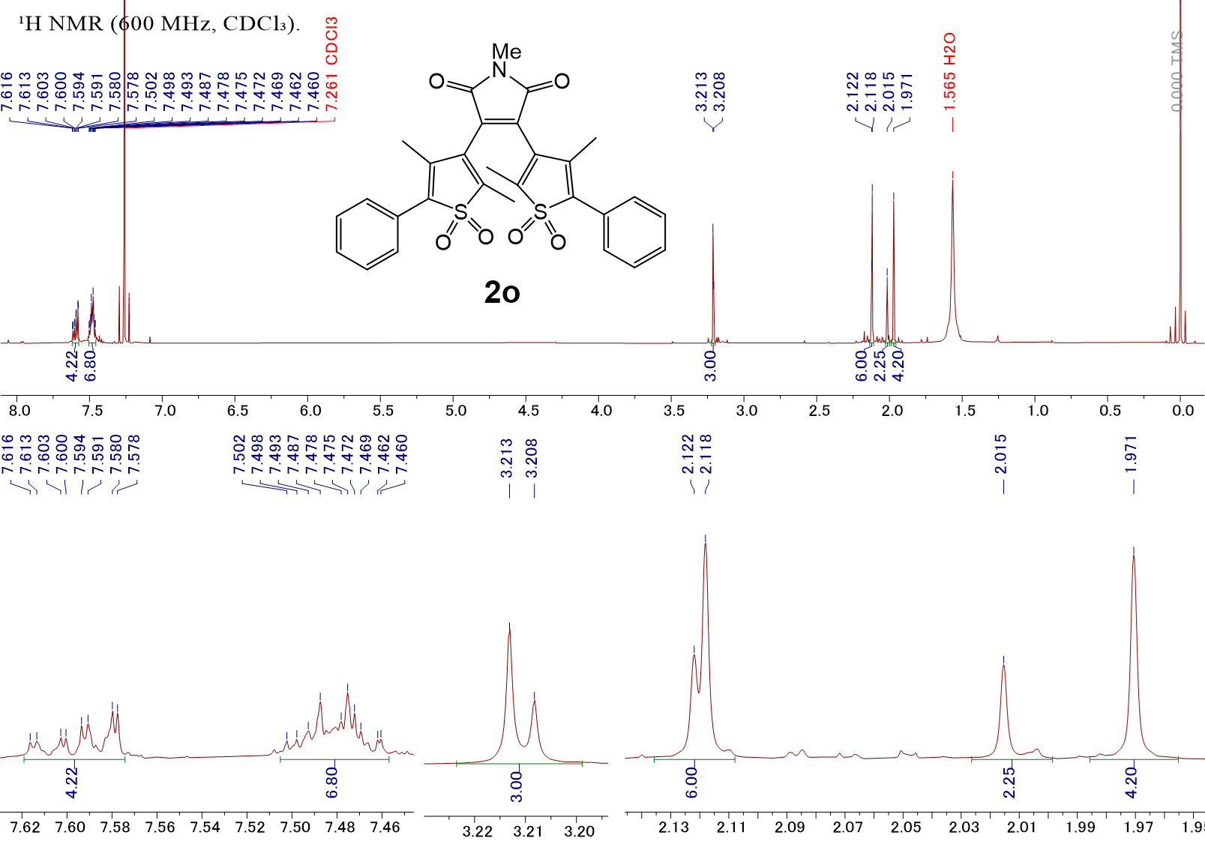
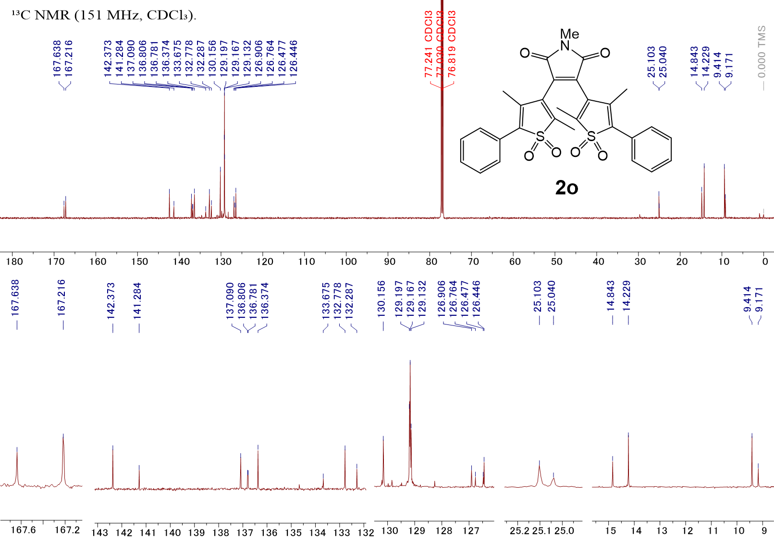
Fig. S1b NMR spectra of 2o.

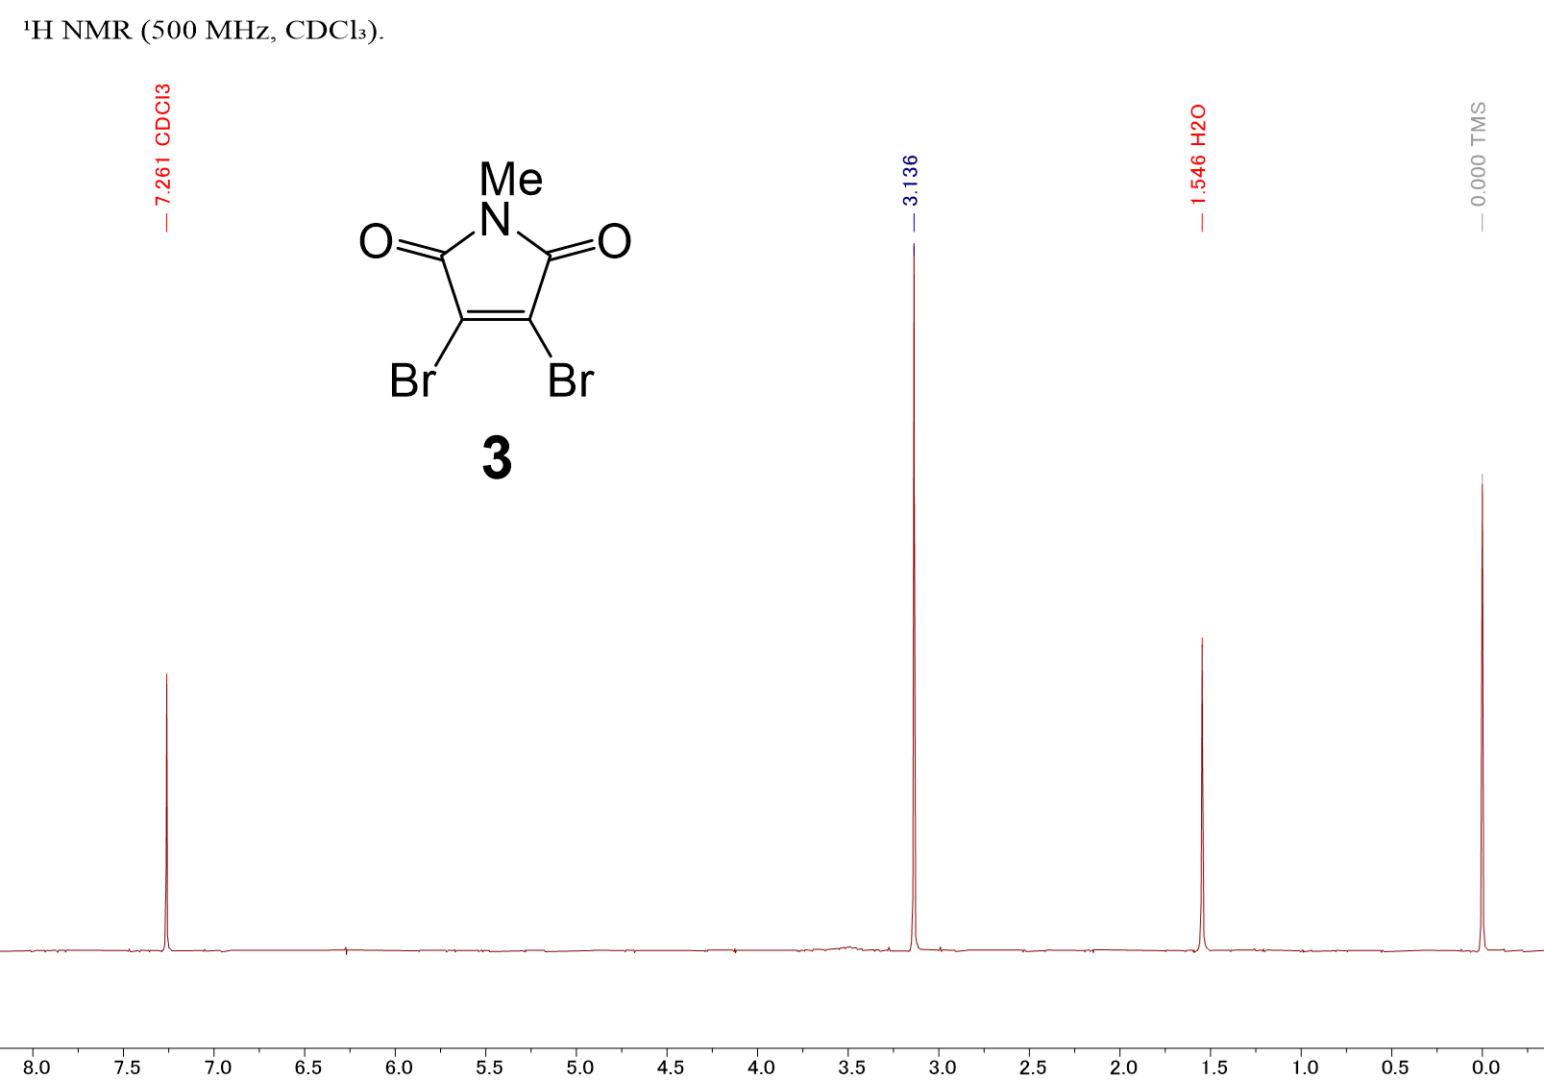

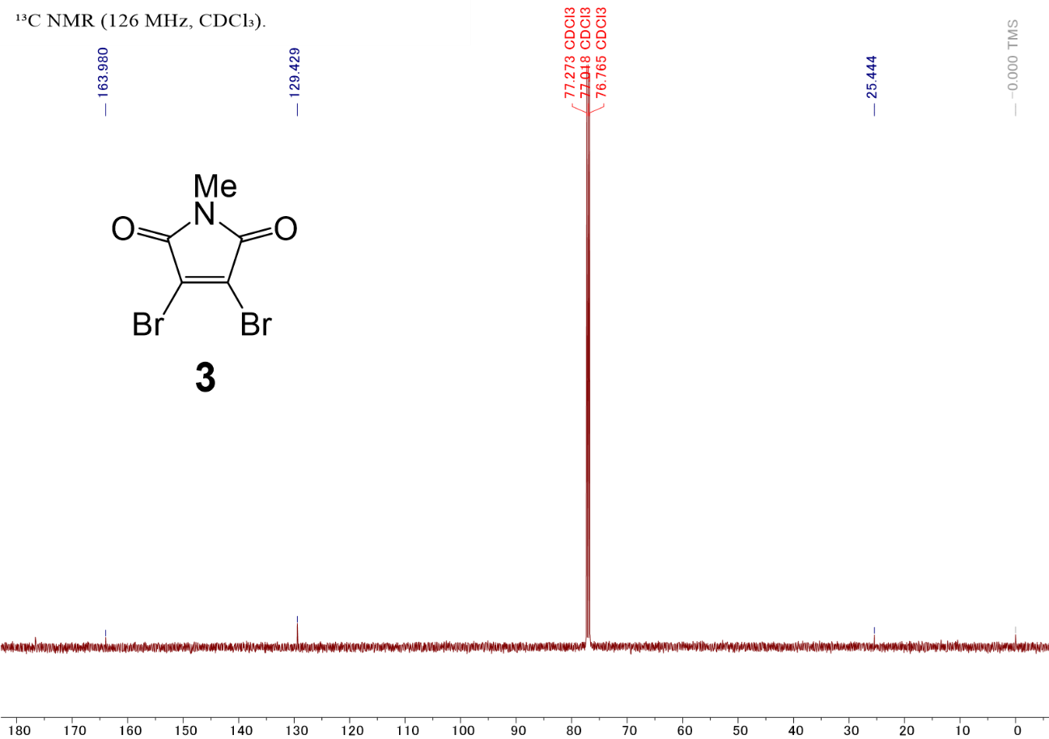
Fig. S1c NMR spectra of 3.
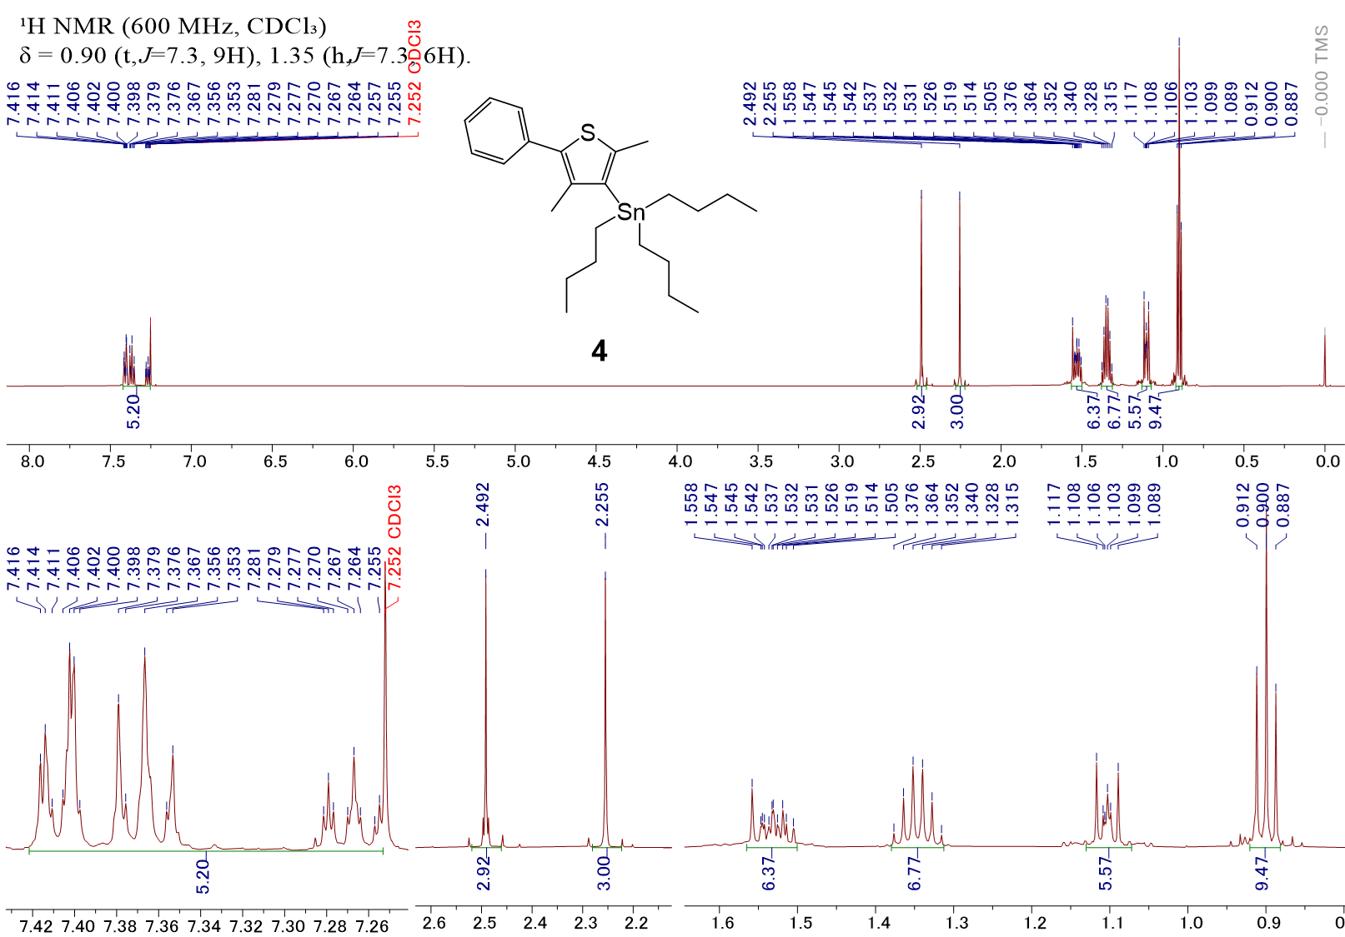
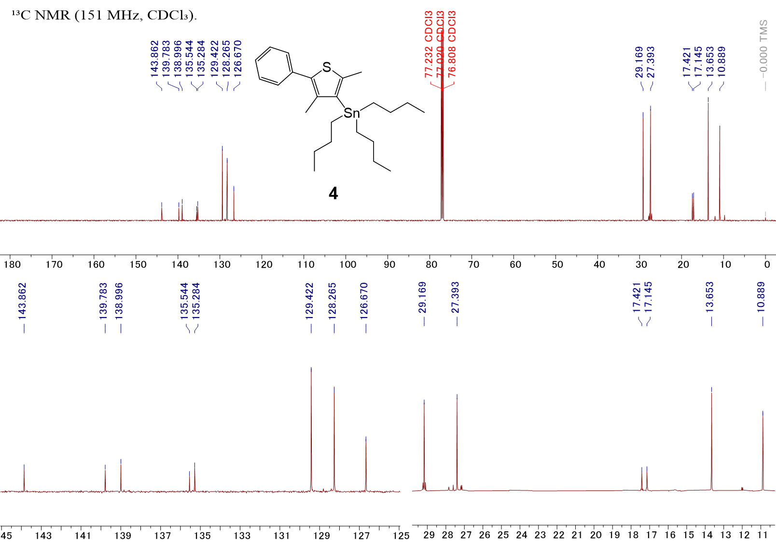
Fig. S1d NMR spectra of 4.

4. APCI-TOF Mass spectra
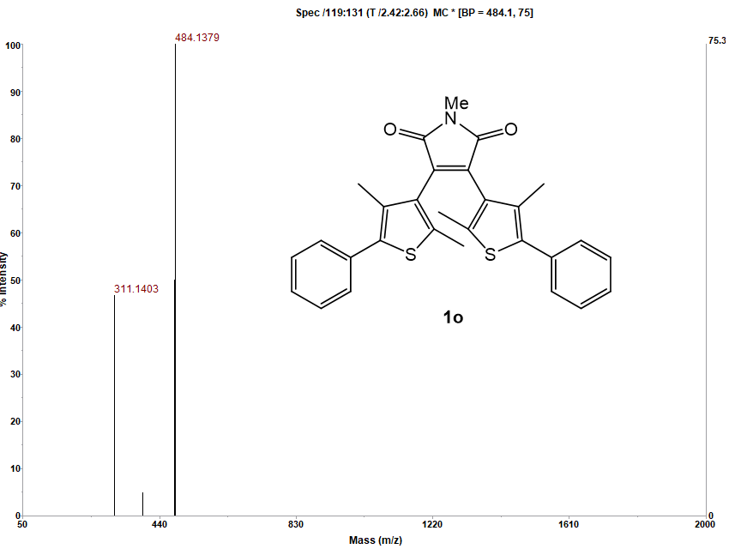
Fig. S2a HR-Mass spectrum of 1o.

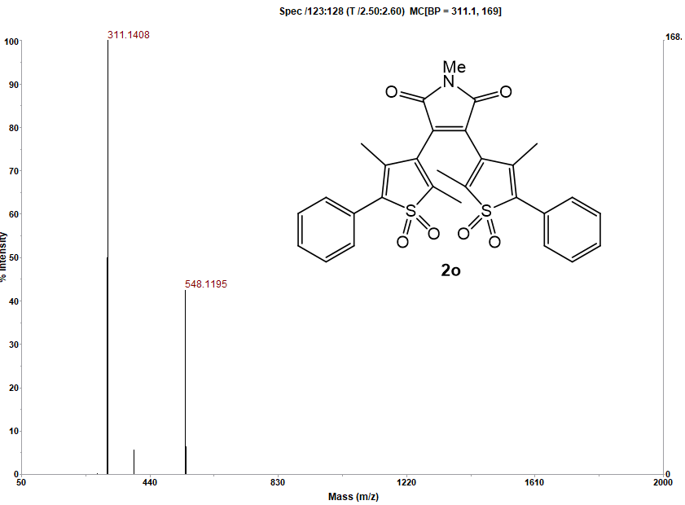
Fig. S2b HR-Mass spectrum of 2o.
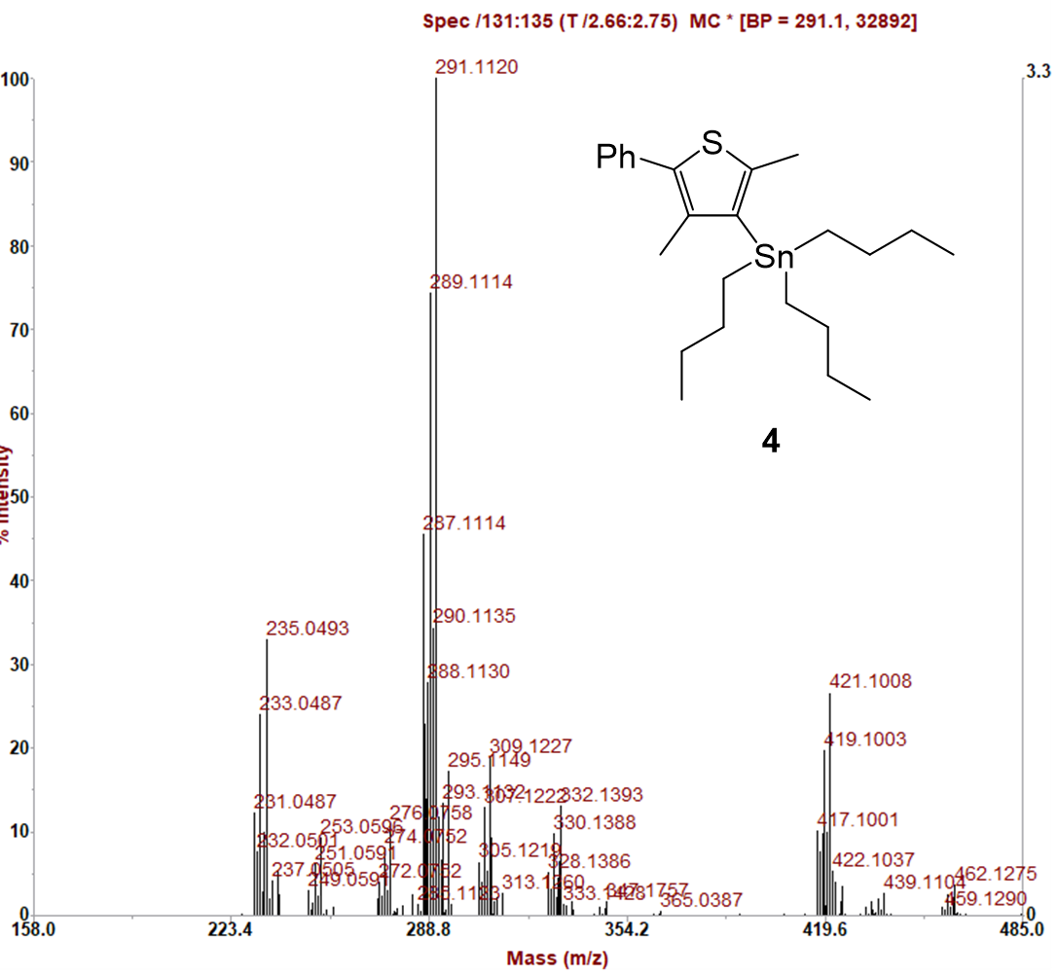
Fig. S2c HR-Mass spectrum of 4.

5. Absorption spectral change of 1o upon 436-nm light irradiation in each solvent
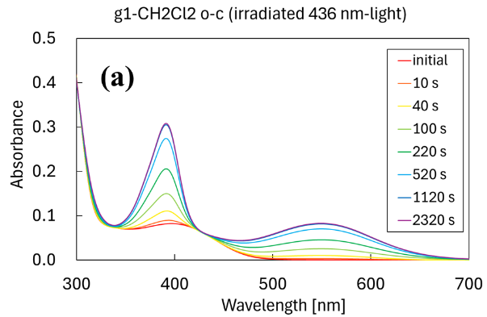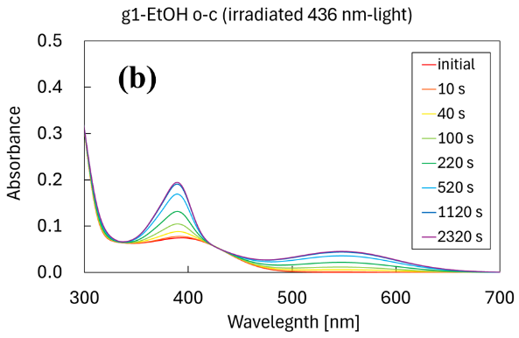
Fig. S3 Absorption spectral change of 1o upon 436-nm light irradiation.
Solvent: a, DCM; b, ethanol. Concentration: 2.1×10⁻⁵ mol dm⁻³.
Light Intensity: a, 1.6 mW cm⁻²; b, 1.5 mW cm⁻².

6. Absorption spectral change of PSS₄₃₆ of 1 upon 550-nm light irradiation in each solvent
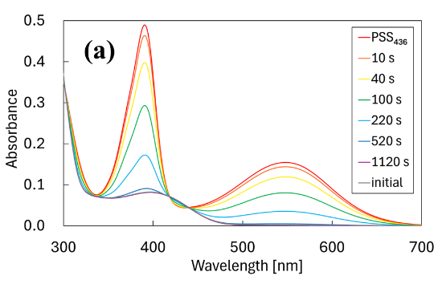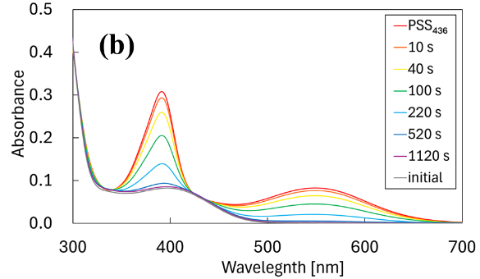
Fig. S4 Absorption spectral change of PSS₄₃₆ of 1 upon 550-nm light irradiation.
Solvent: a, toluene; b, DCM. Concentration: 2.1×10⁻⁵ mol dm⁻³. Light Intensity: 1.3 mW cm⁻².

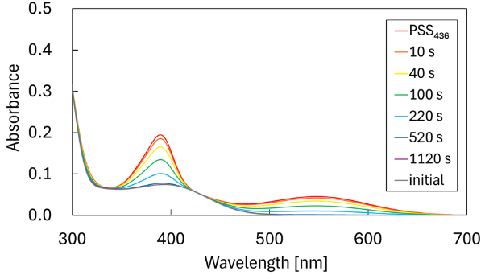
Fig. S5 Absorption spectral change of PSS₄₃₆ of 1 upon 550-nm light irradiation in ethanol.
Concentration: 2.1×10⁻⁵ mol dm⁻³. Light Intensity: 1.3 mW cm⁻²

7. Absorption spectral change of 2o upon 365-nm light irradiation in each solvent
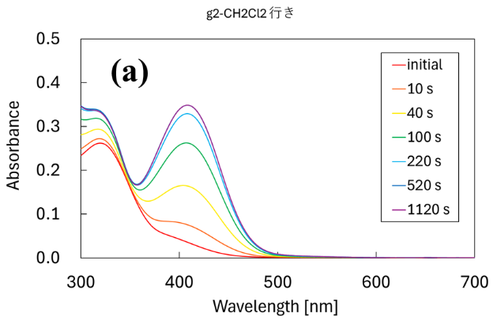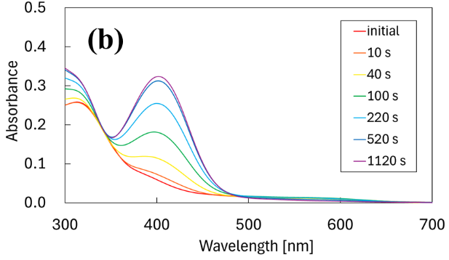
Fig. S6 Absorption spectral change of 2o upon 365-nm light irradiation.
Solvent: a, DCM; b, ethanol. Concentration: 2.3×10⁻⁵ mol dm⁻³.
Light Intensity: a, 2.0 mW cm⁻²; b, 2.1 mW cm⁻².

8. Absorption spectral change of PSS₃₆₅ of 2 upon 436-nm light irradiation in ethanol
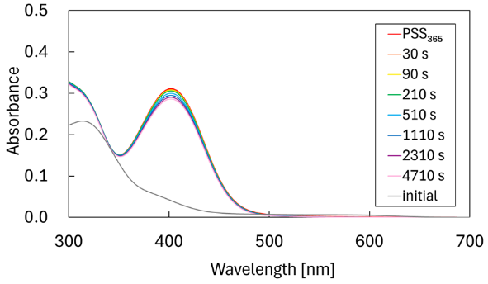
Fig. S7 Absorption spectral change of PSS₃₆₅ of 2 upon 436-nm light irradiation in ethanol.
Concentration: 2.3×10⁻⁵ mol dm⁻³. Light Intensity: 10.3 mW cm⁻²

9. Fluorescence spectral change of 1o upon 436-nm light irradiation in toluene
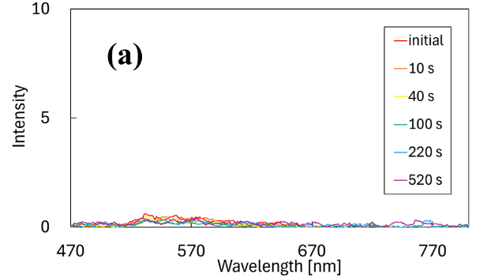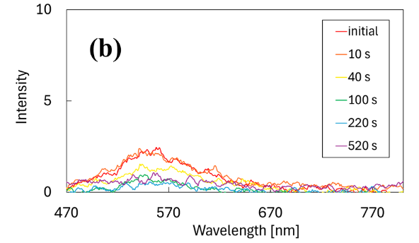
Fig. S8 Fluorescence spectral change of 1o upon 436-nm light irradiation in toluene.
Concentration: 2.1×10⁻⁵ mol dm⁻³.
Irradiation: 436 nm, 2.0 mW cm⁻². Excitation: a, 460 nm; b, 405 nm.

10. Fluorescence spectral change of 2o upon 365-nm light irradiation in each solvent

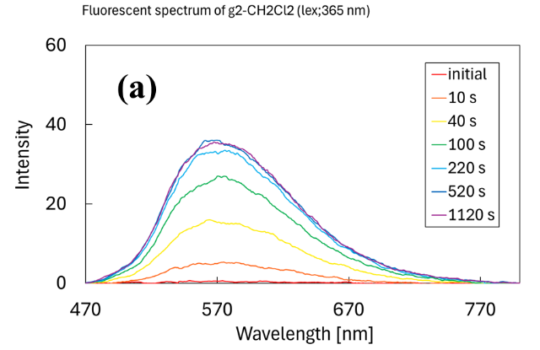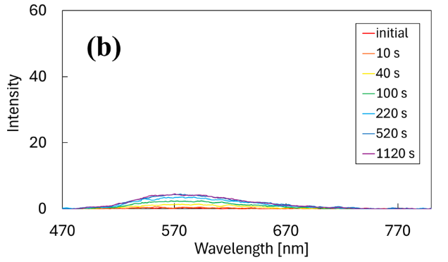
Fig. S9 Fluorescence spectral change of 2o upon 365-nm light irradiation.
Solvent: a, DCM; b, ethanol. Concentration: 2.3×10⁻⁵ mol dm⁻³.
Irradiation: 365 nm, 2.0 mW cm⁻². Excitation: 460 nm.

11. Excitation spectral change of 1o upon 436-nm light irradiation in toluene
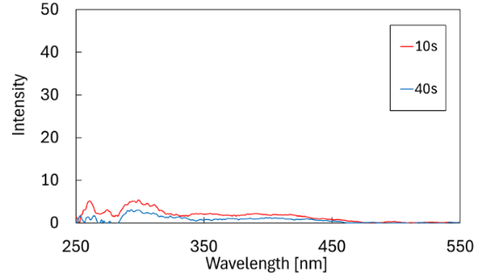
Fig. S10 Excitation spectral change of 1o upon 436-nm light irradiation in toluene.
Concentration: 2.1×10⁻⁵ mol dm⁻³. Irradiation: 436 nm, 2.0 mW cm⁻². Emission: 560 nm.

12. Excitation spectral change of 2o upon 365-nm light irradiation in toluene
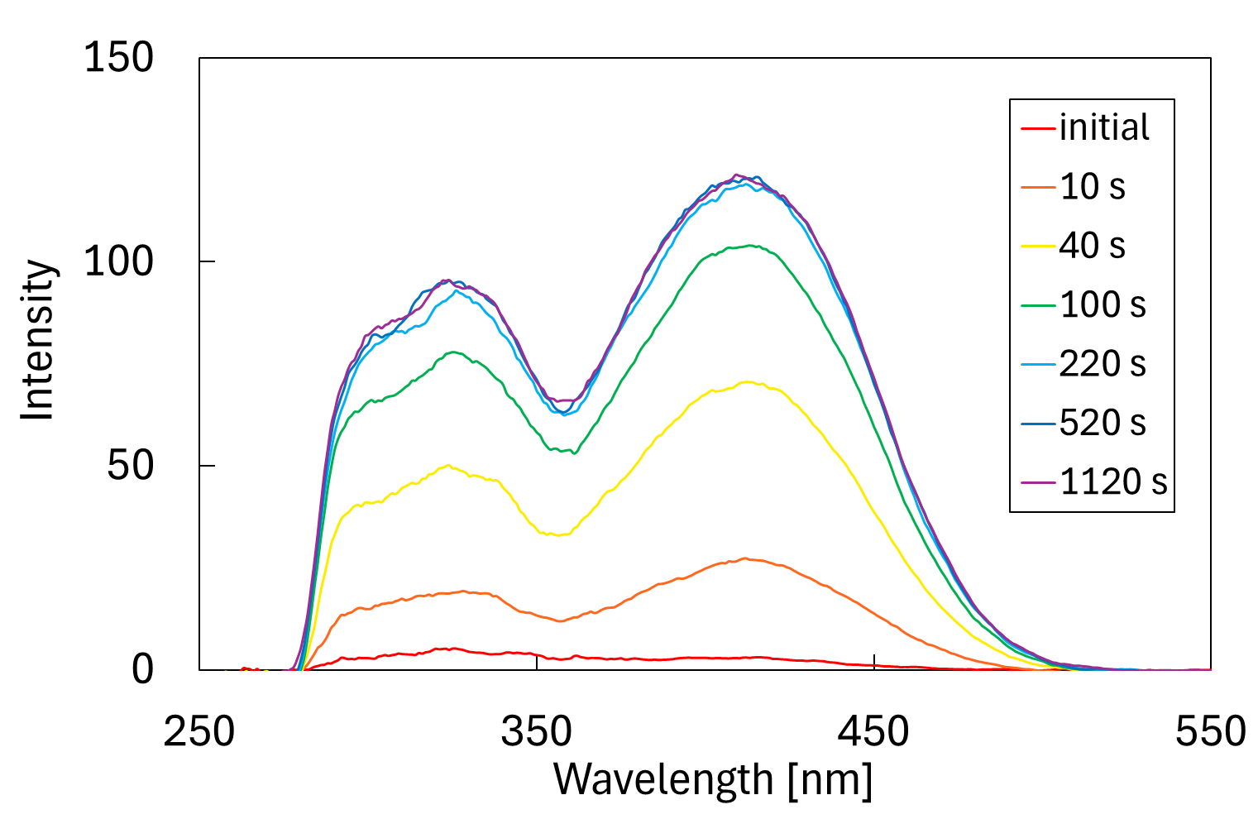
Fig. S11 Excitation spectral change of 2o upon 365-nm light irradiation in toluene.
Concentration: 2.3×10⁻⁵ mol dm⁻³. Irradiation: 365 nm, 2.0 mW cm⁻². Emission: 600 nm.

13. HPLC chromatogram change of 2 in each solvent
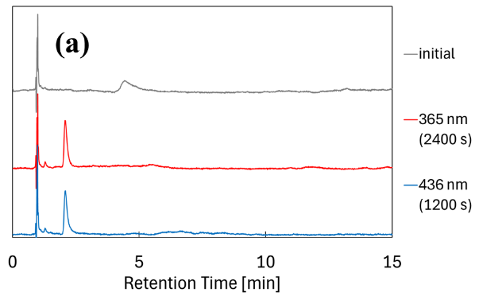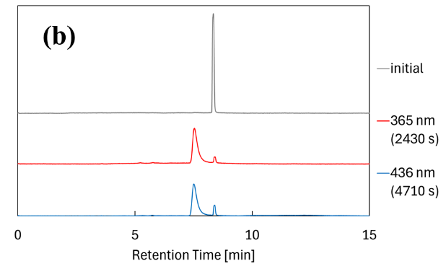
Fig. S12 HPLC chromatogram change of 2 in each solvent.
Solvent: a, toluene; b, ethanol. Concentration: 2.3×10⁻⁵ mol dm⁻³.
Irradiation: a, 365 nm, 2.0 mW cm⁻², 436 nm, 9.7 mW cm⁻²; b, 365 nm, 2.1 mW cm⁻², 436 nm, 10.3 mW cm⁻².
Eluent: 75% t-butyl methyl ether / hexane. Flow: a, 2.0 mL min⁻¹; b, 0.5 mL min⁻¹.
Detect: a, 346 nm; b, 347 nm.

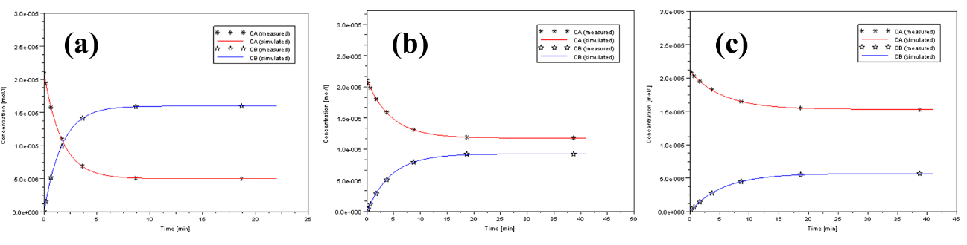
14. Calculation of the quantum yields
Fig. S13 Concentration changes of 1o, 1c and results of fitting simulation upon irradiation with 436-nm light. (a, in toluene; b, in DCM; c, in ethanol)

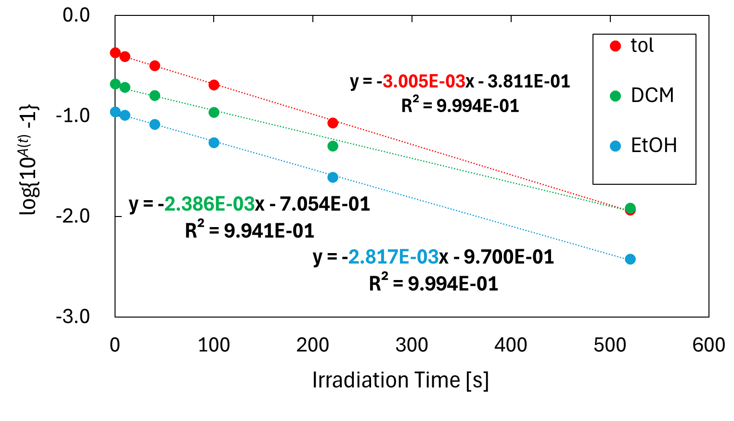
Fig. S14 Change in absorbance of 1c at λ_{max} upon irradiation with 550-nm light. (λ_{max} is at 548 nm in toluene and ethanol, and at 549 nm in DCM)

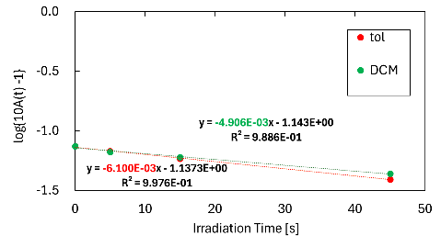
Fig. S15 Change in absorbance of 2o at λ_{max} upon irradiation with 365-nm light. (λ_{max} is at 413 nm in toluene, and at 408 nm in DCM)

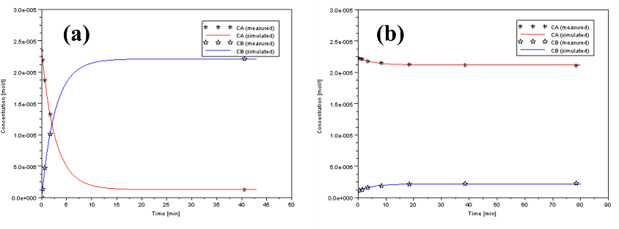

Fig. S16 Concentration changes of 2o, 2c in ethanol solution and results of fitting simulation. (a, cyclization reaction of 2o irradiated with 365-nm light; b, cycloreversion reaction of 2 at PSS₃₆₅ irradiated with 436-nm light)
Table S1. Molar absorption coefficients at excitation wavelength
 |  |  |  | ε [10³ dm³ mol⁻¹ cm⁻¹] ª |  |  | ε [10³ dm³ mol⁻¹ cm⁻¹] ^{b}
DAM | Solvent (E_{T}(30) [kcal mol⁻¹]) |  |  | Open form | Closed form |  | Open form | Closed form
1 | toluene (33.9) |  |  | 2.41 | 2.04 |  | - | 9.64
1 | DCM (40.7) |  |  | 2.53 | 2.84 |  | - | 9.00
1 | ethanol (51.9) |  |  | 2.09 | 2.38 |  | - | 8.04
2 | toluene (33.9) |  |  | 3.66 | 5.76 |  | 0.643 | 9.21
2 | DCM (40.7) |  |  | 3.52 | 7.54 |  | 0.501 | 10.1
2 | ethanol (51.9) |  |  | 4.43 | 8.70 |  | 0.627 | 7.88
a 1: Irradiation with 436-nm light. 2: Irradiation with 365-nm light.
b 1: Irradiation with 550-nm light. 2: Irradiation with 436-nm light.

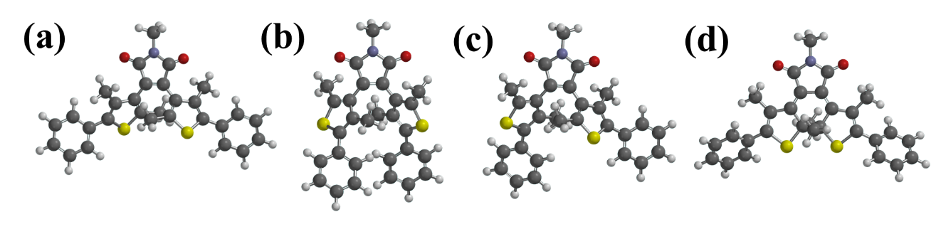
15. Results of DFT calculations of 1 and 2
Fig. S17 Conformer structures of 1 calculated by DFT. (a, o-form_ap_M-helix (photoactive); b, o-form_ap_M-helix (photoinactive); c, o-form_p; d, c-form_S, S)
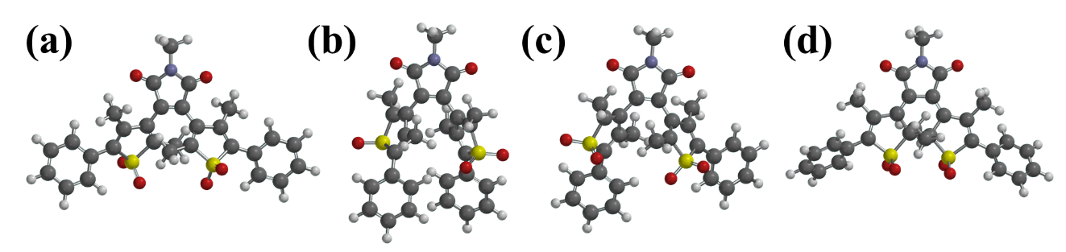
Fig. S18 Conformer structures of 2 calculated by DFT. (a, o-form_ap_M-helix (photoactive); b, o-form_ap_M-helix (photoinactive); c, o-form_p; d, c-form_S, S)
Table S2. Energy of each conformer of 1 and 2

DAM | Conformer |  | Energy [kJ mol⁻¹] | ΔE [kJ mol⁻¹]
1o | (a) | ap_M-helix (photoactive) | -5569506.35 | 0.00
1o | (b) | ap_M-helix (photoinactive) | -5569506.20 | 0.15
1o | (c) | p | -5569505.71 | 0.64
1c | (d) | S, S | -5569461.66 | 44.7
2o | (a) | ap_M-helix (photoactive) | -6358782.27 | 7.94
2o | (b) | ap_M-helix (photoinactive) | -6358790.21 | 0.00
2o | (c) | p | -6358787.84 | 2.37
2c | (d) | S, S | -6358860.91 | -70.7
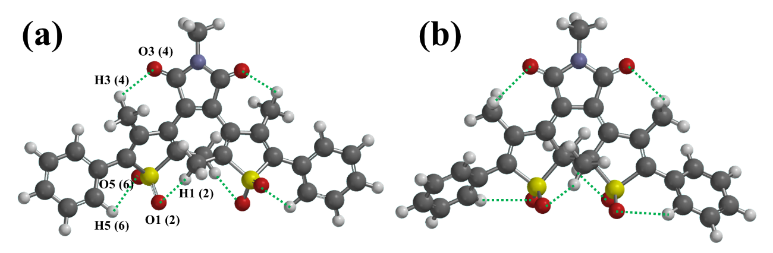
Fig. S19 The atoms related to hydrogen bonding. (a, o-form_ap_M-helix (photoactive); b, c-form_S, S)
Table S3. The distance between O and H [Å]

Conformer |  | S=O and H-C (Me) |  |  | C=O and H-C (Me) |  |  | S=O and H-C (Ph)
 |  | O1-H1 | O2-H2 |  | O3-H3 | O4-H4 |  | O5-H5 | O6-H6
(a) | 2o_ap_M-helix (photoactive) | 2.81 | 2.82 |  | 2.44 | 2.43 |  | 3.69 | 3.68
(b) | 2c_S, S | 2.23 | 2.22 |  | 2.42 | 2.42 |  | 2.39 | 2.44

