Supporting Information

Polyaniline Nanoskein: Synthetic Method, Characterization, and Redox Sensing

Yoochan Hongª, Hyun Soo Kimª, Taeha Lee^{b}, Gyudo Lee^{b}, and Ohwon Kwon^{a*}

ªDepartment of Medical Devices, Korea Institute of Machinery and Materials (KIMM), Daegu 42994, Republic of Korea
^{b}Department of Biotechnology and Bioinformatics, Korea University, Sejong 30019, Republic of Korea

*Corresponding Author:
Dr. Ohwon Kwon
Department of Medical Devices, Korea Institute of Machinery and Materials (KIMM), Daegu 42994, Republic of Korea
Tel: 82-53-670-9001; Fax: 82-53-670-9053; E-mail address: owkwon@kimm.re.kr

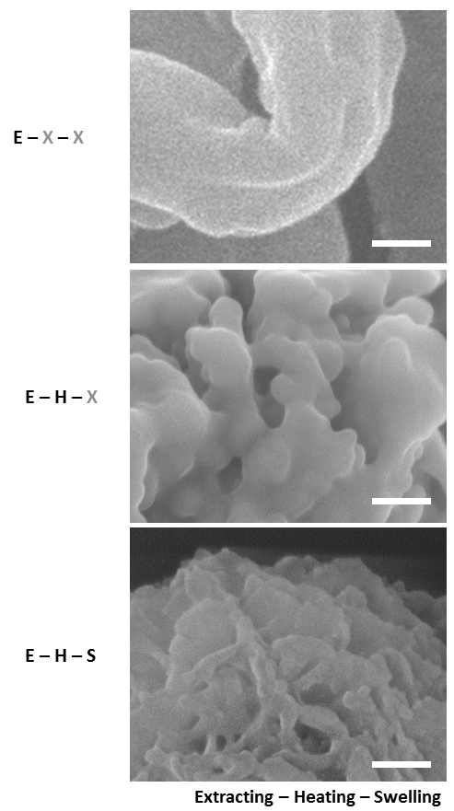
Fig. S1. FESEM images of PANS. Alphabetical characters represent sequential synthetic processes of PANS; (E): extracting reactant with BE, (H): heating sequentially the reactant at 200°C and 300°C, and (S): swelling the reactant using EtOH. Note that (X): no treatment. Scale bars are 100 nm.

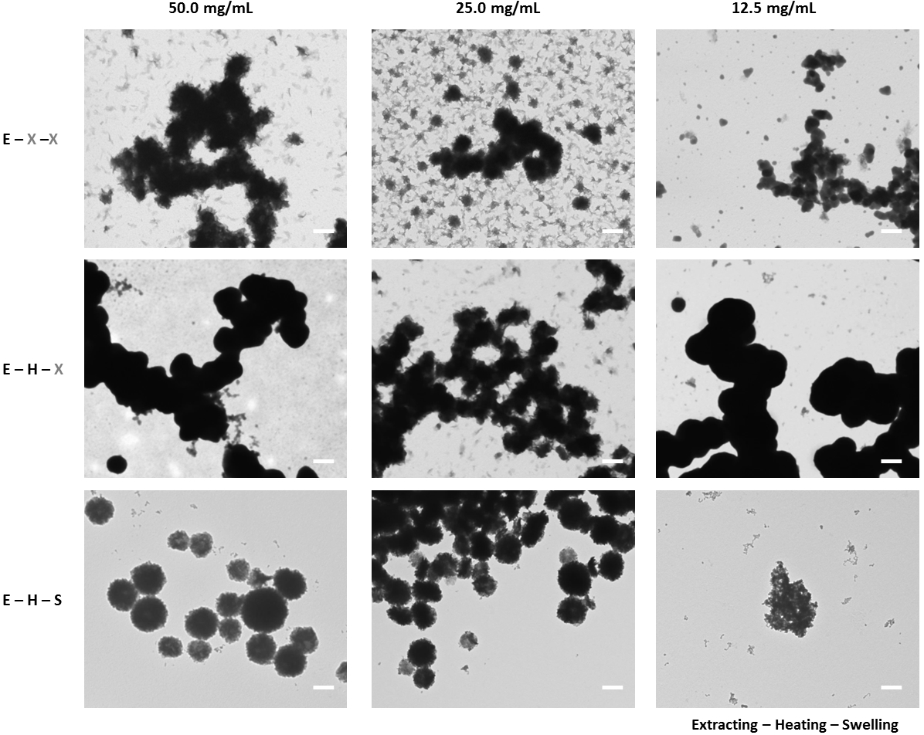
Fig. S2. TEM images of PANS according to changes of feeding amounts of PAni. Alphabetical characters represent sequential synthetic processes of PANS; (E): extracting reactant with BE, (H): heating sequentially the reactant at 200°C and 300°C, and (S): swelling the reactant using EtOH. Scale bars are 500 nm.

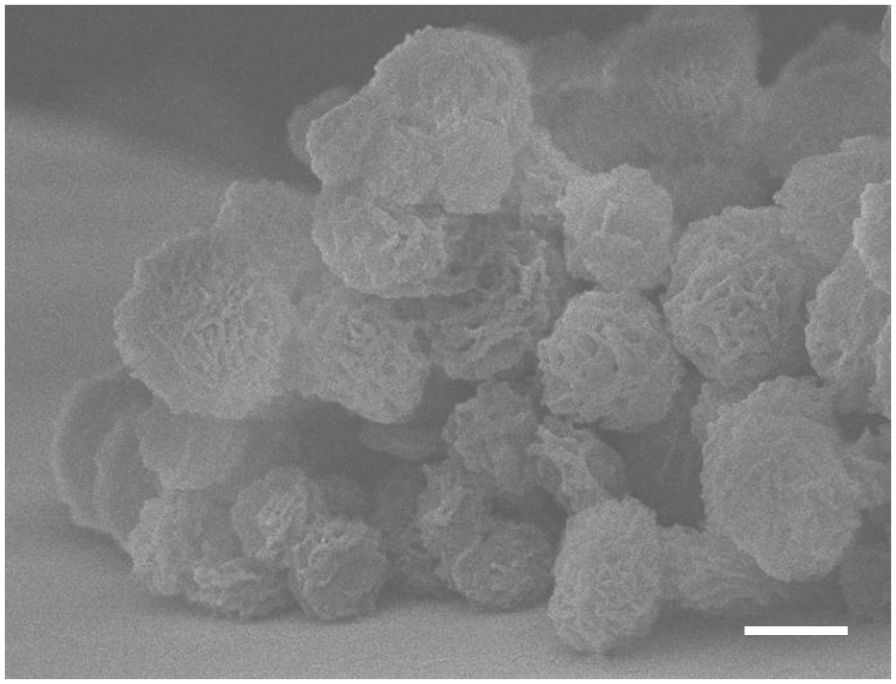
Fig. S3. A 90°-tilted FESEM image of PANS. Scale bar is 500 nm.

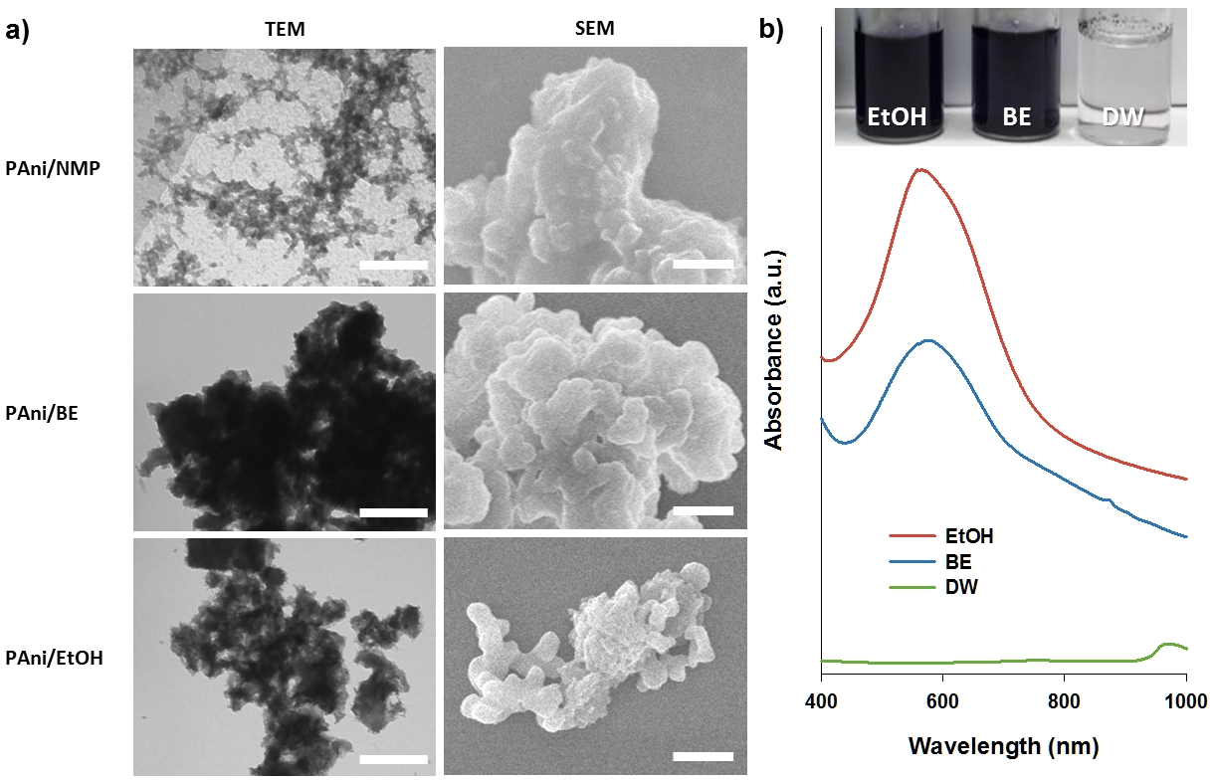
Fig. S4. a) TEM and SEM images of PAni just dispersed in indicated solvents. Scale bars are 500 nm. b) Absorbance spectra of PAni dispersed in indicated solvents. Inset is a photograph of PAni solutions dispersed in indicated solvents.

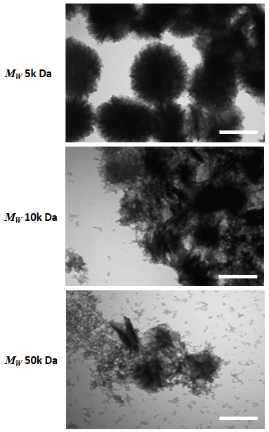
Fig. S5. TEM images of PANS according to changes of molecular weight (M_{W}) of PAni. Scale bars are 200 nm.

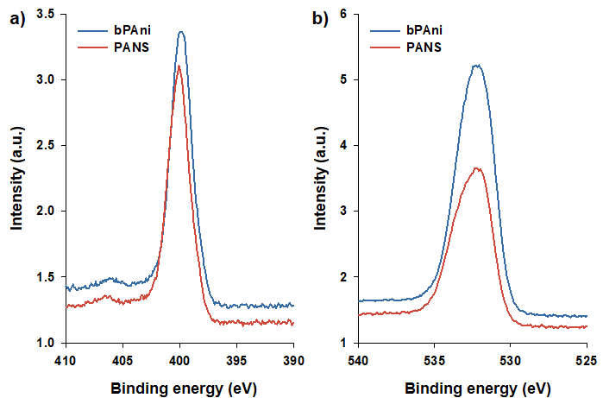
Fig. S6. XPS spectra of a) N_{1s} and b) O_{1s} for bPAni and PANS, respectively.

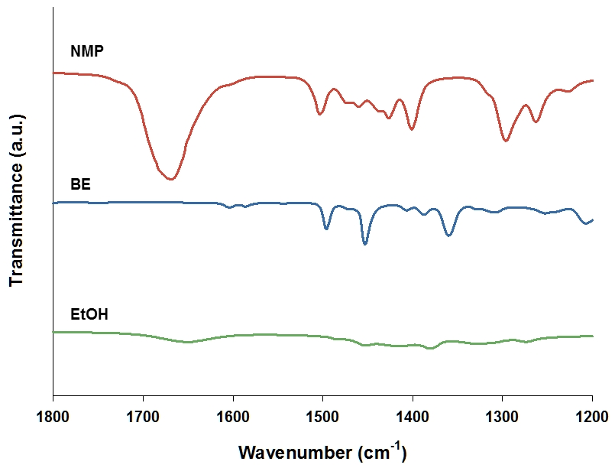
Fig. S7. FTIR spectra of NMP, BE, and EtOH.

