Supplementary materials
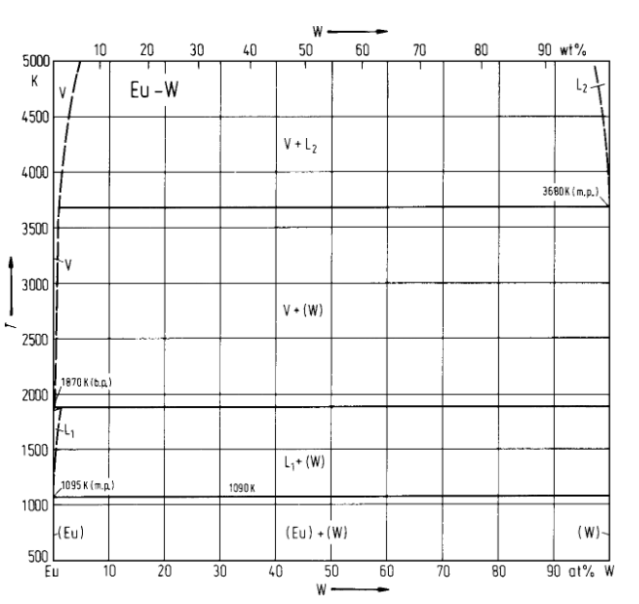
Fig. S1: Eu-W phase diagram

