DOCUMENTATION:
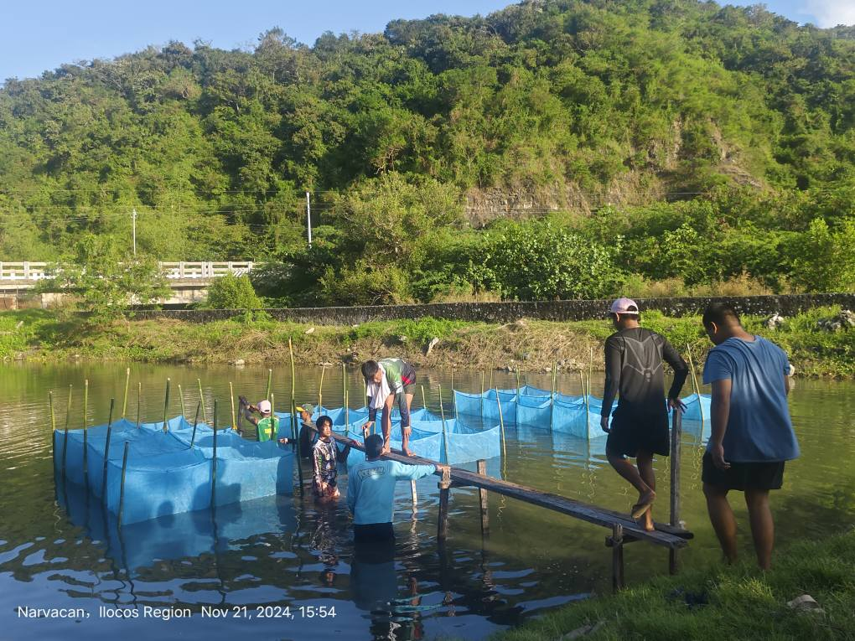
Plate 1. Installation of Hapa Nets
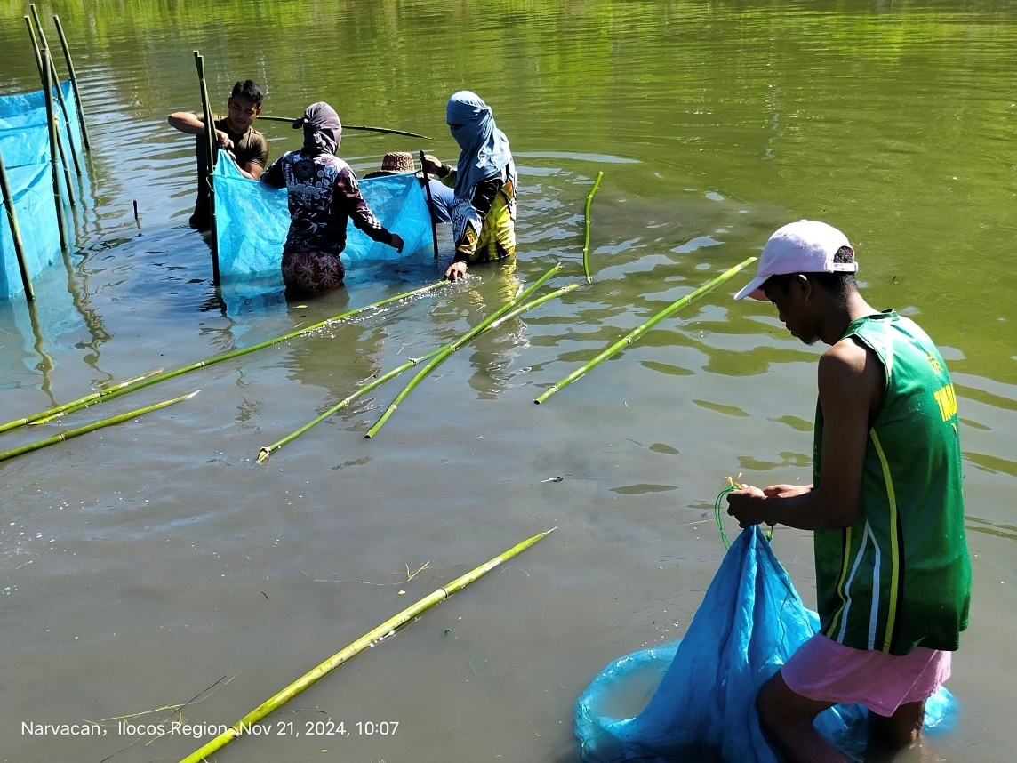
Plate 2. Installation of bamboo tulos

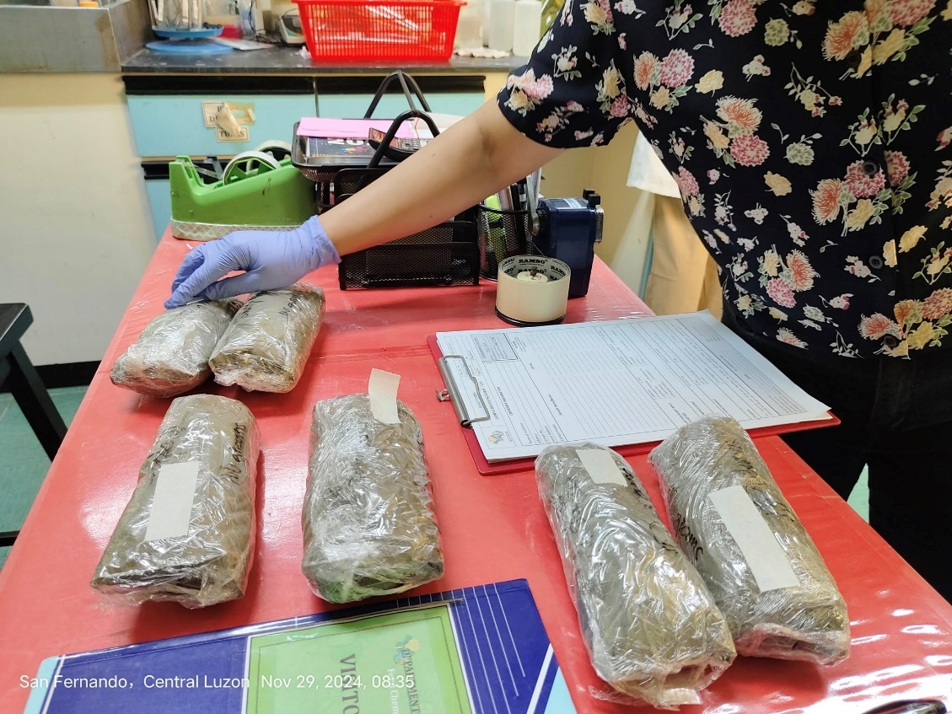
Plate 3. Submission of Samples for Proximate Analysis
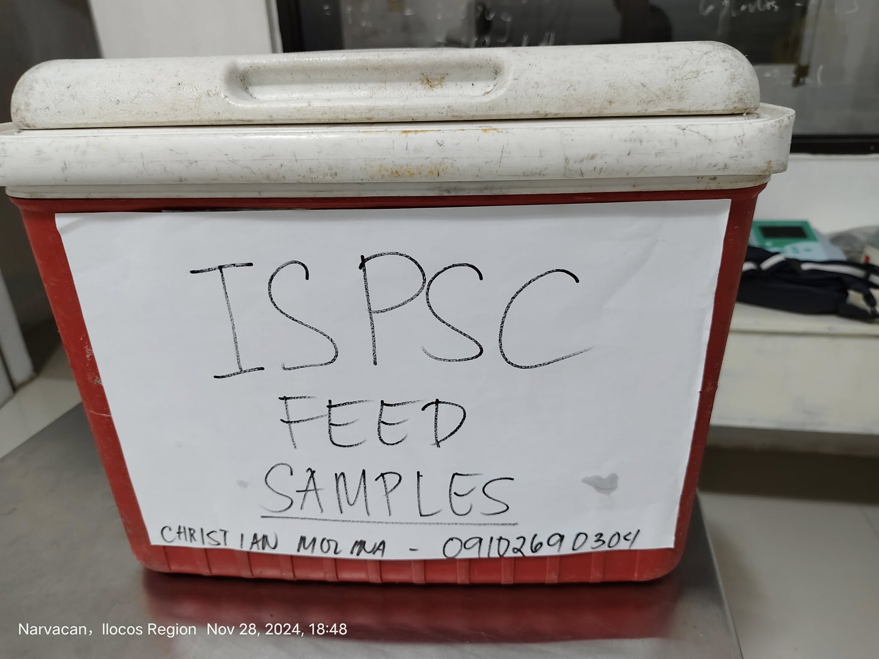
Plate 4. Feed Samples

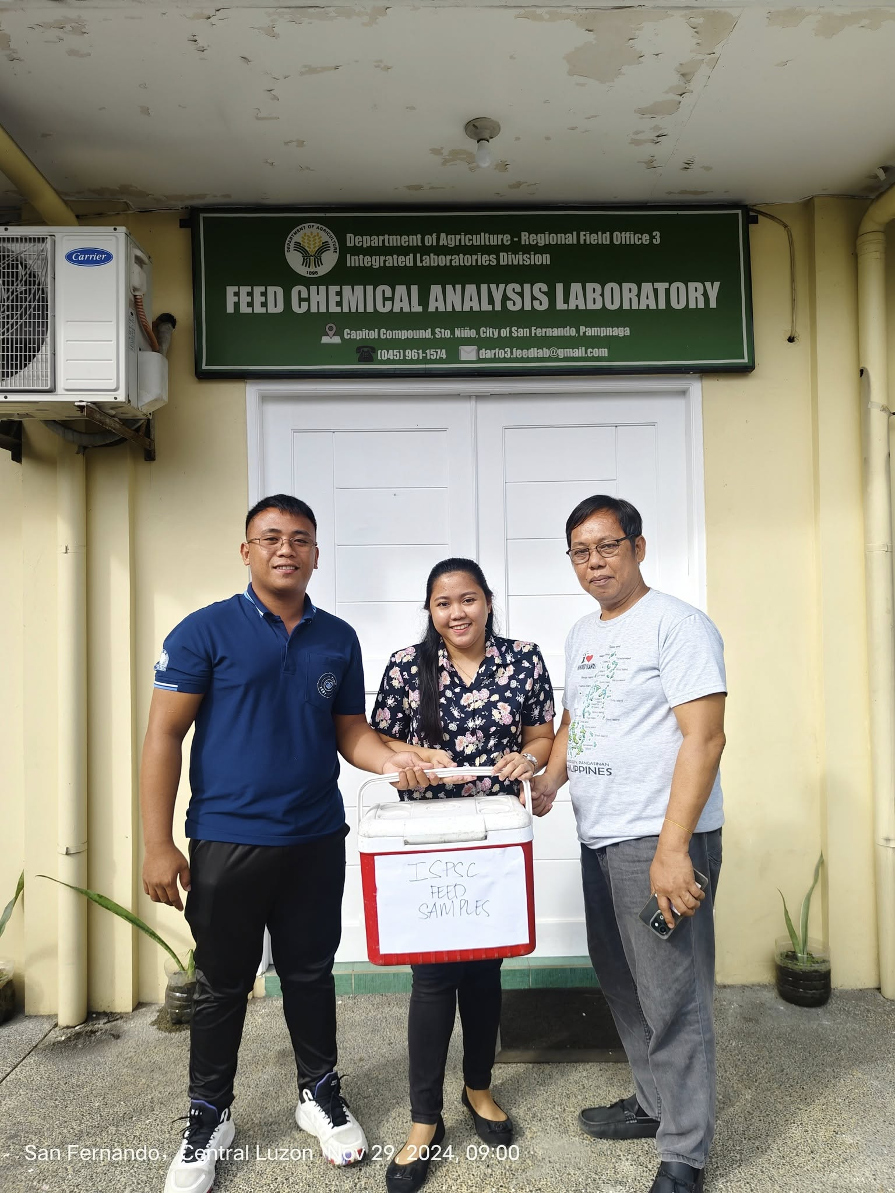
Plate 5. Submission of Samples
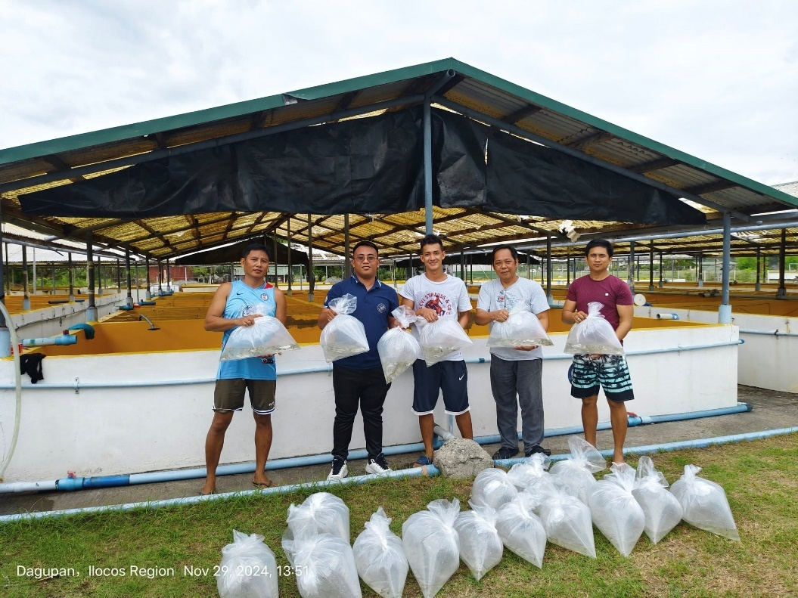
Plate 6. Procurement / Delivery of Milkfish initial Stocks

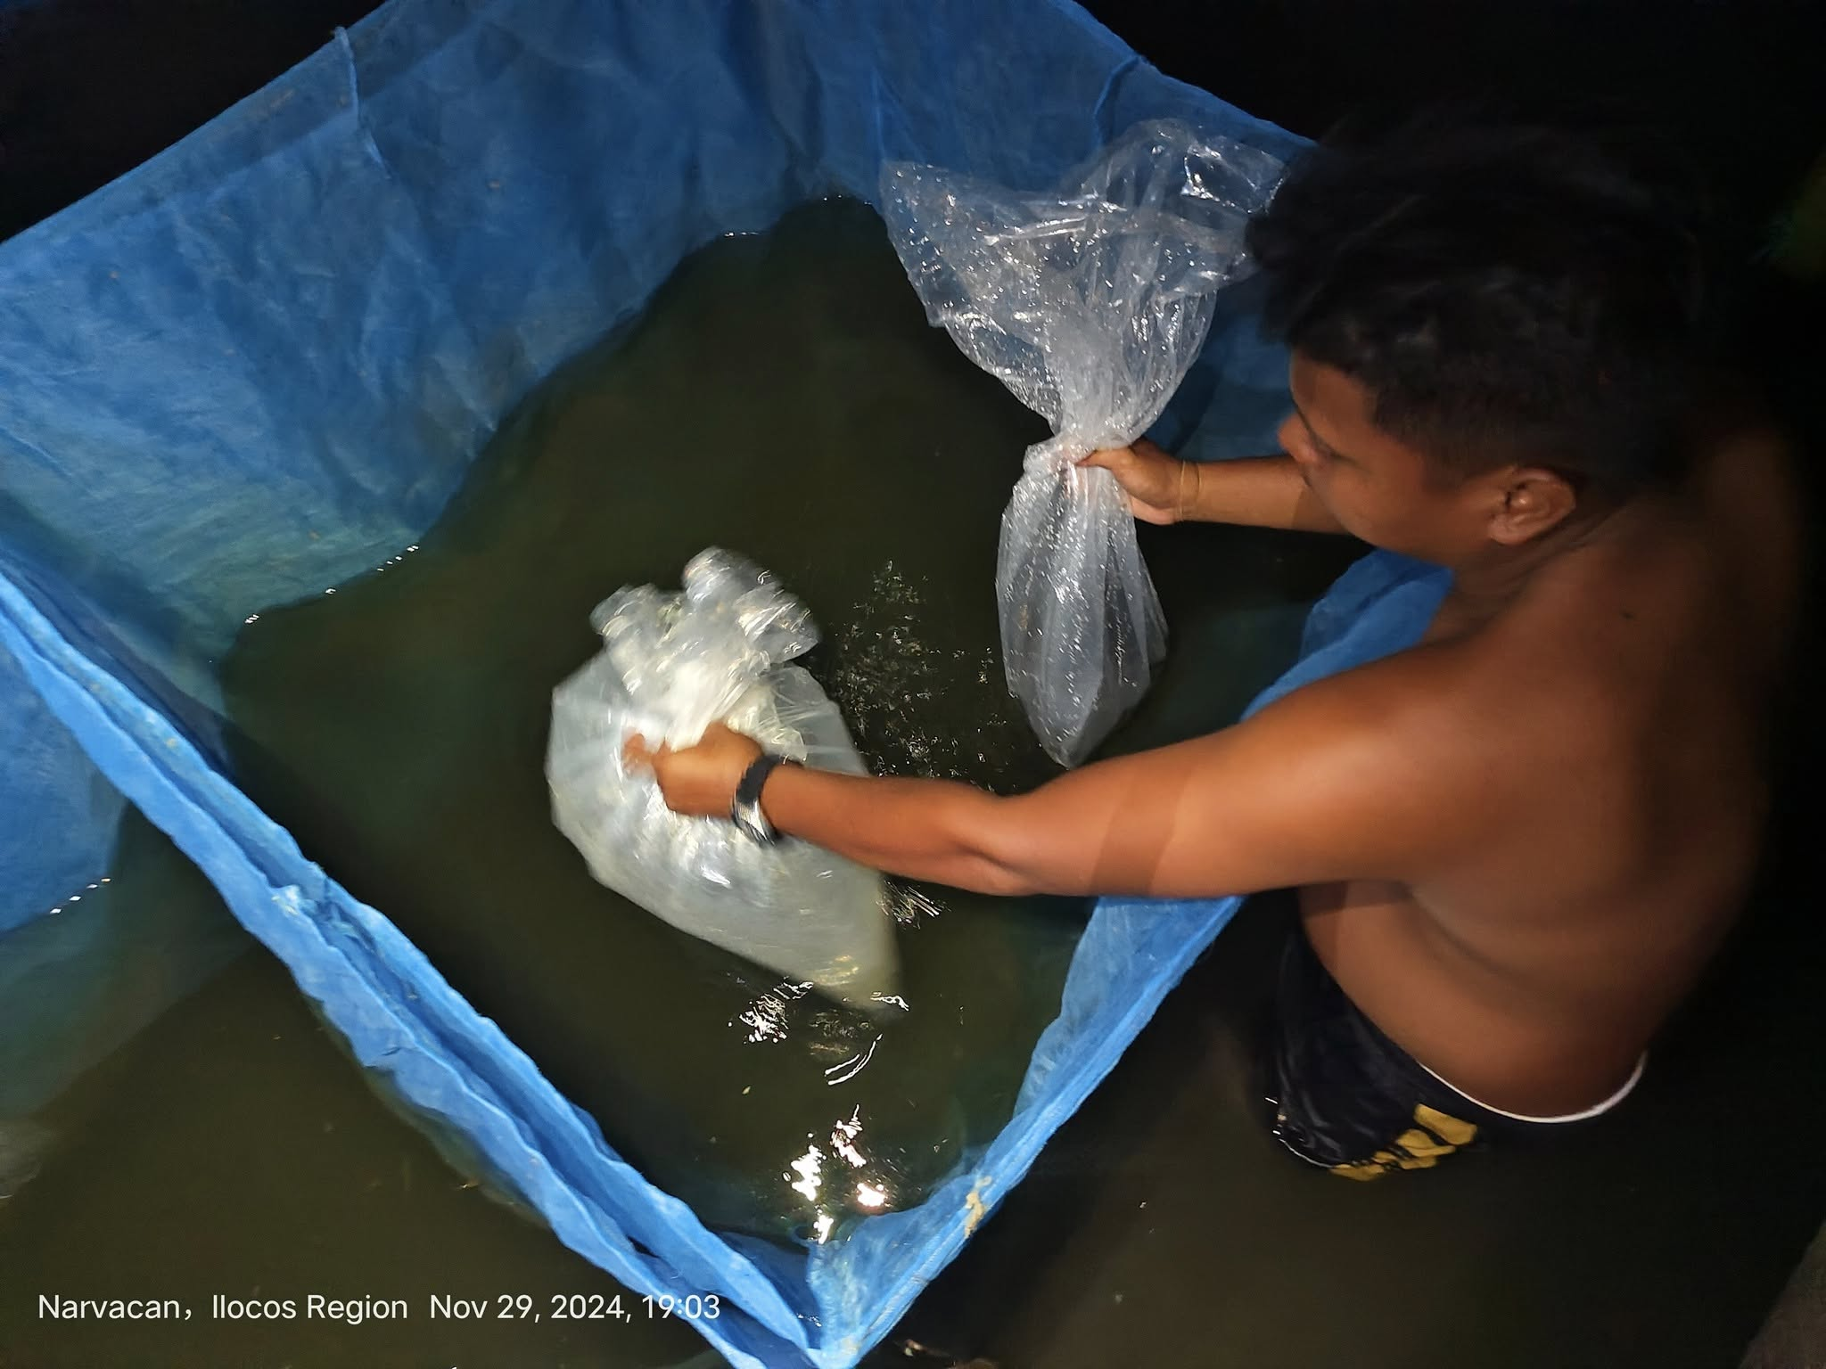
Plate 7. Stocking of Milkfish Fingerlings
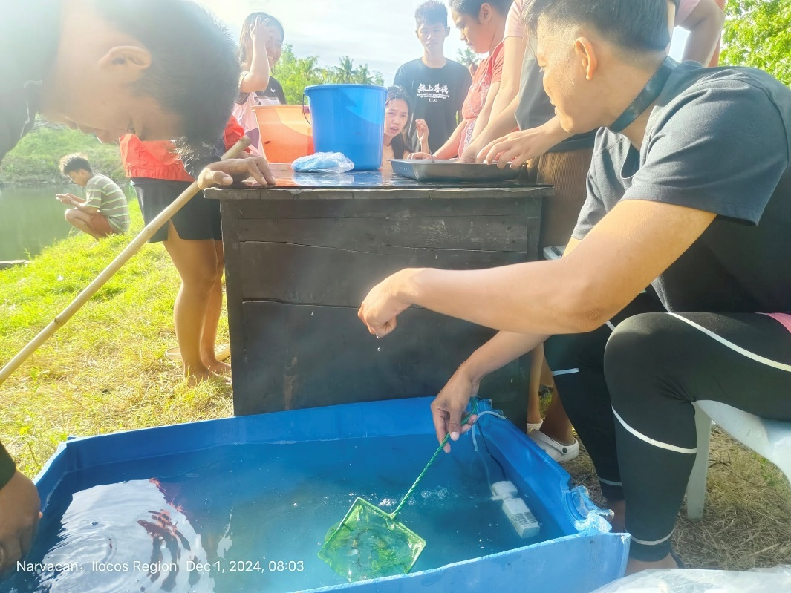
Plate 8. Initial Sampling

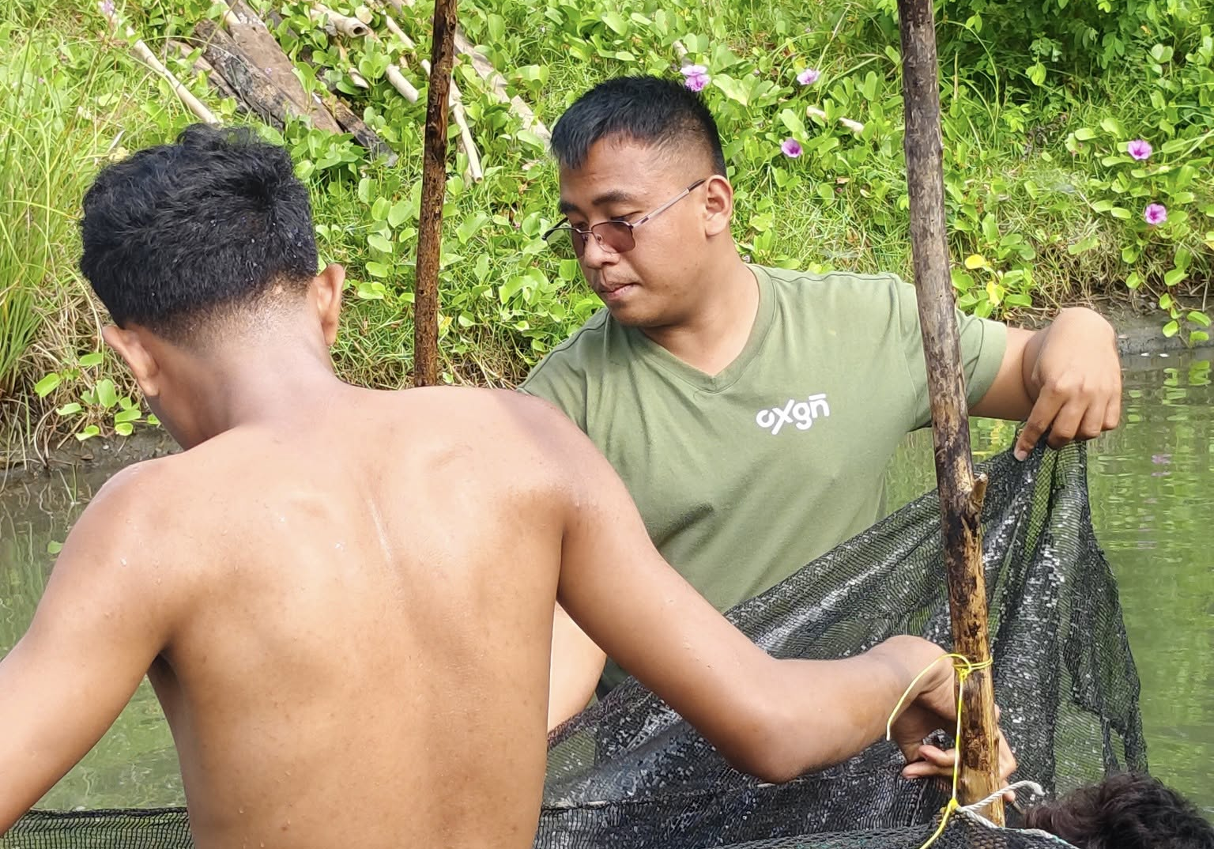
Plate 9. Installation of Nets
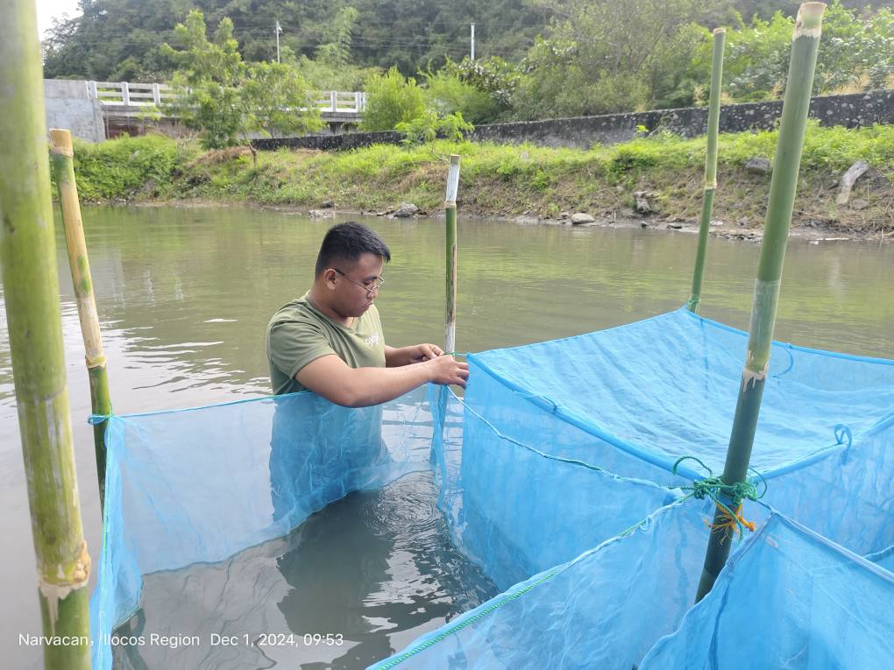
Plate 10. Installation of Nets

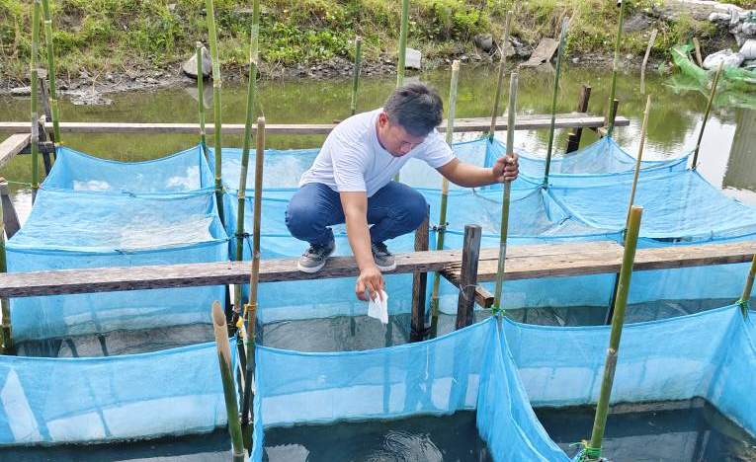
Plate 11. Daily Feeding
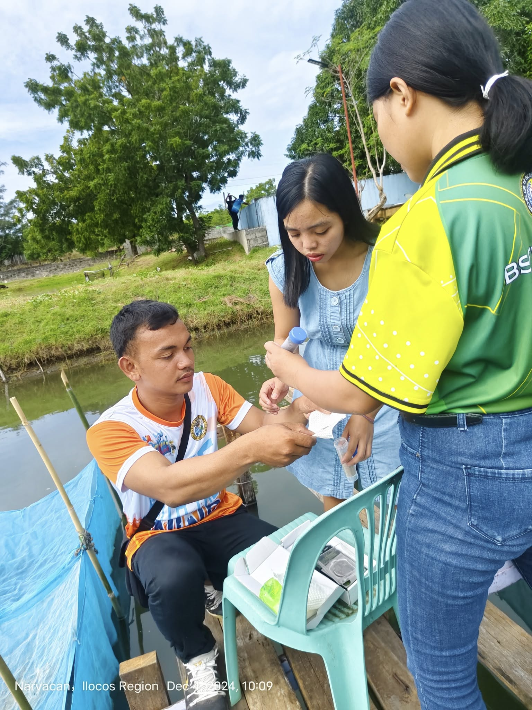
Plate 12. Daily Feeding

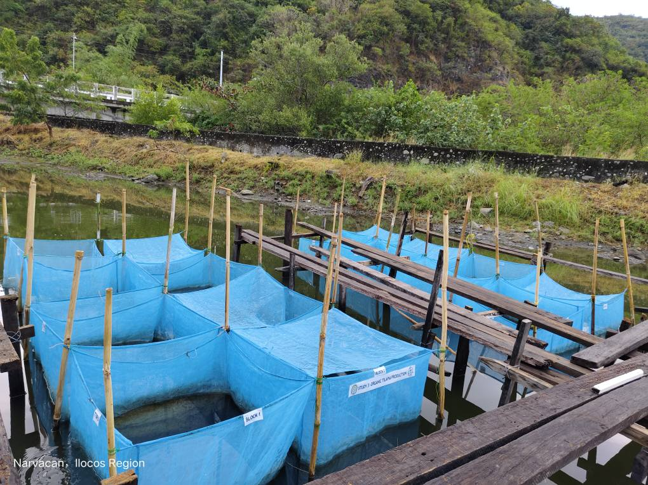
Plate 13. Experimental Lay-out
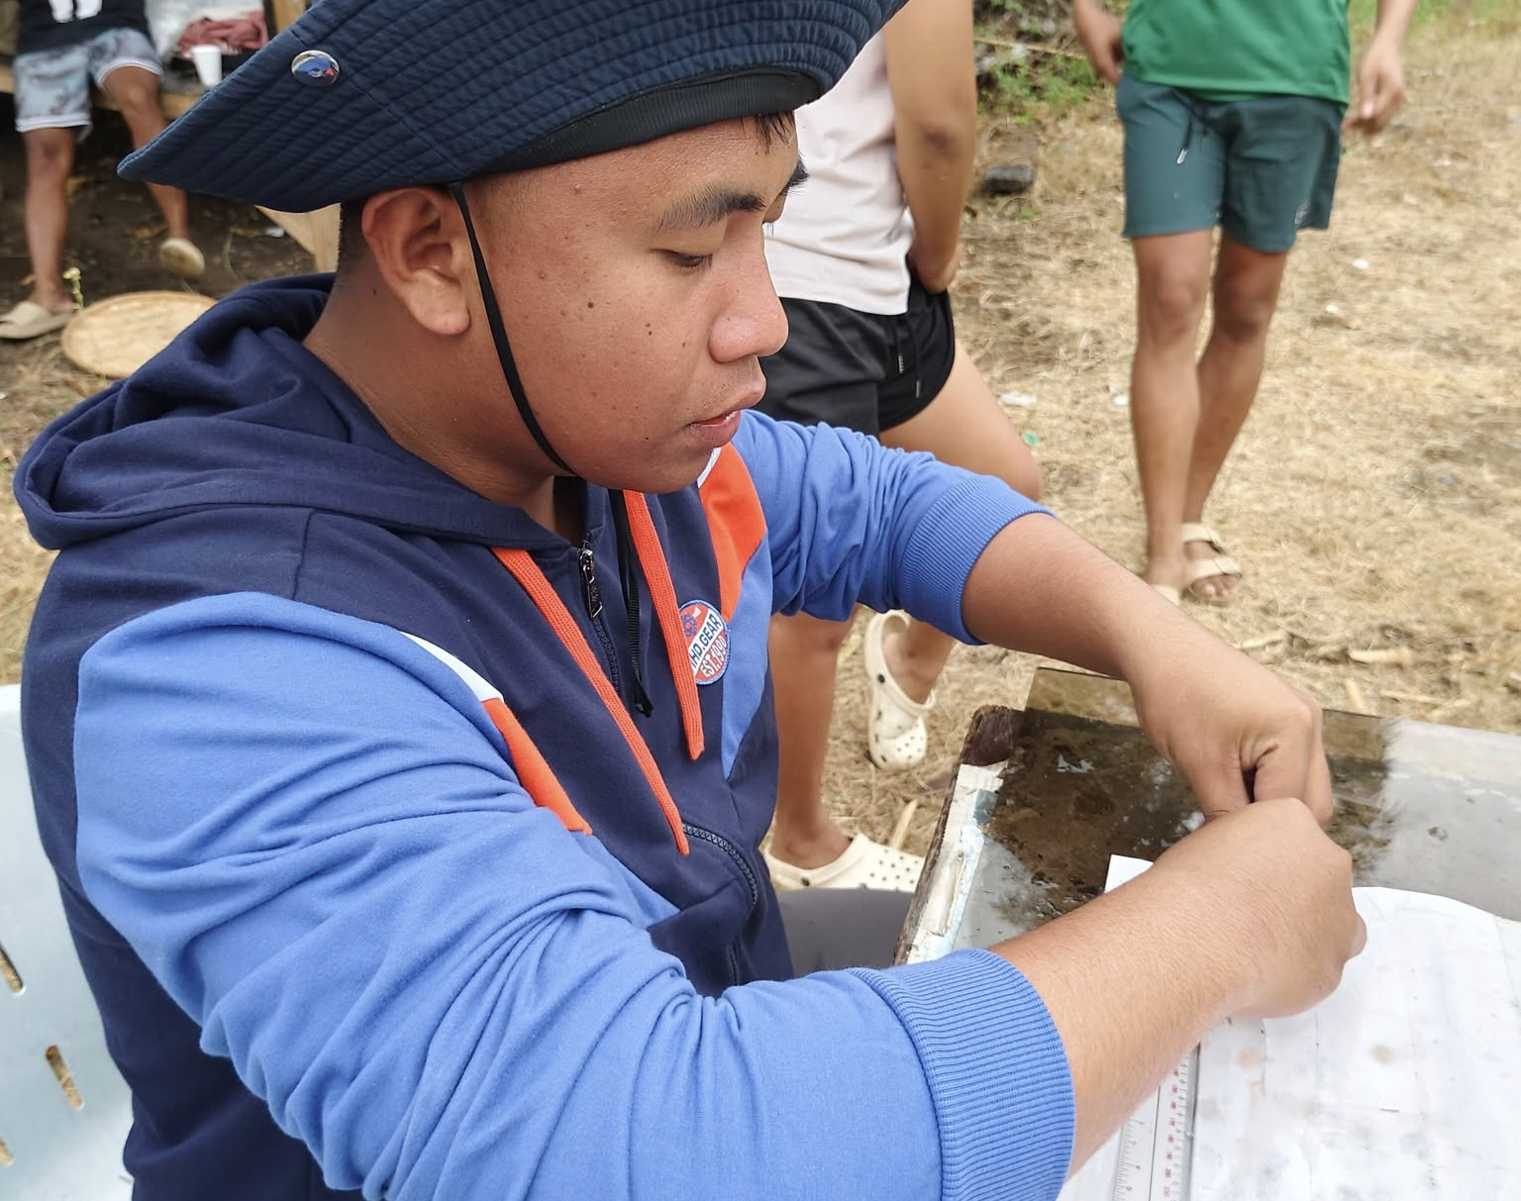
Plate 14. Sampling Procedure

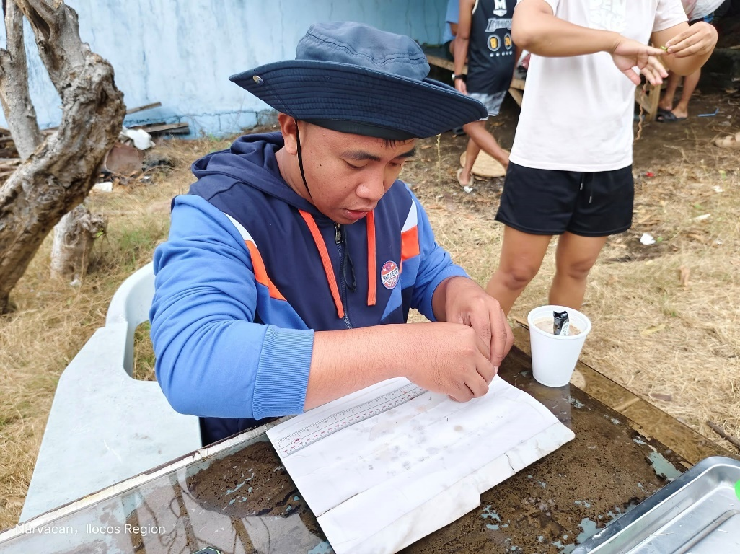
Plate 15. Sampling Procedure
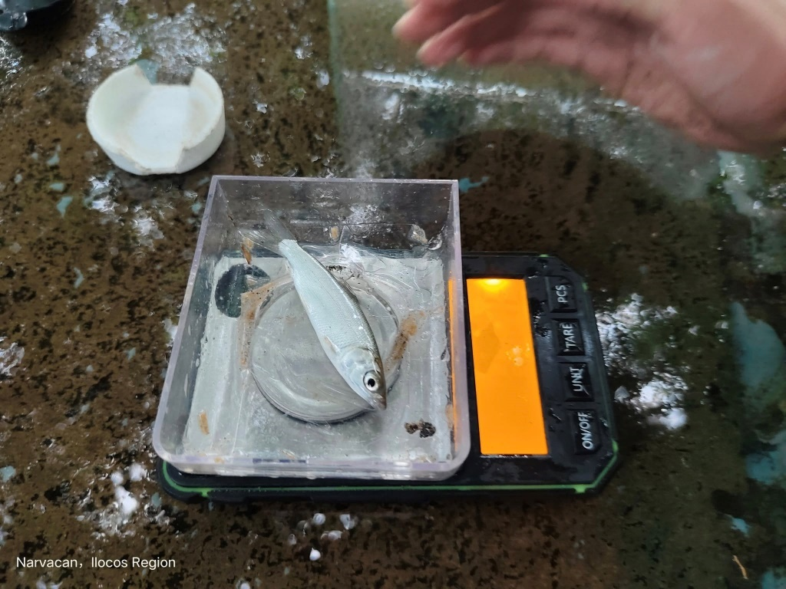
Plate 16. Weighing of Samples

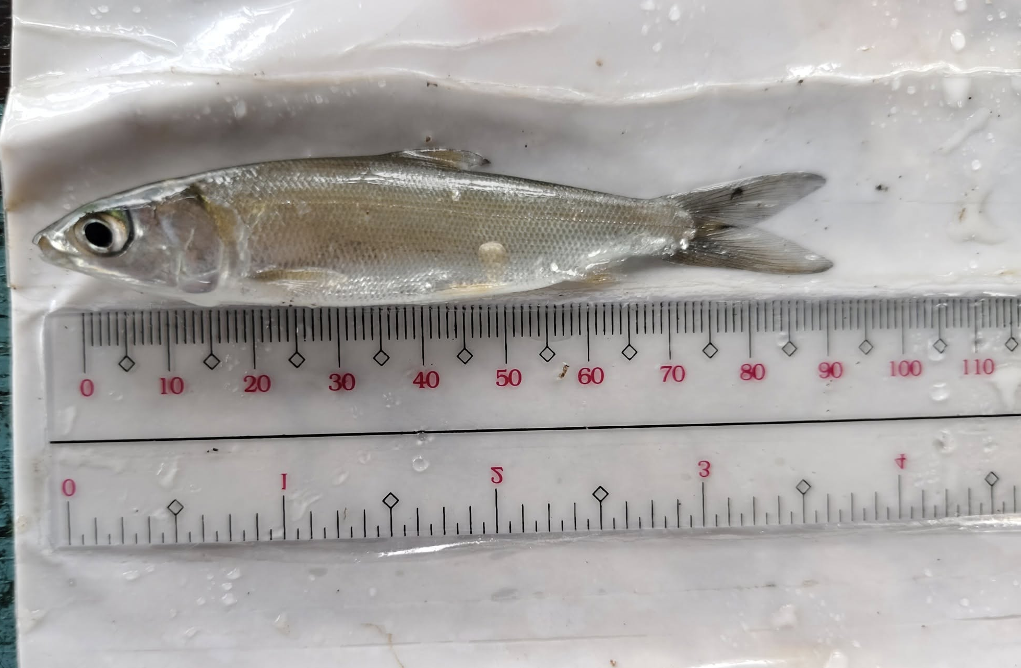
Plate17. Morphometric Measurement
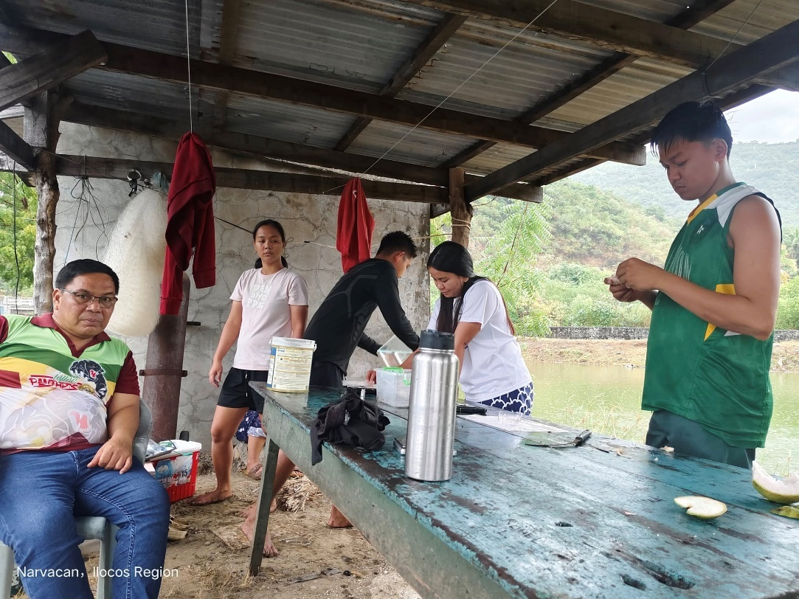
Plate 18. Sampling

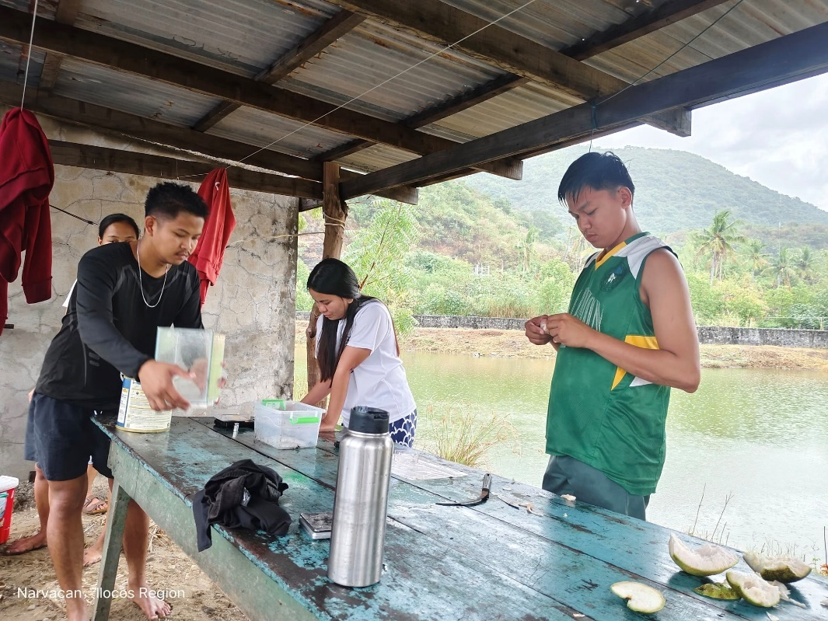
Plate 19. Sampling
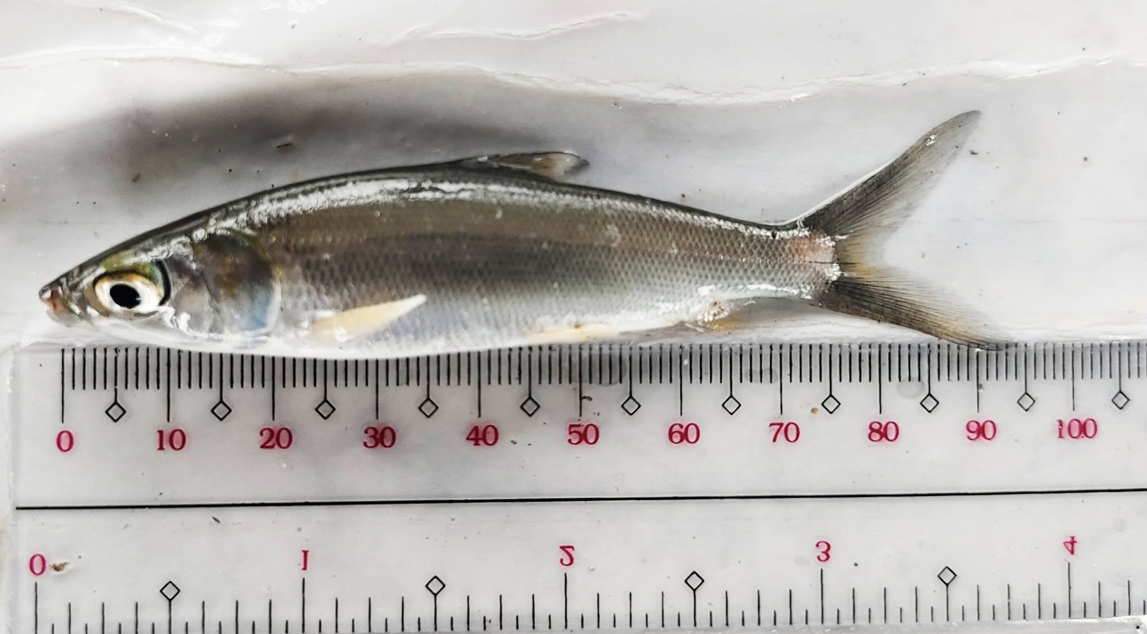
Plate 20. Milkfish Samples

