Supplementary Table S1 Variables and the proportion of deficit used for construction of FI-lab
Variables | Normal Range | Proportion of deficit, n(%)
 |  | Day1 | Day3 | Day5 | Day7
Vital signs
SBP(mmHg) | 90-140 | 187(8.21%) | 188(8.26%) | 266(11.68%) | 294(12.91%)
DBP(mmHg) | 60-90 | 1128(49.54%) | 1335(58.63%) | 1208(53.05%) | 1265(55.56%)
HR(times/min) | 60-100 | 829(36.41%) | 607(26.66%) | 641(28.15%) | 650(28.55%)
SPO₂(%) | ≥90 | 35(1.54%) | 27(1.19%) | 11(0.48%) | 10(0.44%)
Arterial blood
pH | 7.35-7.45 | 1361(59.77%) | 934(41.02%) | 935(41.06%) | 984(43.21%)
PO₂(mmHg) | 85-105 | 1759(77.25%) | 1546(67.90%) | 1503(66.01%) | 1432(62.89%)
PCO₂(mmHg) | 35-45 | 1057(46.42%) | 1004(44.09%) | 1033(45.37%) | 1074(47.17%)
Lactate(mmol/L) | 0.5-2 | 1180(51.82%) | 604(26.53%) | 413(18.14%) | 358(15.72%)
Venous blood
WBC(*10³/L) | 4-10 | 1582(69.48%) | 1520(66.75%) | 1472(64.65%) | 1636(71.85%)
PLT(*10⁹/L) | 150-400 | 1131(49.67%) | 1439(63.20%) | 1431(62.85%) | 1269(55.73%)
Hb(g/dL) | Male: 14-18  Female: 12-16 | 2038(89.50%) | 2195(96.40%) | 2214(97.23%) | 2221(97.54%)
ALT(Units/L) | 0-40 | 995(43.70%) | 979(43.00%) | 946(41.55%) | 922(40.49%)
ALB(g/dL) | 3.5-5.2 | 1093(48.00%) | 746(32.76%) | 727(31.93%) | 723(31.75%)
ALP(Units/L) | Male: 40-130  Female: 35-105 | 704(30.92%) | 618(27.14%) | 709(31.14%) | 800(35.13%)
LDH(Units/L) | 94-250 | 1157(50.81%) | 938(41.19%) | 893(39.22%) | 880(38.65%)
BUN(mg/dL) | 6-20 | 1549(68.03%) | 1640(72.02%) | 1676(73.61%) | 1738(76.33%)
Cr(mg/dL) | Male: 0.5-1.2  Female: 0.4-1.1 | 1404(61.66%) | 1451(63.72%) | 1410(61.92%) | 1355(59.51%)
Glucose(mg/dL) | 70-100 | 2028(89.06%) | 1990(87.40%) | 2036(89.42%) | 2061(90.51%)
K⁺(mmol/L) | 3.3-5.1 | 299(13.13%) | 160(7.03%) | 132(5.80%) | 135(5.93%)
Na⁺(mmol/L) | 133-145 | 540(23.72%) | 586(25.74%) | 626(27.49%) | 685(30.08%)
Ca²⁺(mg/dL) | 8.4-10.3 | 1495(65.66%) | 1430(62.80%) | 1277(56.08%) | 1165(51.16%)
P⁺(mg/dL) | 2.7-4.5 | 1179(51.78%) | 1203(52.83%) | 1107(48.62%) | 1035(45.45%)
Coagulation function
PT(s) | 9.4-12.5 | 1981(87.00%) | 1832(80.46%) | 1730(75.98%) | 1738(76.33%)
INR | 0.9-1.1 | 1999(87.79%) | 1838(80.72%) | 1721(75.58%) | 1746(76.68%)
APTT(s) | 25-36.5 | 1252(54.98%) | 1219(53.54%) | 1167(51.25%) | 1203(52.83%)
SBP=Systolic Blood Pressure; DBP=Diastolic Blood Pressure; HR=Heart Rate; WBC=White Blood Count; PLT=Platelet Count; Hb=Hemoglobin; ALT= Alanine Transaminase; ALB=Albumin; ALP=Alkaline Phosphatase; LDH=Lactate Dehydrogenase; BUN=Blood Urea Nitrogen; Cr=Creatinine; PT=Prothrombin Time; INR=International Normalized Radio; APTT=Activated Partial Thromboplastin Time
Supplementary Table S2 Comparison of the ROC of four days FI-lab for in-ICU mortality
Group | AUC | SE | 95%CI | Z | P | the maximum Youden index | cut-off value
FI-day1 | 0.551 | 0.0125 | 0.530-0.572 | 4.077 | <0.001 | 0.0775 | 0.58
FI-day3 | 0.599 | 0.0122 | 0.579-0.620 | 8.145 | <0.001 | 0.1574 | 0.52
FI-day5 | 0.619 | 0.0121 | 0.599-0.639 | 9.833 | <0.001 | 0.1830 | 0.55
FI-day7 | 0.651 | 0.0118 | 0.631-0.671 | 12.772 | <0.001 | 0.2306 | 0.55
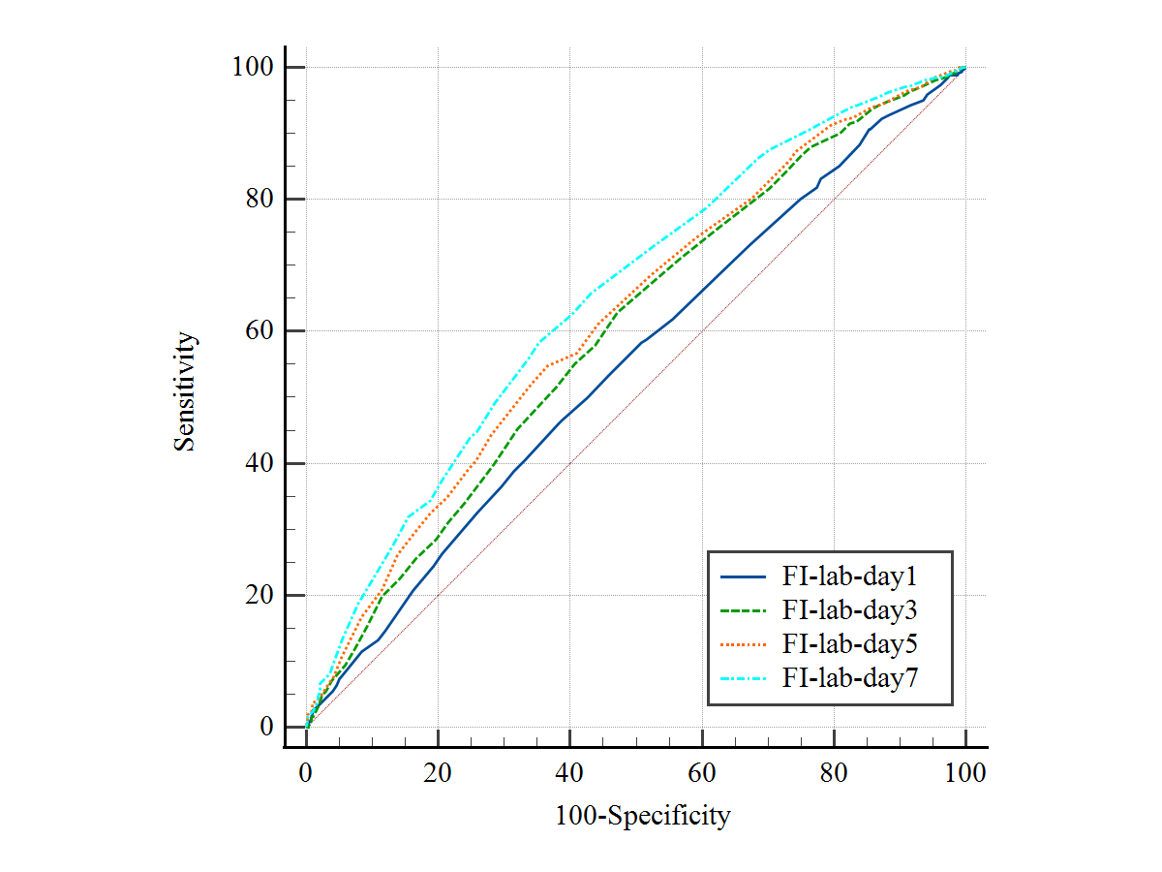
Supplementary Figure S1 ROC of four days FI-lab for in-ICU mortality

