Title: “Biochemical impacts of PET microplastics and cadmium on Danio rerio under environmental conditions.”

Supplementary material

Leslie L. Morales-Espinozaª
Marina Tauche Ferreira^{b}
Cleoni dos Santos Carvalho^{c}
Paulo Donato Frighetto^{d}
Heidi S. Moraes Utsunomiya^{c}
Lino F. Morales-Paredes^{e}
Renata Fracácioª*

ª Programa de Pós-graduação em Ciências Ambientais, Instituto de Ciência e Tecnologia - Câmpus de Sorocaba - Universidade Estadual Paulista Júlio de Mesquita Filho (UNESP) Av. Três de Março, 511, CEP 18087-180, Sorocaba, São Paulo, Brazil.
^{b} Programa de Pós-graduação PPGBMA, Universidade Federal de São Carlos, Campus Sorocaba, Rodovia Joao Leme dos Santos, km 110, SP-264, CEP 18052-780, Sorocaba, São Paulo, Brazil
^{c} Universidade Federal de São Carlos, Campus Sorocaba, Rodovia Joao Leme dos Santos, km 110, SP-264, CEP 18052-780, Sorocaba, São Paulo, Brazil
^{d} Instituto Federal São Paulo, Campus Sertãozinho, R. Américo Ambrósio, CEP, 14169-263, Sertãozinho, São Paulo, Brazil
^{e} Departamento Académico de Química, Facultad de Ciencias Naturales y Formales, Universidad Nacional de San Agustín de Arequipa, Arequipa 04001, Peru

Address correspondence to renata.fracacio@unesp.br, Sorocaba - SP, 18087-180, Brazil, telephone +55 15 99729-8227

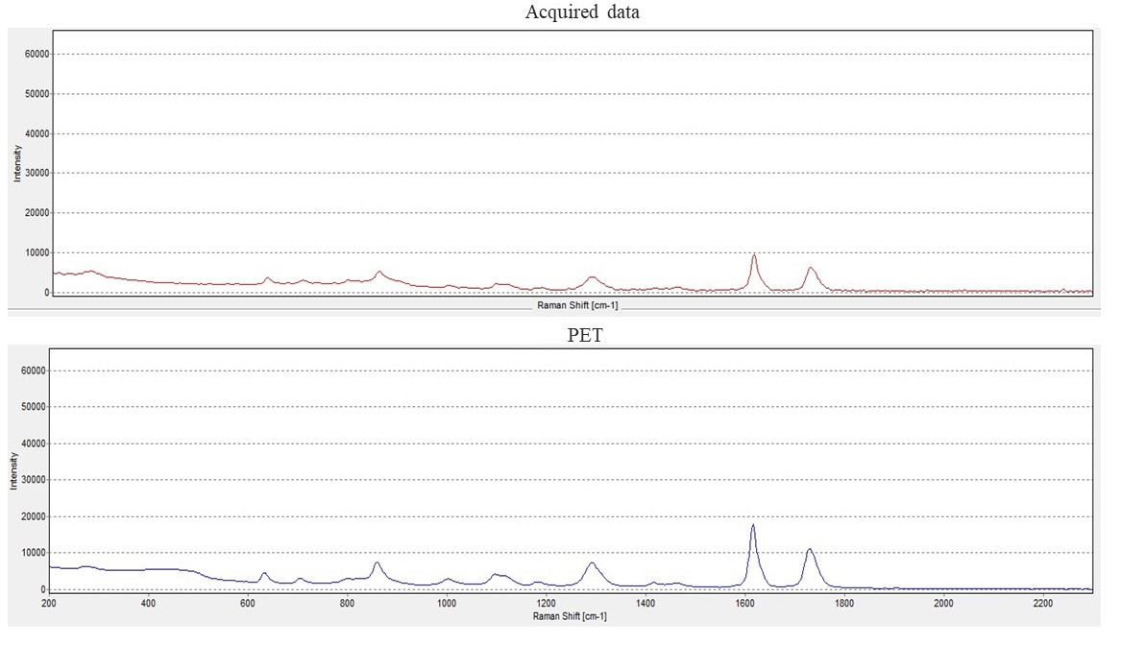
Figure S1: (A)Raman spectra for Polyethylene Terephthalate microplastics (PET-MPs) samples and (B) Polyethylene Terephthalate pure pattern. Match data with a HQI of 96.62%

Table S1: Water parameters from chronic experiments of different sizes and concentrations of PET-MPs and PET in combination with Cadmium with Danio rerio.

Water parameters | Experiment 1  (PET isolated) | Experiment 2 (PET+Cd)
Temperature (°C) | 25.91±0.01 | 25.89±0.01
pH | 6.85±0.08 | 6.74±0.07
Hardness (mg. L⁻¹ of CaCO₃) | 42.87±0.01 | 43.06±0.01
Dissolved oxygen (mg. L⁻¹) | 5.52±0.01 | 6.10±0.01
Condutivity (µS. cm⁻¹) | 182.91±0.05 | 170.31±0.04
Photoperiod (hours of light) | 12 | 12
Results are shown as mean ± standard deviation (S.D.).

Table S2. Changes in biochemical parameters in zebrafish (D. rerio) exposed to different sizes and concentrations of PET-MPs. The number of individuals per treatment was 10.
Biochemical Parameters |  | Treatments
Biochemical Parameters | Statistic values | Control | PET-MP 1-1 | PET-MP 1-2 | PET-MP 2-1 | PET-MP 2-2
Proteins  (mg. L⁻¹) | P = 0.195  H = 6.055 | 24.666±2.987 | 22.002±3.451 | 22.763±2.837 | 23.638±2.476 | 22.435±2.074
Glucose  (mg. L⁻¹) | P = <0.001  F = 8.632 | 13.566±3.119ª | 7.344±1.734^{d} | 12.093±2.389^{ab} | 7.915±1.836^{cd} | 11.211±2.194^{abc}
Triglycerides  (mg. L⁻¹) | P = 0.130  F = 1.900 | 64.613±12.591 | 61.192±11.208 | 49.590±11.908 | 53.174±9.493 | 59.434±10.996
CP  (nmoles. mg protein⁻¹) | P = <0.001  F = 22.452 | 2.788±0.314^{c} | 5.596±0.941ª | 5.561±0.847^{ab} | 4.780±0.719^{ab} | 3.659±0.746^{c}
LDH  (mU. mg protein⁻¹) | P = <0.001  F =15.226 | 0.050±0.009^{abc} | 0.015±0.001 | 0.066±0.020^{ab} | 0.035±0.010^{c} | 0.070±0.020ª
MDH  (mU. mg protein⁻¹) | P = 0.193  H = 6.084 | 0.004±0.003 | 0.004±0.001 | 0.003±0.001 | 0.005±0.001 | 0.004±0.001
Results are shown as mean ± standard deviation (S.D.). Lowercase letters represent significant differences (p < 0.05) between different experimental groups. Acronyms of PET-MPs represent different sizes and concentrations, PET-MP 1-1: 300-425 µm and C: 983 particles. L⁻¹; PET-MP 1-2: 300-425 µm and C:330 particles. L⁻¹; PET-MP 2-1: 53-75 µm and C: 983 particles. L⁻¹ and PET-MP 2-2: 53-75 µm and C: 330 particles. L⁻¹.
Table S3. Changes in biochemical parameters in zebrafish (D. rerio) exposed to PET-MPs in combination with cadmium. The number of individuals per treatment was 8.
Biochemical Parameters |  | Treatments
Biochemical Parameters | Statistic values | Control | Cd | PET-MP 2-2 | PET-MP 2-2+ Cd
Proteins  (mg. L⁻¹) | P = 0.966  F = 0.0874 | 16.554±2.673 | 16.801±1.703 | 16.272±2.539 | 16.794±1.883
Glucose  (mg. L⁻¹) | P = 0.059  H = 2.941 | 7.631±1.554 | 7.335±5.728 | 5.379±5.728 | 8.491±5.728
Triglycerides  (mg. L⁻¹) | P = 0.168  H = 1.847 | 27.117±1.554 | 26.293±1.578 | 35.603±1.106 | 35.233±2.615
CP  (nmoles. mg protein⁻¹) | P = <0.001  F = 8.572 | 2.333±0.555^{cb} | 2.622±0.607 ^{ab} | 1.700±0.343^{bc} | 3.508±0.714ª
LDH  (mU. mg protein⁻¹) | P = 0.003  H = 14.212 | 0.037±0.031^{ab} | 0.006±0.002^{abc} | 0.066±0.010ª | 0.001±0.000^{bc}
MDH  (mU. mg protein⁻¹) | P = <0.001  F = 13.196 | 0.007±0.002^{bc} | 0.019±0.004ª | 0.009±0.003^{bc} | 0.013±0.003^{ab}
Results are shown as mean ± standard deviation (S.D.). Lowercase letters represent significant differences (p < 0.05) between different experimental groups. Acronyms of PET-MPs represent different sizes and concentrations, PET-MP 2-2: 53-75 µm and C: 330 particles. L⁻¹, Cd: Cadmium, PET-MP 2-2+ Cd: 53-75 µm, and C: 330 particles. L⁻¹ in combination of Cadmium.

