Supplementary materials

Supplementary Table 1. Metabolic parameters in brain neoplasms and non-neoplastic lesions

 | [¹⁸F]FET PET TBR |  |  |  |  |  | [¹⁸F]FET PET SUV
 | TBRmax |  |  | TBRmean |  |  | SUVmax |  |  | SUVmean
Diagnosis | mean ± sd | range |  | mean ± sd | range |  | mean ± sd | range |  | mean ± sd | range
ALL | 3.44 ± 1.40 | 1.24-7.07 |  | 2.08 ± 0.46 | 1.01-3.18 |  | 3.85 ± 1.72 | 1.60-8.43 |  | 2.35 ± 0.66 | 1.21-4.04
Brain Neoblastic Lesions (BNL) | 3.82 ± 1.41 | 1.63-7.07 |  | 2.22 ± 0.41 | 1.62-3.18 |  | 4.21 ± 1.82 | 0.91-2.43 |  | 2.44 ± 0.69 | 0.58-1.66
High grade glioma | 4.21 ± 1.41 | 1.73-7.07 |  | 2.25 ± 0.39 | 1.64-3.06 |  | 4.70 ± 1.71 | 2.05-8.13 |  | 2.52 ± 0.60 | 1.21-3.79
Low grade glioma | 2.91 ± 1.88 | 1.63-6.64 |  | 2.00 ± 0.59 | 1.62-3.18 |  | 3.35 ± 2.58 | 1.60-8.43 |  | 2.26 ± 0.94 | 1.32-4.04
CNS lymphoma | 4.00 ± 0.43 | 3.43-4.39 |  | 2.41 ± 0.31 | 1.94-2.61 |  | 4.25 ± 1.04 | 3.43-5.77 |  | 2.58 ± 0.82 | 1.94-3.78
Metastasis | 2.96 ± 0.75 | 1.70-3.75 |  | 2.04 ± 0.27 | 1.65-2.48 |  | 3.11 ± 1.44 | 1.99-6.22 |  | 2.14 ± 0.76 | 1.51-3.70
Meningioma | 4.63 ± 0.96 | 3.95-5.30 |  | 2.77 ± 0.20 | 2.63-2.91 |  | 4.91 ± 1.69 | 3.71-6.10 |  | 2.91 ± 0.62 | 2.47-3.35
Non-neoplastic lesions (NNL) | 2.36 ± 0.60 | 1.24-3.55 |  | 1.70 ± 0.35 | 1.01-2.08 |  | 2.86 ± 0.80 | 1.77-4.56 |  | 2.09 ± 0.47 | 1.51-3.05
Brain abscess | 2.53 ± 0.58 | 1.93-3.55 |  | 1.75 ± 0.38 | 1.01-2.08 |  | 2.89 ± 0.39 | 2.13-3.60 |  | 1.98 ± 0.60 | 1.51-2.49
Encephalomyelitis | 2.15 ± 0.74 | 1.24-3.01 |  | 1.59 ± 0.42 | 1.04-2.04 |  | 2.74 ± 0.82 | 1.77-3.67 |  | 2.16 ± 0.45 | 1.63-2.68
Hematoma | 2.63 ± 0.17 | 2.51-2.75 |  | 1.83 ± 0.01 | 1.82-1.84 |  | 3.34 ± 1.73 | 2.11-4.56 |  | 2.29 ± 1.07 | 1.53-3.05
Infarction | 2.10 | ㅡ |  | 1.74 | ㅡ |  | 2.35 | ㅡ |  | 1.95 | ㅡ

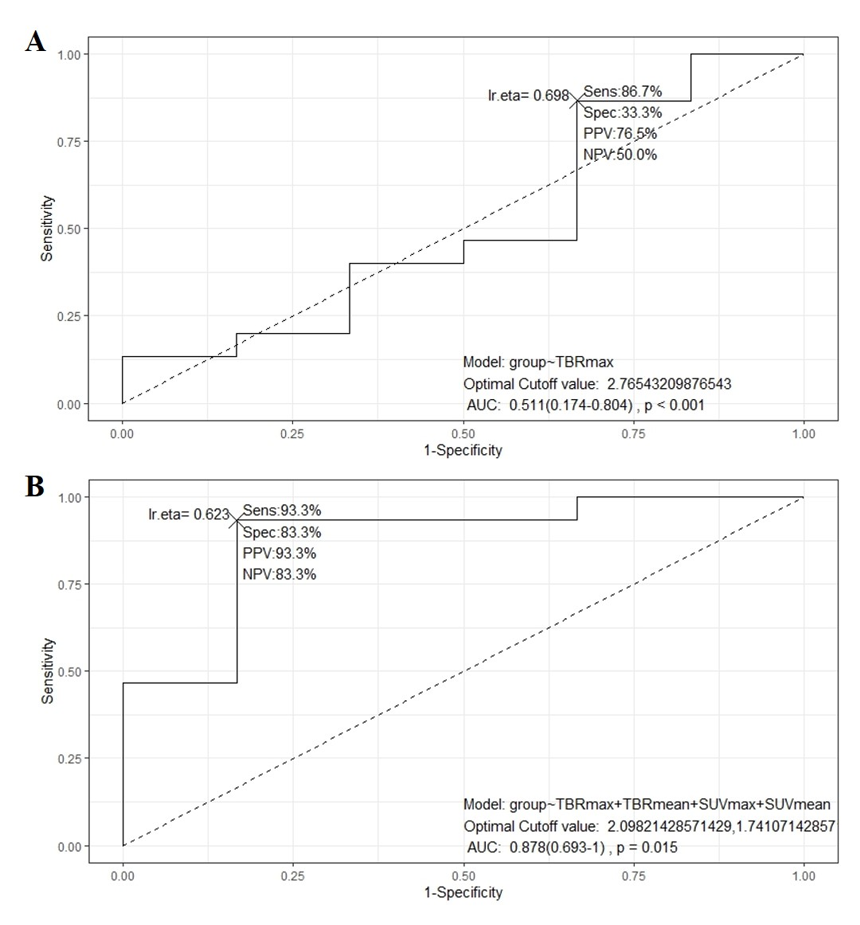

Supplementary figure 1. The ROC curves for differential diagnosis between LGG vs NNL

A, The ROC curve for TBR_{max}; B, The multivariate ROC curves incorporating TBR_{max}, TBR_{mean}, SUV_{max}, and SUV_{mean.}

