Supplementary Information

Global Solar Energy Transition and End-of-Life PV Forecasts Through 2050
Moisés Gómez¹, Vasilis Fthenakis², Mark Z. Jacobson³, Jinhui Li¹, and Xianlai Zeng^{1*}

¹ School of Environment, Tsinghua University, Beijing 100084, China
² Center for Life Cycle Analysis, Columbia University, New York, NY 10027, USA
³ Department of Civil and Environmental Engineering, Stanford University, Stanford, CA 94305-4020, USA

* Corresponding author: School of Environment, Tsinghua University, Beijing 100084, China. Email: xlzeng@tsinghua.edu.cn

Table of Contents
1 Data collection 3
2 Forecast of installed solar capacity 18
2.1 Africa 18
2.2 Asia 22
2.3 Europe 25
2.4 North America 28
2.5 South America 29
2.6 Oceania 30
3 Comparation of models 31
4 Sensitive analysis 32
5 PV modules 34
6 End-of-life (EoL) solar panels 39
7 Others 51
8 References 54

Data collection
Table S1: National Solar Capacity Targets and Long-Term Projections. The "Year" column reflects the most recent data. The "Solar Capacity in 2050 (GW)" column uses the following color codes; blue: Data directly from government reports or comprehensive literature reviews, yellow: Impartial data sourced from a wide range of sources, primarily governmental, for a year prior to 2050, with projections for 2050 derived through modeling based on these sources, and red: No direct data available; projections for 2050 generated through modeling due to missing information.
Continent/country |  | Installed solar capacity (GW) | Solar capacity in 2050 (GW) | Carbon neutrality | Observations | Year | References
Africa | Algeria | 22 (2030) | 6.64 | No target | The main source of energy of Algeria are gas (>60%) and oil (>30%). | 2023 |  | Ref.1 | Ref. 2 |  | Ref. 3
Africa | Angola | No data | 4.29 | No target | The country’s current energy mix consists of 61.8 percent hydropower, 37.6 percent other fossil fuels and 0.6 percent hybrid (solar/fossil fuel). The main source of energy for residential use is traditional biomass (firewood and charcoal). Some 85% of Angolans rely on biomass for most of their energy needs. | - | Ref.1 |  |  | Ref. 2 | Ref. 3
Africa | Benin | No data | 0.403 | Achieved (self-declared) | Benin's energy matrix comprises approximately 60% biomass, 20% fossil fuels, 15% hydropower, and 5% solar power. Biomass remains the dominant source of energy, primarily used for cooking and heating | - | Ref.1 |  |  | Ref. 2 | Ref. 3
Africa | Botswana | No data | 0.0904 | 2060 | Botswana is one of the countries in Africa that have the largest share of biomass consumption in the household sector of up to 92%. Botswana committed to having renewable energy make up at least 30 per cent of it . | - | Ref.1 |  |  | Ref. 2
Africa | Burkina Faso | No data | 1.33 | No target | Total primary energy supply in 2018 was 6071.68 ktoe of which biomass 76% and petroleum products 24%. | - | Ref.1 |  |  | Ref. 2
Africa | Burundi | No data | 0.182 | No target | Historically, wood has been the main fuel to provide heating. The current energy mix consists of hydro-electric and thermal. Some diesel power and solar photovoltaic panels are also used. Over 90% of Burundi's energy requirements are met by the burning of wood, charcoal, or peat. | - | Ref.1 |  |  | Ref. 2
Africa | Cameroon | No data | 0.206 | No target | The primary supply of energy in Cameroon comes from biofuels and waste (70.58%), followed by crude oil (20.17%), natural gas (5.34%), hydropower (3.90%), and other renewable sources (0.01%) like solar, geothermal, and wind. Targets: 32% 2035 below BaU relative to 2010 and 25% share of renewables in energy mix (excl. hydro) by 2035. | - | Ref.1 |  |  | Ref. 2
Africa | Central African Republic | No data | 0.0046 | No target | Historically, wood has been the main fuel to provide heating. The current energy mix consists of hydro-electric and thermal. Some diesel power and solar photovoltaic panels are also used. | - | Ref.1 |  |  | Ref. 2
Africa | Chad | No data | 0.0105 | No target | In 2019, Chad’s energy mix was dominated by biofuels and wastes (85%) with oil products accounting for the rest of the total energy supply. Chad's energy matrix currently relies heavily on fossil fuels, particularly oil, which is a significant part of its economy | - | Ref.1 |  |  | Ref. 2
Africa | Cote d'Ivoire | 5.2 (2030), 8.6 (2040) | 8.6 | 2030 | Most of Cote d'Ivoire's primary energy demand is covered by local oil refinery supplies and domestic gas production | - | Ref.1 |  |  | Ref. 2 | Ref. 3
Africa | Djibouti | No data | 0.00522 | Proposed (2050) | Djibouti relies entirely on imported fossil fuels and electricity to meet its energy needs. Djibouti aims to produce 100% green energy by 2035 | - | Ref.1 |  |  | Ref. 2 | Ref. 3
Africa | Democratic Republic of Congo | No data | 0.01038 | Proposed (2050) | Energy mix in 2021; Oil · 2.4%; Hydro · 3.6% ; Wind, solar, etc. · 0.0% ; Biofuels and waste · 94.0%. | - | Ref.1 |  |  | Ref. 2 | Ref. 3
Africa | Egypt | No data | 24.86 | No target | The country plans to install additional renewable energy capacities that will generate 42% of electricity by 2035. | - | Ref.1 |  |  | Ref. 2
Africa | Equatorial Guinea | No data | 0.0026 | No target | Equatorial Guinea's energy matrix is predominantly fueled by petroleum and natural gas, which together account for over 90% of the country's energy production and export revenues | - | Ref.1 |  |  | Ref. 2
Africa | Eritrea | No data | 0.156 | Proposed (2050) | Most of the country's electricity generated in Eritrea comes from oil that is imported into the country. | - | Ref.1 |  |  | Ref. 2
Africa | Eswatini | No data | 0.158 | 2050 | The total primary energy supply in 2018 was 1,499ktoe of which combustible Renewables and waste 49%, petroleum products 37%, coal 2% and electricity 12%. Most of the biomass, especially wood fuel, was used in the industry sector accounting to about 55% of total consumption. | - | Ref.1 |  |  | Ref. 2
Africa | Ethiopia | No data | 0.305 | 2050 | It is estimated that biomass energy accounted for 85% of total national energy consumption in 2018 | - | Ref.1 |  |  | Ref. 2 | Ref. 3
Africa | Gabon | No data | 0.02 | 2050 | The fuel share of TFC in Gabon are biomass 84%, oil and petroleum products 12%, and electricity 4%. Gabon is a heavily forested country, and biomass still constitutes the majority of the Total primary energy supply of the country. | - | Ref.1 |  |  | Ref. 2
Africa | Gambia | 3.25 (2050) | 3.25 | 2050 (net-zero) | The major source of energy for the whole country is fuel wood, which is extracted from the country’s forest resources, followed by petroleum products, electricity and renewable energy. According to AFREC 2020 energy balance, approximately 82% of the biomass was used I the households followed by 18% in communication and public sectors. |  | Ref.1 |  |  | Ref. 2 | Ref. 3
Africa | Ghana | 1.5 (2040), 3 (2050), 4.8 (2060), 8.9 (2070) | 3 | 2070 (net-zero) | Petroleum accounts for 50% of total final consumption and is followed by biofuels and waste at 36% |  | Ref.1 |  |  | Ref.2
Africa | Guinea | No data | 0.035 | Proposed (2050) | The 2020 energy balance, the main primary energy sources that make up the energy mix in Guinea are biomass, and oil while electricity is mainly generated from hydro-electricity sources and fossil thermal sources. With 77% biomass (mostly charcoal) has the largest contribution in primary energy consumption in Guinea. More than 84% of households have access to biomass. |  | Ref.1 |  |  | Ref. 2
Africa | Guinea-Bissau | No data | 0.0169 | Proposed (2050) | Guinea-Bissau defined its first quantified target for reducing greenhouse gas emissions, committing to a reduction of 30% by 2030 with support and an unconditional target of reducing emissions by 10%. The biomass represents over 84% followed by oil products that takes 15% and electricity at only 1% of the total fuel shares of the total final consumption. |  | Ref.1 |  |  | Ref. 2 | Ref. 3
Africa | Kenya | 50 (2050) | 50 | 2050 (net-zero) | Kenya's energy mix predominantly consists of green energy with geothermal, hydro, wind, and solar accounting for 85% to 90% generation in 2023 | 2023 | Ref.1 |  |  | Ref. 2 | Ref. 3
Africa | Lesotho | No data | 0.006 | Proposed (2050) | Lesotho's energy mix is primarily comprised of biomass (70-80%) of total energy consumption, used mainly for cooking and heating in rural areas. Hydropower contributes around 15-20% to electricity generation, leveraging the country's water resources. Fossil fuels, largely imported, play a minor role, supporting about 5-10% of energy needs, primarily in transportation. |  | Ref.1 |  |  | Ref. 2
Africa | Liberia | 0.06 (2030) | 0.037 | 2050 | Total share of renewable electricity (including large hydro) in the electricity mix more than 45% by 2020 and 75% by 2030 |  | Ref.1 |  |  | Ref. 2 | Ref. 3
Africa | Libya | No data | 0.0913 | No target | Energy mix; Oil · 62.3% ; Natural gas · 34.0% ; Wind, solar, etc. · 0.0% ; Biofuels and waste · 3.7%. |  | Ref.1 |  |  | Ref. 2
Africa | Madagascar | No data | 0.4759 | Proposed (2050) | In 2019, Madagascar's energy mix was dominated by biofuels and wastes (85%), with oil products (11%), coal and hydro accounting for the rest of the total energy supply. |  | Ref.1 |  |  | Ref. 2
Africa | Malawi | No data | 2.06 | Proposed (2050) | Malawi's energy matrix is currently dominated by biomass, which accounts for about 88% of the country's energy consumption, primarily used for cooking and heating in rural areas. Hydropower is the main source of electricity generation, contributing around 8% |  | Ref.1 |  |  | Ref. 2 | Ref. 3
Africa | Mali | No data | 3.3 | Proposed (2050) | In 2019, Mali's energy mix was dominated by oil products (65%) and biofuels and waste (32%). |  |  |  |  | Ref. 2 | Ref. 3
Africa | Mauritania | No data | 1.283 | Proposed (2050) | In 2019, Mauritania's energy mix was dominated by oil products (65%) and biofuels and waste (32%). |  | Ref.1 |  |  | Ref. 2 | Ref. 3
Africa | Mauritius | 0.025-0.25 (2050, version 2014) | 0.25 | Proposed (2050) | The energy mix in Mauritius is dominated by coal and oil. Almost 10% of the country's final energy consumption is generated by renewable sources. |  | Ref.1 |  |  | Ref. 2 | Ref. 3
Africa | Morocco | No data | 12.38 | 2050 | Fossil fuels, primarily natural gas and some coal, plays a role in providing baseload power, comprising about 50-60% of the energy mix. Morocco aims to have 80% of renewable energy by 2050. |  | Ref.1 |  |  | Ref. 2
Africa | Mozambique | 7.5 (2030) | 7.5 | Proposed (2050) | Hydropower is the dominating electricity source with 2,189 MW, 79% of the total energy mix, followed by 442 MW from gas (16%), 108 MW from heavy fuel oil (HFO) (4%) and 41 MW from solar (1%) (2020) | 2024 | Ref.1 |  |  | Ref. 2
Africa | Namibia | No data | 2.545 | 2050 | Approximately 60% of the country's electricity generation is produced by hydropower. Wind energy is expanding and currently provides about 5% of Namibia's electricity. Fossil fuels, mainly imported, contribute roughly 20-30%. Namibia imports a substantial portion of its electricity from neighboring countries, further diversifying its energy sources. |  | Ref.1 |  |  | Ref. 2 | Ref. 3
Africa | Niger | No data | 0.894 | Proposed (2050) | Niger relies on diesel generators and imports electricity for a substantial part of its energy needs |  | Ref.1 |  |  | Ref. 2
Africa | Nigeria | 8 (2030), 81 (2040), 197 (2050), 250 (2060) | 197 | 2060 | Natural gas is the predominant source of electricity in Nigeria, accounting for over 60% of the total installed capacity, with around 7,000 MW from gas-fired plants. Nigeria's energy matrix is evolving with a strong emphasis on expanding renewable energy sources, particularly solar and hydropower, while continuing to rely on natural gas for stability and capacity |  | Ref.1 |  |  | Ref. 2 | Ref. 3
Africa | Republic of the Congo | No data | 0.287 | No target | Wood fuel remains a dominant fuel, especially in rural areas. However, as biomass/wood energy is currently used and is rising swiftly, the rate of deforestation is growing in an unsustainable fashion, and soon the forests of Congo will not be able to support the demand. |  | Ref.1 |  |  | Ref. 2
Africa | Rwanda | 19.4-25 (2050, report) | 25 | Proposed (2050) | The primary energy supply is dominated by biomass (over 98 %), used mainly for cooking and heating, whereas electricity is almost entirely supplied by Hydro energy (53 %). |  | Ref.1 |  |  | Ref. 2
Africa | Senegal | No tada | 3.785 | Proposed (2050) | The country’s electricity mix is dominated by heavy fuel oil (HFO), which accounted for 70% of total electricity generation in 2022. In recent years, renewable energy has overtaken coal, with wind and solar power accounting for 21% of generation in 2022. Senegal already has 0.4 GW of total renewable energy installed capacity and has recently pledged to increase the share to 40% by 2030Senegal has partnered with several countries and the EU to accelerate its renewable energy deployment. The partnership will help increase the share of installed renewable energy capacity to 40% of Senegal’s electricity mix by 2030. |  | Ref.1 |  |  | Ref. 2 | Ref. 3
Africa | Sierra Leone | No data | 0.136 | Proposed (2050) | 80 per cent of the country's electricity is generated from fossil fuels. |  | Ref.1 |  |  | Ref. 2
Africa | Somalia | No data | 0.678 | Proposed (2050) | Somalia relies mainly on high-speed diesel. Somalia is moving towards a mix of energy sources, including solar, wind, and natural gas, which are imported. 65% of Somalis live in rural areas and rely on agriculture and charcoal production for income, using traditional biomass fuels (firewood and charcoal) for 82% of energy. | 2023 | Ref.1 |  |  | Ref. 2
Africa | South Africa | 6 (2030) | 91.22 | 2050 | In South Africa, approximately 85 % (42,000 MW), of the nation’s electricity is generated via coal-fired power stations. Despite environmental concerns, coal will continue to provide the majority of South Africa’s power for the next decade, although the share from renewables will grow rapidly. | 2024 | Ref.1 |  |  | Ref. 2
Africa | South Sudan | No data | 0.203 | Proposed (2050) | South Sudan's energy matrix is currently heavily dependent on biomass and traditional energy sources, with limited access to modern electricity infrastructure. |  | Ref.1 |  |  | Ref. 2
Africa | Sudan | No data | 2.74 | Proposed (2050) | Sudan's energy matrix is diverse but heavily reliant on fossil fuels and hydroelectric power | 2021 | Ref.1 |  |  | Ref. 2 | Ref. 3
Africa | Tanzania | 34 (2050) | 34 | Proposed (2050) | About 45% of the country's electricity comes from hydro | 2023 | Ref.1 |  |  | Ref. 2 | Ref. 3
Africa | Togo | 37 (2050, paper) | 37 | Proposed (2050) | In 2020, Togo's electricity mix was composed of 44.44% thermal, 44.29% importation and 11.27% renewable sources | 2023 | Ref.1 |  |  | Ref. 2
Africa | Tunisia | 1.51 (2030) | 2.842 | 2050 | In 2022, only 3 percent of the electricity produced in Tunisia was from renewable sources. Renewable energy target to 35% of total energy generation by 2030 | 2022 | Ref.1 |  |  | Ref. 2
Africa | Uganda | 7.5 (2030), 45 (2050), 50 (2050, ref.2) | 50 | 2065 | Electricity rises to become the single largest source of energy consumed by 2040, growing to reach 56% of total final consumption by 2050. The grid today is already 99% renewable, with only a small amount of oil-based generation used in critical situations. By 2050, the aim is for clean fuels including solar, geothermal, nuclear and hydropower to account for 75% of the country’s energy supply. | 2022 | Ref.1 |  |  | Ref. 2 | Ref. 3
Africa | Zambia | No data | 1.39 | Proposed (2050) | Although Zambia’s commitment to reduce greenhouse gas emissions remained consistent with their first NDC – pledging, with limited international support, to reduce emissions by 25% by 2030, or by 47% with substantial international support |  | Ref.1 |  |  | Ref. 2
Africa | Zimbabwe | No data | 0.595 | 2050 | By 2030, the country set up a 2 GW on renewable energy. Carbon emissions by 40% by 2050, indicating a shift away from coal – which currently accounts for over a third of electricity generation – towards clean sources | 2022 | Ref.1 |  |  | Ref. 2 | Ref. 3
Asia | Afghanistan | No data | 0.47 | No target | Hydropower dominates the energy sector (63.7%), followed by the use of fossil fuels (35.3%), which includes coal, oil, and natural gas. Renewable energy sources such as solar and wind are also being developed, but they currently contribute a smaller share to the overall energy mix​. The country had 99% reliance on hydro power production in 2011 to 80.6% in 2019. Solar energy currently accounts for about | 2024 | Ref.1 |  |  | Ref. 2
Asia | Armenia | 1 (2030), 2.63 (2050) | 2.63 | 2050 (net-zero) | Armenia’s NDC target is 40% emissions reduction below 1990 level, to be achieved in 2030 | 2022 | Ref. 1 |  |  | Ref.2 | Ref. 3
Asia | Azerbaijan | No data | 0.734 | 2050 | Target of 40% reduction in greenhouse gas emissions by 2050. Baku has set a goal to move from 17 percent to 30 percent of total energy from renewable sources by 2030. | 2022 | Ref.1 |  |  | Ref. 2 | Ref. 3
Asia | Bahrain | 0.2 (2025), 0.4 (2035) | 0.4 | 2060 | Interim goal of a 30% reduction in CO2e emissions by 2035. | 2022 | Ref.1 |  |  | Ref. 2
Asia | Bangladesh | 28 (2050, NZE), 18(2050, ATS) | 28 | 2050 | Bangladesh has set ambitious goals to reduce carbon emissions by 21.8 percent by 2030, focusing on increased use of renewable energy and energy efficiency. Bangladesh is also committed to substantial reductions, aiming to decrease black carbon emissions by 72 percent and methane by 37 percent by 2040. | 2023 | Ref.1 |  |  | Ref. 2
Asia | Cambodia | 5.6 (2050, scenario 5)-7.5 (2050, low carbon emission scenario) | 7.5 | 2050 | Cambodia relies on three main sources for electricity: hydroelectric power plants for more than half, a total maximum capacity of 1,329 MW as of last year, coal power stations of 538 MW, and solar energy of 64.77 MW. Cambodia’s electrification rate is the second-lowest among South East Asian countries. Cambodia plans to increase its power generation capacity by building hydropower and coal-fired plants by 2025, which can contribute to improve self-sufficiency of power supply. | 2023 | Ref.1 |  |  | Ref. 2 | Ref. 3
Asia | China | 890 (2030), 3845 (2060) | 3385.0 | 2060 | Carbon Neutral Scenario. 880 (2030) & 3070 (2060) for Base line Scenario | 2021 | Ref. 1
Asia | Georgia | 1.383 (2050) | 1.4 | 2050 | About 80% of Georgia's electricity generation comes from hydro resources (by 2021).The country aims to reduce its reliance on hydropower, which currently accounts for 78% of its electricity, by diversifying its energy mix with more solar and wind projects. | 2023 | Ref.1 |  |  | Ref. 2
Asia | Hong Kong (region of China) | N/A |  | 2050 | Currently, renewable energy makes up less than 1% of Hong Kong's total electricity supply, but the city aims to increase this to 10% by 2035 through a combination of solar, wind, and waste-to-energy projects Solar power could contribute about 1-2% of Hong Kong's electricity needs by 2050. | 2021 | Ref.1 |  |  | Ref. 2
Asia | India | 1700 (2050), 5630 (2070) | 1700 | 2070 | Over 80%of India’s energy needs are met by three fuels: coal, oil and solid biomass. Coal has underpinned the expansion of electricity generation and industry and remains the largest single fuel in the energy mix. | 2021 | Ref.1 |  |  | Ref. 2 | Ref. 3
Asia | Indonesia | 265 (2050) | 265 | 2050 (net-zero) | Currently, Indonesia's renewable energy sector remains underdeveloped, with only 11% of the country's electricity generation | 2023 | Ref. 1 |  |  | Ref. 2
Asia | Iran | 7.5 (2030), 495-880 (2050, paper ref. 3) | 880 | 2050 (net-zero) | The government has set a target to increase its renewable energy share of electricity production by up to 12% by 2030. | 2024 | Ref. 1 |  |  | Ref. 2 | Ref. 3
Asia | Iraq | 12 (2027 or 2030) | 12 | No target | Iraq also plans to cut its methane emissions by 30 percent by 2030. By 2050, half of its electricity production will come from solar energy. Iraq, OPEC's second-biggest oil producer. | 2024 | Ref. 1 |  |  | Ref. 2
Asia | Israel | 17 (BAU, 2030)-22.9 (reduction, 2030), 30.4 (BAU, 2050)-80.2 (Reduction, 2050) | 80.2 | 2050 (net-zero) | The country's current renewable energy roadmap sets a target of achieving 40% of its electricity from renewables by 2030 | 2022 | Ref. 1 |  |  | Ref. 2
Asia | Japan | 108 (2030), 524 (2050, paper_ref.2), 689 (2050, ref. 3) | 689 | 2050 (net-zero) | Japan imports most of its energy due to scarce domestic resources. As of 2022, the country imports 97% of its oil and is the larger LNG importer globally | 2022 | Ref. 1 |  |  | Ref. 2 | Ref. 3
Asia | Jordan | 25 (2050, paper) | 25 | 2050 | Jordan enhanced its commitment by raising its conditional greenhouse gas emissions reduction target to 31% by 2030 compared to business as usual. | 2020 | Ref. 1 |  |  | Ref. 2 | Ref. 3
Asia | Kazakhstan | No data | 29.3 | 2060 | The coutry has a plan of at least 15 percent of all electricity generated to be provided by renewable energy sources by 2030, and at least 50 percent by 2050.Currently, more than 70 per cent of Kazakhstan’s electricity is produced in ageing coal-fired plants. | 2023 | Ref. 1 |  |  | Ref. 2
Asia | Kuwait | No data | 1.35 | 2060 | Kuwait to double renewable energy production from 15 to 30 percent by 2030 to 50 percent by 2050. The country aims to have an installed renewable energy capacity of around 22 GW by 2030. | 2024 | Ref. 1
Asia | Laos | 11.5 (2030) | 11.5 | 2050 | The country’s power sector is heavily reliant on hydropower (58% and 32% biomass in 2021). Most of the power generated by the Lao PDR is exported to neighboring countries (battery of Southeast Asia) and a small part of the generation is consumed domestically. Laos has committed to unconditionally reduce its GHG emissions by 60% in 2030 compared to the BAU scenario | 2022 | Ref. 1 |  |  | Ref. 2
Asia | Lebanon | 2.5 (2050) | 2.5 | 2050 | The main energy source in the country is oil with 93.1% in 2021. | 2020 | Ref. 1 |  |  | Ref. 2 | Ref. 3
Asia | Malaysia | 150 (2050) | 150 | 2050 | By 2050, primary energy supply in Malaysia is expected to increase by 60% over that of 2018. | 2023 | Ref. 1 |  |  | Ref. 2
Asia | Mongolia | No data | 2.81 | 2050 | Mongolia aims for a renewable energy share of 20% by 2023 and 30% by 2030 of its installed capacity. |  | Ref. 1 |  |  | Ref. 2
Asia | Myanmar | No data | 1.49 | 2040 (land use, land use change and forestry | Increase the share of RE to 39% in electricity generation by 2030 (28% hydro or 5156 MW, and 11% other RE or 2000 MW). Coal will not increase beyond 2030 and completely phase out in 2050. |  | Ref. 1 |  |  | Ref. 2 | Ref. 3
Asia | Nepal | 25 (2050) | 25 | 2045 | Hydropower will remain the main power source in all scenarios for more than another decade. However, just after 2040, solar PV will overtake hydropower in installed capacity. After 2045, the continuing growth of solar PV and additional wind power capacities will lead to a total capacity. | 2023 | Ref. 1
Asia | North Korea | No data | 0.747 | No target |  |  | Ref. 1
Asia | Oman | 13 (2030) | 13 | 2050 | Renewable energy development goals of 11% renewables share in the electricity mix by 2025 and 30% by 2030. | 2024 | Ref. 1 |  |  | Ref. 2
Asia | Pakistan | 12.8 (2030), 26.9 (2047) | 27 | 2050 | Solar and wind are expected to account for a growing share of the electricity mix in the years ahead, rising from around 3% at present to 23% by 2030. Over the following two decades after that, however, this share will likely remain unchanged, as the national regulator expects the country to deploy more coal-fired generation capacity. | 2021 | Ref. 1 |  |  | Ref. 2 | Ref. 3
Asia | Palestine | 0.3 (2030) and 0.1 (CSP) | 2.77 | No target | At present, Palestine imports most of its electricity. The most important renewable energy potential in Palestine is solar energy. | 2021 | Ref. 1 |  |  | Ref. 2
Asia | Philippines | 46.1 (2040) | 46.1 | No target | In 2023, the Philippines relied on fossil fuels to produce 78% of its electricity. Over 20% of the Philippines’ electricity comes from low-carbon sources, with the majority coming from hydropower and geothermal. Renewables like solar and wind made up just 2.5%. This is way below the global average of 13% and even the average among other ASEAN countries, which sits at 4.4%. | 2023 | Ref. 1 |  |  | Ref. 2 | Ref. 3
Asia | Qatar | 5 (2035) | 11.6 | No target | At the end of 2021, solar represented less than 1% of Qatar’s installed capacity with 5 MW. Gas still represents more than 99% of the country’s installed capacity with more than 12.5 GW. | 2022 | Ref. 1 |  |  | Ref. 2
Asia | Saudi Arabia | 40 (2030) | 40 | 2030 (carbon n.), 2050 (net-zero) | Solar PV dominated the renewable power capacity landscape in 2023, accounting for 82.6%, followed by onshore wind at nearly 14.1%, and solar thermal at 3.1%. | 2024 | Ref. 1 |  |  | Ref. 2
Asia | Singapore | 2.5 (baseline scenario), 5 (accelerated scenario) | 5 | 2050 (net-zero) | Singapore plans to integrate photovoltaic modules creatively across its urban landscape, including rooftops, building facades, and even floating solar panels on reservoirs and offshore areas. | 2020 | Ref. 1
Asia | South Korea | 11.7 (2030), 375 (2050) | 375 | 2050 (net-zero) | An interim target of at least 53% renewables in power generation is required in 2030 to transition to an 84% share by 2050. Coal power plants must be phased out by 2035; natural gas power plants by 2045. The gradual electrification of heat, transport, and industry, as well as various flexibility options (such as storage and demand-side flexibility) will facilitate the deployment of renewables while reducing emissions to net zero by 2050.South Korea relies on imports to meet almost 98% of its fossil fuel consumption. | 2022 | Ref. 1 |  |  | Ref. 2
Asia | Sri Lanka | 16.4 (2050) | 16.4 | 2050 | The Sri Lankan government set a goal of achieving 70% renewable energy generation by 2030 and becoming carbon neutral by 2050 | 2017 | Ref. 1 |  |  | Ref. 2
Asia | Syria | No data (14.6, 2050 study, ref. 2) | 14.6 | No target | In 2020, 70% of the energy was produced by oil, 28% by gas and only 1% by renewable sources. | 2022 | Ref. 1 |  |  | Ref. 2
Asia | Taiwan | 30 (2030), 40-80 (2050) | 80 | 2050 (net-zero) | Taiwan plans to generate 20% of its energy from renewable energy by 2025, up from 5% in 2020. In 2022, 79.6% of Taiwan's electricity generation came from fossil fuels (43.4% natural gas, 34.8% coal, 1.4% oil, 1.4% cogeneration, 1.2%), 9.1% from nuclear, 8.6% from renewables, and 1.2% from hydro. Taiwan relies on imports for almost 98% of its energy. | 2022 | Ref. 1 |  |  | Ref. 2
Asia | Tajikistan | No data | 0.0032 | 2050 | Hydropower system in the country produces more than 95% of the country’s electric power. | 2022 | Ref. 1 |  |  | Ref. 2
Asia | Thailand | 15.6 (2037) | 29.35 | 2050 & 2065 (net-zero) | Thailand’s power generation is driven by high reliance on fossil fuels, where gas had the largest share at 64%, followed by coal (20%) and bioenergy (7.7%) in 2022. The Thai Energy Ministry is preparing the National Energy Plan 2024, expected to be launched in September. | 2021 | Ref. 1 |  |  | Ref. 2
Asia | Timor-Leste | No data | 0.0068 | 2050 (proposed) | Independence in 2002 | 2023 | Ref. 1 |  |  | Ref. 2
Asia | Turkey | 33 (2030), 275 (2050, paper) | 275 | 2053 | In the last two decades, Türkiye has experienced a large increase in energy demand which has resulted in Türkiye becoming heavily dependent on oil, coal, and fossil gas imports. | 2023 | Ref. 1 |  |  | Ref. 2 | Ref. 3
Asia | United Arab Emirates | No data (in process the completion of a study of the main potentials for the transformation of the energy sector by 2023-2026) | 43.8 | 2050 | Triple the share of renewable energy by 2030 | 2023 | Ref. 1
Asia | Uzbekistan | No data (some models from IRENA, but work is still on progress) | 3.64 | 2050 | Uzbekistan set a 25 percent target for renewable energy (solar, wind, and hydro) generation by 2030 and carbon neutrality by 2050. The main renewable component of Uzbekistan’s electricity system is hydropower, with 1.85 GW (4.3%) of installed capacity. | 2024 | Ref. 1 |  |  | Ref. 2
Asia | Vietnam | 169-190 (2050) | 190 | 2050 (net-zero) | In 2030, wind, solar, hydropower and biomass will provide 48% of Vietnam’s installed capacity, this share will rise to around 63% in 2050. Solar power will become the dominant energy source in Vietnam’s energy mix in 2050. | 2023 | Ref. 1 |  |  | Ref. 2 | Ref. 3
Asia | Yemen | No data | 3.7 | - | Solar power has become crucial in the country, especially in rural areas where access to central electricity is minimal. About 50% of households now rely on solar energy for their primary power needs. By 2050, Yemen plans to achieve comprehensive electrification through renewable energy systems |  | Ref. 1 |  |  | Ref. 2 | Ref. 3
Europe | Albania | No data | 0.412 | 2050 | Albania depends almost exclusively on hydropower for electricity generation, making it vulnerable to climate impacts. It is a net importer of electricity at a rate of 30 per cent per year, as hydroelectricity is not sufficient to cover its needs. Albania’s primary energy production is dominated by fossil fuels – mainly crude oil – whose share has ranged between 46% and 68% over the last five years. Hydropower is the second largest contributor, with a share ranging from 20% to almost 40%, depending on annual rainfall. | 2023 | Ref. 1 |  |  | Ref. 2
Europe | Austria | 13 (2030), 50 (2040) | 50 | 2040 | Hydropower is the main source of renewable energy in the country. Increase in the production of renewable energy (bioenergy, water, wind, solar) by 60% from 2020 to 2030. Increase of primary energy generation from renewable sources to 49–67% by 2050 | 2023 | Ref. 1 |  |  | Ref. 2
Europe | Belarus | No data | 3.88 | 2050 | Renewables in Belarus comprise largely of biofuels, followed by solar photovoltaic and wind, and increased steadily over the past decade to reach 7.1% of the total primary energy supply in 2019 |  | Ref. 1
Europe | Belgium | Scenarios (2050): 28.8 (behaviour), 39.2 (CORE-95), 41 (TECH), 46.4 (high demand) | 46.4 | 2050 | In 2015, final energy demand was 77% fossil fuels, 17% electricity, and 7% biomass and waste. Electricity production was 62% fossil fuels, with the rest from renewable sources. It was assuming a level of electricity imports between 20 and 30% by 2050 in the main scenarios. | 2021 | Ref. 1
Europe | Bosnia and Herzegovina | Scenario in 2050: 0.37 (no-target), 1.315 (delayed), 1.855 (decarbonization) | 1.9 | 2050 | Coal and hydropower are the main sources of energy in the country. Hydro and wind energy will lead the renewable energy sources in the country. | 2017 | Ref. 1 |  |  | Ref. 2
Europe | Bulgaria | 7 (2030), 12 (2050) | 12 | 2050 | About 41% of electricity was generated by nuclear power plants, followed by thermal power plants – 30.31%, hydroelectric generation – 16%, solar power – 11%, thermal power plants – 10%, wind – 5%, and bioenergy – 0.46%. | 2023 | Ref. 1 |  |  | Ref. 2
Europe | Croatia | 3.8 (2050) | 3.8 | 2050 | Croatia imports about 53 percent of its energy annually, despite having great potential in renewable sources. While hydropower and wind make up over 40% of all electricity production, solar power is greatly underutilized. Croatia will most likely stop using coal by the end of the decade as Croatia’s only coal power plant, Plomin 2, which is located in Istria, operates on imported coal. | 2019 | Ref. 1 |  |  | Ref. 2
Europe | Cyprus | 3 (2050) | 3 | 2050 | Deployment of solar photovoltaics aims at exporting electricity, profiting from an assumed electricity price differential between the Cypriot, Greek and Israeli systems | 2022 | Ref. 1 |  |  | Ref. 2
Europe | Czechia | 27 (2050) | 27 | 2050 | By 2050, the Czech Republic's estimated electricity mix is 4% wind, 17% solar, 78% nuclear, and less than 1% gas. | 2022 | Ref. 1
Europe | Denmark | 2 (2050) | 2.5 | 2050 | A sensitivity calculation suggests that increasing solar capacity will lead to increasing total costs, because the extra investment costs associated with photovoltaic solar modules are not fully offset by the system-related advantage | 2022 | Ref.1
Europe | Estonia | 1 (2030) | 7.712 | 2050 (net-zero) | Estonia's share of renewable electricity is projected to reach 100% in 2030, with wind power becoming the main source of renewable electricity (73% share and 6.84 GW of installed capacity). | 2023 | Ref. 1
Europe | Finland | 2.8 (2030) | 8.52 | 2035 | There is only limited deployment of solar PV in Finland, with the potential limited by the strong seasonality of the solar resource. Reduce economy-wide greenhouse gas emissions (excluding LULUCF) by 60% by 2030, 80% by 2040 and 90-95% by 2050. It also sets out the target for becoming carbon neutral by 2035, while ensuring energy security, reducing energy import dependency, promoting a sustainable economy, and protecting biodiversity. From 2011 to 2021, the share of renewable energy in Finland’s total final energy consumption (TFEC) increased steadily from 34% to 48%, driven mainly by increases in bioenergy (29% to 38% of TFEC), hydro (4.7% to 6.1%) and wind (0.2% to 3.3%). | 2023 | Ref. 1 |  |  | Ref. 2
Europe | France | Scénario M0=208, M1=214, M23=125, N1=118, N2=90, N03=70. Ref. 2=48.1 (2030), 140 (2050). | 214 | 2050 | The scenarios make it possible to achieve carbon neutrality while respecting security of supply | 2022 | Ref. 1 |  |  | Ref. 2
Europe | Germany | 215 (2030- ref.1), 437-440 (2050-ref. 2) | 440 | 2045 | Achieving carbon neutrality in 2045. | 2022 | Ref. 1 |  |  | Ref. 2
Europe | Greece | 13.4 (2030), 40.3 (2050) | 40.3 | 2050 | Wide target of reducing GHG emissions in 2030 to -55% compared to 1990 emission and commitment to achieve climate neutrality by 2050. | 2023 | Ref. 1 |  |  | Ref. 2
Europe | Hungary | 12 (2030), 51 (2050) | 51 | 2050 | Achieving carbon neutrality in 2050. | 2023 | Ref. 1 |  |  | Ref. 2
Europe | Ireland | 4.3 (2030), 5.2 (2040) | 5.2 | 2050 | Wind energy will be the major renewable source of energy. | 2023 | Ref. 1
Europe | Italy | 79.9 (2030), 200 (2050) | 200 | 2050 | Achieving carbon neutrality in 2050. Solar power becoming the main source of renewable electricity. | 2023 | Ref. 1 |  |  | Ref. 2
Europe | Latvia | 48 (2050) | 48 | 2050 | Achieving carbon neutrality in 2050. It main sources of energy are power plants, hydropower and wind. | 2022 | Ref. 1
Europe | Lithuania | 4 (2030), 9 (2050) | 9 | 2050 | Carbon neutrality in 2050. Two thirds of Lithuanian electricity demand is met through imports. The draft updated NECP presents a very ambitious expansion plan for renewable energy sources to change this situation and turn Lithuania into an electricity exporting country. | 2023 | Ref. 1 |  |  | Ref. 2
Europe | Luxembourg | 2.5 (2050) | 2.5 | 2050 | Achieving carbon neutrality in 2050. | 2023 | Ref. 1 |  |  | Ref. 2
Europe | Moldova | 0.248 (2050, WEP), 0.561 (2050, WPM) | 0.561 | 2050 | Carbon neutrality in 2050. WEP (with existing measures) scenario. WPM (with planned measures) scenario. The main driver to reach this target is considered wind parks. | 2023 | Ref. 1
Europe | Montenegro | 0.325 (2050, no target), 0.762 (2050, delayed), 0.498 (2050, decarbonization) | 0.5 | 2050 | Carbon neutrality in 2050. Hydropower is its main source of electricity. | 2017 | Ref. 1
Europe | Netherlands | 25.7 (2030), 42.6 (2040) | 42.6 | 2050 | Carbon neutrality in 2050. | 2023 | Ref 1.
Europe | North Macedonia | 0.457-0.610-0.760 (2040, reference, moderate & green scenarios) | 0.76 | 2050 | Carbon neutrality in 2050. | 2019 | Ref. 1
Europe | Norway | 2.7 +0.3 (2030), 6.6+1.5 (2040), 10.8+3.7 (2050) (+=solar +storage) | 10.8 | 2050 | Carbon neutrality in 2050. Hydropower is its main source of electricity. In 2050, hydro and wind energy will account for nearly 85% of the installed renewable capacity. | 2023 | Ref. 1
Europe | Poland | 29.3 (2030) | 29.3 | 2050 | Carbon neutrality in 2050. Poland explicitly states that this is an estimate and not a target. Report from 2017 estimated a solar capacity installed of 25 in 2050. | 2023 | Ref. 1
Europe | Portugal | 20.4 (2030), 26 (2050, data from 2019) | 26 | 2050 | Carbon neutrality in 2050. | 2023 | Ref. 1 |  |  | Ref. 2
Europe | Romania | 8.3 (2030), 21 (2050) | 21 | 2050 | Carbon neutrality in 2050. | 2023 | Ref. 1 |  |  | Ref. 2
Europe | Russia | No data | 26.19 | 2060 | Carbon neutrality in 2060 (reduce GHG emissions by 80% below 1990 levels by 2050). Large hydropower is expected to outpace other forms of renewable energy in Russia. | 2020 | Ref 1. |  |  | Ref. 2 | Ref. 3
Europe | Serbia | Add 1.54 GW (2030). 1.73 (2030), 18.5 (2050). 0.6-1.1-2.0(2050, paper) | 18.5 | 2050 | Carbon neutrality in 2050. | 2022 | Ref. 1 |  |  | Ref. 2 | Ref. 3
Europe | Slovakia | 1.4 (2030), 2.0 (2050) | 2 | 2050 | Carbon neutrality in 2050. Currently nuclear accounts for around 55% of electricity production. Hydro power is also important in the country. | 2023 | Ref. 1 |  |  | Ref. 2
Europe | Slovenia | 2.9 (2030), 7.35 (2050) | 7.35 | 2050 | Carbon neutrality in 2050. Hydropower constituting the main source of renewable electricity (50%), followed by solar (40%) in 2030. | 2023 | Ref. 1 |  |  | Ref. 2
Europe | Spain | 76 (2030), 80-120 (2050, ref. 2) | 120 | 2050 | Carbon neutrality in 2050. Wind energy becoming the main source of renewable electricity (30.9% share), followed by solar photovoltaic (29.2% share) in 2030. | 2023 | Ref. 1 |  |  | Ref. 2
Europe | Sweden | Increase by under 5 GW in 2030, 32 TWh (2050-work in 2011) | 5 | 2045 | Carbon neutrality in 2045. The reason for Sweden’s low emission rate is that some 70 per cent of electricity production in Sweden comes from hydroelectric (41%) and nuclear (29%) power. | 2023 | Ref. 1 |  |  | Ref. 2 | Ref. 3
Europe | Switzerland | 8.4-33.12 (2050, different scenarios) | 33.12 | 2050 | Carbon neutrality in 2050. Switzerland’s large hydroelectric capacity and high level of interconnections for electricity trading provide a solid foundation towards the objective of net zero carbon emissions in 2050. | 2022 | Ref. 1
Europe | Ukraine | 20 (2050, Net Zero Base scenario), 75 (2050, Net Zero Intense scenario) | 75 | 2050 | Currently, nuclear and wind power are the main sources of energy in Ukraine. | 2023 | Ref. 1
Europe | United Kingdom | 70 (2035), 85-100 (2050) | 100 | 2050 | Net zero. For known policy: 28 and 42 GW by 2035 and 2050, respectively. | 2023 | Ref. 1 |  |  | Ref. 2 | Ref. 3
Oceania | Australia | 69 | 69 | 2050 (net zero) | In 2022, 32% of Australia's total electricity generation was from renewable energy sources, including solar (14%), wind (11%) and hydro (6%). | 2022 | Ref. 1 |  |  | Ref. 2
Oceania | Fiji | 0.223-0.553 (2050, different scenarios) | 0.553 | 2050 | According to the Fiji Low Emission Development Strategy (LEDS) 2018-2050, the country aims to increase the share of electricity generated from renewable energy sources, targeting 100% renewable electricity generation by 2036​ | 2018 | Ref. 1 |  |  | Ref. 2
Oceania | New Zealand | 4.5-10.5 (2050), 6 (2050, ref. 2) | 10.5 | 2050 | New Zealand has abundant renewable energy resources. For the past decade, more than 80% of electricity generation has come from renewable sources (see Exhibit 9).12 Hydro provided 58% and geothermal provided 18% of generation in 2019, with the remainder of the renewable electricity produced by wind and solar. New Zealand also aims for a 100% renewable energy portfolio by 2030 | 2022 | Ref. 1 |  |  | Ref. 2
Oceania | Papua New Guinea | No data | 0.056 | 2050 | Hydro energy is the main source of energy, with a share of 78% of the total renewable energy by 2022. The country aims to increase renewables to 78% of the national energy mix by 2030 and to generate 100% of its electricity from renewable sources by 2050 | 2024 | Ref. 1 |  |  | Ref. 2
North America | Canada | 11.5 (2050, current policy scenario), 27 (2050, evolving policies scenario) | 27 |  | In 2022, Canada's total electricity generation from hydro was 61.7%, which is the third largest producer of hydroelectricity in the world. From 2030-2050, all scenarios see wind and solar dominate new capacity additions. Electricity storage also sees rapid growth. New demand is primarily met by wind and solar while high GHG emission generation technologies see rapid decline. The importance of hydropower remains high. However, there are not major hydropower capacity additions. | 2021 | Ref. 1
North America | Cuba | No data | 3.72 | 2050 | Currently, 95 percent of electrical energy production in Cuba is based on the use of fossil fuels. In 2030 the Island must produce 29 percent of its electricity from renewable sources | 2024 | Ref. 1 |  |  | Ref. 2
North America | Dominican Republic | 1.784 (2030), 1.15 (2030)- 1.34 (2035) | 10.69 | 2050 | The participation of renewable energies in the electricity sector at the national level amounts to 11.5% of total electricity generation. This is made up of 9% hydroelectric energy, 1.5% wind energy, 1% bioenergy, and the rest corresponds to photovoltaic solar energy. | 2022 | Ref. 1 |  |  | Ref. 2 | Ref. 3
North America | Haiti | No data | 0.0376 | No target | The majority of electricity is produced using imported fossil fuels. Haiti faces significant challenges in generating and distributing energy reliably, and lack of access to affordable and reliable power significantly hinders investment and business development |  | Ref. 1 |  |  | Ref. 2 | Ref. 3
North America | Jamaica | No data | 1.335 | No target | By 2030, Jamaica plans to generate 50% of its electricity from renewable sources, with solar energy playing a crucial role. Jamaica’s energy supply relies in imported fossil fuels which represent 91% of total energy supply and 83%  (natural gas and oil) of its 4.4 TWh of electricity generation in 2022 |  | Ref. 1 |  |  | Ref. 2 | Ref. 3
North America | Mexico | 30 (2030) | 30 | 2050 | Targets to generate a share of total electricity from clean energy technologies have been set at 35% by 2024, 40% by 2035 and 50% by 2050 | 2015 | Ref. 1 |  |  | Ref. 2
North America | Puerto Rico | No data. Estimation of 2.5-6 in 2050 by NREL | 9.22 | 2050 | Puerto Rico Energy Public Policy Act (Act 17-2019) mandates that the island achieves 100% renewable energy by 2050. | 2024 | Ref. 1 |  |  | Ref. 2
North America | Trinidad and Tobago | No data | 0.058 | 2050-2060 | In Trinidad and Tobago, electricity generation is primarily from natural gas, which is used to produce steam. | 2021 | Ref. 1 |  |  | Ref. 2 | Ref. 3
North America | United States | 225 (2025), 550 (2030), 1000 (2035), 1600 (2050) | 1600 |  | Solar would need to account for 45% of electricity generation in 2050 | 2021 | Ref 1.
North America (central America countries) | Costa Rica | 1.775 solar & eolic together (2040) | 1.063 | 2050 (net-zero) | As of 2020, the main sources of energy generation were hydroelectric (71.91%), geothermal (14.64%) and wind (12.65%), with solar energy, bagasse biomass and non-renewable fossils contributing less than 1% each. | 2023 | Ref. 1 |  |  | Ref. 2
North America (central America countries) | El Salvador | No data | 9.58 | 2050 | There is a route to 2050, but no specific data or scenarios were presented. In 2020, approximately 85% of the energy generated came from renewable energies, including hydroelectric (35.05%), geothermal (24.60%), solar (15.26%), biomass (9.33%), biogas (0.45%) and wind (0.24%), while the remaining 15% came from fossil fuels |  | Ref. 1 |  |  | Ref. 2
North America (central America countries) | Guatemala | 3.4 (2050) 9.44 (2050) | 9.44 | 2050 | In 2021, 52% comes from hydroelectric generation sources and approximately 23% from non-conventional renewable energy sources (NCRE). | 2022 | Ref. 1
North America (central America countries) | Honduras | No data | 7.624 | 2050 | There is a route to 2050, but no specific data or scenarios were presented. 80% of all electricity generation comes from renewable resources by 2038 and, according to the decarbonization plan in 2050 | 2021 | Ref. 1
North America (central America countries) | Nicaragua | No data-1.5-2.0 (2050) | 2 |  | In 2020, the installed capacity of solar energy in Nicaragua was still small compared to other sources, representing only 1.01% of the total installed capacity. Increase the percentage of electricity generation through renewable energy sources to 60% in 2030, which represents an increase of 35% compared to 2007 | 2020 | Ref. 1 |  |  | Ref. 2
North America (central America countries) | Panama | 0.782 (2030) 0.25 (0.5% of electricity generation, 2050 old report) | 7.532 |  | Panama’s power system had very large installed hydropower capacity (54% of total capacity) and substantial VRE capacity (45.3%). | 2018 | Ref. 1 |  |  | Ref. 2
South America | Argentina | 67.04 (Scenario 1), 111.85 (Scenario 2) in 2050 | 67.04 |  | In 2050 it would be necessary to reach an electrification level of 35% of the total final energy consumption in Scenario 1, and 60% in Scenario 2. | 2023 | Ref. 1
South America | Bolivia | 113.15 (2050, in both scenarios) | 113.15 |  | Best Policy Scenarios (1, 2 & 3). In all scenarios, GHG emissions are eliminated by 2050, and Bolivia would become completely energy independent. | 2020 | Ref. 1
South America | Brazil | 27-91-113 (National Energy Plan-NEP, 2050) | 113 |  | Renewable energy target of 45% of primary energy demand by 2030 | 2020 | Ref. 1 |  |  | Ref. 2
South America | Chile | 2050: 11.579 (Slow Post-Covid Recovery), 24.387 (Towards Carbon Neutrality), 39.772 (Accelerating the Energy Transition) | 39.7 |  | Chile has set the ambitious goal of converting 70% of its total energy consumption to renewable energy by 2030 and has committed to being carbon neutral by 2050. | 2021 | Ref. 1 |  |  | Ref. 2 | Ref. 3
South America | Colombia | 9 (2030), 19 (2040), 24.7 (2050) | 24.7 |  | Generation from solar and geothermal plants remain stable in all scenarios | 2022 | Ref. 1
South America | Ecuador | No data | 0.4132 |  | National Energy Plan (PEN) 2050 (under development). It was expected to be released in December 2023, but it is still under development. | 2021 | Ref. 1 |  |  | Ref. 2
South America | Paraguay | No data/minimal increase | 0 |  | Hydropower (100% in today's country energy source) will continue to dominate the renewable energy sector, with only minimal increases in other renewable sources. | 2021 | Ref. 1 |  |  | Ref. 2
South America | Peru | Increased Ambition: 4 (2030), 5 (2040), 18 (2050). Green Development: 3 (2030), 6 (2040), 17 (2050). | 18 |  | The emissions-free installed capacity established in the Increased Ambition scenario reaches 83%, and 84% in the Green Development scenario. | 2022 | Ref. 1
South America | Uruguay | Trend Scenario: 1.2 (2050). Scenario Aspirational: 2 (2050) | 2 |  | Aspirational goal of CO2 neutrality by 2050. | 2021 | Ref. 1
South America | Venezuela | A total of 26.8 MW of solar energy is projected to be installed by 2023. | 0.07672 |  | Electricity in Venezuela is generated 79.73% from hydroelectric plants and 20% from thermoelectric plants, with additional contributions from wind and small renewable systems in isolated and indigenous communities. | 2021 | Ref. 1

Forecast of installed solar capacity

Africa
Figure S1: Cumulative installed solar capacity (GW) in African countries: historical data (2000-2023) and projections to 2050.

Asia
Figure S2: Cumulative installed solar capacity (GW) in Asian regions: historical data (2000-2023) and projections to 2050.

Europe

Figure S3: Cumulative installed solar capacity (GW) in European countries: historical data (2000-2023) and projections to 2050.

North America
Figure S4: Cumulative installed solar capacity (GW) in North American countries: historical data (2000-2023) and projections to 2050.

South America
Figure S5: Cumulative installed solar capacity (GW) in South American countries: historical data (2000-2023) and projections to 2050.

Oceania
Figure S6: Cumulative installed solar capacity (GW) in Oceanian countries: historical data (2000-2023) and projections to 2050.

Comparation of models
This study employs two growth models: the general Logistic model and the Gompertz model, both of which exhibit sigmoidal (S-shaped) growth dynamics. The Gompertz model is better suited for systems with early rapid growth followed by a gradual slowdown, as it is less symmetric compared to the Logistic model¹. Parameters derived from both models, such as take-off years and average growth rates, were found to be similar (Table 1). The only notable difference is that the Logistic model projects higher cumulative EoL solar capacity by 2050 (3,475 GW) compared to the Gompertz model (2.959 GW). This difference arises from the intrinsic characteristics of the models as the Gompertz model exhibits slower and more prolonged growth beyond the inflection point, resulting in a lower forecast for solar panel retirements compared to the Logistic model.
The outlook for solar energy is exceptionally promising, with installations reaching a record increase of 147 GW from 199 GW in 2022 to 346 GW in 2023, an impressive 74% year-over-year growth, marking the highest percentage rise since 2011. In 2023 alone, solar power accounted for nearly three-quarters of all new renewable capacity additions. According to the latest reports, in the World Energy Transitions Outlook 2024 by IRENA, solar capacity is forecasted to reach 3,840 GW by 2030 and 10,790 GW by 2050 under the Planned Energy Scenario (PES)². Meanwhile, the IEA’s World Energy Outlook 2024 projects 5,838 GW by 2030 and 16,445 GW by 2050 under its Stated Policies Scenario (STEPS)³. These figures illustrate the different expectations under current policy trajectories, with the IEA’s projections reflecting a higher anticipated deployment rate due to varying assumptions about national policy support and investment momentum. For scenarios aligned with net-zero goals by 2050, IRENA and IEA estimate solar capacity requirements could rise to 17,026 GW and 21,618 GW by mid-century, respectively. While both IRENA and IEA's projections factor in scaling and integration challenges for solar PV, neither specifically details strategies for including solar panel replacements within total installed capacity forecasts. Our models, which include considerations for panel replacement, forecast solar capacity at 3,096-3,613 GW by 2030, 7,186-8,641 GW by 2040, and 15,488-16,410 GW by 2050. This includes approximately 2,959-3,475 GW attributed to replacement installations by 2050, an additional 23-27% over initial installations, which underlines the importance of replacement strategies in maintaining solar capacity over time.

Sensitive analysis
b
a
c
d
e
f
i
j
h
g
k
l
Figure S7: Sensitivity analysis of solar panel installation reduction from 5% to 15% of total installed capacity across logistic and Gompertz models; a) and b) Africa; c) and d) depict Asia; e) and f) Europe; g) and h) Oceania; i) and j) North America; and k) and l) South America. Data represent the nations of each continent.

PV modules

Table S2: PV cells and modules parameters.
Information | Values | Unit | References | Data from
Solar cell | 166x166 | mm² x mm²
Module power (~1.8 m²) | 415 | W | ⁴ | Fig. 55
Module power (~2.2 m²) | 500 | W | ⁴ | Fig. 56
Module sizes (residential installations) | 1.8 | m² | ⁴ | Fig. 59
Module sizes (power plant installations) | 2.5 | m² | ⁴ | Fig. 60
Module weight (residential installations) | 21 | kg | ⁴ | Fig. 61
Module weight (power plant installations) | 30 | kg | ⁴ | Fig. 62
Module Size | 2.2 | m² | Average values used
Module power (~2.15 m²) | 212.8 | W/m² | Average values used
Module weight | 25.5 | kg | Average values used

Table S3: Different PV sub-technologies scenarios and their share by 2050⁵.
Scenario proportion in 2050 (%) | 2DS(Base) | High c-Si | High a-Si | High CIGS | High CdTe
c-Si | 50 | 80 | 16.7 | 16.7 | 16.7
a-Si | 16.7 | 6.7 | 50 | 16.7 | 16.7
CIGS | 16.7 | 6.7 | 16.7 | 50 | 16.7
CdTe | 16.7 | 6.7 | 16.7 | 16.7 | 50

Figure S8: Evolution of PV technology with varying dominant sub-technologies; a) 2-degree scenario (2DS), b) high crystalline silicon (c-Si) scenario, c) high amorphous silicon (a-Si) scenario, d) high copper indium gallium selenide (CIGS) scenario, and e) high cadmium telluride (CdTe) scenario.

Table S4: Metal and metalloid intensity for different PV cell technologies.
c-Si (PERC) |  | References | a-Si (SHJ) |  | References
Efficient (%) | 19.6-22.3 | ⁶ | Efficient (%) | 22.4 | ⁷
Material | [kg/MW] |  | Material | [kg/MW]
Al | 184 | ⁸ | Ag | 47 | ⁷
Ag | 15 | ⁹ | Cu | 804 | ⁸
Cu | 884 | ⁹ | In | 5.32 | ⁹
Pb | 62 | ⁸ | Si | 2,749 | ⁸
Si | 3,430 | ⁸ | Sn | 1 | ⁸
Sn | 59 | ⁸ | Al (frame) | 7,452 | ⁸
Al (frame) | 8,768 | ⁸
CIGS |  | References | CdTe |  | References
Efficient (%) | 15.7 | ⁸ | Efficient (%) | 18-22 | ⁶
Material | [kg/MW] |  | Material | [kg/MW]
Cd | 21 | ⁸ | Cd | 62 | ¹⁰
Cu | 92 | ⁸ | Cu | 5181 | ¹¹
In | 15.5 | ⁴ | In | 7.95 | ¹²
Ga | 4 | ¹⁰ | Te | 70 | ¹⁰
Se | 41 | ¹⁰ | Al (frame) | 8,571 | -
Sn | 7 | ⁸ | Frame was calculated as the average of the other frames |  | -
Al (frame) | 9,494 | ⁸ |  |  | -

Table S5: Total metal needed to reach the PV roadmap by 2050 with different technologies dominance in the 2DS, high c-Si, high a-Si, high CIGS, and high CdTe scenarios.
 | Ag | Al | Cd |  | Cu | Ga |  | In | Pb | Se |  | Sn | Te | Si | Al (frames)
 | Mt |  |  |  |  |  |  |  |  |  |  |  |  | Gt
2DS (Base) | 22.43 | 134.47 | 20 | 2129 |  |  | 0.98 | 7.02 | 45.31 |  | 10.01 | 45.07 | 17.09 | 3.18 | 12.64
High c-Si | 22.14 | 215.14 | 8 | 1629 |  |  | 0.39 | 2.82 | 72.49 |  | 4.01 | 69.77 | 6.85 | 4.28 | 12.75
a-Si | 38.01 | 44.91 | 20 | 2090 |  |  | 0.98 | 9.61 | 15.13 |  | 10.01 | 16.84 | 17.09 | 2.85 | 12.00
CIGS | 15.13 | 44.91 | 30 | 1744 |  |  | 2.92 | 14.57 | 15.13 |  | 29.96 | 19.76 | 17.09 | 1.51 | 12.99
CdTe | 15.13 | 44.91 | 50 | 4221 |  |  | 0.98 | 10.89 | 15.13 |  | 10.01 | 16.35 | 51.16 | 1.51 | 12.54

Table S6: Material requirement for the solar energy transition by 2050 with a 20-year PV modules lifespan (early-loss scenario).
Metals in  2050 | Ag | Al | Cd | Cu | Ga | In | Pb | Se | Sn | Te | Si | Al (frames) | Total
Metals in  2050 | Mt |  |  |  |  |  |  |  |  |  | Gt |  | Gt
2DS (Base) | 28.0 | 167.6 | 25.3 | 2654.2 | 1.2 | 8.8 | 56.5 | 12.5 | 56.2 | 21.3 | 4.0 | 15.8 | 22.7
High c-Si | 27.6 | 268.2 | 10.1 | 2030.2 | 0.5 | 3.5 | 90.4 | 5.0 | 87.0 | 8.5 | 5.3 | 15.9 | 23.8
a-Si | 47.4 | 56.0 | 25.3 | 2605.7 | 1.2 | 12.0 | 18.9 | 12.5 | 21.0 | 21.3 | 3.5 | 15.0 | 21.3
CIGS | 18.9 | 56.0 | 38.0 | 2173.7 | 3.6 | 18.2 | 18.9 | 37.3 | 24.6 | 21.3 | 1.9 | 16.2 | 20.5
CdTe | 18.9 | 56.0 | 62.9 | 5261.2 | 1.2 | 13.6 | 18.9 | 12.5 | 20.4 | 63.8 | 1.9 | 15.6 | 23.0

Table S7: Material requirement for the solar energy transition by 2050 with a 25-year PV modules lifespan (regular-loss scenario).
Metals in  2050 | Ag | Al | Cd | Cu | Ga | In | Pb | Se | Sn | Te | Si | Al (frames) | Total
Metals in  2050 | Mt |  |  |  |  |  |  |  |  |  | Gt |  | Gt
2DS (Base) | 25.2 | 151.0 | 22.7 | 2390.7 | 1.1 | 7.9 | 50.9 | 11.2 | 50.6 | 19.2 | 3.6 | 14.2 | 20.5
High c-Si | 24.9 | 241.6 | 9.1 | 1828.7 | 0.4 | 3.2 | 81.4 | 4.5 | 78.3 | 7.7 | 4.8 | 14.3 | 21.4
a-Si | 42.7 | 50.4 | 22.7 | 2347.0 | 1.1 | 10.8 | 17.0 | 11.2 | 18.9 | 19.2 | 3.2 | 13.5 | 19.2
CIGS | 17.0 | 50.4 | 34.2 | 1957.9 | 3.3 | 16.4 | 17.0 | 33.6 | 22.2 | 19.2 | 1.7 | 14.6 | 18.4
CdTe | 17.0 | 50.4 | 56.6 | 4738.8 | 1.1 | 12.2 | 17.0 | 11.2 | 18.4 | 57.4 | 1.7 | 14.1 | 20.8

Table S8: Material requirement for the solar energy transition by 2050 with a 30-year PV modules lifespan (new regular-loss scenario).
Metals in  2050 | Ag | Al | Cd | Cu | Ga | In | Pb | Se | Sn | Te | Si | Al (frames) | Total
Metals in  2050 | Mt |  |  |  |  |  |  |  |  |  | Gt |  | Gt
2DS (Base) | 22.4 | 134.5 | 20.3 | 2129.3 | 1.0 | 7.0 | 45.3 | 10.0 | 45.1 | 17.1 | 3.2 | 12.6 | 18.2
High c-Si | 22.1 | 215.1 | 8.1 | 1628.7 | 0.4 | 2.8 | 72.5 | 4.0 | 69.8 | 6.9 | 4.3 | 12.8 | 19.1
a-Si | 38.0 | 44.9 | 20.3 | 2090.4 | 1.0 | 9.6 | 15.1 | 10.0 | 16.8 | 17.1 | 2.8 | 12.0 | 17.1
CIGS | 15.1 | 44.9 | 30.5 | 1743.8 | 2.9 | 14.6 | 15.1 | 30.0 | 19.8 | 17.1 | 1.5 | 13.0 | 16.4
CdTe | 15.1 | 44.9 | 50.4 | 4220.7 | 1.0 | 10.9 | 15.1 | 10.0 | 16.4 | 51.2 | 1.5 | 12.5 | 18.5

Table S9: Material requirement for the solar energy transition by 2050 with a 35-year PV modules lifespan (ideal-performance scenario).
Metals in  2050 | Ag | Al | Cd | Cu | Ga | In | Pb | Se | Sn | Te | Si | Al (frames) | Total
Metals in  2050 | Mt |  |  |  |  |  |  |  |  |  | Gt |  | Gt
2DS (Base) | 21.0 | 126.1 | 19.0 | 1997.2 | 0.9 | 6.6 | 42.5 | 9.4 | 42.3 | 16.0 | 3.0 | 11.9 | 17.1
High c-Si | 20.8 | 201.8 | 7.6 | 1527.7 | 0.4 | 2.6 | 68.0 | 3.8 | 65.4 | 6.4 | 4.0 | 12.0 | 17.9
a-Si | 35.7 | 42.1 | 19.0 | 1960.7 | 0.9 | 9.0 | 14.2 | 9.4 | 15.8 | 16.0 | 2.7 | 11.3 | 16.0
CIGS | 14.2 | 42.1 | 28.6 | 1635.7 | 2.7 | 13.7 | 14.2 | 28.1 | 18.5 | 16.0 | 1.4 | 12.2 | 15.4
CdTe | 14.2 | 42.1 | 47.3 | 3958.8 | 0.9 | 10.2 | 14.2 | 9.4 | 15.3 | 48.0 | 1.4 | 11.8 | 17.3

End-of-life (EoL) solar panels
Table S10: Cumulative installed solar capacity and EoL projections for the Logistic model, considering varying solar panel lifespans.
 |  | Cumulative capacity (GW) | Cumulative EoL capacity Lifespan: 20y  (GW) | Cumulative EoL capacity Lifespan: 25y  (GW) | Cumulative EoL capacity Lifespan: 30y  (GW) | Cumulative EoL capacity Lifespan: 35y  (GW)
Africa | Algeria | 6.64 | 1.63 | 1.08 | 0.61 | 0.36
Africa | Angola | 4.29 | 1.04 | 0.66 | 0.31 | 0.12
Africa | Benin | 0.40 | 0.10 | 0.06 | 0.03 | 0.01
Africa | Botswana | 0.09 | 0.02 | 0.01 | 0.01 | 0.00
Africa | Burkina Faso | 1.33 | 0.33 | 0.21 | 0.11 | 0.06
Africa | Burundi | 0.18 | 0.04 | 0.03 | 0.02 | 0.01
Africa | Cameroon | 0.21 | 0.05 | 0.03 | 0.02 | 0.01
Africa | Central African Republic | 0.00 | 0.00 | 0.00 | 0.00 | 0.00
Africa | Chad | 0.01 | 0.00 | 0.00 | 0.00 | 0.00
Africa | Cote d’Ivoire | 8.60 | 6.01 | 3.85 | 1.35 | 0.34
Africa | Djibouti | 0.01 | 0.00 | 0.00 | 0.00 | 0.00
Africa | DR Congo | 0.01 | 0.00 | 0.00 | 0.00 | 0.00
Africa | Egypt | 24.86 | 6.11 | 3.98 | 2.13 | 1.06
Africa | Equatorial Guinea | 0.00 | 0.00 | 0.00 | 0.00 | 0.00
Africa | Eritrea | 0.16 | 0.04 | 0.03 | 0.02 | 0.01
Africa | Eswatini | 0.16 | 0.04 | 0.02 | 0.01 | 0.01
Africa | Ethiopia | 0.31 | 0.07 | 0.04 | 0.02 | 0.01
Africa | Gabon | 0.02 | 0.00 | 0.00 | 0.00 | 0.00
Africa | Gambia | 3.25 | 0.16 | 0.06 | 0.01 | 0.00
Africa | Ghana | 3.00 | 0.60 | 0.35 | 0.15 | 0.07
Africa | Guinea | 0.03 | 0.01 | 0.01 | 0.00 | 0.00
Africa | Guinea-Bissau | 0.02 | 0.00 | 0.00 | 0.00 | 0.00
Africa | Kenya | 50.00 | 4.49 | 2.09 | 0.61 | 0.21
Africa | Lesotho | 0.01 | 0.00 | 0.00 | 0.00 | 0.00
Africa | Liberia | 0.04 | 0.01 | 0.01 | 0.00 | 0.00
Africa | Libya | 0.09 | 0.02 | 0.01 | 0.01 | 0.01
Africa | Madagascar | 0.48 | 0.12 | 0.08 | 0.04 | 0.02
Africa | Malawi | 2.06 | 0.50 | 0.33 | 0.17 | 0.08
Africa | Mali | 3.31 | 0.76 | 0.47 | 0.21 | 0.08
Africa | Mauritania | 1.28 | 0.32 | 0.21 | 0.12 | 0.07
Africa | Mauritius | 0.25 | 0.19 | 0.16 | 0.11 | 0.06
Africa | Morocco | 12.38 | 3.00 | 1.96 | 1.06 | 0.57
Africa | Mozambique | 7.50 | 5.72 | 3.90 | 1.55 | 0.44
Africa | Namibia | 2.54 | 0.62 | 0.41 | 0.22 | 0.12
Africa | Niger | 0.89 | 0.22 | 0.14 | 0.07 | 0.03
Africa | Nigeria | 197.00 | 7.04 | 2.33 | 0.32 | 0.07
Africa | Republic of Congo | 0.29 | 0.07 | 0.05 | 0.03 | 0.01
Africa | Rwanda | 25.00 | 1.44 | 0.59 | 0.13 | 0.04
Africa | Senegal | 3.79 | 0.93 | 0.60 | 0.32 | 0.16
Africa | Sierra Leone | 0.14 | 0.03 | 0.02 | 0.01 | 0.01
Africa | Somalia | 0.68 | 0.16 | 0.10 | 0.05 | 0.02
Africa | South Africa | 91.23 | 21.36 | 13.74 | 7.34 | 4.04
Africa | South Sudan | 0.20 | 0.05 | 0.03 | 0.01 | 0.01
Africa | Sudan | 2.74 | 0.63 | 0.40 | 0.20 | 0.09
Africa | Tanzania | 34.00 | 1.54 | 0.58 | 0.11 | 0.03
Africa | Togo | 37.00 | 2.14 | 0.87 | 0.19 | 0.05
Africa | Tunisia | 2.84 | 1.88 | 1.26 | 0.55 | 0.20
Africa | Uganda | 50.00 | 3.33 | 1.42 | 0.36 | 0.12
Africa | Zambia | 1.39 | 0.34 | 0.22 | 0.12 | 0.06
Africa | Zimbabwe | 0.59 | 0.14 | 0.09 | 0.04 | 0.02
Asia | Afghanistan | 0.47 | 0.12 | 0.08 | 0.04 | 0.03
Asia | Armenia | 2.63 | 2.23 | 1.71 | 0.91 | 0.34
Asia | Azerbaijan | 0.73 | 0.18 | 0.12 | 0.06 | 0.03
Asia | Bahrain | 0.40 | 0.08 | 0.05 | 0.02 | 0.01
Asia | Bangladesh | 28.00 | 6.76 | 3.65 | 1.28 | 0.49
Asia | Cambodia | 7.50 | 5.46 | 3.81 | 1.72 | 0.59
Asia | China | 3385.60 | 1409.19 | 937.64 | 481.40 | 232.70
Asia | Georgia | 1.40 | 0.76 | 0.45 | 0.15 | 0.04
Asia | India | 1700.00 | 787.04 | 474.64 | 182.21 | 64.70
Asia | Indonesia | 265.00 | 14.22 | 5.67 | 1.22 | 0.35
Asia | Iran | 880.00 | 41.85 | 16.01 | 3.13 | 0.81
Asia | Iraq | 12.00 | 8.82 | 5.77 | 2.06 | 0.53
Asia | Israel | 80.20 | 42.80 | 27.15 | 11.31 | 4.25
Asia | Japan | 688.96 | 329.55 | 228.35 | 125.26 | 67.00
Asia | Jordan | 25.00 | 15.68 | 10.57 | 4.82 | 1.84
Asia | Kazakhstan | 29.30 | 18.85 | 12.75 | 5.76 | 2.14
Asia | Kuwait | 1.35 | 0.28 | 0.17 | 0.08 | 0.04
Asia | Laos | 11.50 | 8.60 | 5.73 | 2.14 | 0.56
Asia | Lebanon | 2.50 | 2.24 | 1.82 | 1.07 | 0.43
Asia | Malaysia | 150.00 | 50.15 | 26.83 | 8.29 | 2.54
Asia | Mongolia | 2.81 | 1.79 | 1.19 | 0.51 | 0.18
Asia | Myanmar | 1.49 | 0.62 | 0.40 | 0.19 | 0.08
Asia | Nepal | 25.00 | 2.29 | 1.06 | 0.30 | 0.11
Asia | North Korea | 0.75 | 0.27 | 0.18 | 0.09 | 0.05
Asia | Oman | 13.00 | 11.66 | 9.38 | 5.30 | 1.96
Asia | Pakistan | 27.00 | 9.12 | 5.52 | 2.39 | 1.05
Asia | Palestine | 2.77 | 0.67 | 0.43 | 0.22 | 0.10
Asia | Philippines | 46.10 | 19.68 | 11.01 | 3.95 | 1.51
Asia | Qatar | 11.60 | 3.21 | 1.94 | 0.83 | 0.30
Asia | Saudi Arabia | 40.00 | 30.44 | 20.69 | 8.14 | 2.27
Asia | Singapore | 5.00 | 3.51 | 2.50 | 1.24 | 0.50
Asia | South Korea | 375.00 | 192.03 | 121.72 | 51.57 | 20.01
Asia | Sri Lanka | 16.40 | 9.38 | 5.96 | 2.40 | 0.83
Asia | Syria | 14.60 | 9.63 | 6.01 | 2.03 | 0.51
Asia | Taiwan (China mainland) | 80.00 | 58.83 | 42.50 | 21.41 | 8.60
Asia | Tajikistan | 0.0032 | 0.00 | 0.00 | 0.00 | 0.00
Asia | Thailand | 29.35 | 10.60 | 7.55 | 4.59 | 2.78
Asia | Timor-Leste | 0.0068 | 0.00 | 0.00 | 0.00 | 0.00
Asia | Turkey | 275.00 | 120.85 | 72.22 | 27.60 | 9.84
Asia | UAE | 43.80 | 27.50 | 18.45 | 8.25 | 3.06
Asia | Uzbekistan | 3.64 | 0.89 | 0.56 | 0.27 | 0.10
Asia | Vietnam | 189.99 | 148.36 | 108.99 | 54.67 | 20.33
Asia | Yemen | 3.70 | 1.32 | 0.87 | 0.45 | 0.22
Europe | Albania | 0.41 | 0.30 | 0.21 | 0.09 | 0.03
Europe | Austria | 50.00 | 23.29 | 14.83 | 6.62 | 2.85
Europe | Belarus | 3.88 | 1.08 | 0.70 | 0.35 | 0.16
Europe | Belgium | 46.40 | 18.77 | 13.48 | 8.25 | 5.12
Europe | Bosnia & Herzegovina | 1.90 | 1.47 | 1.05 | 0.48 | 0.16
Europe | Bulgaria | 11.99 | 4.57 | 3.31 | 2.07 | 1.33
Europe | Croatia | 3.80 | 1.39 | 0.84 | 0.35 | 0.14
Europe | Cyprus | 3.00 | 2.29 | 1.69 | 0.89 | 0.37
Europe | Czechia | 26.97 | 8.80 | 6.19 | 3.78 | 2.58
Europe | Denmark | 4.15 | 3.31 | 2.80 | 2.08 | 1.31
Europe | Estonia | 7.71 | 2.03 | 1.27 | 0.60 | 0.25
Europe | Finland | 8.52 | 4.46 | 2.84 | 1.20 | 0.45
Europe | France | 214.00 | 73.48 | 47.97 | 24.72 | 13.24
Europe | Germany | 439.83 | 167.64 | 122.98 | 79.48 | 53.62
Europe | Greece | 40.30 | 15.76 | 10.99 | 6.37 | 3.78
Europe | Hungary | 51.00 | 30.71 | 20.17 | 8.52 | 3.01
Europe | Ireland | 5.20 | 3.88 | 2.73 | 1.19 | 0.37
Europe | Italy | 199.81 | 67.87 | 48.56 | 30.97 | 22.01
Europe | Latvia | 48.00 | 13.26 | 5.95 | 1.14 | 0.21
Europe | Lithuania | 9.00 | 7.12 | 5.35 | 2.67 | 0.94
Europe | Luxembourg | 2.50 | 1.25 | 0.85 | 0.44 | 0.23
Europe | Moldova | 0.56 | 0.40 | 0.27 | 0.11 | 0.03
Europe | Montenegro | 0.50 | 0.40 | 0.31 | 0.17 | 0.06
Europe | Netherlands | 42.67 | 35.04 | 30.15 | 20.92 | 10.67
Europe | North Macedonia | 0.78 | 0.52 | 0.37 | 0.18 | 0.08
Europe | Norway | 10.80 | 6.54 | 4.12 | 1.53 | 0.47
Europe | Poland | 29.43 | 21.91 | 18.45 | 11.96 | 5.40
Europe | Portugal | 26.00 | 17.14 | 11.76 | 5.42 | 2.12
Europe | Romania | 20.99 | 5.61 | 3.70 | 2.09 | 1.35
Europe | Russia | 26.19 | 14.04 | 9.11 | 3.97 | 1.51
Europe | Serbia | 18.50 | 14.24 | 9.91 | 4.11 | 1.18
Europe | Slovakia | 2.00 | 0.98 | 0.81 | 0.65 | 0.54
Europe | Slovenia | 7.35 | 2.80 | 1.80 | 0.88 | 0.44
Europe | Spain | 120.01 | 57.50 | 40.45 | 22.86 | 13.02
Europe | Sweden | 5.04 | 4.21 | 3.58 | 2.38 | 1.12
Europe | Switzerland | 33.12 | 16.75 | 11.39 | 5.80 | 2.85
Europe | Ukraine | 75.00 | 46.53 | 32.23 | 15.69 | 6.47
Europe | UK | 99.97 | 47.79 | 34.54 | 20.86 | 12.51
Oceania | Australia | 69.06 | 53.51 | 43.39 | 27.88 | 14.88
Oceania | Fiji | 0.55 | 0.08 | 0.04 | 0.02 | 0.01
Oceania | New Zealand | 10.50 | 5.24 | 3.13 | 1.11 | 0.35
Oceania | Papua New Guinea | 0.06 | 0.03 | 0.02 | 0.01 | 0.00
North America | Canada | 27.00 | 12.76 | 9.19 | 5.50 | 3.29
North America | Cuba | 3.72 | 1.44 | 0.90 | 0.40 | 0.16
North America | Dominican Republic | 10.69 | 2.99 | 1.86 | 0.86 | 0.36
North America | Haiti | 0.0376 | 0.01 | 0.01 | 0.00 | 0.00
North America | Jamaica | 1.33 | 0.62 | 0.40 | 0.18 | 0.07
North America | Mexico | 29.96 | 23.69 | 19.03 | 11.55 | 5.22
North America | Puerto Rico | 9.22 | 2.75 | 1.72 | 0.81 | 0.39
North America | Trinidad & Tobago | 0.06 | 0.02 | 0.01 | 0.01 | 0.00
North America | USA | 1600.00 | 757.68 | 480.62 | 208.46 | 85.83
North America | Costa Rica | 1.06 | 0.49 | 0.32 | 0.14 | 0.06
North America | El Salvador | 9.58 | 6.06 | 4.06 | 1.77 | 0.62
North America | Guatemala | 9.44 | 1.25 | 0.66 | 0.26 | 0.12
North America | Honduras | 7.62 | 2.70 | 1.77 | 0.92 | 0.49
North America | Nicaragua | 2.00 | 0.23 | 0.11 | 0.03 | 0.01
North America | Panama | 7.53 | 1.68 | 1.05 | 0.52 | 0.24
South America | Argentina | 67.04 | 35.42 | 20.95 | 7.00 | 1.95
South America | Bolivia | 113.15 | 7.57 | 3.21 | 0.77 | 0.22
South America | Brazil | 113.00 | 97.46 | 79.77 | 47.92 | 19.50
South America | Chile | 39.70 | 27.85 | 20.36 | 10.60 | 4.35
South America | Colombia | 24.12 | 12.04 | 7.58 | 3.04 | 0.97
South America | Ecuador | 0.41 | 0.13 | 0.09 | 0.05 | 0.03
South America | Paraguay | 0.0008 | 0.00 | 0.00 | 0.00 | 0.00
South America | Peru | 17.87 | 3.44 | 2.00 | 0.83 | 0.35
South America | Uruguay | 2.00 | 0.85 | 0.57 | 0.29 | 0.13
South America | Venezuela | 0.08 | 0.02 | 0.01 | 0.01 | 0.01
 | Total | 12934.90 | 5283.94 | 3475.17 | 1680.90 | 774.13
Table S11: Cumulative installed solar capacity and EoL projections for the Gompertz model, considering varying solar panel lifespans.
 |  | Cumulative capacity (GW) | Cumulative EoL capacity Lifespan: 20y  (GW) | Cumulative EoL capacity Lifespan: 25y  (GW) | Cumulative EoL capacity Lifespan: 30y  (GW) | Cumulative EoL capacity Lifespan: 35y  (GW)
Africa | Algeria | 6.26 | 1.79 | 1.21 | 0.69 | 0.39
Africa | Angola | 4.86 | 1.53 | 1.02 | 0.50 | 0.20
Africa | Benin | 0.40 | 0.35 | 0.28 | 0.16 | 0.06
Africa | Botswana | 0.09 | 0.03 | 0.02 | 0.01 | 0.01
Africa | Burkina Faso | 1.33 | 0.48 | 0.31 | 0.15 | 0.07
Africa | Burundi | 0.18 | 0.06 | 0.04 | 0.02 | 0.01
Africa | Cameroon | 0.21 | 0.07 | 0.05 | 0.03 | 0.01
Africa | Central African Republic | 0.00 | 0.00 | 0.00 | 0.00 | 0.00
Africa | Chad | 0.01 | 0.00 | 0.00 | 0.00 | 0.00
Africa | Cote d’Ivoire | 8.67 | 6.01 | 3.84 | 1.33 | 0.33
Africa | Djibouti | 0.00 | 0.00 | 0.00 | 0.00 | 0.00
Africa | DR Congo | 0.01 | 0.00 | 0.00 | 0.00 | 0.00
Africa | Egypt | 24.86 | 11.27 | 7.52 | 3.64 | 1.53
Africa | Equatorial Guinea | 0.00 | 0.00 | 0.00 | 0.00 | 0.00
Africa | Eritrea | 0.16 | 0.05 | 0.04 | 0.02 | 0.01
Africa | Eswatini | 0.16 | 0.10 | 0.07 | 0.03 | 0.01
Africa | Ethiopia | 0.30 | 0.10 | 0.06 | 0.03 | 0.02
Africa | Gabon | 0.02 | 0.01 | 0.00 | 0.00 | 0.00
Africa | Gambia | 3.24 | 0.25 | 0.11 | 0.02 | 0.01
Africa | Ghana | 3.00 | 0.79 | 0.47 | 0.20 | 0.08
Africa | Guinea | 0.04 | 0.01 | 0.01 | 0.00 | 0.00
Africa | Guinea-Bissau | 0.02 | 0.01 | 0.00 | 0.00 | 0.00
Africa | Kenya | 49.99 | 7.66 | 3.79 | 1.10 | 0.33
Africa | Lesotho | 0.01 | 0.00 | 0.00 | 0.00 | 0.00
Africa | Liberia | 0.04 | 0.01 | 0.01 | 0.01 | 0.00
Africa | Libya | 0.09 | 0.03 | 0.02 | 0.01 | 0.01
Africa | Madagascar | 0.48 | 0.18 | 0.12 | 0.06 | 0.03
Africa | Malawi | 2.06 | 0.99 | 0.66 | 0.31 | 0.12
Africa | Mali | 3.30 | 2.35 | 1.67 | 0.78 | 0.26
Africa | Mauritania | 1.28 | 0.45 | 0.30 | 0.15 | 0.08
Africa | Mauritius | 0.25 | 0.18 | 0.15 | 0.11 | 0.06
Africa | Morocco | 12.38 | 4.88 | 3.23 | 1.60 | 0.74
Africa | Mozambique | 7.48 | 5.77 | 3.98 | 1.63 | 0.48
Africa | Namibia | 2.54 | 0.98 | 0.65 | 0.32 | 0.15
Africa | Niger | 0.89 | 0.33 | 0.21 | 0.10 | 0.04
Africa | Nigeria | 197.29 | 10.05 | 3.71 | 0.61 | 0.13
Africa | Republic of Congo | 0.29 | 0.12 | 0.08 | 0.04 | 0.02
Africa | Rwanda | 25.02 | 2.57 | 1.13 | 0.26 | 0.07
Africa | Senegal | 3.78 | 1.54 | 1.01 | 0.49 | 0.21
Africa | Sierra Leone | 0.14 | 0.05 | 0.03 | 0.01 | 0.01
Africa | Somalia | 0.68 | 0.39 | 0.26 | 0.12 | 0.04
Africa | South Africa | 91.21 | 34.05 | 22.31 | 10.99 | 5.20
Africa | South Sudan | 0.20 | 0.18 | 0.14 | 0.08 | 0.03
Africa | Sudan | 2.74 | 1.12 | 0.72 | 0.32 | 0.13
Africa | Tanzania | 33.99 | 3.50 | 1.50 | 0.31 | 0.07
Africa | Togo | 37.00 | 6.94 | 3.34 | 0.83 | 0.20
Africa | Tunisia | 2.84 | 1.78 | 1.23 | 0.57 | 0.21
Africa | Uganda | 50.03 | 5.24 | 2.38 | 0.60 | 0.17
Africa | Zambia | 1.39 | 0.69 | 0.47 | 0.22 | 0.09
Africa | Zimbabwe | 0.60 | 0.31 | 0.20 | 0.09 | 0.03
Asia | Afghanistan | 0.47 | 0.14 | 0.09 | 0.05 | 0.03
Asia | Armenia | 2.63 | 1.87 | 1.36 | 0.68 | 0.26
Asia | Azerbaijan | 0.73 | 0.28 | 0.18 | 0.09 | 0.04
Asia | Bahrain | 0.40 | 0.09 | 0.05 | 0.02 | 0.01
Asia | Bangladesh | 27.99 | 5.12 | 2.83 | 1.09 | 0.45
Asia | Cambodia | 7.50 | 3.85 | 2.55 | 1.15 | 0.42
Asia | China | 2935.58 | 1211.81 | 826.49 | 444.44 | 222.16
Asia | Georgia | 1.40 | 0.51 | 0.29 | 0.10 | 0.03
Asia | India | 1699.99 | 524.86 | 317.77 | 133.33 | 52.86
Asia | Indonesia | 264.86 | 23.01 | 9.81 | 2.16 | 0.56
Asia | Iran | 880.12 | 99.39 | 43.20 | 9.18 | 2.07
Asia | Iraq | 13.67 | 10.55 | 7.27 | 2.97 | 0.86
Asia | Israel | 80.20 | 28.51 | 17.98 | 8.08 | 3.40
Asia | Japan | 688.86 | 301.71 | 212.20 | 120.55 | 65.96
Asia | Jordan | 25.00 | 11.45 | 7.62 | 3.65 | 1.52
Asia | Kazakhstan | 29.30 | 13.97 | 9.30 | 4.38 | 1.76
Asia | Kuwait | 1.35 | 0.52 | 0.33 | 0.15 | 0.06
Asia | Laos | 11.50 | 8.74 | 5.92 | 2.29 | 0.62
Asia | Lebanon | 2.50 | 2.04 | 1.57 | 0.86 | 0.34
Asia | Malaysia | 150.02 | 30.71 | 16.63 | 5.78 | 2.02
Asia | Mongolia | 2.81 | 1.17 | 0.75 | 0.34 | 0.14
Asia | Myanmar | 1.49 | 0.56 | 0.37 | 0.18 | 0.08
Asia | Nepal | 24.97 | 3.09 | 1.48 | 0.43 | 0.14
Asia | North Korea | 0.75 | 0.26 | 0.17 | 0.09 | 0.05
Asia | Oman | 13.00 | 10.96 | 8.28 | 4.15 | 1.42
Asia | Pakistan | 27.00 | 7.87 | 4.88 | 2.23 | 1.02
Asia | Palestine | 2.77 | 0.69 | 0.43 | 0.22 | 0.10
Asia | Philippines | 45.98 | 20.55 | 11.72 | 4.27 | 1.60
Asia | Qatar | 11.60 | 3.25 | 1.98 | 0.85 | 0.31
Asia | Saudi Arabia | 40.00 | 30.77 | 21.14 | 8.54 | 2.43
Asia | Singapore | 5.00 | 2.73 | 1.90 | 0.97 | 0.42
Asia | South Korea | 374.99 | 133.99 | 85.13 | 39.03 | 16.76
Asia | Sri Lanka | 16.40 | 6.06 | 3.78 | 1.61 | 0.62
Asia | Syria | 14.60 | 4.89 | 2.68 | 0.81 | 0.21
Asia | Taiwan (China mainland) | 80.00 | 44.73 | 31.35 | 16.07 | 6.93
Asia | Tajikistan | 0.00 | 0.00 | 0.00 | 0.00 | 0.00
Asia | Thailand | 66.09 | 12.93 | 7.94 | 4.15 | 2.53
Asia | Timor-Leste | 0.01 | 0.00 | 0.00 | 0.00 | 0.00
Asia | Turkey | 275.00 | 83.70 | 50.52 | 21.12 | 8.32
Asia | UAE | 43.80 | 20.79 | 13.79 | 6.44 | 2.57
Asia | Uzbekistan | 3.64 | 2.89 | 2.15 | 1.07 | 0.38
Asia | Vietnam | 189.98 | 117.77 | 82.94 | 41.10 | 15.95
Asia | Yemen | 3.70 | 1.48 | 0.99 | 0.50 | 0.24
Europe | Albania | 0.41 | 0.21 | 0.14 | 0.07 | 0.02
Europe | Austria | 50.00 | 17.12 | 11.03 | 5.33 | 2.52
Europe | Belarus | 3.88 | 1.49 | 0.96 | 0.45 | 0.19
Europe | Belgium | 46.39 | 20.38 | 14.67 | 8.82 | 5.31
Europe | Bosnia & Herzegovina | 1.90 | 0.96 | 0.62 | 0.27 | 0.10
Europe | Bulgaria | 12.00 | 4.96 | 3.56 | 2.16 | 1.35
Europe | Croatia | 3.80 | 1.15 | 0.71 | 0.31 | 0.14
Europe | Cyprus | 3.00 | 1.70 | 1.21 | 0.64 | 0.29
Europe | Czechia | 26.92 | 8.98 | 6.27 | 3.79 | 2.58
Europe | Denmark | 0.03 | 2.43 | 2.25 | 1.87 | 1.25
Europe | Estonia | 7.71 | 2.17 | 1.35 | 0.62 | 0.26
Europe | Finland | 8.52 | 4.01 | 2.63 | 1.20 | 0.46
Europe | France | 214.01 | 71.63 | 47.43 | 24.91 | 13.37
Europe | Germany | 439.75 | 187.78 | 136.90 | 85.64 | 55.64
Europe | Greece | 40.29 | 16.21 | 11.36 | 6.54 | 3.84
Europe | Hungary | 51.00 | 21.89 | 14.04 | 6.16 | 2.38
Europe | Ireland | 5.23 | 3.79 | 2.74 | 1.28 | 0.42
Europe | Italy | 199.83 | 74.18 | 52.61 | 32.48 | 22.43
Europe | Latvia | 48.00 | 27.77 | 17.14 | 5.91 | 1.53
Europe | Lithuania | 9.00 | 4.97 | 3.29 | 1.43 | 0.51
Europe | Luxembourg | 2.50 | 0.97 | 0.67 | 0.38 | 0.21
Europe | Moldova | 0.56 | 0.24 | 0.15 | 0.06 | 0.02
Europe | Montenegro | 0.50 | 0.32 | 0.22 | 0.10 | 0.03
Europe | Netherlands | 45.39 | 36.33 | 30.54 | 20.66 | 10.49
Europe | North Macedonia | 0.98 | 0.47 | 0.32 | 0.16 | 0.07
Europe | Norway | 10.80 | 3.55 | 2.10 | 0.79 | 0.28
Europe | Poland | 31.17 | 23.83 | 19.47 | 12.09 | 5.35
Europe | Portugal | 26.00 | 11.11 | 7.36 | 3.57 | 1.59
Europe | Romania | 20.97 | 5.91 | 3.87 | 2.14 | 1.36
Europe | Russia | 28.89 | 20.84 | 14.53 | 6.62 | 2.34
Europe | Serbia | 18.50 | 6.10 | 3.37 | 1.04 | 0.28
Europe | Slovakia | 1.95 | 0.98 | 0.81 | 0.65 | 0.54
Europe | Slovenia | 7.35 | 2.44 | 1.60 | 0.82 | 0.43
Europe | Spain | 120.02 | 50.92 | 36.33 | 21.41 | 12.63
Europe | Sweden | 5.40 | 4.32 | 3.57 | 2.28 | 1.06
Europe | Switzerland | 33.12 | 14.00 | 9.62 | 5.15 | 2.68
Europe | Ukraine | 74.99 | 38.81 | 26.84 | 13.56 | 5.88
Europe | UK | 99.90 | 48.40 | 35.35 | 21.49 | 12.77
Oceania | Australia | 69.20 | 46.51 | 36.82 | 23.75 | 13.30
Oceania | Fiji | 0.55 | 0.09 | 0.05 | 0.02 | 0.01
Oceania | New Zealand | 10.50 | 3.05 | 1.78 | 0.68 | 0.24
Oceania | Papua New Guinea | 0.06 | 0.02 | 0.01 | 0.01 | 0.00
North America | Canada | 26.98 | 12.74 | 9.27 | 5.60 | 3.34
North America | Cuba | 3.72 | 1.49 | 0.96 | 0.44 | 0.18
North America | Dominican Republic | 10.69 | 3.20 | 1.99 | 0.90 | 0.37
North America | Haiti | 0.04 | 0.01 | 0.01 | 0.00 | 0.00
North America | Jamaica | 1.33 | 0.51 | 0.33 | 0.16 | 0.07
North America | Mexico | 29.97 | 21.52 | 16.86 | 10.10 | 4.66
North America | Puerto Rico | 9.22 | 3.01 | 1.91 | 0.89 | 0.41
North America | Trinidad & Tobago | 0.06 | 0.02 | 0.01 | 0.01 | 0.00
North America | USA | 1600.01 | 557.96 | 356.14 | 165.82 | 74.63
North America | Costa Rica | 1.06 | 0.36 | 0.23 | 0.11 | 0.05
North America | El Salvador | 9.58 | 4.33 | 2.83 | 1.27 | 0.48
North America | Guatemala | 9.46 | 1.41 | 0.76 | 0.28 | 0.12
North America | Honduras | 7.62 | 2.73 | 1.82 | 0.95 | 0.50
North America | Nicaragua | 2.00 | 0.26 | 0.13 | 0.04 | 0.01
North America | Panama | 7.51 | 1.78 | 1.10 | 0.53 | 0.24
South America | Argentina | 67.04 | 19.68 | 11.16 | 3.88 | 1.21
South America | Bolivia | 113.29 | 11.48 | 5.16 | 1.27 | 0.34
South America | Brazil | 113.01 | 88.44 | 68.90 | 38.87 | 15.54
South America | Chile | 39.70 | 23.01 | 16.52 | 8.70 | 3.73
South America | Colombia | 24.48 | 12.16 | 7.79 | 3.17 | 1.01
South America | Ecuador | 0.41 | 0.15 | 0.10 | 0.05 | 0.03
South America | Paraguay | 0.00 | 0.00 | 0.00 | 0.00 | 0.00
South America | Peru | 19.26 | 3.64 | 2.11 | 0.87 | 0.37
South America | Uruguay | 2.00 | 0.91 | 0.62 | 0.31 | 0.14
South America | Venezuela | 0.08 | 0.02 | 0.02 | 0.01 | 0.01
 | Total | 12528.96 | 4469.36 | 2959.17 | 1495.29 | 722.90

b
a
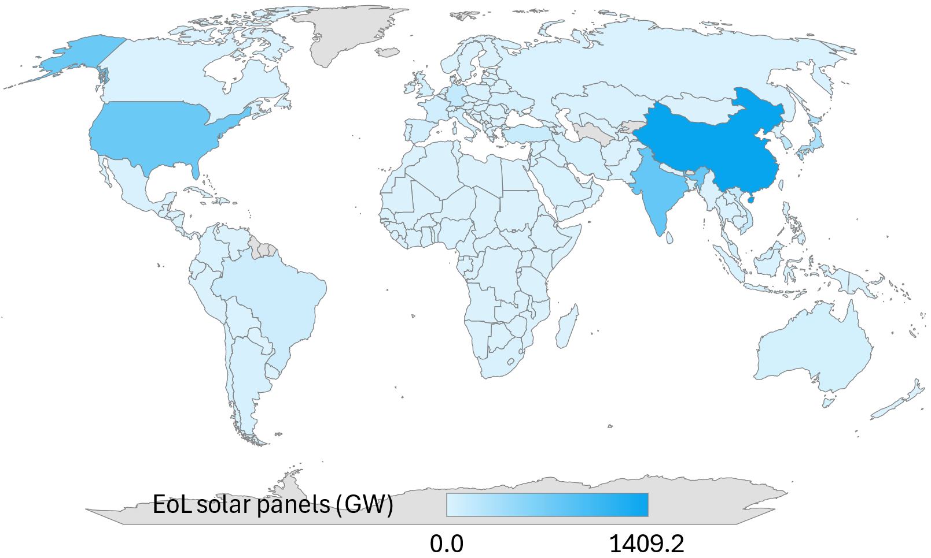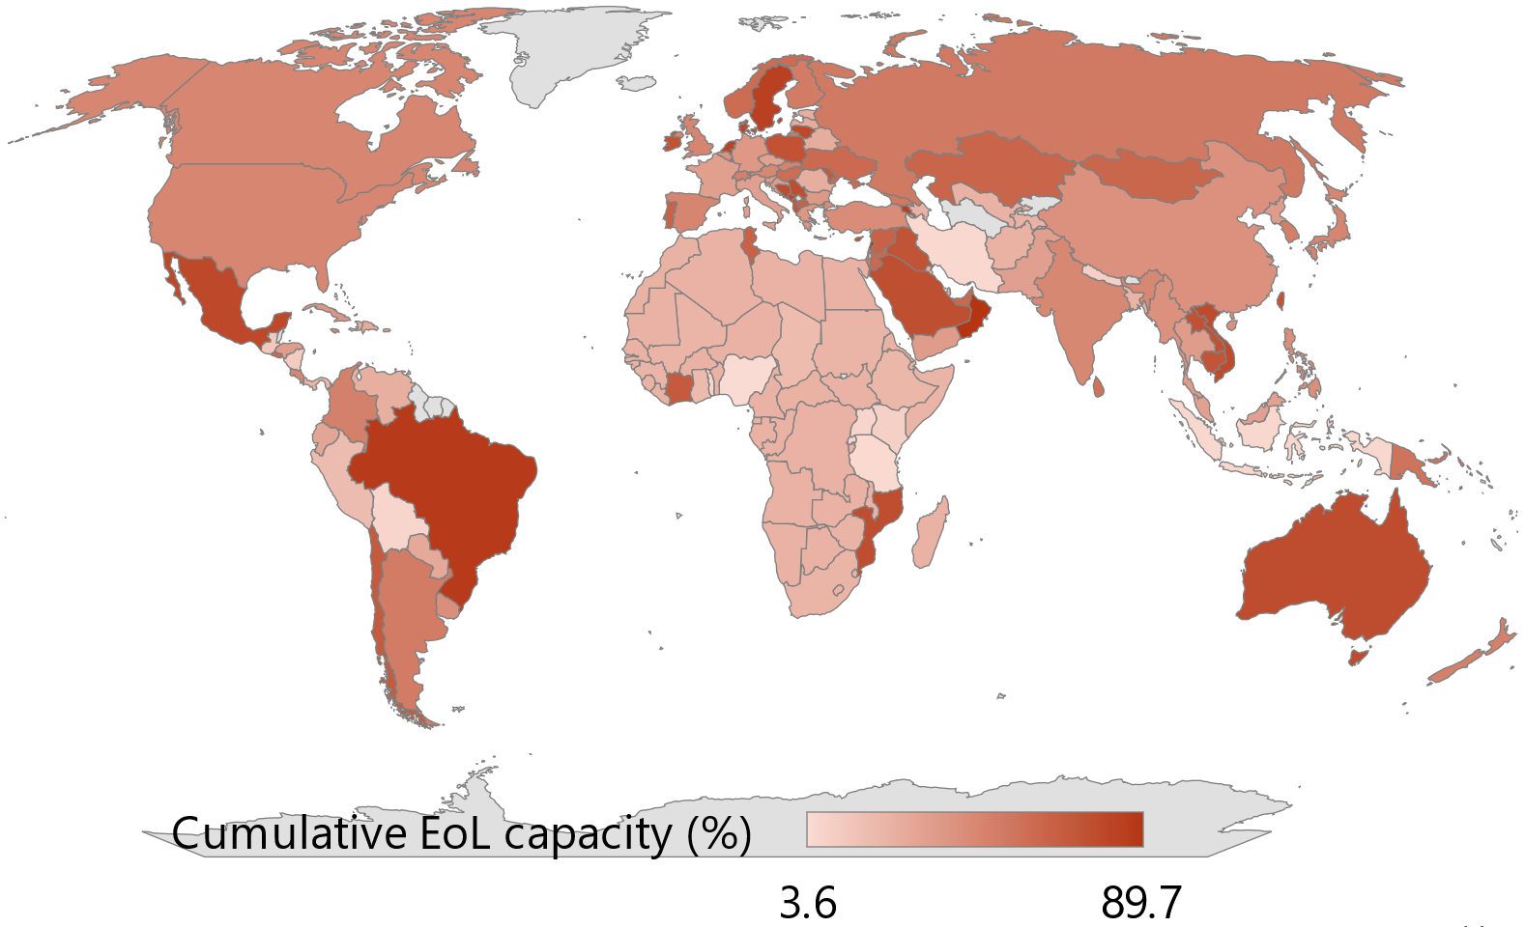
e
d
c
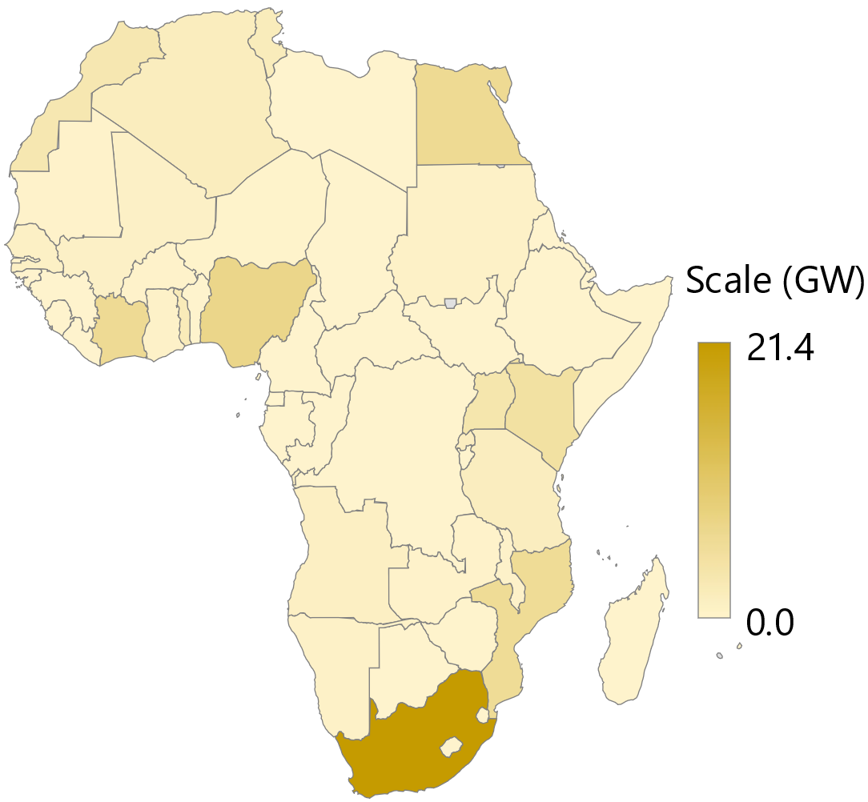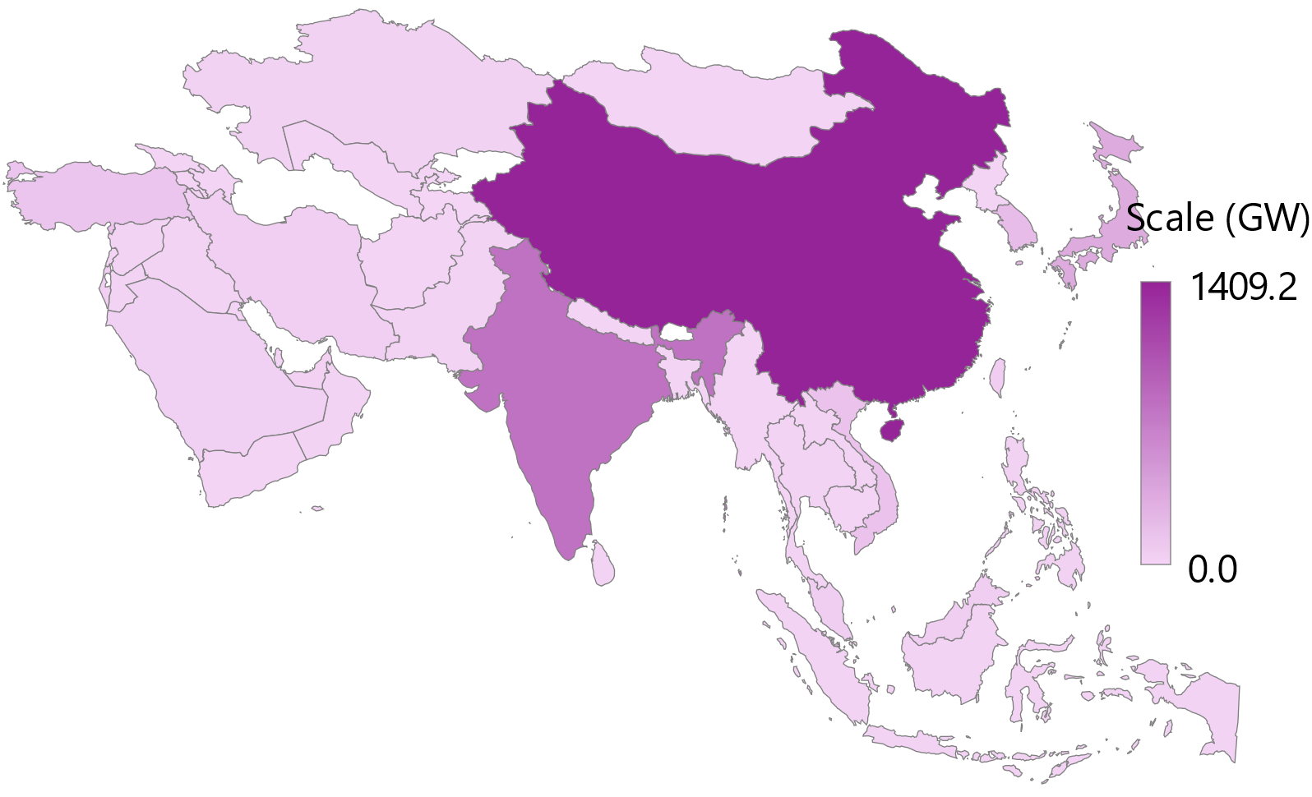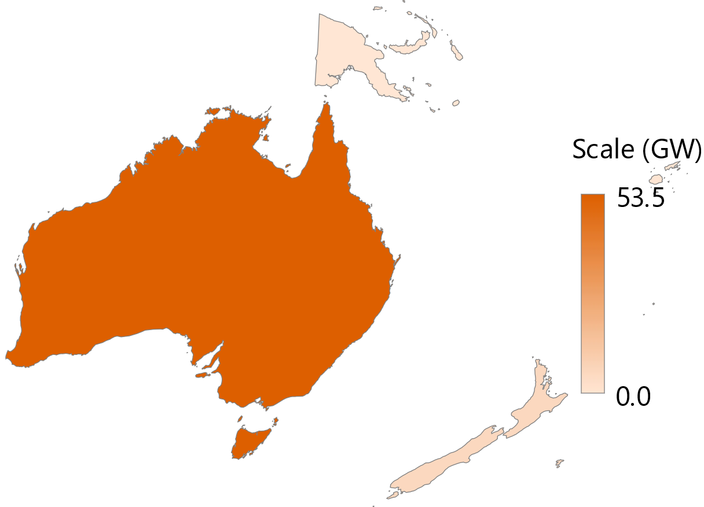
h
g
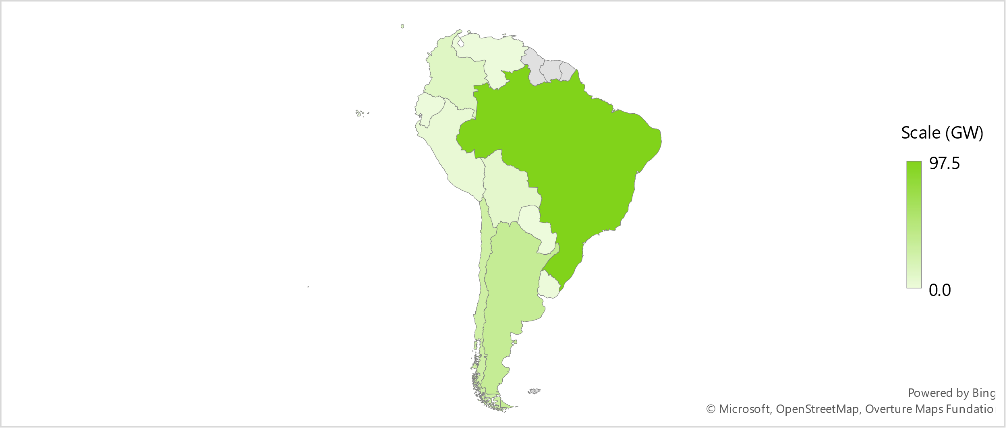
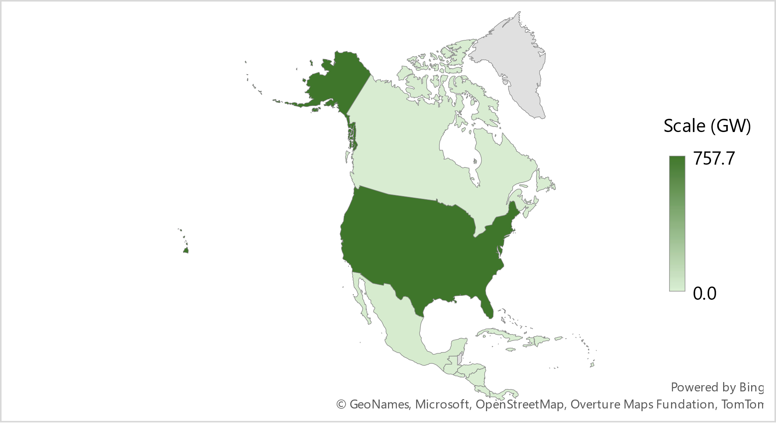
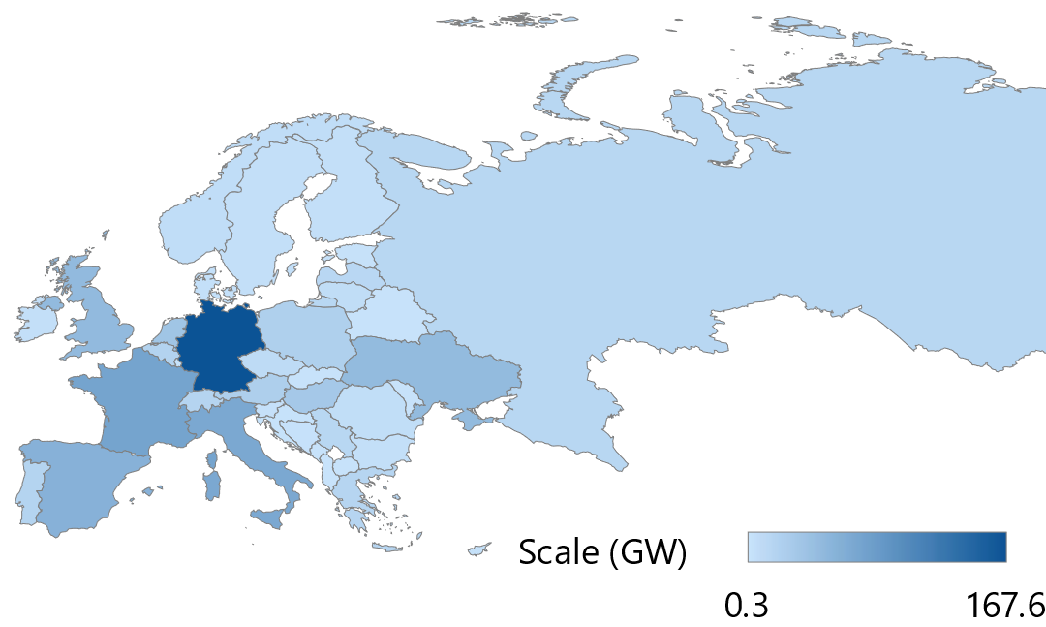
f

Figure S9: Global distribution of End-of-Life (EoL) solar panels with a lifespan of 20 years: (a) cumulative EoL solar panel capacity by countries in 2050, (b) percentage of cumulative EoL solar panel capacity relative to the cumulative installed solar capacity by countries for 2050, and (c–h) cumulative EoL solar panel capacity by 2050, broken down by continent: (c) Africa, (d) Asia, (e) Oceania, (f) Europe, (g) North America, and (h) South America.

a
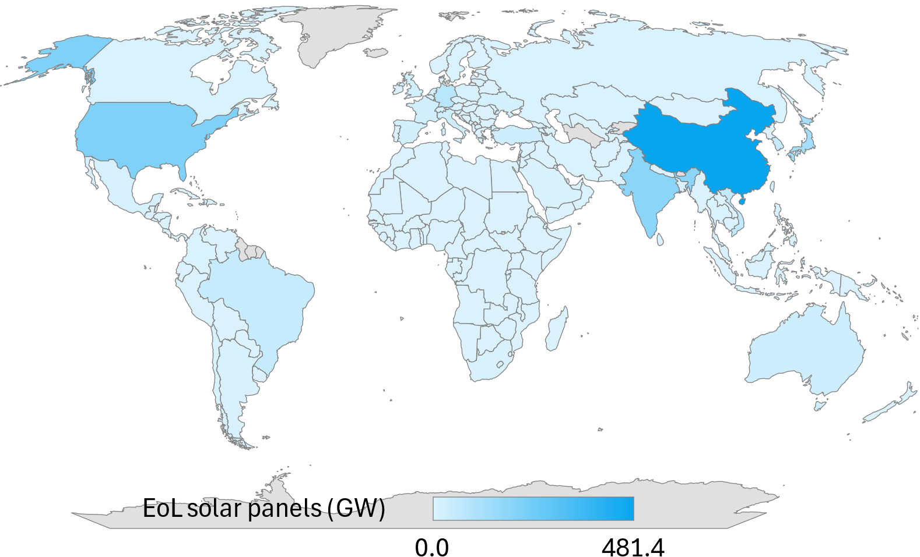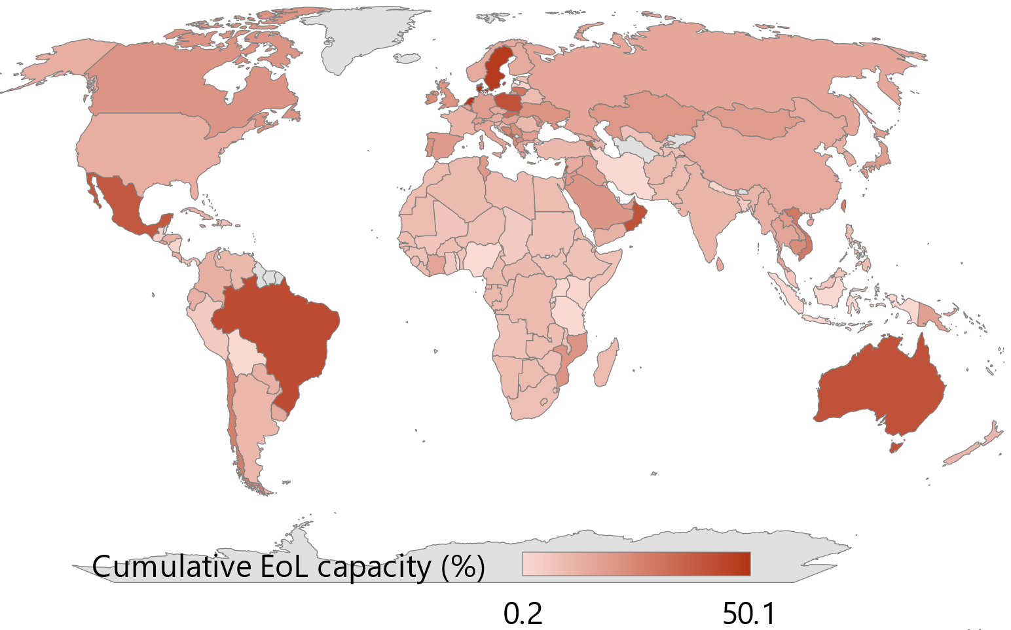
e
d
c
g
f
b
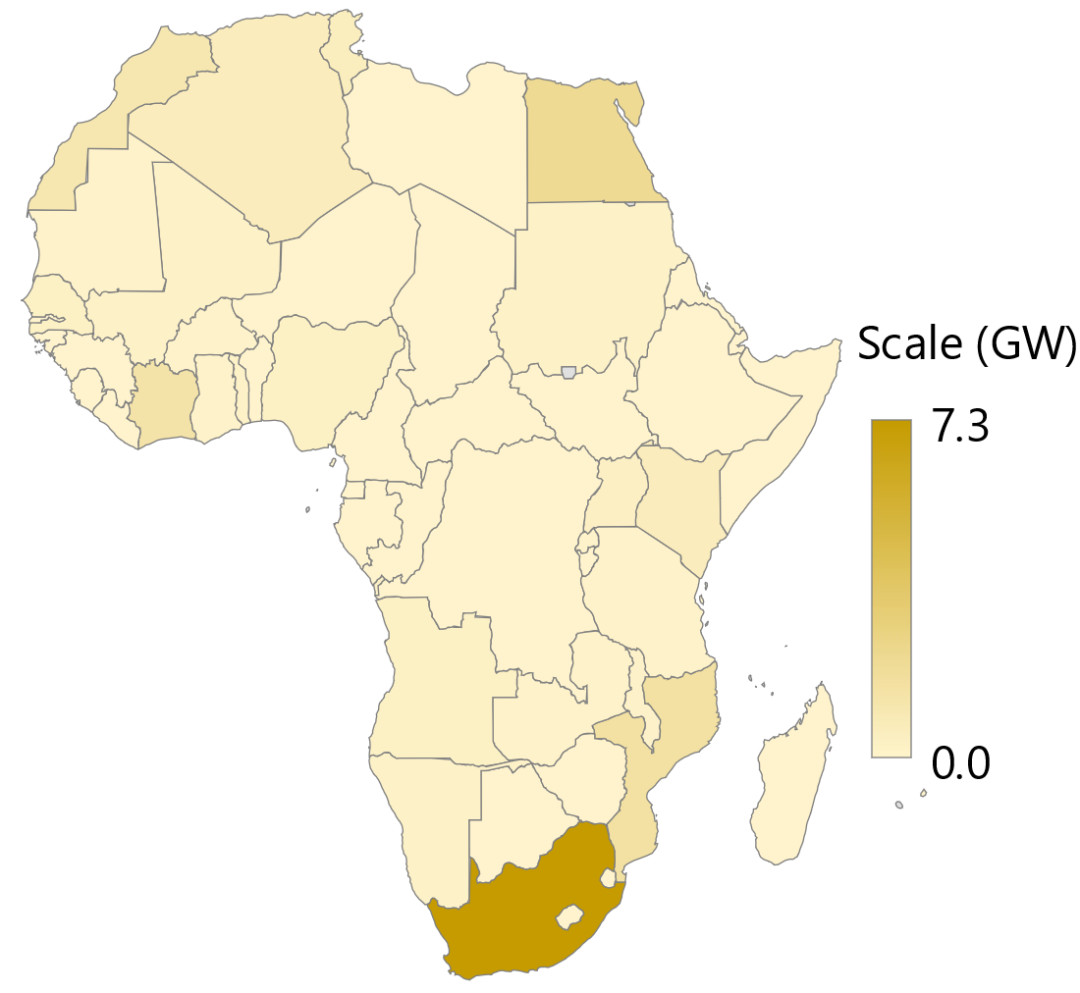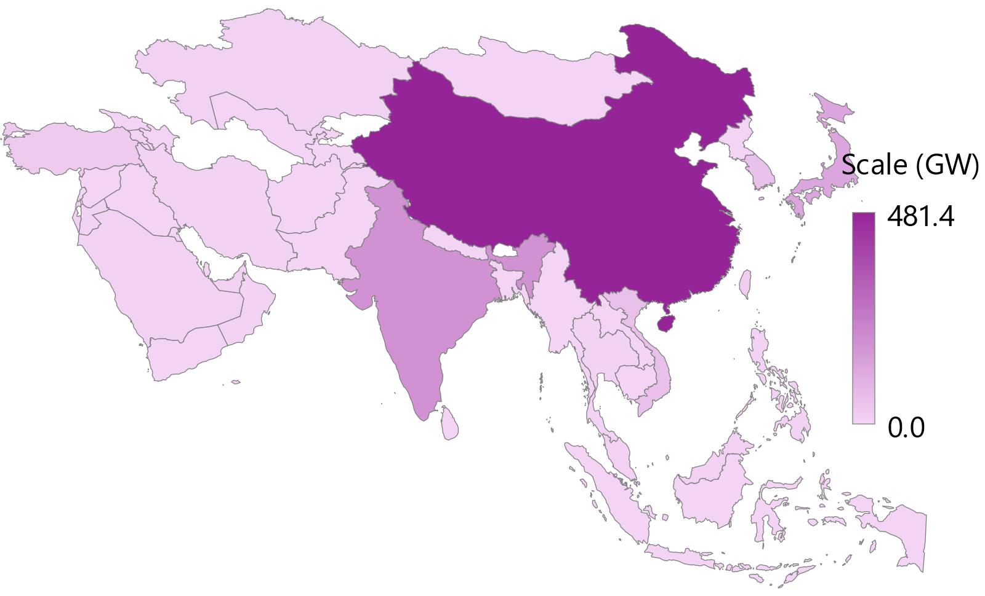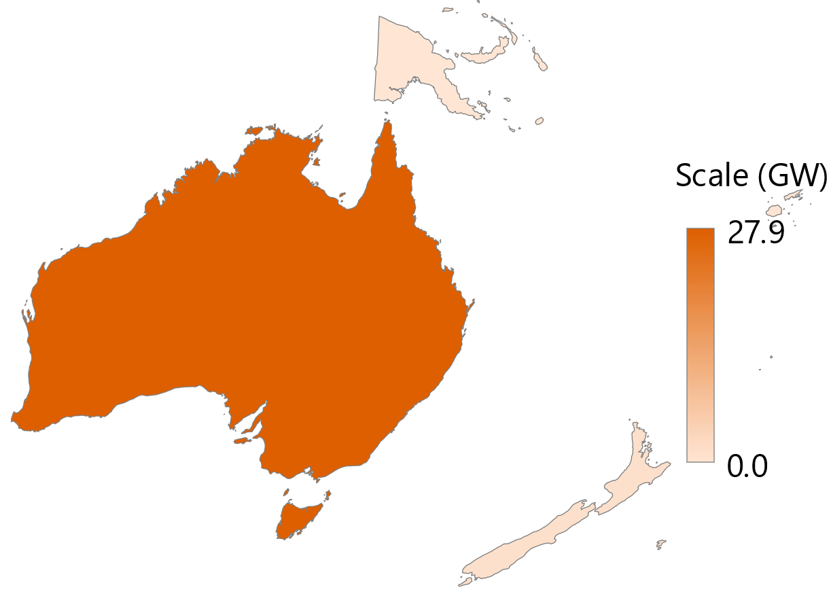
h
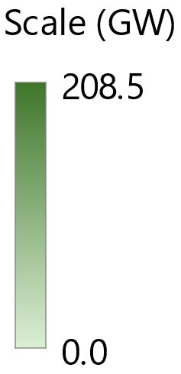
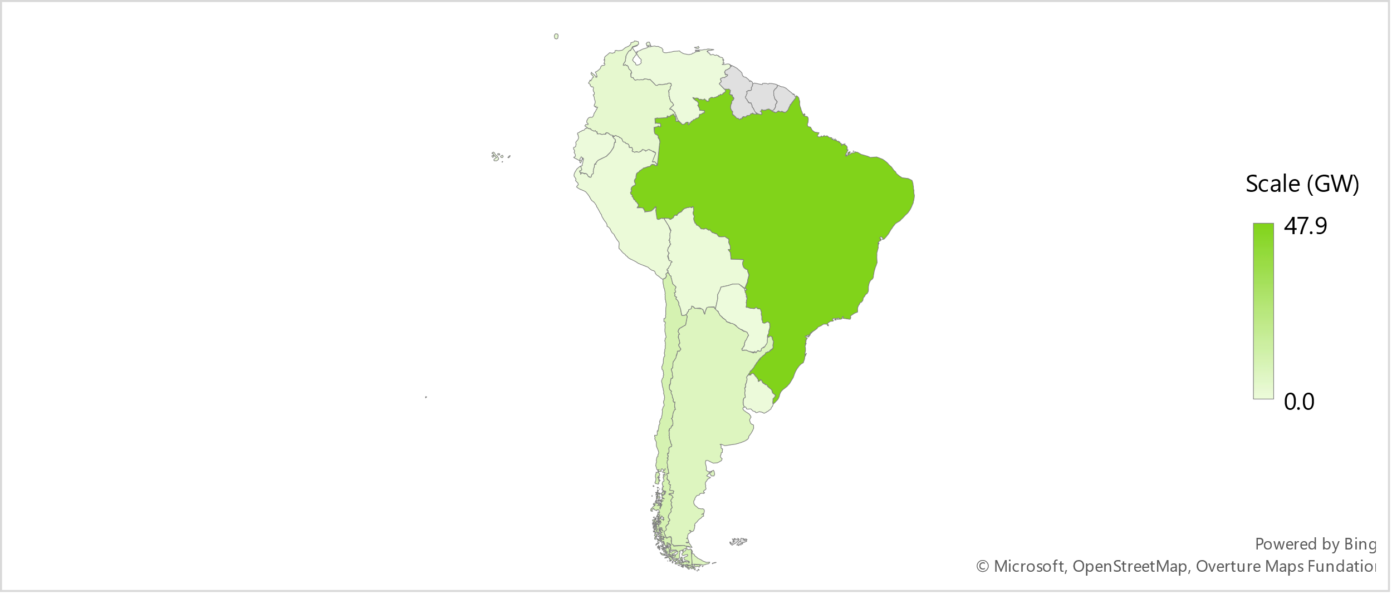
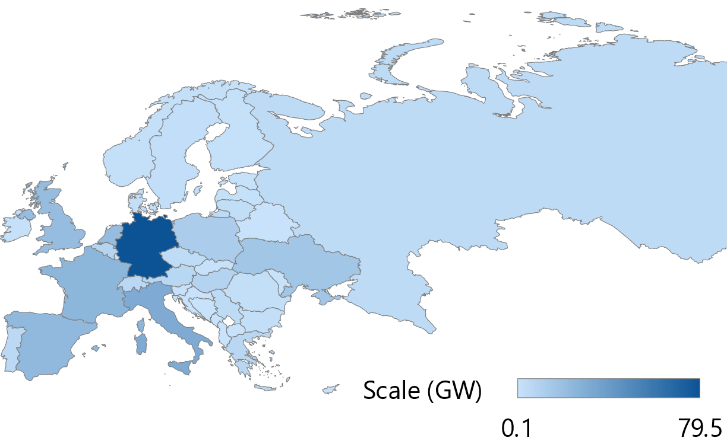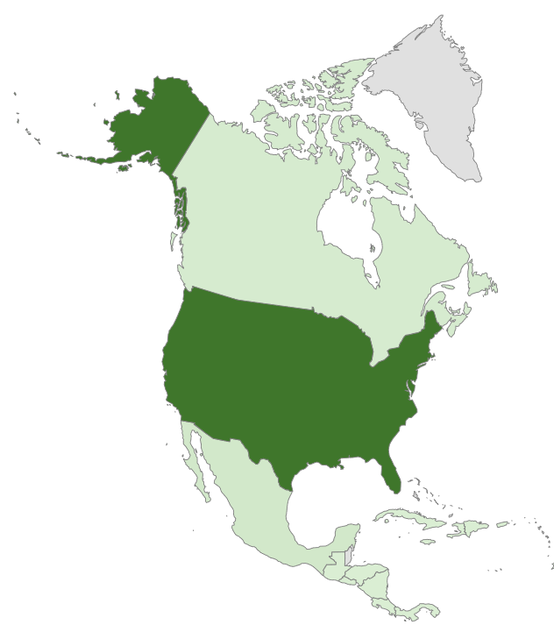

Figure S10: Global distribution of End-of-Life (EoL) solar panels with a lifespan of 30 years: (a) cumulative EoL solar panel capacity by countries in 2050, (b) percentage of cumulative EoL solar panel capacity relative to the cumulative installed solar capacity by countries for 2050, and (c–h) cumulative EoL solar panel capacity by 2050, broken down by continent: (c) Africa, (d) Asia, (e) Oceania, (f) Europe, (g) North America, and (h) South America.

Table S12: Material in EoL solar panels with a 20-year PV modules lifespan (early-loss scenario).
Metals in  2050 | Ag | Al | Cd | Cu | Ga | In | Pb | Se | Sn | Te | Si | Al (frames) | Total
Metals in  2050 | Mt |  |  |  |  |  |  |  |  |  | Gt |  | Gt
2DS (Base) | 8.11 | 48.61 | 7 | 770 | 0.35 | 2.54 | 16.38 | 3.62 | 16.29 | 6.18 | 1.15 | 4.57 | 6.6
High c-Si | 8.00 | 77.78 | 3 | 589 | 0.14 | 1.02 | 26.21 | 1.45 | 25.22 | 2.48 | 1.55 | 4.61 | 6.9
a-Si | 13.74 | 16.24 | 7 | 756 | 0.35 | 3.47 | 5.47 | 3.62 | 6.09 | 6.18 | 1.03 | 4.34 | 6.2
CIGS | 5.47 | 16.24 | 11 | 630 | 1.06 | 5.27 | 5.47 | 10.83 | 7.14 | 6.18 | 0.55 | 4.70 | 5.9
CdTe | 5.47 | 16.24 | 18 | 1526 | 0.35 | 3.94 | 5.47 | 3.62 | 5.91 | 18.49 | 0.55 | 4.53 | 6.7

Table S13: Material in EoL solar panels with a 25-year PV modules lifespan (regular-loss scenario).
Metals in  2050 | Ag | Al | Cd | Cu | Ga | In | Pb | Se | Sn | Te | Si | Al (frames) | Total
Metals in  2050 | Mt |  |  |  |  |  |  |  |  |  | Gt |  | Gt
2DS (Base) | 5.33 | 31.97 | 5 | 506 | 0.23 | 1.67 | 10.77 | 2.38 | 10.72 | 4.06 | 0.76 | 3.00 | 4.3
High c-Si | 5.26 | 51.15 | 2 | 387 | 0.09 | 0.67 | 17.24 | 0.95 | 16.59 | 1.63 | 1.02 | 3.03 | 4.5
a-Si | 9.04 | 10.68 | 5 | 497 | 0.23 | 2.29 | 3.60 | 2.38 | 4.00 | 4.06 | 0.68 | 2.85 | 4.1
CIGS | 3.60 | 10.68 | 7 | 415 | 0.70 | 3.46 | 3.60 | 7.12 | 4.70 | 4.06 | 0.36 | 3.09 | 3.9
CdTe | 3.60 | 10.68 | 12 | 1004 | 0.23 | 2.59 | 3.60 | 2.38 | 3.89 | 12.16 | 0.36 | 2.98 | 4.4

Table S14: Material in EoL solar panels with a 20-year PV modules lifespan (new regular-loss scenario).
Metals in  2050 | Ag | Al | Cd | Cu | Ga | In | Pb | Se | Sn | Te | Si | Al (frames) | Total
Metals in  2050 | Mt |  |  |  |  |  |  |  |  |  | Gt |  | Gt
2DS (Base) | 2.58 | 15.46 | 2 | 245 | 0.11 | 0.81 | 5.21 | 1.15 | 5.18 | 1.96 | 0.37 | 1.45 | 2.1
High c-Si | 2.55 | 24.74 | 1 | 187 | 0.05 | 0.32 | 8.34 | 0.46 | 8.02 | 0.79 | 0.49 | 1.47 | 2.2
a-Si | 4.37 | 5.17 | 2 | 240 | 0.11 | 1.11 | 1.74 | 1.15 | 1.94 | 1.96 | 0.33 | 1.38 | 2.0
CIGS | 1.74 | 5.17 | 4 | 201 | 0.34 | 1.68 | 1.74 | 3.45 | 2.27 | 1.96 | 0.17 | 1.49 | 1.9
CdTe | 1.74 | 5.17 | 6 | 485 | 0.11 | 1.25 | 1.74 | 1.15 | 1.88 | 5.88 | 0.17 | 1.44 | 2.1

Table S15: Material in EoL solar panels with a 35-year PV modules lifespan (ideal-performance scenario).
Metals in  2050 | Ag | Al | Cd | Cu | Ga | In | Pb | Se | Sn | Te | Si | Al (frames) | Total
Metals in  2050 | Mt |  |  |  |  |  |  |  |  |  | Gt |  | Gt
2DS (Base) | 1.19 | 7.12 | 1 | 113 | 0.05 | 0.37 | 2.40 | 0.53 | 2.39 | 0.90 | 0.17 | 0.67 | 1.0
High c-Si | 1.17 | 11.40 | 0 | 86 | 0.02 | 0.15 | 3.84 | 0.21 | 3.70 | 0.36 | 0.23 | 0.68 | 1.0
a-Si | 2.01 | 2.38 | 1 | 111 | 0.05 | 0.51 | 0.80 | 0.53 | 0.89 | 0.90 | 0.15 | 0.64 | 0.9
CIGS | 0.80 | 2.38 | 2 | 92 | 0.15 | 0.77 | 0.80 | 1.59 | 1.05 | 0.90 | 0.08 | 0.69 | 0.9
CdTe | 0.80 | 2.38 | 3 | 224 | 0.05 | 0.58 | 0.80 | 0.53 | 0.87 | 2.71 | 0.08 | 0.66 | 1.0

Others
Table S16: ISO codes for nations.
Nation | Code | Nation | Code
Algeria | DZ | Senegal | SN
Angola | AO | Sierra Leone | SL
Benin | BJ | Somalia | SO
Botswana | BW | South Africa | ZA
Burkina Faso | BF | South Sudan | SS
Burundi | BI | Sudan | SD
Cameroon | CM | Tanzania | TZ
Central African Republic | CF | Togo | TG
Chad | TD | Tunisia | TN
Côte d'Ivoire | CI | Uganda | UG
Djibouti | DJ | Zambia | ZM
Democratic Republic of the Congo | CD | Zimbabwe | ZW
Egypt | EG | Afghanistan | AF
Equatorial Guinea | GQ | Armenia | AM
Eritrea | ER | Azerbaijan | AZ
Eswatini | SZ | Bahrain | BH
Ethiopia | ET | Bangladesh | BD
Gabon | GA | Cambodia | KH
Gambia | GM | China | CN
Ghana | GH | Georgia | GE
Guinea | GN | India | IN
Guinea-Bissau | GW | Indonesia | ID
Kenya | KE | Iran | IR
Lesotho | LS | Iraq | IQ
Liberia | LR | Israel | IL
Libya | LY | Japan | JP
Madagascar | MG | Jordan | JO
Malawi | MW | Kazakhstan | KZ
Mali | ML | Kuwait | KW
Mauritania | MR | Laos | LA
Mauritius | MU | Lebanon | LB
Morocco | MA | Malaysia | MY
Mozambique | MZ | Mongolia | MN
Namibia | NA | Myanmar | MM
Niger | NE | Nepal | NP
Nigeria | NG | North Korea | KP
Republic of the Congo | CG | Oman | OM
Rwanda | RW | Pakistan | PK
Palestine | PS | Poland | PL
Philippines | PH | Portugal | PT
Qatar | QA | Romania | RO
Saudi Arabia | SA | Russia | RU
Singapore | SG | Serbia | RS
South Korea | KR | Slovakia | SK
Sri Lanka | LK | Slovenia | SI
Syria | SY | Spain | ES
Taiwan | TW | Sweden | SE
Tajikistan | TJ | Switzerland | CH
Thailand | TH | Ukraine | UA
Timor-Leste | TL | United Kingdom | GB
Turkey | TR | Australia | AU
United Arab Emirates | AE | Fiji | FJ
Uzbekistan | UZ | New Zealand | NZ
Vietnam | VN | Papua New Guinea | PG
Yemen | YE | Canada | CA
Albania | AL | Cuba | CU
Austria | AT | Dominican Republic | DO
Belarus | BY | Haiti | HT
Belgium | BE | Jamaica | JM
Bosnia and Herzegovina | BA | Mexico | MX
Bulgaria | BG | Puerto Rico | PR
Croatia | HR | Trinidad and Tobago | TT
Cyprus | CY | United States | US
Czechia | CZ | Costa Rica | CR
Denmark | DK | El Salvador | SV
Estonia | EE | Guatemala | GT
Finland | FI | Honduras | HN
France | FR | Nicaragua | NI
Germany | DE | Panama | PA
Greece | GR | Argentina | AR
Hungary | HU | Bolivia | BO
Iceland | SI | Brazil | BR
Ireland | IE | Chile | CL
Italy | IT | Colombia | CO
Latvia | LV | Ecuador | EC
Lithuania | LT | Paraguay | PY
Luxembourg | LU | Peru | PE
Moldova | MD | Uruguay | UY
Montenegro | ME | Venezuela | VE
Netherlands | NL | Iceland | IS
North Macedonia | MK | Greenlnad | GL
Norway | NO | Guyana | GY
Surname | SR | Turkmenistan | TM
French Guiana | GF | New Calelonia | NC
Bhutan | BT | West Sahara | EH
Kyrgyzstan | KG

References
1 Cherp, A., Vinichenko, V., Tosun, J., Gordon, J. A. & Jewell, J. National growth dynamics of wind and solar power compared to the growth required for global climate targets. Nature Energy 6, 742-754, doi:https://doi.org/10.1038/s41560-021-00863-0 (2021).
2 IRENA. World Energy Transitions Outlook 2024: 1.5°C Pathway. (International Renewable Energy Agency, Abu Dhabi, 2024).
3 International Energy Agency (IEA). World Energy Outlook 2024. 398 (2024).
4 Fischer, M., Woodhouse, M., Herritsch, S. & Trube, J. International Technology Roadmap for Photovoltaic (ITRPV): Results 2020. 88 (2021).
5 Kirsten Hund, D. L. P., Thao P. Fabregas, Tim Laing, John Drexhage. Minerals for Climate Action: The Mineral Intensity of the Clean Energy Transition. (Climate Smart Mining Initiative - The World Bank Group, 2020).
6 Allouhi, A., Rehman, S., Buker, M. S. & Said, Z. Up-to-date literature review on Solar PV systems: Technology progress, market status and R&D. J Clean Prod 362, 132339, doi:https://doi.org/10.1016/j.jclepro.2022.132339 (2022).
7 Louwen, A., van Sark, W., Schropp, R. & Faaij, A. A cost roadmap for silicon heterojunction solar cells. Sol Energy Mater Sol Cells 147, 295-314, doi:https://doi.org/10.1016/j.solmat.2015.12.026 (2016).
8 Gervais, E., Shammugam, S., Friedrich, L. & Schlegl, T. Raw material needs for the large-scale deployment of photovoltaics – Effects of innovation-driven roadmaps on material constraints until 2050. Renew Sust Energ Rev 137, 110589, doi:https://doi.org/10.1016/j.rser.2020.110589 (2021).
9 Månberger, A. & Stenqvist, B. Global metal flows in the renewable energy transition: Exploring the effects of substitutes, technological mix and development. Energy Policy 119, 226-241, doi:https://doi.org/10.1016/j.enpol.2018.04.056 (2018).
10 Kavlak, G., McNerney, J., Jaffe, R. L. & Trancik, J. E. Metal production requirements for rapid photovoltaics deployment. Energy Environ Sci 8, 1651-1659, doi:10.1039/C5EE00585J (2015).
11 Fizaine, F. & Court, V. Renewable electricity producing technologies and metal depletion: A sensitivity analysis using the EROI. Ecol Econ 110, 106-118, doi:https://doi.org/10.1016/j.ecolecon.2014.12.001 (2015).
12 Öhrlund, I. Future Metal Demand from Photovoltaic Cells and Wind Turbines ‐ Investigating the Potential Risk of Disabling a Shift to Renewable Energy Systems. (Science and Technology Options Assessment (STOA), European Parliament, 2011).

