Supplemental materials
Fig S1. Participant Screening flowchart.
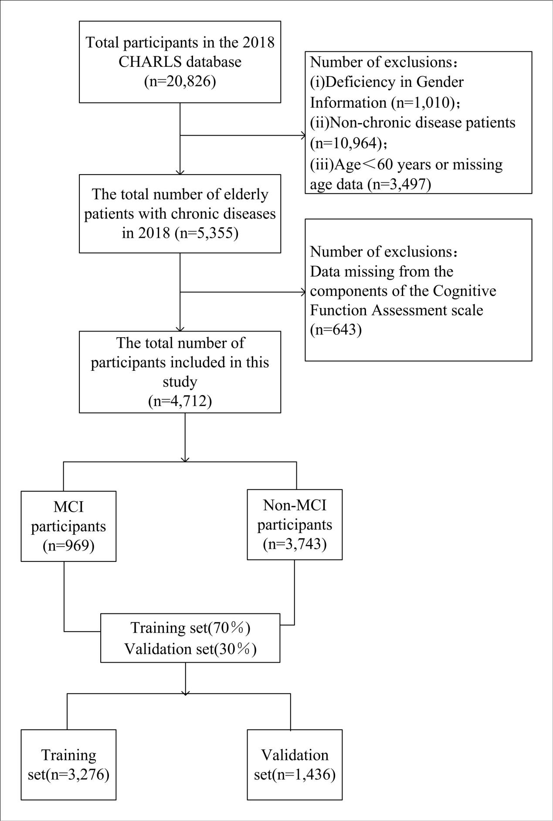

Fig S2. Age distribution and prevalence of MCI among older adults with chronic diseases
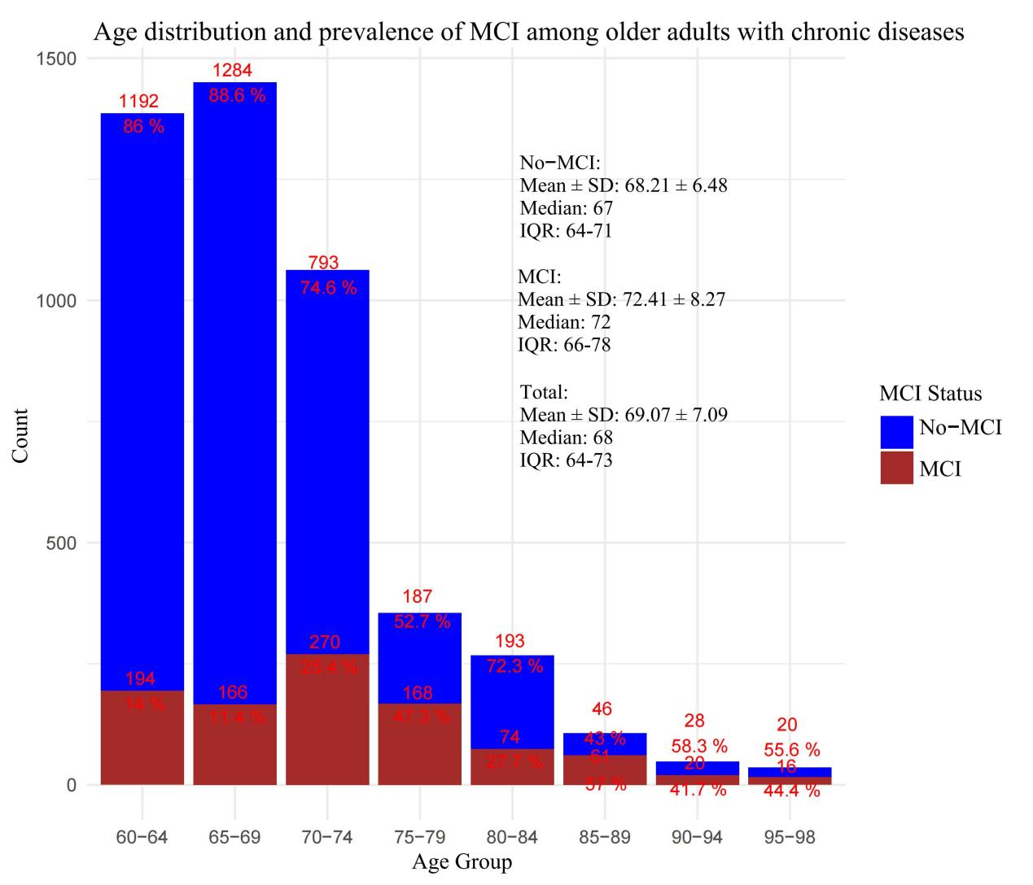

Fig S3. Distribution of each disease in the MCI group and the non-MCI group.

Table S1. Categorical variable assignment.
Variable | Variable assignment
Sex | Male = 1; female = 0
Physical exercise | Yes = 1; NO = 0
Social activity | Yes = 1; NO = 0
Marital satisfaction | Yes = 1; NO = 0
Child satisfaction | Yes = 1; NO = 0
Residence | Urban = 1; Rural = 0
Air quality satisfaction | Yes = 1; NO = 0
Whether he has been hospitalized in the past year(%) | Yes = 1; NO = 0
Fall down(%) | Yes = 1; NO = 0
Hip fracture | Yes = 1; NO = 0
Life satisfaction | Yes = 1; NO = 0
Health satisfaction | Yes = 1; NO = 0
Medical insurance | Yes = 1; NO = 0
Smoke | Yes = 1; NO = 0
Drink | Yes = 1; NO = 0
Physical disability | Yes = 1; NO = 0
Depression | Yes = 1; NO = 0
Distant object vision | Good = 1; Common = 2; Bad = 3
Near object vision | Good = 1; Common = 2; Bad = 3
Hearing | Good = 1; Common = 2; Bad = 3
Be vexed by pain | No = 1; A little = 2; relatively much more = 3
Education | Below junior high school = 1; High school or vocational school = 2; College or above = 3
Memory | Good = 1; Common = 2; Bad = 3
Naptime | ＞90min = 1; ≤90min = 2; 0min = 3
Nighttime sleep | ＜6h = 1; ≥6h and ≤8h = 2; ＞8h = 3
Income | Low income = 1; Middle income = 2; High income = 3
Marriage | have a spouse = 1; have no spouse = 0
Age | 60~69 = 1; 70~79 = 2; ≥80 = 3

variable | VIF | Tolerance
Sex | 1.898 | 0.527
Physical exercise | 1.581 | 0.633
Social activity | 1.058 | 0.946
Marital satisfaction | 1.159 | 0.863
Child satisfaction | 1.146 | 0.873
Residence | 1.119 | 0.893
Air quality satisfaction | 1.089 | 0.918
Whether he has been hospitalized in the past year | 1.040 | 0.961
Fall down | 1.075 | 0.930
Hip fracture | 1.084 | 0.922
Life satisfaction | 1.208 | 0.828
Health satisfaction | 1.201 | 0.833
Medical insurance | 1.028 | 0.973
Smoke | 1.722 | 0.581
Drink | 1.329 | 0.752
Physical disability | 1.150 | 0.870
Depression | 1.126 | 0.888
Distant object vision | 1.437 | 0.696
Near object vision | 1.377 | 0.726
Hearing | 1.264 | 0.791
Be vexed by pain | 1.217 | 0.821
Education | 1.103 | 0.906
Memory | 1.127 | 0.887
Naptime | 1.540 | 0.650
Night time sleep | 1.069 | 0.936
Income | 1.098 | 0.911
Marriage | 1.240 | 0.807
Age | 1.180 | 0.847
ADL score | 1.116 | 0.896
Number of chronic diseases | 1.030 | 0.970
Table S2. Multicollinearity test for variables that are incorporated into the model.
VIF, variance inflation factors. Tolerance,1/VIF.

