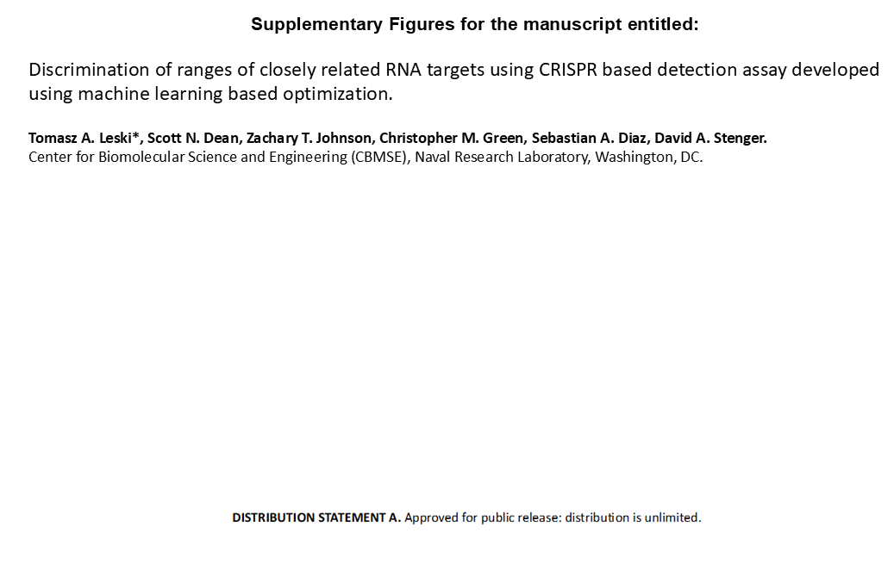

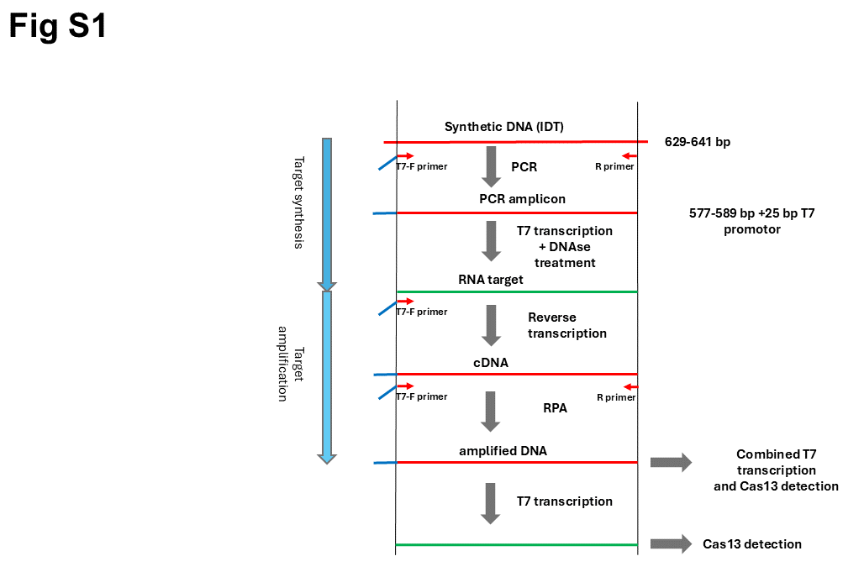
Figure S1. Synthesis of the DNA and RNA fragments used as targets in this study and amplification of the targets using RPA as part of the modified SHERLOCK assay.
Red lines denote DNA (single or double-stranded), green lines denote RNA, blue lines denote T7 promoter sequences.

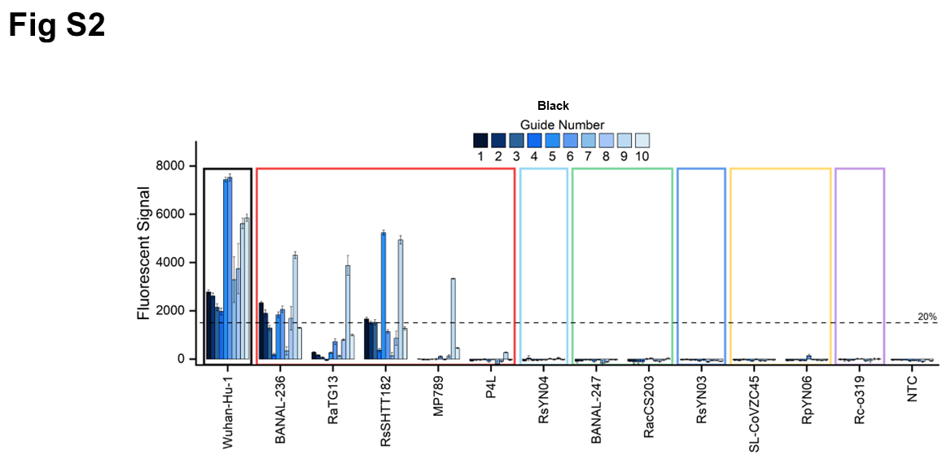
Figure S2. Performance testing results for gRNAs designed for detection of SARS-CoV-2 F11 region (black group).
The height of the bars reflects the cumulative background subtracted fluorescence signal (RFU) obtained for each of the tested crRNAs with their corresponding targets. The colored boxes enclosing results for groups of targets denote specific groups as defined in this study. The vertical line denotes the signal threshold used to classify the gRNA performance into negative (signal less than 20% of the maximum signal), and positive (signal equal or higher than 20%). NTC = no target control.

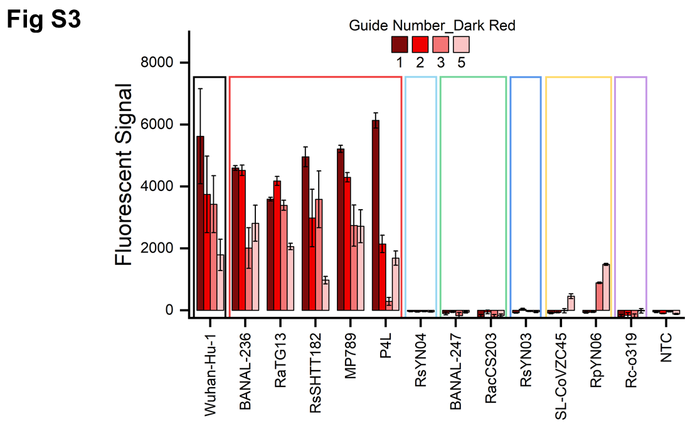
Figure S3. Performance testing results for gRNAs designed for detection of dark-red group of zoonotic sarbecoviruses.
The height of the bars reflects the cumulative background subtracted fluorescence signal (RFU) obtained for each of the tested crRNAs with their corresponding targets. The colored boxes enclosing results for groups of targets denote specific groups as defined in this study. NTC = no target control.

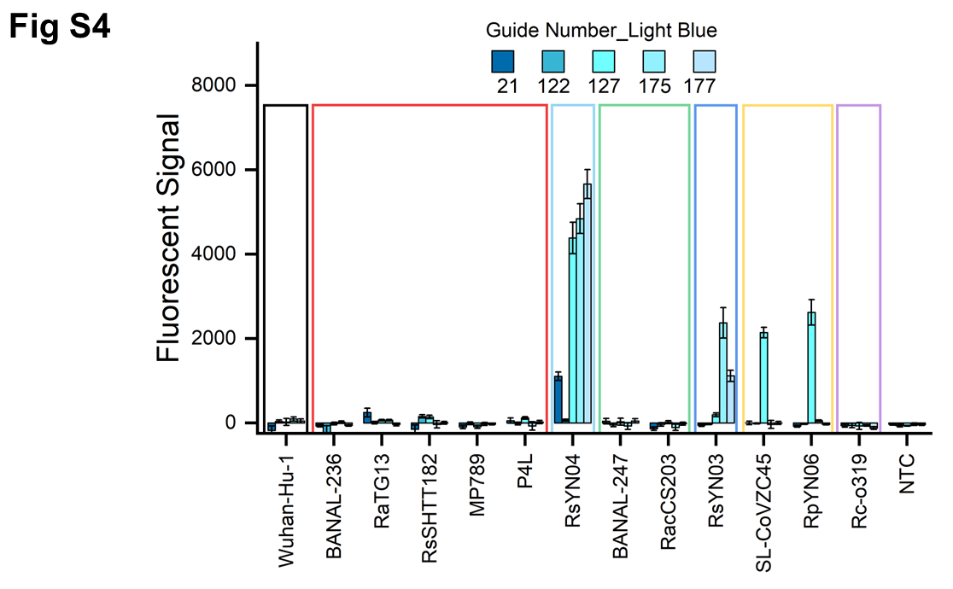
Figure S4. Performance testing results for gRNAs designed for detection of light-blue group of zoonotic sarbecoviruses.
The height of the bars reflects the cumulative background subtracted fluorescence signal (RFU) obtained for each of the tested crRNAs with their corresponding targets. The colored boxes enclosing results for groups of targets denote specific groups as defined in this study. NTC = no target control.

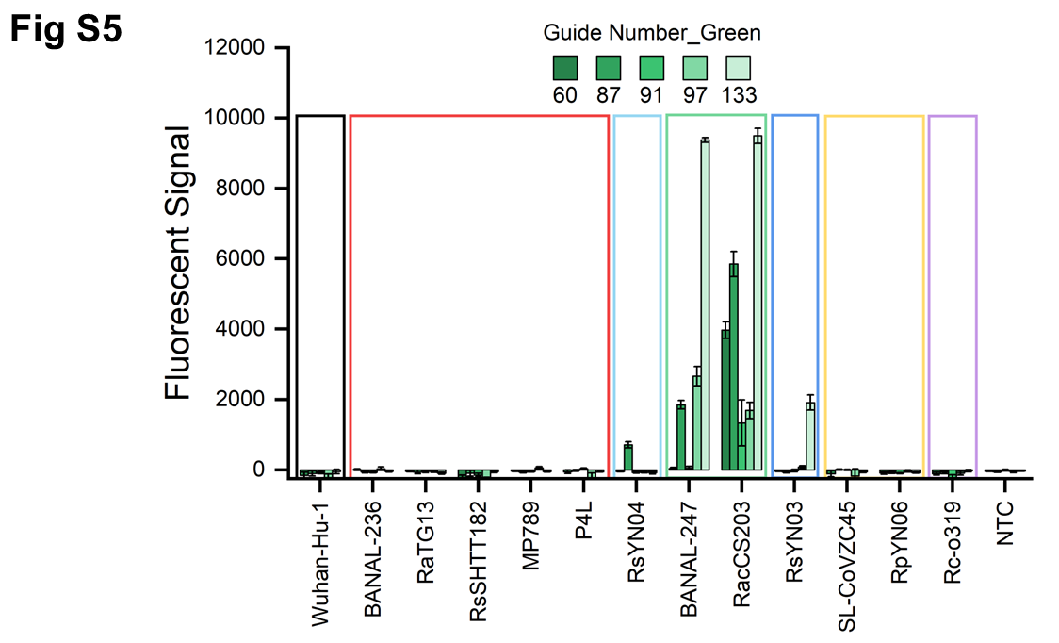
Figure S5. Performance testing results for gRNAs designed for detection of green group of zoonotic sarbecoviruses.
The height of the bars reflects the cumulative background subtracted fluorescence signal (RFU) obtained for each of the tested crRNAs with their corresponding targets. The colored boxes enclosing results for groups of targets denote specific groups as defined in this study. NTC = no target control.

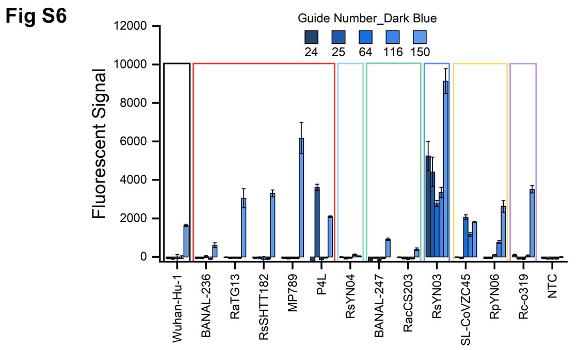
Figure S6. Performance testing results for gRNAs designed for detection of dark-blue group of zoonotic sarbecoviruses.
The height of the bars reflects the cumulative background subtracted fluorescence signal (RFU) obtained for each of the tested crRNAs with their corresponding targets. The colored boxes enclosing results for groups of targets denote specific groups as defined in this study. NTC = no target control.

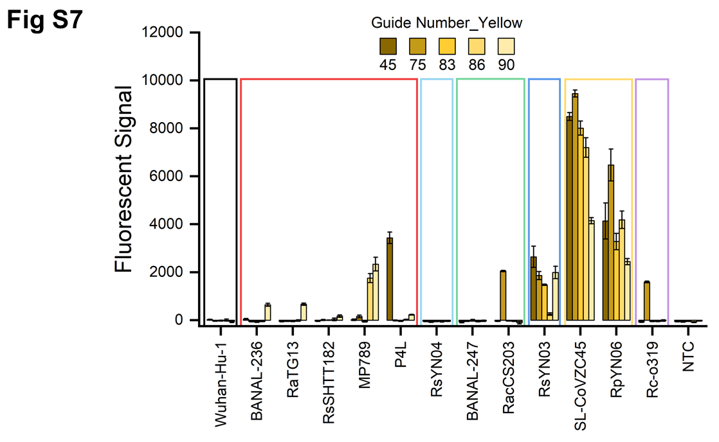
Figure S7. Performance testing results for gRNAs designed for detection of yellow group of zoonotic sarbecoviruses.
The height of the bars reflects the cumulative background subtracted fluorescence signal (RFU) obtained for each of the tested crRNAs with their corresponding targets. The colored boxes enclosing results for groups of targets denote specific groups as defined in this study. NTC = no target control.

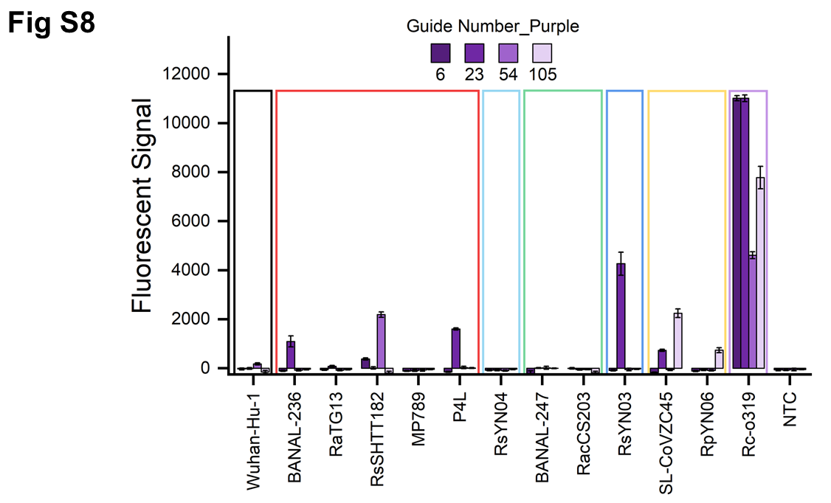
Figure S8. Performance testing results for gRNAs designed for detection of purple group of zoonotic sarbecoviruses.
The height of the bars reflects the cumulative background subtracted fluorescence signal (RFU) obtained for each of the tested crRNAs with their corresponding targets. The colored boxes enclosing results for groups of targets denote specific groups as defined in this study. NTC = no target control.

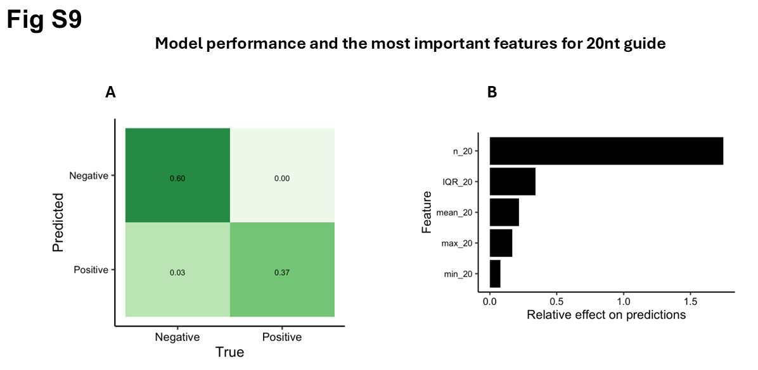
Figure S9. Model performance and the most important features for 20nt guides.
RuleFit classifier model performance. A – Confusion matrix showing percentages of actual assay outcomes versus outcomes produced by the classifier model, B – relative effect of features on model predictions.

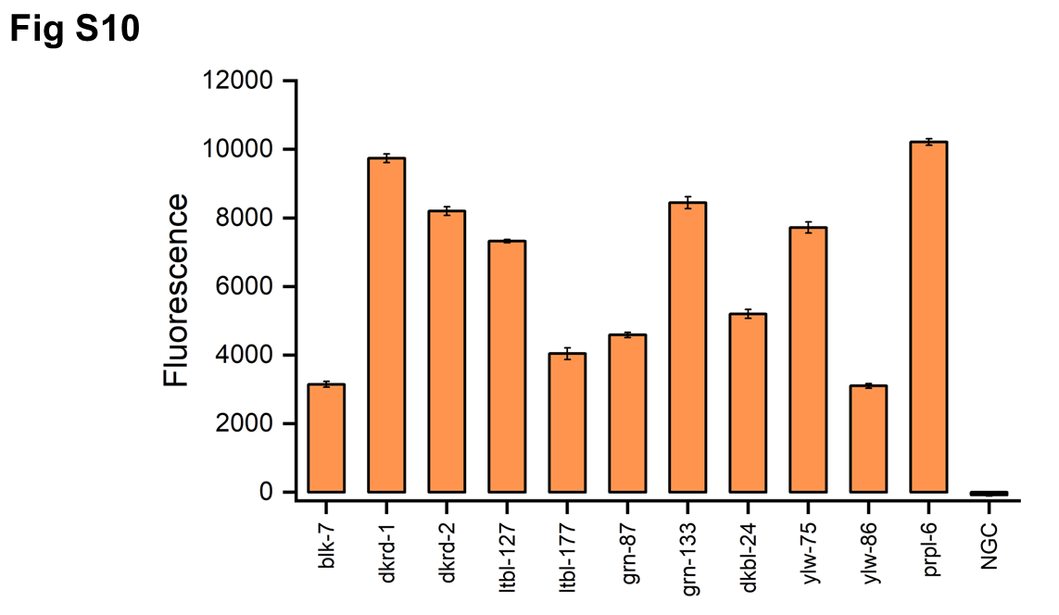
Figure S10. Detection of mixed targets
Modified SHERLOCK assays were conducted using a mixture of all 13 synthetic RNA targets containing equimolar quantities of all targets. Each assay was conducted using one of the 11 gRNAs with differing specificities. NGC = no guide control.

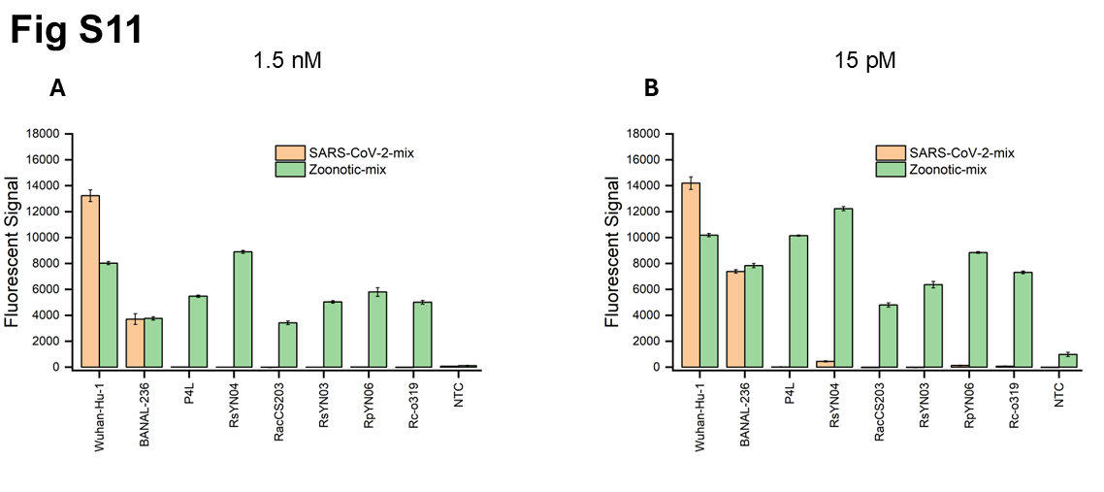
Figure S11. Testing of two-channel modified SHERLOCK assay for detection and discrimination of SARS-CoV-2 and zoonotic near-neighbor sarbecoviruses.
The height of the bars shows the intensity of the fluorescent signal for Wuhan-Hu-1 (SARS-CoV-2) and 12 zoonotic near neighbors for two different concentrations of synthetic F11 RNA targets: 1.5 nM (panel A) and 15 pM (panel B). The results allow for classifying the samples into three groups:
1) containing SARS-CoV-2
2) containing BANAL-236 (the closest known SARS-CoV-2 neighbor in the terms of F11 region)
3) all remaining zoonotic near neighbors.
NTC = no target control.

