Table 5. Example results of tests of the surface layer condition after flow burning
Sample with the lowest corrosion rate
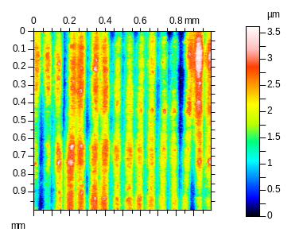 |  |  |  | 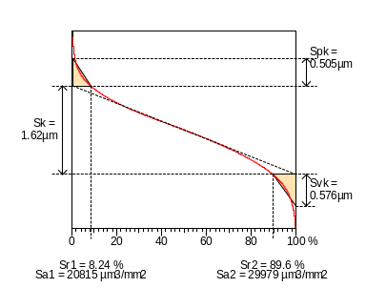 |  |  |  |  | 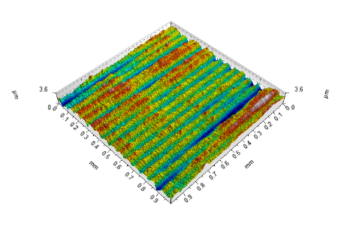
Sq | 0,61 | µm |  | Sal |  | 0,0266 |  | mm | Vvv | 6,92E-05 |  | mm³/mm²
Ssk | -0,0886 |  |  | Str |  | 0,0531 |  |  | Spd | 17870 |  | 1/mm²
Sku | 2,81 |  |  | Std |  | 89,8 |  | ° | Spc | 656 |  | 1/mm
Sp | 1,84 | µm |  | Sdq |  | 0,252 |  |  | S10z | 2,23 |  | µm
Sv | 1,78 | µm |  | Sdr |  | 3,03 |  | % | S5p | 1,5 |  | µm
Sz | 3,62 | µm |  | Vm |  | 2,64E-05 |  | mm³/mm² | S5v | 0,731 |  | µm
Sa | 0,49 | µm |  | Vv |  | 0,000799 |  | mm³/mm² | Sda | 0,000228 |  | mm²
Smr | 8,13 | % |  | Vmp |  | 2,64E-05 |  | mm³/mm² | Sha | 5,52E-05 |  | mm²
Smc | 0,773 | µm |  | Vmc |  | 0,00057 |  | mm³/mm² | Sdv | 2,19E-09 |  | mm³
Sxp | 1,25 | µm |  | Vvc |  | 0,00073 |  | mm³/mm² | Shv | 1,19E-09 |  | mm³
Sample with the highest corrosion rate
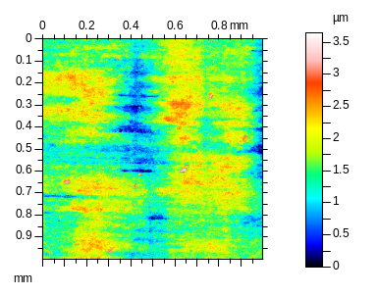 |  |  | 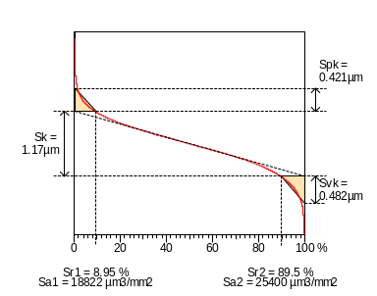 |  |  |  |  |  | 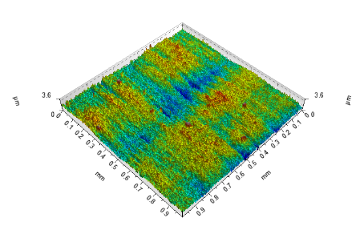
Sq | 0,457 | µm | Sal |  | 0,0957 |  | mm |  | Vvv |  | 5,57e-005 | mm³/mm²
Ssk | -0,0673 |  | Str |  | 0,191 |  |  |  | Spd |  | 29789 | 1/mm²
Sku | 3,29 |  | Std |  | 177 |  | ° |  | Spc |  | 762 | 1/mm
Sp | 2,02 | µm | Sdq |  | 0,329 |  |  |  | S10z |  | 3,53 | µm
Sv | 1,62 | µm | Sdr |  | 5,02 |  | % |  | S5p |  | 1,85 | µm
Sz | 3,64 | µm | Vm |  | 2,2e-005 |  | mm³/mm² |  | S5v |  | 1,68 | µm
Sa | 0,361 | µm | Vv |  | 0,000589 |  | mm³/mm² |  | Sda |  | 7,14e-005 | mm²
Smr | 1,24 | % | Vmp |  | 2,2e-005 |  | mm³/mm² |  | Sha |  | 3,34e-005 | mm²
Smc | 0,567 | µm | Vmc |  | 0,000404 |  | mm³/mm² |  | Sdv |  | 1,82e-009 | mm³
Sxp | 0,936 | µm | Vvc |  | 0,000533 |  | mm³/mm² |  | Shv |  | 1,25e-009 | mm³

