Supplemental Information 3: Figures and Tables
For
Expert elicitation on agricultural enhanced weathering highlights CO₂ removal potential and uncertainties in loss pathways

Buma B, Dietzen C, Gordon DR, Maher K, Neumann RB, Planavsky N, Reershemius T, Suhrhoff TJ, Vicca S, Waring BG, Almaraz M, Calabrese S, Derry LA, M. Granger Morgan, Higgins J, Houlton BZ, Kanzaki Y, Klemme A, Kukla T, Oldfield EE, Power IM, Pearce CR, Silver WL, Zhang S

Tables S1-S3
Figures S1-S2

Table S1: Global potential CDR estimates from experts.

Feedstock | Value | Mean Estimate (Gt year) | Median Estimate (Gt/yr) | Standard deviation
Wollastonite | 5th percentile | -0.07 | 0 | 0.25
Steel slag | 5th percentile | -0.01 | 0.005 | 0.32
Olivine-rich (>50%) rock | 5th percentile | -0.09 | 0 | 0.28
Concrete waste | 5th percentile | -0.06 | -0.01 | 0.29
Basalt | 5th percentile | -0.27 | -0.005 | 0.66
Agricultural Lime | 5th percentile | -0.55 | -0.375 | 0.80
Wollastonite | 95th percentile | 0.86 | 0.1 | 1.25
Steel slag | 95th percentile | 1.16 | 0.25 | 1.42
Olivine-rich (>50%) rock | 95th percentile | 1.22 | 0.5 | 1.55
Concrete waste | 95th percentile | 1.00 | 0.25 | 1.13
Basalt | 95th percentile | 2.05 | 2 | 1.61
Agricultural Lime | 95th percentile | 1.44 | 0.75 | 1.70
Wollastonite | Confidence | 0.71 | 0.7 | 0.14
Steel slag | Confidence | 0.68 | 0.7 | 0.13
Olivine-rich (>50%) rock | Confidence | 0.73 | 0.75 | 0.11
Concrete waste | Confidence | 0.66 | 0.6 | 0.11
Basalt | Confidence | 0.74 | 0.75 | 0.11
Agricultural Lime | Confidence | 0.73 | 0.7 | 0.12
Wollastonite | Best estimate | 0.23 | 0.01 | 0.34
Steel slag | Best estimate | 0.36 | 0.1 | 0.60
Olivine-rich (>50%) rock | Best estimate | 0.47 | 0.1 | 0.70
Concrete waste | Best estimate | 0.30 | 0.1 | 0.53
Basalt | Best estimate | 0.68 | 0.375 | 0.75
Agricultural Lime | Best estimate | 0.67 | 0.175 | 1.11

Table S2. Total pass-through efficiency estimates. Value reflects the amount of fixed carbon estimated to be sequestered for at least 100 years, assuming an on field application of enough material to potentially fix 10 tons of carbon. Values are means of all experts for each all the estimated values.
Feedstock | Stage | Estimate | Value (tons C)
Agricultural Lime | Total (field to marine) | 50th percentile |  | 2.72
Agricultural Lime | Total (field to marine) | 5th percentile |  | 0.56
Agricultural Lime | Total (field to marine) | 95th percentile |  | 5.66
Agricultural Lime | Total (field to marine) | Confidence |  | 0.74
Basalt | Total (field to marine) | 50th percentile |  | 3.20
Basalt | Total (field to marine) | 5th percentile |  | 1.03
Basalt | Total (field to marine) | 95th percentile |  | 5.88
Basalt | Total (field to marine) | Confidence |  | 0.72
Concrete waste | Total (field to marine) | 50th percentile |  | 3.06
Concrete waste | Total (field to marine) | 5th percentile |  | 0.88
Concrete waste | Total (field to marine) | 95th percentile |  | 6.12
Concrete waste | Total (field to marine) | Confidence |  | 0.69
Olivine-rich (>50%) rock | Total (field to marine) | 50th percentile |  | 3.82
Olivine-rich (>50%) rock | Total (field to marine) | 5th percentile |  | 1.41
Olivine-rich (>50%) rock | Total (field to marine) | 95th percentile |  | 6.50
Olivine-rich (>50%) rock | Total (field to marine) | Confidence |  | 0.75
Steel slag | Total (field to marine) | 50th percentile |  | 3.59
Steel slag | Total (field to marine) | 5th percentile |  | 1.53
Steel slag | Total (field to marine) | 95th percentile |  | 6.66
Steel slag | Total (field to marine) | Confidence |  | 0.70
Wollastonite | Total (field to marine) | 50th percentile |  | 3.94
Wollastonite | Total (field to marine) | 5th percentile |  | 1.38
Wollastonite | Total (field to marine) | 95th percentile |  | 7.03
Wollastonite | Total (field to marine) | Confidence |  | 0.71

Table S3. Pass through efficiency by stage. Value reflects the amount of fixed carbon estimated to move through the stage if a hypothetical 10 tons entered the stage as fixed carbon. For the field stage, it assumes an on field application of enough material to potentially fix 10 tons of carbon. Values are means of all experts for each all the estimated values.
Feedstock | Stage | Estimate | Value
Agricultural Lime | Field | 50th percentile | 4.13
Agricultural Lime | Field | 5th percentile | 1.47
Agricultural Lime | Field | 95th percentile | 7.53
Agricultural Lime | Field | Confidence | 0.74
Agricultural Lime | Deep soil | 50th percentile | 5.88
Agricultural Lime | Deep soil | 5th percentile | 2.66
Agricultural Lime | Deep soil | 95th percentile | 8.41
Agricultural Lime | Deep soil | Confidence | 0.70
Agricultural Lime | Freshwater | 50th percentile | 7.09
Agricultural Lime | Freshwater | 5th percentile | 3.97
Agricultural Lime | Freshwater | 95th percentile | 9.16
Agricultural Lime | Freshwater | Confidence | 0.75
Agricultural Lime | Estuary | 50th percentile | 7.16
Agricultural Lime | Estuary | 5th percentile | 4.97
Agricultural Lime | Estuary | 95th percentile | 9.28
Agricultural Lime | Estuary | Confidence | 0.71
Agricultural Lime | Marine | 50th percentile | 8.03
Agricultural Lime | Marine | 5th percentile | 6.28
Agricultural Lime | Marine | 95th percentile | 9.50
Agricultural Lime | Marine | Confidence | 0.73
Basalt | Field | 50th percentile | 3.85
Basalt | Field | 5th percentile | 1.43
Basalt | Field | 95th percentile | 6.88
Basalt | Field | Confidence | 0.75
Basalt | Deep soil | 50th percentile | 5.45
Basalt | Deep soil | 5th percentile | 2.85
Basalt | Deep soil | 95th percentile | 7.85
Basalt | Deep soil | Confidence | 0.67
Basalt | Freshwater | 50th percentile | 7.03
Basalt | Freshwater | 5th percentile | 4.23
Basalt | Freshwater | 95th percentile | 8.90
Basalt | Freshwater | Confidence | 0.73
Basalt | Estuary | 50th percentile | 6.83
Basalt | Estuary | 5th percentile | 4.55
Basalt | Estuary | 95th percentile | 8.93
Basalt | Estuary | Confidence | 0.68
Basalt | Marine | 50th percentile | 7.90
Basalt | Marine | 5th percentile | 6.28
Basalt | Marine | 95th percentile | 9.30
Basalt | Marine | Confidence | 0.69
Concrete waste | Field | 50th percentile | 4.32
Concrete waste | Field | 5th percentile | 2.29
Concrete waste | Field | 95th percentile | 7.65
Concrete waste | Field | Confidence | 0.70
Concrete waste | Deep soil | 50th percentile | 5.53
Concrete waste | Deep soil | 5th percentile | 3.03
Concrete waste | Deep soil | 95th percentile | 7.85
Concrete waste | Deep soil | Confidence | 0.68
Concrete waste | Freshwater | 50th percentile | 6.76
Concrete waste | Freshwater | 5th percentile | 4.26
Concrete waste | Freshwater | 95th percentile | 8.47
Concrete waste | Freshwater | Confidence | 0.72
Concrete waste | Estuary | 50th percentile | 6.97
Concrete waste | Estuary | 5th percentile | 4.91
Concrete waste | Estuary | 95th percentile | 8.76
Concrete waste | Estuary | Confidence | 0.67
Concrete waste | Marine | 50th percentile | 7.76
Concrete waste | Marine | 5th percentile | 6.44
Concrete waste | Marine | 95th percentile | 9.06
Concrete waste | Marine | Confidence | 0.70
Olivine-rich (>50%) rock | Field | 50th percentile | 4.65
Olivine-rich (>50%) rock | Field | 5th percentile | 2.09
Olivine-rich (>50%) rock | Field | 95th percentile | 7.21
Olivine-rich (>50%) rock | Field | Confidence | 0.76
Olivine-rich (>50%) rock | Deep soil | 50th percentile | 5.65
Olivine-rich (>50%) rock | Deep soil | 5th percentile | 3.44
Olivine-rich (>50%) rock | Deep soil | 95th percentile | 8.32
Olivine-rich (>50%) rock | Deep soil | Confidence | 0.69
Olivine-rich (>50%) rock | Freshwater | 50th percentile | 7.18
Olivine-rich (>50%) rock | Freshwater | 5th percentile | 4.26
Olivine-rich (>50%) rock | Freshwater | 95th percentile | 9.06
Olivine-rich (>50%) rock | Freshwater | Confidence | 0.76
Olivine-rich (>50%) rock | Estuary | 50th percentile | 7.38
Olivine-rich (>50%) rock | Estuary | 5th percentile | 5.12
Olivine-rich (>50%) rock | Estuary | 95th percentile | 9.12
Olivine-rich (>50%) rock | Estuary | Confidence | 0.69
Olivine-rich (>50%) rock | Marine | 50th percentile | 8.15
Olivine-rich (>50%) rock | Marine | 5th percentile | 6.38
Olivine-rich (>50%) rock | Marine | 95th percentile | 9.32
Olivine-rich (>50%) rock | Marine | Confidence | 0.73
Steel slag | Field | 50th percentile | 5.25
Steel slag | Field | 5th percentile | 3.09
Steel slag | Field | 95th percentile | 8.03
Steel slag | Field | Confidence | 0.70
Steel slag | Deep soil | 50th percentile | 6.31
Steel slag | Deep soil | 5th percentile | 3.50
Steel slag | Deep soil | 95th percentile | 8.66
Steel slag | Deep soil | Confidence | 0.69
Steel slag | Freshwater | 50th percentile | 7.50
Steel slag | Freshwater | 5th percentile | 4.47
Steel slag | Freshwater | 95th percentile | 9.31
Steel slag | Freshwater | Confidence | 0.74
Steel slag | Estuary | 50th percentile | 7.41
Steel slag | Estuary | 5th percentile | 5.06
Steel slag | Estuary | 95th percentile | 9.28
Steel slag | Estuary | Confidence | 0.70
Steel slag | Marine | 50th percentile | 8.16
Steel slag | Marine | 5th percentile | 6.59
Steel slag | Marine | 95th percentile | 9.50
Steel slag | Marine | Confidence | 0.71
Wollastonite | Field | 50th percentile | 5.25
Wollastonite | Field | 5th percentile | 2.47
Wollastonite | Field | 95th percentile | 8.28
Wollastonite | Field | Confidence | 0.73
Wollastonite | Deep soil | 50th percentile | 6.22
Wollastonite | Deep soil | 5th percentile | 3.34
Wollastonite | Deep soil | 95th percentile | 8.84
Wollastonite | Deep soil | Confidence | 0.70
Wollastonite | Freshwater | 50th percentile | 7.59
Wollastonite | Freshwater | 5th percentile | 4.50
Wollastonite | Freshwater | 95th percentile | 9.28
Wollastonite | Freshwater | Confidence | 0.77
Wollastonite | Estuary | 50th percentile | 7.34
Wollastonite | Estuary | 5th percentile | 4.97
Wollastonite | Estuary | 95th percentile | 9.28
Wollastonite | Estuary | Confidence | 0.68
Wollastonite | Marine | 50th percentile | 8.22
Wollastonite | Marine | 5th percentile | 6.56
Wollastonite | Marine | 95th percentile | 9.50
Wollastonite | Marine | Confidence | 0.71

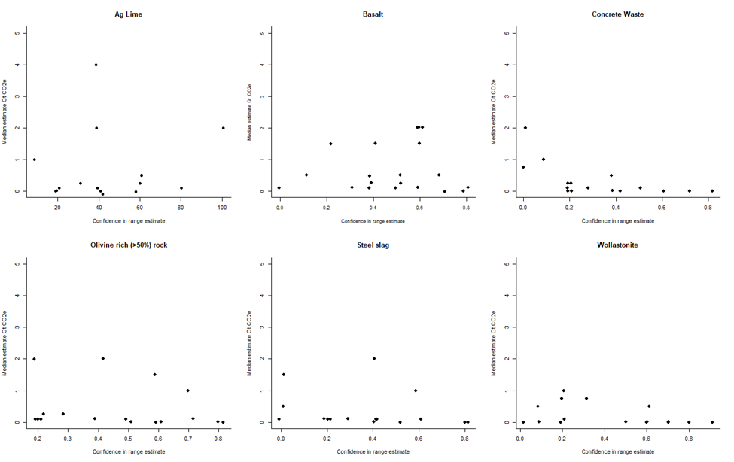
Figure S1. Individual responses comparing confidence in range estimate (x-axis) to best estimate of global scale of CDR per year. Confidence rescaled from 50% (low confidence; equal chance the real value is within the reported range) to 100% to 0 - 1.0.

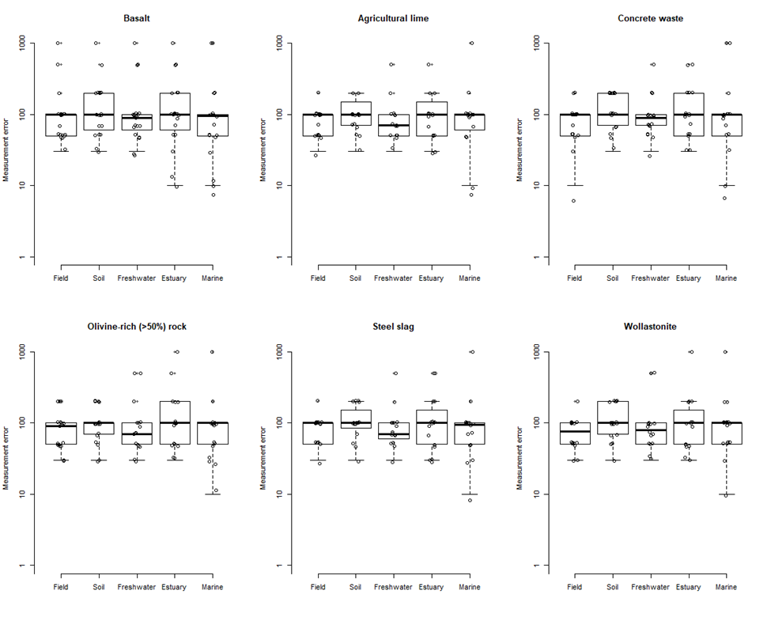
Figure S2. Individual estimates of measurement error by feedstock and stage. An estimated error of 100% means the error in an estimate is approximately equal to the magnitude of the signal. Larger values indicate the error is larger than the signal (e.g., 200% equals 2x the signal). Note the log scale.

