1. Soil water content in the 0-40 cm layer during the maize growing season
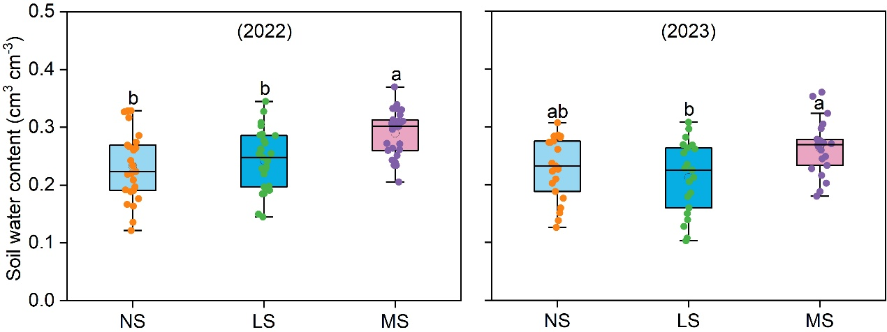
Figure 1

2. Electrical conductivity (EC_{1:5}) of the 0-40 cm soil layer during the maize growing season
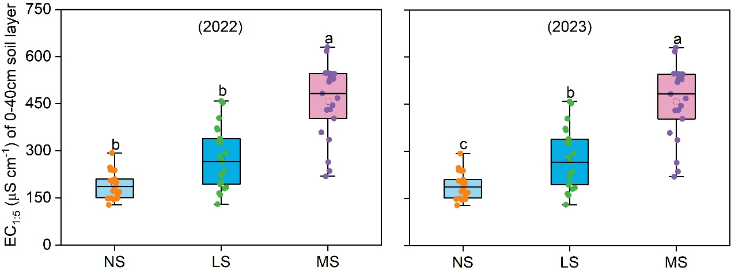
Figure 2

3. N₂O emission fluxes in 2022
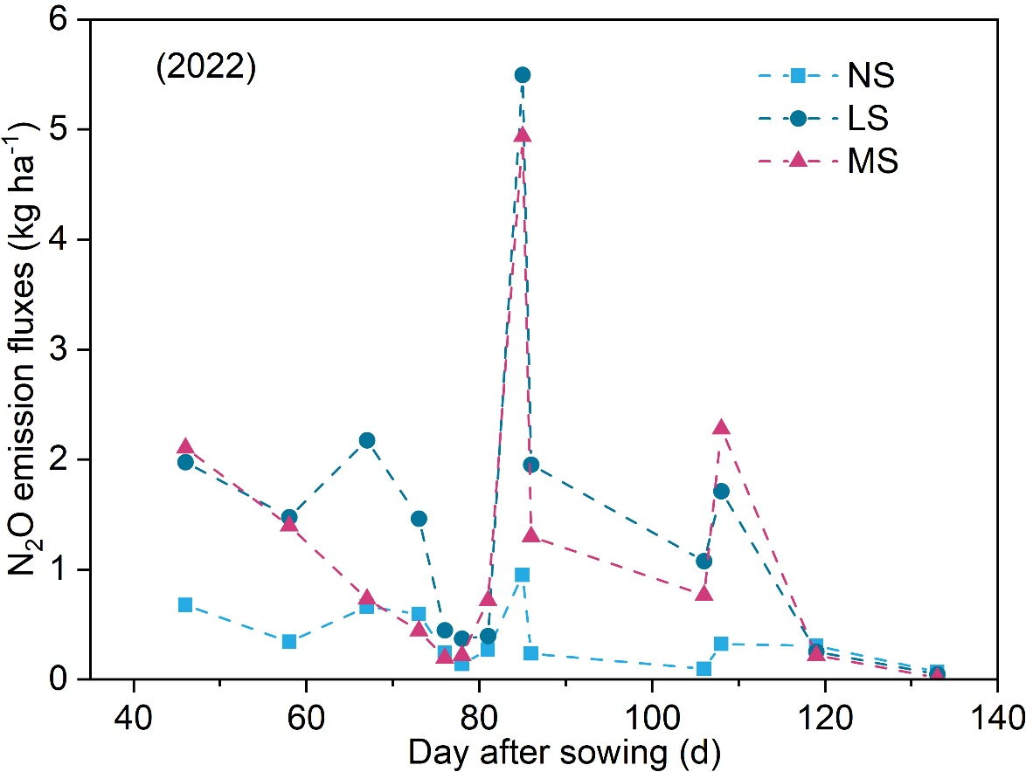
Figure 3

4. N₂O emission fluxes in 2023
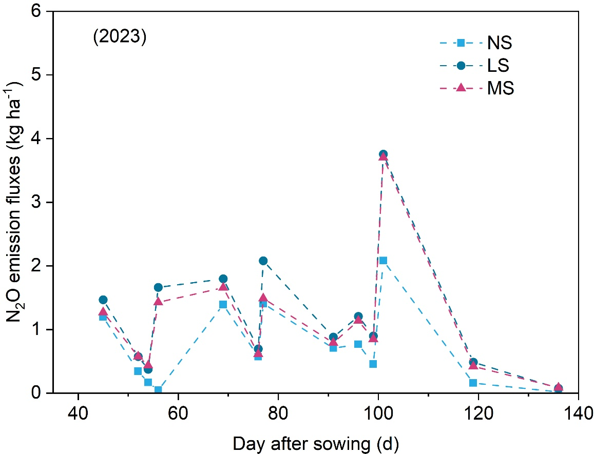
Figure 4

5. NH₃ emission fluxes in 2022
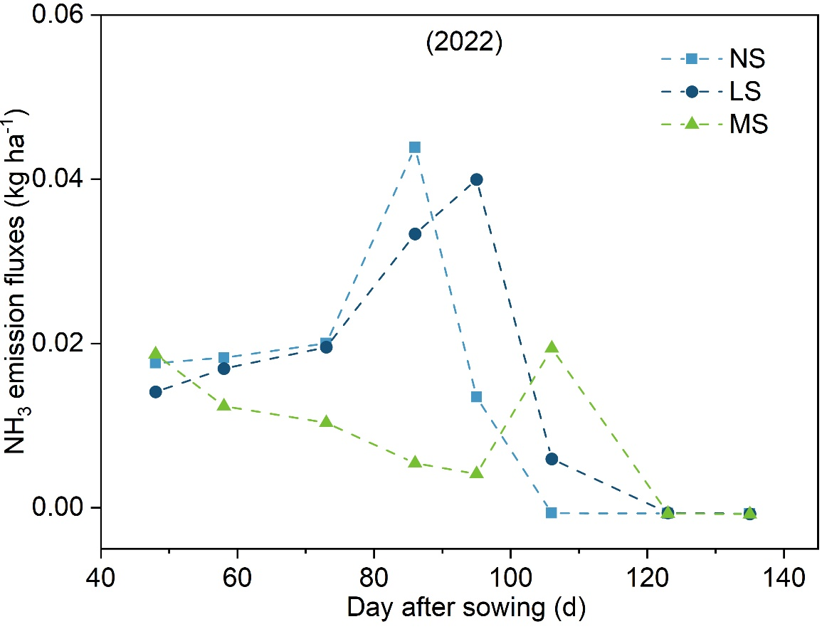
Figure 5

6. NH₃ emission fluxes in 2023
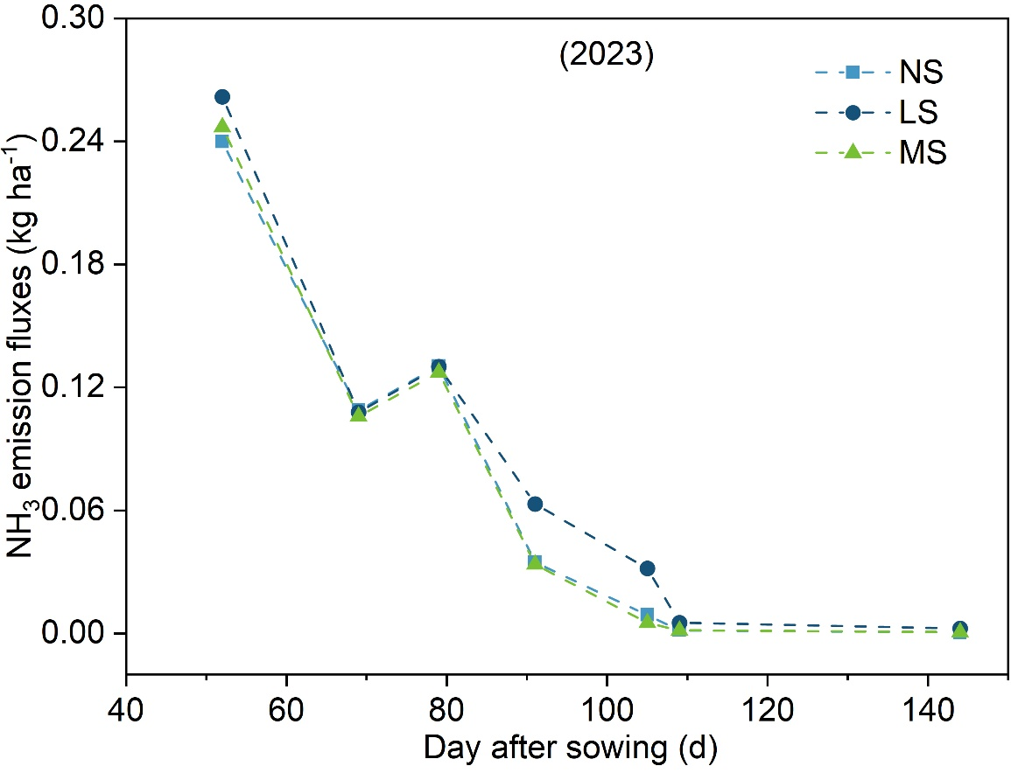
Figure 6

