Supporting Information
Anion-tuned d-p hybridization breaks activity-stability trade-off in single-atom hydrogen evolution catalysts
Rouna Jia^{1,2}, Zongyan Liu^{1,2}, Yang Wang^{1,2 *}, Feiyu Li¹, Jingyang Zhao¹, Zhong Huang³, Wen Yue⁴, Haozhi Wang^{1,2 *}, Mingxin Huang⁵, Yida Deng^{1,2 *}

¹ State Key Laboratory of Tropic Ocean Engineering Materials and Materials Evaluation, School of Materials Science and Engineering, Hainan University, Haikou, 570228, China;

² Key Laboratory of Pico Electron Microscopy of Hainan Province, Hainan University, Haikou, 570228, China;

³ School of Information and Communication Engineering, Hainan University, Haikou, 570228, China;

⁴ State Key Laboratory of Deep Earth Exploration and Imaging, China University of Geosciences, Beijing, 100083, China;

⁵ Department of Mechanical Engineering, The University of Hong Kong, Hong Kong.

Experimental Section
1. Chemical and Reagents
All chemicals were of reagent-grade and used without further purification. Hexaammonium heptamolybdate tetrahydrate ((NH₄)₆Mo₇O₂₄·4H₂O), thiourea (NH₂CSNH₂), selenourea (NH₂CSeNH₂), and Potassium hexachlororhodate (K₃RhCl₆) were obtained from Sigma-Aldrich. Deionized (DI) water was produced using a Millipore ultrapure water system.
2. Material synthesis
2.1 Synthesis of MoS_{x}Se_{2-x}
MoS_{x}Se_{2-x} was synthesized following previously reported methods with minor modification. To prepare MoSSe, 1 mmol of (NH₄)₆Mo₇O₂₄·4H₂O, 1.25 mmol of NH₂CSNH₂, and 1.25 mmol of NH₂CSeNH₂ were dissolved in 30 mL of deionized water and stirred vigorously for 1 h to form a homogeneous solution. The solution was then transferred to a 50 mL Teflon-lined autoclave and maintained at 230 °C for 20 h. After cooling to room temperature, the resulting precipitates were filtered, washed with ethanol and water, and dried at 60 ℃ overnight. Stable MoSSe was obtained by heat-treatment the metastable MoSSe solid solution at 300 °C. Similarly, MoS₂, MoS_{1.5}Se_{0.5}, MoS_{0.5}Se_{1.5}, and MoSe₂ nanosheets were synthesized using the same procedure, adjusting only the amounts of NH₂CSNH₂ and NH₂CSeNH₂.
2.2 Synthesis of Rh_{SA}-MoS_{x}Se_{2-x}
Rh single atoms anchored on MoS_{x}Se_{2-x} substrates (Rh_{SA}-MoS_{x}Se_{2-x}) were synthesized using a universal electrodeposition method in a standard three-electrode system. Initially, 10 mg of each as-prepared MoS_{x}Se_{2-x} catalysts (10 mg) was dispersed in 1 mL of ethanol containing 30 μL of Nafion solution and sonicated until a homogeneous ink was formed. Subsequently, 250 μL of the ink was formed. Subsequently, 250 μL of the ink was drop-cast onto Ni foam (1×1 cm) and dried at room temperature, resulting in a catalyst loading of 2.5 mg cm⁻². A carbon rod and a saturated calomel electrode (SCE) were used as the counter and reference electrode, respectively. The electrolyte consisted of 200 μM Rh precursors and 1 M KOH. Electrochemical depositions were performed by sweeping the potential from 0.10 V to -0.55 V at a scan rate of 5 mV s⁻¹ for cathodic deposition, with the process repeated five times. After depositions, the electrode was rinsed with deionized water and used directly for subsequent electrochemical measurements.
3. Electrode preparatory method and electrochemical measurement
Electrochemical measurement was performed using a three-electrode system on a CHI760E electrochemical workstation (Chenhua Shanghai) at room temperature. The working electrode was prepared by dispersing 10 mg of catalyst in 1 mL of ethanol containing 30 μL of Nafion solution, followed by sonication to form a homogeneous ink. Then, 250 μL of this ink was drop-cast dropwise onto a 1×1 cm Ni foam and dried at room temperature, yielding a catalyst loading of 2.5 mg cm⁻². A carbon rod and a saturated calomel electrode (SCE) served as the counter and reference electrode, respectively. HER activities were evaluated via linear sweep voltammetry (LSV) in 1 M KOH electrolyte at 25 °C, with all data corrected to the reversible hydrogen electrode (RHE) scale with 90% iR compensation applied. CO stripping experiments were conducted in 1.0 M KOH solution. The working electrode with catalysts was immersed in the electrolyte, and CO was purged for 30 min to achieve CO saturation. After CO adsorption at open circuit potential, the electrode was transferred to an Ar-saturation 1.0 M KOH electrolyte. CO stripping voltammetry was recorded between 0.02 and 0.8 V (vs. RHE) at a scan rate of 50 mV·s⁻¹. Electrochemical impedance spectroscopy (EIS) was performed over a frequency range of 10 to 0.1 Hz. Long-term stability was assessed using chronopotentiometry at a constant current density of 10 mA cm⁻².
The electrochemical active surface area (ECSA) was determined by measuring the electrochemical double-layer capacitance (C_{dl}). Cyclic voltammetry (CV) was conducted in a non-Faradaic region (0.37-0.47 V vs. RHE) at scan rates ranging from 20 to 100 mV s⁻¹. The C_{dl} was calculated by plotting the current density difference (ΔJ) between anodic and cathodic sweeps at a fixed potential against the scan rate, where the slope represents C_{dl}. The ECSA was calculated as ECSA = C_{dl}/C_{s}, where C_{s} is the specific capacitance of the material. A general specific capacitances value of C_{s} = 40 uF cm⁻² in 1 M KOH was used, based on typical commonly reported values for surface area estimation.
4. Structural characterization
X-ray diffraction (XRD) analysis was conducted using a Rigaku Ultima IV diffractometer (Japan). Scanning electron microscope (SEM) images were obtained with a Thermo Scientific Verios G4 UC microscope SEM. Transmission electron microscopy (TEM) was performed on a Thermo Scientific Talos F200X G2 TEM equipped with X-ray energy-dispersive spectroscopy (EDS). Atomic-resolution scanning TEM (AC-STEM) images were acquired using a JEOL JEM-ARM200F aberration-corrected microscope. Inductively coupled plasma optical emission spectrometry (ICP-OES) was carried out on an Agilent 7700 instrument (USA) to determine the composition of materials. X-ray photoelectron spectroscopy (XPS) was conducted using a Thermo Scientific K-Alpha spectrometer (USA) to analyze chemical valence states and surface atomic ratios, with calibration based on the C 1s peak at 284.8 eV. Raman spectroscopic experiments were performed with a confocal microscope Raman system Xplora Plus (HORIBA France), the excitation wavelength of the semiconductor laser was 532 nm, the laser power was 100 mW.
5. XAFS measurements.
X-ray absorption fine structure spectroscopy (XAFS) measurements at the Rh L-edge were performed in transmission mode using a Si (111) monochromator at the BL14W1 beamline of the Shanghai Synchrotron Radiation Facility (SSRF), China. The SSRF storage ring operated at 3.5 GeV with a maximum current of 210 mA. All spectra were acquired under ambient conditions.
6. In situ Raman measurements.
In situ Raman spectroscopic experiments were performed with a confocal microscope Raman system Xplora Plus (HORIBA France). The excitation wavelength of the semiconductor laser was 532 nm, the laser power was 100 mW, and all Raman measurements were performed with a 50× microscope objective with a numerical aperture of 0.55. Raman frequencies were calibrated using silicon wafers during each experiment. In situ electrochemical Raman experiments were carried out in an in-house made Raman cell with Rh_{SA}-MoS_{x}Se_{2-x} decorated 1×1 cm Ni foam as the working electrode, Pt wire as a counter electrode, and Hg/HgO as a reference electrode. An CHI760E electrochemical workstation (Chenhua Shanghai) was used to control the potential.
7. Operando ATR-FTIR measurements.
Operando attenuated total reflectance Fourier-transform infrared spectroscopy (ATR-FTIR) data were recorded using a Fourier transform infrared spectrometer equipped with independent DigiTect detector bits and Transit channels for fast MIR measurements (INVENIO, BRUKER OPTICS). The electrochemical experiment was performed using an H-type cell, where an Rh_{SA}-MoS_{x}Se_{2-x} decorated 1×1 cm Ni foam, Ag/AgCl electrode and Pt foil were used as the working electrode, reference electrode and counter electrode, respectively. Prior to formal ATR-FTIR measurements, a potential was applied to the as-constructed working electrode for a period of time until reliable signals were obtained. Background curves were collected under open circuit conditions. All ATR-FTIR spectra were recorded under the resolution of 4 cm⁻¹.
8. Calculation Details
Density functional theory (DFT) calculations were performed using the projector augmented-wave (PAW) pseudopotential method with the Perdew-Burke-Ernzerhof (PBE) exchange-correlation functionals, as implemented in the Vienna Ab-initio Simulation Package (VASP)^{1–7}. A plane-wave cutoff energy of 400 eV was used for electronic structure calculations. The convergence criterion for electronic self-consistency was set to 10⁻⁵ eV, and the force convergence threshold for structural optimization was set below 0.01 eV/Å. The basal planes of Rh_{SA}-MoS₂, Rh_{SA}-MoSSe, Rh_{SA}-MoSe₂, MoS₂, MoSSe, and MoSe₂ were simulated modeled using 4×4 supercells, with vacuum thicknesses exceeding 15 Å. The free energy (G) was calculated as E_{total} + ZPE - TS, where E_{total} is DFT-calculated total energy, ZPE is the zero-point energy, T is temperature, and S is the entropy.

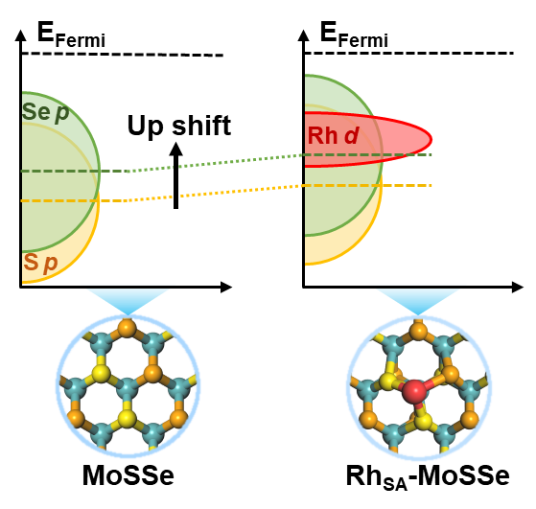
Supplementary Fig. 1. Schematic illustration of the incorporation of Rh single atoms to modulate the electronic structure of the substrates via metal-support interactions (MSIs).

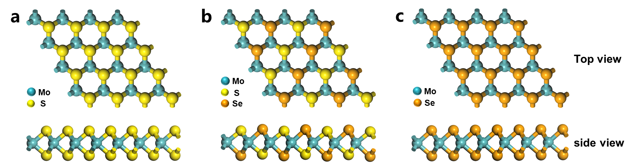
Supplementary Fig. 2. Structure models of MoS_{x}Se_{2-x} (0 ≤ x ≤ 2). Structure models of (a) MoS₂, (b) MoSSe, and (c) MoSe₂, depicted in top and side view. Blue, yellow, and orange spheres represent molybdenum (Mo), sulfur (S), and selenium (Se) atoms, respectively.

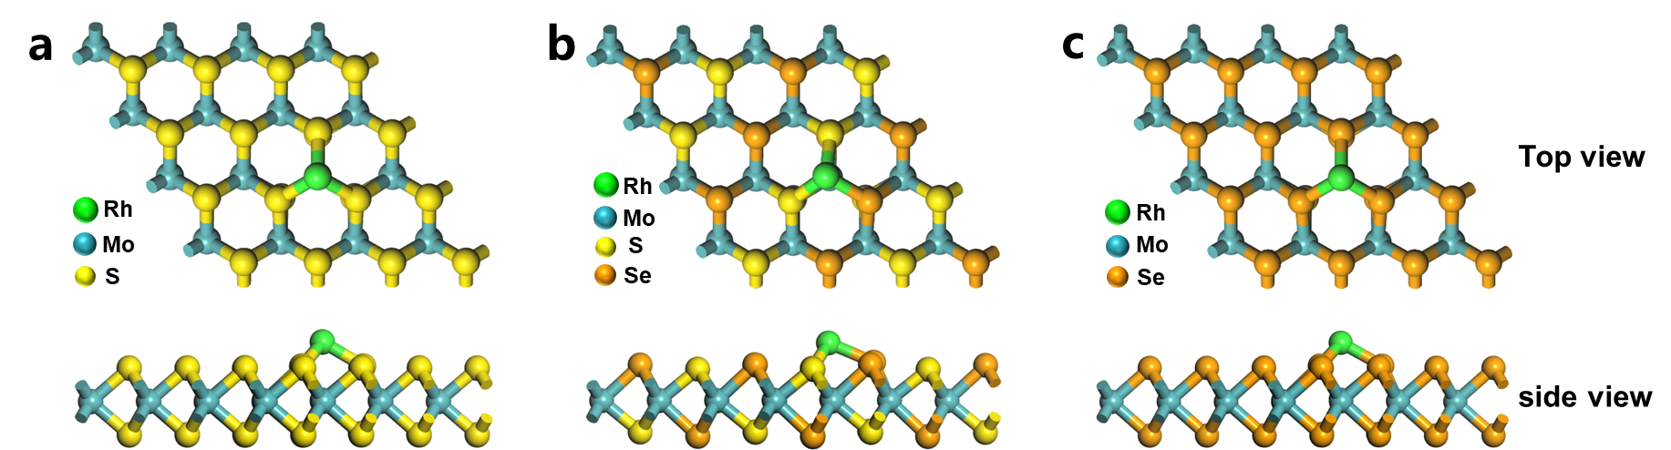
Supplementary Fig. 3. Structure models of Rh_{SA}-MoS_{x}Se_{2-x} (0 ≤ x ≤ 2). Structure models of (a) Rh_{SA}-MoS₂, (b) Rh_{SA}-MoSSe, and (c) Rh_{SA}-MoSe₂, presented in top and side view. Green, blue, yellow, and orange spheres represent rhodium (Rh), Mo, S, and Se atoms, respectively.

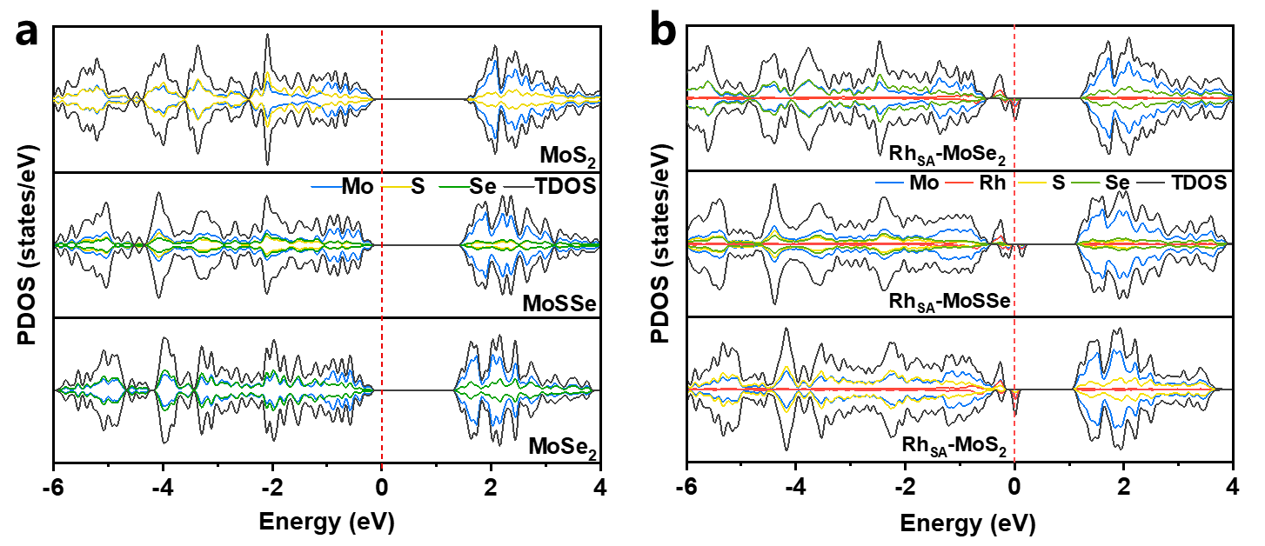
Supplementary Fig. 4. (a) Calculated density of states (DOS) for MoS₂, MoSSe, and MoSe₂. (b) Calculated DOS for Rh single-atom anchored systems: Rh_{SA}-MoS₂, Rh_{SA}-MoSSe, and Rh_{SA}-MoSe₂.

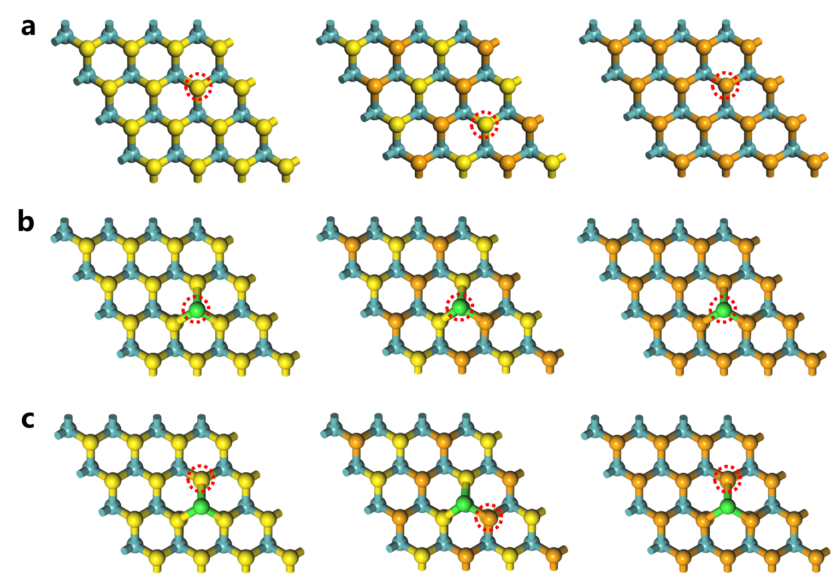
Supplementary Fig. 5. (a) S/Se sites for H adsorption in MoS_{x}Se_{2-x}. (b) Rh sites and (c) surrounding S/Se sites for H adsorption in Rh_{SA}-MoS_{x}Se_{2-x}.

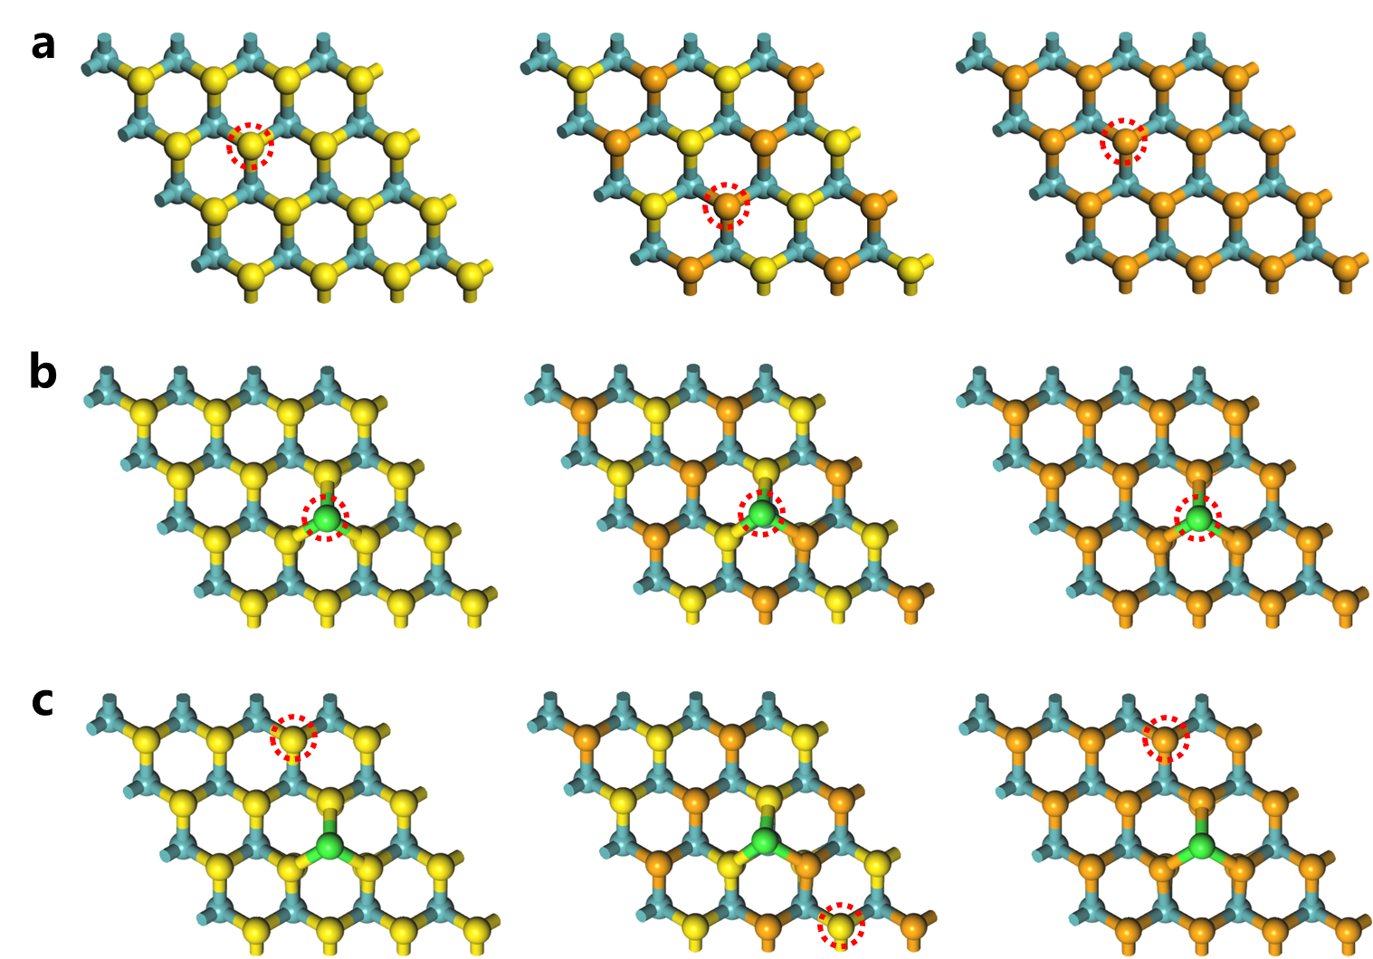
Supplementary Fig. 6. (a) S/Se sites for OH adsorption in MoS_{x}Se_{2-x}. (b) Rh sites and (c) surrounding S/Se sites for OH adsorption in Rh_{SA}-MoS_{x}Se_{2-x}.

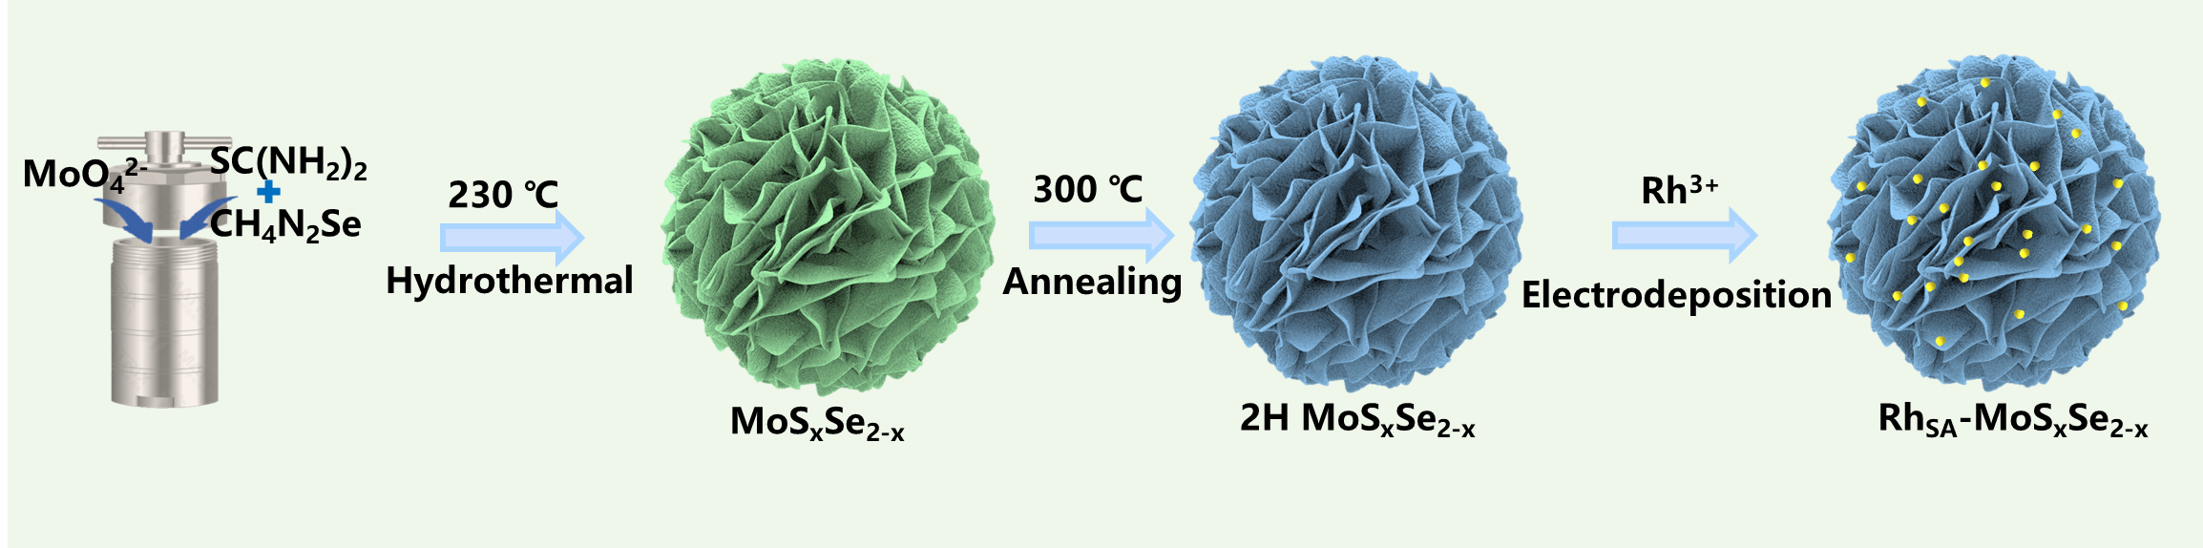
Supplementary Fig. 7. Synthetic pathway for Rh_{SA}-MoS_{x}Se_{2-x} catalysts.

Supplementary Fig. 8. SEM images of (a) MoS₂, (b) MoS_{1.5}Se_{0.5}, (c) MoSSe, (d) MoS_{0.5}Se_{1.5}, and (e) MoSe₂.

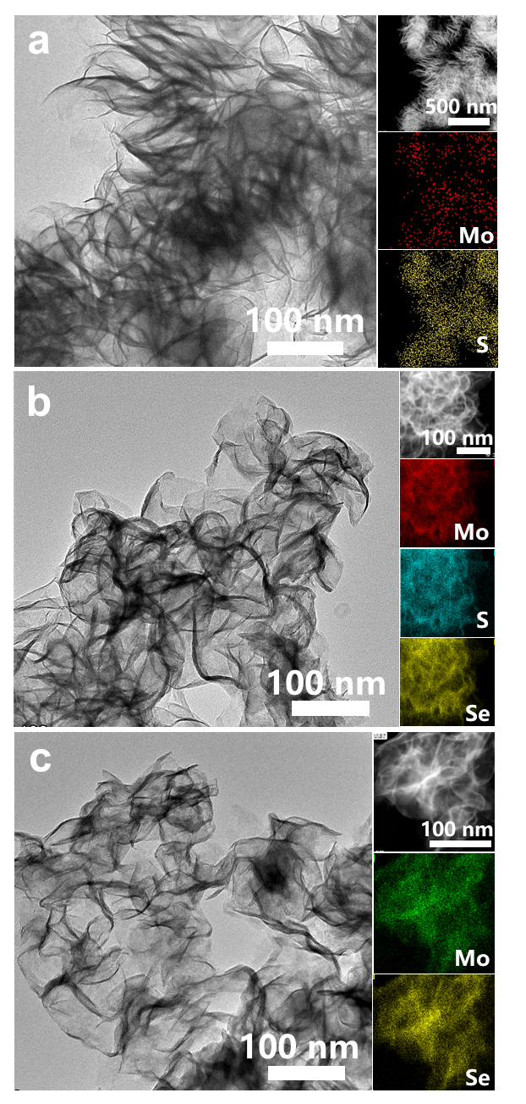
Supplementary Fig. 9. TEM images and corresponding EDS elemental mapping of (a) MoS₂, (b) MoSSe, and (c) MoSe₂.

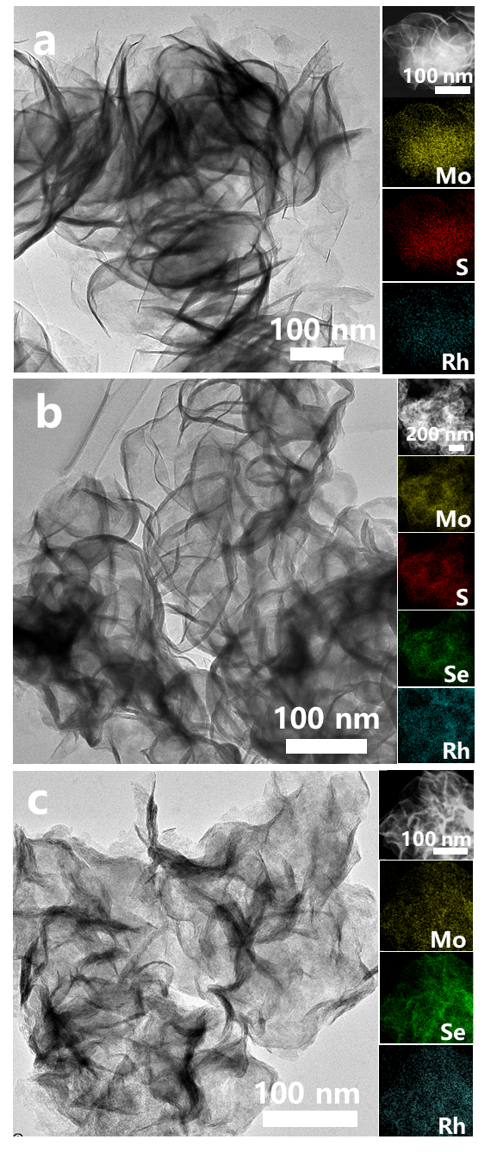
Supplementary Fig. 10. TEM images and corresponding EDS elemental mapping of (a) Rh_{SA}-MoS₂, (b) Rh_{SA}-MoSSe, and (c) Rh_{SA}-MoSe₂.

Supplementary Fig. 11. XRD patterns of MoS₂, MoS_{1.5}Se_{0.5}, MoSSe, MoS_{0.5}Se_{1.5}, MoSe₂, Rh_{SA}-MoS₂, Rh_{SA}-MoS_{1.5}Se_{0.5}, Rh_{SA}-MoSSe, Rh_{SA}-MoS_{0.5}Se_{1.5}, and Rh_{SA}-MoSe₂.

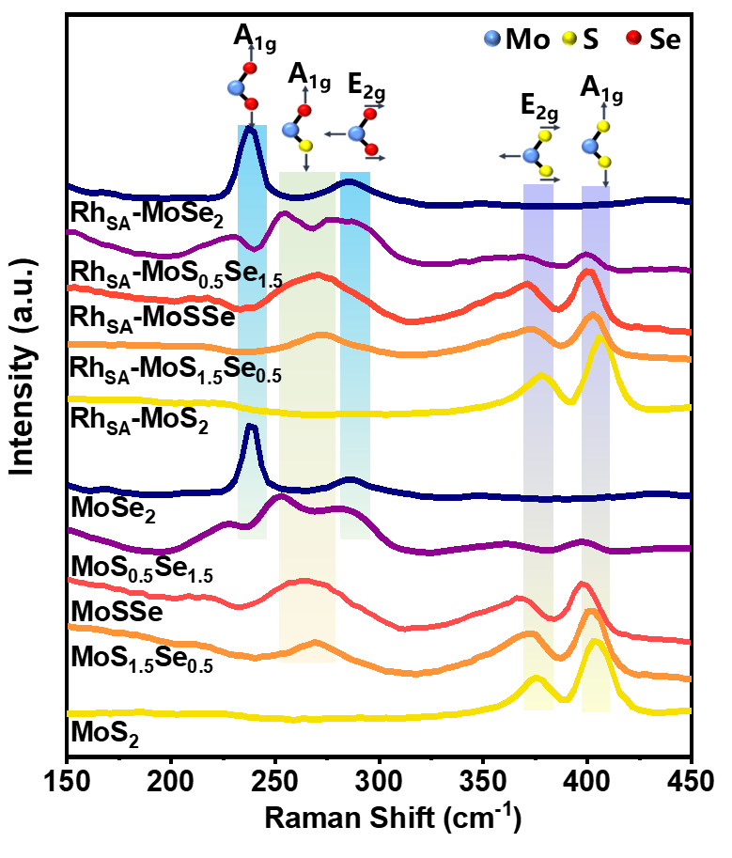
Supplementary Fig. 12. Raman spectra of MoS₂, MoS_{1.5}Se_{0.5}, MoSSe, MoS_{0.5}Se_{1.5}, MoSe₂, Rh_{SA}-MoS₂, Rh_{SA}-MoS_{1.5}Se_{0.5}, Rh_{SA}-MoSSe, Rh_{SA}-MoS_{0.5}Se_{1.5}, and Rh_{SA}-MoSe₂.

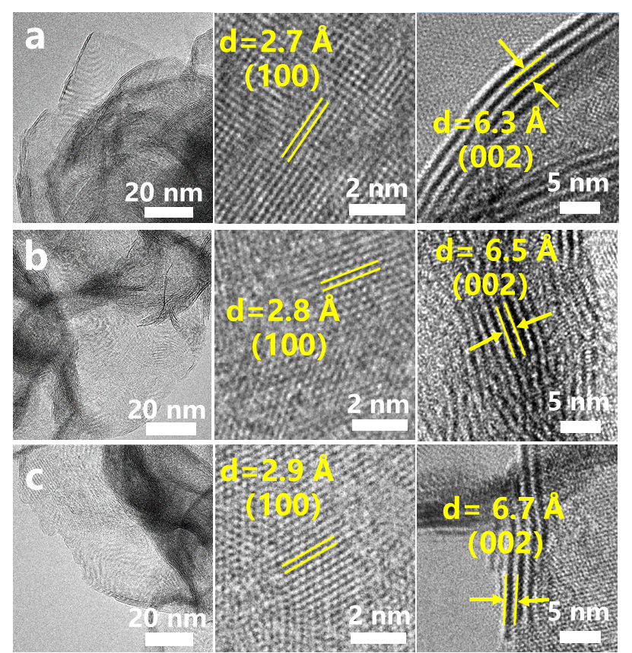
Supplementary Fig. 13. High-resolution transmission electron microscopy (HRTEM) images of (a) MoS₂, (b) MoSSe, and (c) MoSe₂.

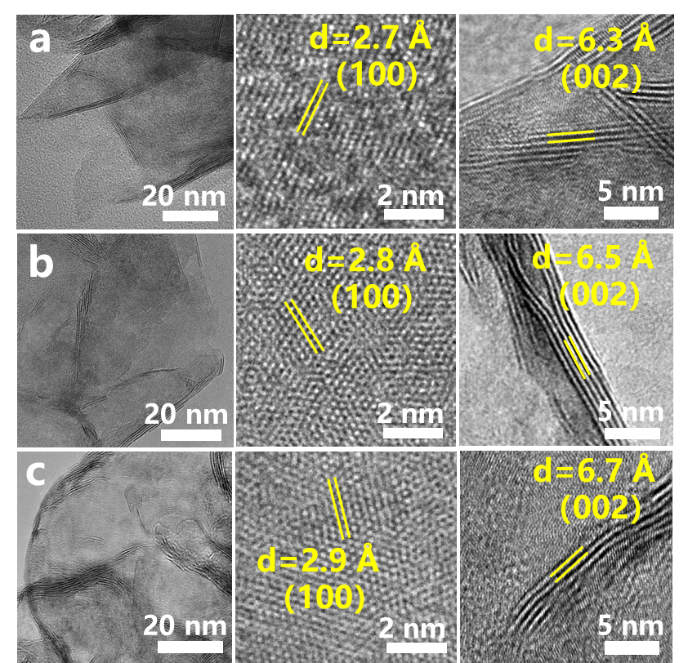
Supplementary Fig. 14. High-resolution transmission electron microscopy (HRTEM) images of (a) Rh_{SA}-MoS₂, (b) Rh_{SA}-MoSSe, and (c) Rh_{SA}-MoSe₂.

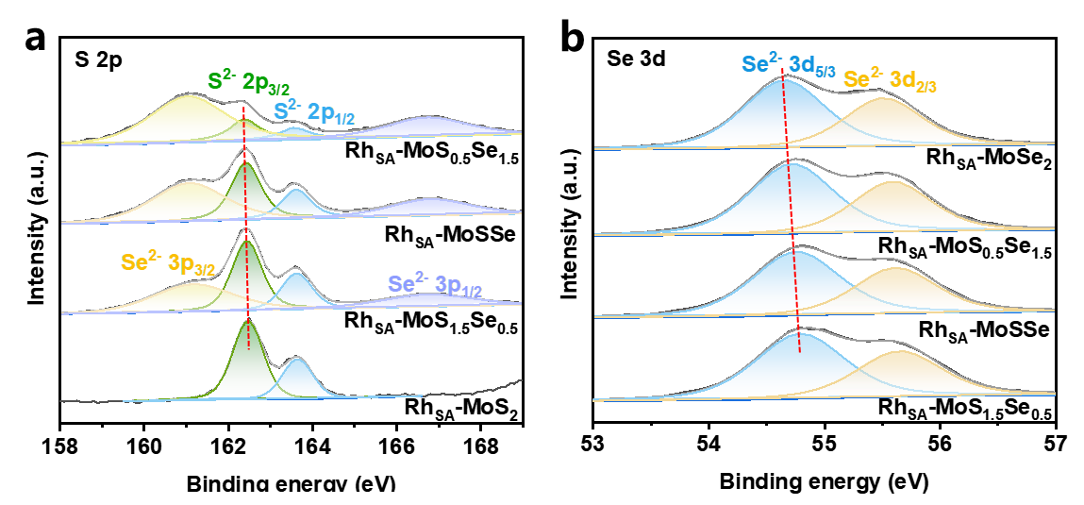
Supplementary Fig. 15. (a) S 2p and (b) Se 3d XPS spectras of Rh_{SA}-MoS₂, Rh_{SA}-MoS_{1.5}Se_{0.5}, Rh_{SA}-MoSSe, Rh_{SA}-MoS_{0.5}Se_{1.5}, and Rh_{SA}-MoSe₂.

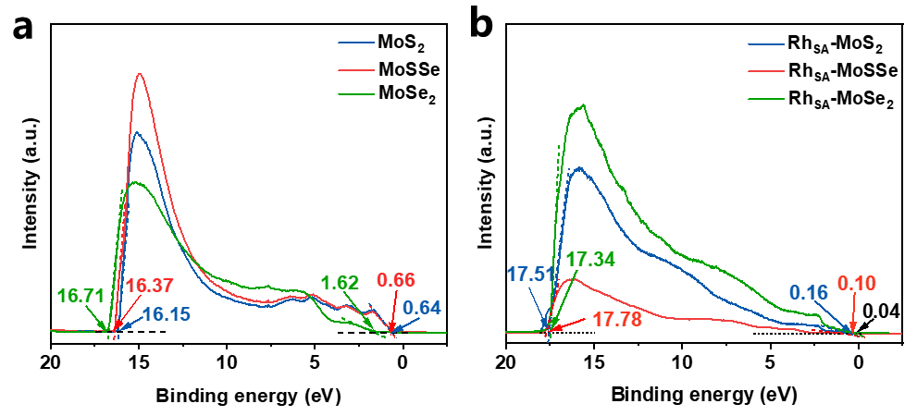
Supplementary Fig. 16. (a) UPS spectra of MoS₂, MoSSe, and MoSe₂. (b) UPS spectra of Rh_{SA}-MoS₂, Rh_{SA}-MoSSe, and Rh_{SA}-MoSe₂.

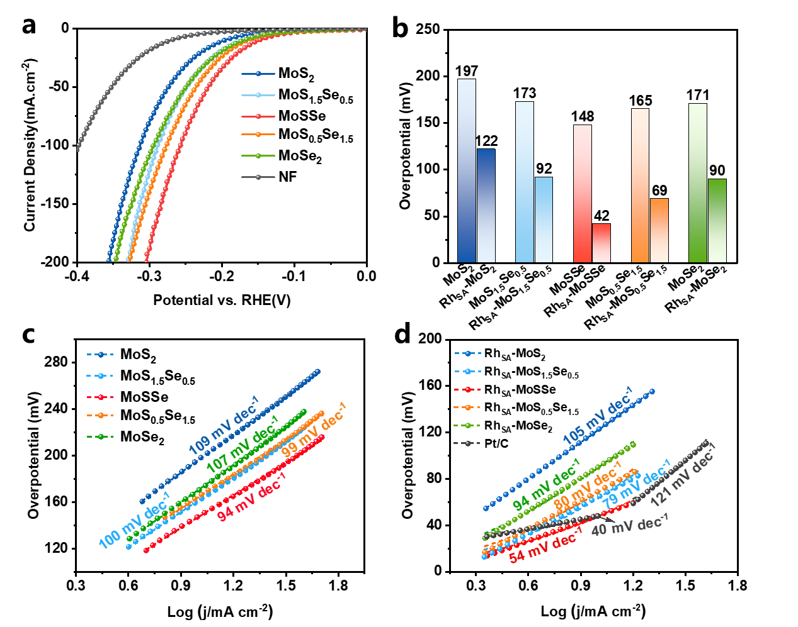
Supplementary Fig. 17. (a) HER polarization curves and (c) corresponding Tafel slopes for MoS₂, MoS_{1.5}Se_{0.5}, MoSSe, MoS_{0.5}Se_{1.5}, and MoSe₂ catalysts. (b) Overpotentials at current densities of 10 mA cm⁻² for MoS₂, MoS_{1.5}Se_{0.5}, MoSSe, MoS_{0.5}Se_{1.5} MoSe₂, Rh_{SA}-MoS₂, Rh_{SA}-MoS_{1.5}Se_{0.5}, Rh_{SA}-MoSSe, Rh_{SA}-MoS_{0.5}Se_{1.5}, and Rh_{SA}-MoSe₂. (d) Tafel slopes for Rh_{SA}-MoS₂, Rh_{SA}-MoS_{1.5}Se_{0.5}, Rh_{SA}-MoSSe, Rh_{SA}-MoS_{0.5}Se_{1.5}, Rh_{SA}-MoSe₂, and Pt/C catalysts.

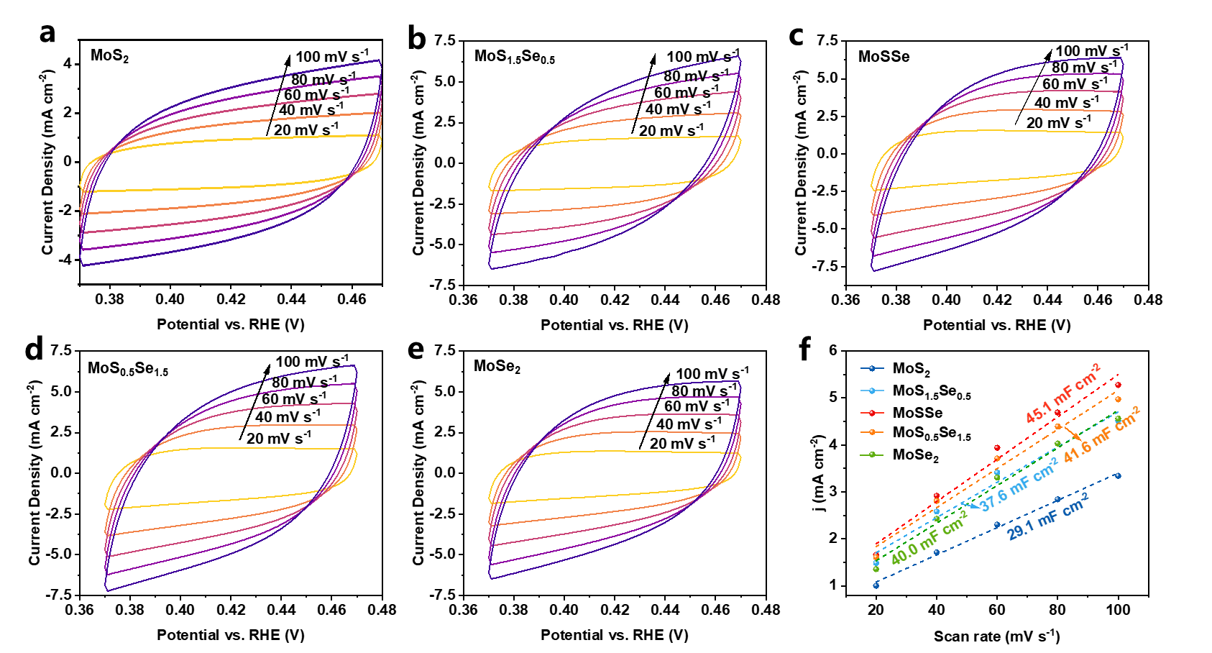
Supplementary Fig. 18. Double-layer capacitance analysis. CVs of (a) MoS₂, (b) MoS_{1.5}Se_{0.5}, (c) MoSSe, (d) MoS_{0.5}Se_{1.5}, and (e) MoSe₂, recorded at scan rates of 20, 40, 60, 80, and 100 mV s⁻¹. (f) Plots of current densities versus scan rate, where ∆j represents the difference between anodic and cathodic current densities at 0.42 V vs. RHE. The slopes of the linear fits correspond to twice the electrochemical double-layer capacitance.

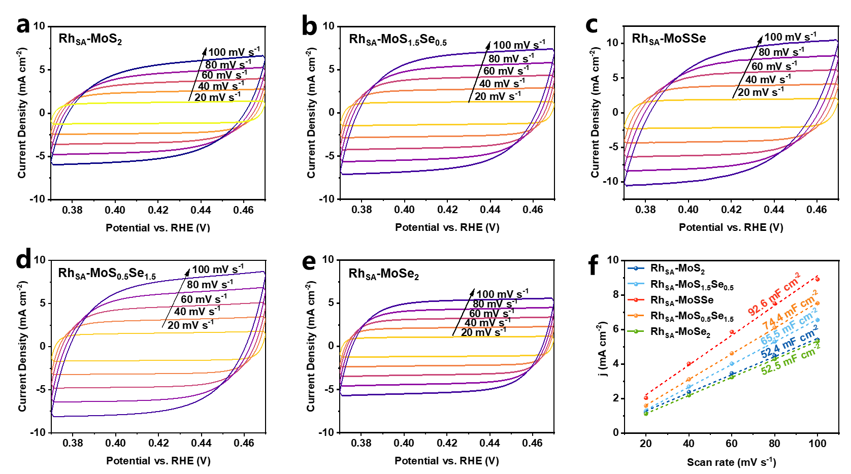
Supplementary Fig. 19. Double-layer capacitance measurements. CVs of (a) Rh_{SA}-MoS₂, (b) Rh_{SA}-MoS_{1.5}Se_{0.5}, (c) Rh_{SA}-MoSSe, (d) Rh_{SA}-MoS_{0.5}Se_{1.5}, and (e) Rh_{SA}-MoSe₂, recorded at scan rates of 20, 40, 60, 80, and 100 mV s⁻¹. (f) Plots of current density versus scan rate, where ∆j represents the difference between anodic and cathodic current densities at 0.42 V vs. RHE. The slopes of the linear fits correspond to twice the electrochemical double-layer capacitance.

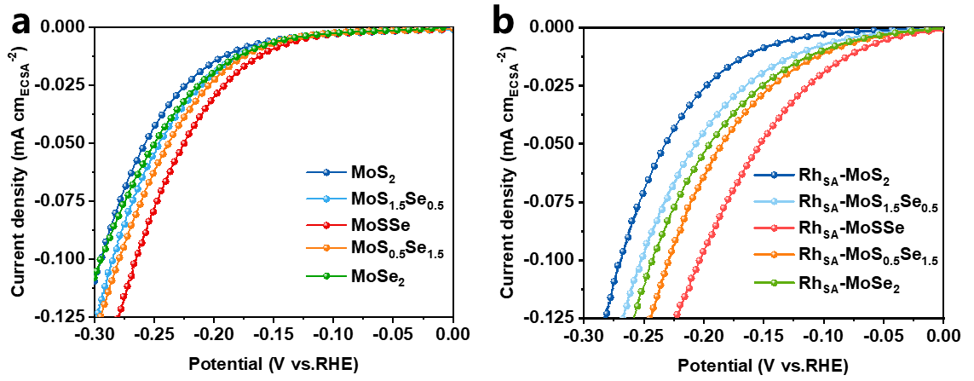
Supplementary Fig. 20. HER activities of (a) MoS_{x}Se_{2-x} and (b) Rh_{SA}-MoS_{x}Se_{2-x} catalysts, normalized to ECSA.

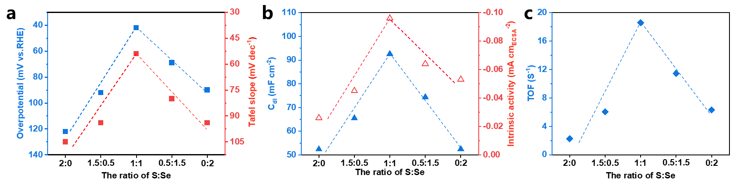
Supplementary Fig. 21. (a) Correlation between the S:Se ratio in Rh_{SA}-MoS_{x}Se_{2-x} and overpotential at 10 mA cm⁻² and Tafel slope. (b) Correlation between the S:Se ratio in Rh_{SA}-MoS_{x}Se_{2-x} and C_{dl} and intrinsic activity. (c) Correlation between the S:Se ratio in Rh_{SA}-MoS_{x}Se_{2-x} and overpotential at 10 mA cm⁻².

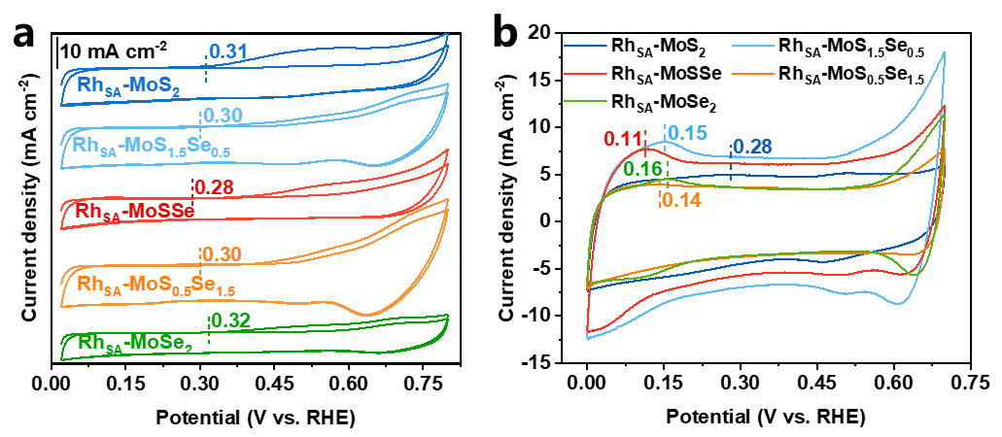
Supplementary Fig. 22. (a) CO-stripping voltammetry curves and (b) CV curves of Rh_{SA}-MoS₂, Rh_{SA}-MoS_{1.5}Se_{0.5}, Rh_{SA}-MoSSe, Rh_{SA}-MoS_{0.5}Se_{1.5}, and Rh_{SA}-MoSe₂.

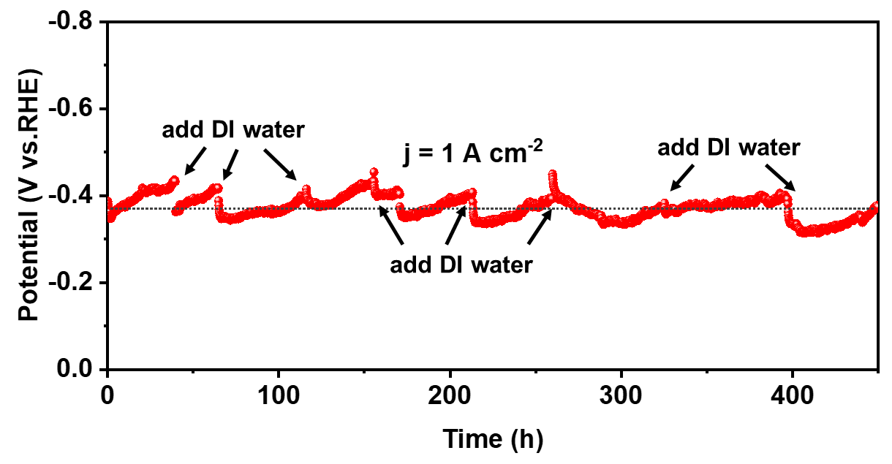
Supplementary Fig. 23. Chronoamperometric (CP) curves of Rh_{SA}-MoSSe at a current density of 1 A cm⁻².
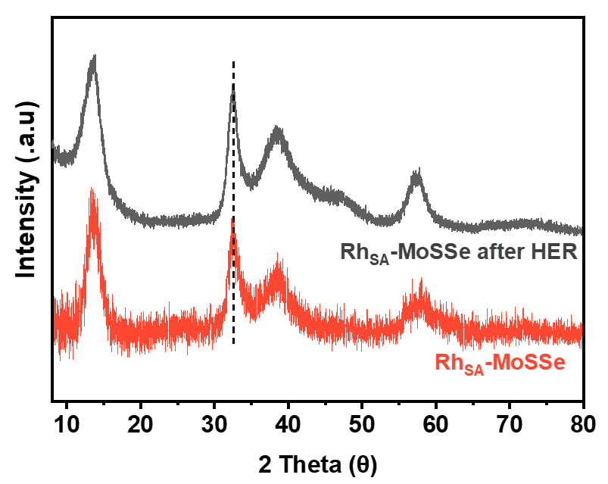
Supplementary Fig. 24. XRD patterns of Rh_{SA}-MoSSe before and after long-term HER testing.

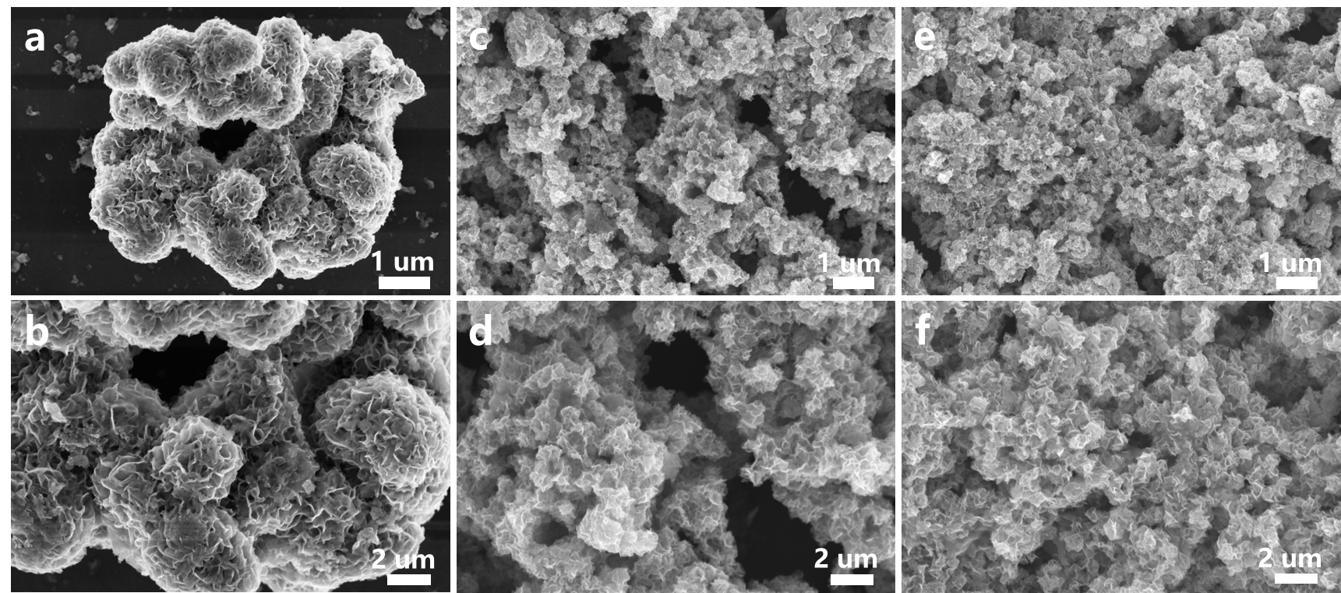
Supplementary Fig. 25. SEM images of (a, b) Rh_{SA}-MoS₂, (c, d) Rh_{SA}-MoSSe, and (e, f) Rh_{SA}-MoSe₂ after long-term HER testing.

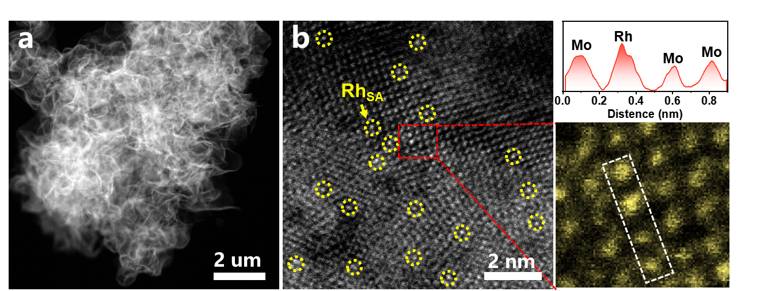
Supplementary Fig. 26. ACTEM images of Rh_{SA}-MoSSe after long-term HER testing.

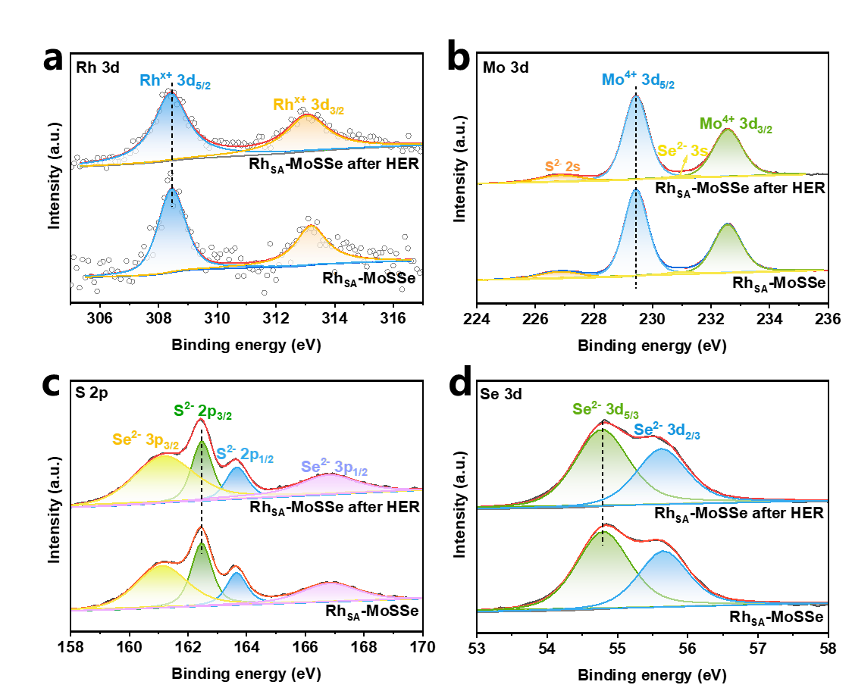
Supplementary Fig. 27. XPS spectra of (a) Rh 3d, (b) Mo 3d, (c) S 2p, and (d) Se 3d for Rh_{SA}-MoSSe before and after long-term HER testing.

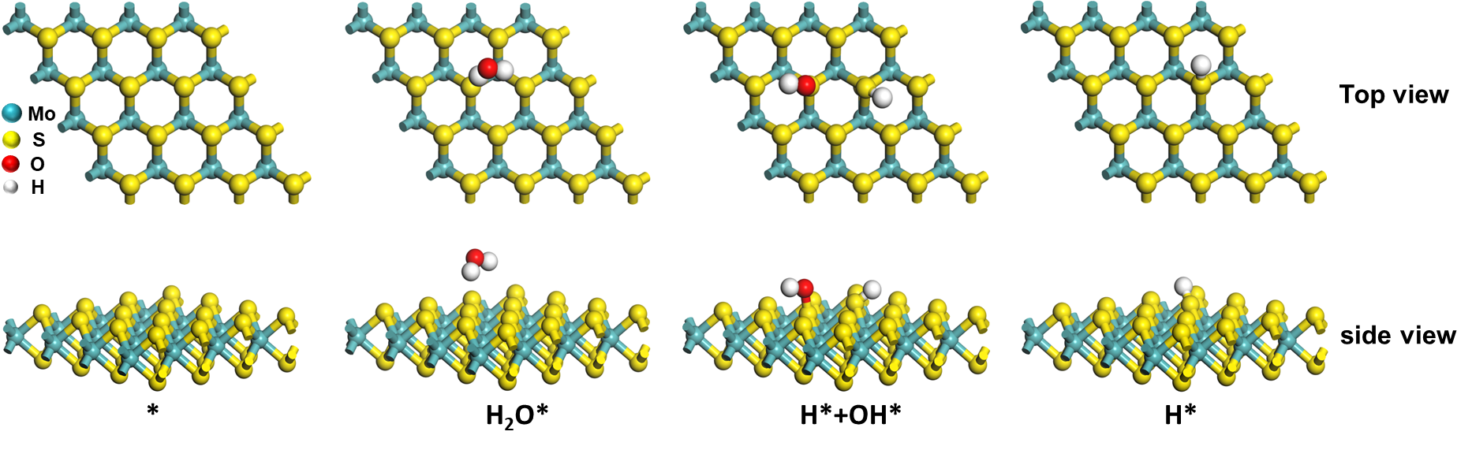
Supplementary Fig. 28. Diagram illustrating the HER at S sites on MoS₂.

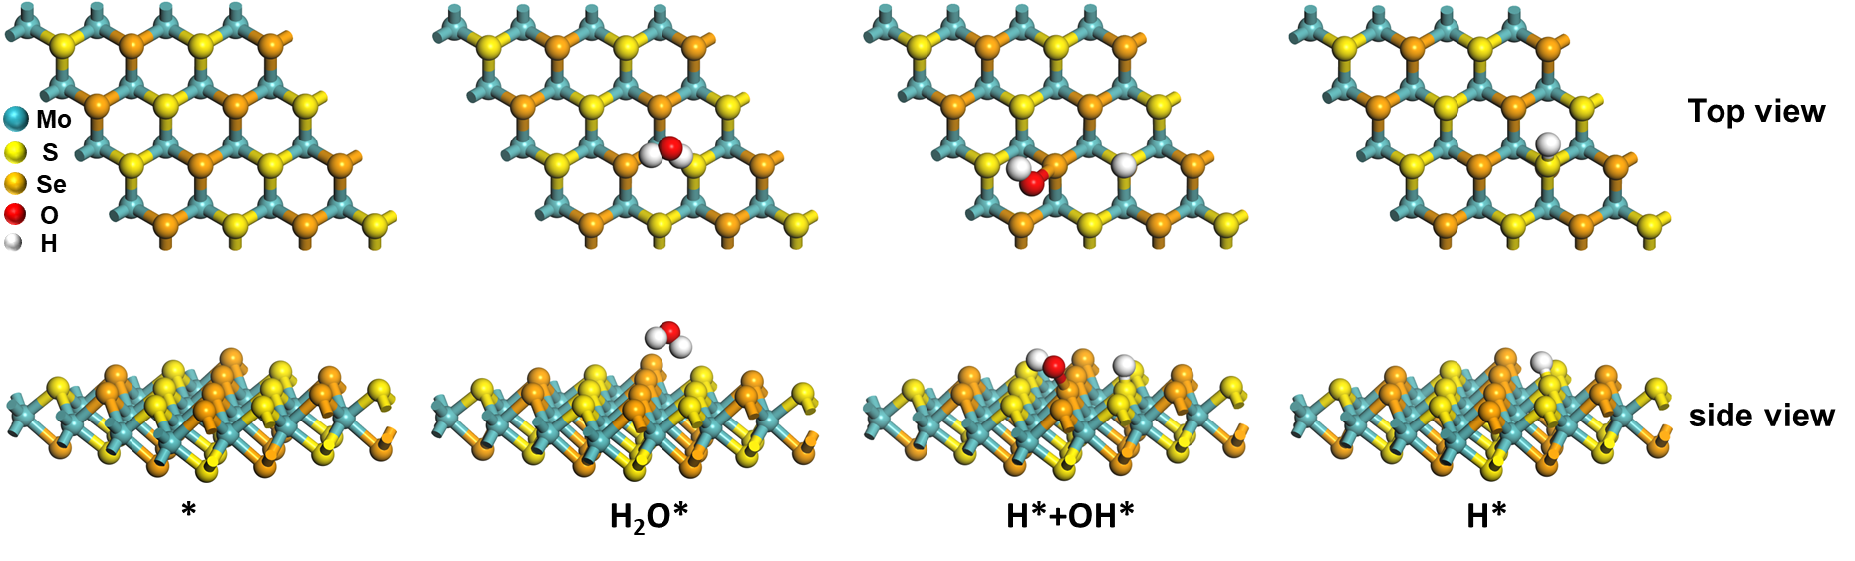
Supplementary Fig. 29. Diagram illustrating the HER at S/Se sites on MoSSe.

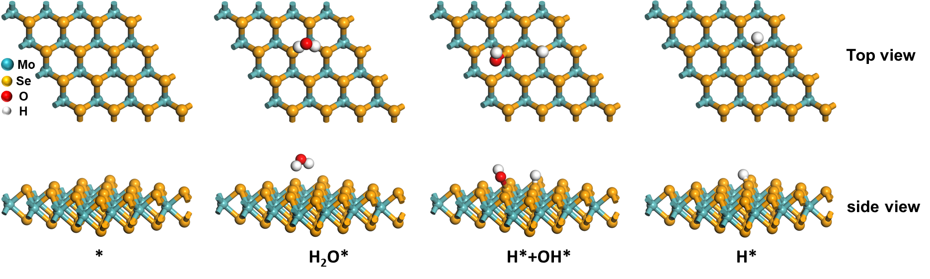
Supplementary Fig. 30. Diagram illustrating the HER at Se sites on MoSe₂.

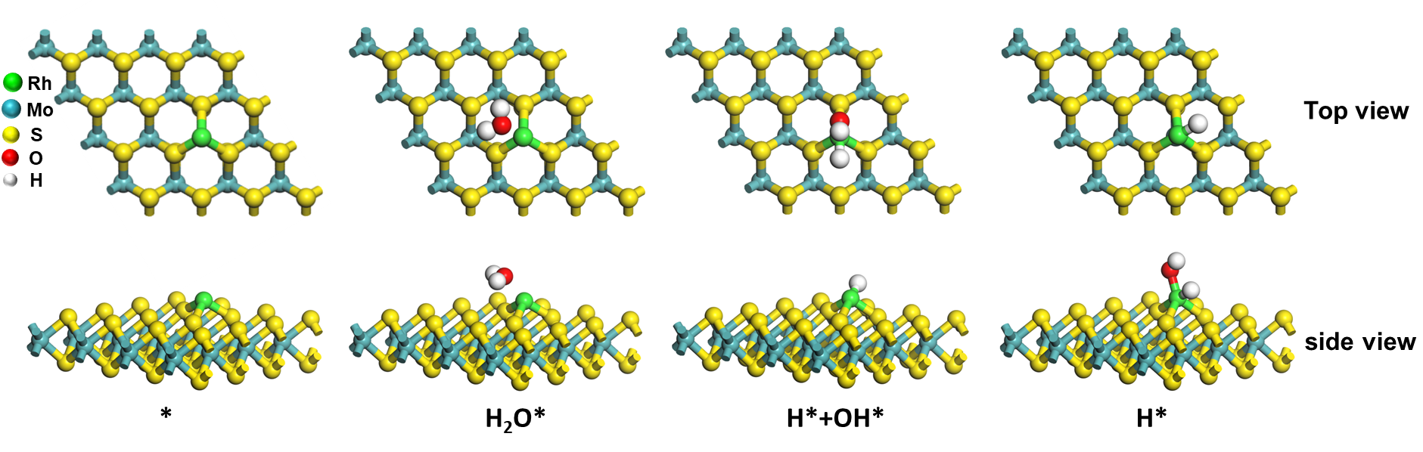
Supplementary Fig. 31. Diagram illustrating the HER at Rh sites on Rh_{SA}-MoS₂.

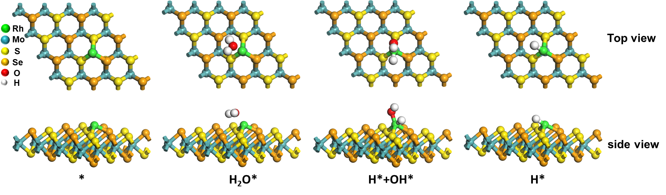
Supplementary Fig. 32. Diagram illustrating the HER at Rh sites on Rh_{SA}-MoSSe.

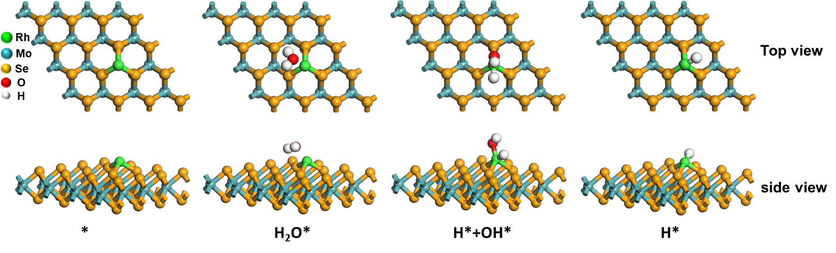
Supplementary Fig. 33. Diagram illustrating the HER at Rh sites on Rh_{SA}-MoSe₂.

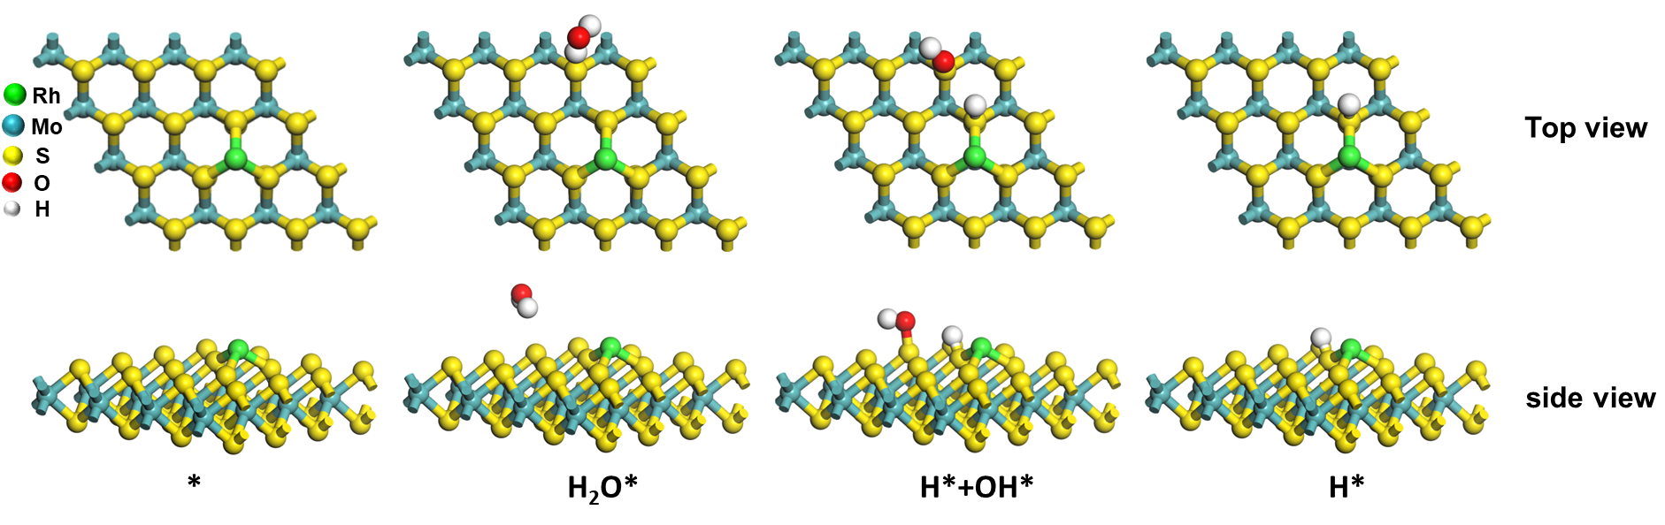
Supplementary Fig. 34. Diagram illustrating the HER at S sites surrounding Rh single-atom on Rh_{SA}-MoS₂.

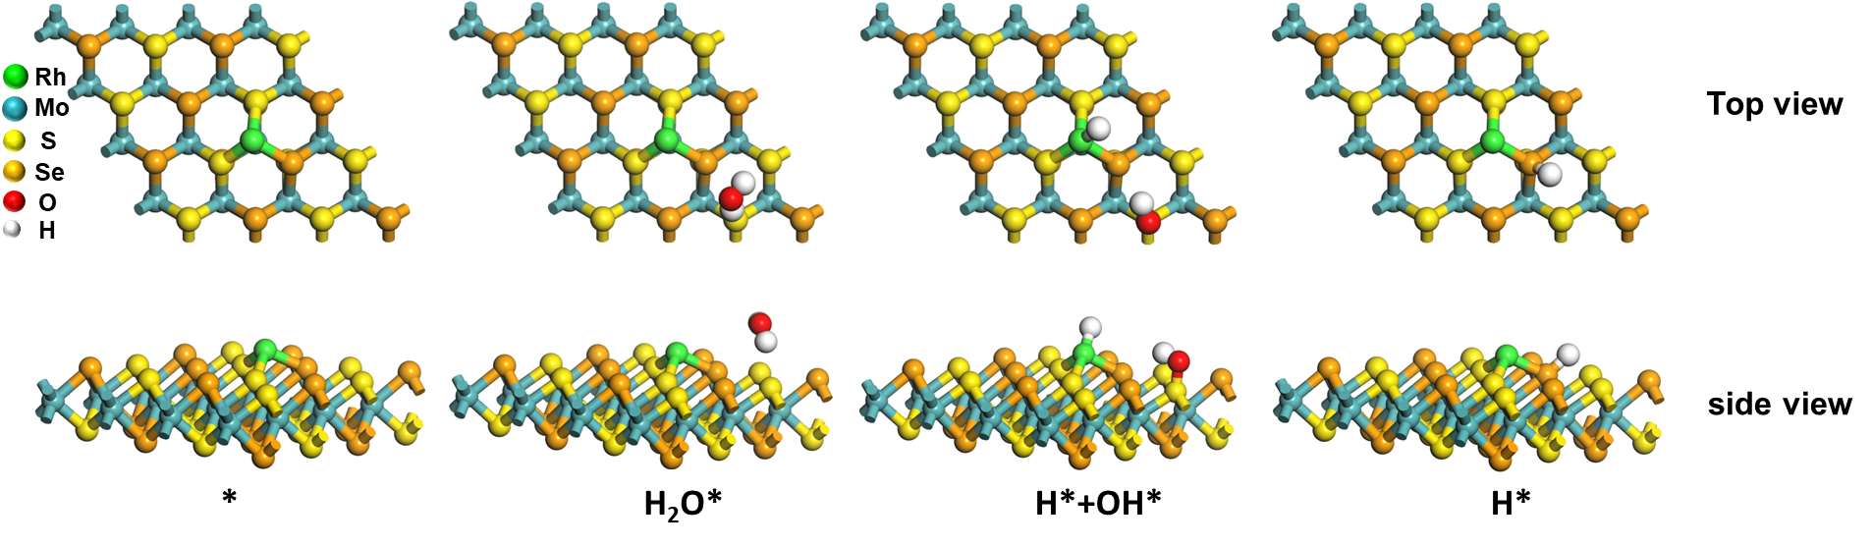
Supplementary Fig. 35. Diagram illustrating the HER at S/Se sites surrounding Rh single-atom on Rh_{SA}-MoSSe.

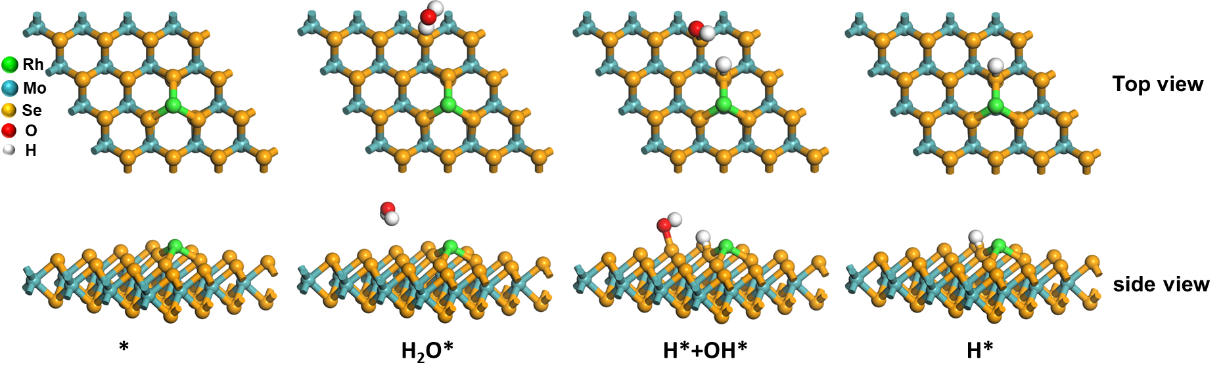
Supplementary Fig. 36. Diagram illustrating the HER at Se sites surrounding Rh single-atom on Rh_{SA}-MoSe₂.

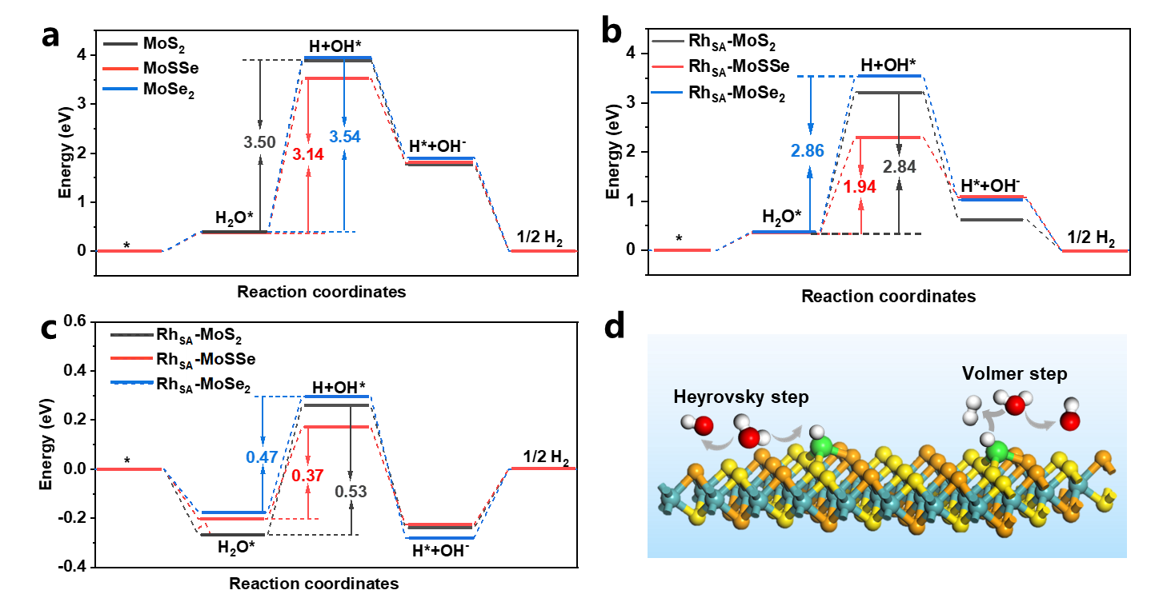
Supplementary Fig. 37. Gibbs free energy diagram for the HER process on: (a) MoS_{x}Se_{2-x} at S/Se sites, (b) Rh_{SA}-MoS_{x}Se_{2-x} at S/Se sites surrounding Rh single-atom, and (c) Rh_{SA}-MoS_{x}Se_{2-x} at Rh sites. (d) Schematic representations of the HER mechanism for Rh_{SA}-MoS_{x}Se_{2-x}.

Supplementary Table 1. Comparison of HER activity for Rh_{SA}-MoS_{x}Se_{2-x} with previously reported state-of-the-art noble metal-based and TMDs-based catalysts.
Catalysts | electrolyte | TOF (S⁻¹) | Ref.
Rh_{SA}-MoSSe | 1 M KOH | 18.58@100 mV | This work
Rh_{SA}-MoS₂ | 1 M KOH | 2.27@100 mV | This work
Rh_{SA}-MoS_{1.5}Se_{0.5} | 1 M KOH | 6.05@100 mV | This work
Rh_{SA}-MoS_{0.5}Se_{1.5} | 1 M KOH | 11.45@100 mV | This work
Rh_{SA}-MoSe₂ | 1 M KOH | 6.32@100 mV | This work
Rh-MoS₂ | 0.5 M H₂SO₄ | 5.33@100 mV | 8
Rh-MoSe₂ | 0.5 M H₂SO₄ | 0.29@50 mV | 9
Pt/np-Co_{0.85}Se | 1.0 M PBS | 3.93@100 mV | 10
np-Co0.85Se | 1.0 M PBS | 0.17@100 mV | 10
Ce₁-Ru_{n}/NC | 1 M KOH | 5.23@50 mV | 11
Ru_{n}/NC | 1 M KOH | 0.9@50 mV | 11
Pd, Ru, Rh, Pt, Re-MoSe₂ | 1 M KOH | 3.34@200 mV | 12
Rh, Pd, Re-MoSe₂ | 1 M KOH | 1.86@200 mV | 12
Pd, Re-MoSe₂ | 1 M KOH | 0.34@200 mV | 12
Rh-MoS₂ | 1 M KOH | 0.50@50 mV | 13
Pt/VG Ar-5 | 1 M KOH | 22.6@150 mV | 14
Pt-SAs/MoSe₂ | 1 M KOH | 6.21@50 mV | 15
Pt-SAs/MoS₂ | 1 M KOH | 1.02@50 mV | 15
Pt-SAs/WS₂ | 1 M KOH | 0.56@50 mV | 15
Pt-SAs/WSe₂ | 1 M KOH | 0.52@50 mV | 15
Cu-Ru/RuSe₂ NSs/C | 1 M KOH | 0.88@100 mV | 16
p-1T-MoS₂ | 0.5 M H₂SO₄ | 0.5@153 mV | 17

Supplementary References
1. Blöchl, P. E. Projector augmented-wave method. Phys. Rev. B 50, 17953–17979 (1994).
2. Kresse, G. & Furthmüller, J. Efficient iterative schemes for ab initio total-energy calculations using a plane-wave basis set. Phys. Rev. B 54, 11169–11186 (1996).
3. Kresse, G. & Furthmüller, J. Efficiency of ab-initio total energy calculations for metals and semiconductors using a plane-wave basis set. Comput. Mater. Sci. 6, 15–50 (1996).
4. Kresse, G. & Hafner, J. Ab initio molecular dynamics for liquid metals. Phys. Rev. B 47, 558–561 (1993).
5. Wien, T. U. & Hauptstrage, W. Ab Initio Molecular-Dynamics Simulation of the Liquid-Metal-Amorphous-Semiconductor Transition in Germanium. Phys. Rev. B 49, 14251–14269 (1994).
6. Kresse, G. & Joubert, D. Kresse, Joubert - Unknown - From ultrasoft pseudopotentials to the projector augmented-wave method. Phys. Rev. B 59, 1758–1775 (1999).
7. Perdew, J. P., Burke, K. & Ernzerhof, M. Generalized gradient approximation made simple. Phys. Rev. Lett. 77, 3865–3868 (1996).
8. Meng, X. et al. Distance Synergy of MoS₂-Confined Rhodium Atoms for Highly Efficient Hydrogen Evolution. Angew. Chem. Int. Ed. 59, 10502–10507 (2020).
9. Liu, S. et al. Tuning the Electronic Structure of Se via Constructing Rh-MoSe₂ Nanocomposite to Generate High-Performance Electrocatalysis for Hydrogen Evolution Reaction. ACS Sustain. Chem. Eng. 6, 9137–9144 (2018).
10. Jiang, K. et al. Single platinum atoms embedded in nanoporous cobalt selenide as electrocatalyst for accelerating hydrogen evolution reaction. Nat. Commun. 10, 1743 (2019).
11. Shen, F. et al. Oxophilic Ce single atoms-triggered active sites reverse for superior alkaline hydrogen evolution. Nat. Commun. 15, 448 (2024).
12. Luo, Z. et al. Creating High-entropy Single Atoms on Transition Disulfides through Substrate-induced Redox Dynamics for Efficient Electrocatalytic Hydrogen Evolution. Angew. Chem. Int. Ed. 63, e202405017 (2024).
13. Cheng, Y. et al. Rh-MoS₂ Nanocomposite Catalysts with Pt-Like Activity for Hydrogen Evolution Reaction. Adv. Funct. Mater. 27, 2–7 (2017).
14. Tsounis, C. et al. Pt Single Atom Electrocatalysts at Graphene Edges for Efficient Alkaline Hydrogen Evolution. Adv. Funct. Mater. 32, 2203067 (2022).
15. Shi, Y. et al. Electronic metal-support interaction modulates single-atom platinum catalysis for hydrogen evolution reaction. Nat. Commun. 12, 3021 (2021).
16. Wang, K. et al. Cu-Doped Heterointerfaced Ru/RuSe₂ Nanosheets with Optimized H and H₂O Adsorption Boost Hydrogen Evolution Catalysis. Adv. Mater. 35, 2300980 (2023).
17. Yin, Y. et al. Contributions of Phase, Sulfur Vacancies, and Edges to the Hydrogen Evolution Reaction Catalytic Activity of Porous Molybdenum Disulfide Nanosheets. J. Am. Chem. Soc. 138, 7965–7972 (2016).

