SUPPLEMENTS

Cardiorenal heart failure with preserved ejection fraction is caused by a reversible rise of mineralocorticoid-induced fibroblast subtypes
Supplemental figures
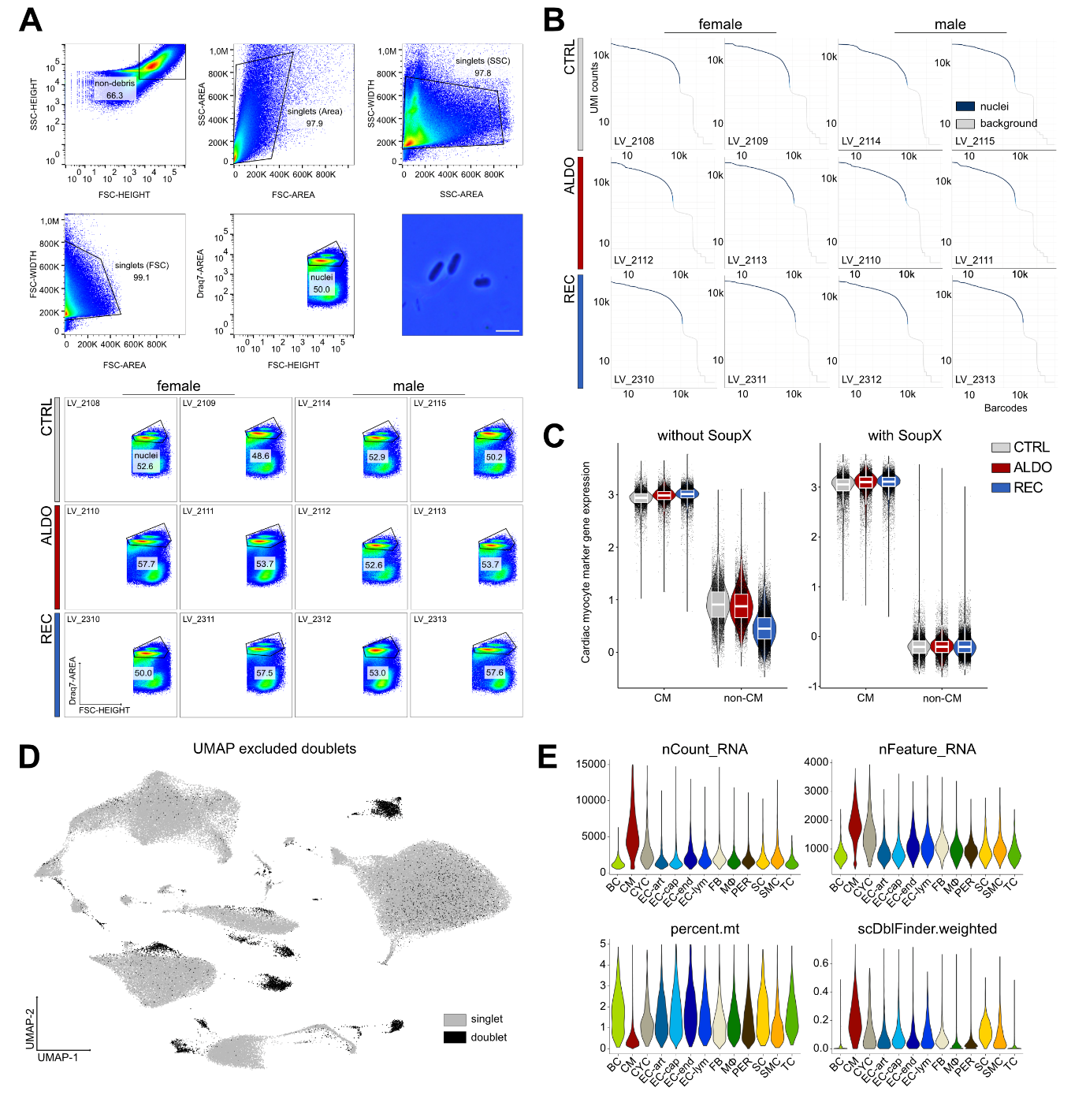
Supplemental Figure 1: Experimental and computational quality control pipeline for single-nucleus RNA-sequencing of cardiac tissue.
A, Gating strategy to enrich viable nuclei isolated from whole left ventricular tissue. The strategy includes removal of doublets and integrity staining via Draq7. This was further assessed visually after Trypan blue staining under light microscope (scale bar: 10 µm). B, Barcode rank plots after aligning reads via CellRanger (7.0.0) to the mm10-2020-A reference genome. C, Ambient cardiomyocyte (CM) mRNA contamination was removed using SoupX. The violin plots show the AddModuleScores for a set of CM markers for CMs and non-CMs. The same data was processed without and with SoupX with iterating contamination fractions. The panel on the right shows the clean data after sample specific removal of reads. D, Heterotypic doublets were called with scDblFinder. Excluded doublets are shown in UMAP projection. E, Quality control metrics for the final object split by cell type. nCount_RNA: number of mRNAs per nucleus; nFeature_RNA: number of genes detected per nucleus; percent.mt: percentage of mitochondrial genes; scDblFinder.weighted: score applied for doublet detection.

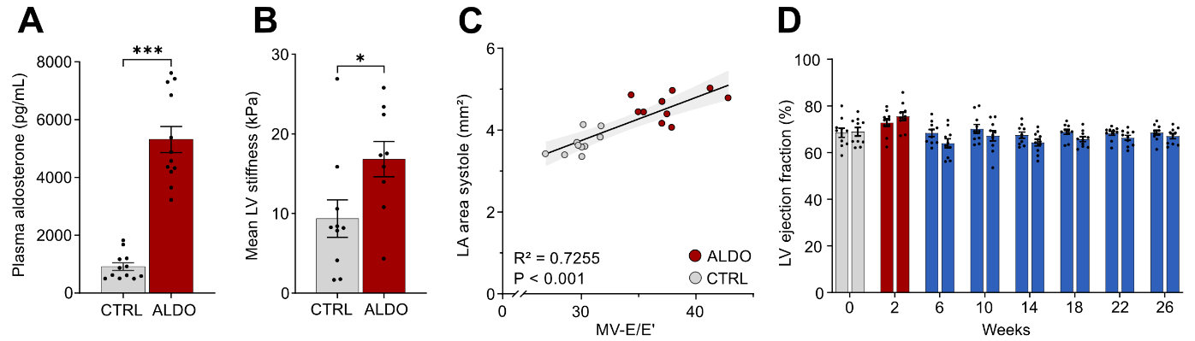
Supplemental Figure 2: Additional characterization of ALDO-induced HFpEF phenotype and recovery.
A, Plasma aldosterone concentrations measured by ELISA. B, Left ventricular passive myocardial stiffness quantified by nanoindentation. C, Scatter plot of mitral valve E/E’ ratio versus left atrial area in systole from CTRL and ALDO-treated mice with linear regression analysis. D, Left ventricular ejection fraction determined from short-axis M-mode echocardiography. Data are presented as mean±SEM, n=8-12 biological replicates per group; A, B unpaired t-test, D two-way ANOVA with Bonferroni post-hoc test, P<0.05 (*), P<0.001 (***).

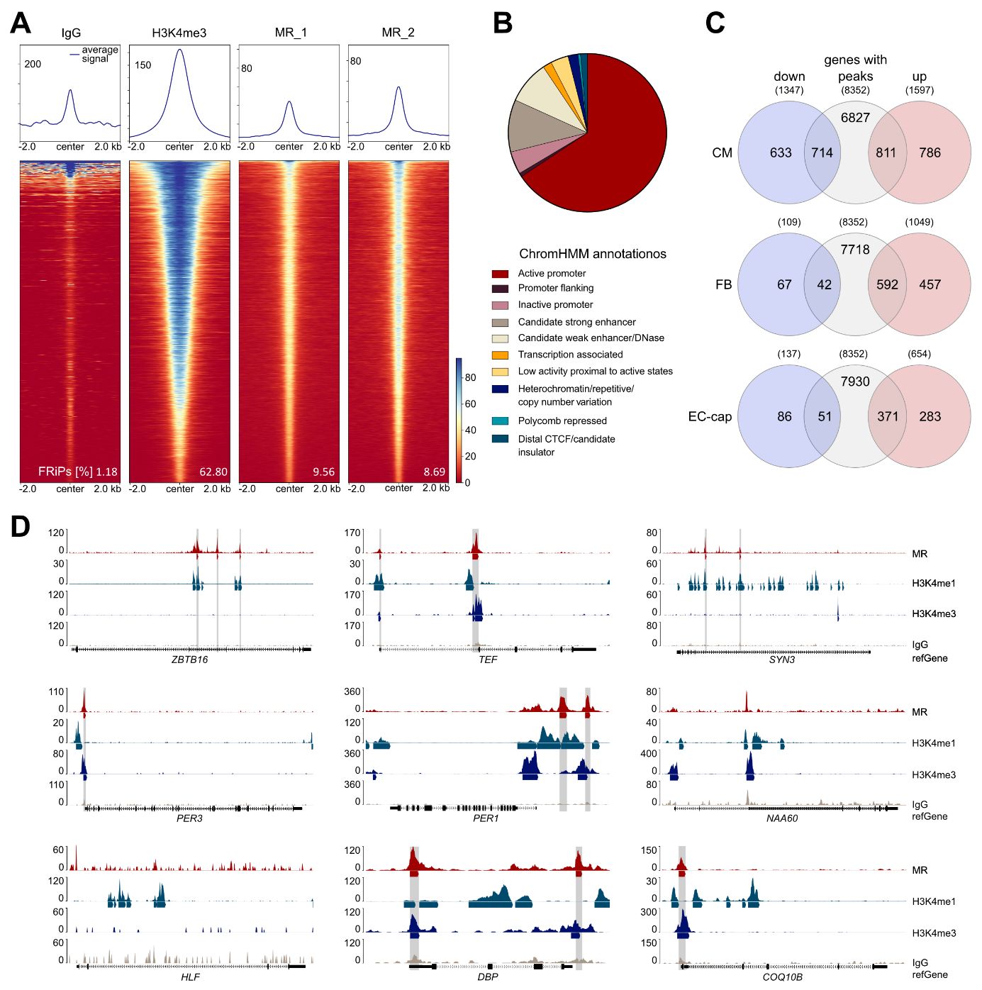
Supplemental Figure 3. In vitro MR CUT&RUN assay using HeLa FRT/TO cells stably expressing an N-terminal GFP-tagged human MR
HeLa FRT/TO cells stably expressing GFP-tagged human MR were treated with aldosterone (100 nM, 2 h) in medium containing 5% charcoal-stripped fetal calf serum. Two different MR antibodies were used to identify MR target genes. A, Sunset plot showing ranked MACS2 narrow peaks centered around peak summits for the IgG negative control, H3K4me3 positive control, and the two MR antibodies. Fragments of reads in peaks (FRiPs) are shown to assess signal quality. B, Chromatin state annotation of conserved MR peaks (shared between both antibodies) based on ChromHMM segmentation of HeLa-S3 cells, mapped to the hg38 genome using LiftOver. C, Overlap of differentially expressed genes (ALDO vs. CTRL, adjusted p < 0.05) with genes harboring proximal MR binding peaks, shown for cardiomyocytes (CMs), fibroblasts (FBs), and capillary endothelial cells (EC-cap). D, Genome browser tracks showing average signal intensity (bigwigAverage) for both MR antibodies, H3K4me3, H3K4me1 (ENCFF360CQR), and IgG control across the nine protein-coding genes that are ubiquitously upregulated by aldosterone in CMs, FBs, and capillary ECs.

