SUPPLEMENTAL INFORMATION

Renewable fuels for hard-to-abate transportation: Exploring the impact of biomass availability and variable renewable potentials

Theis Madsen, Rasmus Bramstoft, Claire Bergaentzlé, Frederik Fristed, Dogan Keles

Contents
S1. Extended data – biomass availability 2
S2. Extended data – Variable renewable energy potential 3
S3. Extended data – National renewable liquid fuel demands 5
S4. Extended results – National fuel production 8
S5. Extended results – Renewable fuel trade 12
S6. Extended results – Power system buildout and utilisation 13
S7. Extended results – The impact of alternative demand scenarios 14
S8. Extended results – Sensitivity of the representative days used in the investment runs 15
S9. Extended method – Further coupling of Balmorel and OptiFlow 16
S10. Extended discussion – Literature comparison 17

Extended data – biomass availability
The availability of sustainable biomass is defined at a regional level in this study. We derive potentials from the JRC ENSPRESSO database[1], following the same methodology as used for the variable renewable potentials presented in the previous section. The potentials considered are residues from primary forestry and agriculture, presented in Table S 1.
Table S 1: Biomass potential
 | Woody biomass |  |  | Agricultural biomass
Country | Low | Medium | High | Low | Medium | High
Austria | 19 | 78 | 232 | 15 | 23 | 33
Belgium | 4 | 16 | 47 | 4 | 7 | 11
Bulgaria | 9 | 37 | 118 | 13 | 26 | 42
Croatia | 4 | 16 | 51 | 3 | 8 | 14
Czechia | 12 | 50 | 149 | 23 | 36 | 50
Denmark | 5 | 19 | 53 | 10 | 22 | 34
Estonia | 7 | 30 | 93 | 4 | 6 | 8
Finland | 35 | 139 | 433 | 12 | 18 | 24
France | 42 | 168 | 595 | 103 | 191 | 299
Germany | 76 | 303 | 877 | 125 | 195 | 262
Greece | 2 | 8 | 39 | 6 | 21 | 40
Hungary | 13 | 51 | 157 | 23 | 47 | 77
Ireland | 4 | 15 | 44 | 0 | 0 | 0
Italy | 31 | 124 | 368 | 24 | 61 | 108
Latvia | 13 | 52 | 156 | 4 | 7 | 9
Lithuania | 7 | 28 | 88 | 12 | 18 | 24
Luxembourg | 0 | 2 | 6 | 0 | 0 | 1
Netherlands | 2 | 7 | 20 | 3 | 6 | 9
Poland | 45 | 179 | 532 | 41 | 71 | 104
Portugal | 14 | 56 | 175 | 3 | 7 | 14
Romania | 33 | 131 | 379 | 30 | 62 | 102
Slovakia | 8 | 32 | 96 | 7 | 13 | 20
Slovenia | 8 | 33 | 96 | 0 | 1 | 2
Spain | 24 | 96 | 307 | 34 | 89 | 164
Sweden | 45 | 181 | 614 | 11 | 17 | 24
Norway | 11 | 43 | 137 | 3 | 5 | 7
Switzerland | 10 | 40 | 114 | 0 | 4 | 6
United Kingdom | 10 | 41 | 125 | 36 | 65 | 99
Total | 493 | 1975 | 6102 | 548 | 1025 | 1589

Extended data – Variable renewable energy potential
This study follows the same methodology approach for modelling variable renewable energy (VRE) as [2]. Three main parameters restrict the electricity generation from wind and solar, 1) a regional potential describing the max allowed investments, 2) the regional full load hours describing the quality of the resource, and 3) a time-series describing the variability over a year. Within a region, onshore VRE resources are further split into resource grades, to account for sub-regional variability with different profiles and full load hours. The regional potentials are based on the JRC ENSPRESSO database [1], which determines renewable potentials for Europe by considering land-use restrictions from a bottom-up-based analysis. The potentials are split into either two or three resource grades based on the potential. The full load hours and time series are based on the Correlations in renewable energy sources (CorRES) simulated model [3], and are kept constant through the scenarios in this study. We present all VRE potentials and full load hours for solar and wind in Table S 2 and Table S 3. In the scenarios with varying accessibility to VRE, these potentials are varied by +/- 50%.

Table S 2: VRE potential
 | Solar Potential (GW) |  |  | Full load hours (h)
Country | RG1 | RG2 | RG3 | RG1 | RG2 | RG3
Austria | 37 | 37 | 0 | 1409 | 1275 | 0
Belgium | 26 | 26 | 0 | 1263 | 1142 | 0
Bulgaria | 15 | 60 | 75 | 1714 | 1551 | 1127
Croatia | 25 | 25 | 0 | 1509 | 1365 | 0
Czechia | 11 | 45 | 56 | 1315 | 1190 | 1127
Denmark | 38 | 38 | 0 | 1310 | 1185 | 0
Estonia | 14 | 14 | 0 | 1217 | 1101 | 0
Finland | 18 | 18 | 0 | 1088 | 984 | 0
France | 82 | 329 | 411 | 1671 | 1555 | 1366
Germany | 59 | 200 | 235 | 1259 | 1139 | 1127
Greece | 16 | 63 | 78 | 1672 | 1512 | 1127
Hungary | 16 | 64 | 80 | 1587 | 1436 | 1127
Ireland | 11 | 45 | 57 | 1107 | 1002 | 1127
Italy | 44 | 177 | 221 | 1799 | 1674 | 1471
Latvia | 24 | 24 | 0 | 1196 | 1082 | 0
Lithuania | 47 | 47 | 0 | 1190 | 1077 | 0
Luxembourg | 2 | 2 | 0 | 1303 | 1179 | 0
Netherlands | 34 | 34 | 0 | 1231 | 1114 | 0
Poland | 45 | 179 | 223 | 1253 | 1134 | 1127
Portugal | 46 | 46 | 0 | 1825 | 1651 | 0
Romania | 38 | 152 | 190 | 1621 | 1467 | 1127
Slovakia | 30 | 30 | 0 | 1476 | 1336 | 0
Slovenia | 9 | 9 | 0 | 1492 | 1350 | 0
Spain | 66 | 263 | 329 | 2021 | 1881 | 1652
Sweden | 35 | 35 | 0 | 1154 | 1044 | 0
Norway | 12 | 12 | 0 | 1159 | 1049 | 0
Switzerland | 18 | 18 | 0 | 1465 | 1325 | 0
United Kingdom | 35 | 139 | 173 | 1326 | 1233 | 1084
Total | 851 | 2129 | 2129
Average |  |  |  | 1415 | 1287 | 1216

Table S 3: VRE potential 2
 | Wind Potential (GW) |  |  |  | Full load hours
Country | RG1 | RG2 | RG3 | Offshore | RG1 | RG2 | RG3 | Offshore
Austria | 16 | 16 | 0 | 0 | 3111 | 2257 | 0 | 0
Belgium | 4 | 4 | 0 | 8 | 3089 | 2854 | 0 | 4704
Bulgaria | 15 | 15 | 0 | 2 | 2732 | 1887 | 0 | 3230
Croatia | 5 | 5 | 0 | 4 | 3063 | 2253 | 0 | 2695
Czechia | 5 | 5 | 0 | 0 | 3031 | 2360 | 0 | 0
Denmark | 6 | 6 | 0 | 85 | 3793 | 3347 | 0 | 4696
Estonia | 12 | 12 | 0 | 19 | 2912 | 2450 | 0 | 4084
Finland | 13 | 13 | 0 | 35 | 3132 | 2425 | 0 | 4313
France | 26 | 104 | 131 | 53 | 3434 | 2830 | 1960 | 4369
Germany | 31 | 31 | 0 | 75 | 3292 | 2801 | 0 | 4676
Greece | 15 | 58 | 73 | 10 | 3213 | 1947 | 930 | 4346
Hungary | 21 | 21 | 0 | 0 | 2462 | 2116 | 0 | 0
Ireland | 35 | 35 | 0 | 51 | 4710 | 4187 | 0 | 5460
Italy | 13 | 53 | 66 | 10 | 2681 | 1778 | 1058 | 4055
Latvia | 25 | 25 | 0 | 13 | 2913 | 2503 | 0 | 4265
Lithuania | 29 | 29 | 0 | 2 | 3083 | 2758 | 0 | 4040
Luxembourg | 0 | 0 | 0 | 0 | 2235 | 2147 | 0 | 0
Netherlands | 3 | 3 | 0 | 68 | 3587 | 3038 | 0 | 4650
Poland | 12 | 47 | 58 | 11 | 3048 | 2677 | 2186 | 4144
Portugal | 12 | 12 | 0 | 10 | 2700 | 1951 | 0 | 4055
Romania | 50 | 50 | 0 | 22 | 2375 | 1755 | 0 | 3231
Slovakia | 5 | 5 | 0 | 0 | 2989 | 2234 | 0 | 0
Slovenia | 0 | 0 | 0 | 0 | 3182 | 1963 | 0 | 0
Spain | 53 | 214 | 267 | 10 | 2792 | 1998 | 1333 | 4055
Sweden | 61 | 61 | 0 | 43 | 3523 | 2545 | 0 | 4050
Norway | 7 | 7 | 0 | 90 | 4680 | 3487 | 0 | 4539
Switzerland | 6 | 6 | 0 | 0 | 2487 | 1734 | 0 | 0
United Kingdom | 17 | 66 | 83 | 166 | 4582 | 3809 | 3043 | 4682
Total | 497 | 904 | 678 | 787
Average |  |  |  |  | 3173 | 2503 | 1752 | 4207

Extended data – National renewable liquid fuel demands
We use a variety of decarbonisation reports [4], [5], [6] to generate different renewable liquid fuel demands (as mentioned in the experimental procedures). These are system-level demands, so to disaggregate the demand to regional levels, we utilise projections from [7] as distribution keys. In the three following tables (Table S 4,Table S 5,Table S 6) we present the assumed demand levels for aviation, shipping, and heavy road transportation in TWh, where the medium scenario is considered the baseline used in the paper. The focus of this study is on aviation and shipping, so we keep the heavy road demand constant (derived from [4] and used in [2]).

Table S 4: Baseline transport demand in 2050 by country and sector (TWh).
Country | Aviation | Shipping | Heavy road
Austria | 6.9 | - | 1.7
Belgium | 14.7 | 72.2 | 1.3
Bulgaria | 2.3 | 0.7 | 0.9
Croatia | 1.5 | 0.0 | 0.4
Czechia | 3.2 | - | 1.8
Denmark | 9.6 | 7.4 | 1.5
Estonia | 0.5 | 3.2 | 0.2
Finland | 5.9 | 3.1 | 1.8
France | 59.3 | 16.1 | 12.8
Germany | 87.9 | 23.4 | 12.8
Greece | 9.7 | 19.7 | 1.2
Hungary | 2.1 | - | 1.9
Ireland | 8.7 | 1.7 | 3.5
Italy | 34.6 | 21.4 | 7.2
Latvia | 1.2 | 2.5 | 0.5
Lithuania | 1.0 | 1.6 | 0.7
Luxembourg | 5.0 | - | 0.6
Netherlands | 37.1 | 111.6 | 3.3
Poland | 7.6 | 2.6 | 2.5
Portugal | 11.3 | 7.1 | 8.2
Romania | 3.3 | 0.4 | 1.3
Slovakia | 0.4 | - | 1.3
Slovenia | 0.2 | 1.5 | 1.3
Spain | 46.0 | 61.7 | 0.5
Sweden | 7.7 | 22.6 | 7.3
Norway | 8.2 | 24.5 | 2.4
Switzerland | 11.0 | - | 1.5
United Kingdom | 41.8 | 45.3 | 11.3
Total | 428.8 | 450.4 | 91.7

Table S 5: High transport demand in 2050 by country and sector (TWh).
Country | Aviation | Shipping | Heavy road
Austria | 8.4 | - | 1.7
Belgium | 17.9 | 88.1 | 1.3
Bulgaria | 2.8 | 0.9 | 0.9
Croatia | 1.8 | 0.1 | 0.4
Czechia | 3.9 | - | 1.8
Denmark | 11.7 | 9.1 | 1.5
Estonia | 0.7 | 3.9 | 0.2
Finland | 7.3 | 3.8 | 1.8
France | 72.4 | 19.7 | 12.8
Germany | 107.3 | 28.6 | 12.8
Greece | 11.9 | 24.1 | 1.2
Hungary | 2.6 | - | 1.9
Ireland | 10.6 | 2.0 | 3.5
Italy | 42.2 | 26.1 | 7.2
Latvia | 1.5 | 3.1 | 0.5
Lithuania | 1.2 | 2.0 | 0.7
Luxembourg | 6.1 | - | 0.6
Netherlands | 45.2 | 136.2 | 3.3
Poland | 9.3 | 3.2 | 2.5
Portugal | 13.7 | 8.7 | 8.2
Romania | 4.0 | 0.5 | 1.3
Slovakia | 0.5 | - | 1.3
Slovenia | 0.3 | 1.9 | 1.3
Spain | 56.2 | 75.3 | 0.5
Sweden | 9.4 | 27.5 | 7.3
Norway | 10.1 | 29.9 | 2.4
Switzerland | 13.5 | - | 1.5
United Kingdom | 51.0 | 55.3 | 11.3
Total | 523.3 | 549.7 | 91.7

Table S 6: Baseline transport demand in 2050 by country and sector (TWh).
Country | Aviation | Shipping | Heavy road
Austria | 5.1 | - | 1.7
Belgium | 10.9 | 53.8 | 1.3
Bulgaria | 1.7 | 0.5 | 0.9
Croatia | 1.1 | 0.0 | 0.4
Czechia | 2.4 | - | 1.8
Denmark | 7.2 | 5.5 | 1.5
Estonia | 0.4 | 2.4 | 0.2
Finland | 4.4 | 2.3 | 1.8
France | 44.2 | 12.0 | 12.8
Germany | 65.5 | 17.5 | 12.8
Greece | 7.3 | 14.7 | 1.2
Hungary | 1.6 | - | 1.9
Ireland | 6.5 | 1.2 | 3.5
Italy | 25.8 | 15.9 | 7.2
Latvia | 0.9 | 1.9 | 0.5
Lithuania | 0.7 | 1.2 | 0.7
Luxembourg | 3.7 | - | 0.6
Netherlands | 27.6 | 83.2 | 3.3
Poland | 5.7 | 2.0 | 2.5
Portugal | 8.4 | 5.3 | 8.2
Romania | 2.4 | 0.3 | 1.3
Slovakia | 0.3 | - | 1.3
Slovenia | 0.2 | 1.1 | 1.3
Spain | 34.3 | 46.0 | 0.5
Sweden | 5.7 | 16.8 | 7.3
Norway | 6.1 | 18.3 | 2.4
Switzerland | 8.2 | - | 1.5
United Kingdom | 31.2 | 33.8 | 11.3
Total | 319.6 | 335.7 | 91.7

Extended results – National fuel production
In the main document, we present the resulting renewable liquid fuel production mostly through graphics. In this section, we show the national fuel production in all scenarios for each type of fuel, used to generate the results in the main document. Table S 7 shows production from Bio-FT, Table S 8 shows production from methanol upgrading, Table S 9 shows the production of methanol for transport use directly, and Table S 10 shows the production of e-ammonia

Table S 7: Production Bio-FT in 2050 in TWh.
 | Low biomass |  |  | Medium biomass |  |  | High biomass
Country | Res | Mod | Acc | Res | Mod | Acc | Res | Mod | Acc
Austria | 4 | 5 | 5 | 7 | 7 | 6 | 8 | 7 | 7
Belgium | 4 | 4 | 5 | 13 | 9 | 8 | 15 | 14 | 14
Bulgaria | 3 | 3 | 3 | 3 | 3 | 3 | 3 | 3 | 3
Croatia | 1 | 1 | 1 | 2 | 1 | 1 | 2 | 2 | 2
Czechia | 2 | 2 | 2 | 4 | 4 | 4 | 4 | 4 | 4
Denmark | 3 | 3 | 3 | 9 | 8 | 8 | 13 | 13 | 13
Estonia | 1 | 1 | 1 | 3 | 2 | 2 | 1 | 1 | 1
Finland | 6 | 6 | 6 | 9 | 9 | 8 | 8 | 7 | 7
France | 24 | 28 | 28 | 56 | 46 | 45 | 71 | 68 | 68
Germany | 29 | 34 | 32 | 79 | 68 | 66 | 104 | 102 | 102
Greece | 7 | 8 | 8 | 13 | 11 | 11 | 11 | 11 | 11
Hungary | 3 | 3 | 3 | 4 | 3 | 3 | 4 | 4 | 4
Ireland | 1 | 2 | 2 | 4 | 4 | 4 | 10 | 9 | 9
Italy | 15 | 15 | 15 | 38 | 31 | 30 | 42 | 40 | 38
Latvia | 2 | 2 | 2 | 3 | 3 | 3 | 2 | 2 | 2
Lithuania | 1 | 2 | 2 | 2 | 2 | 2 | 2 | 2 | 2
Luxembourg | 1 | 1 | 1 | 4 | 3 | 3 | 5 | 4 | 4
Netherlands | 10 | 7 | 9 | 28 | 23 | 22 | 39 | 35 | 35
Poland | 11 | 11 | 12 | 15 | 15 | 15 | 16 | 15 | 15
Portugal | 3 | 3 | 4 | 10 | 9 | 8 | 13 | 12 | 12
Romania | 4 | 4 | 4 | 5 | 5 | 5 | 5 | 5 | 5
Slovakia | 1 | 1 | 1 | 1 | 1 | 1 | 2 | 2 | 2
Slovenia | 1 | 1 | 1 | 2 | 2 | 2 | 2 | 2 | 2
Spain | 11 | 13 | 12 | 37 | 35 | 34 | 51 | 44 | 48
Sweden | 14 | 17 | 16 | 40 | 39 | 38 | 54 | 52 | 50
Norway | 3 | 3 | 3 | 10 | 10 | 9 | 12 | 11 | 11
Switzerland | 5 | 6 | 5 | 10 | 9 | 9 | 11 | 11 | 10
United Kingdom | 9 | 9 | 10 | 35 | 24 | 25 | 49 | 45 | 45
Total | 176 | 197 | 196 | 447 | 384 | 375 | 558 | 527 | 527

Table S 8: Upgrading of methanol in 2050 in TWh
 | Low biomass |  |  | Medium biomass |  |  | High biomass
Country | Res | Mod | Acc | Res | Mod | Acc | Res | Mod | Acc
Austria | 5 | 3 | 3 | 2 | 2 | 2 | 1 | 1 | 1
Belgium | 14 | 13 | 13 | 5 | 9 | 9 | 3 | 4 | 4
Bulgaria | 1 | 1 | 1 | 0 | 1 | 1 | 0 | 0 | 0
Croatia | 1 | 1 | 1 | 0 | 0 | 0 | 0 | 0 | 0
Czechia | 3 | 3 | 3 | 1 | 1 | 1 | 1 | 1 | 1
Denmark | 9 | 9 | 9 | 5 | 6 | 6 | 2 | 2 | 2
Estonia | 0 | 0 | 0 | 0 | 0 | 0 | 0 | 0 | 0
Finland | 3 | 2 | 2 | 1 | 1 | 1 | 1 | 1 | 1
France | 52 | 47 | 48 | 23 | 32 | 34 | 13 | 15 | 15
Germany | 83 | 78 | 81 | 36 | 47 | 50 | 16 | 18 | 19
Greece | 5 | 4 | 4 | 2 | 2 | 2 | 2 | 2 | 2
Hungary | 1 | 1 | 1 | 0 | 1 | 1 | 0 | 0 | 0
Ireland | 11 | 10 | 10 | 8 | 8 | 8 | 2 | 3 | 3
Italy | 29 | 29 | 29 | 13 | 16 | 16 | 8 | 10 | 11
Latvia | 1 | 0 | 0 | 0 | 0 | 0 | 0 | 0 | 0
Lithuania | 1 | 0 | 0 | 0 | 0 | 0 | 0 | 0 | 0
Luxembourg | 4 | 4 | 4 | 2 | 2 | 2 | 1 | 1 | 1
Netherlands | 33 | 34 | 33 | 14 | 19 | 20 | 6 | 8 | 8
Poland | 4 | 3 | 3 | 3 | 2 | 2 | 1 | 1 | 2
Portugal | 12 | 11 | 11 | 5 | 6 | 7 | 2 | 3 | 3
Romania | 1 | 1 | 1 | 0 | 0 | 0 | 0 | 0 | 0
Slovakia | 0 | 0 | 0 | 0 | 0 | 0 | 0 | 0 | 0
Slovenia | 0 | 0 | 0 | 0 | 0 | 0 | 0 | 0 | 0
Spain | 48 | 46 | 46 | 23 | 26 | 27 | 12 | 18 | 15
Sweden | 32 | 29 | 30 | 10 | 10 | 11 | 3 | 4 | 6
Norway | 8 | 8 | 8 | 2 | 3 | 3 | 1 | 1 | 1
Switzerland | 8 | 7 | 7 | 3 | 4 | 4 | 1 | 2 | 2
United Kingdom | 47 | 50 | 48 | 20 | 34 | 33 | 7 | 12 | 12
Total | 413 | 395 | 396 | 179 | 233 | 241 | 83 | 110 | 110

Table S 9: Production of methanol for direct transport use in 2050 in TWh.
 | Low biomass |  |  | Medium biomass |  |  | High biomass
Country | Res | Mod | Acc | Res | Mod | Acc | Res | Mod | Acc
Austria | 0 | 0 | 0 | 0 | 0 | 0 | 0 | 0 | 0
Belgium | 28 | 25 | 20 | 27 | 20 | 22 | 36 | 33 | 26
Bulgaria | 0 | 0 | 0 | 0 | 0 | 0 | 0 | 0 | 0
Croatia | 0 | 0 | 0 | 0 | 0 | 0 | 0 | 0 | 0
Czechia | 0 | 0 | 0 | 0 | 0 | 0 | 0 | 0 | 0
Denmark | 3 | 2 | 2 | 3 | 3 | 4 | 3 | 3 | 3
Estonia | 1 | 1 | 1 | 1 | 1 | 1 | 2 | 1 | 1
Finland | 1 | 1 | 1 | 1 | 1 | 1 | 2 | 2 | 2
France | 7 | 4 | 3 | 6 | 6 | 7 | 4 | 4 | 4
Germany | 7 | 6 | 6 | 5 | 6 | 6 | 4 | 4 | 4
Greece | 6 | 4 | 4 | 7 | 8 | 8 | 9 | 9 | 8
Hungary | 0 | 0 | 0 | 0 | 0 | 0 | 0 | 0 | 0
Ireland | 1 | 0 | 0 | 1 | 0 | 0 | 1 | 0 | 0
Italy | 8 | 8 | 8 | 8 | 8 | 8 | 10 | 8 | 9
Latvia | 1 | 1 | 1 | 1 | 1 | 1 | 1 | 1 | 1
Lithuania | 0 | 0 | 0 | 0 | 0 | 1 | 1 | 1 | 1
Luxembourg | 0 | 0 | 0 | 0 | 0 | 0 | 0 | 0 | 0
Netherlands | 56 | 38 | 40 | 48 | 35 | 37 | 62 | 43 | 44
Poland | 1 | 1 | 1 | 1 | 1 | 1 | 1 | 1 | 1
Portugal | 2 | 1 | 2 | 2 | 1 | 2 | 2 | 2 | 2
Romania | 0 | 0 | 0 | 0 | 0 | 0 | 0 | 0 | 0
Slovakia | 0 | 0 | 0 | 0 | 0 | 0 | 0 | 0 | 0
Slovenia | 0 | 0 | 0 | 0 | 0 | 0 | 0 | 0 | 0
Spain | 24 | 11 | 11 | 12 | 12 | 13 | 25 | 22 | 22
Sweden | 3 | 4 | 4 | 4 | 4 | 4 | 5 | 4 | 5
Norway | 4 | 3 | 3 | 6 | 5 | 5 | 16 | 8 | 7
Switzerland | 0 | 0 | 0 | 0 | 0 | 0 | 0 | 0 | 0
United Kingdom | 26 | 17 | 20 | 24 | 15 | 19 | 31 | 26 | 26
Total | 179 | 127 | 126 | 157 | 131 | 139 | 216 | 171 | 166

Table S 10: Production e-ammonia in 2050 in TWh.
 | Low biomass |  |  | Medium biomass |  |  | High biomass
Country | Res | Mod | Acc | Res | Mod | Acc | Res | Mod | Acc
Austria | 0 | 0 | 0 | 0 | 0 | 0 | 0 | 0 | 0
Belgium | 43 | 46 | 51 | 43 | 50 | 49 | 35 | 38 | 44
Bulgaria | 0 | 0 | 0 | 0 | 0 | 0 | 0 | 0 | 0
Croatia | 0 | 0 | 0 | 0 | 0 | 0 | 0 | 0 | 0
Czechia | 0 | 0 | 0 | 0 | 0 | 0 | 0 | 0 | 0
Denmark | 4 | 4 | 4 | 1 | 1 | 1 | 0 | 0 | 0
Estonia | 2 | 2 | 2 | 0 | 0 | 1 | 1 | 2 | 2
Finland | 2 | 2 | 2 | 0 | 0 | 0 | 0 | 1 | 1
France | 6 | 9 | 9 | 4 | 4 | 4 | 0 | 1 | 1
Germany | 5 | 6 | 6 | 4 | 3 | 2 | 0 | 0 | 0
Greece | 12 | 15 | 15 | 8 | 9 | 10 | 8 | 9 | 10
Hungary | 0 | 0 | 0 | 0 | 0 | 0 | 0 | 0 | 0
Ireland | 0 | 1 | 1 | 1 | 1 | 1 | 1 | 1 | 1
Italy | 11 | 11 | 11 | 4 | 9 | 9 | 3 | 6 | 6
Latvia | 1 | 1 | 1 | 0 | 0 | 1 | 1 | 1 | 1
Lithuania | 1 | 1 | 1 | 0 | 0 | 0 | 1 | 1 | 1
Luxembourg | 0 | 0 | 0 | 0 | 0 | 0 | 0 | 0 | 0
Netherlands | 54 | 73 | 70 | 62 | 75 | 73 | 45 | 66 | 65
Poland | 2 | 2 | 2 | 0 | 0 | 0 | 0 | 1 | 1
Portugal | 3 | 4 | 4 | 3 | 3 | 3 | 2 | 2 | 2
Romania | 0 | 0 | 0 | 0 | 0 | 0 | 0 | 0 | 0
Slovakia | 0 | 0 | 0 | 0 | 0 | 0 | 0 | 0 | 0
Slovenia | 1 | 1 | 1 | 0 | 0 | 0 | 0 | 0 | 0
Spain | 32 | 45 | 46 | 43 | 42 | 41 | 27 | 31 | 30
Sweden | 14 | 14 | 14 | 9 | 10 | 10 | 2 | 3 | 3
Norway | 20 | 21 | 21 | 17 | 18 | 18 | 7 | 15 | 16
Switzerland | 0 | 0 | 0 | 0 | 0 | 0 | 0 | 0 | 0
United Kingdom | 16 | 22 | 21 | 18 | 25 | 22 | 12 | 15 | 15
Total | 230 | 279 | 280 | 218 | 253 | 245 | 145 | 194 | 199

Extended results – Renewable fuel trade
In the main document, we describe a cascading effect of fuel trade through regions to offset gaps in others. We showed the example of France ramping up production of biokerosene and export to the UK when VRE deployment decreased, followed by increased e-methanol export from the UK to the Netherlands to cover a reduced ammonia output. This section expands on how fuel trade changes across the scenarios. In Figure S 1 we show the total fuel trade in 2050 for all scenarios.

Restricting VRE expansion in high- and medium-biomass availability scenarios increases fuel trade, most significantly with biokerosene and e-methanol. In the high biomass availability scenarios, the trade with these two fuels increases by 37 and 67 % when changing VRE expansion potential from ‘accessible’ to ‘restricted’. This change is even higher at 68 and 89 % in the medium biomass availability scenarios, respectively. This effect is caused by a general change in biomass use, following the reduced capacity for the energy system to support the same level of hydrogen production. Less of the produced e-methanol is upgraded to jet fuel to meet shipping demands instead (previously covered by e-ammonia), which induces further production of bio kerosene. In the high biomass availability scenarios, the increase is driven mostly by France through the UK, utilising excess bioresources in France. In the medium biomass availability scenarios, the larger increase is caused by the further use of biomass and export of biokerosene from Poland, induced by the increased pressure on bioresources in other regions.

In the low-biomass scenarios, fuel trade is more static, given the overall higher pressure on bioresources. Instead, trade is generally higher with e-kerosene from countries with good VRE resources, such as the UK. From the perspective of the aviation and shipping industries, it is important to be aware of the resources both within regions but also in surrounding regions, to mitigate risks from sub-optimal VRE deployment.
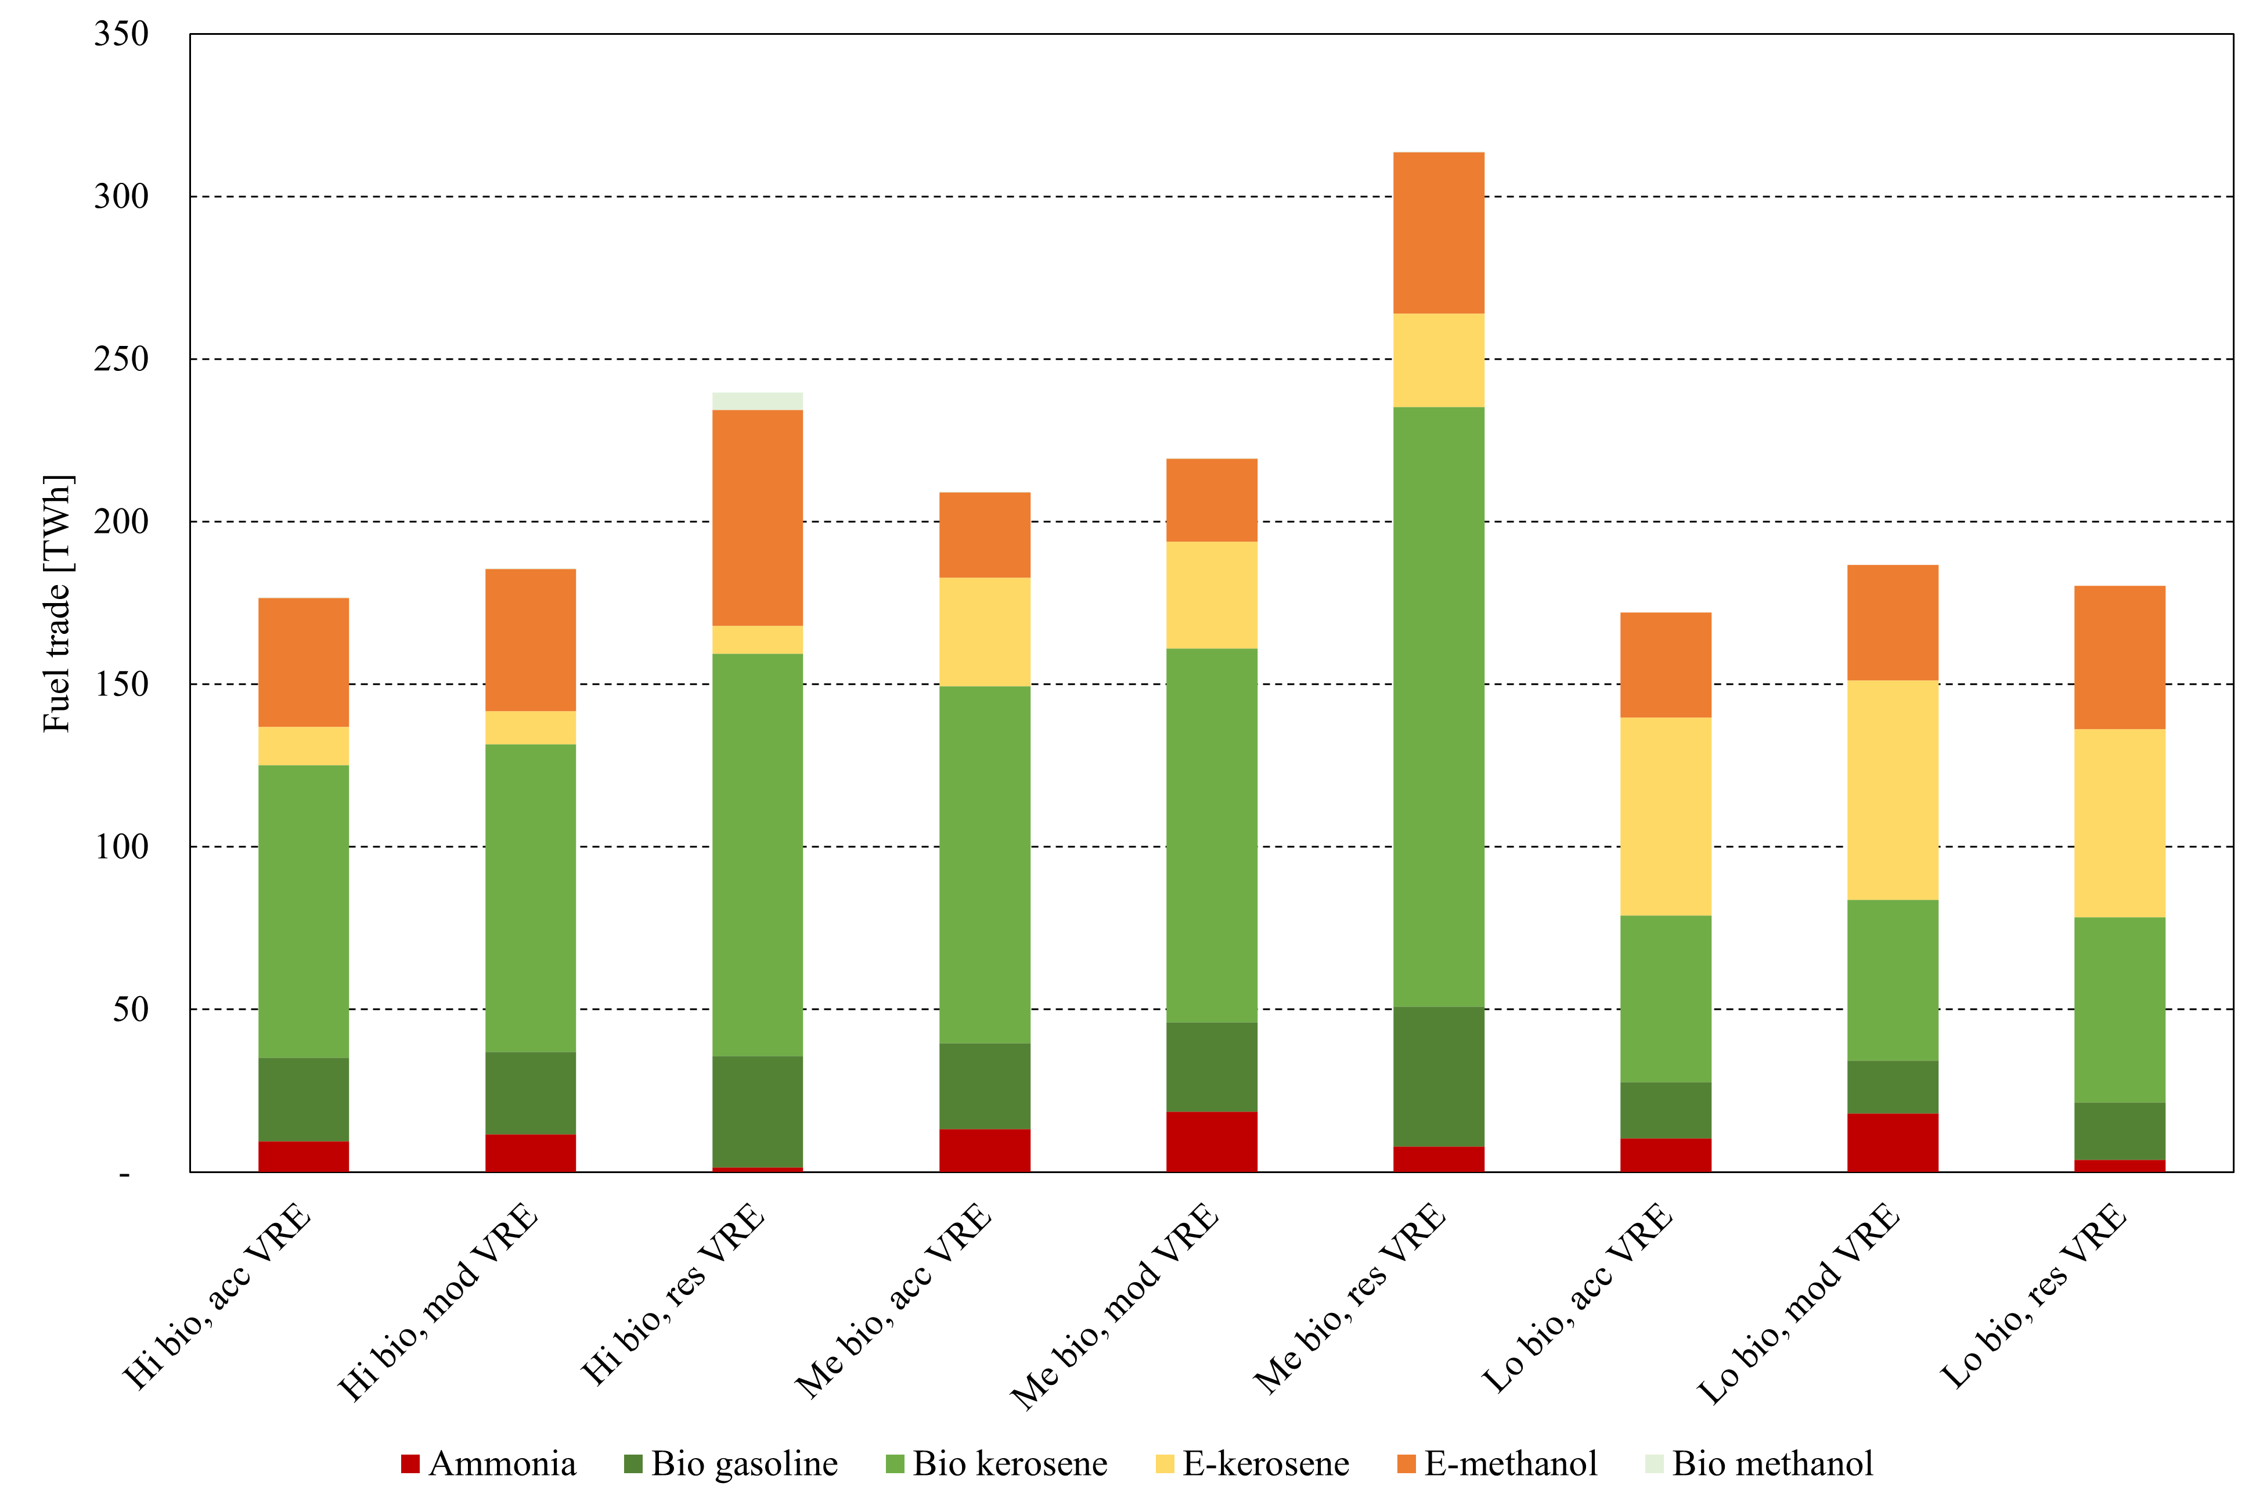
Figure S 1: Total fuel trade by scenario and type in 2050 in TWh.

Extended results – Power system buildout and utilisation
The supply of renewable liquid fuels is tied directly to the interconnected European energy system. In the main document Section 2.2, we describe how changing VRE potentials causes a geographical redistribution of wind and solar capacity. This leads to lower utilisation of the same total investments caused by a movement to regions with lower full load hours, leading to higher total costs.
In this section, we go into further detail about how the scenarios impact the electricity supply mix and the utilisation of VRE technologies. In Figure S 2 we show the electricity production in TWh by technology type and the average capacity factor of those technologies in % for all nine scenarios (presented in the same order as section 2.1 in the main document).

In all scenarios, electricity production is moving towards a system dominated by wind and solar production, with some level of hydro and thermal generation. To help balance the intermittency of VRE technologies, the system retains a level of thermal production (including nuclear) in all scenarios and peak generation from fuel cells and part of the thermal capacity with low capacity factors.

Between scenarios with the three different considered biomass availabilities, we see electricity production that follows the stepwise changing demand for e-fuels, but with a composition that remains largely unchanged. Furthermore, the average capacity factor of VRE technologies remains stable.

Changes in VRE accessibility have a stronger effect on the composition and utilisation of the power system. Improved conditions for VRE deployment enable further electrification leading to higher production across all biomass availability levels, higher utilisation of onshore resources, and lower thermal generation. Furthermore, restricting access to high-potential VRE regions causes a consistent reduction in the average capacity factor for onshore renewables, in particular for wind. For example, in scenarios with high biomass availability and accessible VRE deployment, no onshore wind is built in the lowest resource-grade areas in France. When restricting VRE deployment, some onshore wind capacity is moved to the lower grade areas, leading to a lower average capacity factor. We further see more offshore wind in areas previously unused. In Ireland and Denmark, the restricted VRE scenario leads to 57 GW offshore wind, leading to an increase in the capacity factor on average.
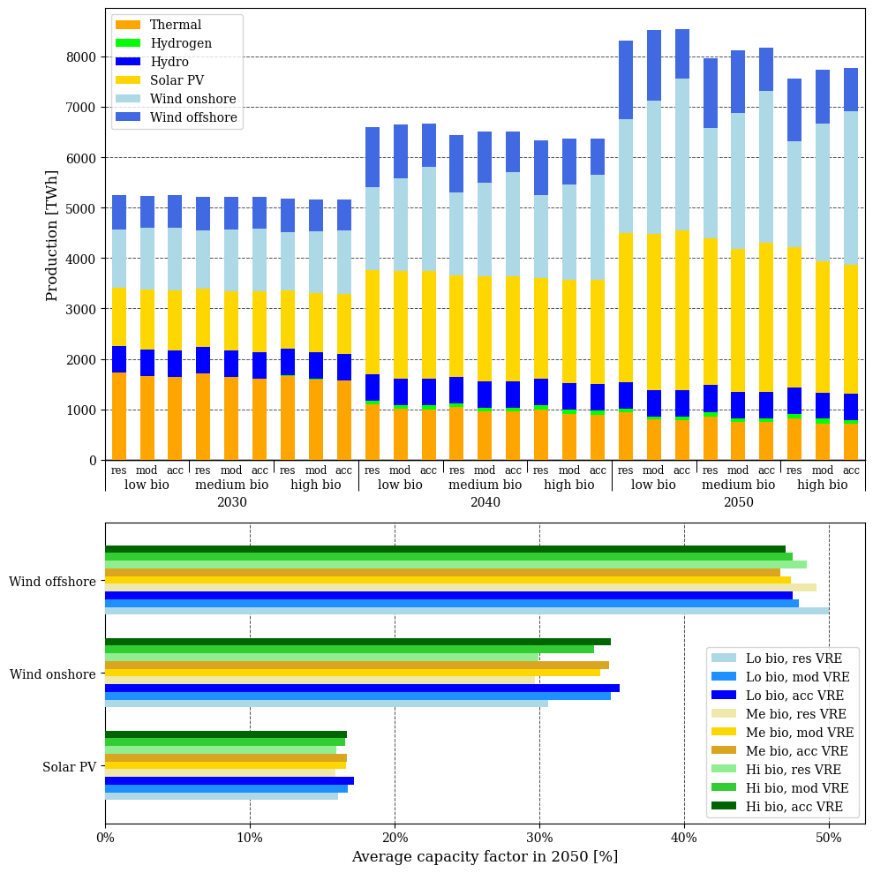
Figure S 2: Total electricity production by type and scenario towards 2050 in TWh. Furthermore, the average capacity factor of VRE technologies in %.

Extended results – The impact of alternative demand scenarios
We explore the impact of different demand scenarios on fuel production portfolios, by considering the maximum and minimum demand levels documented in [4], [5], [6] to create 18 additional scenarios ranging from low to high demand. Figure S 3 shows the results in a heat map visualising the production of 1) bio-FT products, 2) methanol upgrading products, 4) ammonia, and 5) methanol used directly.

We see that higher kerosene demands are supplied by bio-FT in high biomass scenarios, and by methanol upgrading in low biomass scenarios. This result confirms that bio-kerosene from FT is the least cost option, but there is a need for adoptable and scalable technologies to accommodate uncertainties, for example, related to future demand levels and biomass potentials. The upscale of kerosene produced from methanol upgrading, in low biomass scenarios, is increasingly supplied by DAC in the higher demand scenario, which increases the production of CO2 in 2050 in the most restrictive scenarios (low biomass, restrictive VRE) from 12 Mt in the low demand scenario to 62 Mt in the high demand scenario.

Furthermore, the results reveal dynamics regarding the supply of maritime fuels where ammonia supply is highly impacted in low biomass potential scenarios, while in the high biomass scenarios, the variations in demand levels impact both the ammonia and methanol production. The effect on both methanol and ammonia in the high biomass scenarios for the different demand levels can be associated with the national/regional differences in the production portfolio, as visualised in Figure 3 a) to b), which are scaled according to the variations in the demand levels.
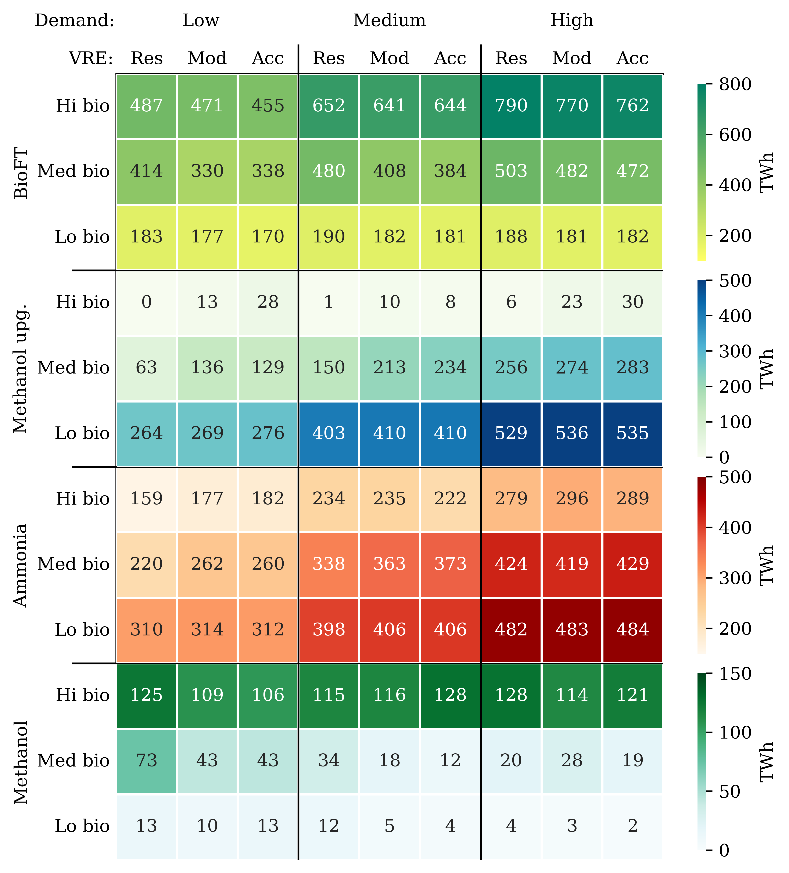
Figure S 3: Total fuel production by fuel type split between biomass availability, VRE expansion potential, and demand projection in TWh.

Extended results – Sensitivity of the representative days used in the investment runs
Using the Balmorel model in conjunction with the OptiFlow model has drawbacks regarding model complexity. The added network topology introduced by the fuel production increases the model size, resulting in computational tractability challenges. A potential method to mitigate these challenges is by reducing the temporal- or geographical resolution. Bramstoft et al and Lester et al [8], [9], for example, focus on Denmark as a case study, where the reduced geographical scale makes it possible to use a larger number of fuel pathways, but might not work at larger scales. The alternative option of reducing the temporal resolution should also be done carefully. The deployment of VRE, which is a significant part of this study, has strong temporal characteristics that can affect which technology is installed, in what amount, and where. Instead, we use a third method to mitigate this issue. Instead of singular investment & dispatch runs, we perform investment runs for each scenario with a reduced temporal resolution, using just a single day of the week as a representative. From these investment runs, we save the fuel production capacity only (excluding hydrogen production), which we load in subsequent runs. We hypothesize that the fuel production capacity investments themselves are less affected by temporal fluctuations than VRE and hydrogen investments, but to make sure, we perform a sensitivity on how the temporal settings influence fuel production in the investment runs.

In the investment runs, only a single representative day in a week is used to generate the capacities. With the medium-VRE medium-biomass availability, we run the model for each of the seven days of the week and assess the impacts on fuel production in 2050 (see Figure 1). In a study, Campion performs a sensitivity analysis of different weather years (multi-year and single-year, as well as deterministic and stochastic) for an ammonia plant [10], finding only smaller differences in the sizing of the ammonia plant itself. We also find the variability in fuel production between settings to be minimal, which leads us to believe that it is a fair tradeoff to improve both geographical and temporal resolution. In Figure S 4, “Day 1” is the run used for our study.
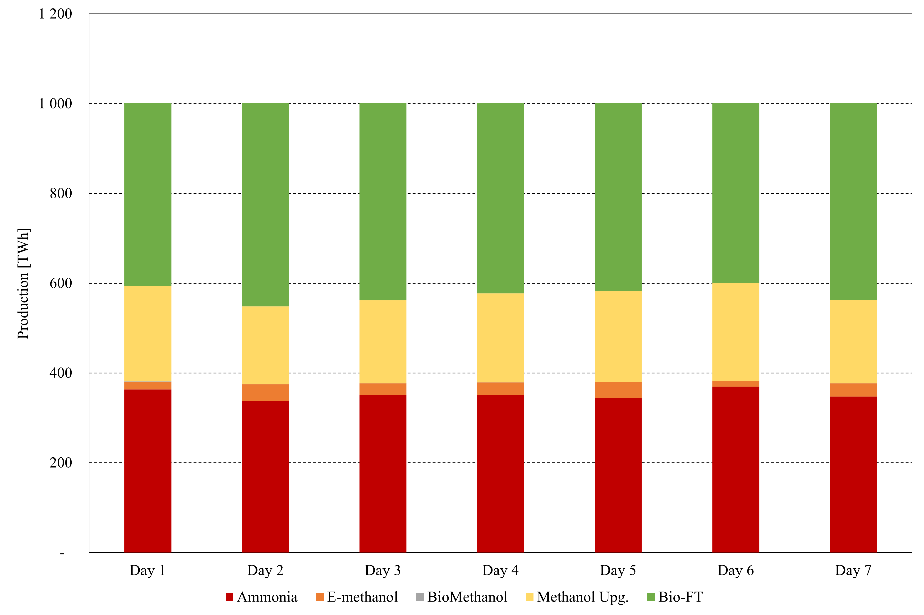
Figure S 4: Total fuel production in 2050 for investment runs with seven different representative days. The scenario with medium biomass availability and moderate VRE expansion potential is used.

Extended method – Further coupling of Balmorel and OptiFlow
The main feature of the combined use of Balmorel and OptiFlow is that it allows us to endogenise many assumptions regarding how to utilize biomass, hydrogen, and CO2. Biofuels may be produced from biomass; however, this reduces the amount available for use to produce electricity and heat. Alternatively, biomass could be combusted and used as a source of biogenic CO2 for utilization or sequestration. The utilization route for e-fuels could allow for a second use for the carbon in biomass, as well as better utilize the intermittency from VREs through electrolytic hydrogen. In production Figure S 5 we illustrate the structure of the two models, as well as the exchanges between them.
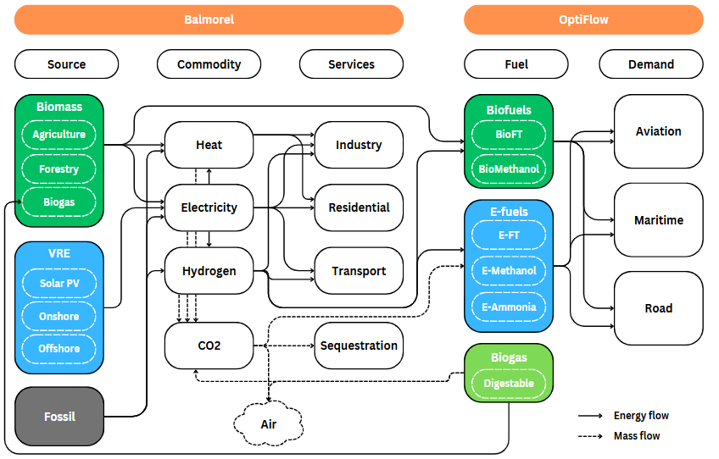
Figure S 5: Simplified diagram showing the combined Balmorel-Optiflow modeling framework.

The left side of the figure represents the classic Balmorel model, while the right side of the figure represents OptiFlow model. Between the two are exchanges of commodities. Electricity and heat may flow both ways depending on the process, allowing for e.g. use of waste heat in district heating networks. Biogas is produced in OptiFlow, which can then be used for combustion in Balmorel. Hydrogen, biomass, and CO2 is handled in Balmorel, from where it may be used in production processes. Compared to previous work, the coupling of biogas, biomass, hydrogen, and CO2 is novel work done in this study. An additional new development is the investment transfer of fuel production capacity between years modelled years. This aspect is important to consider due to the lifetime of the investments, which can lead to lock-in effects.

Biomass
The coupling of biomass across the two models ensures that biomass used for either electricity, heating, or fuel production comes from a combined, exogenously defined, pool. This allows for endogenous decision-making and prioritization between either using biomass directly for biofuel production or using it in conventional combustion for heat and electricity, potentially combined with carbon capture. Equation 1 describes the implementation in the model for each year, country, and fuel (y,c,f).

$$\sum_{\begin{aligned}a∈CA \\ s∈S \\ t∈T\end{aligned}}{\left(\sum_{g∈GF}{{vfuel}_{y,a,g,s,t}} +\sum_{\begin{aligned}proc∈FPROC \\ flow∈FFLOW\end{aligned}}{{vflow}_{y,a,proc,flow,s,t}} \right)} ≤F_{y,c,f}^{max} ∀ y,c,f$$

The two variables $vfuel$ and $vflow$ describe the fuel consumption in Balmorel and OptiFlow respectively, matched at the (y)yearly-, (c)country-, and (f)fuel-level by the parameter $F^{max}$ describing the maximum consumption. The fuel consumption in Balmorel is summed over technologies g consuming fuels f, while fuel consumption in OptiFlow is summed over (proc)processes and (flow)flows connected to fuel f. The combined consumption is summed over weeks, hours, and areas a within country c. In the special case of biogas, the same equation is used. However, instead of limiting the use by some level given by the parameter F^max, we set this parameter to 0 and reverse the sign of vflow. Thus, to consume biogas in Balmorel, this needs to be produced in OptiFlow.

Hydrogen
The hydrogen coupling across the models combines the infrastructure capabilities and geographical characteristics of Balmorel with the endogenized consumption for fuel production in OptiFlow. This allows for detailed analysis of needed hydrogen infrastructure across Europe combined with products further in the value chain than pure hydrogen. Equation 2 describe how this is implemented in the hydrogen balancing equation, for each year, region, week, and hour (y, r, s, t).

$$\sum_{\begin{aligned}a∈RA \\ g∈G_{prod}\end{aligned}}{{vgen}_{y,a,g,s,t}^{H2}} +\sum_{\begin{aligned}a∈RA \\ g∈G_{sto}\end{aligned}}{{vsto}_{y,a,g,s,t}^{H2}} +\sum_{r^{'}}{{vim}_{y,r^{'},r,s,t}^{H2}} -\sum_{r^{'}}{{vex}_{y,r,r^{'},s,t}^{H2}} =⋯$$
$$D_{y,r,s,t}^{H2}+\sum_{\begin{aligned}a∈RA \\ proc∈{proc}^{H2} \\ flow∈{flow}^{H2}\end{aligned}}{{vflow}_{y,a,proc,flow,s,t}^{H2}} ∀ y,r,s,t$$

The left-hand side of the equation describes hydrogen produced from producing units (e.g. electrolyzers) and loading/unloading of storage by the variables $vgen$ and $vsto$, summed over areas a within region r and technologies g for production and storage. Additionally, $vim$ and $vex$ describe hydrogen imported from or exported to other regions. The right-hand side contains the hydrogen demand, either defined exogenously with $D^{H2}$ or endogenously by the variable $vflow^{H2}$.

Carbon capture, utilization, and storage
The prioritization of how to manage captured CO2, fossil and biogenic, towards 2050 is an important factor in meeting our climate goals. Investment into generation capacity with carbon capture results in some available quantity that may either be stored or utilized. Equation 3 describes how this works in the model for each year, region, week, and hour (y, r, s, t), as well as a subset of CO2 processes:

$${vflow}_{y,a,proc,flow,s,t}^{CO2}≤\sum_{g∈{Gproc}^{CO2}}{EMI_{g}⋅{vfuel}_{y,a,g,s,t}⋅η_{g}^{CAP} } ∀ y,r,proc^{CO2},flow^{CO2},s,t$$

The right-hand side of the equation describes all captured CO2 in Balmorel. A subset of technologies g include carbon capture, managed by the fuel emission intensity $EMI_{g}$, capture efficiency $η_{g}^{CAP}$, and fuel consumption $vfuel_{y,a,g,s,t}$ of that technology. An additional set $Gproc^{CO2}$ connects technologies using biomass or fossil fuels to the respective processes. This total captured CO2 acts as an upper bound for what is available for fuel production, ${vflow}_{y,a,proc,flow,s,t}^{CO2}$.

Investment transfer
A vast amount of new investments is necessary to accomplish the green transition. Due to the large energy system shift expected and uncertainty in how we should use biomass and CO2 resources, we have to consider the impact our investments may have further in the future. In Equation 4, we show how fuel production capacity accumulated from year to year.

$${vproc}_{y,a,proc}^{ACC}={vproc}_{y-1,a,proc}^{ACC}+{vproc}_{y,a,proc}^{NEW} ∀y,a,proc∈proc^{INV}$$

The accumulated capacity of the subset of processes $proc^{INV}$ that are investment options is tracked throughout the modelling horizon in ${vproc}_{y,a,proc}^{ACC}$, controlled by the accumulated investments in previous years (y-1) and new investments ${vproc}_{y,a,proc}^{NEW}$ in this year.

Extended discussion – Literature comparison
This study focuses on how the potential renewable liquid fuel sector will be affected by the effective expansion of variable renewable energy generation and by sustainable biomass availability. We find that sustainable biomass scarcity is a main driver for changes in the composition between biofuels and E-fuels. This result is in line with national studies, like Lester et al. [23], regional studies like Rosendal et al. [26], and global sectoral studies like Frantz et al. [4] focusing on the decarbonisation of the shipping sector. These studies show that biofuels are the least-cost production pathway, but when biomass potentials are limited, E-fuel production becomes essential. While our results align regarding the overall dynamics between the composition of bio- and E-fuels, we expand the state of knowledge in showing when and where to produce renewable liquid fuels in a European context, which is crucial for the policy and investment decision-makers facilitating the transition.

We show that changing the regional accessibility to VRE potentials impacts not only the overall system costs but also the hydrogen transmission system, which is used to support the production of e-fuels. While hydrogen transmission infrastructure build-out has been investigated using partly exogenously defined demand levels, such as in Neumann et al [27], we endogenise the hydrogen needs for fuel production, and investigate the trade-offs and synergies by varying biomass availability and VRE potentials, to uncover the need for E-fuels and hydrogen infrastructure build-out in the future. While we identify similar hydrogen corridors towards the center of Europe, as in Kountouris et al. [28] and Neumann et al. [27], we show the dynamics with varying the needs for hydrogen infrastructure as well as electrolysis capacity in the different scenarios, with the least electrolysis capacity needed in the high biomass and accessible VRE scenario.

We show that biomass scarcity increases the importance of carbon management, affecting production pathways in the fuel sector, and sourcing strategies in the transport sector. We find that biomass is being utilised directly for fuel production and for fuel production via CCU and green hydrogen, and for direct combustion with CCS. The competition of biomass usage in the hard-to-abate transport sectors and the entire energy system to achieve European decarbonising targets has been studied in Millinger et al. (a and b) [15], [22], who find that biomass should be prioritized in applications allowing for carbon reuse and that E-fuels and sequestration are prioritized in the long term. Our findings align well with these results and expand on the effects that occur between regions that can influence fuel trading and the importance of the effective development of the supporting energy system.

Bibliography
[1] P. Ruiz et al., ‘ENSPRESO - an open, EU-28 wide, transparent and coherent database of wind, solar and biomass energy potentials’, Energy Strategy Reviews, vol. 26, p. 100379, Nov. 2019, doi: 10.1016/j.esr.2019.100379.
[2] I. Kountouris, R. Bramstoft, T. Madsen, J. Gea-Bermúdez, M. Münster, and D. Keles, ‘A unified European hydrogen infrastructure planning to support the rapid scale-up of hydrogen production’, Nat Commun, vol. 15, no. 1, p. 5517, Jun. 2024, doi: 10.1038/s41467-024-49867-w.
[3] M. J. Koivisto and J. P. Murcia Leon, ‘Pan-European wind and solar generation time series (PECD 2021 update)’, 2022, Technical University of Denmark. doi: 10.11583/DTU.C.5939581.V3.
[4] A. Wang et al., ‘Analysing future demand, supply, and transport of hydrogen’, 2021.
[5] Eurelectric, ‘Decarbonisation Speedways’, Jun. 2023. [Online]. Available: https://www.eurelectric.org/publications/decarbonisation-speedways-full-report/
[6] ENTSO-G and ENTSO-E, ‘TYNDP 2024 Draft Scenarios Report’, May 2024. [Online]. Available: https://2024.entsos-tyndp-scenarios.eu/
[7] European Commission. Directorate General for Energy., European Commission. Directorate General for Climate Action., and European Commission. Directorate General for Mobility and Transport., EU reference scenario 2020: energy, transport and GHG emissions : trends to 2050. LU: Publications Office, 2021. Accessed: Oct. 10, 2024. [Online]. Available: https://data.europa.eu/doi/10.2833/35750
[8] R. Bramstoft, A. Pizarro-Alonso, I. G. Jensen, H. Ravn, and M. Münster, ‘Modelling of renewable gas and renewable liquid fuels in future integrated energy systems’, Applied Energy, vol. 268, p. 114869, Jun. 2020, doi: 10.1016/j.apenergy.2020.114869.
[9] M. S. Lester, R. Bramstoft, and M. Münster, ‘Analysis on Electrofuels in Future Energy Systems: A 2050 Case Study’, Energy, vol. 199, p. 117408, May 2020, doi: 10.1016/j.energy.2020.117408.
[10] N. Campion, ‘Power-to-X and Alternative Fuels for the Maritime Industry’, Technical University of Denmark, 2023.

