Supplementary materials
Graphical abstact
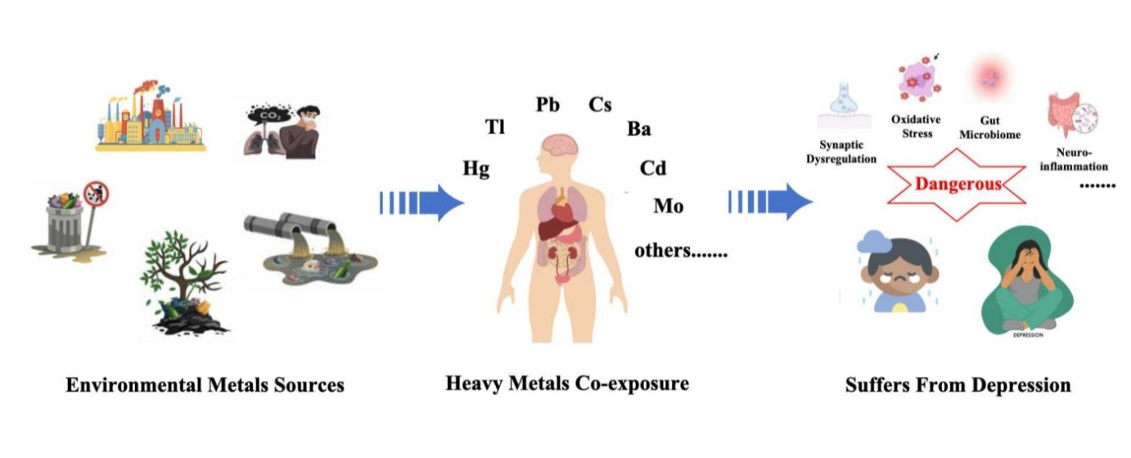

Figure
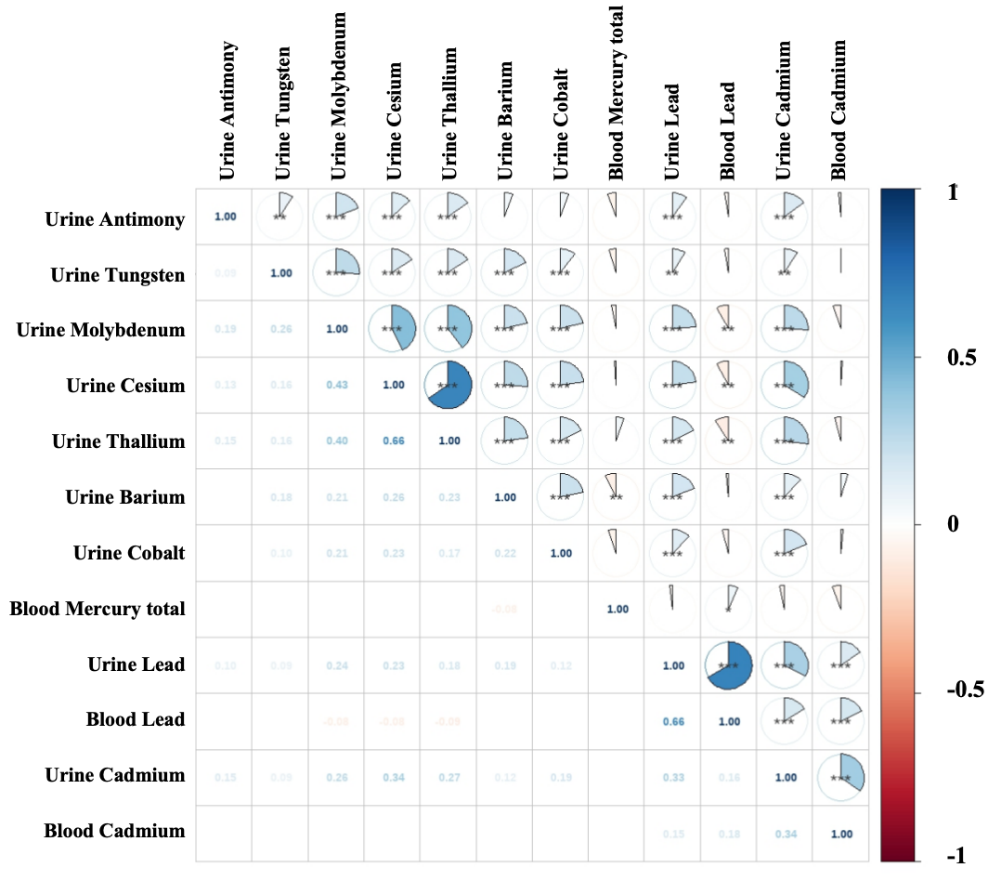
Fig. S1 Pearson correlation coefficients between exposures to the 12 heavy metals. The variation in color intensity reflects the degree of correlation, where dark blue represents the highest positive correlation and dark red indicates the most substantial negative correlation. * p < 0.05; ** p < 0.01; *** p < 0.001.
Tables
Table S1. Joint effect of heavy metal mixtures on the prevalence of depression in the WQS model.
Outcome | OR | 95% CI | P-value
Positive
Crude model | 1.76 | 1.54-2.02 | ＜ 0.001
Model I | 1.17 | 1.02-1.35 | 0.026
Negative
Crude model | 0.69 | 0.62-0.76 | ＜ 0.001
Model I | 0.81 | 0.70-0.94 | 0.006
WQS, weighted quantile sum; OR: odds ratio; CI: confidence interval; The crude model was not adjusted for any covariates, while Model I was adjusted for all covariates.

Table S2. PIPs of each heavy metal for the prevalence of depression in BKMR model.
 | PIPs
Barium_urine | 0.448
Cobalt_urine | 0.382
Antimony_urine | 0.186
Tungsten_urine | 0.184
Lead_urine | 0.158
Cadmium_urine | 0.126
Blood_cadmium | 0.114
Blood_lead | 0.104
Cesium_urine | 0.000
Molybdenum_urine | 0.000
Thallium_urine | 0.000
Blood_mercury_total | 0.000
This model adjusted for all covariates. PIPs, posterior inclusion probabili probabilities; BKMR, Bayesian kernel machine regression.

