Supplementary materials
1D and 2D NMR and HRESIMS spectra of the new compound sinensidin (10)
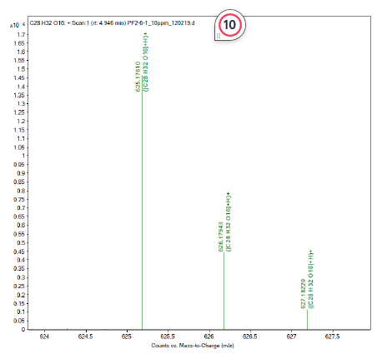
HRESIMS spectrum of sinensidin (10)
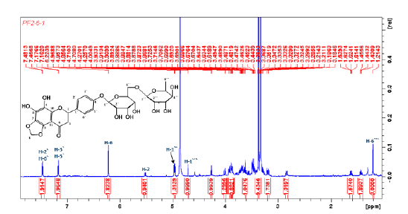
¹H NMR spectrum of sinensidin (10)
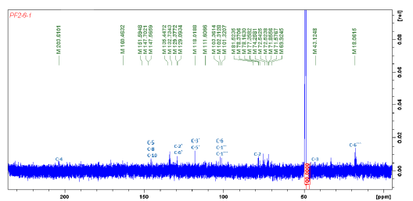
¹³C NMR spectrum of sinensidin (10)
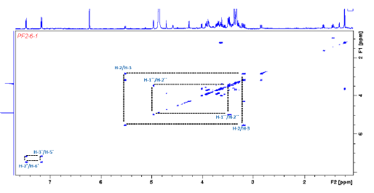
¹H-¹H COSY spectrum of sinensidin (10)
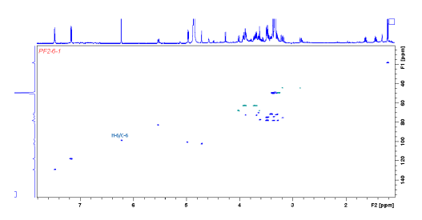
¹H-¹³C HSQC spectrum of sinensidin (10)
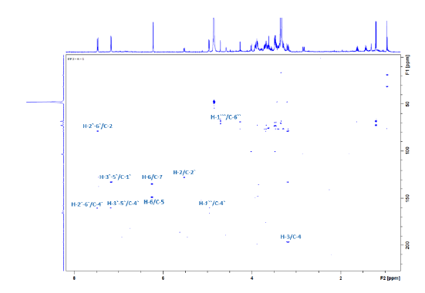
¹H-¹³C HMBC spectrum of sinensidin (10)

Table S1: HR-ESIMS data of the isolated flavonoids (1-14)
Pseudomolecular ion and molecular formula | Flavonoids
Pseudomolecular ion and molecular formula | 1 | 2 | 3 | 4 | 5 | 6 | 7
[M+H]⁺ ion | m/z 345.0974  (calculated 345.0974) | m/z 389.1230  (calculated 389.1236) | m/z 359.1141  (calculated 359.1130) | m/z 433.1577  (calculated 433.1498) | m/z 403.1388  (calculated 403.1392) | m/z 373.1317  (calculated 373.1287) | m/z 373.1284  (calculated 373.1287)
Molecular formula | C₁₈H₁₆O₇ | C₂₀H₂₀O₈ | C₁₉H₁₈O₇ | C₂₂H₂₄O₉ | C₂₁H₂₂O₈ | C₂₀H₂₀O₇ | C₂₀H₂₀O₇
Pseudomolecular ion and molecular formula
Pseudomolecular ion and molecular formula | 8 | 9 | 10 | 11 | 12 | 13 | 14
[M+H]⁺ ion | m/z 611.1953  (calculated 611.1976) | m/z 581.1895  (calculated 581.1870) | m/z 625.1761  (calculated 625.1768) | m/z 609.1451  (calculated 609.1455) | m/z 625.1763  (calculated 625.1768) | m/z 373.1286  (calculated 373.1287) | m/z 343.1181  (calculated 343.1181)
Molecular formula | C₂₈H₃₄O₁₅ | C₂₇H₃₂O₁₄ | C₂₈H₃₂O₁₆ | C₂₇H₃₀O₁₆ | C₂₈H₃₂O₁₆ | C₂₀H₂₀O₇ | C19H₁₈O₆

Table S2: ¹H NMR (600 MHz) data for the isolated flavonoids 1-9 and 11-14
Carbon  number | ¹H NMR chemical shift δ_{H} in ppm (coupling constant J in Hz)
Carbon  number | 1 | 2 | 3 | 4 | 5 | 6 | 7 | 8 | 9 | 11 | 12 | 13 | 14
Aglycone
2 | - | - | - | - | - | - | - | 5.50, dd  (3.1, 12.0) | 5.42, dd  (3.1, 12.4) | - | - | - | -
3 | 6.58, s | 6.61, s | 6.60, s | - | 6.64, s | 6.60, s | 6.60, s | 2.78, dd  (3.1, 17.2)  3.26, dd  (12.0, 17.2) | 2.83, dd  (3.1, 17.1)  3.29, dd  (12.4, 17.1) | - | - | 6.60, s | 6.59, s
4 | - | - | - | - | - | - | - | - | - | - | - | - | -
5 | - | - | - | - | - | 6.97, s | - | - | - | - | - | - | -
6 | - | - | - | - | - | - | - | 6.14, d  (2.5) | 6.19, d  (2.0) | 6.23, d  (2.1) | 6.23, d  (2.0) | - | -
7 | - | - | - | - | - | - | - | - | - | - | - | - | -
8 | 6.55, s | - | 6.55, s | - | - | - | 6.97, s | 6.12, d  (2.5) | 6.22, d  (2.0) | 6.42, d  (2.1) | 6.44, d  (2.0) | - | 6.59, s
9 | - | - | - | - | - | - | - | -- | - | - | - | - | -
10 | - | - | - | - | - | - | - |  | - | - | - | - | -
1’ | - | - | - | - | - | - | - | - | - | - | - | - | -
2’ | 7.33, d  (2.1) | 7.43, d  (2.1) | 7.34, d  (2.1) | 7.81, d  (2.0) | 7.41, d  (2.1) | 7.33, d  (2.1) | 7.33, d (2.1) | 6.93, d  (2.1) | 6.93, d  (2.1) | 7.60, d  (2.0) | 7.96, d  (2.0) | 7.88, d (8.8) | 7.82, d (8.8)
3’ | - | - | - | - | - | - | - | - | - | - | - | 7.03, d  (8.8) | 7.00, d  (8.8)
4’ | - | - | - | - | - | - | - | - | - | - | - | - | -
5’ | 7.04, d  (8.3) | 7.00, d  (8.5) | 6.98, d  (8.0) | 7.01, d  (8.5) | 7.00, d  (8.5) | 6.96, d  (8.4) | 6.96, d (8.4) | 6.95, d  (8.4) | 6.95, d  (8.3) | 6.89, d  (8.4) | 6.94, d  (8.4) | 7.03, d  (8.8) | 7.00, d  (8.8)
6’ | 7.50, dd  (8.3, 2.1) | 7.59, dd  (2.1, 8.5) | 7.51, dd  (8.0, 2.1) | 7.83, dd  (2.0, 8.5) | 7.57, dd  (8.5, 2.1) | 7.51, dd  (8.4, 2.1) | 7.51, dd  (8.4, 2.1) | 6.91, dd  (8.4, 2.1) | 6.91, dd  (2.1, 8.3) | 7.65, dd  2.0, 8.4) | 7.65, dd  (2.0, 8.4) | 7.88, d (8.8) | 7.82, d (8.8)
3-OMe | - | - | - | 3.88, s | - | - | - | - | - | - | 3.97, s | - | -
5-OMe | - | - | - | 3.97, s | 3.95, s | - | 3.92 s | - | - | - | - | 4.10, s | 3.98, s
6-OMe | 3.93, s | 4.11, s | 3.98, s | 3.94, s | 3.95, s | 3.99, s | 3.99 s | - | - | - | - | 3.95, s | 3.91, s
7-OMe | 3.97, s | 3.95, s | 3.93, s | 4.09, s | 4.10, s | 3.99, s | 3.96 s | - | - | - | - | 3.95, s | 3.97, s
8-OMe | - | 3.98, s | - | 4.00, s | 4.02, s | 3.92, s | - | - | - | - | - | 4.02, s | -
3’-OMe | 3.97, s | 3.97, s | 3.99, s | 3.97, s | 3.96, s | 3.96, s | 3.96 s | 3.78, s | - | - | - | - | -
4’-OMe | - | 3.98, s | 3.97, s | 3.96, s | 3.97, s | 3.98, s | 3.99 s | - | - | - | - | 3.89, s | 3.88, s
Glycone (glucose)
1’’ | - | - | - | - | - | - | - | 4.98, d  (8.5) | 4.96, d  (7.0) | 5.12, d  (7.7) | 5.25, d  (7.6) | - | -
2’’ | - | - | - | - | - | - | - | 3.63* | 3.36* | 3.49* | 3.49* | - | -
3’’ | - | - | - | - | - | - | - | 3.45* | 3.60* | 3.31* | 3.32* | - | -
4’’ | - | - | - | - | - | - | - | 3.40* | 3.90* | 3.29* | 3.30* | - | -
5’’ | - | - | - | - | - | - | - | 3.54* | 3.46* | 3.43* | 3.43* | - | -
6’’ | - | - | - | - | - | - | - | 3.42*  3.80, m | 3.41*  4.01, m | 3.41*  3.81, m | 3.44*  3.84, m | - | -
Glycone (rhamnose)
1’’’ | - | - | - | - | - | - | - | 4.52, d  (1.9) | 4.71, d  (2.1) | 4.54, d  (1.5) | 4.55, d  (1.5) | - | -
2’’ | - | - | - | - | - | - | - | 3.27* | 3.65* | 3.65* | 3.63* | - | -
3’’ | - | - | - | - | - | - | - | 3.28* | 3.33* | 3.55* | 3.56* | - | -
4’’ | - | - | - | - | - | - | - | 3.18* | 3.29* | 3.30* | 3.28* | - | -
5’’ | - | - | - | - | - | - | - | 3.38* | 3.65* | 3.49* | 3.43* | - | -
6’’ | - | - | - | - | - | - | - | 1.09, d  (6.2) | 1.11, d  (6.2) | 1.14, d  (6.2) | 1.11, d  (6.2) | - | -
Spectra of compounds 1-6, 13 and 14 were obtained CDCl₃ and that of compounds 8,9,11 and 12 were in CD₃OD
*Unresolved peaks, determined by 2D COSY, HSQC and HMBC experiments

Table S3: ¹³C NMR (150 MHz) data for the isolated flavonoids 1-9 and 11-14
Carbon number | Chemical shift δ_{C} in ppm
Carbon number | 1 | 2 | 3 | 4 | 5 | 6 | 7 | 8 | 9 | 11 | 12 | 13 | 14
Aglycone
2 | 164.4 | 164.7 | 164.4 | 153.5 | 161.4 | 161.2 | 161.7 | 78.8 | 78.0 | 159.5 | 159.0 | 161.5 | 161.6
3 | 104.7 | 104.4 | 104.9 | 141.1 | 107.1 | 107.7 | 107.6 | 42.5 | 42.3 | 135.7 | 135.6 | 107.1 | 104.2
4 | 183.3 | 183.3 | 183.0 | 174.3 | 177.7 | 177.6 | 177.7 | 197.5 | 198.7 | 179.5 | 179.5 | 177.7 | 182.8
5 | 153.6 | 149.9 | 153.6 | 148.6 | 149.6 | 96.9 | 152.3 | 163.5 | 165.1 | 163.2 | 163.2 | 151.7 | 154.9
6 | 133.1 | 137.2 | 133.1 | 144.2 | 144.4 | 158.0 | 144.8 | 96.8 | 98.1 | 100.0 | 100.1 | 144.4 | 131.9
7 | 159.1 | 153.0 | 159.1 | 151.7 | 152.2 | 146.0 | 158.1 | 165.6 | 167.0 | 166.2 | 166.2 | 148.8 | 158.0
8 | 91.1 | 131.2 | 91.0 | 138.6 | 138.1 | 140.7 | 96.6 | 96.0 | 97.3 | 95.0 | 95.0 | 138.3 | 96.6
9 | 153.5 | 146.3 | 153.4 | 147.1 | 148.7 | 143.0 | 154.9 | 163.0 | 164.7 | 158.5 | 158.7 | 148.0 | 153.0
10 | 106.5 | 108.2 | 106.5 | 115.4 | 115.1 | 113.2 | 113.1 | 103.8 | 105.1 | 105.7 | 105.9 | 115.3 | 107.3
1’ | 123.8 | 124.1 | 124.2 | 123.8 | 124.2 | 124.5 | 124.4 | 131.4 | 131.0 | 123.2 | 123.2 | 124.2 | 124.2
2’ | 108.7 | 109.1 | 109.2 | 111.3 | 111.3 | 109.1 | 109.1 | 114.6 | 129.3 | 117.8 | 114.7 | 128.0 | 128.0
3’ | 147.2 | 149.8 | 149.7 | 149.1 | 149.6 | 149.7 | 149.7 | 146.9 | 116.5 | 146.0 | 148.5 | 115.0 | 114.8
4’ | 149.6 | 152.1 | 152.7 | 151.4 | 152.9 | 153.0 | 152.9 | 148.4 | 149.2 | 150.4 | 151.0 | 162.7 | 162.5
5’ | 115.4 | 111.7 | 111.6 | 111.4 | 111.5 | 111.5 | 111.5 | 112.5 | 116.5 | 116.2 | 116.3 | 115.0 | 114.8
6’ | 121.1 | 120.5 | 120.4 | 122.3 | 119.9 | 120.0 | 120.0 | 118.4 | 129.3 | 123.7 | 124.2 | 128.0 | 128.0
3-OMe | - | - | - | 60.2 | - | - | - | - | - | - | - | - | -
5-OMe | 56.7 | 62.1 | - | 62.6 | 62.5 | - | 61.9 | - | - | - | - | 62.0 | 62.5
6-OMe | 61.2 | 61.4 | 56.7 | 62.2 | 62.2 | 56.7 | 62.6 | - | - | - | - | 62.4 | 61.9
7-OMe | - | 62.4 | 61.2 | 62.0 | 61.9 | 61.9 | 56.5 | - | - | - | - | 62.6 | 56.6
8-OMe | 56.5 | 56.5 | - | 62.3 | 62.1 | 62.5 | - | - | - | - | - | 62.2 | -
3’-OMe | - | 56.4 | 56.5 | 56.3 | 56.3 | 56.5 | 56.4 | 56.2 | - | - | 56.9 | - | -
4’-OMe | - | - | 56.5 | 56.2 | 56.2 | 56.4 | 56.7 | - | - | - | - | 55.8 | 55.8
Glycone (glucose)
1’’ | - | - | - | - | - | - | - | 101.1 | 101.3 | 104.8 | 104.5 | - | -
2’’ | - | - | - | - | - | - | - | 76.0 | 72.5 | 75.9 | 76.1 | - | -
3’’ | - | - | - | - | - | - | - | 78.8 | 78.0 | 77.4 | 77.5 | - | -
4’’ | - | - | - | - | - | - | - | 70.7 | 71.4 | 71.5 | 72.4 | - | -
5’’ | - | - | - | - | - | - | - | 76.7 | 80.8 | 78.3 | 78.3 | - | -
6’’ | - | - | - | - | - | - | - | 66.8 | 69.9 | 68.7 | 68.1 | - | -
Glycone (rhamnose)
1’’’ | - | - | - | - | - | - | - | 103.8 | 102.3 | 102.5 | 102.7 | - | -
2’’’ | - | - | - | - | - | - | - | 71.7 | 74.8 | 72.2 | 72.2 | - | -
3’’’ | - | - | - | - | - | - | - | 72.5 | 72.2 | 72.4 | 71.8 | - | -
4’’’ | - | - | - | - | - | - | - | 73.4 | 74.3 | 74.1 | 74.0 | - | -
5’’’ | - | - | - | - | - | - | - | 68.8 | 77.3 | 69.8 | 69.9 | - | -
6’’’ | - | - | - | - | - | - | - | 18.3 | 18.0 | 18.0 | 18.0 | - | -
Spectra of compounds 1-6, 13 and 14 were obtained CDCl₃ and that of compounds 8,9,11 and 12 were in CD₃OD

