Supplementary Information for

“Magnetochiral Spin-polarized Tunneling on Topological Vortices with Chiral Domains”

Seongjoon Lim¹, Fei-Ting Huang¹, Shangke Pan^{1,2}, Kefeng Wang¹, Jaewook Kim¹, Sang-Wook Cheong^{1*}
¹ Rutgers Center for Emergent Materials and Department of Physics and Astronomy, Piscataway, NJ 08854, USA
²State Key Laboratory Base of Novel Function Materials and Preparation Science, School of Material Sciences and Chemical Engineering, Ningbo University, Ningbo, Zhejiang 315211, China
*To whom correspondence should be addressed;
Email: sangc@physics.rutgers.edu

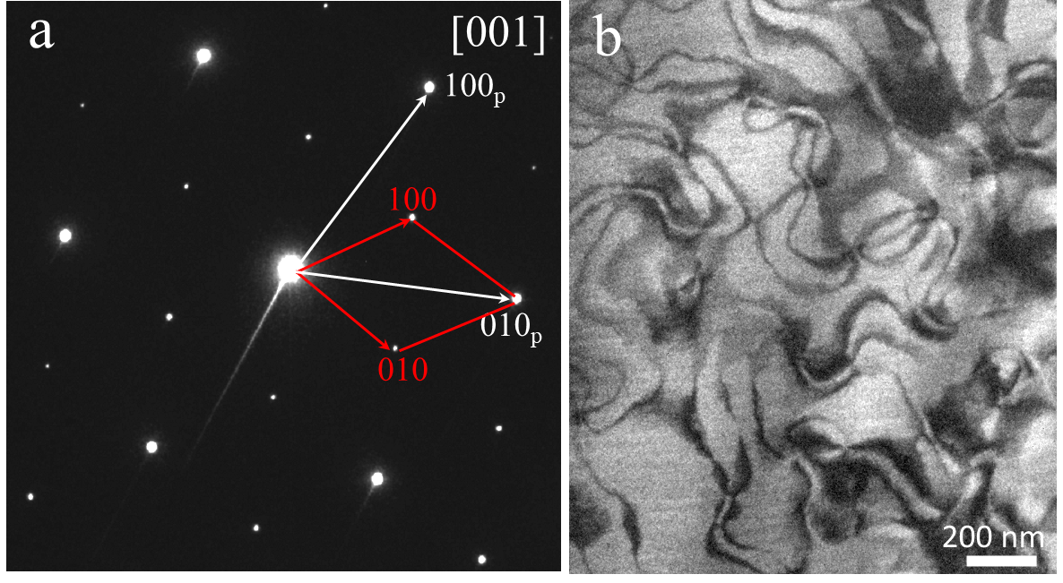
Figure S1. Manipulation of Topological Defect Density with Cooling Rate. (a) Selected area electron diffraction pattern along [001] direction remains intact after quenching, which means that the chiral structure does not change during quenching. The primitive cell and the tripled supercell are depicted with the white and the red arrows, respectively. (b) Superlattice DF-TEM image of the quenched crystal showing a high density of topological defects with the size of a few hundred nanometers in contrast to the furnace cooled sample in Fig. 1b. The structural transtion from primitive P6₃/mmc to chiral P6₃22 is estimated to be around 1000ºC and the defect (vortex/antivortex) density has been changing according to the universal Kibble-Zurek mechanism¹, which shows the emergent continuous symmetry that describes the scaling of defect density at a finite cooling speed.

Supplementary Note 1.
Effect of Thermal Energy on Cleaving Behavior
One of the important features of van der Waals layered materials such as graphene and transition metal dichalcogenides (TMDs) is cleaving, which stems from the weak coupling between layers. The feature not only means we can cleave a bulk crystal once but also it continues to thinning down a crystal to the monolayer limit. Moreover, the obtained structures show almost no surface reconstruction from the bulk structure due to the chrge-neutral nature of van der Waals gaps. Altogether, the cleavability and the robustness of surface are important properties in the utilization of various few-layered van der Waals materials. Similarly, in the case of Co_{1/3}NbS₂, it does show a reasonable cleavability although the Co-intercalated gap requres a relatively stronger force than its host material, NbS₂. However, cleaved Co-type surface shows a different chracteristics from other layered materials in terms of stability, i.e. the exposed Co ions are not stable at roomt temperature.
Co ions are intercalated in the van der Waals gap and show a localized d-orbital with the valence of 2+ as a result of charge transfer with the NbS₂ matrix. That is the reason why the isolated orbital can bear localized magnetic moment, which forms the antiferromagnetic order at low temperature. These isolated orbitals of Co ions sustain the ordering at room temperature, and there is no degradation of the structure. According to our DF-TEM measurements comparing crystals with different cooling rates (Fig. S1), they do not lose ordering until they reach a temperature close to 1000ºC until Co intercalants change into a disordered high-temperature phase (P6₃/mmc). The stability, however, is limited to Co ions contained in the bulk structure, and any Co ions exposed to a surface are not stable. In the initial experimental efforts to observe cleaved surfaces in STM, we could only see highly disordered surfaces until we found the reason, the thermal diffusion.
Fig. S2a shows an STM topography of a Co_{1/3}NbS₂ surface cleaved at room temperature. Even though it was transferred to the cryogenic measurement setup right after the cleaving, which means that the time exposed for the surface to room temperature is less than a few minutes, the surface shows a complete disorder compared to one cleaved at low temperature (e.g. Fig. 2). No hint of the original $\left(\sqrt{3}×\sqrt{3}\right)R30°$ ordering of Co lattice could be observed. One interesting feature is that we could still find Co deficient linear regions such as one in Fig. S2b which we believe that they are Upper domain boundaries.
The surface thermal difusion of exposed intercalated ions at room temperature seems to be a common feature of isotructural 1/3 intercalated TMDs. Similar characteristics has been observed from Co_{1/3}TaS₂ as well as Ni_{1/3}TaS₂, which we successfully synthesized together with Co_{1/3}NbS₂ and conducted TEM and STM measurements. Fig. S2c and e show the topography of a Co_{1/3}TaS₂ surface after cleaving at room temperature. In particular, atomic scale image in Fig. S2c reveals the positions of Co ions with respect to the host TaS₂ lattice grid. In a bulk structure, all the Co ions occupy the same intercalation site, i.e. either one of A, B, or C, within a domain. However, Co ions in the image occupy all of A, B, and C sites, and some of Co ions occupy even the hollow sites marked with X. Therefore, it is obvious that the Co ions exposed to vacuum at room temperature can move away from their original positions, and in the end they form aggregations as can be seen in some areas of Fig. S2e. Since the crystals stored at room temperature was stable, the diffusion phenomenon should be limited to exposed surfaces after cleaving. To test the idea that the disordering is due to the thermal energy at room temperature, we have cleaved the samples at low temperature with cryogenic cooling to the cleaving stage. The samples stay cooled at the stage for an hour with the temperature reading of about 80 K prior to cleaving to get a thermal equilibrium. The low temperature cleaving results are markedly different as shown in the main text (Fig. 2 for Co_{1/3}NbS₂) as well as in Fig. S2f for Co_{1/3}TaS₂. The low temperature cleaved surfaces show clear ordering of Co ions revealing $\left(\sqrt{3}×\sqrt{3}\right)R30°$. In the case of Co_{1/3}TaS₂, however, it can be seen that the number of Co left on the surface is less than that of Co_{1/3}NbS₂. That may be a result of different inter-layer coupling between NbS₂ and TaS₂, or difference in Co concentration, and it will be subject to future investigation. The destruction of the chiral structure due to thermal diffusion can be a critical issue especially when considering an application that creates a thin device by cleaving down to quasi two-dimensional limit. Therefore, in the case of 1/3 intercalated (Nb,Ta)S₂ samples cleaved at room temperature, it should be noted that any Co ions that are exposed to room temperature will lose the original chiral structure, which means that a structure with two (Nb,Ta)S₂ layers is the smallest unit maintaining the chiral structure.
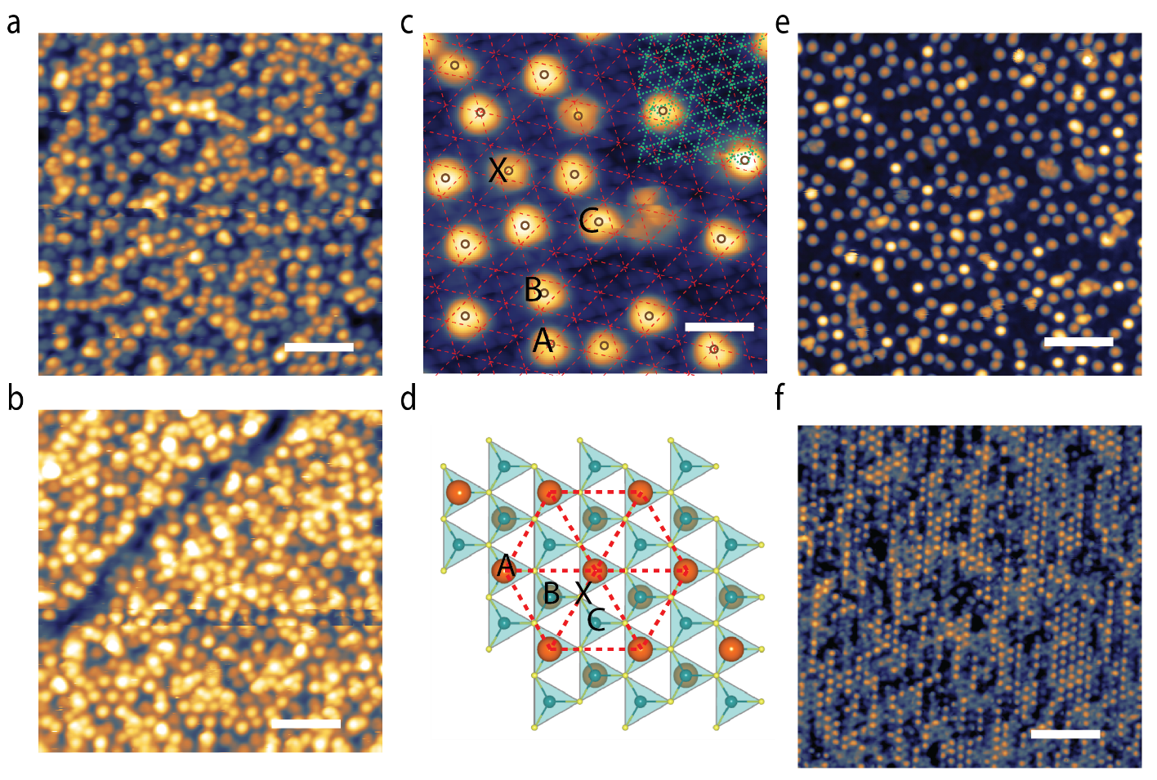
Figure S2. Temperature Dependent Cleaving Behavior. (a) STM topography of a Co_{1/3}NbS₂ surface cleaved at room temperature. (b) Another region of the sample in (a) showing a suspicious domain boundary-like feature. (-0.2 V, 50 pA, scale bar: 4 nm) (c) Atomic scale STM topography of room temperature cleaved Co_{1/3}TaS_{2.} The host material unit cell grid is shown as the dashed green mesh on the upper right corner, and the $\left(\sqrt{3}×\sqrt{3}\right)R30°$ unit cell grid is shown as the dashed red mesh. The positions of surface Co ions are marked with black circles that can be compared with the crystallographic positions in the model of (d). While most of the positions are B, there exist also A, C, and X. (d) Registration of surface Co ions in the atomic model showing an AB-stacked structure. A, B, and C are as discussed in the main text, and X is the hollow site which is normally prohibited in the bulk structure. (e,f) Comparison of room temperature (e) and low temperature (f) cleaved surface of Co_{1/3}TaS₂. The low temperature cleaved one is showing the $\left(\sqrt{3}×\sqrt{3}\right)R30°$ ordering together with partial removal of surface Co ions during cleaving. (parameters of e: -50 mV, 100 pA, f: -20 mV, 500 pA, scale bars: 4 nm)

Supplementary Note 2.
Verification of Tip Magnetization
There are diverse types of magnetized tips used in SP-STM such as ferromagnetic bulk, ferromagnetic coated, antiferromagnetic bulk, and antiferromagnetic coated ones that can be used according to the purpose of the measurement². Co_{1/3}NbS₂ and its isostructural chiral intercalaed TMDs show various magnetic orders that have complicated phase transitions as a function of temperature or magnetic field. In this study, we intended to exclude the effect of any magnetic order, so it is required to minimize stray magnetic field from a tip as it can affect the magnetic ordering of sample as well as the sophisticated spin polarization mechanism of magnetochiral interaction. It has been reported that the effect of stray field of ferromagnetic tip can reach up to 300 mT³, which normally does not make a problem for materials with large coercivity. However the chiral 1/3 intercalated TMDs often show magnetic orders (or anomaly) with very low critical fields. For example, the critical field of magnetoresistance in Cr_{1/3}NbS₂ was reported to be around 170 mT⁴. Therefore the stray field of a ferromagnetic tip is sufficient to affect the magnetic ordering of a 1/3 intercalated TMD. Considered all these factors, we believe the use of antiferromagnetic tip is the essential element in the current study. We adopted a material transfer method to coat a tip that can be applied to Cr(001) surface. A Pt/Ir alloy tip is prepared by electron beam bombardment to remove any potential contamination and then it is indented few nanometers toward the Cr(001) surface with few volts of negative bias applied to the tip. Then the tip is pulled out with a few nm/s speed until the current drops, and several repetition of the process resulted in a successful Cr transfer to the tip end.
In order to verify the magnetization of the Cr coated Pt/Ir tip, we have used the layer-by-layer antiferromagnetic contrast of Cr(001) in tunneling spectroscopy. The Cr(001) surface shows a different magnetic ordering from the bulk due to the suppressed spin density wave and the absence of spin flip transition^{5–7}. It shows a magneticc structure, in which Cr magnetic moments ferromagnetically align within a layer and antiferromagnetically align between adjacent layers. As a result, the magnetization shows the rotation of π whenever it undergoes a single atom height step. We have obtained the characteristic layer-by-layer contrast after repeated indentation. A representative result is shown in Fig. S3 where a monoatomic step is shown together with some traces of bulk impurities and particulate debris. The particulate debris have been made during the indentation process. The antiferromagnetic alignment of magnetic moment in the adjacent layers can be seen in the spatial-resolved tunneling spectroscopy in Fig. S3b. The drastic change of tunneling spectral intensity is shown by a contrast change across the step edge. The tunneling spectra obtained on the upper and the lower terace are depicted in red and blue curves in Fig. S3c, respectively. The verified tips have showed a successful observation of magnetochiral spin-polarized tunneling effect as shown in the main text. However, one of the drawback of using an antiferromagnetic tip is that its magnetization direction is usually random orientation. Therefore, this acts as a difficulty for quantitative study, and it makes hard to get the real spin-polarization ratio from the spectroscopy. In other words, the spin-polarization ratio could be underestimated by the alignment of the tip magnetization toward more in-plane direction. It is required to try cross-validation of the tip magnetization direction with a system that can measure both sensitivities along in-plane and out-of-plane direction.

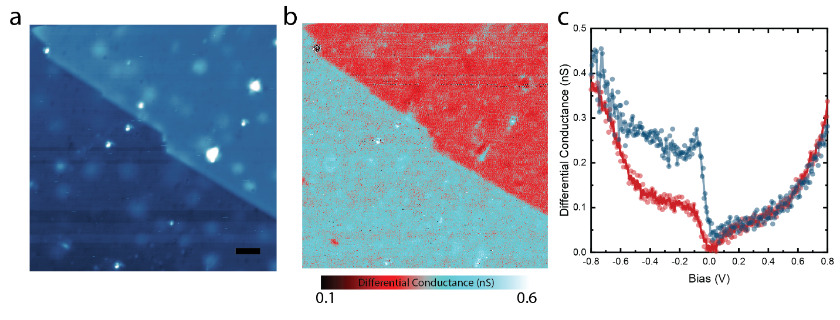
Figure S3. Verification of Magnetized Tip on Cr(001) Surface. (a) STM topography of Cr(001) surface with a monatomic step edge. ( -0.3 V, 100 pA, scale bar: 5 nm) (b) Spatial-resolved spin-polarized tunneling spectroscopy of the same region measured at -0.3 V. Clear contrast change due to the antiferromagnetic alignment of adjacent Cr layers is shown. (c) spin-polarized tunneling spectra obtained from the upper (red) and lower (blue) terrace in (a). The parallel (blue) and antiparallel (red) alignment of the tip magnetization and the surface magnetic moment produces two different tunneling spectra.
Supplementary Note 3.
Atomic Model of Chiral Domain Boundaries around a Topological Vortex
Studies on chiral 1/3 intercalated TMDs have been conducted for several decades mainly due to their various magnetisms that can be tuned by intercalant species and the change of host matrix material⁸. Especially in the case of Cr_{1/3}NbS₂, which is a variant that shows in-plane ferromagnetic order, helical magnetic order has been observed as a result of the competition between the ferromagnetic coupling that prefers parallel alignment and the inter-layer dzyaloshinskii-moriya (DM) interaction that prefers perpendicular alignment⁴. In addition to that, large anomalous hall effect of Co_{1/3}NbS₂ attracted much attention due to the accompanied magnetization anomaly near the antiferromagnetic phase transition⁹.
As a common feature of all the chiral 1/3 intercalated TMDs, domain boundaries from the structural chirality and the antiphase give the material the unique formation of six domains surrounding a topological vortex. However, little has been studied about the interaction of the exotic magnetic states mentioned above with topological vortex and chiral domains in real space. In particular, in the case of the helical magnetic order, it can be expected that the handedness of the magnetic helicity will be determined by structural chirality. However, there have been no exact atomic model of the domain boundaries so far, which gives a hurdle¹⁰. Therefore, providing a precise atomic model of the topological vortex and chiral domains will be helpful for further understanding of the interaction between the structural chirality and the helical magnetism. Based on the STM observation, we present the atomic scale model of the structural chiral domains around a topological vortex. To our best knowledge, there has been no spatially resolved surface scanning probe study on chiral domains/boundaries and topological vortex network in any of the 1/3 intercalated TMDs. It is highly likely the model can be applied to most of the isostructural 1/3 intercalated TMDs.
Fig. S4a is the atomic model of a chiral structural domain boundary drawn in accordance with the observation in Fig. 3a. The model is assuming an idealized straight domain boundary, although the real ones exhibit a curved orientation change as in Fig. 1b or Fig. 2. However, it does not change the fact that domain boundary has less density of Co ions than the inside region of a domain. The Co-deficient nature is represented by the inter-row distance compared between normal and boundary region in the schematic. The model depicts the situation of an Upper domain boundary as can be seen from the change of the intercalant site on the surface (solid blue to solid red circles), while that does not change in Lower Co (hollow green circles). A similar model can be constructed for a Lower domain boundary by exchanging Upper and Lower Co lattice. It should be noted that the model previously proposed¹⁰ by the author and the model presented at this time are different in that the intercalant density is lower near the domain boundary, but the change does not give a difference to the extintion rule observed in DF-TEM. Whether the boundary region gives additional or deficient number of Co intercalant does not change the fact that the region has antiphase shift along all three equivalent $\vec{q}$ directions, and it makes the boundary observable in DF-TEM relevant to all three $\left(\sqrt{3}×\sqrt{3}\right)R30°$ superlattice peak directions¹⁰. Nevertheless, that can be of importance when one tries to study the interaction of the localized magnetic moments of Co ions across a domain boundary.
Six chiral structural domain boundaries converge at a topological vortex, which possesses a topological robustness. The robustness means that a topological vortex cannot be removed by themselves, and can be removed only by going out of the sample or annihilated by the recombination with a nearby antivortex. The topological robustness can be also witnessed in the structure of the domain boundary. Fig. S4b shows the approach and the (virtual) crossing of two chiral structural domain boundaries. The Upper and Lower domain boundaries change the intercalant site in the Upper and the Lower Co, respectively. (i.e. the solid line exchanges the solid blue and red circles. The dashed line changes the hollow red and green circles.) However, their crossing at the center resulted in a switch of both of the Upper and the Lower Co lattice and eventually forms a AA-type stacking. As the crystal structure only allows AB-type stacking, we can see that the crossing of an Upper and a Lower domain boundary is not allowed. As a result, the topological vortex structure as shown in Fig. S4c forms a robust defect while the order of domain appearance cannot be altered.

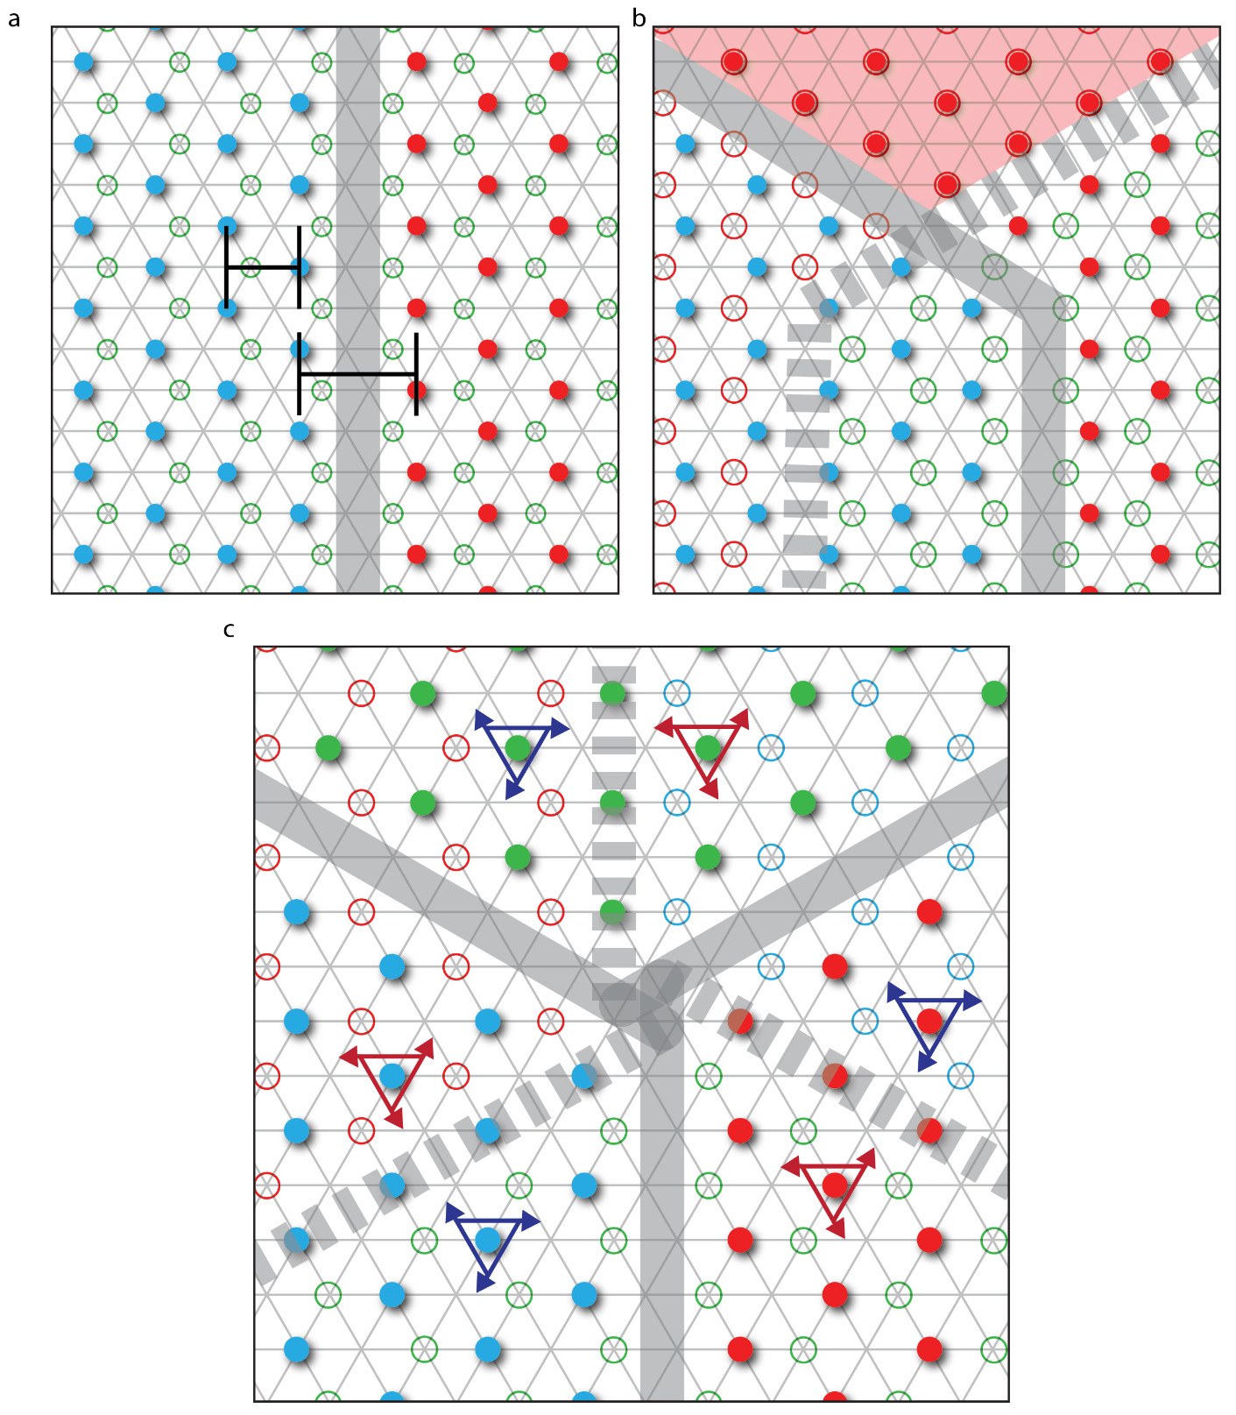
Figure S4. Atomic Model of Chiral Structural Domain Boundary and Topological Vortex. (a) Atomic model of Upper domain boundary. The Co intercalation site is changed in Upper Co lattice from blue to red circles across the boundary, while that of Lower Co lattice (green circle) is intact. The Co deficient nature of the boundary is represented by the average distance between Co rows inside the domain and the domain boundary region. (b) Prohibition of domain-boundary crossing. Crossing of the Upper (solid line) and the Lower (dashed line) domain boundary results in a formation of the AA-type stacking (red shade) that is prohibited in the crystal structure. The mechanism forces the domains not to change the order of appearance around a topological vortex and contribute to the topological robustness of the vortex structure. (c) Atomic model of a topological vortex and nearby chiral structural domains. The alternating arrangement of Upper and Lower domain boundaries results in a complete circulation through all the permutations of the stacking sequence. The opposite chiralities are depicted by the red and the blue triangular arrows.

Supplementary Note 4.
Rotation of Displacement Vector around a Topological Vortex
The topological robustness can also be examined in the change of the displacement vectors of the sulfur lattice where we can define topological charge¹¹. Fig. S5 shows the change of the sulfur displacement vectors that is projected to a point of the unit cell grid. In other words, they are analyzed by the modulus to unit cell translation. The shift of the Upper or the Lower Co at the domain boundary causes the displacement vectors to rotate by 2π/3 between any adjacent domains. Eventually, when the displacement vector completes a winding around the vortex, the displacement vector finishes 4π rotation. It should be noted that in the case of two opposite domains showing the same sulfur displacement vector, they have the reversed stacking sequence due to the anti-phase shift. The completion of 4π rotation represents a completed circular pattern in the discrete order parameter space that is formed by using S displacement vector as an order parameter¹². In order to remove the circular pattern, one must pass through the center point which means the breaking of the chiral distortion of the crystal structure. Similar entangled domain boundaries and its robustness can be found in various systems¹¹ such as hybrid improper ferroelectrics¹³, incommensuration in charge density wave¹⁴, or dislocation in metal interfaces¹⁵.

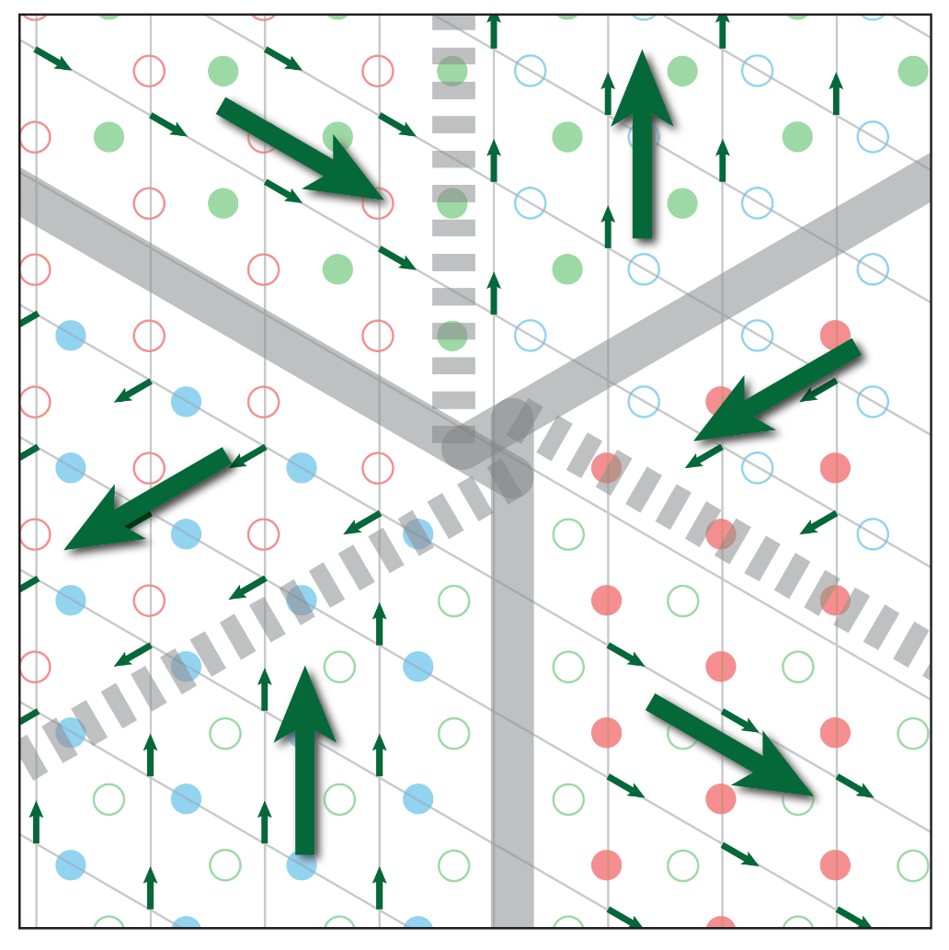
Figure S5. Rotation of Displacement Vectors of Sulfur Lattice. (a) The atomic model of a topological vortex is analyzed in association with a unit cell grid. The hexagonal unit cell grid is overlaid through all the six domains and one particular sulfur position at the crossing point is analyzed. The displacement vectors of the sulfur ions (sitting at the crossing points) rotate by 2π/3 across a boundary and result in a complete 4π rotation around the vortex. Note that two domains with the same displacement vector direction exhibits the opposite stacking sequences, which results in prohibited dissociation of the vortex as described in the SI note 3.

Supplementary Note 5.
Determination of the Zero Crossing Point
When we obtain tunneling spectra across two domains with opposite chirality, it is obvious that the slopes are different throughout the measured bias range. The difference in the slopes means that the magnetochiral spin-polarized tunneling effect contributes the opposite way in the domains with different chiralities. However, the determination of the exact crossing point, where the magnetochiral effect vanishes, is a sophisticated problem. Usually tunneling spectra in STM are measured using a constant tip height to remove any change of tunneling barrier between a tip and a sample. However, the selection of the tip height, which is done by choosing a combination of a bias and a tunneling current, is subject to various experimental details. In general, the normalization bias, which is the applied bias before the feedback is open, should be selected far from the specific features of a spectrum or from the opposite side of the region of interest. In our case, we had to select the normalization bias close to the point where the spectra have the vanished magnetochiral effect, and that has been done by tracing the systematic change of the crossing point upon change of the normalization bias. In other words, the crossing point was measured with various normalization biases, and we found a convergence of the crossing point towards the zero-bias whenever the normalization bias moves towards zero. Fig. S6 shows the two representative spectra showing the effect of the normalization bias change. The solid and hollow curves show the spectra using normalization biases of -10 mV and +10 mV, respectively. The crossing points were measured at -9.5 mV and +6.5 mV, respectively, which are all between the normalization bias and the zero. By changing the normalization bias closer to zero, the crossing point converges to zero no matter bias polarity we chose. As a result of the convergence, we were able to find that the magnetochiral spin-polarized tunneling effect vanishes at the zero bias. Since the normalization bias cannot be located exactly at zero bias due to the instability of the feedback system, the spectra shown in the main text were obtained through the average of two measurements from normalization biases of +1 mV and -1 mV.
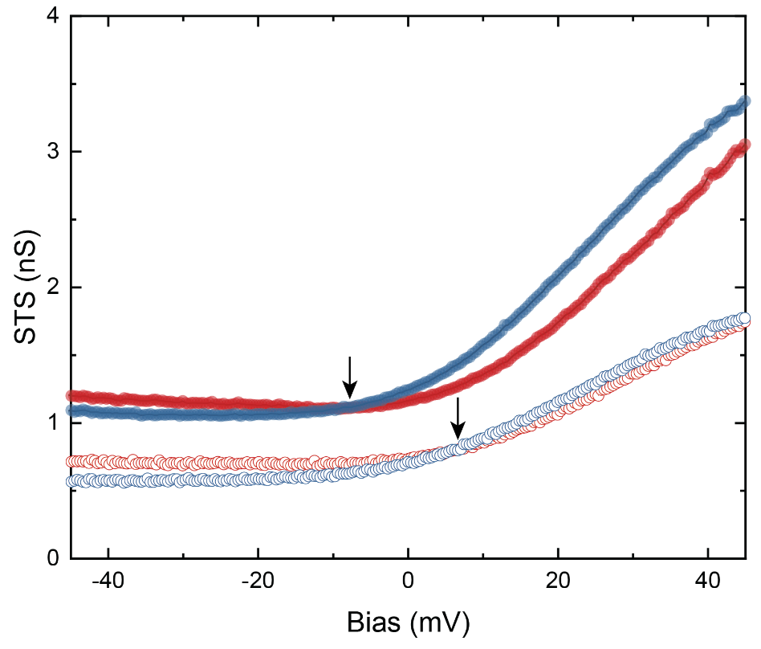
Figure S6. Determination of the Crossing Point. Two sets of spin-polarized tunneling spectra obtained with the normalization biases of -10 mV (solid) and +10 mV (hollow). The red and blue colors depict two domains with opposite chiralities. The crossing points for the two biases were measured at -9.5 mV and +6.5 mV, respectively. (black arrows) There observed a systematic convergence of the crossing points towards zero bias as the normalization bias approaches to zero in both bias polarities.

References

1. Lin, S.-Z. et al. Topological defects as relics of emergent continuous symmetry and Higgs condensation of disorder in ferroelectrics. Nature Physics 10, 970–977 (2014).
2. Wiesendanger, R. Spin mapping at the nanoscale and atomic scale. Rev. Mod. Phys. 81, 1495–1550 (2009).
3. Kubetzka, A., Bode, M., Pietzsch, O. & Wiesendanger, R. Spin-Polarized Scanning Tunneling Microscopy with Antiferromagnetic Probe Tips. Phys. Rev. Lett. 88, 057201 (2002).
4. Wang, L. et al. Controlling the Topological Sector of Magnetic Solitons in Exfoliated Cr1/3NbS2 Crystals. Phys. Rev. Lett. 118, 257203 (2017).
5. Hänke, T. et al. Absence of spin-flip transition at the Cr(001) surface: A combined spin-polarized scanning tunneling microscopy and neutron scattering study. Phys. Rev. B 71, 184407 (2005).
6. Kleiber, M., Bode, M., Ravlić, R., Tezuka, N. & Wiesendanger, R. Magnetic properties of the Cr(001) surface studied by spin-polarized scanning tunneling spectroscopy. Journal of Magnetism and Magnetic Materials 240, 64–69 (2002).
7. Kleiber, M., Bode, M., Ravlić, R. & Wiesendanger, R. Topology-Induced Spin Frustrations at the Cr(001) Surface Studied by Spin-Polarized Scanning Tunneling Spectroscopy. Phys. Rev. Lett. 85, 4606–4609 (2000).
8. Parkin, S. S. & Friend, R. H. 3d transition-metal intercalates of the niobium and tantalum dichalcogenides i. Magnetic properties. Philosophical Magazine B: Physics of Condensed Matter; Statistical Mechanics, Electronic, Optical and Magnetic Properties 41, 65–93 (1980).
9. Ghimire, N. J. et al. Large anomalous Hall effect in the chiral-lattice antiferromagnet CoNb 3 S 6. Nature Communications 9, 3280 (2018).
10. Horibe, Y. et al. Color Theorems, Chiral Domain Topology, and Magnetic Properties of FexTaS2. J. Am. Chem. Soc. 136, 8368–8373 (2014).
11. Huang, F.-T. & Cheong, S.-W. Aperiodic topological order in the domain configurations of functional materials. Nature Reviews Materials 2, 17004 (2017).
12. Mermin, N. D. The topological theory of defects in ordered media. Rev. Mod. Phys. 51, 591–648 (1979).
13. Oh, Y. S., Luo, X., Huang, F.-T., Wang, Y. & Cheong, S.-W. Experimental demonstration of hybrid improper ferroelectricity and the presence of abundant charged walls in (Ca,Sr)3Ti2O7 crystals. Nat Mater 14, 407–413 (2015).
14. Lim, S., Kim, J., Won, C. & Cheong, S.-W. Atomic-Scale Observation of Topological Vortices in the Incommensurate Charge Density Wave of 2H-TaSe2. Nano Lett. 20, 4801–4808 (2020).
15. Shao, S., Wang, J., Misra, A. & Hoagland, R. G. Spiral Patterns of Dislocations at Nodes in (111) Semi-coherent FCC Interfaces. Scientific Reports 3, 1–7 (2013).

