Appendices
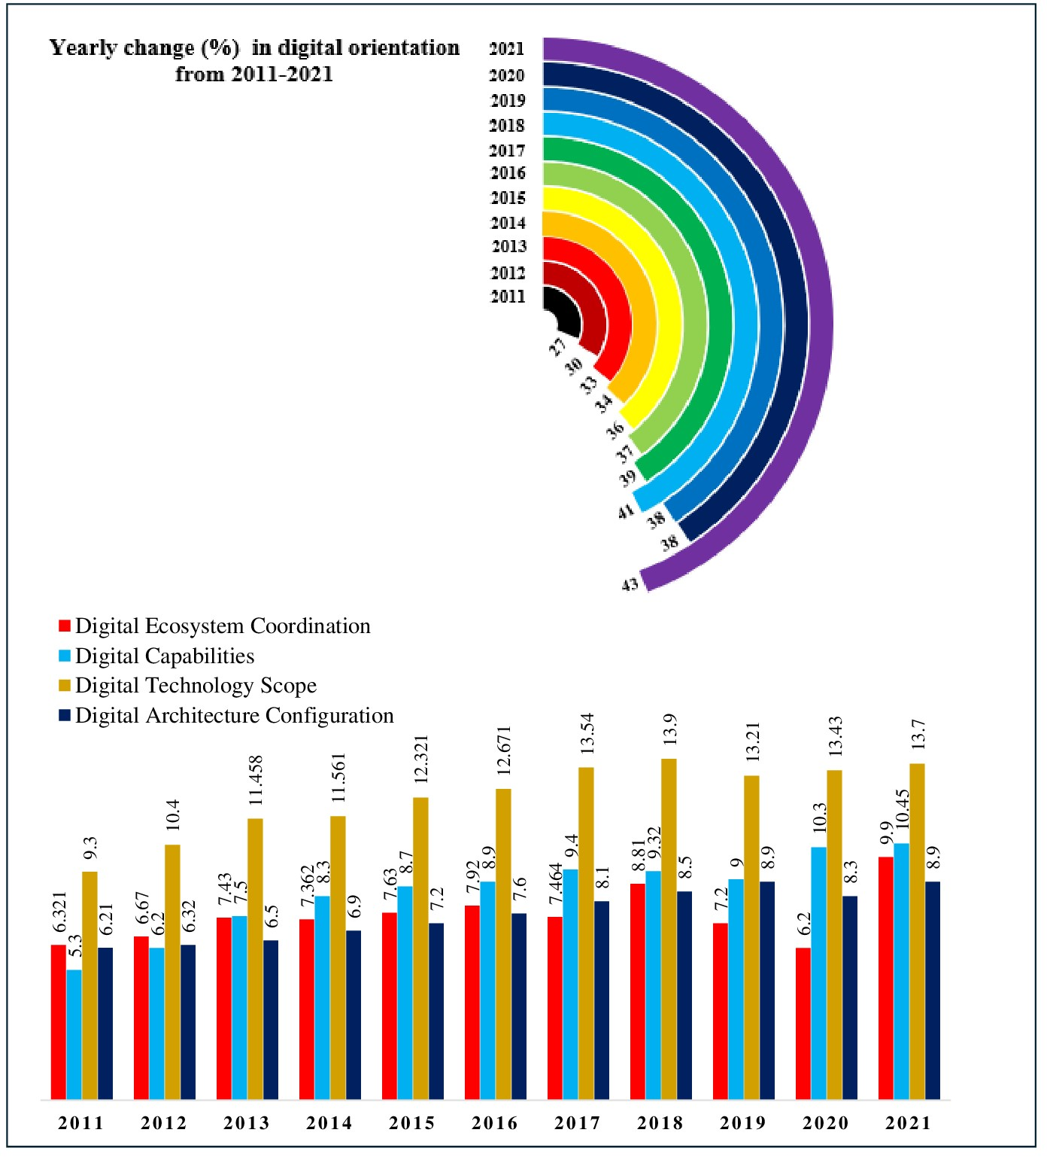

Appendix 1 . Yearly change in digital orientation dimensions
Appendix 2 Value-added intellectual capital (VAIC) measurement
Value-added intellectual capital | VAIC | VAIC = HCE + SCE + CEE
Value added | VA | VA= Operating profit + Salaries and wages + Depreciation + Amortization.
Human capital efficiency | HCE | HCE = VA/HC  Human capital (HC)= Total salaries and wages.
Structural capital efficiency | SCE | SCE = SC/VA  Structural capital (SC) = VA - HC.
Capital employed efficiency | CEE | CEE = VA/CE  Capital employed (CE) = Total assets - Current liabilities.

