Additional figure 1

A New Tool: The microFLOQ®Direct Swab

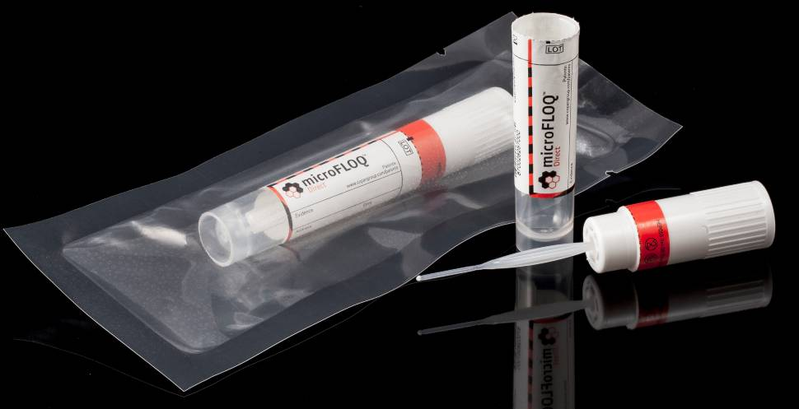

a
b
Additional figure 1: Illustration of microFLOQ® Direct swab (source COPAN Flock Technologies), a: microFLOQ® Direct swab in its sterile packaging, b: The head of the swab with the flocked fibers on the extremity and the breaking point (blue arrow).

Additional figure 2

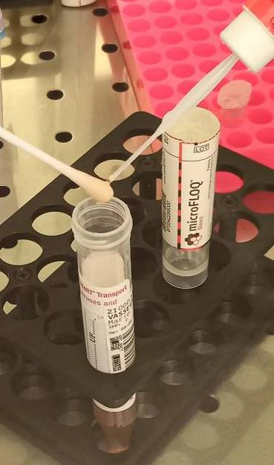

Additional figure 2: Subsampling method using the microFLOQ® Direct swab by tapping the tip of the swab used for nasopharyngeal collection.

Additional figure 3

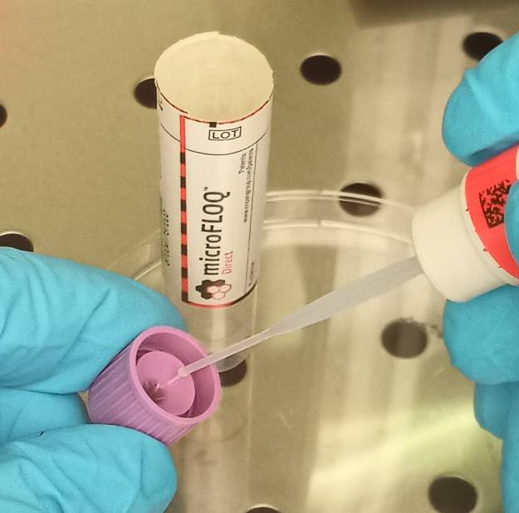

Figure 3: Subsampling method using the microFLOQ® Direct swab by touching the tip in the transport medium present inside the cap of the sample.

