Development a New Carbon Nanocomposite Containing MWCNT as adsorbent for Effective Removal of Cloxacillin
Amir-Mohammad Golkarieh¹, Navid Nasirizadeh²*, Reza Jahanmardi¹, Mohammad Dehghani², Saeed Jafari²,
¹ Department of polymer engineering, Science and research branch, Islamic Azad University, Tehran, Iran
² Department of textile and polymer engineering, Yazd branch, Islamic Azad University, Yazd, Iran
Corresponding author: Navid Nasirizadeh, nasirizadeh@iauyazd.ac.ir
Fax number: +9835-3187-2280
Table of content:
Scheme S1- Chemical structure of Cloxacillin.
Scheme S2 - Schematic diagram for modification of screen printed carbon electrode with graphene oxide and gold nanourchin.
Fig. S1. FESEM images of the screen printed carbon electrode modified with (a) graphene oxide and (b) gold nanourchin/graphene oxide.
Fig S2 - Zeta potential of MWCNTs -carbon composite adsorbent particles at different pHs.
Table S1 4 - Summary of FTIR spectroscopy for MWCNT/CC after adsorption of Clox.
Fig S3. Kinetic data for removal of Clox by the designed carbon nanocomposite (pH =5.0, adsorbent: 1.52 g/L modified nanocomposite with 2.9 wt.% MWCNTs) at different initial concentration of Clox versus contact time.
Fig S4- Kinetic adsorption data for the carbon nanocomposites containing MWCNTs at different initial concentration of Clox versus contact time (pH =5.0, adsorbent: 1.52 g/L modified nanocomposite with 2.9 wt.% MWCNTs).
Fig S5. van't Hoff Plot of the Thermodynamic Data from Clox adsorption on MWCNT-CC.

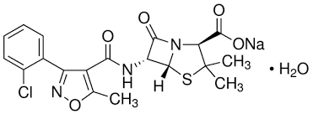
Scheme S1- Chemical structure of Cloxacillin.
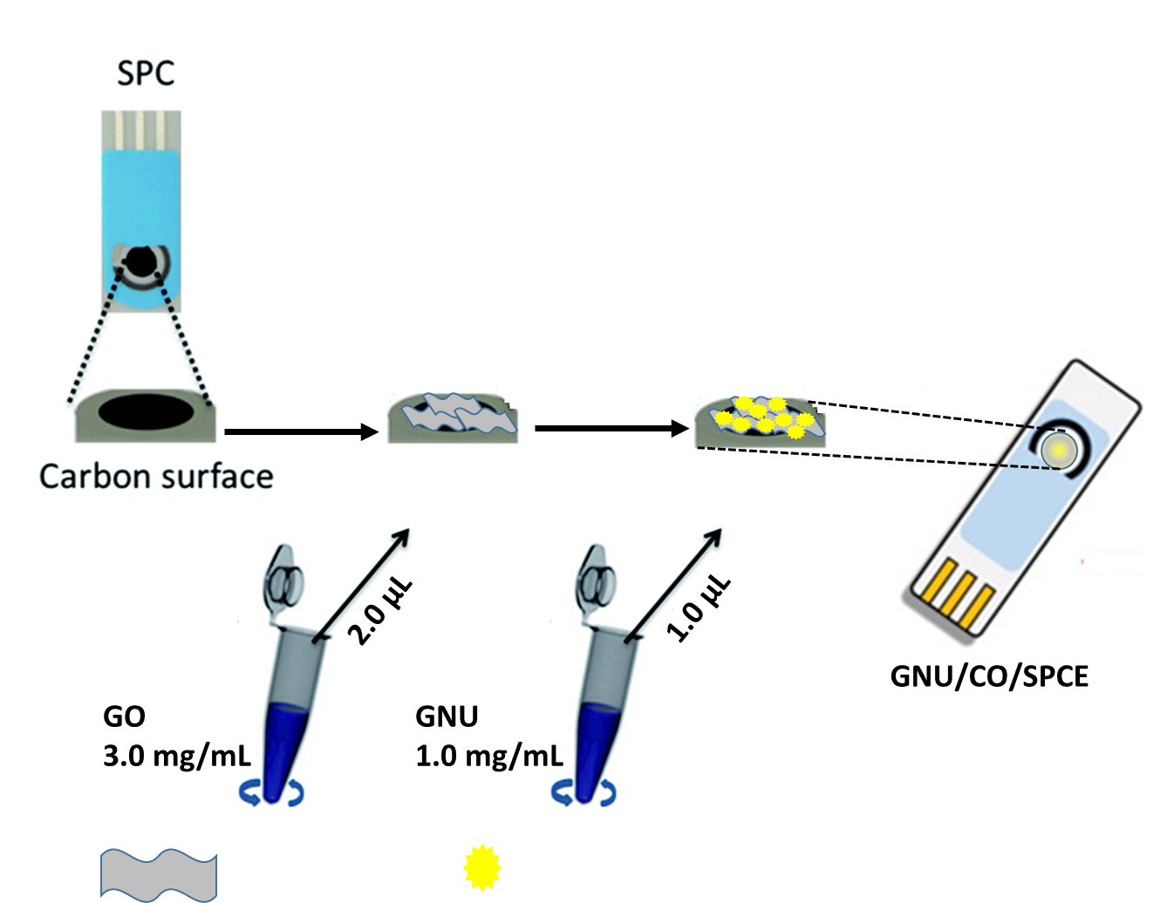
Scheme S2 - Schematic diagram for modification of screen printed carbon electrode with graphene oxide and gold nanourchin.
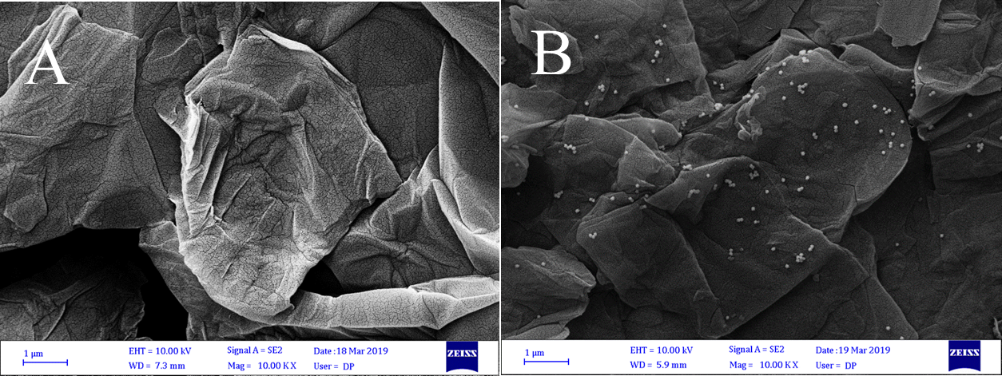
Fig. S1. FESEM images of the screen printed carbon electrode modified with (a) graphene oxide and (b) gold nanourchin/graphene oxide.
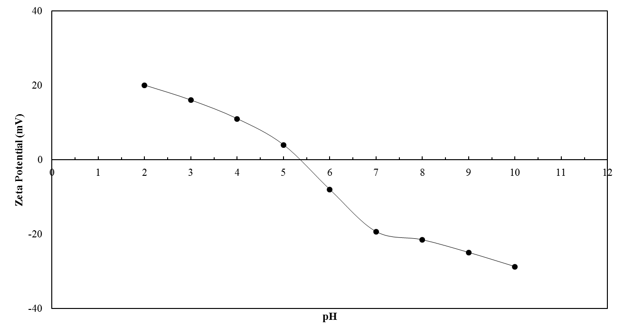
Fig S2 - Zeta potential of MWCNTs -carbon composite adsorbent particles at different pHs.
Table S1 4 - Summary of FTIR spectroscopy for MWCNT/CC after adsorption of Clox.
Sample | Absorption band (cm⁻¹) | Functional group
Clox | 3502 | O-H (Stretch)
Clox | 3357 | O-H (Stretch)
Clox | 1764 | C=O (carboxylic acid)
Clox | 1604 | N-H
Clox | 1504 | N-O
Clox | 1419 | (Aromatic) C-C
Clox | 1334 | (Aromatic) -N
Clox | 1143 | -COO
Clox | 773 | C-Cl
MWCNT-CC | 3357-3502 | O-H (Stretch)
MWCNT-CC | 1143 | -COO

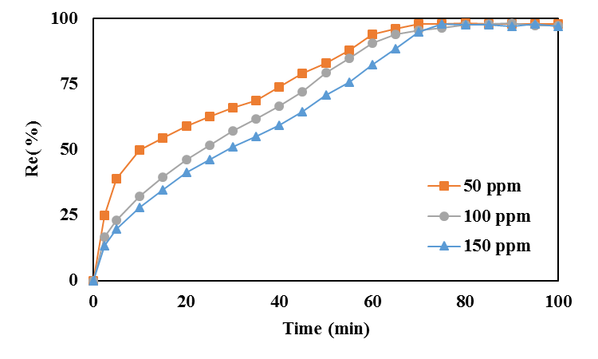
Fig S3. Kinetic data for removal of Clox by the designed carbon nanocomposite (pH =5.0, adsorbent: 1.52 g/L modified nanocomposite with 2.9 wt.% MWCNTs) at different initial concentration of Clox versus contact time.
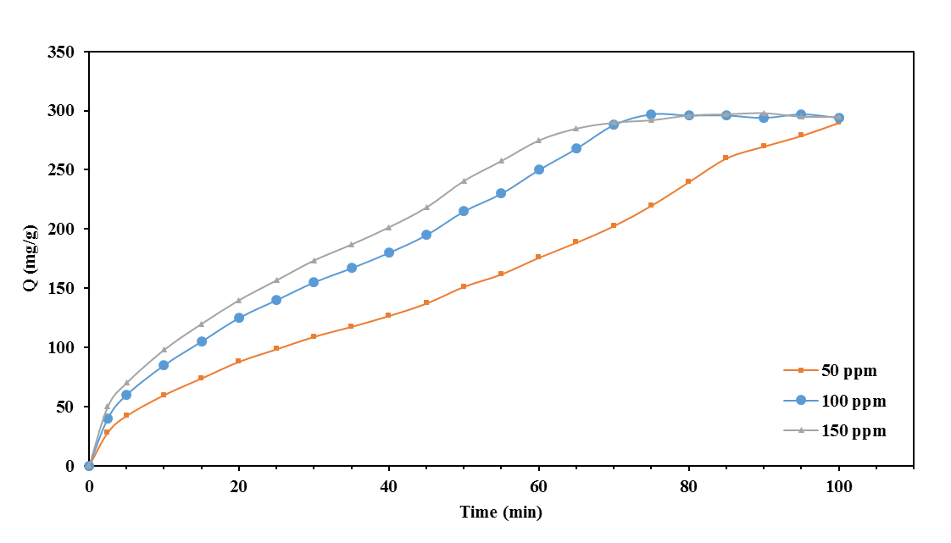
Fig S4- Kinetic adsorption data for the carbon nanocomposites containing MWCNTs at different initial concentration of Clox versus contact time (pH =5.0, adsorbent: 1.52 g/L modified nanocomposite with 2.9 wt.% MWCNTs).

Fig S5. van't Hoff Plot of the Thermodynamic Data from Clox adsorption on MWCNT-CC.

