Injectable Bioresorbable Conductive Hydrogels for Multimodal Brain Tumor Electroimmunotherapy
Authors: Amit Singh Yadav¹, Umut Aydemir¹, Karin Hellman¹, Peter Ekström¹, Abdelrazek H. Mousa^{2,3}, Jiaxin Li⁴, Muhammad Anwar Shameem², Johan Bengzon^{4,5}, Fredrik Ek¹, Martin Hjort¹ and Roger Olsson^{1,2,6}*
¹Chemical Biology & Therapeutics, Department of Experimental Medical Science, Lund University; SE-221 84 Lund, Sweden,
²Department of Chemistry and Molecular Biology, University of Gothenburg; SE-405 30 Gothenburg, Sweden.
³Chemistry Department, King Fahd University of Petroleum and Minerals; Dhahran 31261, Saudi Arabia
⁴Department of Neurosurgery, Skane University Hospital; Lund, Sweden
⁵Kamprad Laboratory, Department of Clinical Sciences, Lund University; Lund, Sweden ⁶Department of Chemistry, Lund University; P.O. Box 124, 221 00 Lund, Sweden

*Corresponding author. Email: roger.olsson@med.lu.se

Supplementary Figures

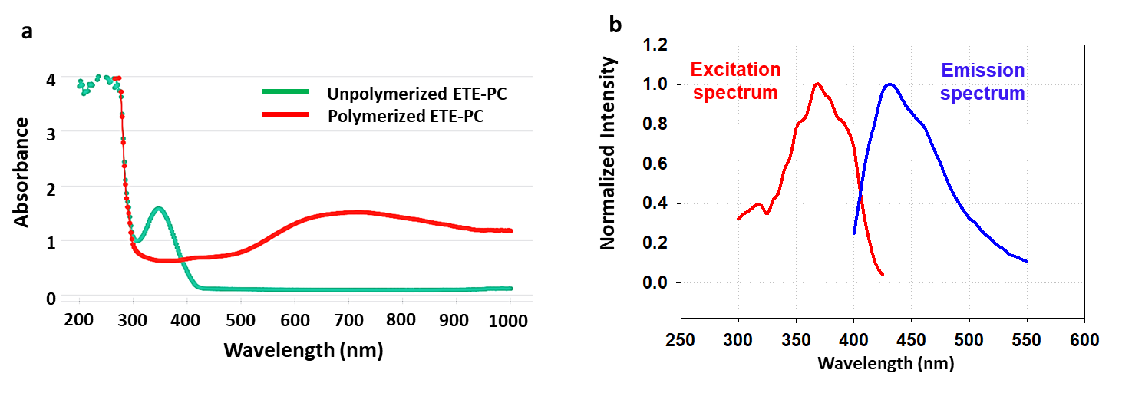

Fig. S1: Physicochemical characterization of ETE-PC (a) UV-Visible spectra of unpolymerized vs polymerized ETE-PC. (b) Fluorescence spectra of ETE-PC representing excitation and emission maxima.
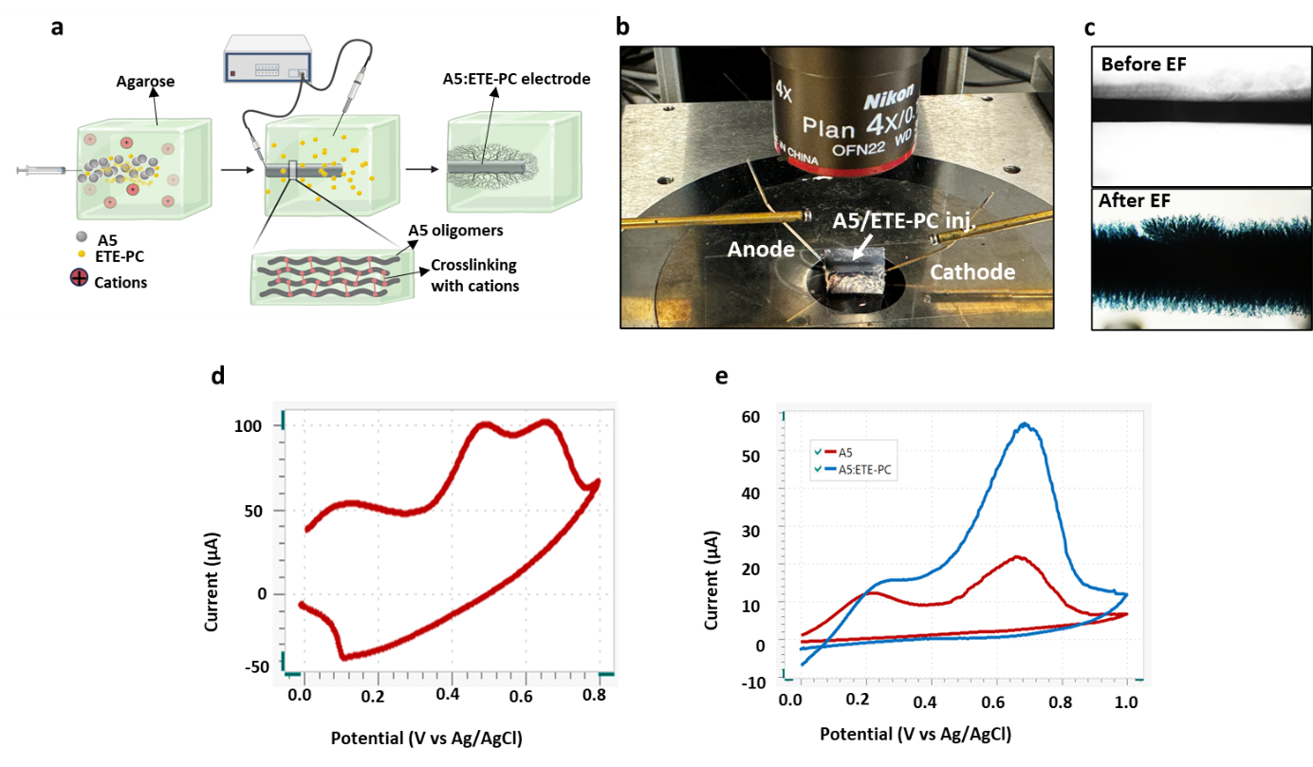

Fig. S2: Evaluation of A5:ETE-PC 3D flexible electrode in agarose. (a) Schematic representation of A5:ETE-PC electrode assembly in agarose. (b) Experimental setup for electrofunctionalization of ETE-PC on A5 for electrode assembly after injection in agarose mold. (c) ETE-PC electrofunctionalization on A5 after applying a bias of 2V via Au-coated W-electrode. (d) Cyclic voltammetry characterization of ETE-PC electrofunctionalization on A5 recorded between –0.01 and 0.8 V potential range and 10 mV/ s scan rate in 0.5% agarose (PBS, pH7.4). (e) A5 vs. A5:ETE-PC Cyclic voltammograms recorded between –0.01 and 0.8 V potential range and 50 mV/s scan rate in 0.5% agarose (PBS, pH7.4).

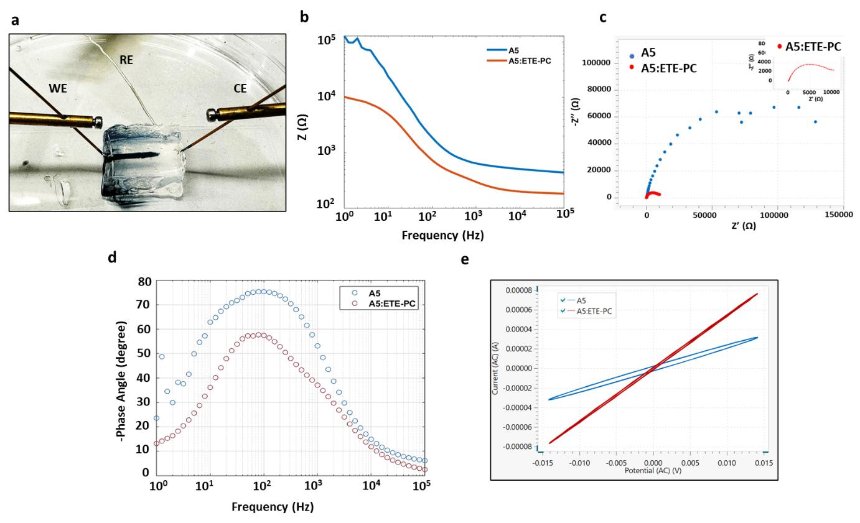
Fig. S3: Electrical impedance spectroscopic evaluation of A5 vs A5:ETE-PC electrode. (a) Three electrode system including A5:ETE-PC electrode (externally connected with Au coated metal electrode) as working electrode, Au coated metal as counter electrode and Ag/AgCl as reference electrode for electrochemical impedance spectroscopy (EIS) analysis in agarose mold. (b) EIS characterization is used to compare the impedance of Au vs. A5:ETE-PC electrode in 0.5% agarose. Bode plot demonstrate impedance. (c) Nyquist plots of EIS measurement using A5 or A5:ETE-PC electrodes in agarose mold (inset: magnified Nyquist plot for A5:ETE-PC electrode). (d) Bode plot of EIS measurement using A5 or A5:ETE-PC electrodes in agarose mold showing phase angle. (e) Lissajous plot showing current as a function of potential for EIS measurements using A5 or A5:ETE-PC electrodes in agarose mold.

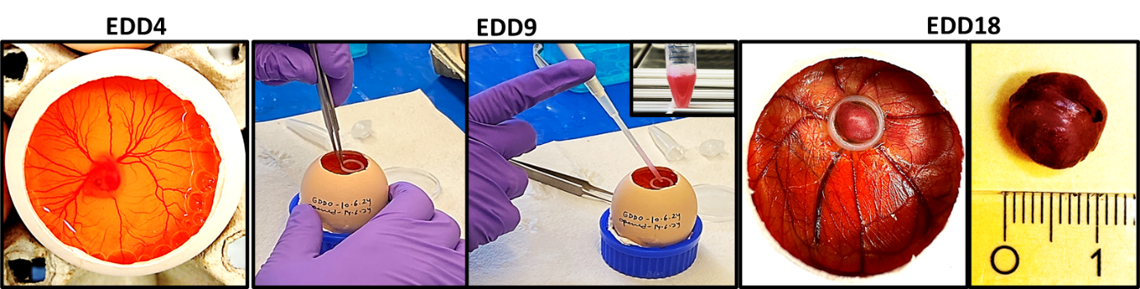
Fig. S4: Development of chicken chorioallantoic membrane (CAM) in vivo tumor model

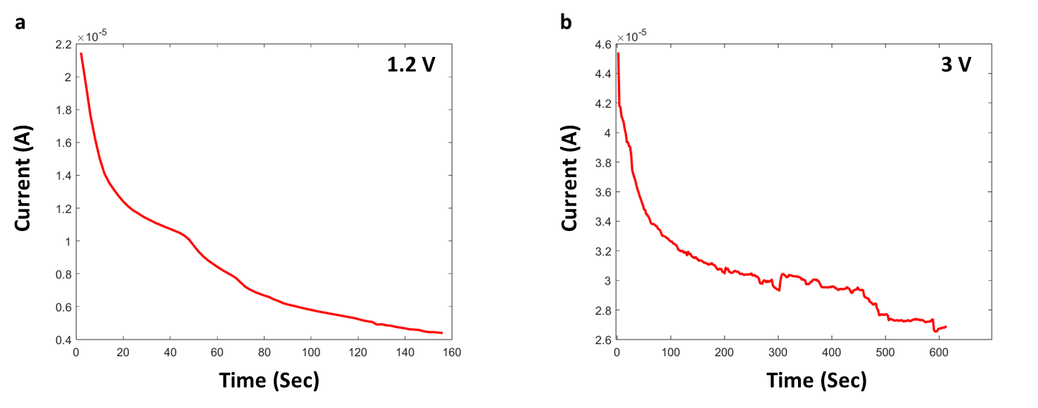

Fig. S5: Evaluation of A5:ETE-PC electrode in U87 tumors. Current flow during in vivo electrofunctionalization of A5+ETE-PC, (a) 1.2 V was initially applied for 2.5 minutes between the microcapillary and counter electrode during functionalization (b) Second electrofunctionaliztion was performed after 5 min by applying 3V for 10 min.

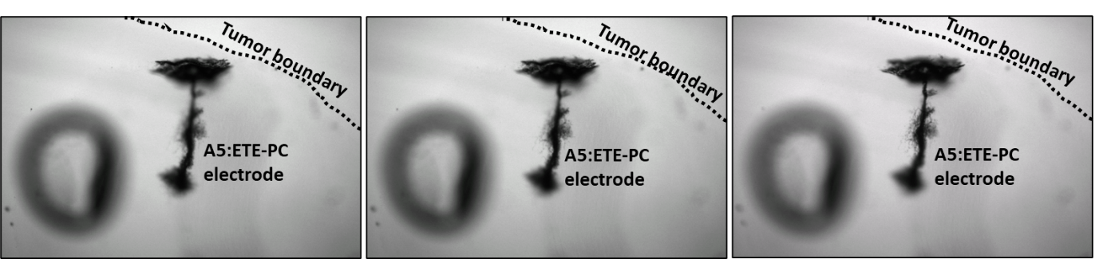
Fig. S6: 3D reconstructed image of A5:ETE-PC electrode in tumor at various focuses after tissue clearing process.

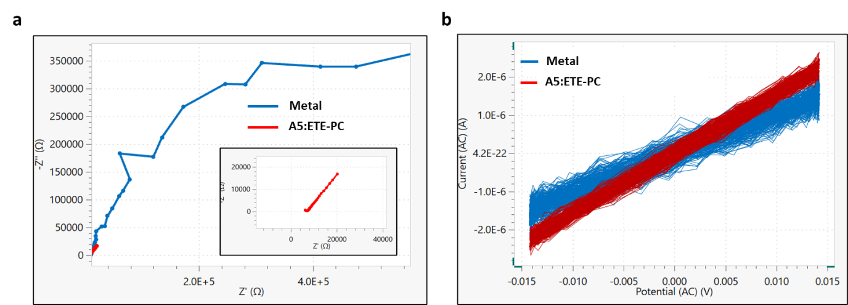
Fig. S7: Electrochemical impedance spectroscopic evaluation of A5:ETE-PC electrode in U87 tumors. (a) Nyquist plots of EIS measurement with metal or A5:ETE-PC electrode in tumor. (inset: magnified Nyquist plot for A5:ETE-PC electrode in tumor). (b) Lissajous plot showing current as a function of potential for EIS measurements with metal or A5:ETE-PC electrode in tumor
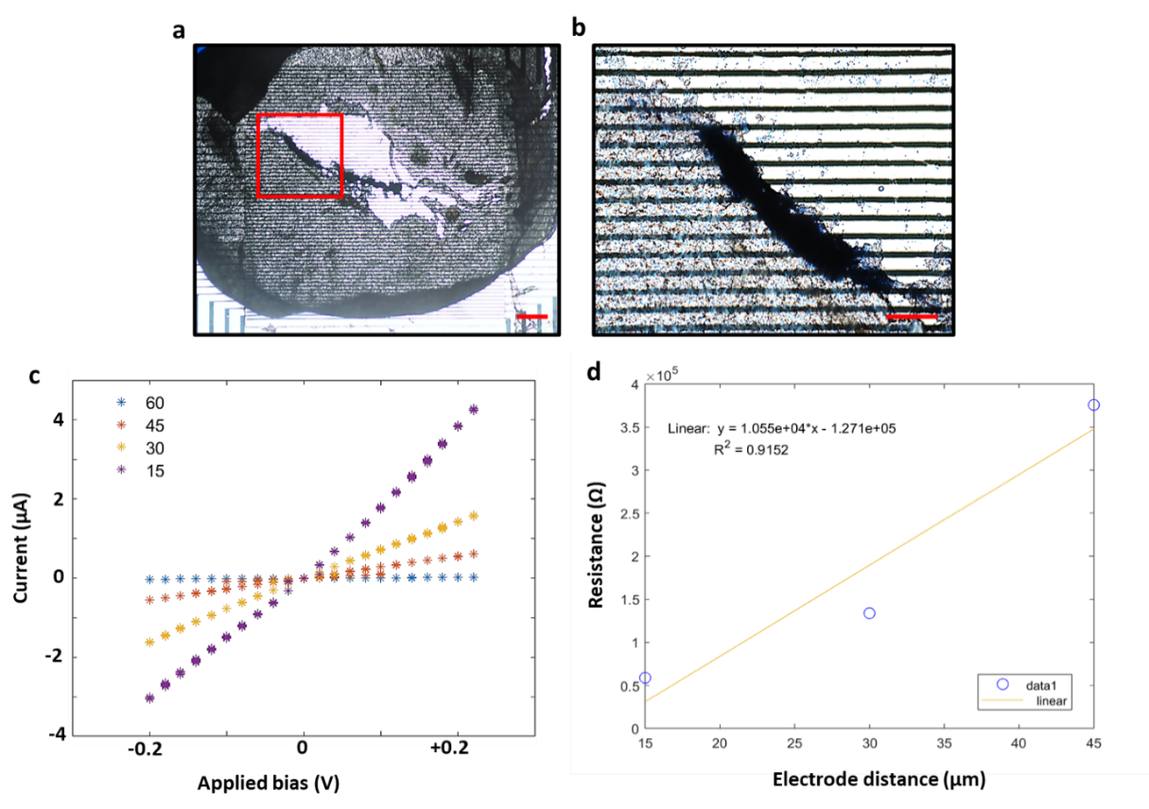

Fig. S8: Electrical properties of A5:ETE-PC in tumor tissue. (a-c) Electrical measurements of sectioned tumor injected with A5:ETE-PC. Images show lower and higher magnification of A5:ETE-PC containing tumor section on glass slide with interdigitated gold electrodes. Current–voltage sweeps obtained with increasing distance between electrodes; scale bar: 300 µm (a), 100 µm (b). (d) Linear Curve Fitting of resistance vs electrode distance data acquired from electrical measurements of A5:ETE-PC containing tumor section on glass slide with interdigitated gold electrodes. Data point at 60 µm was excluded as it was out of range.
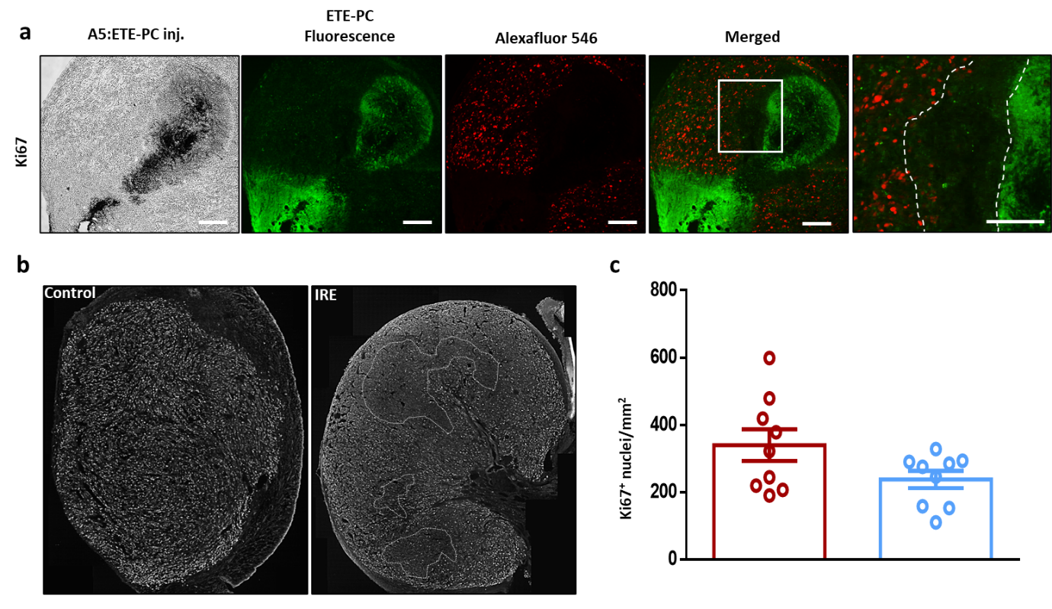
Fig. S9: A5:ETE-PC electrode mediated IRE inhibits tumor cell proliferation. (a) Fluorescence images of IRE-treated tumor (3x10, 1000 V pulses, 1ms) demonstrate staining of Ki67 in U87 tumor sections (16 µm). ETE-PC monomer fluorescence (green), Ki67 (red). Scale bar: 200 µm. (b) Ki67 stained nuclei in binary images of the whole tumor section created from multiple overlapping images. (c) The number of Ki67⁺ nuclei and the area of the whole section were calculated from 9 different sections in control and IRE groups each. The plot represents Ki67⁺ nuclei/mm² in tumor sections, mean ± SEM, n=9 from 3 independent experiments.
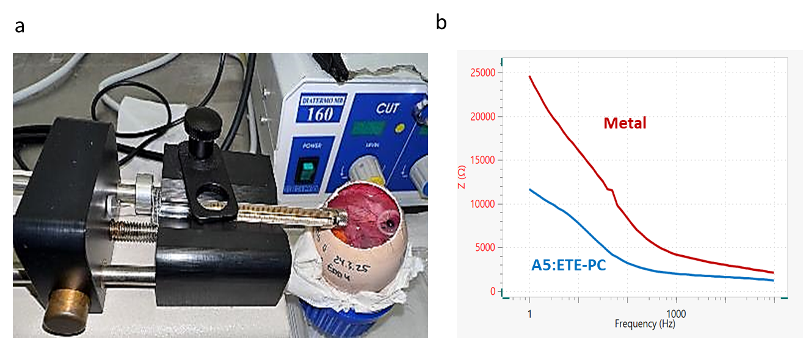

Fig. S10: Convection enhanced delivery of A5: ETE-PC in U87 tumor. (a) Set up for convection enhanced delivery of A5:ETE-PC in U87 tumor (b) Bode plot showing impedance of metal vs A5:ETE-PC electrode injected via CED.

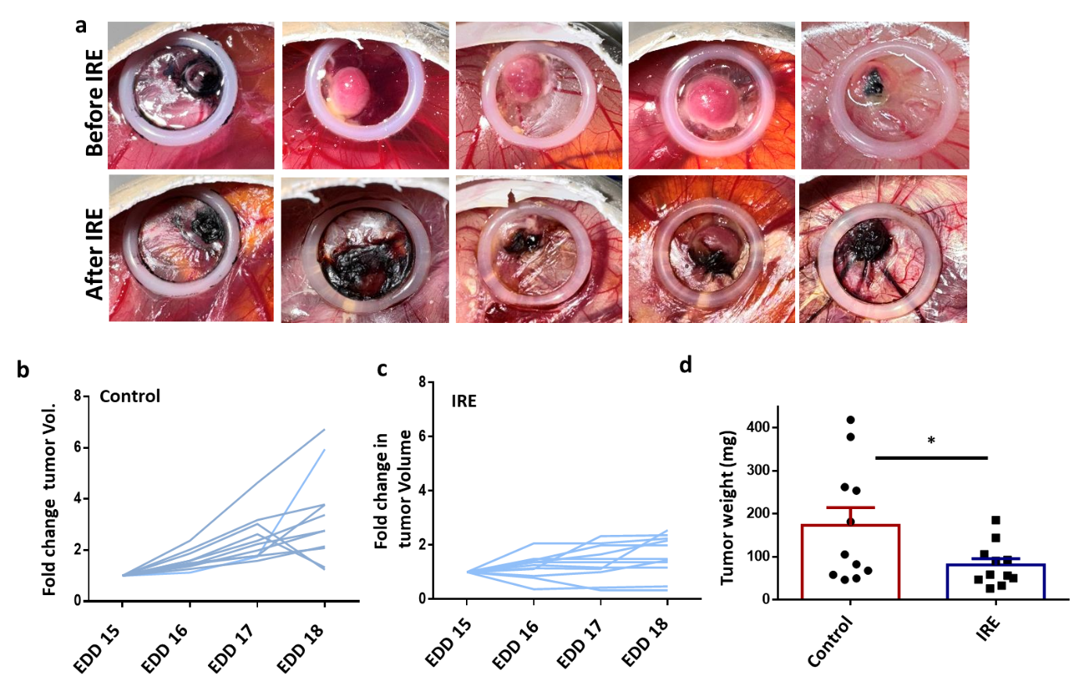
Fig. S11: IRE via A5: ETE-PC electrode abrogates U87 tumor growth. (a) Photographs of tumor before and after convection enhanced delivery of A5:ETE-PC followed by IRE. Images were taken 24-48 h post IRE. (b) Line graphs representing the growth of individual tumors in control and IRE groups. (c) Tumors were excised, weighed, and analyzed statistically. The bar graph represents mean tumor weight ± SEM, n=11. Unpaired t-test was used to compare difference in tumor weight; *p < 0.05
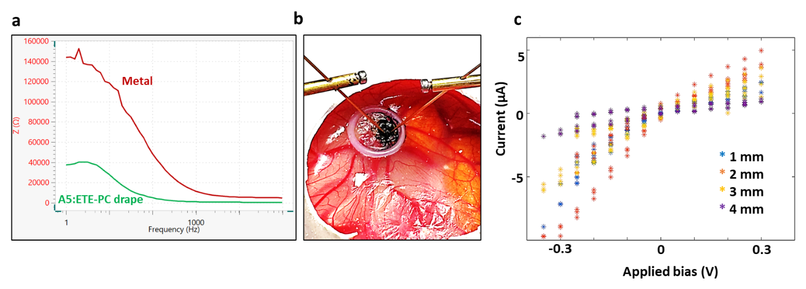
Fig. S12: EIS analysis of A5:ETE-PC Drape (a) EIS analysis if tumor cavity before and after drape formation. Bode plot represents impedance of metal electrode vs A5:ETE-PC drape in resection cavity. (b) Electrical analysis was performed between two Au coated electrodes placed at various distances on A5:ETE-PC drape in resection cavity. (c) Current–voltage sweeps obtained between the contacts on drape shown in the figure.

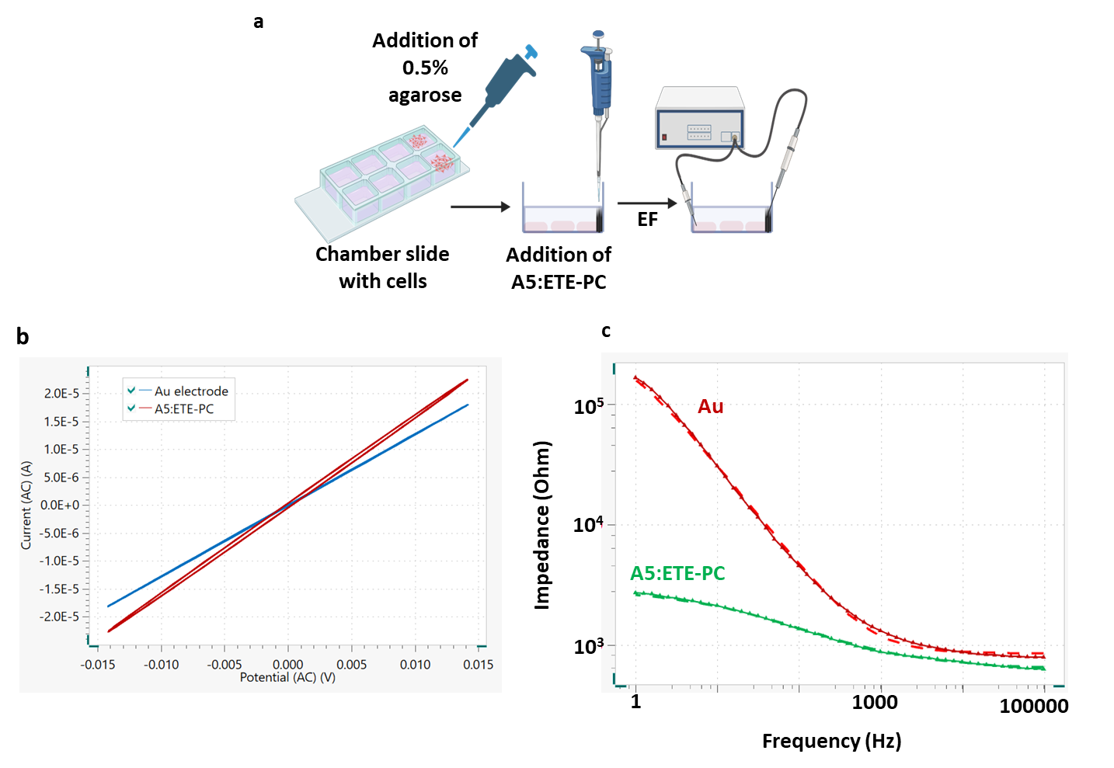

Fig. S13: Evaluation of in vitro model for cell-based studies. (a) Schematic representation of A5:ETE-PC electrode assembly for in vitro studies. (b) Lissajous plot showing current as a function of potential for EIS measurements using Au coated metal or A5:ETE-PC electrodes in in vitro agarose model for cell-based studies. (c) Bode plots showing impedance measurement using Au coated metal or A5:ETE-PC electrodes in in vitro agarose model for cell-based studies.
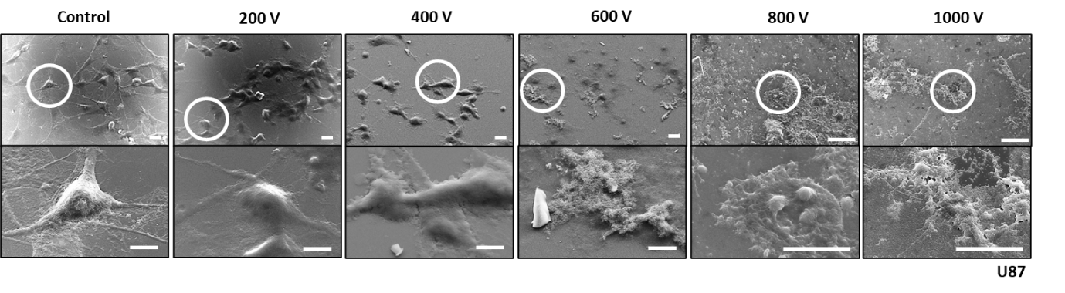

Fig. S14: A5:ETE-PC electrode induces irreversible electroporation in U87 cells. SEM images detailing the morphology of U87 cells undergone IRE; scale bar: 20 µm (upper panel), 10 µm (lower panel).

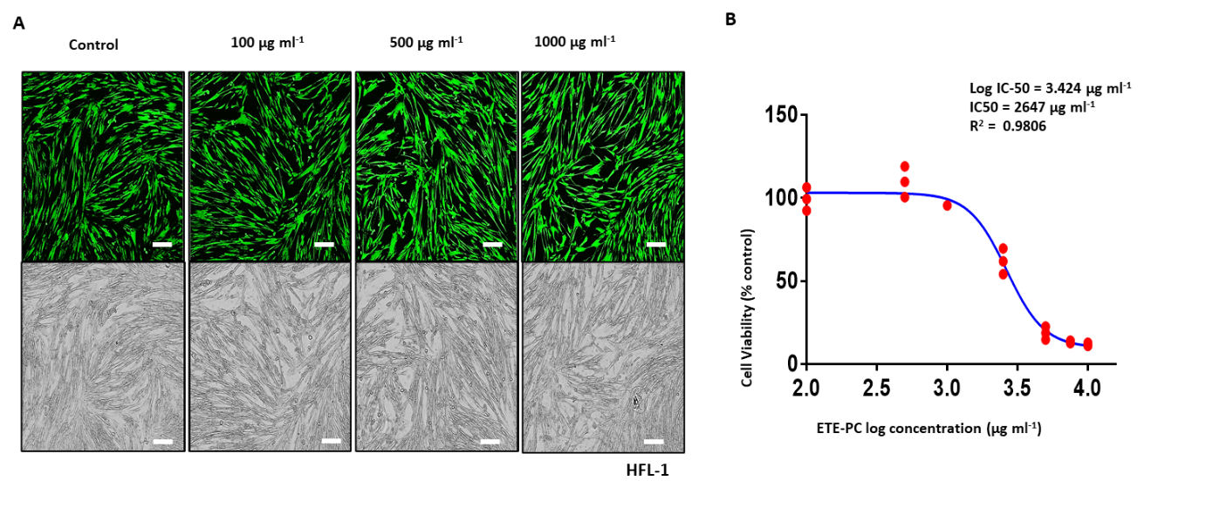
Fig. S15: In vtrobiocompatibility of ETE-PC. (a) Cytotoxicity of ETE-PC in normal human lung fibroblasts (HFL1) was determined by live(green)/dead(red) cell staining (Calcein-AM/PI) post-treatment with various concentrations of ETE-PC for 24 h. The upper and lower panels show fluorescence and corresponding brightfield images; scale bar: 100 µm. (b) Dose (log concentration) vs response curve showing IC50 of ETE-PC in HFL1 cells. The half-maximal inhibitory concentration (IC50) of ETE-PC in HFL1 cells was calculated by MTT cytotoxicity assay after treatment with 0.1–10 mg ml⁻¹ of ETE-PC.
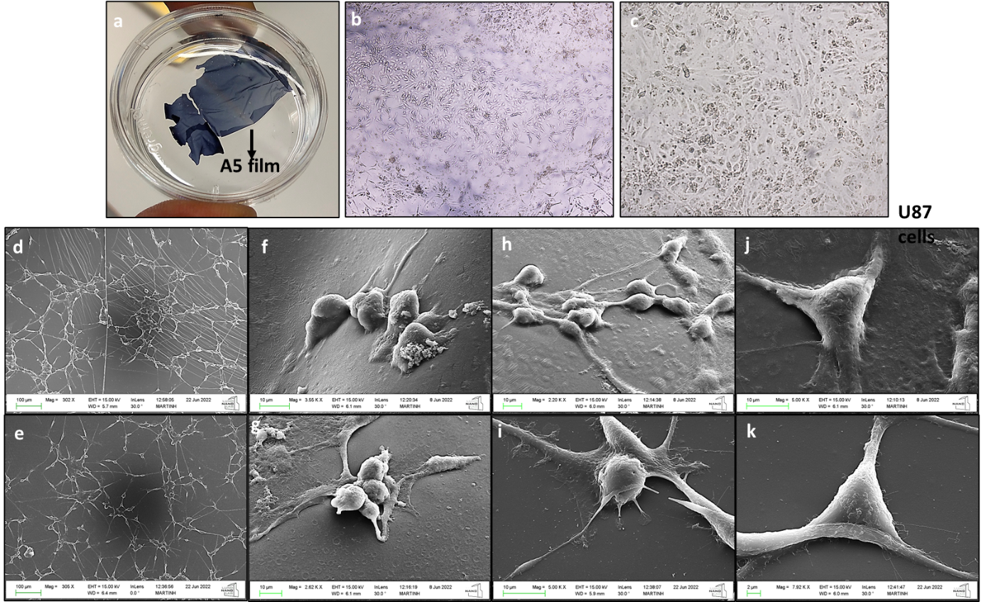

Fig. S16: Cell interaction with A5. (a) Image representing A5 film with U87 cells grown on it. (b&c) Phase contrast images of U87 cells grown on A5 film. (d-k) SEM images of U87 cells grown on A5 film. Scale bar denotes in d, e - 100 µm, f-j – 10 µm and k – 2 µm.

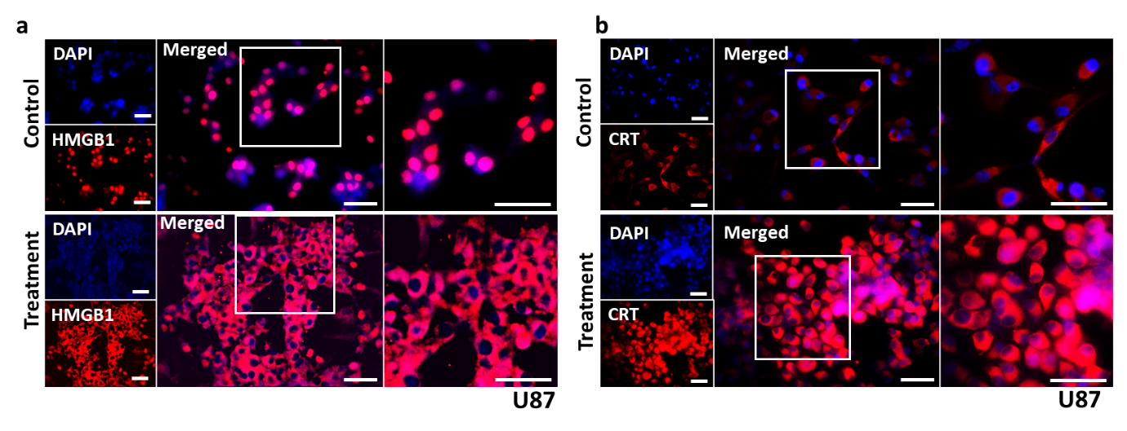
Fig. S17: A5:ETE-PC mediated IRE induces immunogenic cell death (ICD). Immunofluorescence images represent staining of ICD markers (a) HMGB1 and (b) calreticulin in U87 cells post-IRE via A5:ETE-PC electrode. Untreated cells were used as control. Scale bar: 100 µm.
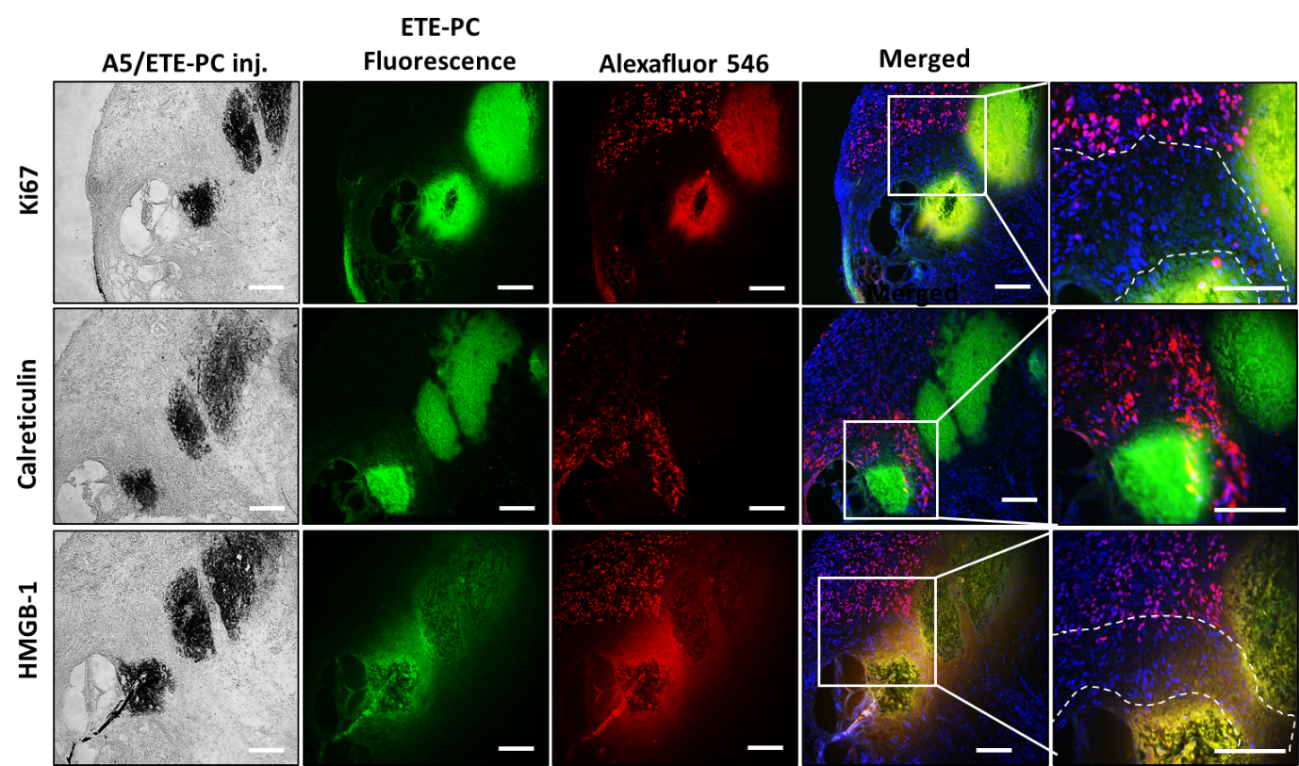

Fig. S18: IRE application via A5:ETE-PC electrode inhibits cell proliferation and induces immunogenic cell death in in vivo tumors. In situ assembly of A5:ETE-PC electrode was done in in vivo U87 tumors and IRE treatment (3 x 10, 500 V pulses, 1ms) was given. Tumors were harvested after 24 h, sectioned, stained and imaged using fluorescence microscope. Fluorescence images demonstrate staining of proliferation marker Ki67 and ICD markers HMGB1 & calreticulin in U87 tumor sections (16 µm). ETE-PC monomer fluorescence (green), Ki67 (red) and nucleus (DAPI, blue). Scale bar: 200 µm.

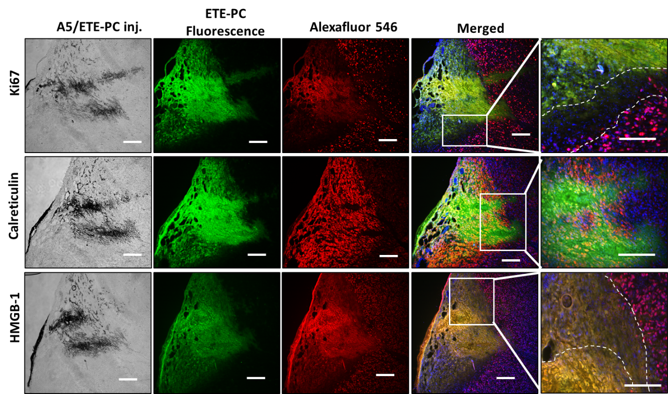
Fig. S19: IRE application via A5:ETE-PC electrode inhibits cell proliferation and induces immunogenic cell death in in vivo tumors. In situ assembly of A5:ETE-PC electrode was done in in vivo U87 tumors and IRE treatment (3 x 10, 2000 V pulses, 1ms) was given. Tumors were harvested after 24 h, sectioned, stained and imaged using fluorescence microscope. Fluorescence images demonstrate staining of proliferation marker Ki67 and ICD markers HMGB1 & calreticulin in U87 tumor sections (16 µm). ETE-PC monomer fluorescence (green), Ki67 (red) and nucleus (DAPI, blue). Scale bar: 200 µm.

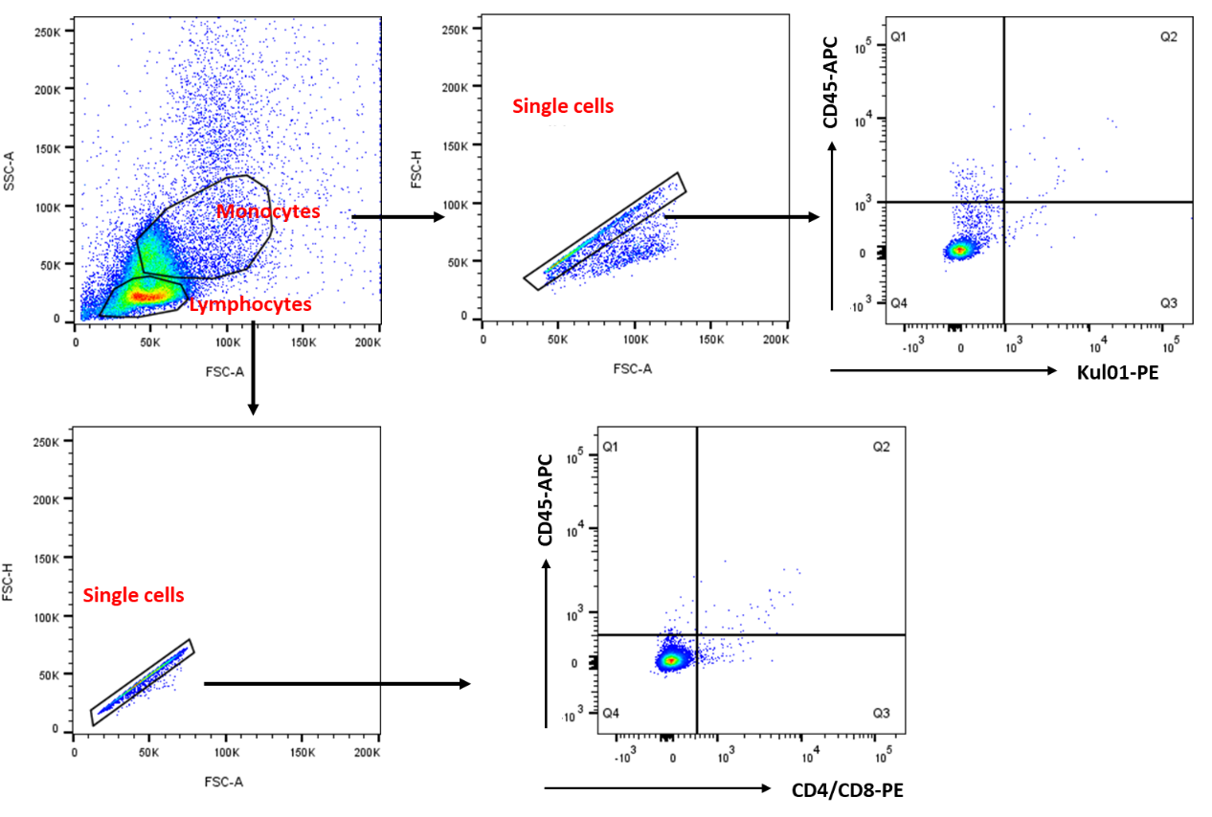
Fig. S20: Gating strategy for analysis of T lymphocytes and monocytes/macrophages.
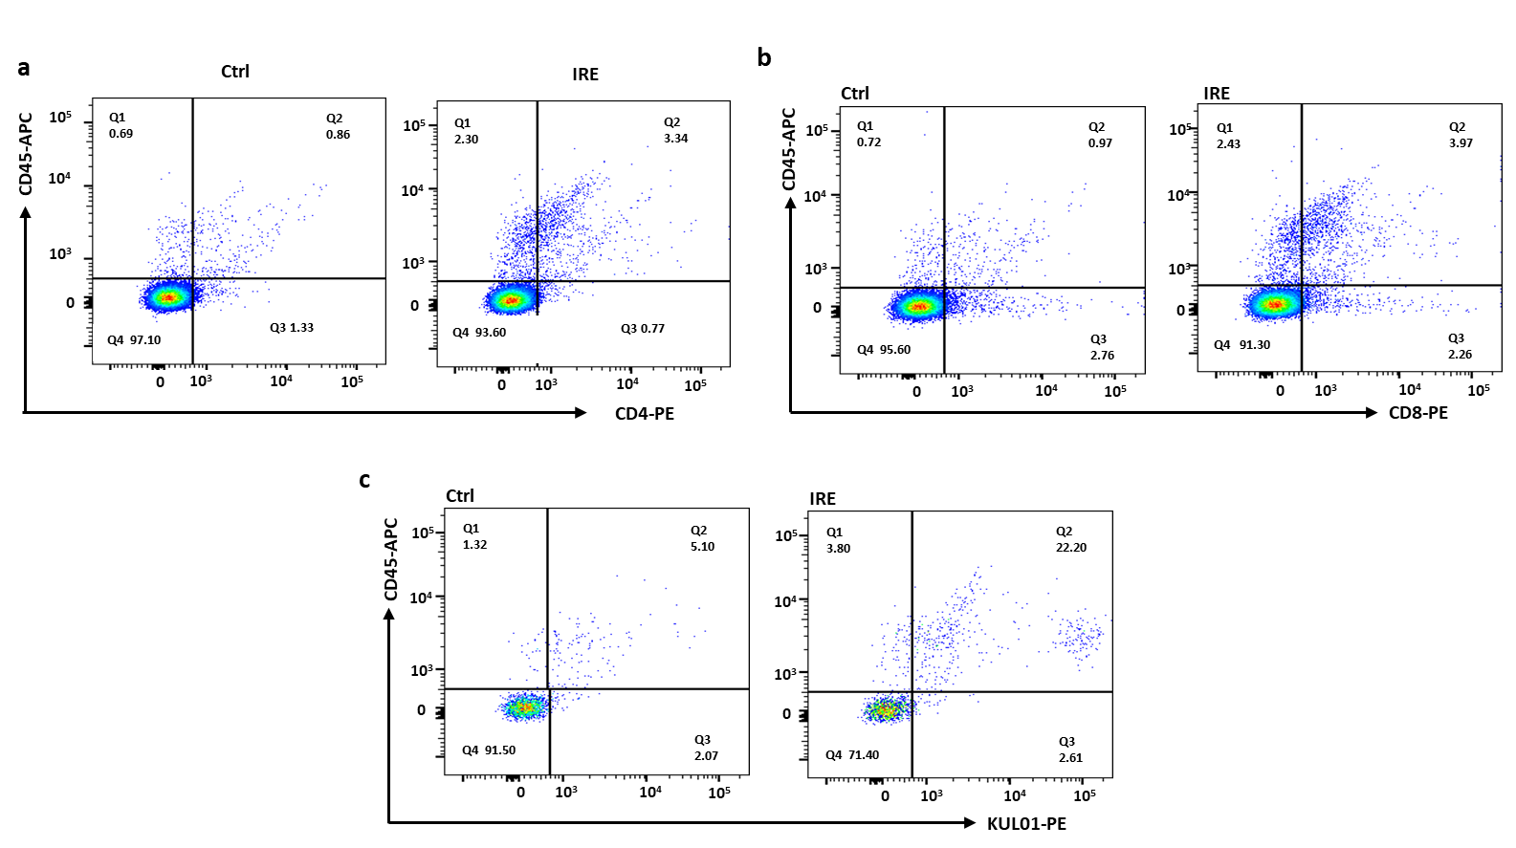
Fig. S21: IRE application via A5:ETE-PC electrode induces ICD and immune cell infiltration in tumors. (a-c) Immune cell infiltration was examined by flow cytometry as a percentage of CD45⁺CD4⁺ and CD45⁺CD8⁺ T cells along with CD45⁺KUL01⁺ macrophages in IRE treated (3 x 200, 1000-1500 V cm⁻¹ pulses, 300 µs) vs control tumor 72 h post-Ire treatment.

