Supplementary information
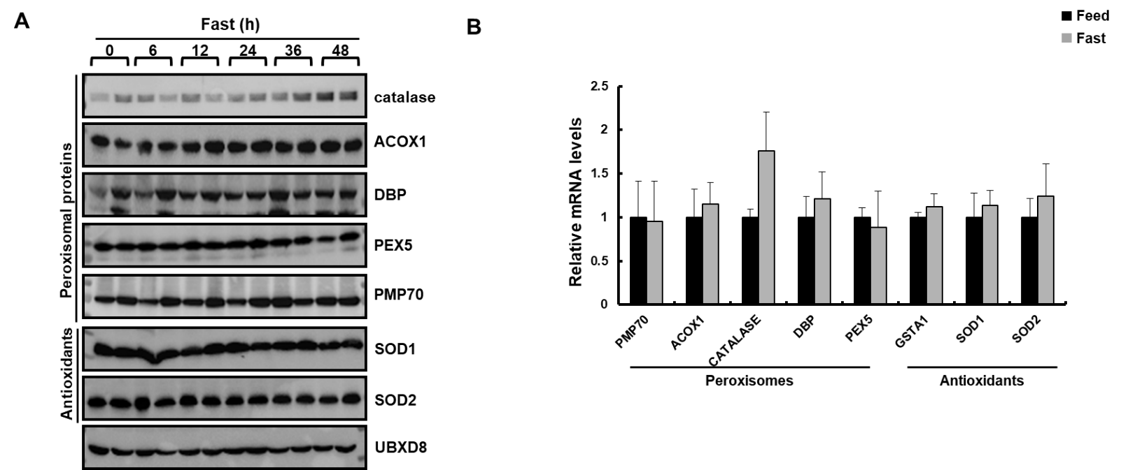

S1. Catalase expression was specifically increased during sustained fasting
(A) Liver samples from WT mice fasted at indicated time were homogenized and immunoblot analysis was performed. Protein expression was measured using whole-cell lysates with the indicated antibodies. (B) qPCR analysis of peroxisomes and antioxidant genes from the liver of WT mice fed and fasted for 48 h. Values represent mean ± SD (n = 3, 4). *P < 0.05 versus WT fed.

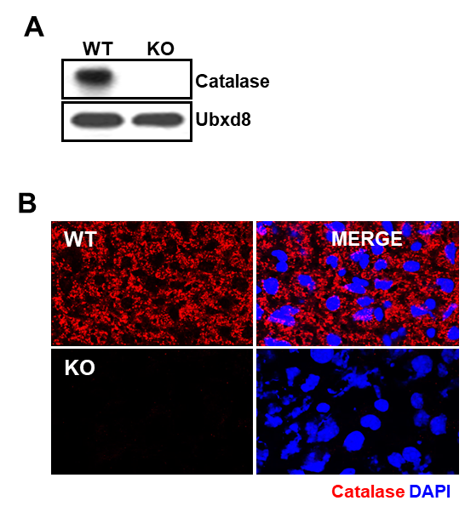

S2. The expression of catalase was successfully depleted in mice
(A) Liver samples from WT and catalase KO mice were homogenized and immunoblot analysis were performed from whole cell lysates with anti-catalase. (B) Representative fluorescence images of liver, fixed and immunostained with anti-catalase (red) and DAPI (blue).

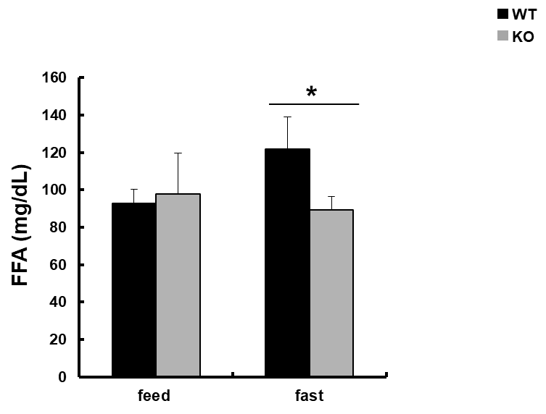

S3. Sustained fasting decreased the level of free fatty acid in serum of catalase KO mice.
FFA level was analyzed from serum of mice fasted for 0 and 48 h. *P <0.05 WT 48 h fasting versus KO 48 h of fasting

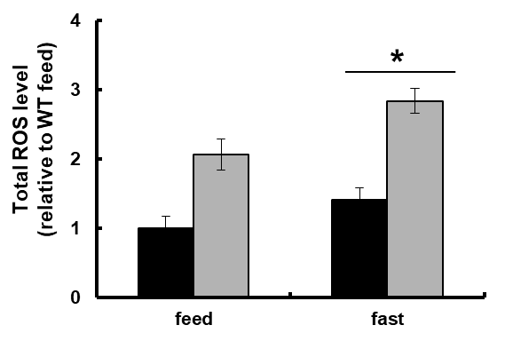

S4. Sustained fasting increased ROS level in WAT of catalase KO mice
Total ROS was measured from WAT. *P <0.05 WT 48 h fasting versus KO 48 h of fasting

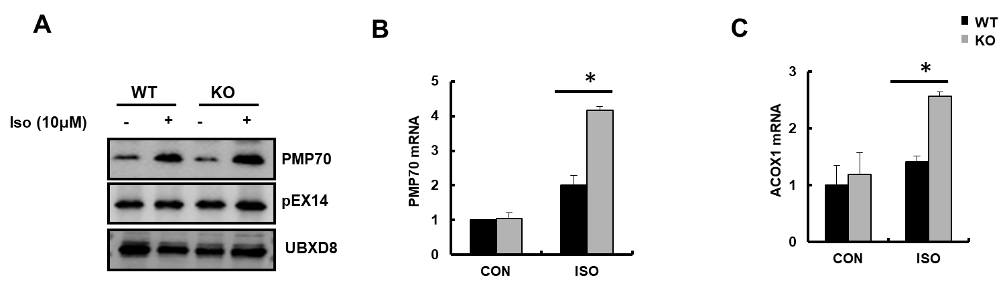

S5. Lipolysis by isoproterenol increased the peroxisomal enzyme in primary BAT of catalase KO mice
(A) Total cell lysates prepared from isoproterenol treated brown adipocytes were immunoblotted with antibodies indicated. Q-PCR analysis of (B) PMP70 and (C) ACOX1 in treated brown adipocytes. *P <0.05 WT ISO versus KO ISO.

Table S1. List of antibodies used in this study
antibody | Application | Dilution | company | cat. No. | source
ACOX1 | WB | 1:1000 | proteintech | 10957-1-AP | rabbit
TOM20(F-10) | WB | 1:1000 | santa cruz | sc-17764 | Mouse
catalase | WB and IF | 1:500 | abcam | ab4877 | rabbit
ADFP (Plin2) | WB | 1:1000 | abcam | ab52355 | rabbit
Phospho-p38 MAPK | WB | 1:1000 | cell signaling | #9211S | rabbit
P38-MAPK | WB | 1:1000 | cell signaling | #9212 | rabbit
pex5 | WB | 1:1000 | genetex | GTX109798 | rabbit
PMP70 | WB and IF | 1:2000 and 1:500 | abcam | ab3421 | rabbit
ANGPTL3 | WB | 1:1000 | abcam | Ab84035 | rabbit
ANGPTL4 | WB | 1:1000 | Santa cruz | sc-373761 | mouse
CD36 | WB | 1:1000 | Novus biologicals | NB400-144 | rabbit
DBP | WB | 1:1000 | Origene | TA308904 | rabbit
UBXD8 | WB | 1:2000 |  |  | rabbit
Seipin | WB | 1:1000 | abnova | H00026580-A02 | Mouse
PGC-1α | WB | 1:1000 | santa cruz | sc-13067 | rabbit
SOD1 | WB | 1:1000 | Santa cruz | sc-11407 | rabbit
SOD2 | WB | 1:1000 | Santa cruz | sc-30080 | rabbit
PLIN1 | IF | 1:500 | abcam | ab-3526 | rabbit
p-HSL | WB | 1:1000 | cell signaling | 8334S | rabbit
HSL | WB | 1:1000 | cell signaling | 8334S | rabbit
ATGL | WB | 1:1000 | cell signaling | 2138S | rabbit
UCP1 | WB | 1:1000 | abcam | ab-10983 | rabbit
α-Tubulin | WB | 1:1000 | sigma | T5168-2ML | Mouse

IF: Immunofluorescence
WB: Western blot

Table S2. List of primer sequence used for Q-PCR
Gene | Mouse primer sequences | Reference
36B4 | Forward 5’-CACTGGTCTAGGACCCGAGAAG -3’ | Bioneer
36B4 | Reverse 5’-GGTGCCTCTGGAGATTTTCG-3’ | Bioneer
PMP70 | Forward 5’- gattgaagagtggggtcgag -3’ | Bioneer
PMP70 | Reverse 5’- tctgtcgccttcccaaag -3’ | Bioneer
Catalase | Forward 5’- ccttcaagttggttaatgcaga -3’ | Bioneer
Catalase | Reverse 5’- caagtttttgatgccctggt -3’ | Bioneer
DBP | Forward 5’- gggagcagtacttggagctg-3’ | Bioneer
DBP | Reverse 5’- tcagcaataactgcttcacatttt -3’ | Bioneer
PEX5 | Forward 5’- cacatccgcttcctatgaca-3’ | Bioneer
PEX5 | Reverse 5’- aaaaggctgagggtggtca-3’ | Bioneer
GSTA1 | Forward 5’- cttctgacccctttccctct-3’ | Bioneer
GSTA1 | Reverse 5’- gctgccaggctgtaggaac-3’
ACC-1 | Forward 5’- TGGACAGACTGATCGCAGAGAAAG-3’ | Bioneer
ACC-1 | Reverse 5’- TGGAGAGCCCCACACACA-3’
FAS | Forward 5’-GCTGCGGAAACTTCAGGAAAT-3’  Reverse 5’-AGAGACGTGTCACTCCTGGACTT-3’ | Bioneer
CD36 | Forward 5’-GGAACTGTGGGCTCATTGC-3’  Reverse 5’-CATGAGAATGCCTCCAAACAC-3’ | Bioneer
SCD-1 | Forward 5’-CCGGAGACCCCTTAGATCGA-3’  Reverse 5’- TAGCCTGTAAAAGATTTCTGCAAACC-3’ | Bioneer
LPL | Forward 5’-ctggtgggaaatgatgtgg-3’  Reverse 5’-ctggtgggaaatgatgtgg-3’ | Bioneer
PPARα | Forward 5’-ACAAGGCCTCAGGGTACCA-3’  Reverse 5’-GCCGAAAGAAGCCCTTACAG-3’ | Bioneer
SREBP-1c | Forward 5’- GGAGCCATGGATTGCACATT-3’ | Bioneer
SREBP-1c | Reverse 5’- GGCCCGGGAAGTCACTGT -3’ | Bioneer
PGC-1α | Forward 5’-AACCACACCCACAGGATCAGA-3’ | Bioneer
PGC-1α | Reverse 5’- TCTTCGCTTTATTGCTCCATGA-3’ | Bioneer
UCP1 | Forward 5’-GAGGTGTGGCAGTGTTCATTG-3’ | Bioneer
UCP1 | Reverse 5’- GGCTTGCATTCTGACCTTCA-3’ | Bioneer

