Table S1 | Indexing of the peaks identified on the alkaline vents analogues’ diffractograms (1h, 5h, 24h, 48h, 72h, 96h and 10d). For each phase, peaks are labelled with chloride green rust (PDF4 ID: 00-040-0127 / noted Cl – green rust), carbonated green rust (PDF4 ID: 00-052-0163), magnetite (PDF4 ID: 01-076-1849), amakinite (COD ID: 00-900-9104), halite (PDF4 ID: 00-005-0628) and iron (PDF4 ID: 01-087-0722).
5h
d-spacing (Å) | Relative intensity (I %) | h k l
4.86 | 4655 | [1 1 1] 4.8497  Magnétite
2.97 | 3927 | [2 2 0] 2.9698  Magnétite
2.82 | 13453 | [2 0 0] 2.8210  Halite
2.53 | 5677 | [3 1 1] 2.53270  Magnétite
2.10 | 3140 | [4 0 0] 2.1000  Magnétite
1.99 | 3155 | [2 2 0] 1.9940  Halite
1.61 | 2787 | [5 1 1] 1.6166  Magnétite
1.48 | 2920 | [4 4 0] 1.4849  Magnétite

24h
d-spacing (Å) | Relative intensity (I %) | h k l
7.82 | 8494 | [0 0 3] 7.9300  Cl - Green Rust
4.86 | 6681 | [1 1 1] 4.8497  Magnétite
3.90 | 5054 | [0 0 6] 3.9700  Cl - Green Rust
3.26 | 4295 | [1 1 1] 3.2600  Halite
2.96 | 6335 | [2 2 0] 2.9698  Magnétite
2.83 | 4788 | [2 0 0] 2.8210  Halite
2.69 | 4116 | [0 1 2] 2.7100  Green Rust
2.53 | 11314 | [3 1 1] 2.5327  Magnétite
2.10 | 4693 | [4 0 0] 2.1000  Magnétite
1.99 | 3435 | [2 2 0] 1.9940  Halite
1.72 | 3083 | [4 2 2] 1.7146  Magnétite
1.62 | 3698 | [5 1 1] 1.6166  Magnétite
1.49 | 3874 | [4 4 0] 1.4849  Magnétite

48h
d-spacing (Å) | Relative intensity (I %) | h k l
7.59 | 26045 | [0 0 3] 7.4970  CO₃ - Green Rust
4.85 | 18783 | [1 1 1] 4.8497  Magnétite
4.62 | 15664 | [0 0 1] 4.6050  Amakinite
3.79 | 14960 | [0 0 6] 3.7530  CO₃ - Green Rust
2.97 | 22705 | [2 2 0] 2.9698  Magnétite
2.82 | 13954 | [1 0 0] 2.8215  Amakinite
2.68 | 14909 | [0 1 2] 2.6980  CO₃ - Green Rust
2.53 | 51806 | [3 1 1] 2.5327  Magnétite
2.41 | 14876 | [1 0 -1] 2.4058  Amakinite
2.35 | 13141 | [0 1 5] 2.3470  CO₃ - Green Rust
2.10 | 20600 | [4 0 0] 2.1000  Magnétite
2.03 | 11291 | [1 1 0] 2.0229  Iron
1.99 | 11209 | [2 2 0] 1.9940  Halite
1.97 | 11638 | [0 1 8] 1.9650  CO₃ - Green Rust
1.78 | 11407 | [1 0 -2] 1.7839  Amakinite
1.72 | 12910 | 4 2 2] 1.7146  Magnétite
1.62 | 17850 | [5 1 1] 1.6166  Magnétite
1.49 | 20363 | [4 4 0] 1.4849  Magnétite

72h
d-spacing (Å) | Relative intensity (I %) | h k l
7.60 | 9781 | [0 0 3] 7.4970  CO₃ - Green Rust
4.87 | 7142 | [1 1 1] 4.8497  Magnétite
4.61 | 6937 | [0 0 1] 4.6050  Amakinite
4.19 | 5426
3.80 | 5477 | [0 0 6] 3.75300  CO₃ - Green Rust
2.97 | 7749 | [2 2 0] 2.9698  Magnétite
2.82 | 5495 | [1 0 0] 2.8215  Amakinite
2.67 | 5016 | [0 1 2] 2.6730  CO₃ - Green Rust
2.53 | 15730 | [3 1 1] 2.5327  Magnétite
2.41 | 5856 | [1 0 -1] 2.4058  Amakinite
2.35 | 4430 | [0 1 5] 2.3470  CO₃ - Green Rust
2.10 | 6341 | [4 0 0] 2.1000  Magnétite
2.03 | 4369 | [1 1 0] 2.0229  Iron
1.97 | 3877 | [0 1 5] 1.9650  CO₃ - Green Rust
1.78 | 3877 | [1 0 -2] 1.7839  Amakinite
1.72 | 4174 | [4 2 2] 1.7146  Magnétite
1.63 | 3940 | [2 -1 0] 1.6290  Amakinite
1.62 | 5203 | [5 1 1] 1.6166  Magnétite
1.55 | 3605
1.54 | 3534
1.49 | 5801 | [4 4 0] 1.4849  Magnétite

96h
d-spacing (Å) | Relative intensity (I %) | h k l
7.59 | 9290 | [0 0 3] 7.4970  CO₃ - Green Rust
4.85 | 8430 | [1 1 1] 4.8497  Magnétite
4.59 | 7880 | [0 0 1] 4.6050  Amakinite
3.79 | 5830 | [0 0 6] 3.7530  CO₃ - Green Rust
2.97 | 9391 | [2 2 0] 2.9698  Magnétite
2.82 | 6262 | [1 0 0] 2.8215  Amakinite
2.68 | 5480 | [0 1 2] 2.6730  CO₃ - Green Rust
2.53 | 18543 | [3 1 1] 2.5327  Magnétite
2.41 | 6660 | [1 0 -1] 2.4058  Amakinite
2.35 | 4825 | [0 1 5] 2.3470  CO₃ - Green Rust
2.10 | 7290 | [4 0 0] 2.1000  Magnétite
2.03 | 4970 | [1 1 0] 2.0229  Iron
1.78 | 4396 | [1 0 -2] 1.7839  Amakinite
1.71 | 4591 | [4 2 2] 1.7146  Magnétite
1.63 | 4435 | [2 -1 0] 1.6290  Amakinite
1.62 | 5870 | [5 1 1] 1.6166  Magnétite
1.49 | 6540 | [4 4 0] 1.4849  Magnétite

10d
d-spacing (Å) | Relative intensity (I %) | h k l
7.58 | 10520 | [0 0 3] 7.4970  CO₃ - Green Rust
4.85 | 6230 | [1 1 1] 4.8497  Magnétite
4.60 | 6185 | [0 0 1] 4.6050  Amakinite
3.95 | 4840
3.79 | 5080 | [0 0 6] 3.7530  CO₃ - Green Rust
2.97 | 5583 | [2 2 0] 2.9698  Magnétite
2.82 | 4030 | [1 0 0] 2.8215  Amakinite
2.67 | 4100 | [0 1 2] 2.6730  CO₃ - Green Rust
2.53 | 9323 | [3 1 1] 2.5327  Magnétite
2.41 | 4130 | [1 0 -1] 2.4058  Amakinite
2.35 | 3576 | [0 1 5] 2.3470  CO₃ - Green Rust
2.10 | 4155 | [4 0 0] 2.1000  Magnétite
2.03 | 3360 | [1 1 0] 2.0229  Iron
1.97 | 3050 | [0 1 5] 1.9650  CO₃ - Green Rust
1.78 | 2852 | [1 0 -2] 1.7839  Amakinite
1.72 | 2852 | [4 2 2] 1.7146  Magnétite
1.62 | 3437 | [2 -1 0] 1.6290  Amakinite
1.59 | 2661 | [5 1 1] 1.6166  Magnétite
1.49 | 3483 | [4 4 0] 1.4849  Magnétite

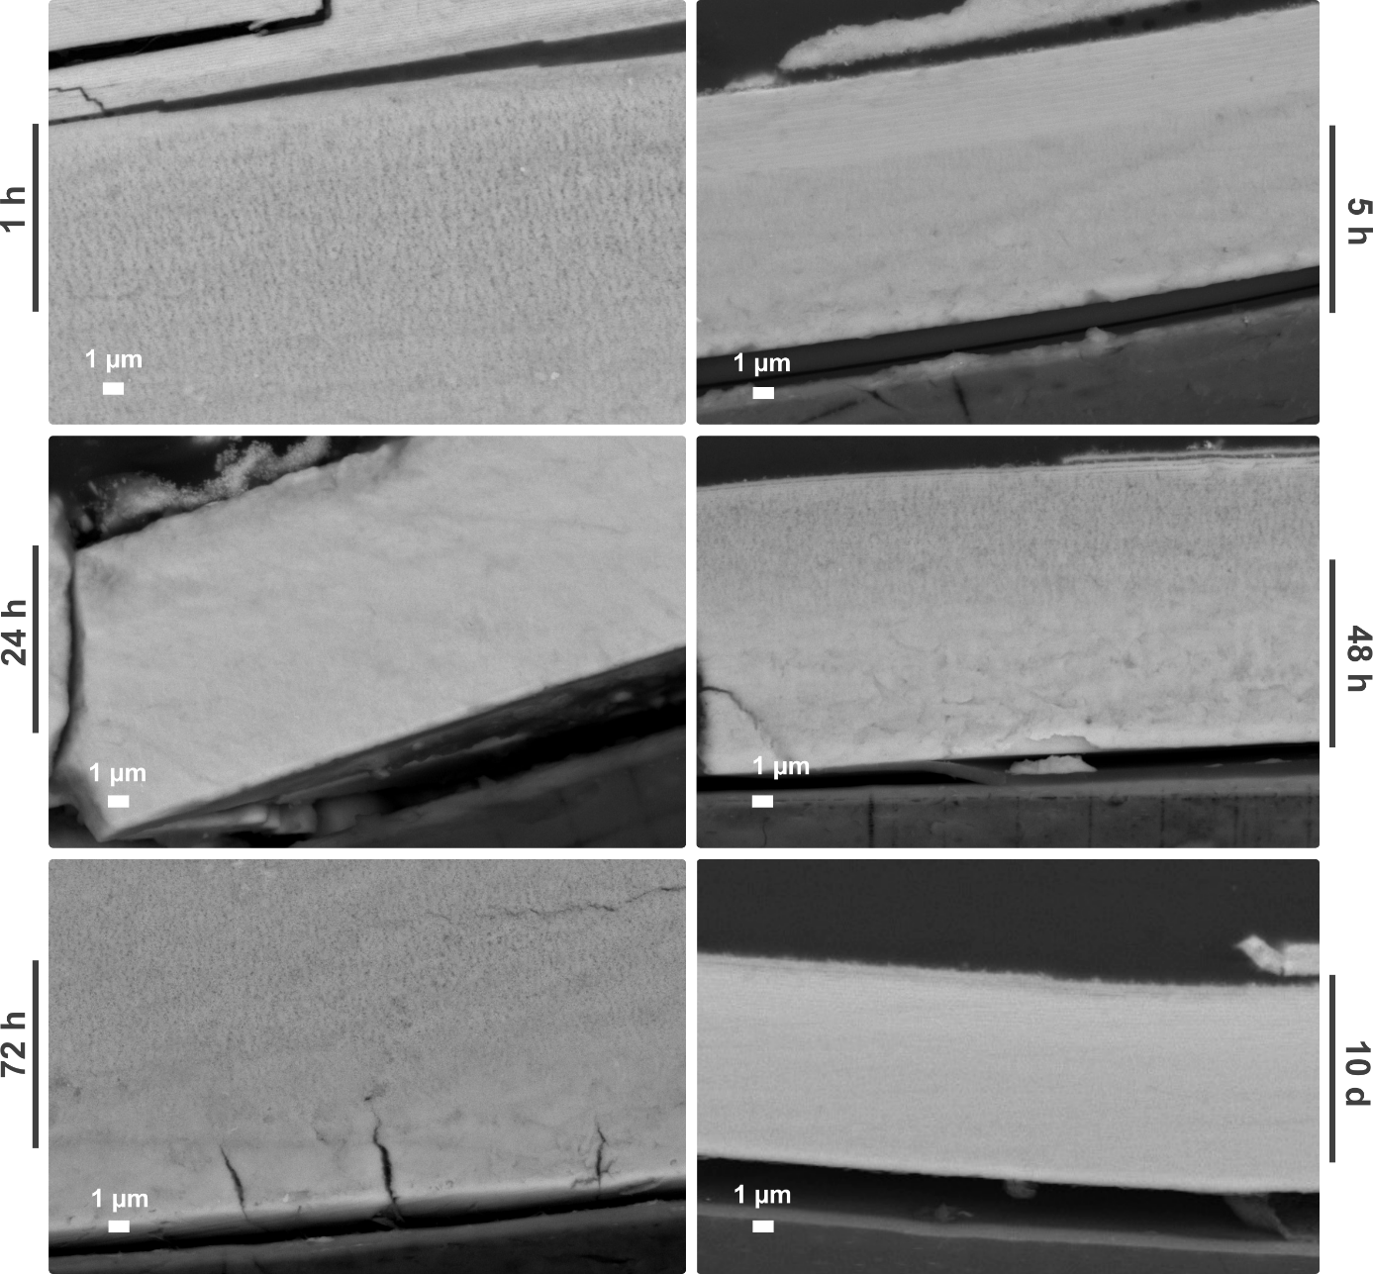
Figure S2 | Evolution of the blue area, i.e. the contact with de dialysis membrane (bottom black area on the images). In the course of time, the area does not significantly evolve.

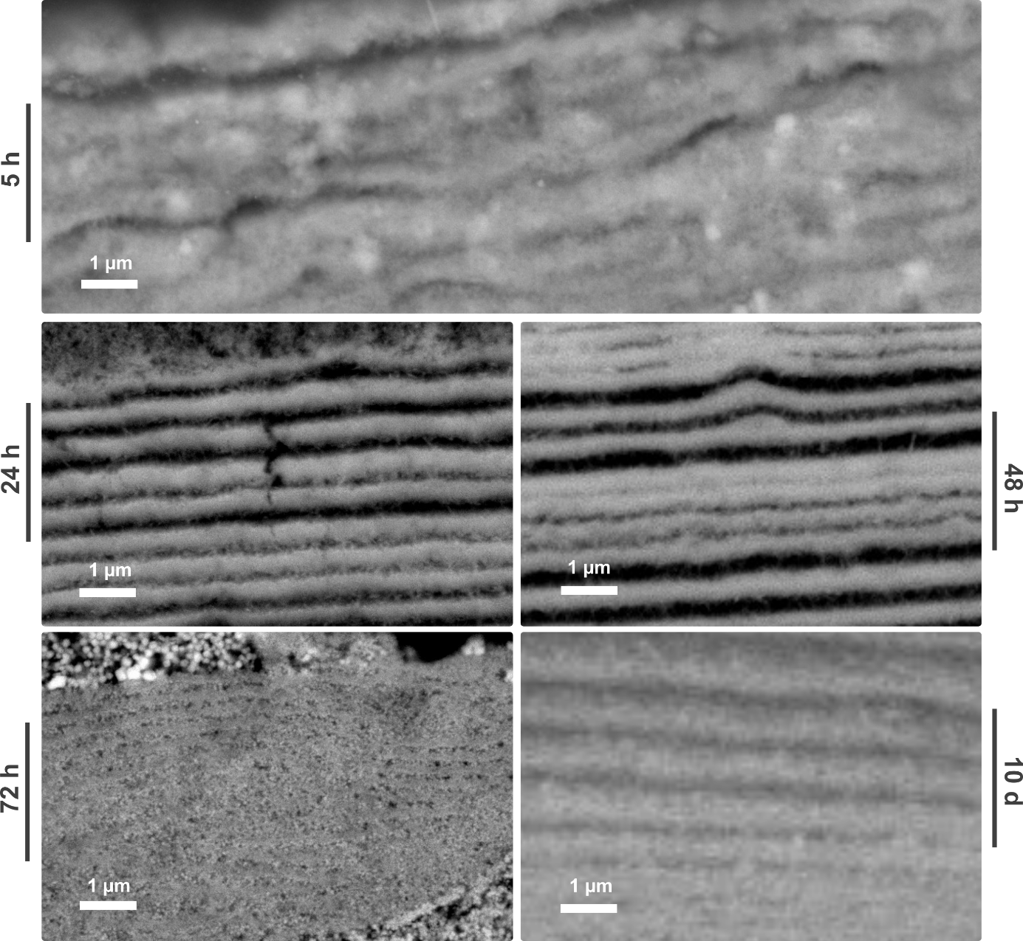
Figure S3 | Evolution of the cyan area, i.e. the extension of the contact area with the dialysis membrane. In the course of time, the area does not significantly evolve, except for a better structuring of the laminae and an increase in the grain size of the magnetite.

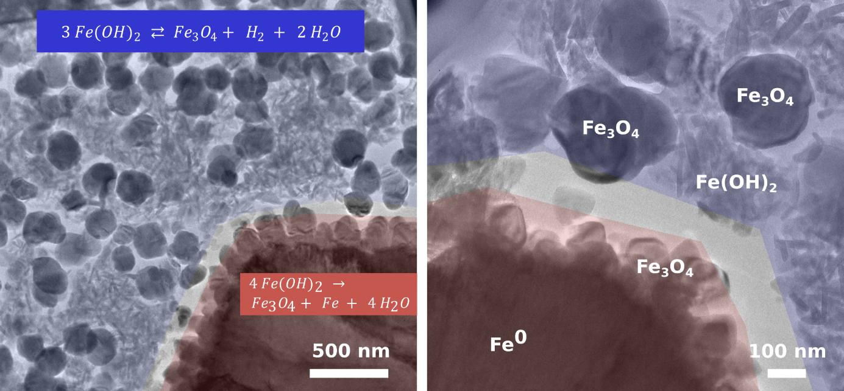
Figure S4 | TEM observation of the FIB section. The blue highlights a zone of high porosity, which we interpret as the zone of Fe(OH)₂ oxidation producing Fe₃O₄ and H₂.The red highlights the zone of Fe²⁺ disproportionation (from Fe(OH)₂) into Fe³⁺ (Fe₃O₄) and Fe⁰.

