Supplementary Information: Partially Melted Low Velocity Zones Reveal an Active Martian Mantle Below Elysium Planitia

Contents
1. Data preprocessing 3
1.1. Marsquake locations 3
1.2. Polarization filter 5
2. Receiver function analysis 6
2.1. RFs of the clustered CF events 6
2.2. Observations of coherent arrivals 9
2.3. Bootstrap test 11
2.4. Upper mantle conversion or crustal multiple reflection 13
3. Phase picking of PP/SS precursors 16
3.1. SS precursors of event S0976a 16
3.2. PP precursor of event S0976a 21
3.3. SS precursors of event S1153a 23
3.4. Comodulation analysis 30
4. Seismic inversion results 34
4.1. Crustal structure beneath the InSight lander 34
4.2. Additional RF inversions 37
4.3. Crustal structures beneath the southern edge of AP and eastern CF 43
4.4. PP/SS precursor inversions based on travel time and amplitude 47
4.5. Amplitude of the PP precursor associated with the LVZ 49
4.6. Moho structures beneath the southern edge of AP and eastern CF 54
5. Further seismic support for the upper mantle LVZ 62
5.1. P-wave RF of event S1222a 62
5.2. S-wave RFs of events S1153a and S1415a 65
5.3. Autocorrelation reflectivity 68
5.4. Seismicity and body wave amplitude reduction 71
6. LVZ thickness 75
6.1. Effects of LVZ thickness on body wave travel times 75
6.2. Back azimuth-dependent variation of LVZ thickness 81
6.3. Effects of LVZ thickness on Rayleigh wave group velocities 86
6.4. Effects of LVZ thickness on RFs and SS precursors 87
7. Sensitivities of seismic velocities to temperature and composition 92
7.1. Direct Perple_X calculation 92
7.2. Mineral physical calculation 98
8. Martian mantle solidus and geotherm 103
8.1. Dry solidus and its variation with Mg# 103
8.2. Hydrous solidus 104
8.3. Upper mantle geotherms 105
References 119

1. Data preprocessing

1.1. Marsquake locations
The Marsquake service (MQS) obtained the epicentral distances for 42 LF family events based on their differential travel times of P and S waves and the inverted models of Mars’s interior¹. Of these, 24 events are fully located, with back azimuths estimated from body wave polarizations^{2,3}. Ceylan, et al. ⁴ relocate 35 events based on the similarity of envelope shapes, while Wang, et al. ⁵ provide back azimuth estimations for 44 events through a varying-parameter polarization analysis. A total of 28 LF family events with consistent relocation results across these two studies are shown in Supplementary Fig. 1. Most of these events are located in the Cerberus Fossae (CF), a region is distinguished by active extensional faults⁴⁻¹¹. In addition, two newly located events S1153a and S1415a, with distances of ~80º–90º, are close to the Tharsis region^{4,12}.

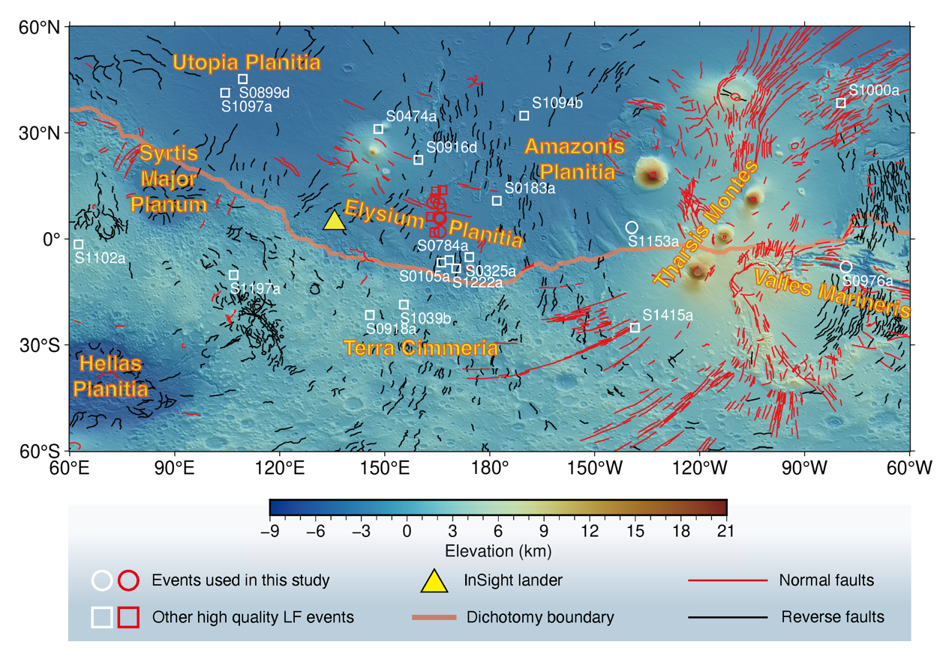
Supplementary Fig. 1 | Distribution of all high quality low-frequency family events. Circles denotes events used in RF and PP/SS precursor inversions, while squares indicate other events not used in the inversions. Cerberus Fossae (CF) events are highlighted in red color. Yellow triangle marks the location of InSight lander. Background map contains elevation data and normal and reverse faults on Mars’s surface¹³.

1.2. Polarization filter
The polarization filter is a time-domain method used to enhance the seismic body wave phases and suppress noise based on the fact that the body wave exhibits a linear polarization with a dominant direction of particle motion, while the noise is non-polarized¹⁴. To perform the polarization filter, we first cut the three-component waveform data $X_{i}(t)$ (i = 1, 2, 3 (Z, R, T)) within a time window with a length of L and a center time of $t_{0}$. The data covariance matrix within this window is computed. Then we get the rectilinearity RL and the direction weight $D_{i}$ at time $t_{0}$ as:
$RL\left(t_{0}\right)={\left[1-{\left(\frac{λ_{2}}{λ_{1}}\right)}^{n}\right]}^{J}$, (1)
$D_{i}=e_{i}^{K}$, (2)
where $λ_{1}$ and $λ_{2}$ are the largest and second largest eigenvalues of the data covariance matrix, $e_{i}$ is the i-th component of the eigenvector correspond to $λ_{1}$, and n, J, and K are empirical exponents. Here we set n = 0.5, J = 1, and K = 2. The length of cut window L is set to be 2 s for P wave and 3 s for S wave based on the frequency bands of their dominant energies. The computed RL and $D_{i}$ are then smoothed by taking the average of all values within the cut window¹⁴. The RL has a value between 0 and 1. A larger value of RL represents a higher degree of linear polarization. The polarization filtered seismogram is defined as:
$X_{i}^{f}\left(t\right)=X_{i}(t)∙RL(t)∙D_{i}(t)$, (3)
where i = 1, 2, 3 (Z, R, T).

2. Receiver function analysis

2.1. RFs of the clustered CF events
To reduce the influence of RF noise from individual events, we calculate the P- RFs of 12 CF events that have similar locations among refs. ²⁻⁵. It is noteworthy that in the context of high-frequency waveforms, the RFs of marsquakes originating from different directions could be affected by a back azimuth-dependent heterogeneity¹⁵, such as dipping interfaces and/or seismic anisotropy¹⁶⁻¹⁸. The CF events analyzed in our study distribute along a north-south direction cluster, ~30º in distance east to the InSight lander⁵. Given the location uncertainties, both ref. ⁹ and ref. ⁴ suggest that the source region situates at the center of the Cerberus fault system, with a back azimuth of ~85º. It is thus reasonable to assert that the RFs derived from these closely located CF events share coherent converted phases.
The vertical and radial component waveforms of CF marsquakes are first bandpass filtered between 0.05 and 0.9 Hz to isolate the dominant seismic signal energy, while suppressing noises such as high-frequency wind-excited lander modes, environmentally induced transient spikes and donks, 2.4 Hz resonance, and the 1 Hz tick noise^{19,20}. Then, P-RFs are calculated using the time domain iterative deconvolution method²¹ and are bandpass filtered into 0.15–0.85 Hz.
In our computed P-RFs, coherent arrivals are observed in six of the twelve CF events, namely S0173a, S0235b, S0809a, S0820a, S1048d, and S1133a (Supplementary Fig. 2a). In contrast, the RFs of the remaining six events lack either a clear direct P wave (e.g., S0802a, S0864a, S0407a, and S1015f) or distinct Ps converted waves (e.g., S1022a, S0484b, S0864a, S0407a, and S1015f). The instability of the latter six RFs may result from waveform contaminations and/or incomplete deconvolution due to event-specific noise. Notably, S0802a, S0407a, and S0484b are classified as quality-B events by MQS². Including these less stable RFs in the stacking process would not affect the appearances and arrival times of converted phases, but significantly reduces their amplitudes (Supplementary Fig. 2b). To evaluate waveform consistency more quantitatively, we compute cross-correlation coefficients (CCs) across all RFs, producing a similarity matrix. For the direct P waves within a -2 s to 2 s window, the former six events, along with S0802a and S1022a, exhibit higher similarities with CCs exceeding 0.6 (Supplementary Fig. 2c). As the window length extends to include later Ps converted phases, the similarities decrease, with only the former six RFs maintaining a high degree of similarity (Supplementary Fig. 2d–e). Based on this analysis, Therefore, we opt to use only the former six consistent RFs for subsequent analyses and inversions.

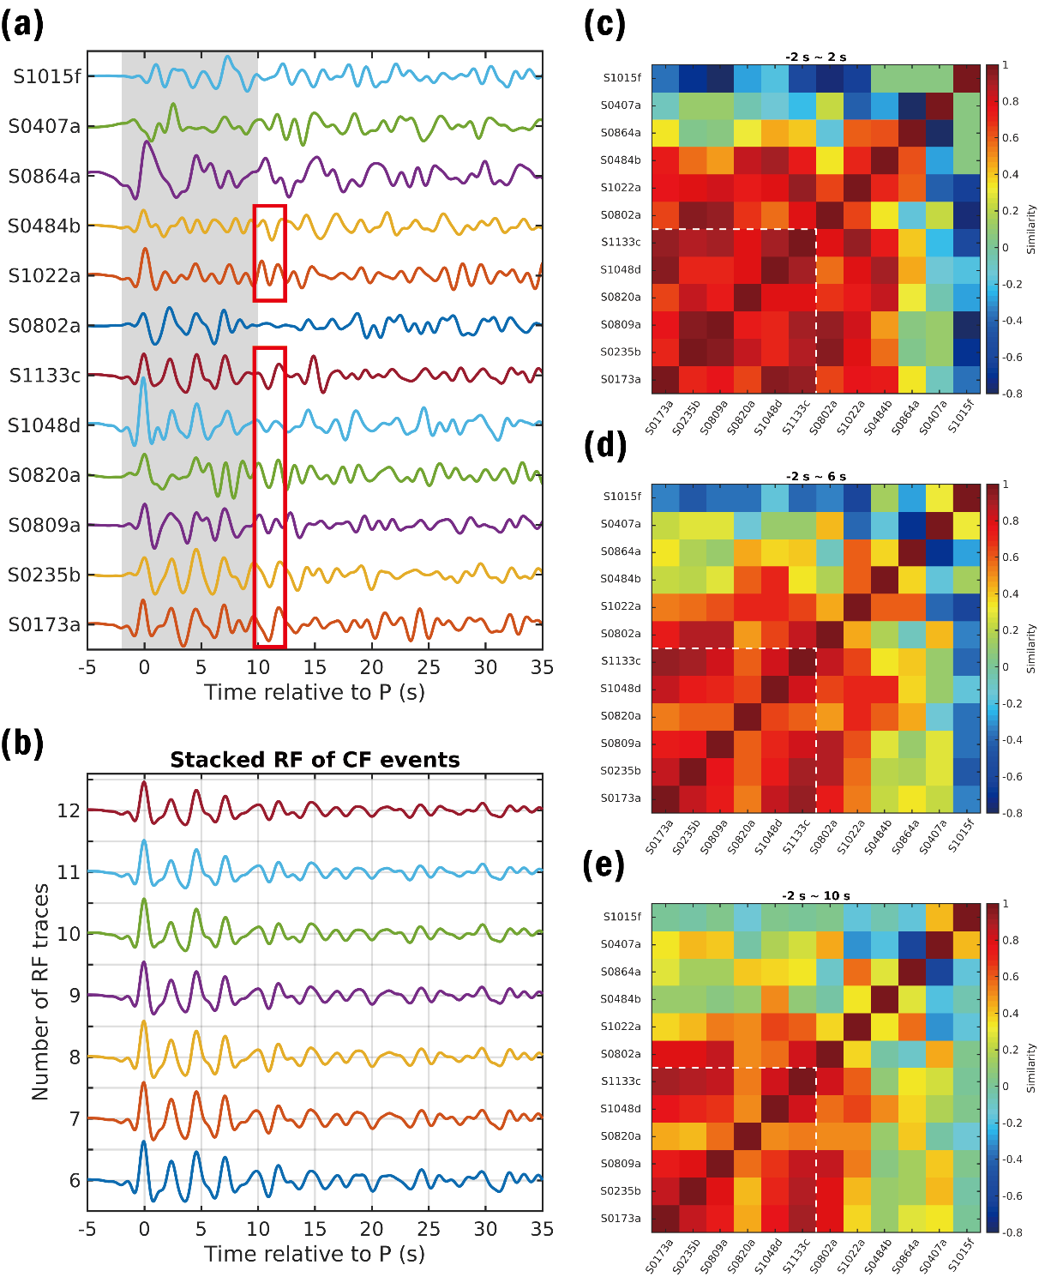
Supplementary Fig. 2 | RFs of CF events and their similarity. (a) RFs from 12 CF events. The shaded window from -2 s to 10 s highlights coherent arrivals identified in previous studies. Red box indicates Ps conversions at the LVZ. (b) Stacked RFs from different subsets of CF events. The bottom trace shows the stack of six selected events., while upper traces include additional events. The converted phase amplitudes are reduced with more events. (c–e) Similarity matrixes for RFs within time windows of -2–2 s, -2–6 s, and -2–10 s, respectively. Similarity decreases with longer windows, with high coherence limited to the first six events (outlined by white dashed lines).

2.2. Observations of coherent arrivals
Within the initial 10 s window of the RFs from the closely located CF events, we identify three positive P-to-s converted arrivals at 2.4 s, 4.7 s, and 7.1 s (Extended Data Fig. 1a), which are interpreted as conversions from two mid-crustal interfaces and the Moho beneath the InSight lander²²⁻²⁵. In addition, a coherent negative arrival at ~11 s is consistently observed in the RFs of all six selected marsquakes, as well as events S1022a and S0484b (Supplementary Fig. 2a). This negative phase could be attributed to either a Ps wave converted from a low velocity zone (LVZ) in the upper mantle or from a multiple reflection phase associated with intra-crustal interfaces (Supplementary Text 2.4). If this negative phase originates from an upper mantle LVZ, it should be accompanied by another multiple phase at a significantly later arrival time. However, discerning clear and consistent phases beyond 10 s proves challenging (Extended Data Fig. 1a), as they may be distorted by the effects of small-scale heterogeneities, random noises, and scattered wavefields^{16,22,26}. To extract the first order features from the RFs, ref. ¹⁶ proposed a principal component analysis (PCA) analysis, affirming that the first few principle components are sufficiently capture the coherent RFs reflecting subsurface structures. Here, we use optimal singular value hard thresholding (SVHT) ²⁷ to extract the principal components and reconstruct the RF data matrix, where the coherent phases are more distinct. In the process of singular value decomposition, the original observed RF data matrix can be expressed by
$Y_{n×m}=X_{n×m}+σZ_{n×m}$, (4)
where $X_{n×m}$ is the uncontaminated RF data matrix, and $Z_{n×m}$ is the matrix of random noise with zero mean and unit variance. n is data points of each RF trace, and m is the number of RF traces, which is six in the case of our study. The singular value decomposition of original RF data matrix is presented as
$Y_{n×m}=U_{n×n}{∙S}_{n×m}∙V_{m×m}^{T}$. (5)
$U$ and $V$ compose of the left and right singular vectors of $Y$. The singular values of $Y$, $y_{1}, y_{2}, ⋯, y_{m}$, which are diagonal elements of $S$, are truncated according to a hard threshold,
$τ=ω(γ)∙y_{med}$, (6)
where $y_{med}$ is the median value of $y_{i}$, $γ=m/n$ is the matrix aspect ratio, and
$ω\left(γ\right)≈0.56γ^{3}-0.95γ^{2}+1.82γ+1.43.$ (7)
The truncated singular values are
$x_{i}=\left\{\begin{aligned}y_{i}, if y_{i}≥τ \\ 0, if y_{i}<τ\end{aligned}\right., for i=1, 2, ⋯, m.$ (8)
Then, we reconstruct the RF data matrix as
${\hat{X}}_{n×m}=U_{n×n}∙{\left[\begin{matrix}\begin{matrix}x_{1} & … & 0 \\ ⋮ & ⋱ & ⋮ \\ 0 & … & x_{m}\end{matrix} \\ \begin{matrix}0 & … & 0 \\ ⋮ & ⋱ & ⋮ \\ 0 & … & 0\end{matrix}\end{matrix}\right]}_{n×m}∙V_{m×m}^{T}$. (9)
The reconstructed RFs show consistent waveforms up to 35 s after the direct P wave (Extended Data Fig. 1b). Except for the prominent phases within 10 s, highly coherent arrivals are observed subsequently, among which two positive phases at ~15 s and ~24 s are previously identified²². Notably, our observations reveal two coherent phases at ~11 s and ~31 s with negative polarities.

2.3. Bootstrap test
To evaluate the effect of deconvolution window and the robustness of identified RF phases, we implement a bootstrap strategy involving 200 realizations. In each iteration, the start and end times of the deconvolution window are randomly selected within the range of -25 s to -15 s, and 50 s to 90 s, respectively, relative to the direct P arrivals. Compared to the raw RFs, the SVD reconstructed RFs are less affected by the deconvolution window, showing much greater coherence and consistence, except for event S0820a (Supplementary Fig. 3). Typically, only the largest singular value is retained in the RF reconstruction (Extended Data Fig. 1c). However, due to the relatively noisy raw RF of S0820a and its lower similarity to other events (Supplementary Fig. 2e), the second singular value is included in the SVHT in a few cases under medium to long deconvolution windows (Supplementary Fig. 3c). Overall, the bootstrap results suggest that, while the raw RFs are affected by the choice of the deconvolution window, the reconstructed RFs and our identified phases remains stable and reliable.

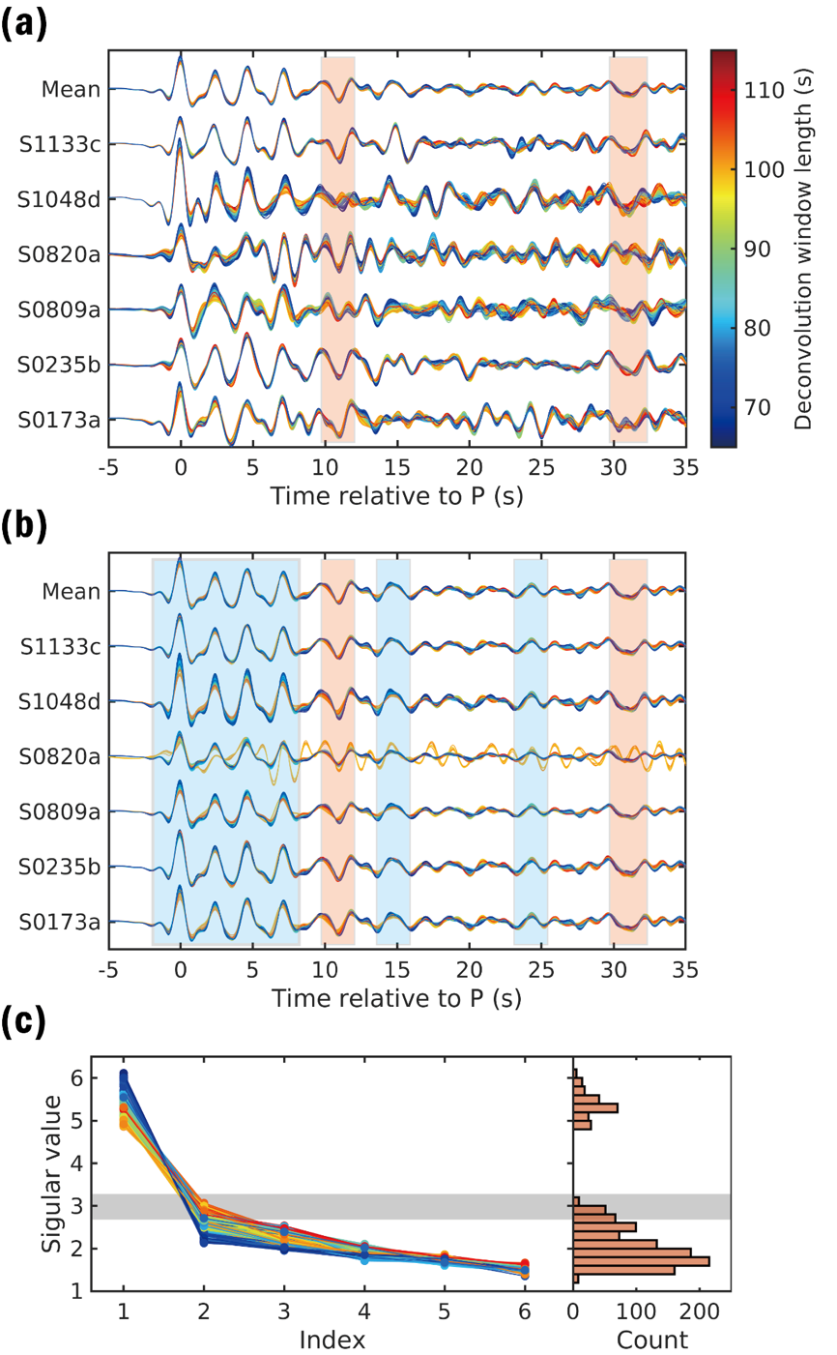
Supplementary Fig. 3 | Bootstrap test on the deconvolution window. (a) Raw RF waveforms obtained using different deconvolution windows, with colors indicating window length. (b) Corresponding RFs after singular value decomposition (SVD) denoising. (c) Singular value distributions from 200 bootstrap samples. Grey shaded zone bounds the upper and lower limits of the hard threshold values.

2.4. Upper mantle conversion or crustal multiple reflection
Joshi et al. ²² also report the identification of a negative arrival at ~11 s in the RFs, which they interpret it as a P-to-S conversion from a LVZ at a depth of ~70–75 km. They discount the possibility that this negative phase corresponds to crustal multiples (e.g., PpSs or PsPs) from the ~8–10 km discontinuity. To further investigate this, we compute the RFs and differential travel times for crustal multiples using three- and four-layer Martian crustal models in previous studies^{22,24,25,28-30}, and compare the results with our observations. None of the existing models successfully reproduces the negative phases observed at both ~11 s and ~31 s (Supplementary Fig. 4a–b). Specifically, the PpSs or PsPs converted at the ~8–10 km discontinuity arrives ~9–10 s after the direct P wave, earlier than the observed negative phase at ~11 s. Moreover, the amplitude of this crustal multiple is highly model dependent. Three-layer crustal models produce distinct and strong negative arrivals at ~9 s. In contrast, four-layer crustal models, either incorporating a shallow interface at ~2–4 km depth or a gradient uppermost crustal structure, predict weak amplitudes of this phase. The lack of pronounced negative multiples at ~9 s in the observed RFs supports the preference for a four-layer crustal structure beneath the InSight landing site. However, aside from the model proposed by ref. ²², which includes a RF time window to 30 s in the inversion, none of the previously published crustal models adequately fit for the observed RFs beyond 10 s, especially for the negative arrivals at ~11 s and ~31 s (Supplementary Fig. 4a).
An alternative explanation for the observed negative phase at 11 s is that it represents a multiple (PpPs) converted at an intracrustal LVZ. In this case, the associated direct conversion (Ps) would arrive at ~3–4 s after the P wave with a negative polarity, potentially obscured between the two observed positive phases at 2.4 s and 4.7 s. This would imply a mid-crust LVZ between the ~10-km and ~20-km interfaces. However, RF inversion results for such a five-layer crust suggests unrealistically low velocities in the lower crust and also fails to produce the observed negative phase at 31 s (Supplementary Text 4.2). In summary, we interpret the negative arrivals at ~ 11 s and ~31 s as deeper mantle conversions rather than crustal multiple reflections (Supplementary Fig. 4c), highlighting the need for further investigations into the upper mantle structure.

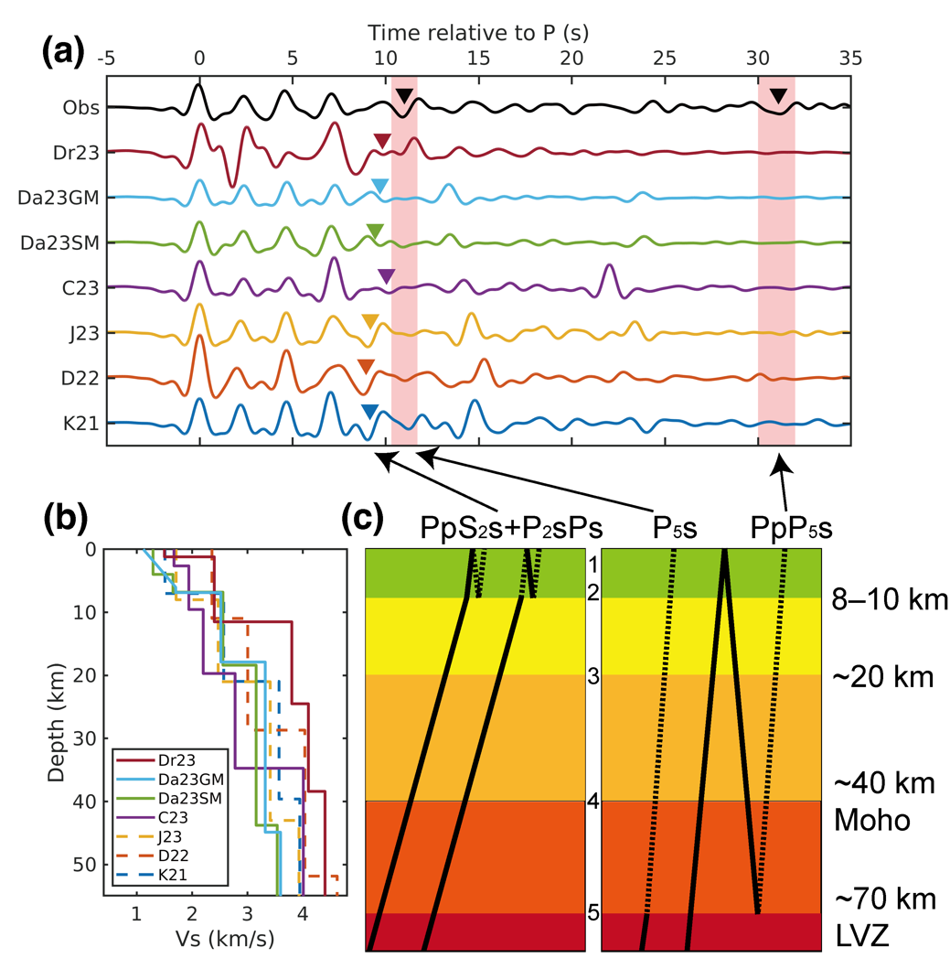
Supplementary Fig. 4 | Comparison of the negative phase in RF with crustal multiples. (a) Observed mean RF in this study (Obs) and synthetic RFs calculated using published three- and four-layer crustal models from refs. ²⁵ (K21), ²⁸ (D22), ²² (J23), ²⁹ (C23), ²⁴ (D23_SM and D23_GM), and ³⁰ (Dr23). Black triangles mark the observed negative phases at ~11 s and ~31 s. Colored triangles indicate predicted arrivals of crustal multiples from the 8–10 km interface (PpS₂s and P₂sPs). (b) Vs structures of the Martian crustal models derived from previous RF inversions. Dashed lines represent the three-layer-crust model, while solid lines denote the four-layer-crust model. (c) Ray paths of crustal multiples (PpS₂s and P₂sPs), the Ps phase converted at the top of LVZ (P₅s), and its multiple (PpP₅s). Solid lines indicate the P wave segments; dashed lines indicate converted S wave segments. Numbers represent the index of crustal and upper mantle interfaces.

3. Phase picking of PP/SS precursors

3.1. SS precursors of event S0976a
We analyze the transverse component displacement waveform to detect SS precursor phases from event S0976a. Considering the location uncertainties, we consider five back azimuth values evenly spaced within the 3σ uncertainty range of 91.08º to 104.16º. Different corner frequencies for bandpass filtering are applied, followed by a polarization filter (Supplementary Fig. 5). Supplementary Fig. 6 shows an example of waveform matching within a 3.0–6.5 s band. For this analysis, we use the filtered waveform from -6 s to 8 s relative to the SS peak as the template. Using a threshold $C_{lim}$ of 0.6 (Methods), we identify two potential precursor intervals, occurring ~19 s and ~40–50 s before the SS peak. Within these intervals, we observe waveforms that closely resemble the SS waveform, exhibiting alternating positive and negative CC peaks. This pattern is indicative of the cycle skipping, which could potentially lead to a false precursor pick. After comparing results across different frequency bands, we identify consistent peaks at -19.00 s and -46.55 s as two SS precursor signals, while CC peaks with inverted polarity observed at -21.3 s, and -44.1 s and -48.9 s are considered as corresponding sidelobes. In contrast to the robust identification of the two SS precursors across all frequencies, other signals, such as the arrivals from -3 s to -12 s, the negative pulse at -32.7 s, and the positive pulse at -39.5 s, are only prominent on a few limited frequency bands and/or show considerable amplitude reduction after polarization filtering (Supplementary Fig. 5b–f). Thus, despite their high waveform similarities to the SS at certain frequencies, they are not considered as valid SS precursors.
We further evaluate the identified two SS precursors by calculating the probability density functions of their delay times and amplitude ratios relative to the SS, by varying the back azimuth and corner frequencies of bandpass filtering (Supplementary Fig. 7b–c). The first SS precursor arrives 18.85 ± 0.09 s before the SS with an amplitude ratio of 0.29 ± 0.11. The second one arrives 46.25 ± 0.06 s before the SS with an amplitude ratio of -0.25 ± 0.10.
Similar to the previous study³¹, we do not detect consistent positive signals indicative of precursors from a Moho interface, likely due to the weak velocity jump across it^{24,25,31}. A small positive signal at -39.5 s with high similarity to the SS is the most probable Moho-related precursor (Supplementary Fig. 6b). However, polarization analysis indicates that the corresponding rectilinearity is below 0.4 (Supplementary Fig. 6c), resulting in a significant amplitude reduction after the polarization filter (Supplementary Fig. 5b–f). Consequently, we exclude it as a reliable detection of an SS precursor.

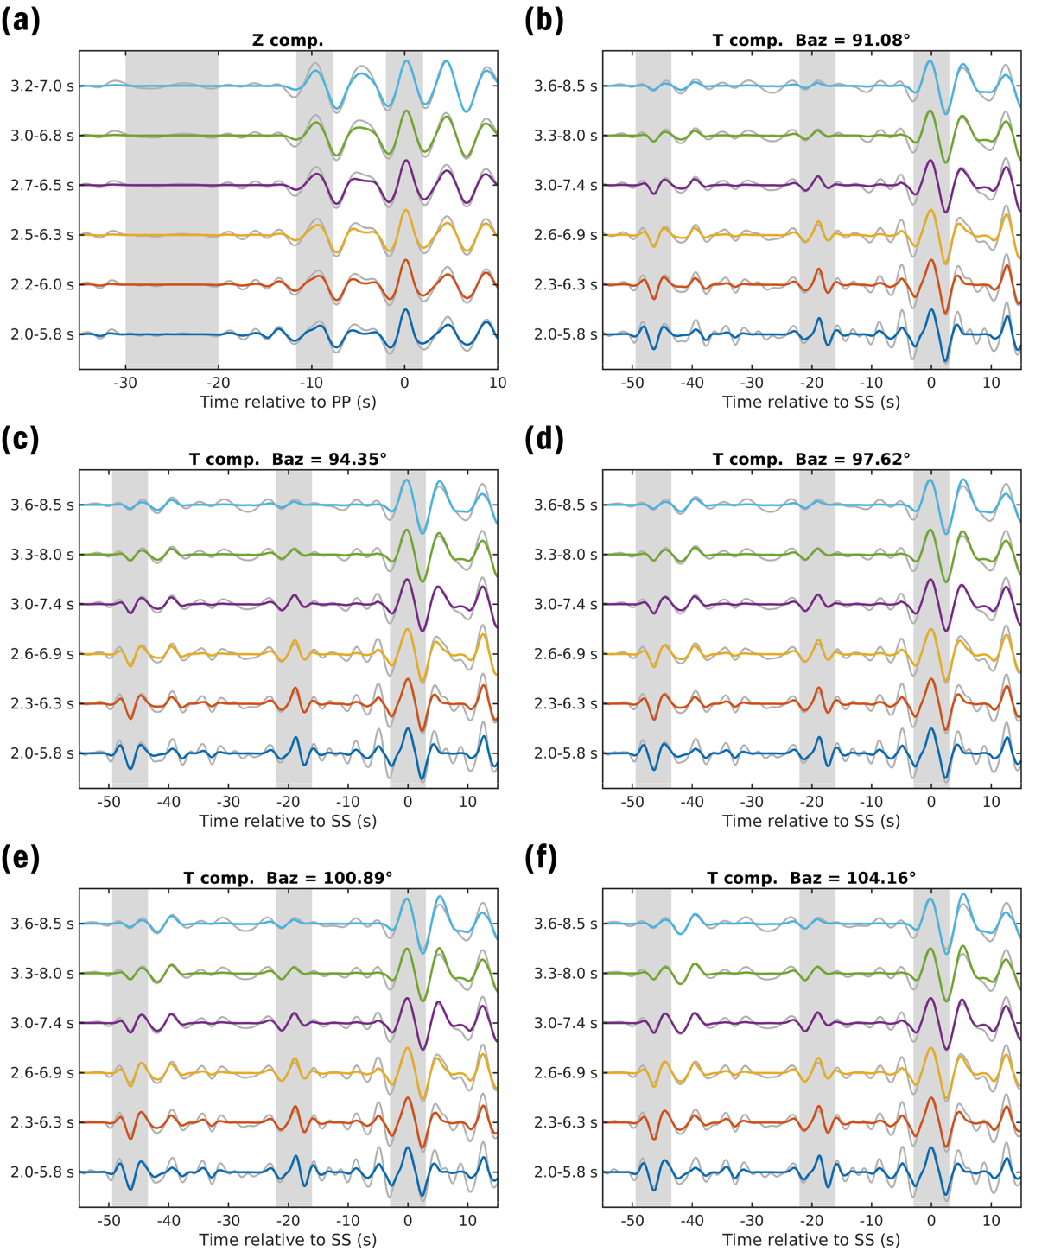
Supplementary Fig. 5 | Picking of the PP and SS precursors of event S0976a. (a) PP and its precursors on vertical component filtered within different frequency bands. (b)–(f) SS and its precursors on transverse component filtered within different frequency bands. Five different values of the back azimuth are used to rotate the waveforms into radial and transverse directions. Gray lines represent bandpass filtered traces; colored lines show polarization filtered traces. All traces are normalized to the peak amplitude of the PP/SS phase and aligned to their respective peak times. Gray vertical bands highlight the PP/SS arrivals and associated precursors. No definitive PP precursor associated with LVZ is identified. The root mean square amplitude within 20–30 s before the PP arrival is used to estimate the uncertainty of a zero-amplitude ratio of this phase.

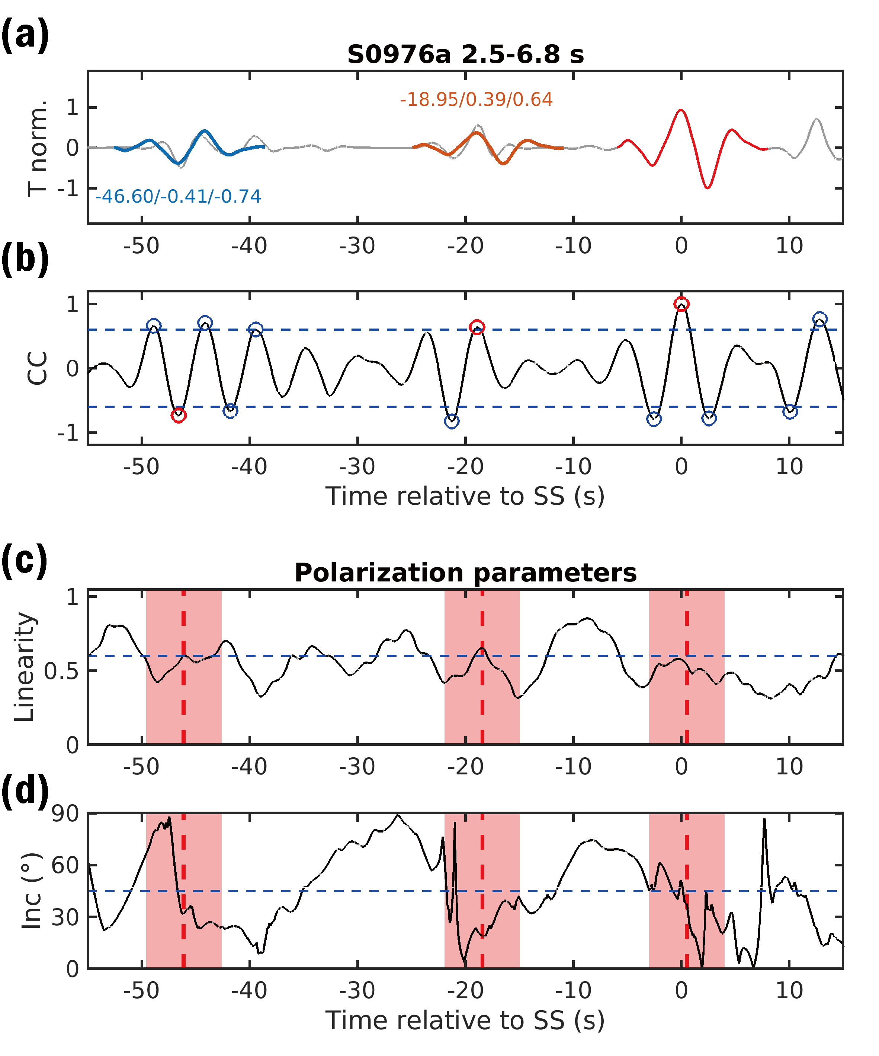
Supplementary Fig. 6 | Picks of the SS precursors of event S0976a. (a) Bandpass and polarization filtered waveform on transverse component. The corner frequencies for bandpass filtering are 1/6.8 Hz and 1/2.5 Hz. The amplitude is normalized to the peak amplitude of SS wave. Red line represents the template waveform between -6 s and 8 s. Blue and orange lines represent the template waveforms scaled to the precursor amplitudes with corresponding time shifts. The adjacent texts denote the values of time shift, amplitude ratio, and cross-correlation coefficient. (b) The values of cross-correlation coefficient (CC). Blue dashed lines represent the threshold value C_{lim} of 0.6. Circles denote the peaks with the absolute CC values above the C_{lim}, of which the red ones stand for the final picks of SS wave and its precursors. (c) Rectilinearity derived from polarization. Blue dashed line represents a value of 0.6. (d) Incidence angle calculated from the eigenvector associated with the principal direction. Blue dashed line represents a value of 45º. Red shaded areas denote the intervals of SS waves and its precursors. Dashed red lines denote the CC peak times of SS waves and its precursors.

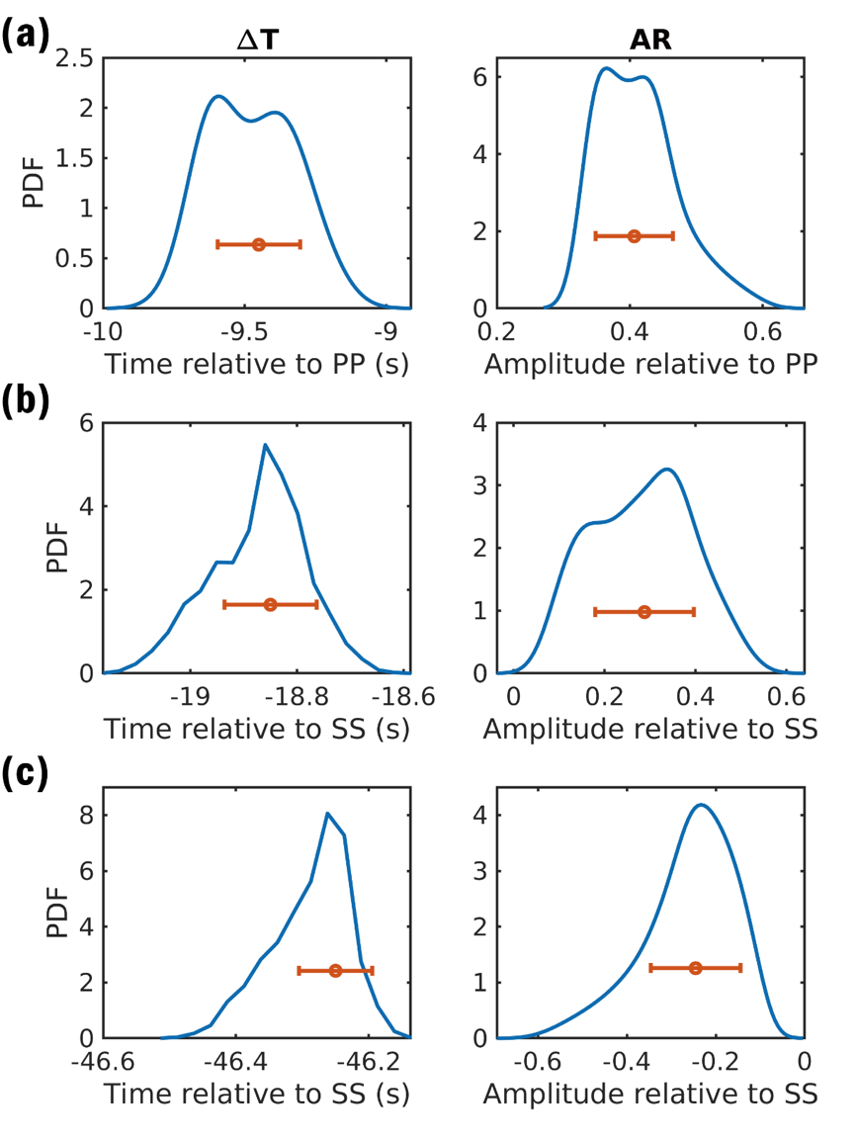
Supplementary Fig. 7 | The distributions of delay times and amplitude ratios of the PP and SS precursors of event S0976a. (a)–(c) are for the first PP precursor, the first SS precursor, and the second SS precursor, respectively. The blue lines denote the probability density functions. Horizontal orange errorbars denote the median values with their 1σ intervals.

3.2. PP precursor of event S0976a
To detect the PP precursor phases of S0976a, we analyze the vertical component displacement waveforms filtered within different frequency bands (Supplementary Fig. 5a). Supplementary Fig. 8 shows an example of waveform matching at the frequency band of 2.5–7.0 s. The template waveform is cut within a window from -4 s to 4 s relative to the PP peak. A clear precursor phase is observed at 9.6 s before the PP wave, which is aligned with the pick in previous study and is confirmed as the precursor related to the 20-km interface³¹. For a $C_{lim}$ of 0.6, we also identify two negative CC peaks at 7.6 s and 20.9 s before the PP. The negative peak at 7.6 s is likely the sidelobe of the PP precursor, despite its high CC peak value at this frequency. The negative CC peak at 20.9 s is presumably associated with a deeper low velocity interface, corroborated by the observed negative SS precursor at 46.3 s before SS. However, its amplitude is weak to definitively confirm it as the precursor phase.
Similarly, the probability density functions of delay time and amplitude ratio of the picked PP precursor are measured across different filtering bands (Supplementary Fig. 7a). The PP precursor arrives 9.45 ± 0.15 s before the PP with an amplitude ratio of 0.41 ± 0.06. In contrast to the SS precursor, an observable PP precursor associated with the deeper LVZ is lack, which suggests that the reflection coefficient at the low-velocity zone is small and the corresponding PP precursor amplitude falls below the noise level. Nevertheless, the weak amplitude of the PP precursor can be used a proxy to better constrain the velocity and density jump across the deeper low velocity interface (see further discussion in Supplementary Text 4.2). For simplicity, we assign an amplitude ratio of zero for this hypothetical PP precursor and define its uncertainty using the noise level, which is quantified as the mean value of the root mean square amplitudes of the waveforms filtered across various frequency bands within a window 20–30 s before the PP.

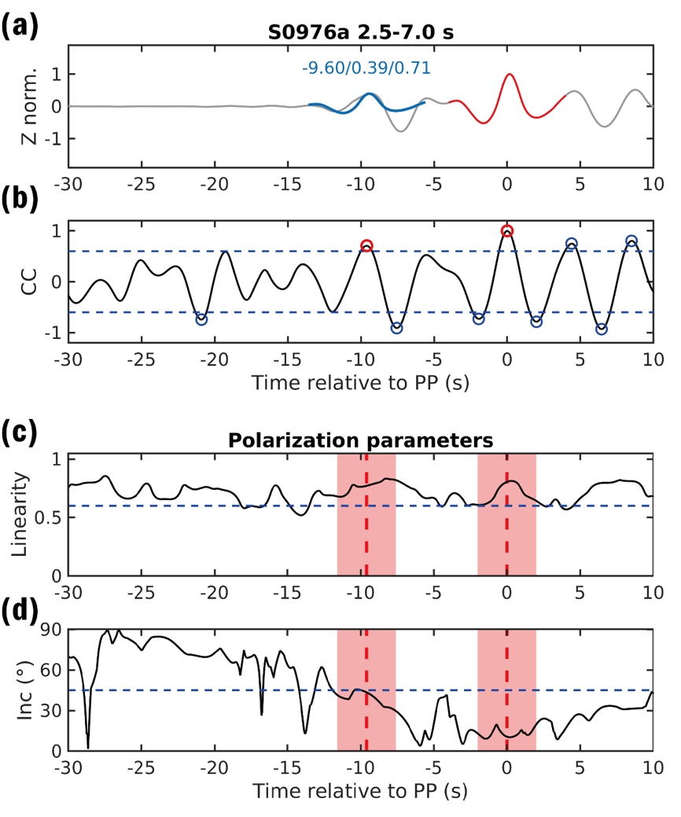
Supplementary Fig. 8 | Pick of the PP precursor of event S0976a. Detailed figure captions are same as in Supplementary Fig. 6.

3.3. SS precursors of event S1153a
Event S1153a has a distance of ~84.8º and a back azimuth of ~87.2º relative to the InSight lander^{2,5}. The SS wave and its precursors of S1153a provide us an opportunity to illuminate the subsurface structure in the eastern region of Elysium Planitia and to the east of Cerberus Fossae, an area characterized by active seismicity and the potential presence of a mantle plume^{7,9,11} (Fig. 1). The PP wave of S1153a is not explored in current study considering its observed weak amplitude.
Here, we identify the SS wave by employing the waveform matching based on the Hilbert transform of the S wave within a 10 s window^{28,32-34} (Supplementary Fig. 9). The transverse component is used and bandpass filtered to 0.2–0.8 Hz. Considering a possible polarity reversal due to the difference of take-off angles between the SS and S waves, we keep all CC peaks that satisfy |CC| > 0.6 on both bandpass and polarization filtered traces as candidates (Methods). The waveforms at ~45 s, ~70 s, ~90 s, and ~113 s after the S wave show high similarities with the template (Supplementary Fig. 9a). Travel time calculation results using updated Martian interior models^{28,35} suggest that the SS wave of S1153a is most likely to arrive ~82 s after the S wave (Supplementary Fig. 10c). The CC peaks, which occur 90 s after S wave, display the highest PDF of the SS wave’s arrival time. Therefore, we designate the phase at 90 s as the SS wave, categorizing the first two phases as SS precursors and the last phase as a potential postcursor.
Analogous to the procedure for S0976a, we use varying back azimuths and frequency bands to pick S1153a’s SS precursors (Supplementary Fig. 11). Supplementary Fig. 12 displays an example of the waveform matching with a back azimuth of 87.17º and a frequency band of 0.2–0.8 Hz. The template waveform is chosen within a 6 s window centered at the SS peak. With CC peaks larger than 0.6, we identify two SS precursor phases given their consistent existences across different frequencies and back azimuths (Supplementary Fig. 11). The first is observed to arrive 45.1 s before SS wave and exhibits a negative polarity, while the second is a positive phase that arrives 20.9 s before the SS wave. Other CC peaks at 38.3 s, 31.6 s, and 14.4 s before the SS wave are not classified as SS precursors due to the diminished amplitudes after polarization filtering (Supplementary Fig. 11).
Finally, we pick one negative and one positive SS precursor from the waveform of S1153a, both of which exhibit time shifts comparable to those observed in event S0976a, suggesting the existence of a similar subsurface structure beneath the bounce points of the two events. We further obtain the PDFs of their delay times and amplitude ratios relative to the SS wave (Supplementary Fig. 13). The first SS precursor arrives 20.90 ± 0.04 s before the SS wave with an amplitude ratio of 0.67 ± 0.14. The second one arrives 45.10 ± 0.03 s before the SS wave with an amplitude ratio of -0.42 ± 0.16.

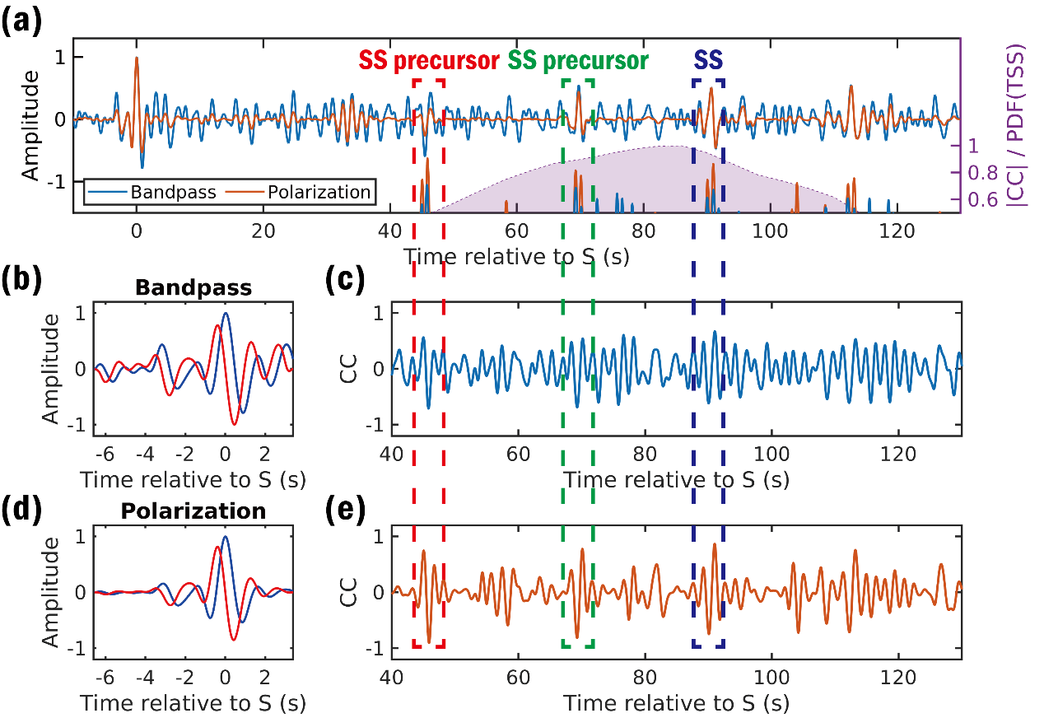
Supplementary Fig. 9 | Picks of the SS wave and its precursors of event S1153a. (a) Bandpass (blue line) and polarization (orange line) filtered transverse component velocity waveforms. Waveforms are filtered into 0.2–0.8 Hz. Amplitudes are normalized to the peak values of the direct S wave. Bottom part shows the CC peaks (blue and orange lines) and smoothed relative PDF of the SS arrival times (purple dot line and area). (b) Bandpass filtered direct S wave (blue line) and its Hilbert transformed (red line) waveforms. (c) CC values of the waveform matching using the bandpass filtered and Hilbert transformed S wave. (d)–(e) is the same as (b)–(c) but for the polarization filtered waveform. Waveforms at 45 s, 70 s, and 90 s after the S wave have high similarities with the template in both bandpass and polarization filtered traces. The final observation exhibits the greatest likelihood of being an SS wave, given that it has the maximum PDF associated with its arrival time.

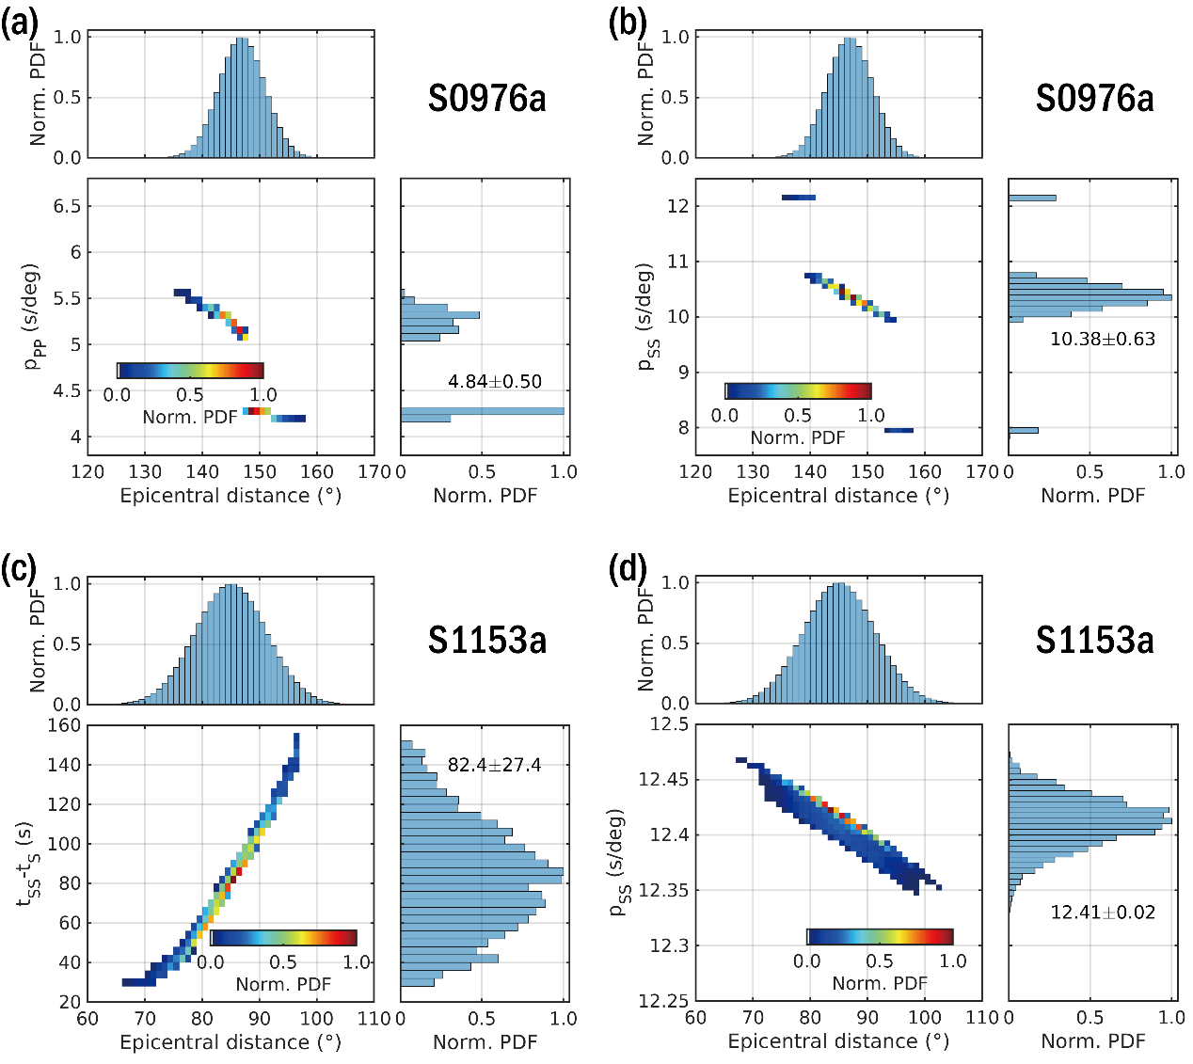
Supplementary Fig. 10 | Distributions of ray parameters and SS-S travel time difference of events S0976a and S1153a. In each subfigure, top left panel shows the normalized PDF of epicentral distance from MQS Catalog²; bottom left panel shows the normalized joint PDF of epicentral distance and ray parameters or SS-S travel time difference, which are calculated using Taup by setting a variety of source depth from 0 to 100 km; bottom right panel shows the normalized PDF of ray parameters or SS-S travel time difference.

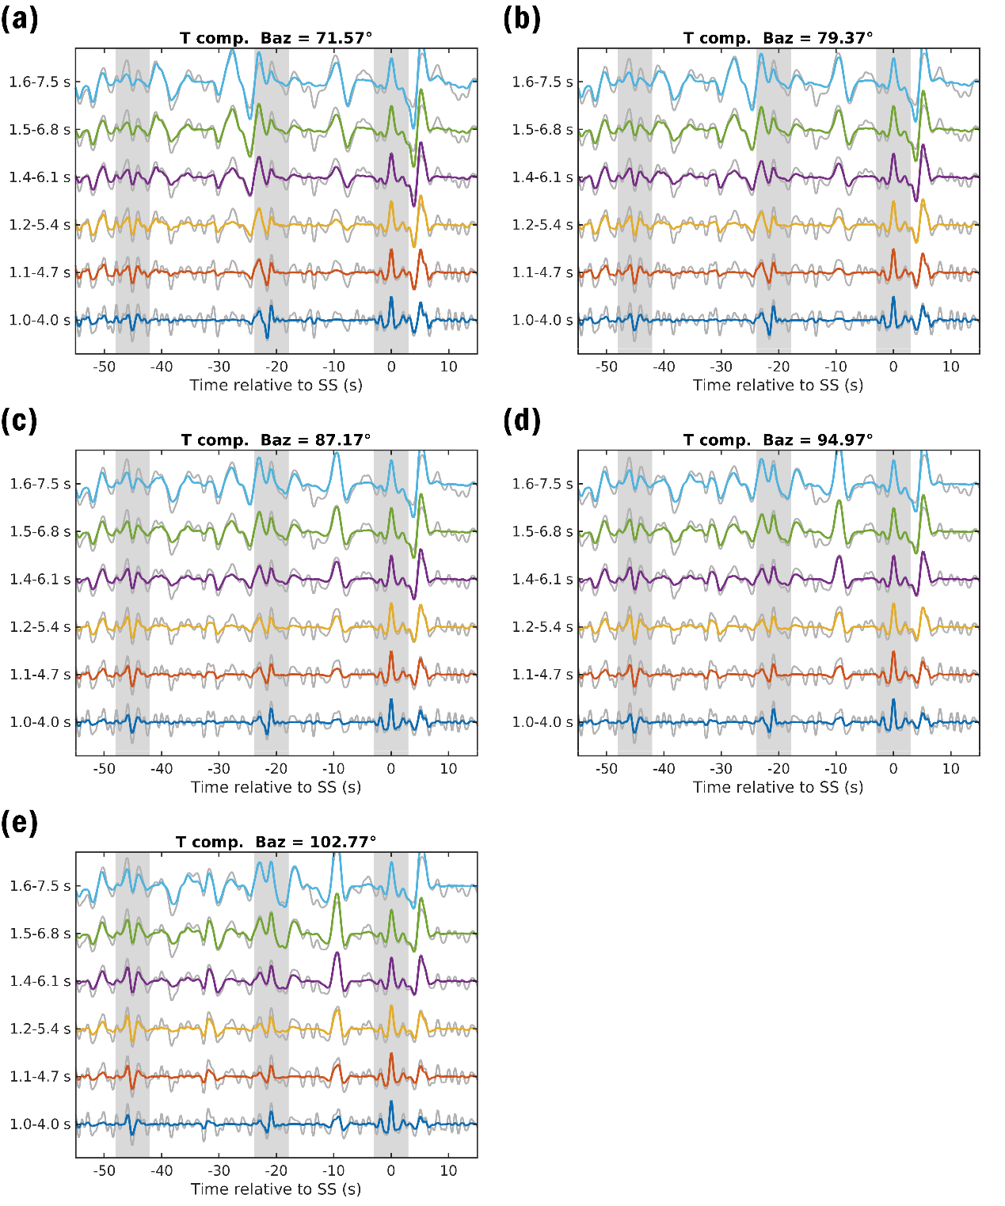
Supplementary Fig. 11 | Picking of the SS precursors of event S1153a. (a)–(e) SS and its precursors on transverse component filtered within different frequency bands. Five different values of the back azimuth are used to rotate the waveforms into radial and transverse directions. The gray lines represent the bandpass filtered waveforms, while the colored lines represent the polarization filtered waveforms. All traces are normalized to the peak amplitude of the SS wave. The time is aligned to the peak time of the SS wave. The gray vertical bands denote the SS waves and their identified precursor phases.

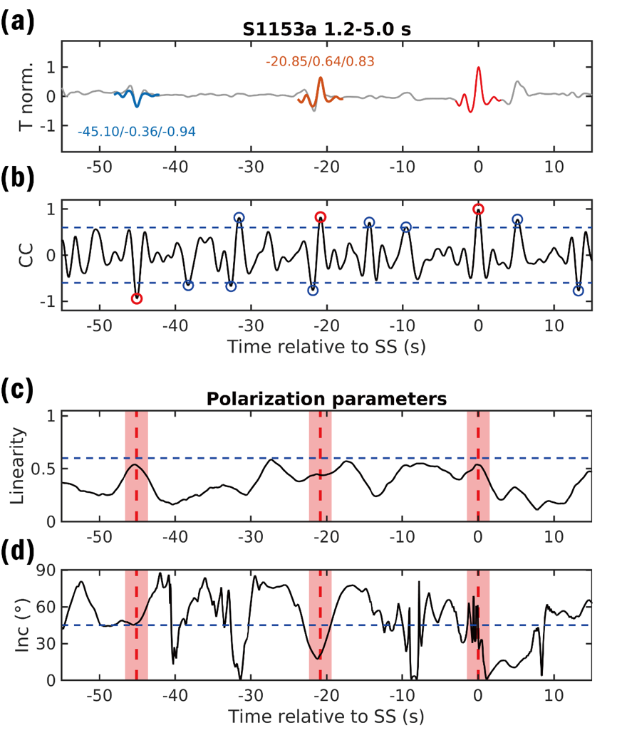
Supplementary Fig. 12 | Picks of the SS precursors of event S1153a. Detailed figure captions are same in Supplementary Fig. 6.

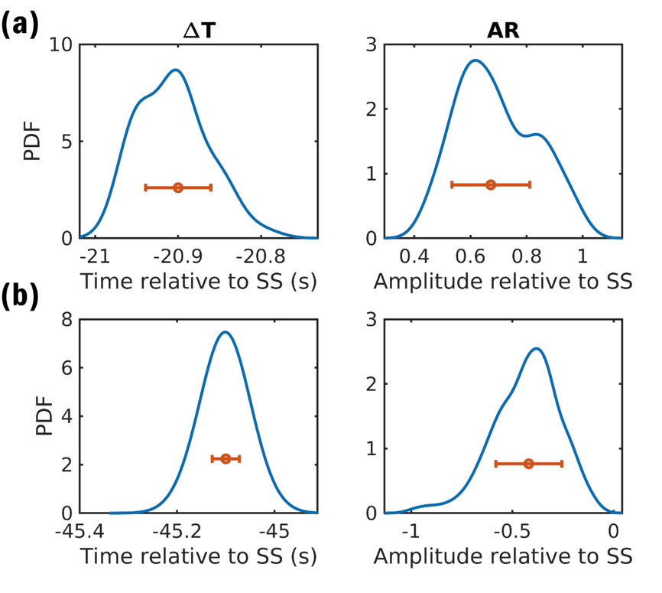
Supplementary Fig. 13 | The distributions of delay times and amplitude ratios of the SS precursors of event S1153a. (a) and (b) are for the first and second SS precursors, respectively. Detailed figure captions are the same as Supplementary Fig. 7.

3.4. Comodulation analysis
In addition to marsquake signals, the InSight seismometer has captured noise arising from atmospheric energy injection, rendering the identification of seismic phases a challenging task¹⁹. To address this, comodulation analysis has been extensively employed to assess the contributions of atmospheric injection into the InSight seismic records, helping to distinguish true marsquake signals characterized by energy exceeding the ambient environmental noise³⁶. In the comodulation analysis, environmental variables such as pressure, wind speed, and wind-excited weather-sensitive lander modes serve as proxies for atmospheric effects. These variables are used to estimate injected ground motion by matching the statistical moments (mean and variance) of seismic and environmental signals^{20,31,36-39}.
Here, we apply the comodulation analysis to investigate the body wave phases of two distant marsquakes S0976a and S1153a, focusing on the PP, SS, and their precursors. Considering the absence of pressure and wind speed data for event S1153a due to power limitation, we only use the weather-sensitive lander mode at ~4 Hz as the proxy for atmospheric injection in this study. The seismic power envelopes are calculated in discrete half-octave frequency bands and compared with the environmental noise, which is computed as the combined power energy envelope of ZNE three component waveforms within the 3.7–4.3 Hz range (Supplementary Figs. 14–15).
As an LF event, S0976a is characterized by pronounced seismic energy within the period range of 1.4–8.0 s, with environmental noise predominating above 1 Hz (Supplementary Fig. 14a–b). In the vertical component, the PP wave exhibits an energy peak that surpasses the atmospheric injection within the 1.4–5.7 s period. However, at this frequency band, the precursor at ~9.5 s before PP shows comparable energy to the environmental noise (Supplementary Fig. 14c–d), likely due to a significant atmospheric energy injection occurring between the arrivals of the precursor and PP. Another earlier atmospheric injection peak, ~20–35 s prior to the PP arrival, would further obscures the detection of an earlier precursor. In contrast, the tangential component analysis reveals robust and consistent seismic peak energies for both the SS and its two identified precursors, all exceeding the environmental noise levels at periods of 2.0–5.7 s (Supplementary Fig. 14e–f).
Unlike S0976a, event S1153a displays considerably higher frequency energy above 1 Hz and a distinct amplification of the 2.4 Hz resonance (Supplementary Fig. 15a–b). Below 1 Hz, the energy of the P wave is not significantly larger than the environmental noise, making it difficult to identify PP or PP precursors through waveform matching (Supplementary Fig. 15c–d). In contrast, the S wave exhibits a pronounced energy peak between 1.4 and 4.0 s, and both the SS and its two precursors have amplitudes surpassing atmospheric injections, confirming their marsquake origins (Supplementary Fig. 15e–f).

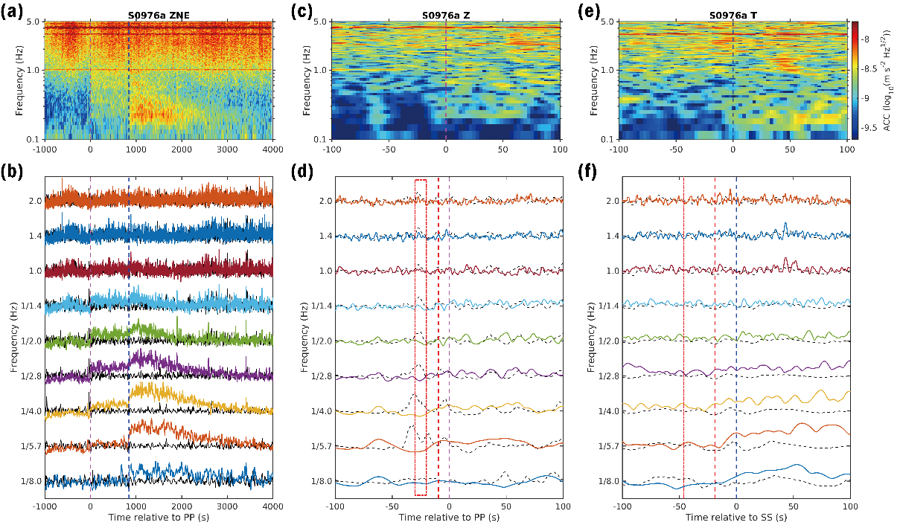
Supplementary Fig. 14 | Comodulation analysis of event S0976a. (a) Spectrogram of the combined energy power in ZNE three directions. (b) Comparison of the combined seismic energy power in ZNE three directions (colored lines) and atmospheric energy power (black lines). The seismic energy power is calculated in half-octave frequency bands centered from 1/8.0 to 2.0 Hz. The atmospheric energy power is calculated in the frequency range of 3.7–4.3 Hz and then smoothed to corresponding central frequencies. Magenta and blue dashed vertical lines denote the arrivals of PP and SS waves, respectively. (c) Spectrogram of the vertical direction energy power around PP wave. (d) Comparison of the seismic energy power in vertical direction (colored lines) and atmospheric energy power (black dashed lines). Magenta dashed vertical line denotes the PP arrival. Red dashed vertical line denotes the identified PP precursor arrival at ~9.5 s before the PP wave. Red dot-dashed rectangle denotes the time window 20–30 s before the PP wave, within which a possible PP precursor phase may exist. (e) Spectrogram of the tangential direction energy power around SS wave. (f) Comparison of the seismic energy power in tangential direction (colored lines) and atmospheric energy power (black dashed lines). Blue dashed vertical line denotes the SS arrival. Red dashed vertical line denotes the identified SS precursor arrival at ~18.9 s before the SS wave. Red dot-dashed vertical line denotes the identified SS precursor arrival at ~46.3 s before the SS wave.

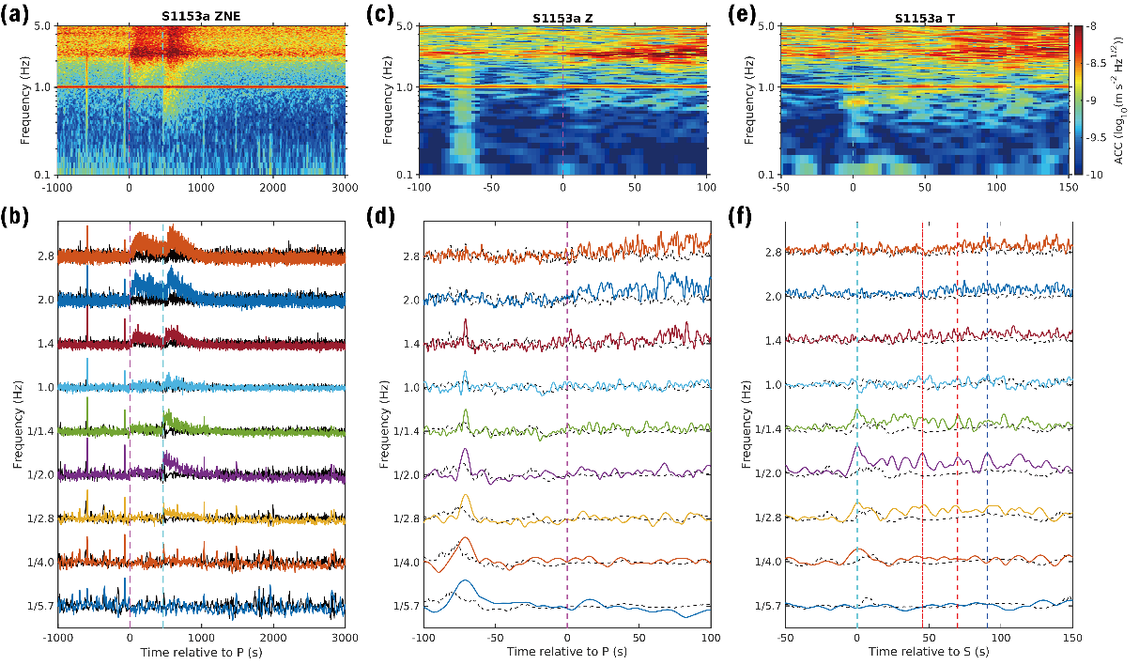
Supplementary Fig. 15 | Comodulation analysis of event S1153a. Detailed figure caption is same as in Supplementary Fig. 14. Magenta and cyan dashed vertical lines denote the P and S wave arrivals, respectively. Blue dashed vertical line denotes the identified SS wave arrival. Red dashed vertical line denotes the identified SS precursor arrival at ~20.9 s before the SS wave. Red dot-dashed vertical line denotes the identified SS precursor arrival at ~45.1 s before the SS wave.

4. Seismic inversion results

4.1. Crustal structure beneath the InSight lander
Our RF inversion results show a crustal structure similar to previous findings^{24,29}. The S-wave velocities of the four crustal layers and the uppermost mantle are 1.5 ± 0.1 km/s, 2.0 ± 0.2 km/s, 2.9 ± 0.2 km/s, 3.4 ± 0.2 km/s, and 3.7 ± 0.2 km/s, respectively. The depths of the intracrustal interfaces and the Moho are 4.5 ± 0.8 km, 7.9 ± 0.4 km, 23.6 ± 1.6 km, and 46.2 ± 3.3 km, respectively. Notably, the deep crustal structures, specifically the ~20-km interface and the Moho, have depths and velocities in close agreement with the results of ref. ²² and are exhibit less uncertainties than those in refs. ^{24,25,28}. Such an improvement likely results from stronger constraints provided by multiples at two deeper crustal layers.
It is also worth mentioning that the depth of the first layer in our inversion (~4.5 km) is close to that derived from the joint inversion of RF and Vs,app (~4.0 km) ²⁴, but is considerably greater than those from Rayleigh wave ellipticity (~2–3 km) ²⁹, surface wave dispersion and body wave travel times from nearby impacts (~1.2 km) ³⁰, and P wave particle motions (~0.75 km) ⁴⁰. While a minor peak at ~2–3 km appears in the PDF of the thickness of the shallow layer, the Vp/Vs ratio and the depth of the first layer remain poorly resolved (Supplementary Fig. 16c–d). This is due to the absence of a distinct ~1 s arrival in our observed mean RFs within the frequency band of 0.15–0.85 Hz (Extended Data Fig. 1), which is, however, evident in the high frequency RFs¹⁵.

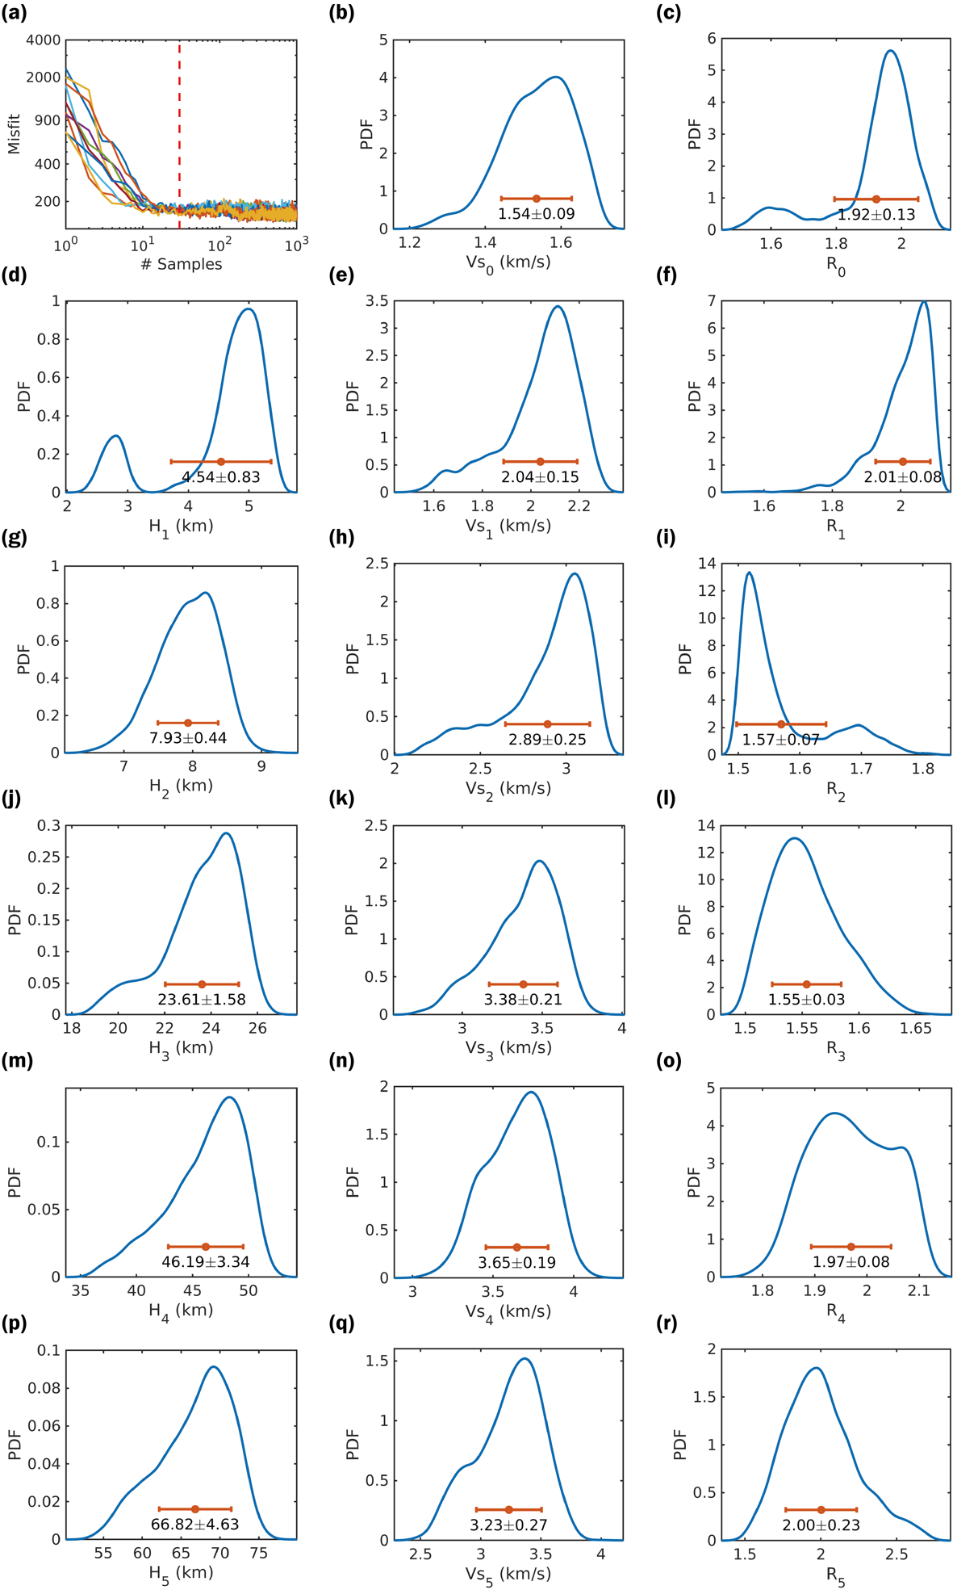
Supplementary Fig. 16 | Misfit of the RF inversion and posterior distributions of model parameters. (a) Misfit changes of all accepted models in ten parallel Markov chains. Red dashed line separates the first 30 models in each chain, which are regarded as in the burn-in phases. (b)–(r) Marginal PDFs of the posterior distributions for all model parameters. R stands for the Vp/Vs ratio. The error bar in each subfigure shows the mean value and the standard deviation.

4.2. Additional RF inversions
The RF inversion employing a three-layer crust leads to a substantial increase in misfit compared to the reference inversion using four-layer crust (Supplementary Fig. 17). In particular, the three-layer crust model predicts a larger amplitude of direct P (Supplementary Figs. 17e-f). Such a misfit argues for the requirement of a much lower velocity in the shallowest crust, which further supports our choice of a four-layer crust as proposed by refs. ^{15,24,29,30,40}. Moreover, omitting this uppermost crustal layer leads to much lower velocities for deeper layers and shallower interface depths, due to the inherent trade-offs in the RF analysis⁴¹ (Supplementary Fig. 17a). Therefore, a four-layer crust can provide a more accurate shallow structure and simultaneously better resolve the deep structures, including the upper mantle LVZ, which is the primary focus of this study.
We also perform additional inversion for models without an upper mantle LVZ. Such an inversion yields a nearly identical crustal structure but increase the misfit and fails to predict the negative arrivals at ~11 s and ~31 s (Supplementary Fig. 18). To further explore the possibility that the observed negative phase at ~11 s is a multiple converted from an intracrustal LVZ, we also perform an inversion with a five-layer crust with a mid-crust LVZ lies between the ~10-km and ~20-km interfaces (Supplementary Fig. 19a). While this model can reasonably reproduce the RF waveform up to 25 s, it fails to fit the negative phase at ~31 s (Supplementary Fig. 19b–d). In addition, the introduced mid-crust LVZ at ~15–20 km depth in the inversion generates extreme low velocities in the lower crust and shallower Moho depth (Supplementary Fig. 19a).
To balance model complexity and data fit, we further employ the Akaike Information Criterion⁴² (AIC) and the Bayesian Information Criterion⁴³ (BIC) to evaluate and compare different model configurations. These criteria quantify how well a model explains the observed data while penalizing excessive complexity to avoid overfitting. The AIC and BIC are defined as
$AIC=2k-2ln⁡(L)$, (10)
$BIC=kln(n)-2ln⁡(L)$, (11)
where k is the number of model parameters, L is the likelihood, and n is the number of data. Given the definition of misfit function and its relationship with the likelihood, these expressions can be reformulated as
$AIC=2k+misfit$, (12)
$BIC=kln\left(n\right)+misfit$. (13)
Both AIC and BIC consistently favor the four-layer crust with an upper mantle LVZ as the optimal configuration for RF inversion (Supplementary Fig. 20). This model offers the best trade-off between fit and complexity. In contrast, the three-layer crustal model is strongly disfavored. Alternative models, such as those omitting the upper mantle LVZ or introducing a mid-crustal LVZ, produce intermediate results but fail to outperform the four-layer crust model with an upper mantle LVZ.

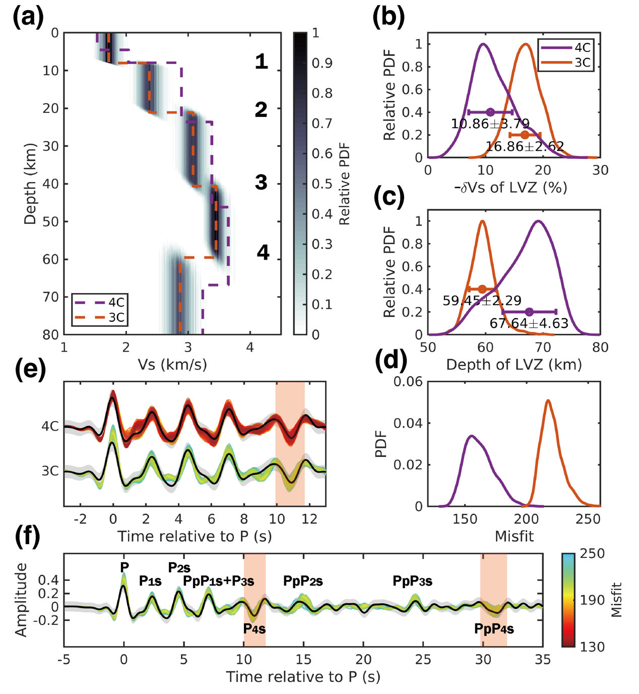
Supplementary Fig. 17 | Results of the RF inversion with a three-layer crust setting. (a) Normalized PDF of the Vs posterior distribution for one thousand models in a single Markov chain. Orange dashed line denotes the mean model from this inversion (three-layer crust or 3C). Purple dashed line denotes the mean model from the reference inversion (four-layer crust or 4C). (b) Comparison of the LVZ Vs reductions derived from this inversion and the reference inversion. (c) Comparison of the LVZ depths derived from this inversion and the reference inversion. (d) Comparison of the RF fits for the first 12 s between this inversion and the reference inversion. (e) Comparison of the misfit distributions between this inversion and the reference inversion. The misfit of reference inversion with a four-layer crust is much smaller than that of the inversion with a three-layer crust. (f) RF fit and misfit distribution of this inversion. Colorbar shows the range of misfit values, which is set to 130–250 for a better visional comparison.

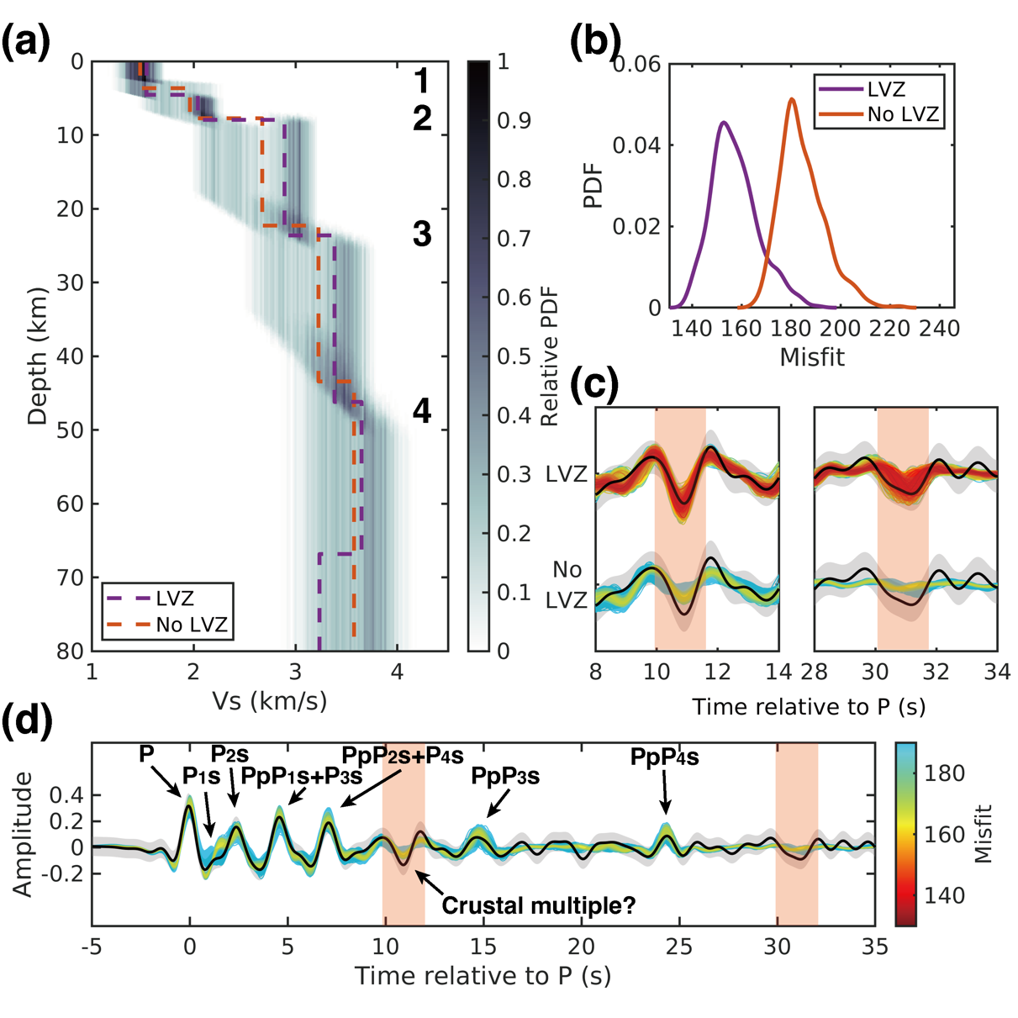
Supplementary Fig. 18 | Results of the RF inversion without an upper mantle LVZ setting. (a) Normalized PDF of the Vs posterior distribution for one thousand models in a single Markov chain. Orange dashed line denotes the mean model from this inversion (no LVZ). Purple dashed line denotes the mean model from the reference inversion (LVZ). Two inversions have the same initial models except for the upper mantle LVZ. (b) Comparison of the misfit distributions between this inversion and the reference inversion. (c) Comparison of the fits for the two negative arrivals at ~11 s and ~31 s between this inversion and the reference inversion. (d) RF fit and misfit distribution of this inversion. Colorbar shows the range of misfit values, which is set to 130–190 for a better visional comparison in (c). Names of phases are annotated. Orange shaded areas in (c) and (d) show the position of two negative arrivals. In this inversion, the negative phase at ~11 s is regarded as a possible crustal multiple. The synthetic RFs of inverted models exhibit no energy at ~31 s and an extremely weak negative wiggle at ~11 s.

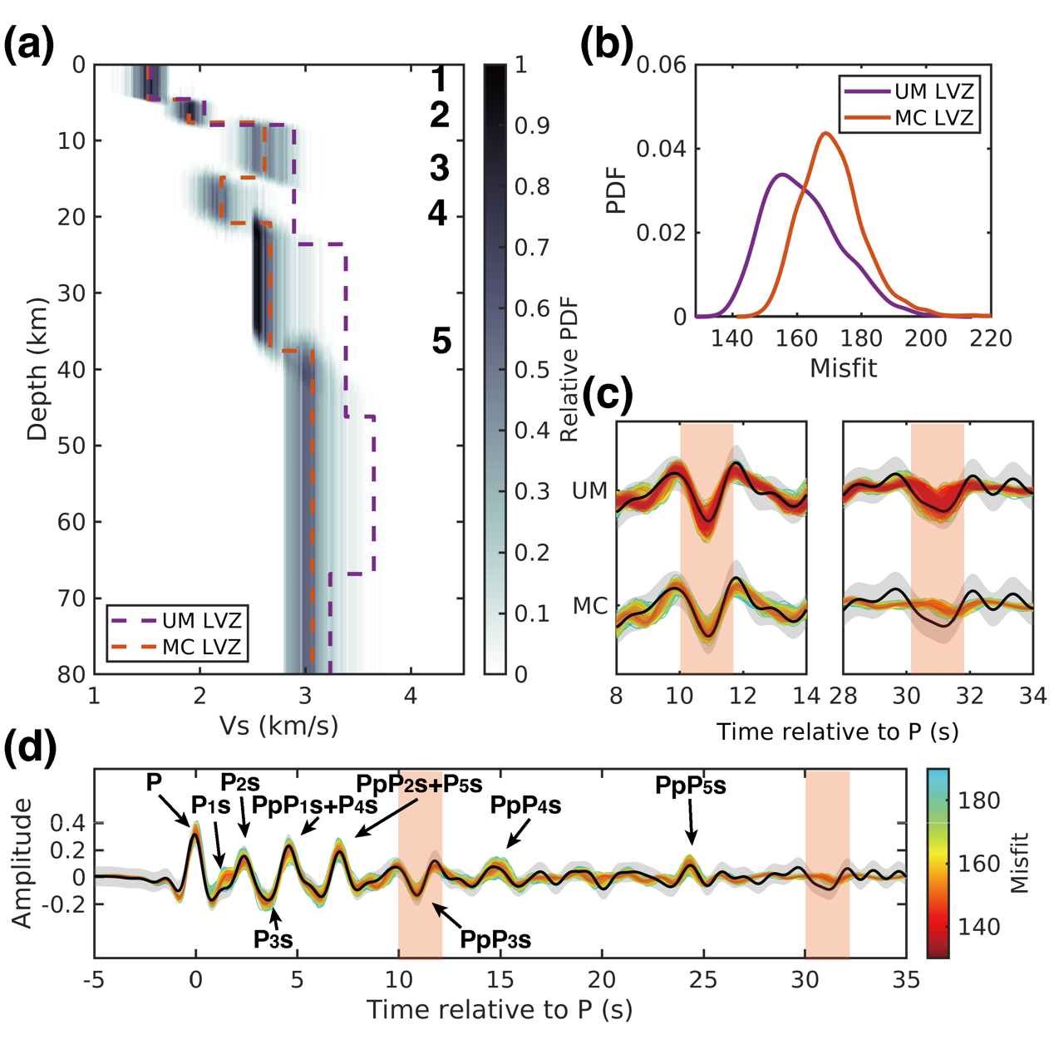
Supplementary Fig. 19 | Results of the RF inversion with a middle crustal LVZ setting. (a) Normalized PDF of the Vs posterior distribution for one thousand models in a single Markov chain. Orange dashed line denotes the mean model from this inversion (MC LVZ; middle crustal LVZ). Purple dashed line denotes the mean model from the reference inversion (UM LVZ; upper mantle LVZ). (b) Comparison of the misfit distributions between this inversion and the reference inversion. (c) Comparison of the fits for the two negative arrivals at ~11 s and ~31 s between this inversion and the reference inversion. (d) RF fit and misfit distribution of this inversion. Colorbar shows the range of misfit values, which is set to 130–190 for a better visional comparison in (c). Names of phases are annotated. Orange shaded areas in (c) and (d) show the position of two negative arrivals. In this inversion, the negative phase at ~11 s is regarded as a multiple conversion from the low velocity interface at depth of 15 km. The synthetic RFs of inverted models exhibit no energy at ~31 s.

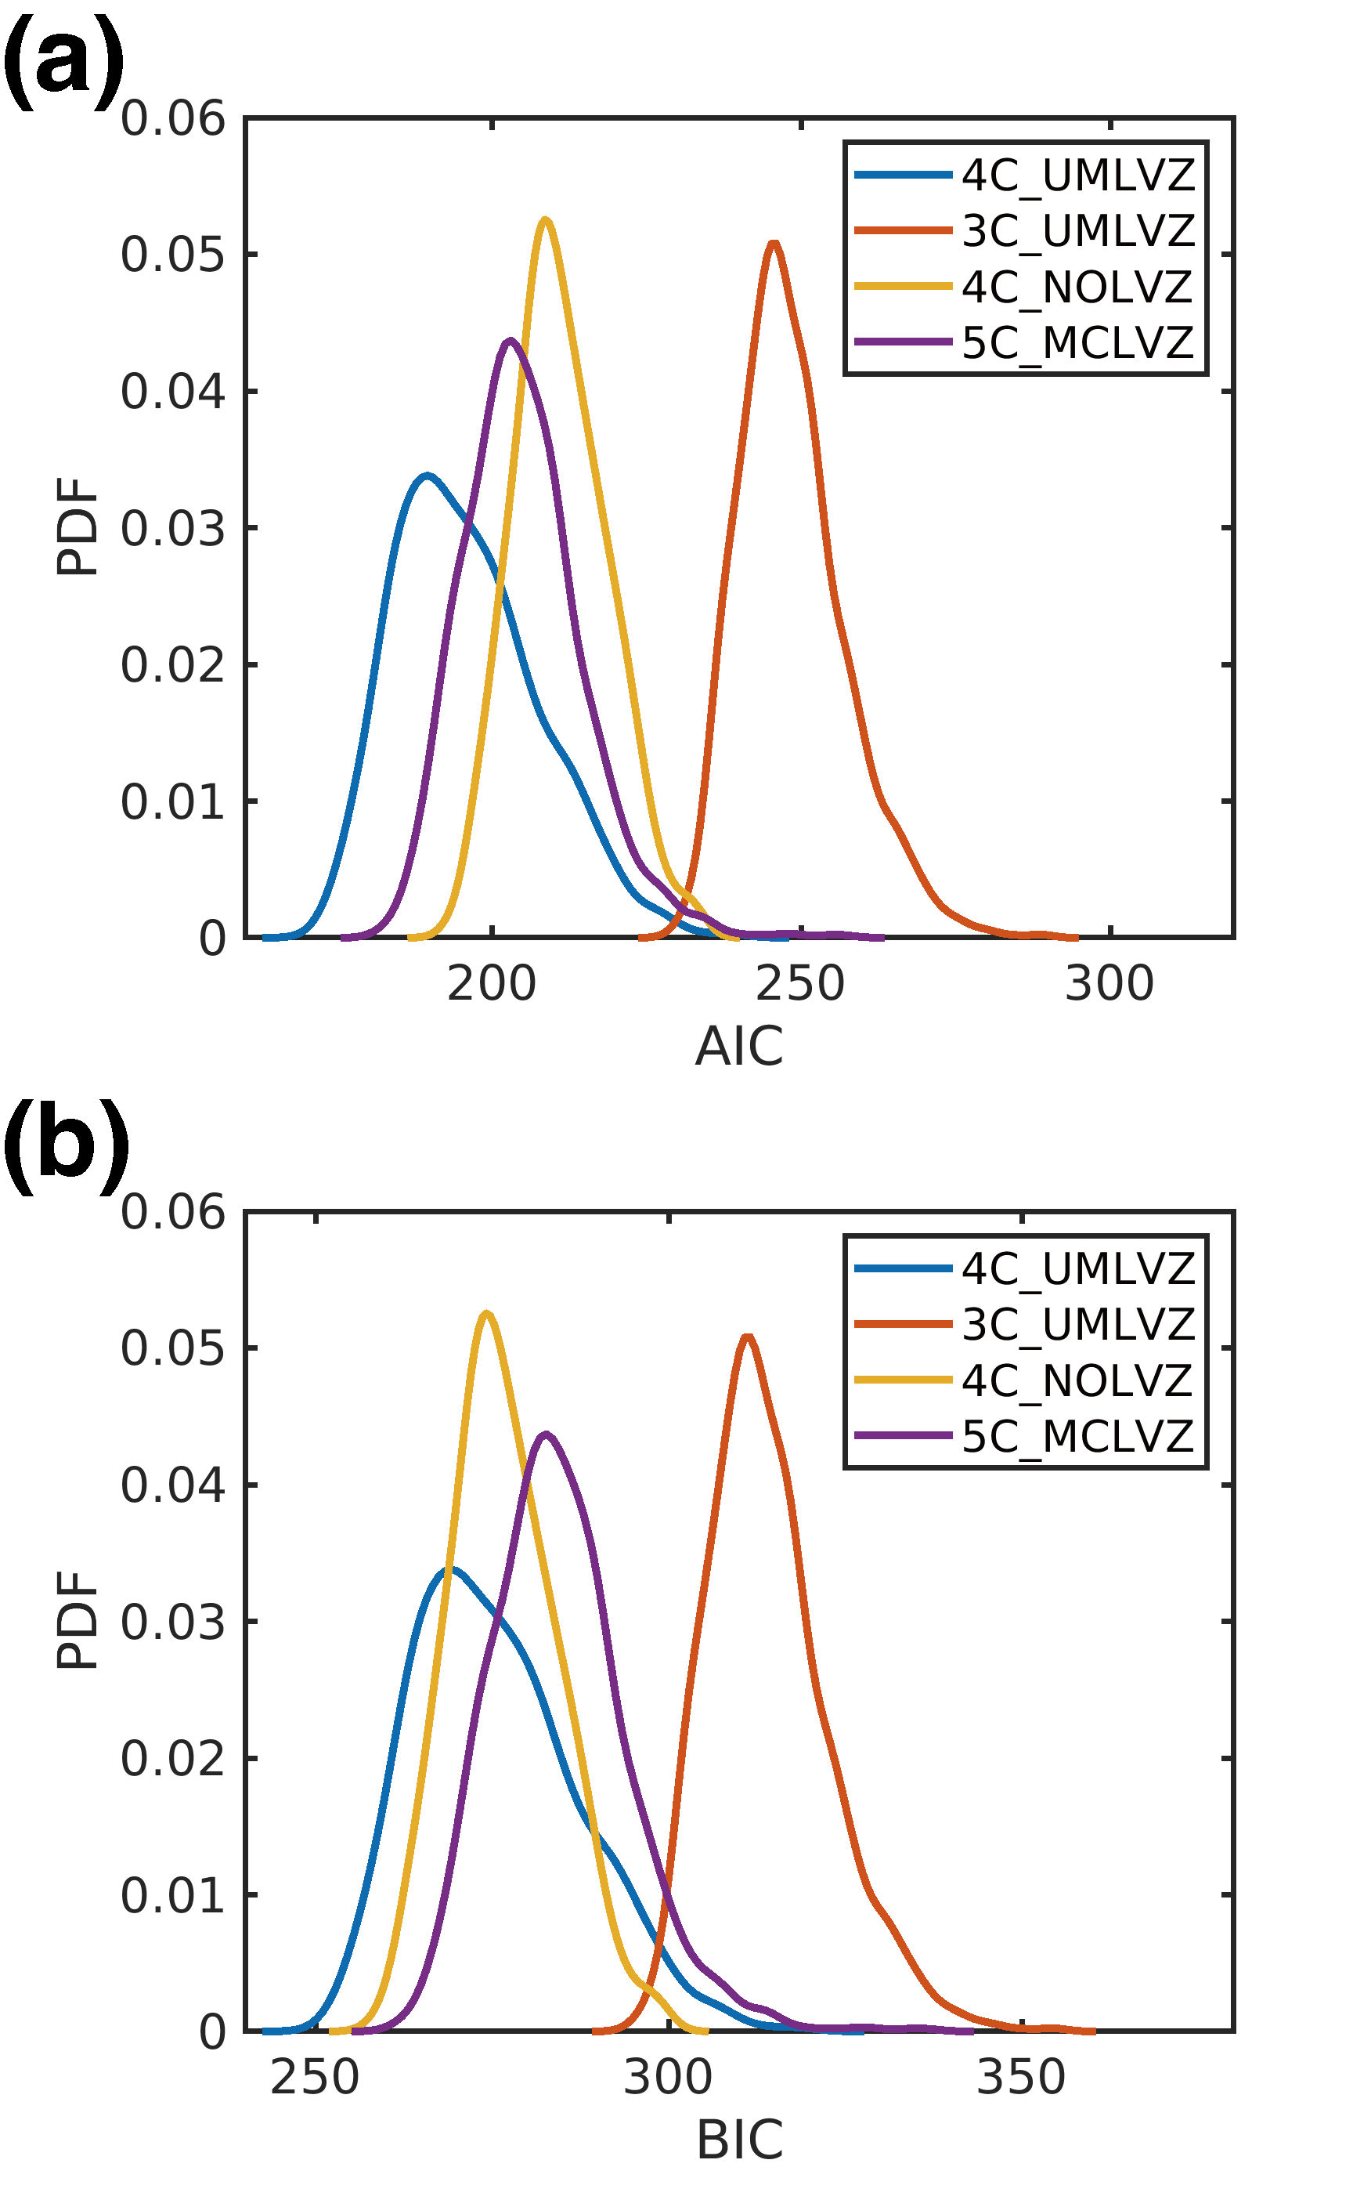
Supplementary Fig. 20 | Probability density distributions of model selection criteria for different inversion results. (a) Akaike Information Criterion (AIC) and (b) Bayesian Information Criterion (BIC) values computed from RF inversion results using four different model configurations: a four-layer crust with an upper mantle low-velocity zone (4C_UMLVZ), a three-layer crust with an upper mantle LVZ (3C_UMLVZ), a four-layer crust without an upper mantle LVZ (4C_NOLVZ), and a five-layer crust with a mid-crustal LVZ (5C_MCLVZ). Lower AIC and BIC values indicate better model performance. Both criteria consistently favor the 4C_UMLVZ model, highlighting its balance between data fit and model complexity.

4.3. Crustal structures beneath the southern edge of AP and eastern CF
Beneath the southern edge of AP, our joint inversion of both PP and SS precursors of event S0976a identifies a crustal interface at the depth of 28.9 ± 3.7 km (Supplementary Fig. 21b). This result agrees with that of ref. ³¹ (23.3 ± 4.9 km from SS precursor inversion or 17.6 ± 2.5 km from PP precursor inversion), and is consistent with the results derived from RFs (20 ± 5 km in ref. ²⁵; 22–27 km in ref. ²⁸; and 21 ± 3 km in ref. ²²) and body wave travel times (24.5 ± 18.9 km in ref. ³⁴). The upper crust Vp and Vs are 5.3 ± 0.5 km/s and 2.7 ± 0.3 km/s, respectively (Supplementary Fig. 21d and g), greater than those reported in ref. ³¹ (3.8 ± 1.0 km/s and 2.2 ± 0.4 km/s). This discrepancy arises from the shorter relative times of precursors in our waveform matching analysis (9.5 ± 0.2 s and 18.9 ± 0.1 s), compared to those picked in ref. ³¹ (10.2 ± 0.2 s and 19.3 ± 0.5 s). Our inversion constrains the lower crustal Vp and Vs to be 6.8 ± 0.7 km/s and 3.6 ± 0.4 km/s, respectively (Supplementary Fig. 21e and h). The inversion of S1153a’s SS precursors reveals an intracrustal discontinuity beneath the eastern CF at a depth of 28.1 ± 6.6 km (Supplementary Fig. 22b), across which Vs increases from 2.3 ± 0.4 km/s to 3.5 ± 0.4 km/s (Supplementary Fig. 22d–e).
Since the amplitude of precursor is also strongly affected by the density contrast across the interface, we did not impose strict assumptions or apply a scaling law between velocity and density. This allows for a more comprehensive investigation of the density distributions. The results show a density jump from 2.5 ± 0.4 g/cm³ to 3.0 ± 0.5 g/cm³ across the intracrustal interface beneath the southern edge of AP (Supplementary Fig. 21j–k), and a density jump from 2.0 ± 0.5 g/cm³ to 3.0 ± 0.6 g/cm³ beneath the eastern CF (Supplementary Fig. 22g–h).
The lower crust and uppermost mantle beneath both regions exhibit similar Vs’s and densities. However, the upper crustal Vs and density beneath the eastern CF are ~0.4 km/s and ~0.5 g/cm³ lower, compared to the southern edge of AP. This difference likely reflects variations in composition and porosity between the two regions. The eastern CF situated within the northern lowlands covered by Late-Amazonian volcanic rocks, while the southern edge of AP is close to the dichotomy boundary, which is geologically more diverse, comprising ancient Noachian rocks in the southern highlands, and Hesperian to Amazonian transitional units in the northern lowlands and near the boundary. Ref. ⁴⁴ found the similar lower velocities in the lowlands, attributing them to the accumulations of sedimentary rocks and a relatively higher porosity.

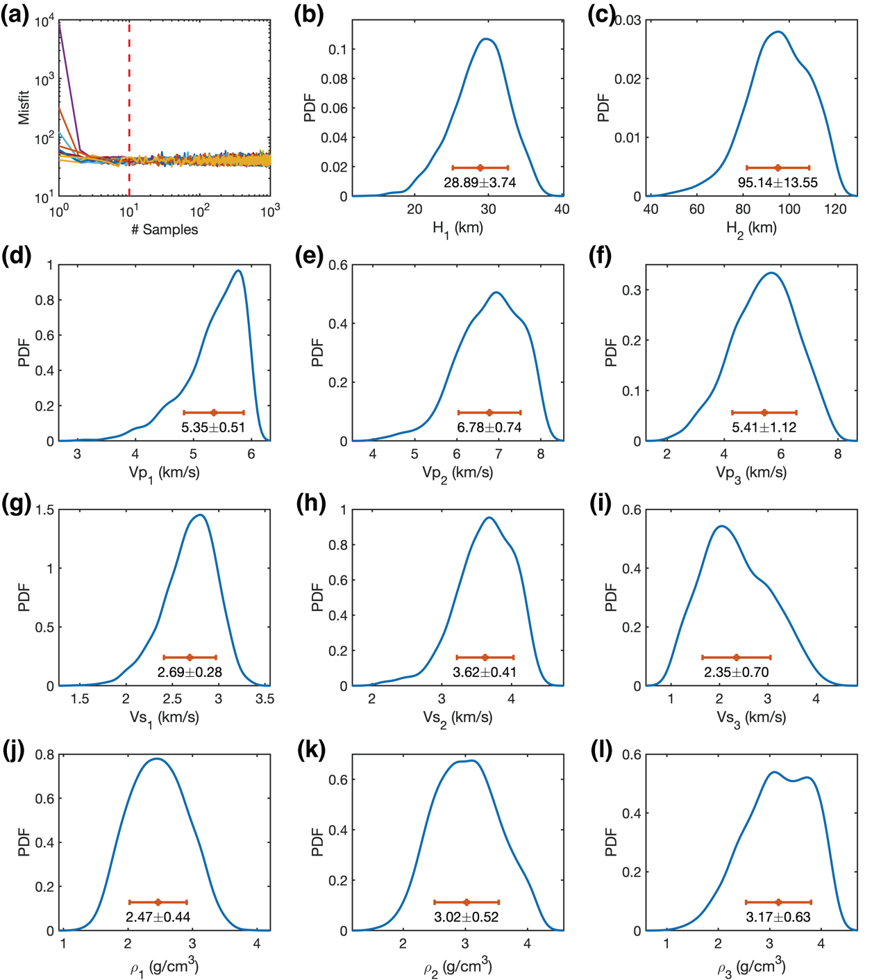
Supplementary Fig. 21 | Results of the joint inversion of PP and SS precursors of event S0976a. (a) Misfit changes of all accepted models. Red dashed line separates the first 30 models, which are regarded as in the burn-in phases. (b)–(l) Marginal PDFs of the posterior distributions for all model parameters. The error bar in each subfigure shows the mean value and the standard deviation.

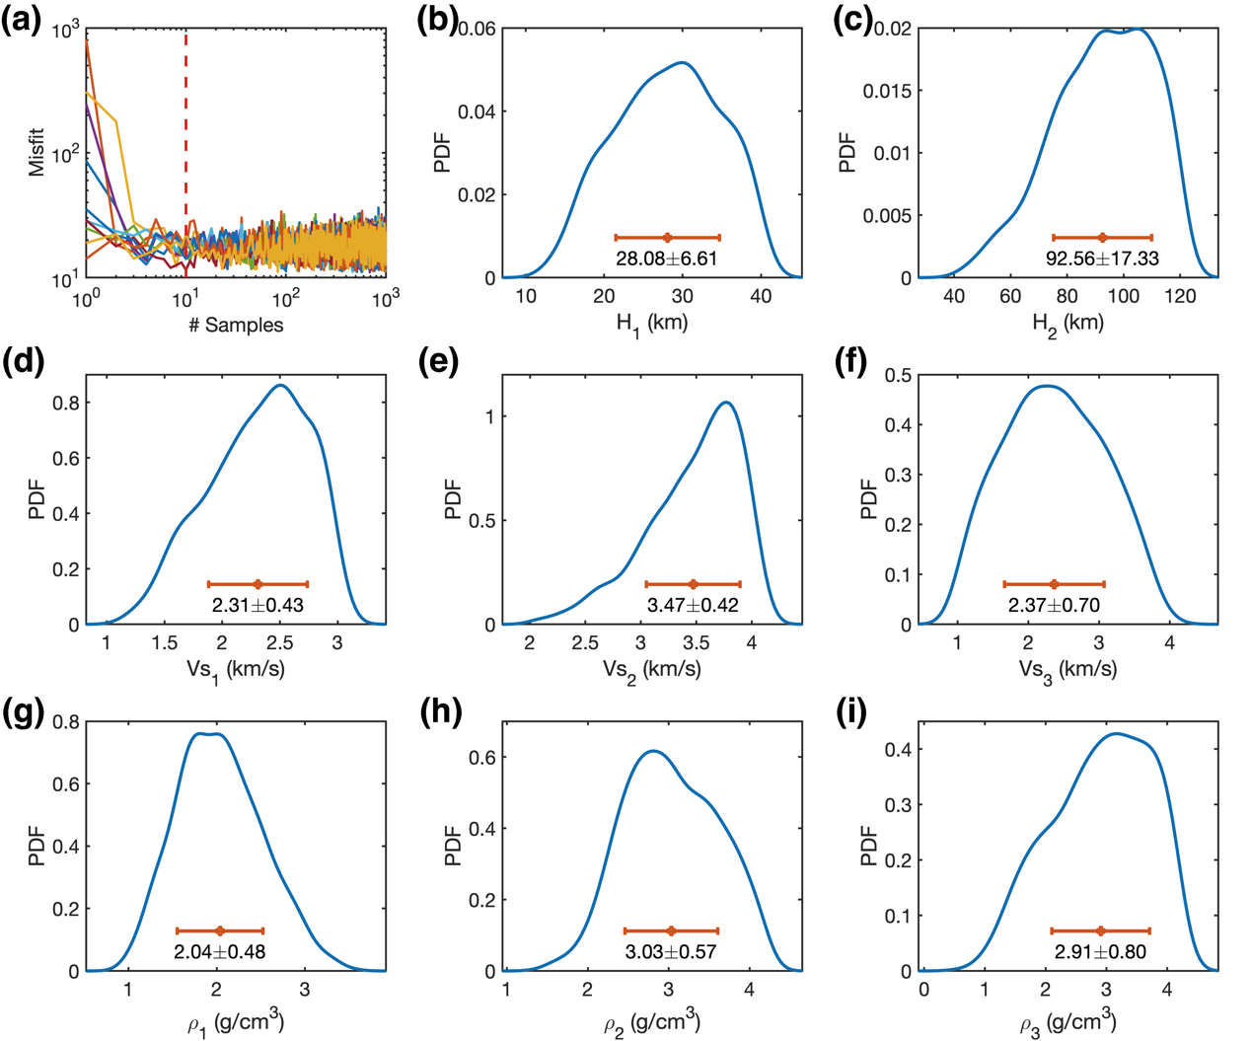
Supplementary Fig. 22 | Results of the inversion of SS precursors of event S1153a. Detailed figure captions are same as in Supplementary Fig. 21.

4.4. PP/SS precursor inversions based on travel time and amplitude
Instead of fitting the whole waveforms of PP/SS precursors, we perform additional inversions by only fitting the differential travel times and amplitude ratios of PP/SS precursors relative to PP/SS waves. The model parameter settings are the same as those in the waveform inversions. For each model, we calculate the synthetic differential travel time (ΔT) and amplitude ratios (AR) of the precursors based on ray theory⁴⁵. The misfit function is defined as
$Φ_{precursors}=\sum_{i=1}^{N_{PP}}{\left[{\left(\frac{{ΔT}_{obs}-{ΔT}_{syn}}{σ_{ΔT}}\right)}_{i}^{2}+{\left(\frac{{AR}_{obs}-{AR}_{syn}}{σ_{AR}}\right)}_{i}^{2}\right]}$
$+\sum_{j=1}^{N_{SS}}{\left[{\left(\frac{{ΔT}_{obs}-{ΔT}_{syn}}{σ_{ΔT}}\right)}_{j}^{2}+{\left(\frac{{AR}_{obs}-{AR}_{syn}}{σ_{AR}}\right)}_{j}^{2}\right]}$, (14)
where $N_{PP}$ and $N_{SS}$ are numbers of the identified PP and SS precursors, $σ$ is the corresponding pick uncertainty. For event S0976a, due to the absence of a confirmed PP precursor associated with the LVZ, we assign an AR of zero to this PP precursor and also exclude its ΔT in the misfit function (Extended Data Fig. 2a). For event S1153a, the first term in the misfit function is omitted, as no PP or PP precursor phases are picked. The model parameters distributions from inversions fitting only ΔT’s and AR’s closely match results from the waveform inversions (Supplementary Fig. 23g–j and Fig. 2i–k), but exhibit slightly lower model uncertainties. This is likely because fitting the whole waveforms suffers from larger misfits due to distorted waveforms caused by heterogeneous structures and noise, which reduces similarity between precursors and PP/SS.

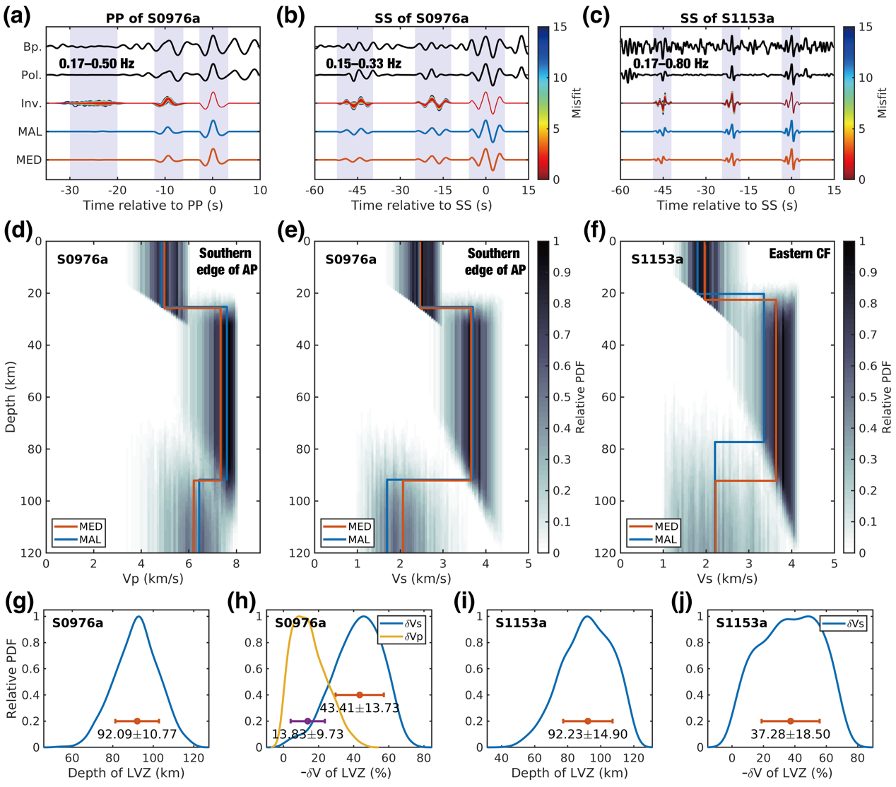
Supplementary Fig. 23 | Results of the PP/SS precursor inversions fitting only differential travel times and amplitude ratios. (a–c) Observed and inverted waveforms of PP, SS, and their precursors of events S0976a and S1153a. In each plot, from top to bottom, are bandpass filtered data (Bp.), polarization filtered data (Pol.), predicted waveforms for all accepted models in the inversions (Inv.), for the maximum-likelihood model (MAL), and for the median model (MED). The bandpass frequency ranges are list below the Bp. traces. Blue shaded areas show the PP and SS waves and their precursors identified by a waveform matching method. (d–f) Posterior distributions of the inverted Vp and Vs models below the southern edge of AP and the eastern CF, respectively. Orange line represents the median model, while blue line represents the maximum-likelihood model. (g–j) Posterior distributions of the depths and Vp and Vs reductions of the LVZs. Error bars show the median values with 1σ uncertainty intervals.

4.5. Amplitude of the PP precursor associated with the LVZ
For events S0976a, the PP precursor associated with the upper mantle LVZ are not detected (Supplementary Text 3.2). One possible explanation is that the reduction in Vp across the LVZ is insufficient to generate a discernible PP precursor, as indicated by inversion results showing a subtle Vp reduction (Fig. 3h). Density contrast may also play an important factor in the amplitude of precursor. However, the inverted density in the LVZ remains uncertain. Beneath the southern edge of AP, there is no apparent density contrast across the top boundary of the LVZ, while a density drop within the LVZ is obtained beneath the eastern CF, albeit with considerable uncertainty (Supplementary Fig. 24).
To further investigate factors affecting the amplitude of the PP precursor, we examine P wave reflection coefficients by varying Vp and density perturbations of the LVZ (δVp and δρ), while fixing the structure above the LVZ using the median model derived from S0976a’s inversion. A -40% perturbation in Vs (δVs) is incorporated within the LVZ (Supplementary Fig. 25). We then grid-search δVp and δρ to compute both the bottom P-to-P and S-to-S reflection coefficients at the LVZ top (R_{P^LVZP} and R_{S^LVZS}), and their associated precursor amplitude ratios (AR) relative to PP/SS (Supplementary Fig. 25). Since the AR of the SS precursor on tangential component and R_{S^LVZS} depend only on δρ (given fixed δVs), δρ is constrained between -23% and 6% to match the observed -25% ± 10% AR of the SS precursor (Supplementary Fig. 25b). Within this range of δρ, the AR of the PP precursor approaches zero for δVp between -22% and 8% (parallelogram in Supplementary Fig. 25a), a result of a nearly negligible P wave reflection coefficient at the LVZ top (R_{P^LVZP} = ±0.05) with a specific combination of δVp and δρ (parallelogram in Supplementary Fig. 25c). For a smaller Vs reduction (e.g., δVs = -35% as shown in Supplementary Fig. 26), matching the observed SS precursor would require a lower δρ and thus a larger Vp reduction to explain the characteristics of the PP precursors. These trade-offs highlight the considerable uncertainties in constraining seismic velocities and density within the LVZ.

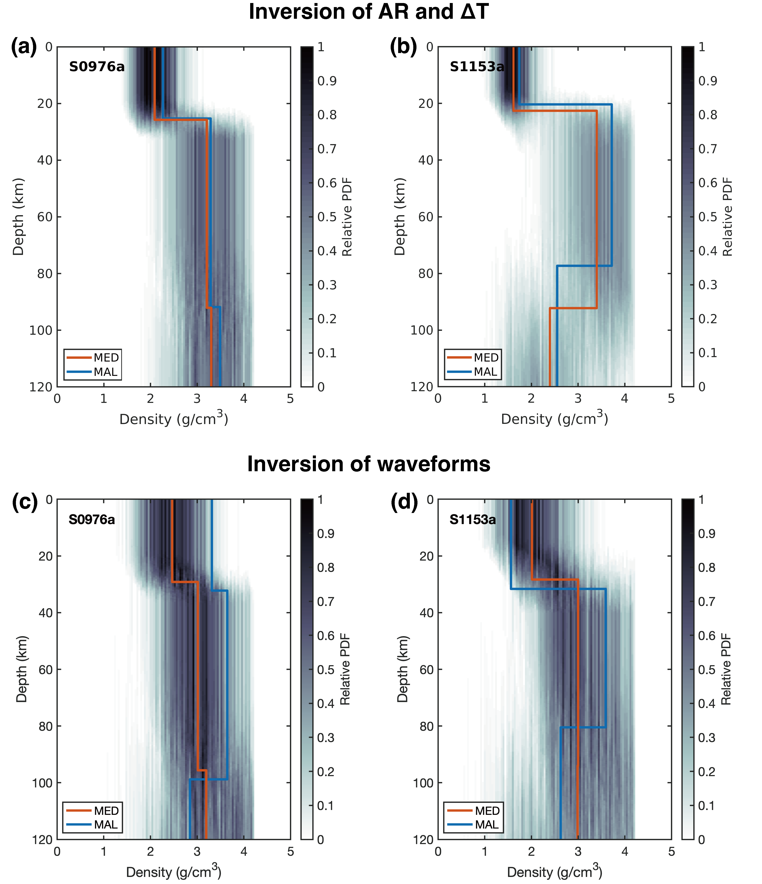
Supplementary Fig. 24 | Relative PDFs of the density profiles below the bounce points. Orange and blue lines denote the median and maximum likelihood models. Density increases at the ~20-km interface for both cases. For the inversion of S0976a, there is no obvious density variation across the upper mantle LVZ at depth of ~90 km, while for S1153a, a density reduction along with a larger uncertainty is obtained, especially for the inversion of ΔT and AR.

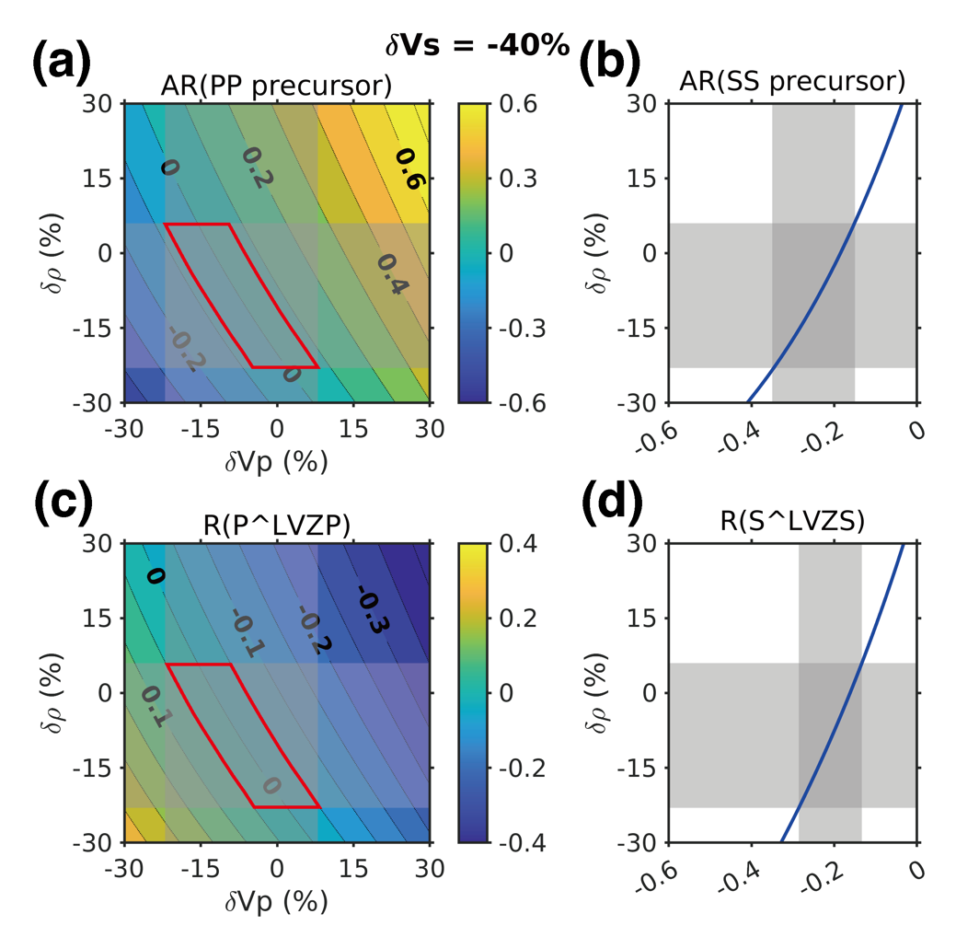
Supplementary Fig. 25 | Amplitude ratios of PP and SS precursors and reflection coefficients of P and S waves at the LVZ’s top boundary calculated with a fixed Vs reduction of 40%. (a) Amplitude ratios of PP precursor bouncing off below the LVZ’s top boundary with varying Vp and density perturbations. (b) Amplitude ratios of SS precursors bouncing off below the LVZ’s top boundary with different density perturbations. (c) Reflection coefficients of P wave bouncing off below the LVZ’s top boundary with varying Vp and density perturbations. (d) Reflection coefficients of S wave bouncing off below the LVZ’s top boundary with different density perturbations. Shaded areas denote the ranges of Vp, Vs, and density perturbations constrained by the observed amplitude ratio of the SS precursor. Red parallelograms denote the ranges of Vp and density perturbations constrained by the observed near zero amplitude PP precursor with an uncertainty estimated by the noise level within a time window of 20–30 s before the PP wave (± 0.07).

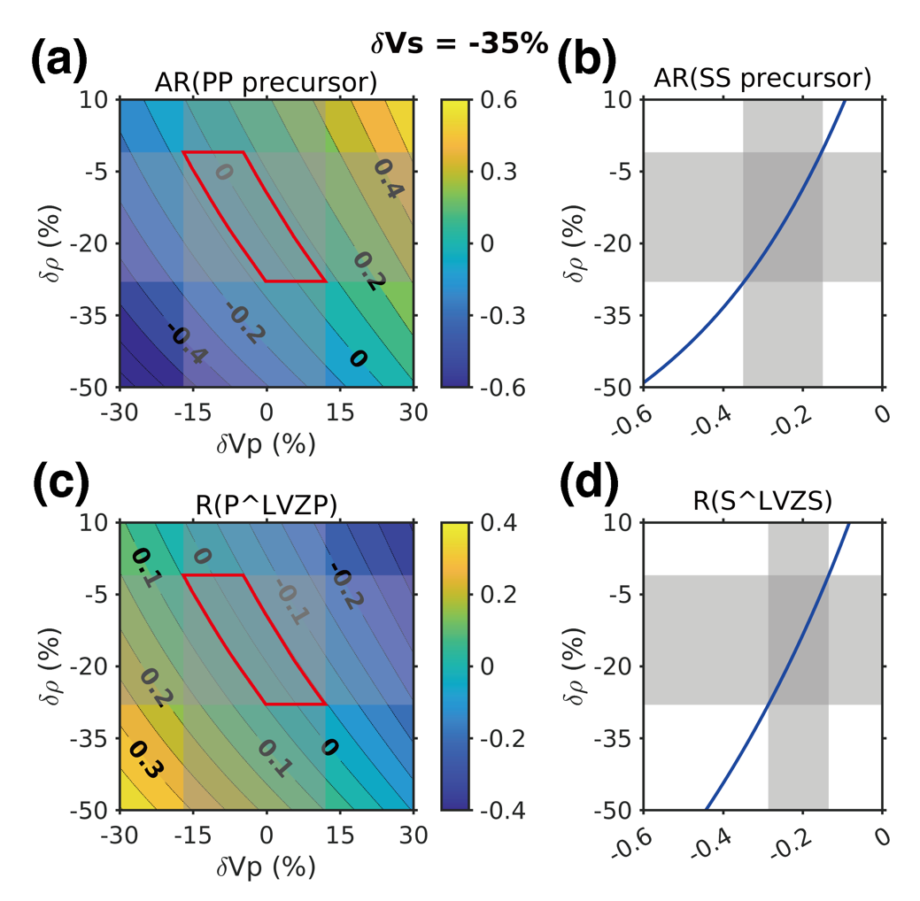
Supplementary Fig. 26 | Amplitude ratios of PP and SS precursors and reflection coefficients of P and S waves at the LVZ’s top boundary calculated with a fixed Vs reduction of 35%. Detailed figure captions are the same as Supplementary Fig. 25.

4.6. Moho structures beneath the southern edge of AP and eastern CF
Due to the lack of confidently identified PP and SS precursors associated with the Moho, we excluded a velocity jump across it in our inversions. However, this does not necessarily imply uniform velocities between the lower crust and the uppermost mantle. One possibility is that Moho-related precursors have weak amplitudes due to a subtle velocity jump, as indicated by RF inversion results (Fig. 2c), rendering them indistinguishable from noise. To test this, we introduce small velocity jumps across hypothetical Moho interfaces, with depths estimated from crustal models and the differential times of two possible Moho-related SS precursors at 39.5 s and 31.6 s before the SS waves of events S0976a and S1153a, respectively. These two arrivals were previously not regarded as SS precursors due to their inconsistent amplitudes and low degrees of polarization (Supplementary Figs. 5 and 11), but if interpreted as Moho reflections, they yield overlapping crustal thicknesses slightly larger than those from gravity and topography data⁴⁶ (Supplementary Fig. 27).
We establish the crustal structure using the median model from the precursor inversion results, then introduce a series of Vs jumps across the Moho interface. A grid search is performed to determine the depth and velocity contrast of the upper mantle LVZ by matching the ΔT and AR of the SS precursor (Supplementary Figs. 28–31). As the Moho Vs jump increases from 0 to 0.5 km/s, the best-fitting LVZ depth rises from 91 to 96 km for event S0976a, and from 92 to 109 km for S1153a (Supplementary Figs. 28 and 30), and the velocity reductions within the LVZ slightly increases (a–c in Supplementary Figs. 29 and 31). However, the resulting models predict very weak Moho-related SS precursors, with amplitudes below 8% and 2% of the SS waves for S0976a and S1153a, respectively (d–e in Supplementary Figs. 29 and 31).
Our synthetic tests indicate that a small impedance of the Moho discontinuity results in a too weak Moho-related SS precursor to be identified. Such a small impedance across Moho could serve as evidence for the metasomatic underplating process on Mars proposed by ref. ⁴⁷. On Earth, similar underplating occurs beneath oceanic islands associated with hotspot volcanism, forming a basal crustal layer with seismic velocities intermediate between gabbro and peridotite⁴⁸, or a serpentinized sub-Moho layer⁴⁹. Upper mantle velocities can also be reduced by partial melting or magma chambers, as observed beneath the Canary Islands⁵⁰. Notably, the eastern CF lies within Elysium Planitia, while the southern edge of AP is close to both Elysium Planitia and Tharsis, which are volcanic-tectonic regions with lava flows from recent volcanic activity within the last few to tens of millions of years^{51,52}. If these Martian regions share similarities with terrestrial oceanic hotspots, processes such as mafic–ultramafic underplating or upper mantle serpentinization could reduce the velocity contrast across the Moho.

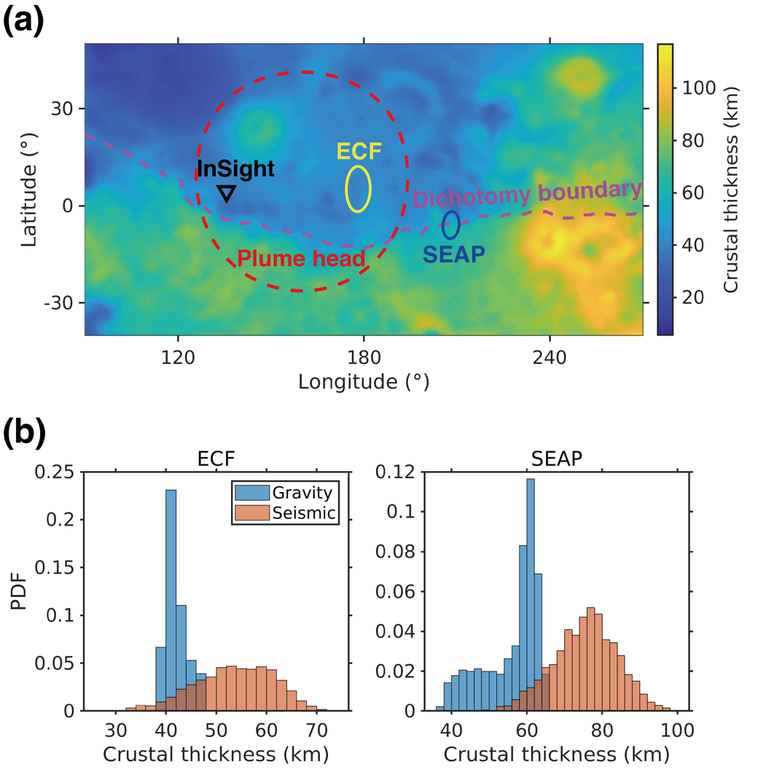
Supplementary Fig. 27 | Crustal thicknesses at eastern CF and southern edge of AP. (a) Regional distribution of the crustal thickness from Wieczorek, et al. ⁴⁶. Black triangle denotes the location of InSight lander. Yellow and blue ellipses denote the locations of bounce points of S1153a (eastern CF) and S0976a (southern edge of AP). Red dashed circle denotes the location of plume head proposed by ref. ¹¹. Purple dashed line denotes the Martian dichotomy boundary from ref. ⁵³. (b) Comparison of the crustal thicknesses at bounce points derived from topography and gravity data by ref. ⁴⁶ (gravity) and from our seismic inversion results with potential Moho-related SS precursors (seismic). The crustal thicknesses at two bounce points from seismic data have overlapping distributions but slightly larger values than those from gravity data.

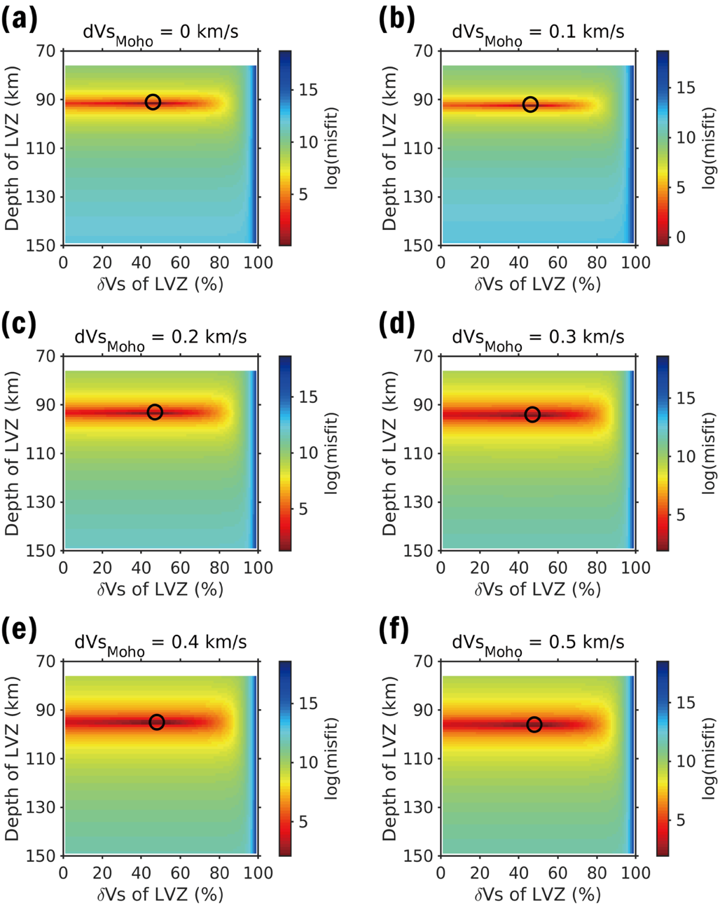
Supplementary Fig. 28 | Grid search results of the depth and Vs reduction of the upper mantle LVZ below the southern edge of AP. (a)-(f) correspond to a series of Vs jump across the Moho from 0 to 0.5 km/s. Black circle in each panel denotes the best fitting values of the LVZ depth and Vs reduction.

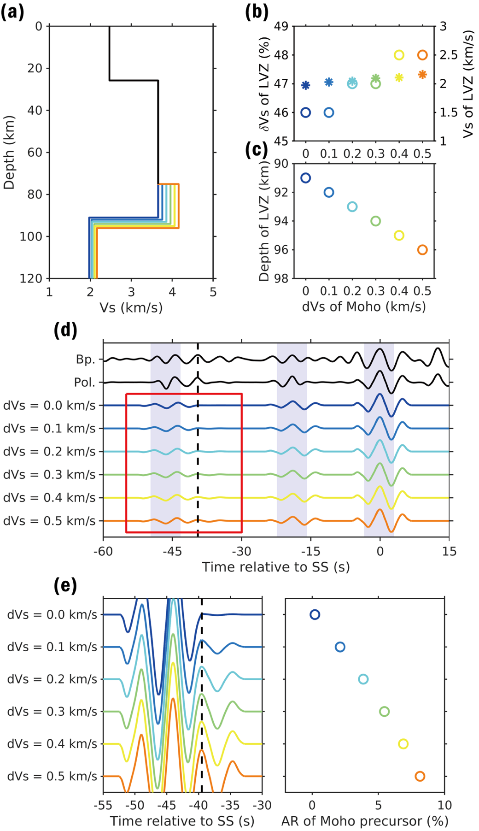
Supplementary Fig. 29 | Synthetic test result of the potential velocity jump across Moho below the southern edge of AP. (a) Vs models used in the test. The crustal structure is fixed as the median model from precursor inversion. The Moho depth is calculated from crustal structure and the 39.5 s differential travel time of a potential Moho-related SS precursor. A series of Vs jumps from 0 to 0.5 km/s is set across the Moho interface. Depth and velocity reduction of the upper mantle LVZ are best fitting values derived from the grid search in Supplementary Fig. 28. (b) Best fitting values of the Vs reduction and absolute Vs for different Vs jumps across the Moho. Circles denote the Vs reduction, while stars denote the absolute Vs. (c) Best fitting values of the LVZ depth for different Vs jumps across the Moho. (d) Synthetic waveforms of the SS and SS precursors for models in (a). Top two traces show the observed waveforms after bandpass (Bp.) filtering and polarization (Pol.) filtering. (e) Left panel shows the zoomed waveforms around the Moho-related SS precursors within the time window shown by red rectangle in (d). Black dashed line denotes the arrival of the Moho-related SS precursor (39.5 s). Right panel shows the amplitude ratio of synthetic Moho-related SS precursor relative to the SS wave.

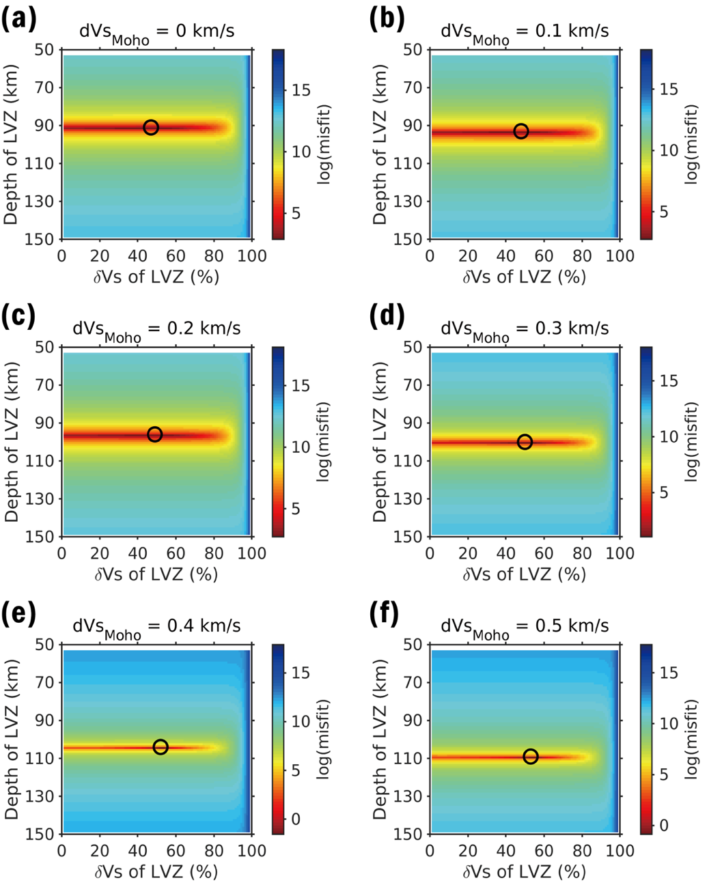
Supplementary Fig. 30 | Similar to Supplementary Fig. 28 but beneath the eastern CF.

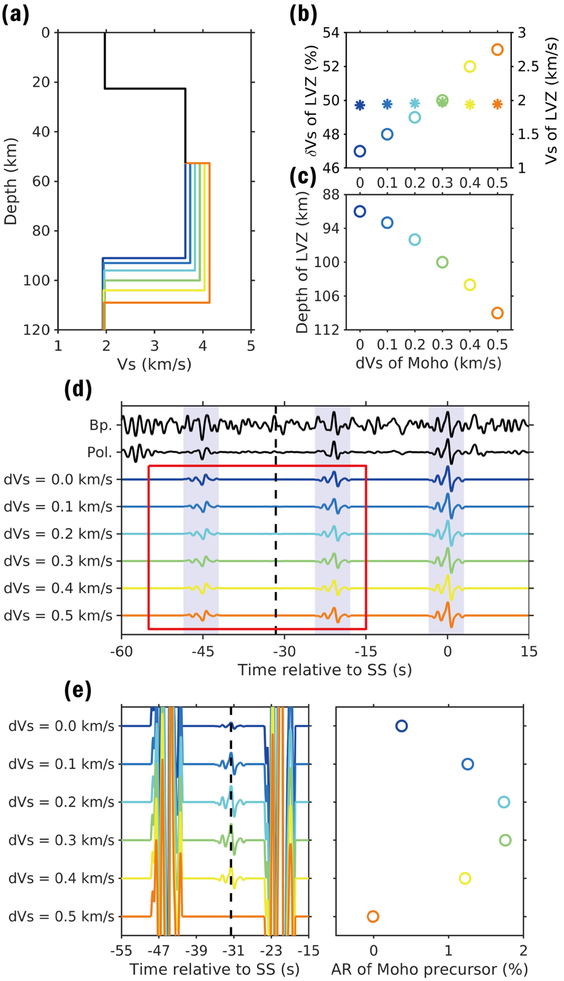
Supplementary Fig. 31 | Similar to Supplementary Fig. 29 but beneath the eastern CF.

5. Further seismic support for the upper mantle LVZ

5.1. P-wave RF of event S1222a
The largest detected marsquake, S1222a, exhibits high-quality waveforms across a broad frequency range (1/30–35 Hz) ⁵⁴. Its high frequency P-wave RF has been used to elucidate a more detailed upper crustal structure beneath the InSight landing site, revealing a shallow interface at ~2 km depth¹⁵. However, in this study, we exclude S1222a from the RF inversion due to its distinct back azimuth compared to those used CF events. Back azimuth-dependent structural variations can lead to differences in RF waveforms^{15,16}. Indeed, the RF of S1222a at 0.15–0.85 Hz shows a clear discrepancy from those CF events, including a strong converted phase at ~1 s and its associated multiples, resulting in a more complex waveform (Supplementary Fig. 32). Geological mapping shows a smooth terrain to the east of the InSight landing site, but several secondary craters to the southeast, such as Corintito⁵⁵. This could suggest a more fracturing shallowest layer along the direction of S1222a, enhancing converted and reverberated phases in the uppermost crust. Deeper converted phases, such as a negative phase at ~12 s, are also observed but slight distorted by the shallow multiples.
To reduce the influence of the shallow layer and focus on deeper structures, we analyze the RF of S1222a within a lower frequency band of 0.1–0.4 Hz. This suppresses shallow conversions and highlights the deeper Ps phases at ~5 s, ~8 s, and ~12 s (Supplementary Fig. 32). Notably, the negative phase at ~12 s aligns with those observed for CF events, supporting the presence of an upper mantle LVZ beneath the InSight landing site. However, both converted phases at ~ 8 s (Moho-converted) and ~12 s in S1222a is approximately 1 s delayed compared to CF events, possibly due to local structural variations or crustal thickness differences along different back azimuths. These complexities can lead to complicated RFs for stable phase identification and the travel time difference of the LVZ-converted Ps waves observed for other events (Supplementary Fig. 33).

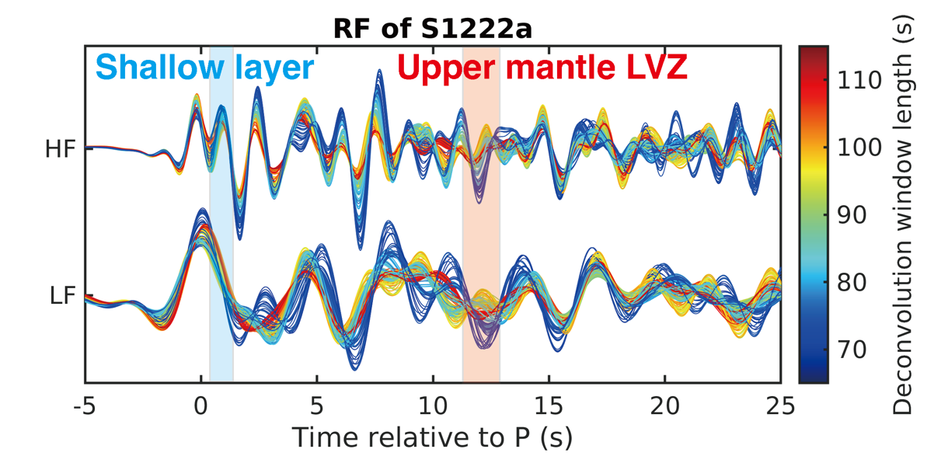
Supplementary Fig. 32 | P-wave RF of event S1222a. RFs are calculated and bandpass filtered in two frequency bands, which are 0.15–0.85 Hz (HF), and 0.1–0.4 Hz (LF). Different lengths of the deconvolution time window are employed to test the stability of RF. In the HF RF waveform, there exist clear ~1 s converted phase (shaded blue band) and its multiple reverberations. However, in the LF RF waveform, the shallow layer related phases are attenuated, leaving phases converted at deeper layers more evident, including the negative conversion at the upper mantle LVZ (shaded red band).

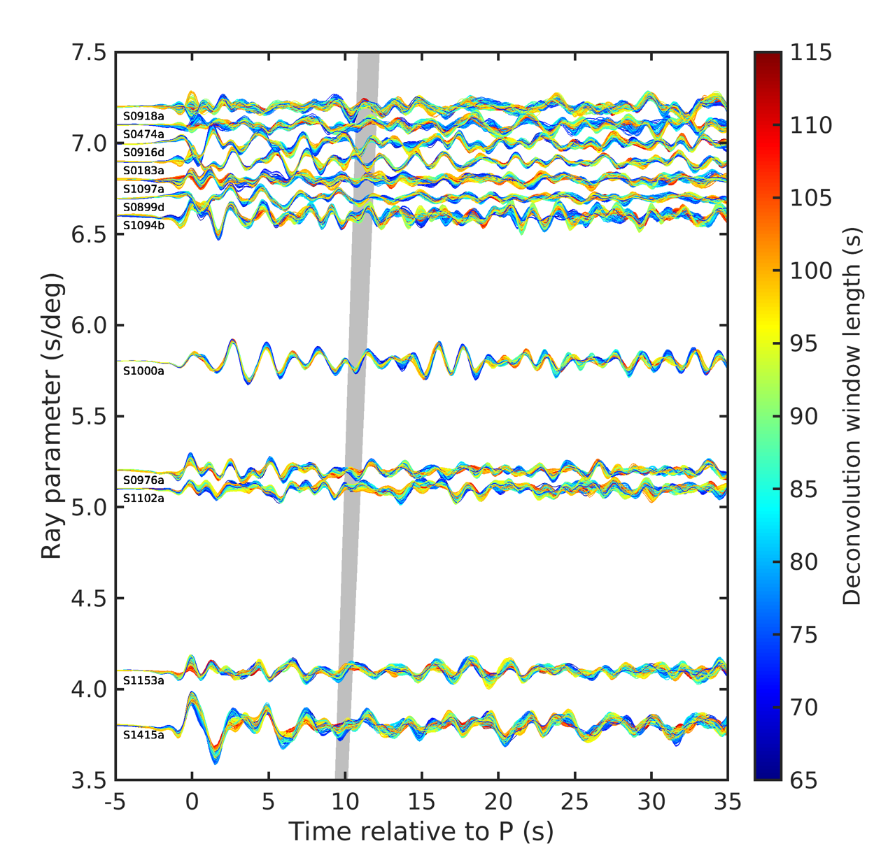
Supplementary Fig. 33 | P-wave RFs of other events. RFs are arranged based on ray parameters, with slight shifts applied to some traces for visual clarity. Shaded area indicates the predicted arrival time window of Ps phases converted at the upper mantle LVZ from inverted models. Different lengths of the deconvolution time window are employed to test the stability of RFs. No coherent Ps phases are identified for these events due to their unstable RF waveforms.

5.2. S-wave RFs of events S1153a and S1415a
Compared to the P-wave RF, S-wave RF offers a significant advantage that the converted Sp phases arrive prior to the direct S wave, while multiples follow after, allowing clearer separation. Consequently, S-wave RFs are extensively used for terrestrial studies of the crust and upper mantle structure, such as Moho, mid-lithospheric discontinuity (MLD), and lithosphere-asthenosphere boundary (LAB) ⁵⁶⁻⁵⁹. S-wave RFs of marsquakes have been analyzed by refs. ^{23,25,28} and only one Sp at ~3 s before S wave is confidently identified in the stacked trace. For individual event S0235b, its S-wave RF shows two additional Sp phases at ~6 s and ~9 s prior to S wave, suggesting a deep Moho²³. However, due to the larger incidence angle of Sp wave in comparison to S wave, the epicentral distance must be sufficiently large to avoid post-critical incidence, particularly for imaging deeper interfaces. Based on the inverted crust and upper mantle structure, an Sp converted at the top of the LVZ requires a ray parameter smaller than ~7–9 s/deg, corresponding to an epicentral distance greater than 65º, assuming the mantle models in ref. ²⁸ (Supplementary Fig. 34a). Thus, S1153a and S1415a, two quality-A LF family events with distances of ~85º, are suitable for S-wave RF analysis.
We calculate the S-wave RFs of S1153a and S1415a using the iterative time domain deconvolution method (Supplementary Fig. 34b) after rotating the Z-R component waveforms into L-Q directions, based on the apparent incidence angle derived from the inverted models (Supplementary Fig. 34c). Both RFs, and their stacked trace, display a positive phase at ~7.5 s and a negative phase ~11 s before the direct S. Their amplitudes and arrival times match the synthetic Sp arrivals converted at the Moho and LVZ top, respectively (Supplementary Fig. 34d). Other Sp waves converted at the intracrustal interfaces are less prominent, possibly due to heterogeneities further away from the station, where Sp conversion points lie, and interference from other phases near the S arrival⁶⁰. Despite these complexities, the observed negative arrivals at ~11 s in S-wave RFs reaffirm the presence of an upper mantle LVZ beneath InSight.

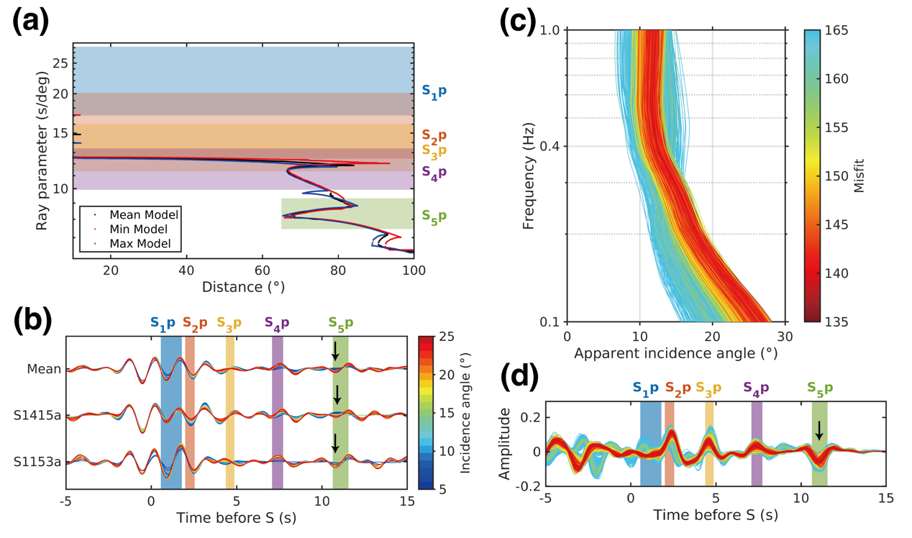
Supplementary Fig. 34 | S-wave RF analysis. (a) S-wave ray parameter versus epicenter distance. Black, red, and blue dots are S-wave ray parameters calculated using the mean, minimum, and maximum velocity models in ref. ⁶¹. Colored shaded areas denote the critical ray parameters of Sp converted waves based on the inverted models in Fig. 2c. Only events beyond 65º distance (green area) can generate Sp phases converted from the top of the upper mantle LVZ. (b) S-wave RFs of two distant events S1415a and S1153a, and their average. Colored bands mark predicted Sp arrivals from four interfaces. Line color indicates the incidence angle used for rotation. Arrow shows the Sp from the top of the upper mantle LVZ. (c) Synthetic frequency-dependent incidence angles of S waves based on models from Fig. 2c. Line color corresponds to misfit values. (d) Synthetic S-wave RFs based on models from Fig. 2c. Vertical bands mark Sp conversions, and the arrow highlights the one from the LVZ top.

5.3. Autocorrelation reflectivity
The autocorrelation function (ACF) extracted by seismic interferometry can be used to extract the body wave reflection phases corresponding to subsurface interfaces. Martian crustal structures have also been investigated by ACFs^{25,62-64}. Here, we review of all identified signals in vertical ACFs reported in previous literatures and compare them with the synthetic P-wave reflections predicted by our inverted models.
Synthetic P wave reflections are computed using the reflectivity method⁶⁵, with or without surface multiples. The synthetic waveforms are filtered to 1.5–3.0 Hz and compared with the observed ACFs within a 30-second window (Supplementary Fig. 35) to better isolate crust and upper mantle reflections. The synthetic results indicate that the P waves reflected at the four crustal interfaces and the top of the LVZ, denoted as P_{di}P (i=1–5), arrive at ~3.1 s, ~5.0 s, ~11.7 s, ~20.3 s, and ~26.0 s, respectively. Additional reflections at ~6 s, ~15 s, and ~23 s in the reflectivity simulations correspond to the double reflection from the ~4-km-deep interface (P_{d1}P2), triple reflection from the ~8-km-deep interface (P_{d2}P3), and the double reflection from the ~24-km-deep interface (P_{d3}P2), respectively. With the aid of a more detailed structure of the Martian crust and upper mantle, we now have a clear and comprehensive interpretation of the observed ACFs:
(1) P_{d1}P arrives at ~3.1 s and is submerged in the zero-lag side lobes, rendering it unidentifiable in the ACFs.
(2) The signal observed at ~5–6 s by Deng and Levander ⁶³, Compaire, et al. ⁶², and Knapmeyer-Endrun, et al. ²⁵ is identified as P_{d2}P.
(3) The signal at 6.15 s in Schimmel, et al. ⁶⁴ could be either P_{d2}P or P_{d1}P2.
(4) The signal present at ~10–11 s or ~11.5 s in Deng and Levander ⁶³, Knapmeyer-Endrun, et al. ²⁵, and Schimmel, et al. ⁶⁴ is identified as P_{d3}P.
(5) Two arrivals observed by Compaire, et al. ⁶² at 10.6 s and 12.6 s are most likely P_{d3}P and P_{d2}P2, although it remains unclear which arrives first.
(6) The signal at ~21 s, as observed in Deng and Levander ⁶³, Compaire, et al. ⁶², and Knapmeyer-Endrun, et al. ²⁵ is identified as P_{d4}P (PmP).
(7) Two closely spaced signals, denoted as ‘f’ by Schimmel, et al. ⁶⁴ at 23.8 s and 24.5 s, are identified as P_{d3}P2 and P_{d5}P, respectively.
(8) In addition, there are other weak signals reported in various studies that were not identified as seismic phases but are consistent with our synthetic results. For instance, the arrival at ~15 s in Deng and Levander ⁶³ corresponds to P_{d2}P3, and the arrival at ~25 s in both Deng and Levander ⁶³ and Compaire, et al. ⁶² corresponds to P_{d5}P.
In the ACF results from Schimmel, et al. ⁶⁴, the ~25 s signal is most significant in the 1.5–3.0 Hz band for the stacks using 3% and 30% data set (Supplementary Fig. 35). Given their improved processing that avoids aseismic signal bias, and the consistency of this signal over other frequency bands⁶⁴, and its good match with our synthetics, we interpret this signal as P wave reflection from the top of the upper mantle LVZ. In summary, these autocorrelation results not only validate the crustal structure inverted by RFs, but also provide independent evidence for an upper mantle LVZ beneath the InSight landing site.

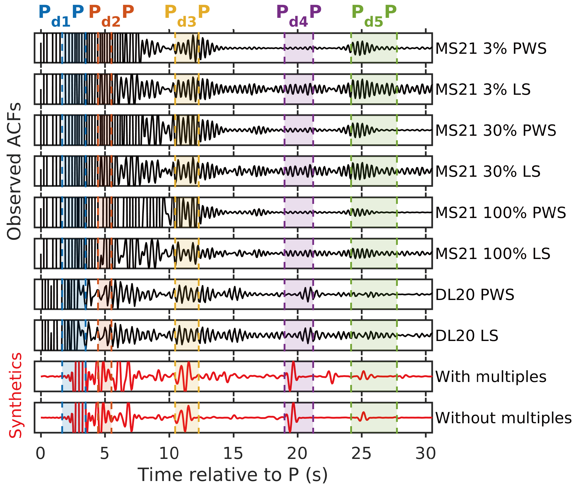
Supplementary Fig. 35 | Autocorrelation reflectivity analysis. Comparison of the observed ACFs (black traces) in ref. ⁶³ (DL20) and ref. ⁶⁴ (MS21) with the synthetic P wave reflections (red traces). Both observations and synthetics are bandpass filtered into 1.5–3.0 Hz. PWS denotes the phase weighted stacking, and LS denotes the linear stacking. In ref. ⁶⁴, there are three datasets considering different data segmentation and selection strategies, referred to as 100%, 30%, and 3% datasets. The synthetic waveforms are calculated by reflectivity method with and without multiples reflected at surface. Each trace is normalized to a distinct amplitude for a better view and comparison. Colored dashed bands denote the arrival time ranges of the reflected phases from five interfaces.

5.4. Seismicity and amplitude reduction
Previous studies of marsquake locations and Martian seismicity have noted a lack of LF marsquakes within ~25° distance to the InSight lander^{3-5,37,66}, potentially attributable to the upper mantle LVZ, which could significantly distort ray paths and change the amplitudes of body waves. To investigate this hypothesis, we perform synthetic waveform simulations to evaluate the impact of LVZ on P and S wave amplitudes. We construct a series of 1D models by incorporating upper mantle LVZs with different thicknesses on the basis of the InSight_KKS21_GP model^{1,25,33}, placing the top of the LVZ at a depth of 68 km, as inferred from RF inversions. Synthetic waveforms are generated using the fk package⁶⁷, with focal mechanism (strike: 76°, dip: 63°, rake: -104°), source depth (33 km), and azimuth (260°) assigned to those obtained for event S0235b in a previous study¹⁰. The synthetics are filtered into 0.1–1 Hz to match the dominant frequency of LF events. Envelopes are calculated within a time window of -5–15 s relative to the P and S arrival times (Supplementary Fig. 36), and peak P and S amplitudes are extracted from the vertical and transverse components, respectively, for comparison across models.
Results demonstrate that the LVZ distorts ray paths beyond ~9° (Supplementary Fig. 37a–b) and reduces both P and S amplitudes (Supplementary Fig. 37c), by ~30% for P waves at distances of ~20°–30° and ~50% for S waves at ~15°–25°. Such significant amplitude reductions between 15° and 25°, particularly for S waves, contributing to the apparent absence of lack of seismicity within this distance range⁴. It is worth noting that amplitudes can increase at distance of ~10°for P waves. However, no seismicity has been detected in this distance range, likely because S waves amplitudes remain low if an LVZ is present (Supplementary Fig. 37c).
A recent study⁶¹ locates two LF events, S0474a and S0918a, at the distances of 19.7° ± 2.5° and 16.8° ± 2.2°, respectively, which significantly deviate from those reported in the MQS catalogue² (29.1° ± 12.5° and 27.9° ± 4.6°). If the MQS catalogue locations are accurate, both events lie outside the predicted shadow zone. Moreover, S0474a is also categorized as a CF event, with a back azimuth of ~97° in MQS catalogue. However, if the locations in ref. ⁶¹ are more accurate, both events fall within ~25º distance range but have back azimuths that differ notably from CF events. Specifically, S0474a, with a back azimuth of ~29º, is located to the north of InSight near Elysium Mons, while S0918a lies to the south with a back azimuth of ~165º⁶¹. One possible explanation is that the LVZ primarily extends in an east-west direction, so the ray paths of both events may not sufficiently sample it along the north-south direction. This lateral variation in the LVZ could be related to the plume-induced stress field along east-west direction ¹¹, or the deep seismic anisotropy⁶⁸.

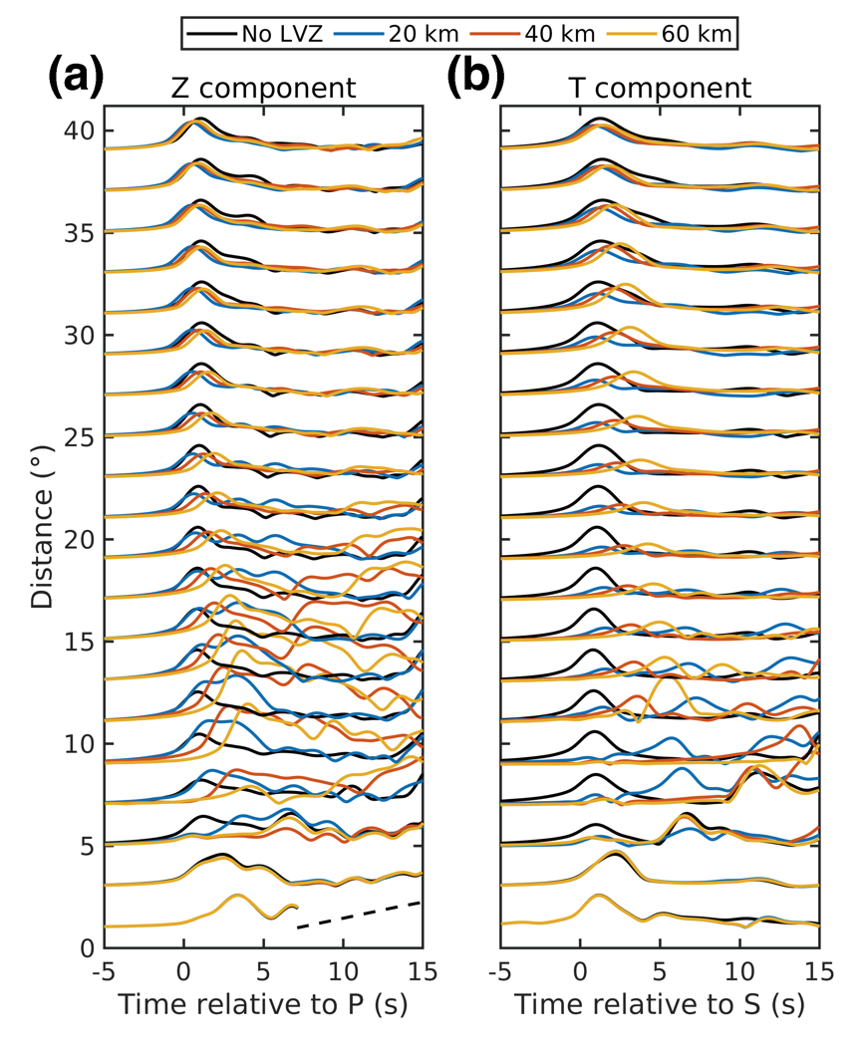
Supplementary Fig. S36 | Synthetic P and S wave envelopes in (a) vertical and (b) transverse components, respectively. Black lines denote the waveforms calculated from the previously published 1D Mars model (InSight_KKS21_GP) ^{1,25,33}, in which there is not an upper mantle LVZ. Colored lines denote the waveforms calculated from the 1D Mars models incorporating an upper mantle LVZ with different thicknesses. Waveforms are normalized to the peak amplitudes of No-LVZ model results. Dashed line in (a) denotes the arrivals of S waves, which are cut off at closest distances.

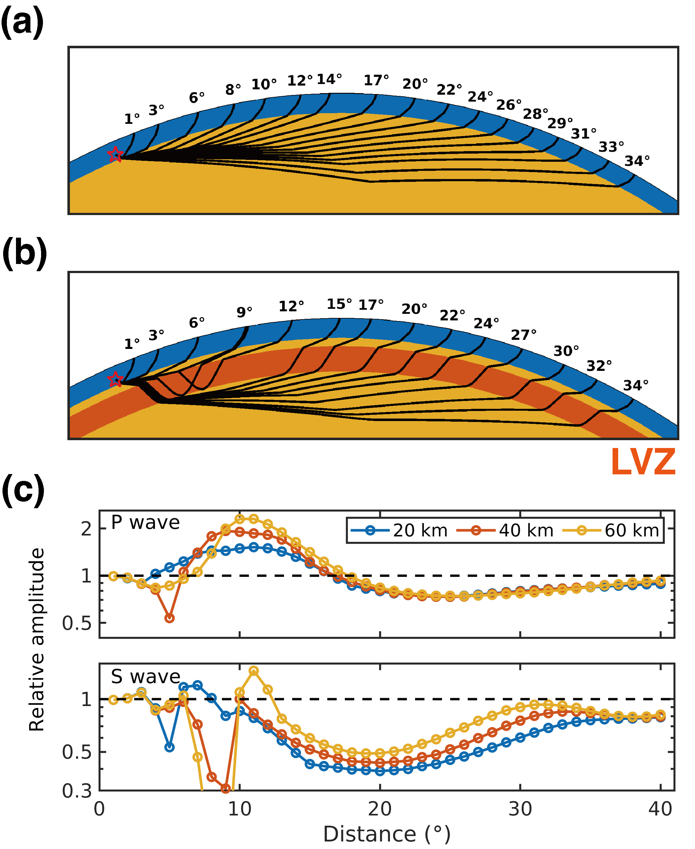
Supplementary Fig. S37 | Illustration of the effects of LVZ on seismic ray paths and amplitudes. (a) S-wave ray paths for 1D Mars model (InSight_KKS21_GP) ^{1,25,33} without the upper mantle LVZ. (b) S-wave ray paths for 1D Mars model with the upper mantle LVZ. Red star marks a 33-km-depth source. Crust, mantle, and upper mantle LVZ are distinguished by different colors. (c) P and S wave amplitudes for models with varying LVZ thicknesses. Amplitudes are normalized to the No-LVZ model results. The LVZ causes ~30% reduction in P wave amplitudes at 20–30° distance range, and ~50% reduction in S wave amplitudes at 15–25° distance range.

6. LVZ thickness

6.1. Effects of LVZ thickness on body wave travel times
For 1D models containing upper mantle LVZs with different thicknesses, as defined in Methods, we use the TauP toolkit⁶⁹ to compute body wave travel times. To evaluate model performance, we define a misfit function based on differential travel times:
$Φ_{T}=\sum_{i=1}^{Ne}{\frac{{\left(T_{i}^{cal}-T_{i}^{obs}\right)}^{2}}{σ_{T}^{2}+{\left(\frac{∂T}{∂d}σ_{d_{i}}\right)}^{2}}}$. (15)
where $T_{i}^{cal}$ and $T_{i}^{obs}$ are the calculated and observed differential travel times of event i, Ne is the number of events with body wave travel time picks, $σ_{T}$ is the time pick error, $σ_{d_{i}}$ is the uncertainty in depth for depth phases or in distance for other phases, and $\frac{∂T}{∂d}$ is the partial derivative of differential travel time with respect to event distance or depth. Observations and uncertainties are from Table S1.1 in ref. ⁶¹.
Our results show that the differential travel times of surface-reflected waves (PP/SS and PPP/SSS) relative to direct P/S are significantly influenced by the LVZ structure, as surface-reflected waves sample the LVZ multiple times, unlike other phases such as ScS, SKS, and depth phases (Supplementary Fig. 38). For these surface reflected phases, the 20-km-thick LVZ model offers better fits compared to the model without an LVZ (a–d in Supplementary Figs. 39–41). There is a trade-off between LVZ thickness and the velocity reduction. A thicker LVZ requires smaller velocity drops to match observations. Nevertheless, overly thick LVZ (> 40–60 km) would yield much larger misfits than the reference model without an LVZ. ⁶¹ (Supplementary Fig. 42).

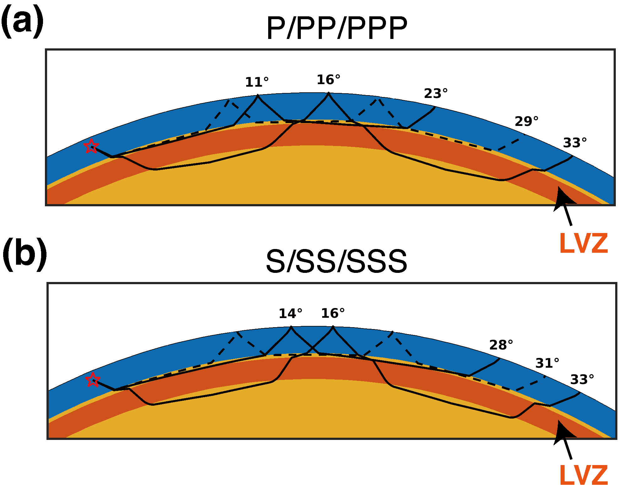
Supplementary Fig. 38 | Ray paths of different waves in the model with an upper mantle LVZ. (a) Ray paths for P, PP, and PPP waves. (b) Ray paths for S, SS, and SSS waves. Solid lines represent P (at 11° and 16° distances), PP (at 23° and 33° distances), S (at 14° and 16° distances), and SS (at 28° and 33° distances) phases. Dashed lines denote PPP (at 29° distance) and SSS (at 31° distance) phases. Red stars mark the sources within the crust. Crust, mantle, and upper mantle LVZ are distinguished by different colors.

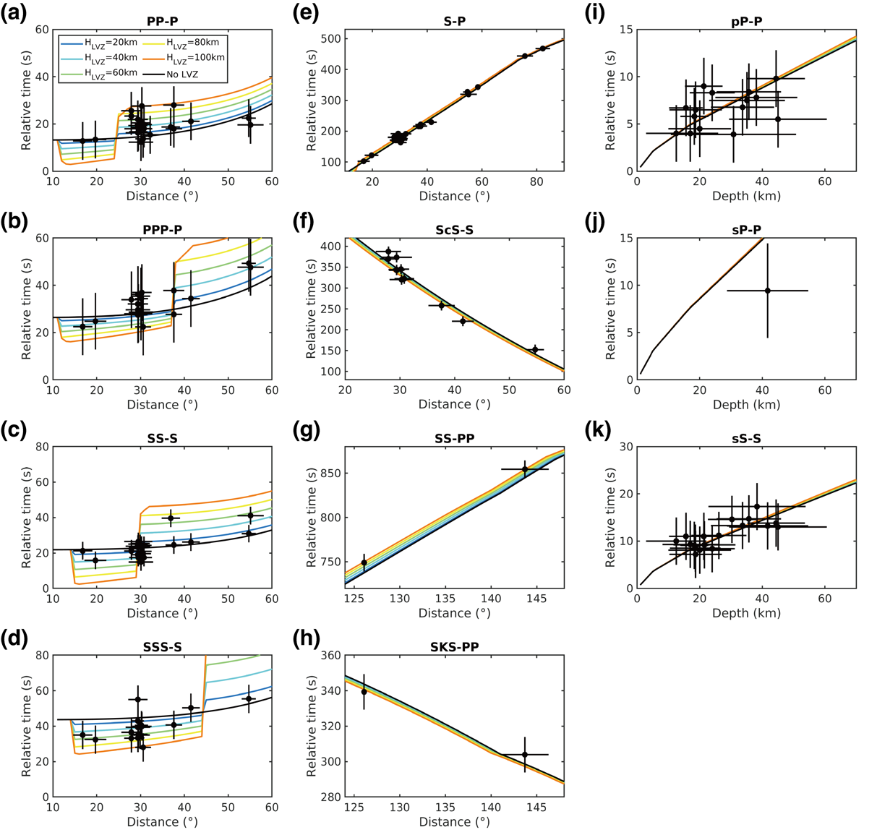
Supplementary Fig. 39 | Differential travel time curves of the models with a Vp reduction of 10% and a Vs reduction of 11%. Black and colored lines denote the theoretical differential travel times of different phases. Black dots with errorbars denotes the picked differential travel times of all 31 events in ref. ⁶¹. Vertical errorbar represents the error of picked travel time. Horizontal errorbar represents the inverted uncertainty of distance or depth for each event in ref. ⁶¹.

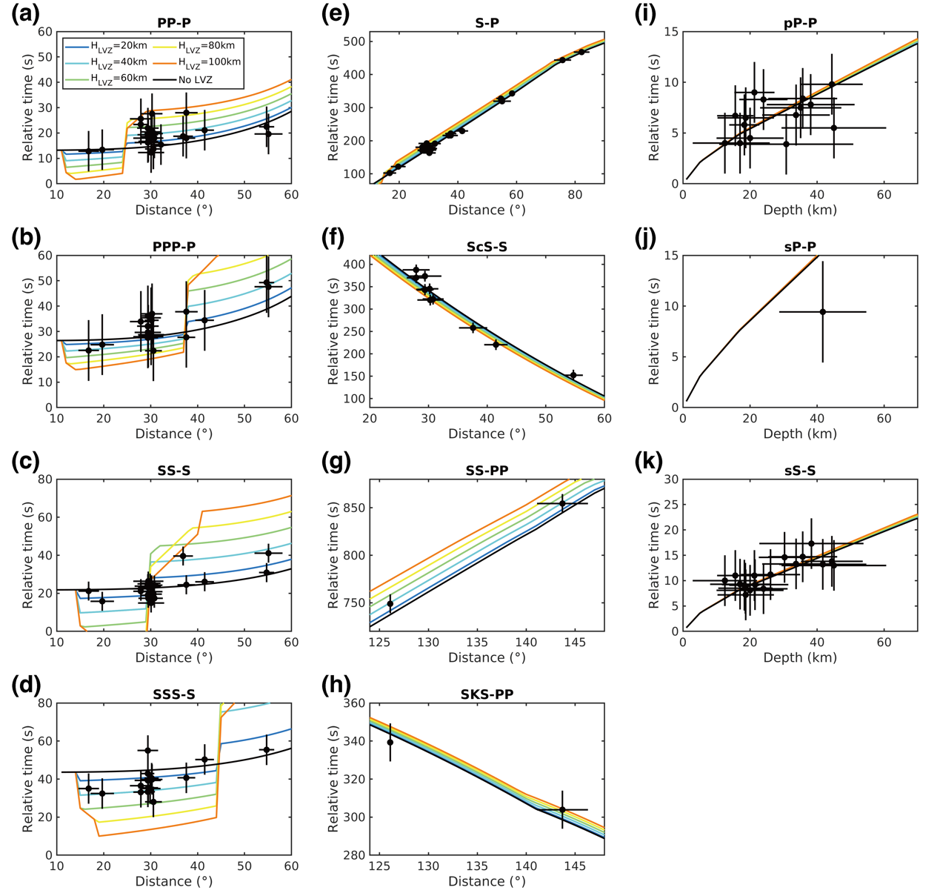
Supplementary Fig. 40 | Differential travel time curves of the models with a Vp reduction of 12% and a Vs reduction of 25%. Figure captions are same as in Supplementary Fig. 39.

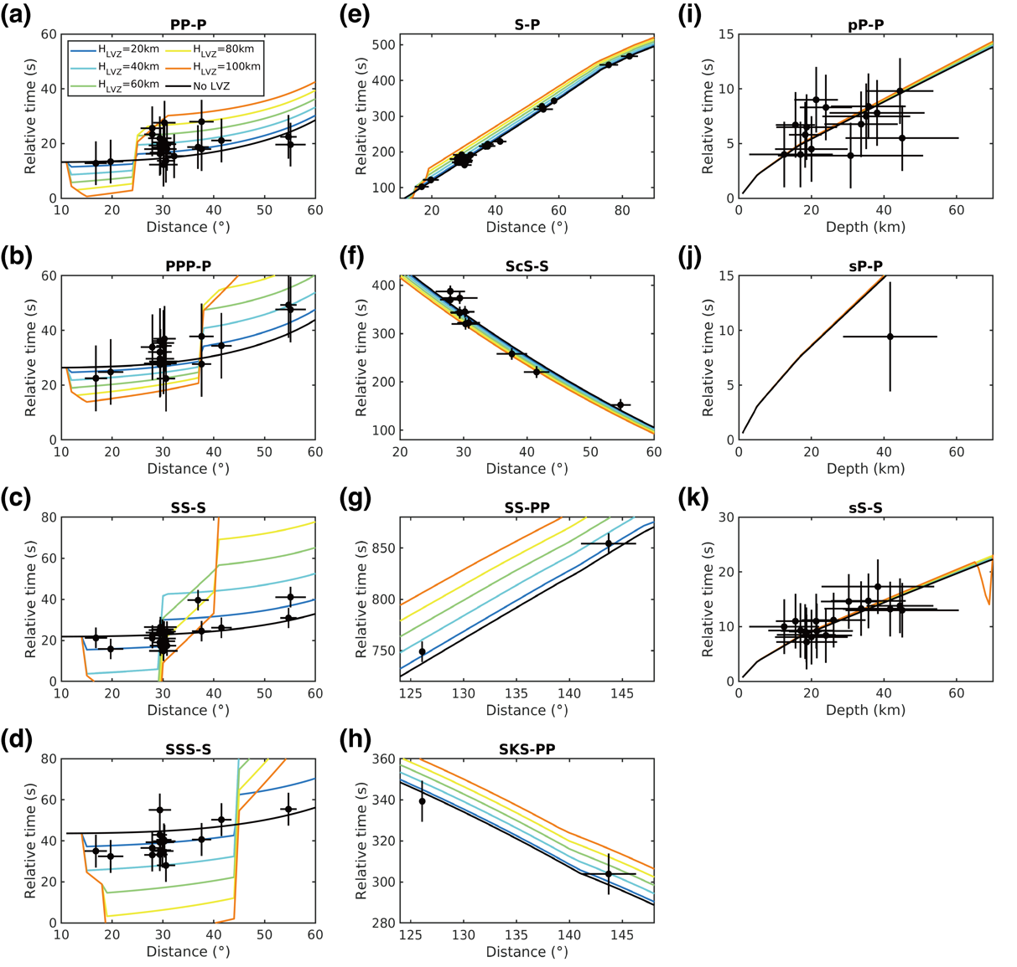
Supplementary Fig. 41 | Differential travel time curves of the models with a Vp reduction of 14% and a Vs reduction of 40%. Figure captions are same as in Supplementary Fig. 39.

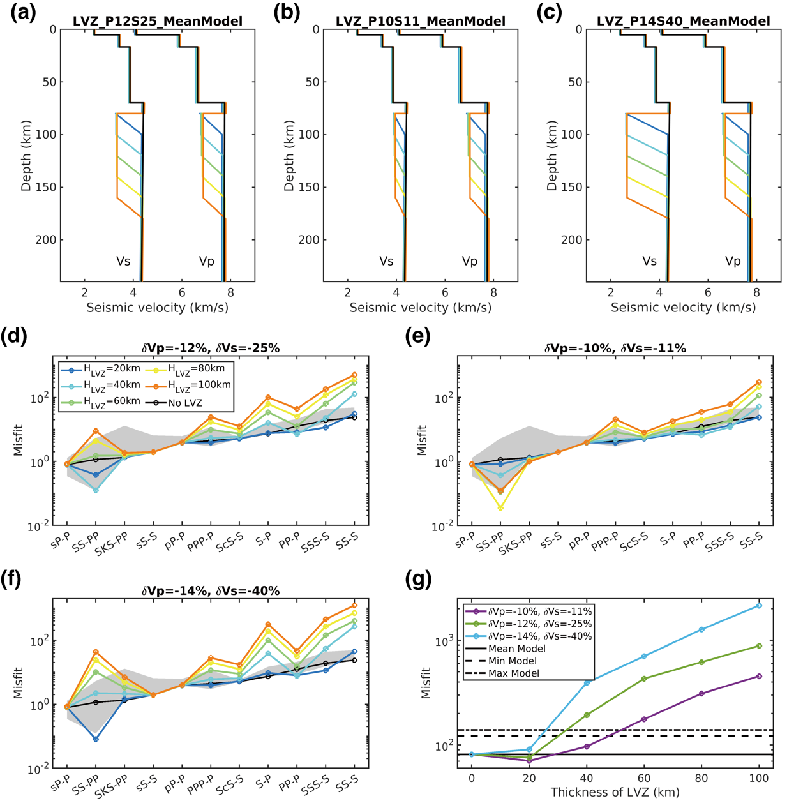
Supplementary Fig. 42 | Effect of the thickness and velocity perturbations of LVZ on the differential travel times of body waves. (a) 1D Vs and Vp models with different LVZ thicknesses. The thickness of constant velocity layer is from 0 to 80 km, while the gradient layer has a fixed thickness of 20 km. Black lines denote the mean model in ref. ⁶¹. Colored lines denote models containing an upper mantle LVZ below 80 km depth with a 12% Vp reduction and a 25% Vs reduction. (b) Similar with (a) except for a 10% Vp reduction and a 11% Vs reduction within the LVZ. (c) Similar with (a) except for a 14% Vp reduction and a 40% Vs reduction within the LVZ. (d)–(f) Misfit values of all differential travel times of body wave phases calculated using the models in (a)–(c). Black lines denote the misfit values of the mean 1D model in ref. ⁶¹. Phases are arranged with ascending order for the misfit values. Grey shaded areas denote the misfit values of all 1D models in ref. ⁶¹. Colored lines denote misfits of the models containing an LVZ with different thicknesses. (g) The summed misfit values of all phases varying with different thicknesses of the LVZ. Horizontal solid line denotes the misfit for mean 1D model in ref. ⁶¹. Horizontal dashed lines denote the misfits for minimum and maximum 1D models in ref. ⁶¹.

6.2. Back azimuth-dependent variation of LVZ thickness
Body wave travel times suggest that the average LVZ thickness is less than 40–60 km, depending on the velocity perturbations within the LVZ (Supplementary Fig. 42). If the LVZ is a localized structure and associated with the Elysium mantle plume¹¹, events originating from other regions may not sample it, resulting in no significant travel time anomalies. To test this, we examine travel time anomalies in relation to back azimuth from ref. ⁶¹. Based on the locations of the Elysium plume head¹¹ and the Martian dichotomy boundary⁵³, events within 60° distance are categorized into three groups by back azimuths: southern highlands events (BAZ: 120°–300°), northern lowlands events (BAZ: 300°–60°), and Elysium Planitia events (BAZ: 60°–120°) (Supplementary Fig. 43). We focus on of five differential travel time pairs that are mostly sensitive to LVZ structure (Supplementary Fig. 42d–f).
The results reveal a back azimuth-dependent variation in differential travel time anomalies (Supplementary Fig. 44). Events from the northern lowlands and southern highlands are generally consistent with predictions for models with no LVZ or a very thin LVZ (thickness < 20 km), although discrepancies across different phases (Supplementary Fig. 38) suggest possible regional variations. For instance, for the largest detected marsquake, S1222a, the S-P travel time show no LVZ signature (Supplementary Fig. 44a), but PP-P and PPP-P travel times support a thick LVZ (Supplementary Fig. 44b–c). This inconsistency may be due to varying sampling regions of these phases or uncertainty in S1222a’s location^{2,54,70}.
Compared to events from the northern lowlands and southern highlands, Elysium Planitia events display a wide range of body wave differential travel times up to 20–30 s, despite similar epicentral distances of ~30° (Supplementary Fig. 44a–e). Within the 60°–120° back azimuth range, no consistent relationship emerges between travel time anomalies and back azimuth across different phase pairs. Most S-P travel times support an LVZ thickness of 0–20 km, except for a few events near ~85° back azimuth suggesting a thicker LVZ (Supplementary Fig. 44f). The SS-S and SSS-S travel times are mostly consistent at ~25 s and ~40 s, respectively; with SSS-S indicating an LVZ thickness of 20–40 km, while SS-S is less diagnostic due to the large variations at ~30º (Supplementary Fig. 44i–j). Lateral variation of crustal thickness⁶¹ further complicate interpretation.
PP-P travel times for Elysium Planitia events show a distinct back azimuth-dependent pattern, which increase from ~60° to ~80°, and then decrease at larger back azimuths (Supplementary Fig. 44g). This suggests a thicker LVZ at ~80° back azimuth, which coincides with the center of the CF and the Elysium plume head. In contrast, most PPP-P travel times do not favor the presence of an LVZ at 80 km depth (Supplementary Fig. 44h). These complex differential travel time patterns among different phase pairs likely reflect differences in their sampling regions and 3D structures. In a simplified 1D model with an LVZ at 80 km depth, PPP and SSS at ~30° do not sample the LVZ, whereas P, S, and PP do, and SS may graze its top (Supplementary Fig. 38). Thus, if the LVZ is shallower and is sampled by PPP, the PPP-P travel times could show significant delays, as observed in Supplementary Fig. 44h. Overall, within the 60°–120° back azimuth range, the complex differential travel time patterns among different phases suggest complicated and laterally varied upper mantle LVZ structures beneath Elysium Planitia.

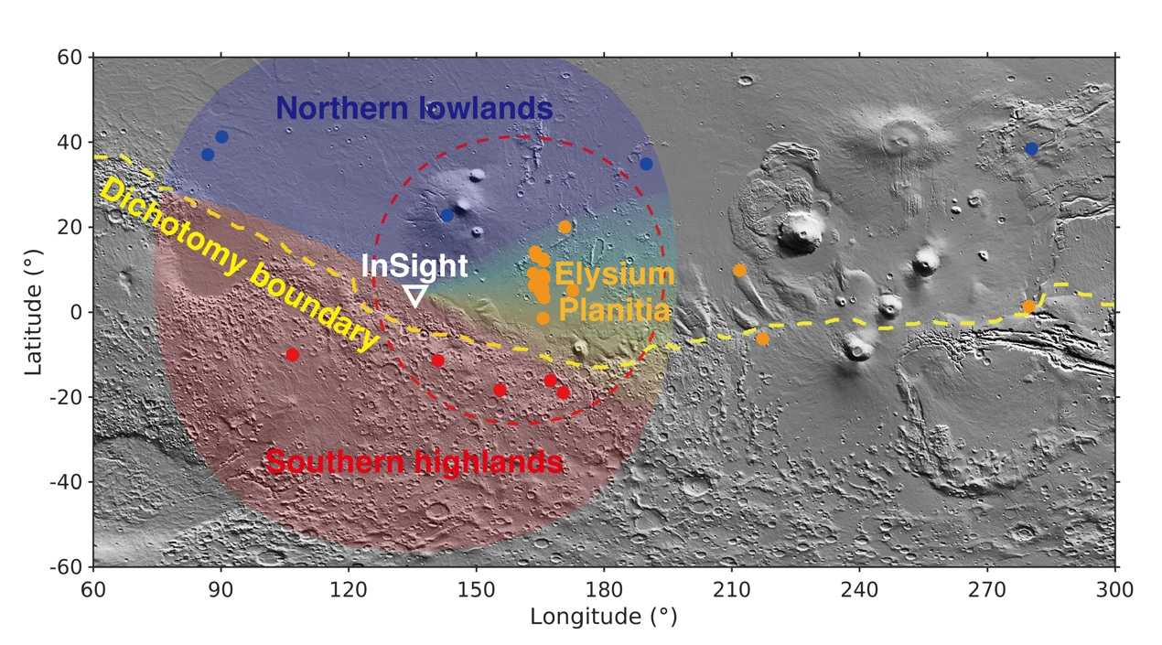
Supplementary Fig. 43 | Source locations of all events used in ref. ⁶¹. Events are divided into three groups according to their back azimuths. Red dots denote the Southern highlands events with back azimuths of 120°–300°. Blue dots denote the Northern lowlands events with back azimuths of -60°–60°. Orange dots denote the Elysium Planitia events with back azimuths of 60°–120°. Note that several distant events are also categorized as Elysium Planitia events while they are not included in the following analyses. White triangle denotes the InSight landing site. Yellow dashed line denotes the Martian dichotomy boundary. Red dashed circle denotes the position of the plume head beneath Elysium Planitia proposed in ref. ¹¹.

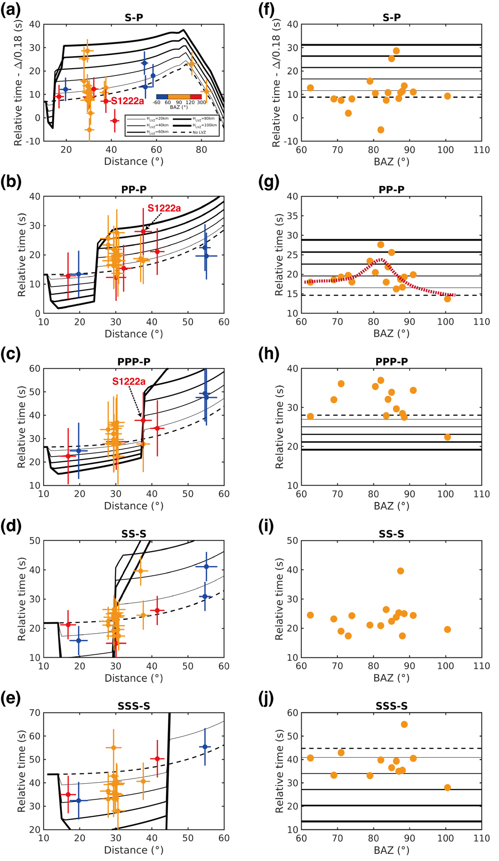
Supplementary Fig. 44 | Observed and synthetic differential travel times of five phase pairs that are sensitive to the LVZ thickness. (a–e) Variations of differential travel times with epicentral distance. Dots with errorbars denote the observations in ref. ⁶¹, where the colors stand for different back azimuth ranges. Solid black lines denote the taup calculated differential travel times with models containing the LVZ. Line thickness corresponds to the thickness of LVZ. Dashed black lines denote those calculated with the mean 1D model in ref. ⁶¹ that without the LVZ. (f–j) Variations of differential travel times with back azimuth of the Elysium Planitia events. Dots denote the observations. Solid and dashed lines denote the taup calculated results at 30° distance with different LVZ model settings. Note that the observed PP-P travel times indicate an increase of LVZ thickness as back azimuth varying from 60° to 80°, and a decrease of LVZ thickness as the further increase of back azimuth (red dashed line in g). At 30° distance, SS wave turns off at the top of the LVZ, and SS-S travel times vary significantly, making it unable to constrain the LVZ thickness.

6.3. Effects of LVZ thickness on Rayleigh wave group velocities
If the upper mantle LVZ is a large-scale feature, Rayleigh wave group velocity may offer greater sensitivity to its thickness and velocity reduction than body wave travel times. Most of Rayleigh wave group velocity measurements focus on periods below 50 s due to low signal-to-noise ratios at lower frequencies^{17,30,44,71-73}, primarily resolving crustal structures. However, two long period results provide dominant sensitivity to upper mantle depths^{74,75}. Specifically, the average group velocity measured from R2–R7 of S1222a at periods of 70–100 s is ~3.8 km/s, suggesting a high uppermost mantle Vs of ~4.41 km/s⁷⁴. In contrast, autocorrelation R2 wave yield lower group velocities, ~ 3.58 km/s⁷⁵, at 100–200 s. This discrepancy likely reflects different sampling regions: the R2–R7 of S1222a at 70–100 s reflect the crustal and uppermost mantle structures along the great circle path between the S1222a source and the InSight lander, while the autocorrelation R2 waves at 100–200 s provide a global average and are more sensitive to deeper upper mantle regions.
To further investigate these variations, we compute Rayleigh wave group velocities (20–200 s) using the same set of LVZ models used in body wave travel time tests, with the mode summation code Mineos⁷⁶. The reference model without an LVZ produces a dispersion curve that closely matches the observed values from S1222a, while the synthetic group velocities at 100–200 s are higher than those derived from autocorrelation R2 waves (Extended Data Fig. 4g–i). LVZ models with modest velocity reductions generate synthetic dispersion curves between the two observations and show lower group velocities at periods exceeding 70 s as the LVZ thickness increases (Extended Data Fig. 4g). For models with stronger velocity reductions, the drop in group velocity becomes more pronounced (Extended Data Fig. 4h–i). For example, an LVZ thicker than 40–60 km with a δVs = -25% or thicker than 20–40 km with a δVs = -40% would result in group velocities below 3.5 km/s, too low to fit either observation. Therefore, these results suggest that if the LVZ is a large-scale feature, its thickness likely does not exceed 40 km.

6.4. Effects of LVZ thickness on RFs and SS precursors
To examine how localized LVZ thickness affects the waveforms of RFs, we model the LVZ as a constant velocity layer overlying a gradient bottom boundary, where velocities increase linearly to align with the mean model from ref. ⁶¹. Beneath InSight, the best fitting model in RF inversion is used as the velocity structure above LVZ. A grid search over the thicknesses of the constant velocity layer (H1) and the thickness of the gradient bottom boundary (H2) (Supplementary Fig. 45) is performed and waveform misfits are calculated against the observed RF (Supplementary Fig. 46). The results show that RF is mainly affected by H2, with little dependence on H1. Specifically, misfit decreases as H2 increases from 0 to 18 km and remains stable with further increases in H2, while variations in H1 show no significant impact. In particular, the arrival time of the Ps conversion at the bottom boundary of the LVZ depends on LVZ thickness (H1), while its amplitude is governed by the sharpness of the bottom boundary (H2). The absence of a clear signal of the Ps conversion at the bottom boundary of the LVZ in observations suggests that a weak converted phase and a gradual velocity increase over a bottom boundary thicker than 18 km.
We also perform synthetic tests for the SS precursors of S0976a to investigate the LVZ thickness beneath the southern edge of AP (Supplementary Fig. 47). Similar to the Ps converted wave, H1 and H2 affect respectively the arrival time and amplitude of the SS precursor reflecting off the bottom of the LVZ, which appears as a positive pulse. Notably, a strong positive pulse is observed 84 s before the SS in the data (Supplementary Fig. 47b). If this arrival originates from reflection at the bottom of the LVZ, it would require an abrupt velocity jump at the boundary. However, given its significantly early arrival time relative to the SS, it has not been confidently identified as an SS precursor and may instead be a different phase or just noise. Similar synthetic tests for S1153a are not performed due to possible contaminations from noise and S coda. Although current RFs and SS precursors cannot fully resolve detailed LVZ structure, our synthetic tests indicate that the bottom of the LVZ is a gradient transition layer at least ~20 km thick, rather than a sharp interface.

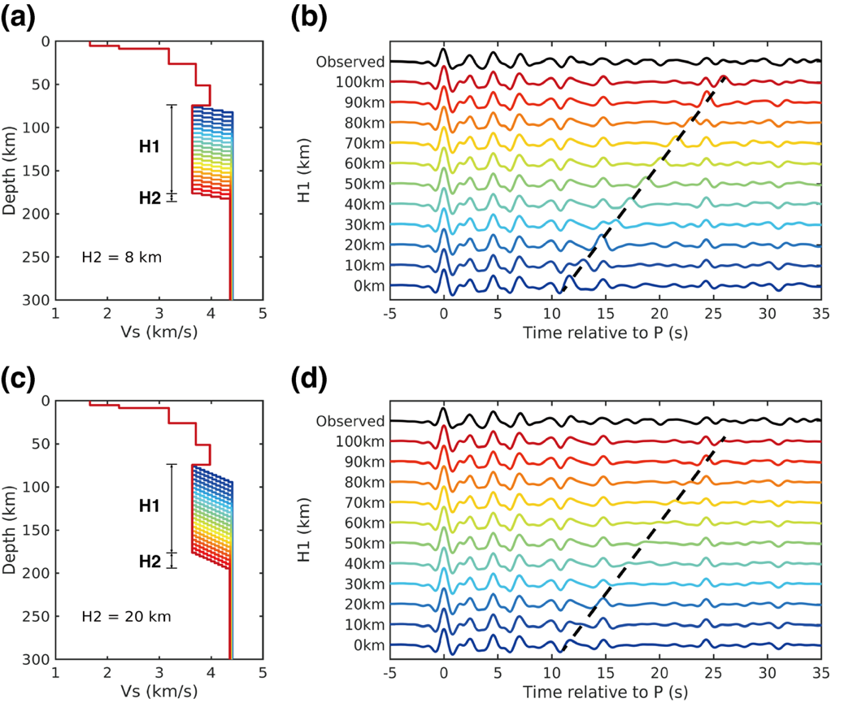
Supplementary Fig. 45 | Effect of LVZ thickness on the RF waveform. The LVZ is divided into two parts: a constant velocity layer with thickness of H1, and a gradient layer with thickness of H2 and velocity linearly increasing to the upper mantle value in the mean 1D model of ref. ⁶¹. (a) Vs models based on the best fitting RF inversion result and different LVZ thicknesses with H1 ranging from 0 to 100 km and H2 fixed to be 8 km. (b) Comparison of the observed RF with the synthetics calculated using models in (a). (c)–(d) are similar with (a)–(b) except for that H2 is set to be 20 km. Dashed lines in (b) and (d) denote the arrival of Ps phase converted as the bottom boundary of LVZ. Note that the amplitude of this phase is stronger if the LVZ has a sharper velocity increase on its bottom boundary.

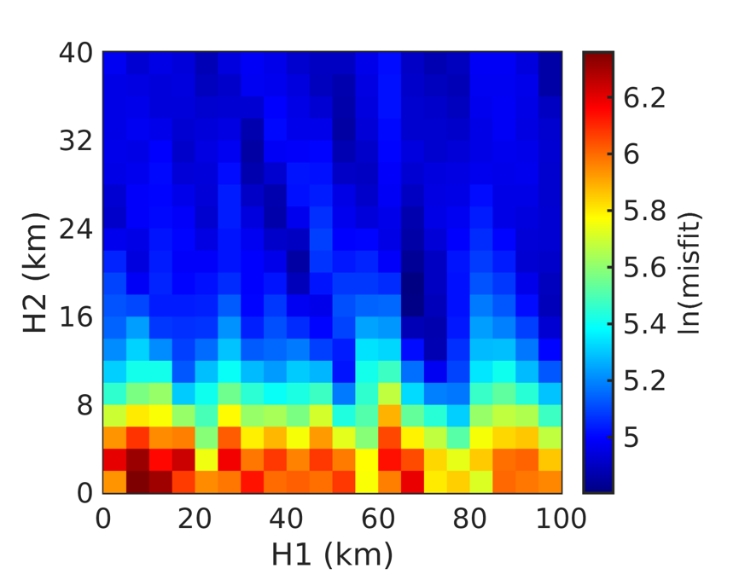
Supplementary Fig. 46 | Misfit distribution of the grid search with different settings of the LVZ thickness. H1 and H2 represent the thicknesses of the constant velocity layer and the gradient layer, respectively. The misfit decreases as H2 increases from 0 to 18 km, and remains stable as H2 further increases. In contrast, no systematic change in the misfit value is observed for variations in H1.

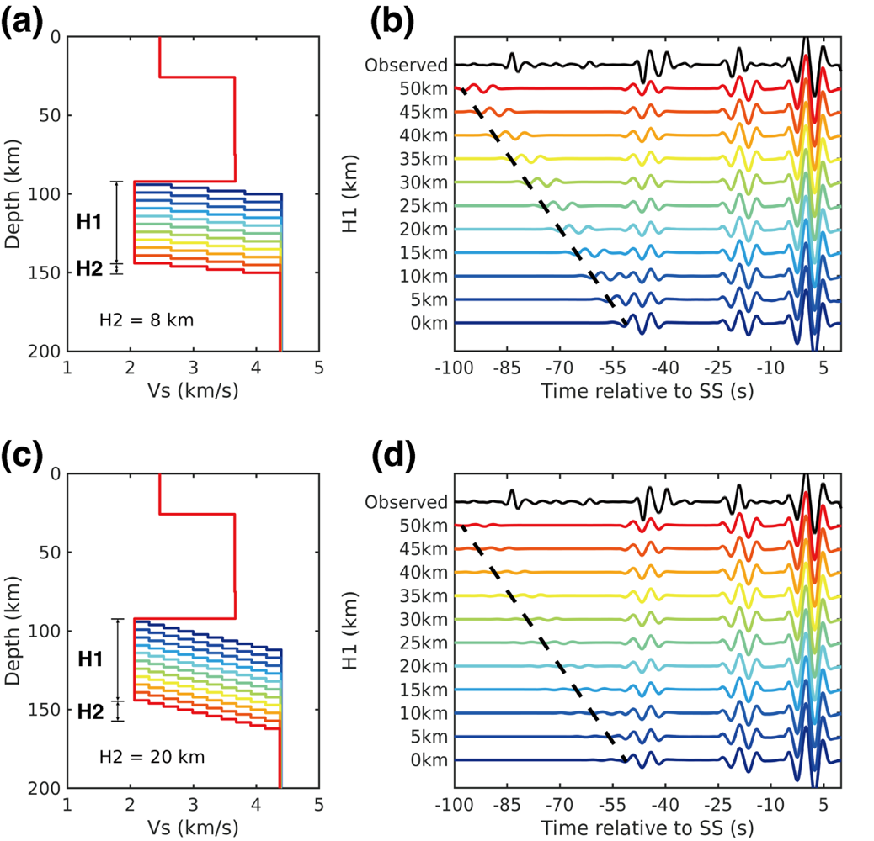
Supplementary Fig. 47 | Effect of LVZ thickness on the waveform of SS precursor. H1 and H2 represent the thicknesses of the constant velocity layer and the gradient layer, respectively. (a) Vs models based on the median model of precursor inversion and different LVZ thicknesses with H1 ranging from 0 to 50 km and H2 fixed to be 8 km. (b) Comparison of the observed SS and its precursors with the synthetics calculated using models in (a). (c)–(d) are similar with (a)–(b) except for that H2 is set to be 20 km. Dashed lines in (b) and (d) denote the arrival of SS precursor that bounces off below the bottom boundary of LVZ. Note that the amplitude of this phase is stronger if the LVZ has a sharper velocity increase on its bottom boundary.

7. Sensitivities of seismic velocities to temperature and composition

7.1. Direct Perple_X calculation
We use Perple_X Gibbs energy minimization software⁷⁷ with thermodynamic database of ref. ⁷⁸ to derive the sensitivities of seismic velocities on temperature and Mg# . Similar to ref. ³⁹, we examine a range of Mg# from 60 to 80 (Supplementary Fig. 48), constructed by mixing different proportions of chondritic compositions⁷⁹ into DW85 model⁸⁰. EH45 model⁸¹ is also included as it yields better fits for the InSight observations, including triplicated P and S³⁹ and SKS⁸². Although other compositional parameters, such as Mg/Si and refractory element contents also vary, their impacts on seismic velocities are comparatively minor³⁹. Unlike ref. ³⁹, which focuses on the phase transition at ~1000 km depth, we also extend our study to lower Mg# considering the elevated iron enrichment observed in Elysium Planitia⁸³ (Supplementary Fig. 49). For each composition, we calculate Vp, Vs, and their temperature derivatives at various temperatures but fixed pressure of 0.8 GPa, corresponding to the LVZ depth (Supplementary Figs. 50–51). Considering the possible presence of a plume head underneath Elysium Planitia¹¹ and the inverted low Vs value, we explore a broad temperature range, from 460 K⁸⁴ to the melting point 1431.5 K⁸⁵ (Supplementary Fig. 52). The calculated average temperature derivatives are -5.62×10⁻⁴ km/s/K for V_{P} and -3.41×10⁻⁴ km/s/K for Vs (Supplementary Fig. 50c–d). Similarly, within the same temperature range, the average velocity derivatives with respect to Mg# are 0.0096 km/s for V_{P} and 0.0159 km/s for Vs (Supplementary Fig. 51c–d).

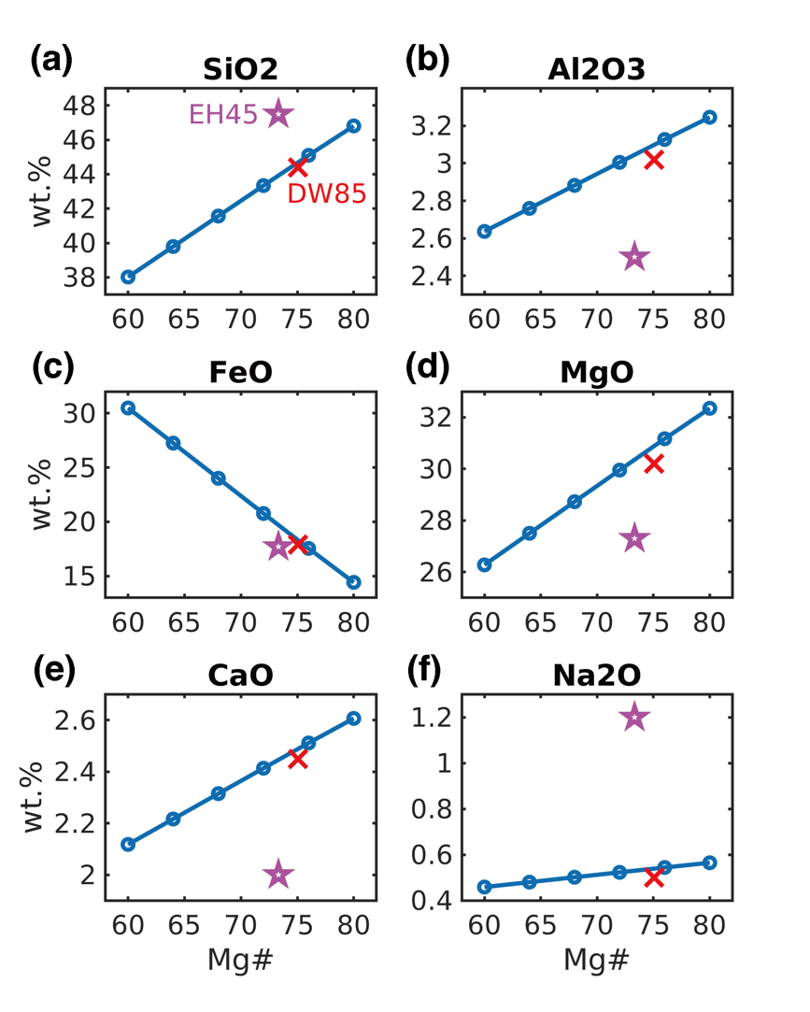
Supplementary Fig. 48 | Bulk compositions of EH45 model, DW85 model, and those with variable Mg#. (a)–(f) show the weight percent of each major elements. Purple pentacle denotes EH45 model. Red cross denotes DW85 model. Circles denote the compositions with variable Mg#, which are constructed based on DW85 model with different fractions of chondrite model.

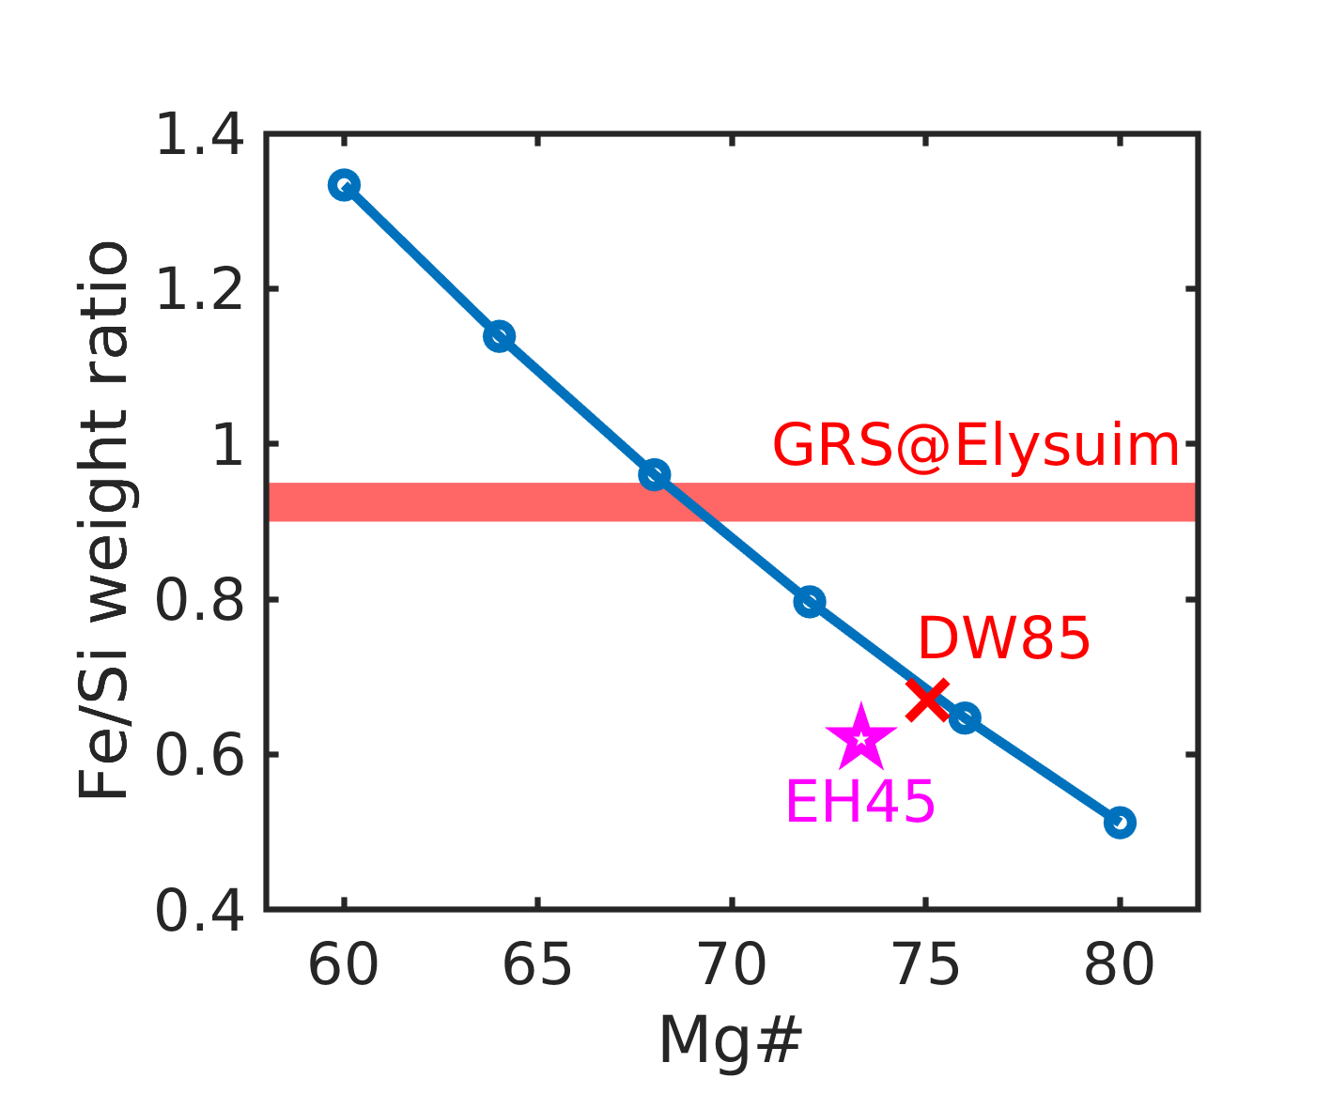
Supplementary Fig. 49 | Fe/Si weight ratio of different bulk composition models. Red horizontal band shows the Fe/Si weight ratio Elysium Planitia measured by Gamma Ray spectrometer⁸³.

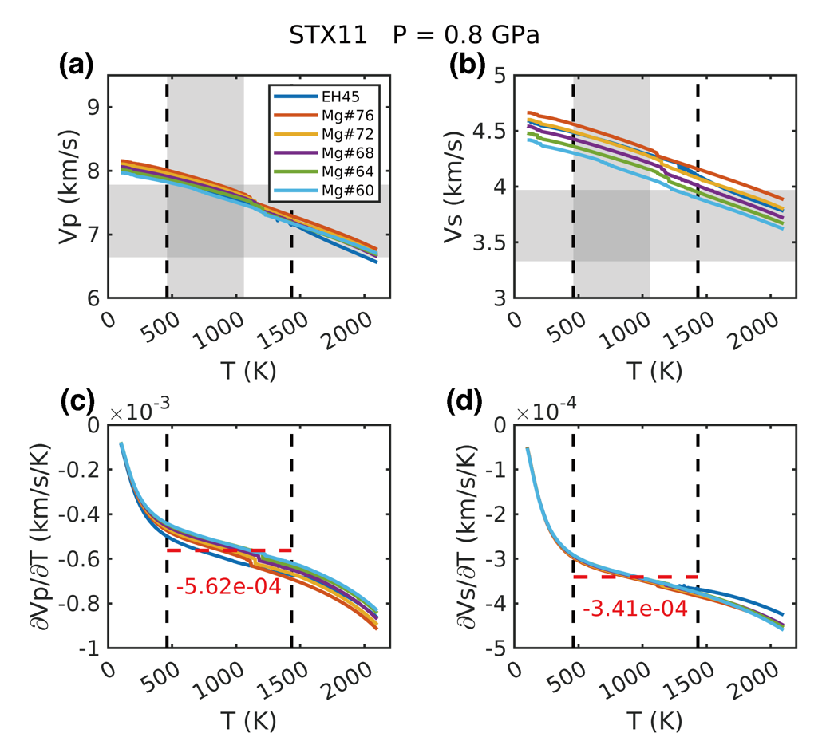
Supplementary Fig. 50 | Vp, Vs, and their temperature derivatives from Perple_X calculations with different mantle compositions. (a) Vp’s at different temperatures. (b) Vs’s at different temperatures. (c) Vp derivatives to temperature. (d) Vs derivatives to temperature. All values are calculated under the pressure of 0.8 GPa. Horizontal shaded zones denote the Vp and Vs values from our seismic inversions. Vertical shaded zones denote the temperature range between 460 K and 1060 K, which are obtained from thermal evolution modeling at 0.8 GPa. Vertical dashed lines denote the lower and upper limits of the temperatures of 460 K and 1431.5 K, between which the derivatives of velocities to temperature are averaged. The average temperature derivatives are labelled as horizontal red dashed lines and numbers in (c) and (d).

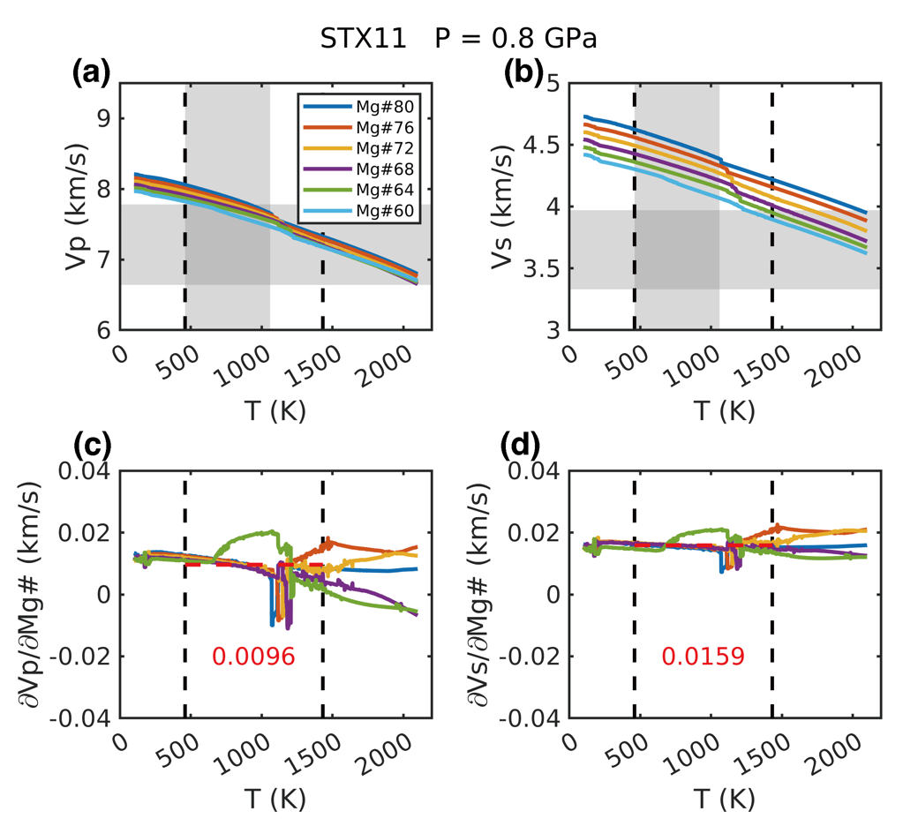
Supplementary Fig. 51 | Vp, Vs, and their Mg# derivatives from Perple_X calculations with different mantle compositions. (a) Vp’s at different temperatures. (b) Vs’s at different temperatures. (c) Vp derivatives to Mg#. (d) Vs derivatives to Mg#. All values are calculated under the pressure of 0.8 GPa. Horizontal shaded zones denote the Vp and Vs values from our seismic inversions. Vertical shaded zones denote the temperature range between 460 K and 1060 K, which are obtained from thermal evolution modeling at 0.8 GPa. Vertical dashed lines denote the lower and upper limits of the temperatures of 460 K and 1431.5 K, between which the derivatives of velocities to Mg# are averaged. The average Mg# derivatives are labelled as horizontal red dashed lines and numbers in (c) and (d).

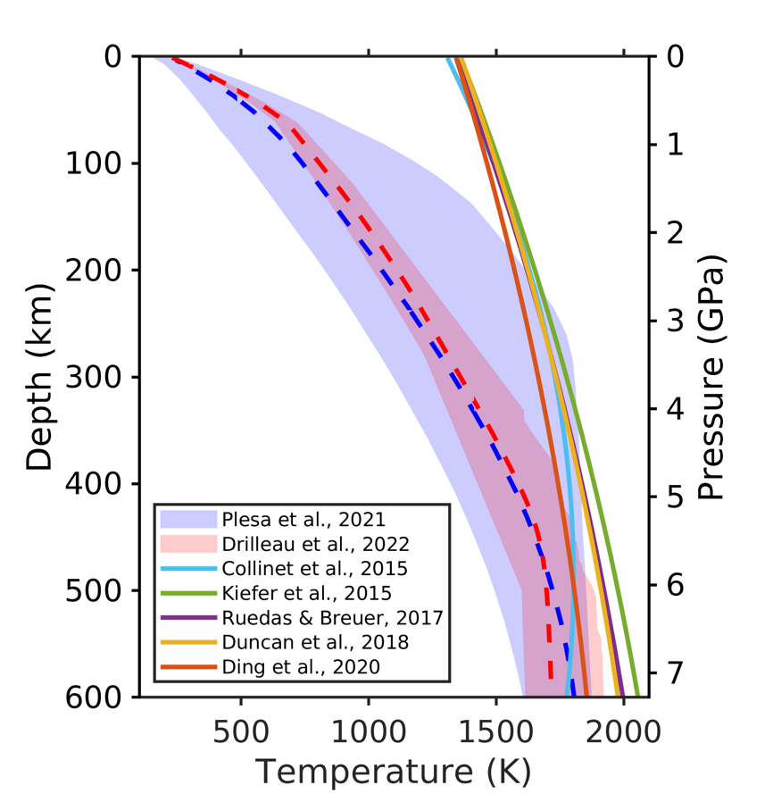
Supplementary Fig. 52 | Temperature profiles and mantle solidi of Mars from previous studies. Shaded blue and red areas show the distribution of temperatures within Mars’s interior from thermal evolution modelling with medium crustal HPE enrichment⁸⁴ and geodynamic inversion with InSight data³⁴. Dashed lines denote the mean temperature profiles. Solid colored lines denote the solidi of anhydrous Martian mantle in different studies⁸⁵⁻⁸⁹.

7.2. Mineral physical calculation
Alternative way to calculate velocity derivatives with respect to temperature and composition is using mineral physical model, which computes the densities and elastic moduli of different mineral phases based on experimental data and empirical formulars. At the depth of the LVZ, the Martian upper mantle is primarily composed of olivine (ol), orthopyroxene (opx), and clinopyroxene (cpx) ⁹⁰. The density, bulk modulus, and shear modulus of this mineral assemblage are calculated as follows⁹¹,
$ρ=\sum_{i=1}^{3}{ρ_{i}V_{i}}$, (16)
$M=\frac{1}{2}\left[\sum_{i=1}^{3}{M_{i}V_{i}}+{\left(\sum_{i=1}^{3}{M_{i}^{-1}V_{i}}\right)}^{-1}\right]$, (17)
where $V_{i}$, $ρ_{i}$, and $M_{i}$ represent the volume percentage, density, and bulk (K) or shear (G) modulus of each component, respectively. The P and S wave velocities are then derived by:
$V_{P}=\sqrt{\frac{K+4/3G}{ρ}}$, (18)
$V_{s}=\sqrt{\frac{G}{ρ}}$. (19)
In the mineral physical model, the relative volume ($V_{0}/V$) is first calculated under given temperature and pressure conditions using the third-order Birch–Murnaghan equation of state⁹²,
$P=3/2*K_{T0}\left(T\right)*\left[{\left(\frac{V_{0}}{V}\right)}^{\frac{7}{3}}-{\left(\frac{V_{0}}{V}\right)}^{\frac{5}{3}}\right]\left\{1-3/4*\left[4-K_{T0}^{'}\right]\left[{\left(\frac{V_{0}}{V}\right)}^{\frac{2}{3}}-1\right]\right\}$, (20)
where P and T are pressure and temperature, $V_{0}$ is the initial volume of the unit cell, and $K_{T0}$ and $K_{T0}^{'}$ are respectively the isothermal bulk modulus and its pressure derivative. The relative volume is then used to obtain the Eulerian strain,
$f=\left[{\left(\frac{V_{0}}{V}\right)}^{\frac{2}{3}}-1\right]/2$. (21)
Subsequently, the density $ρ$, adiabatic bulk modulus $K_{S}$ and shear modulus G of each mineral phase are determined using the following equations^{93,94}:
$ρ\left(T\right)=ρ_{0}\left(T\right){\left(1+2f\right)}^{\frac{3}{2}}$, (22)
$K_{S}\left(T\right)=K_{S0}\left(T\right){\left(1+2f\right)}^{\frac{5}{2}}\left[1+(3K_{S0}^{'}-5)f\right]$, (23)
$K_{S0}\left(T\right)=K_{S0}\left(300K\right)+{\left({∂K_{S}}/{∂T}\right)}_{P}\left(T-300\right)$, (24)
$G\left(T\right)={\left(1+2f\right)}^{\frac{5}{2}}\left[G_{0}\left(T\right)+(3K_{T0}\left(T\right)G_{0}^{'}-5G_{0}\left(T\right))f\right]$, (25)
$G_{0}\left(T\right)=G_{0}\left(300K\right)+{\left({∂G}/{∂T}\right)}_{P}\left(T-300\right)$, (26)
in which the elastic moduli at room temperature and pressure, along with their derivatives⁹⁴⁻⁹⁸.
To evaluate the impact of composition on seismic velocities, we first use Perple_X to obtain the volume fractions of ol, opx, and cpx, and then calculate their densities and elastic moduli using equations (20)–(26), following calculating Vp and Vs with equations (16)–(19). The pressure is fixed at 0.8 GPa and the temperature range between 460 K and the melting point (1431.5 K) ⁸⁵ is used to obtain the temperature and compositional derivatives of velocities (Supplementary Fig. 53a–b). The average derivatives of Vp and Vs with respect to temperature are -5.89×10⁻⁴ km/s/K and -3.12×10⁻⁴ km/s/K, respectively (Supplementary Fig. 53c–d). The derivative on Mg# are 0.0101 km/s for Vp and 0.0162 km/s for Vs (Supplementary Fig. 53e–f). These values agree well with the direct Perple_X calculations (Supplementary Figs. 50–51).
The mineral physical model also allows assessment of the effects of water content on seismic velocities. The results indicate that even with water content as high as 2000 ppm, the reductions in Vp and Vs are less than 0.004 km/s and 0.002 km/s, respectively (Supplementary Fig. 54), suggesting that water, compared to temperature and composition, has a negligible direct influence on seismic velocity, which is consistent with experiment results⁹⁹.

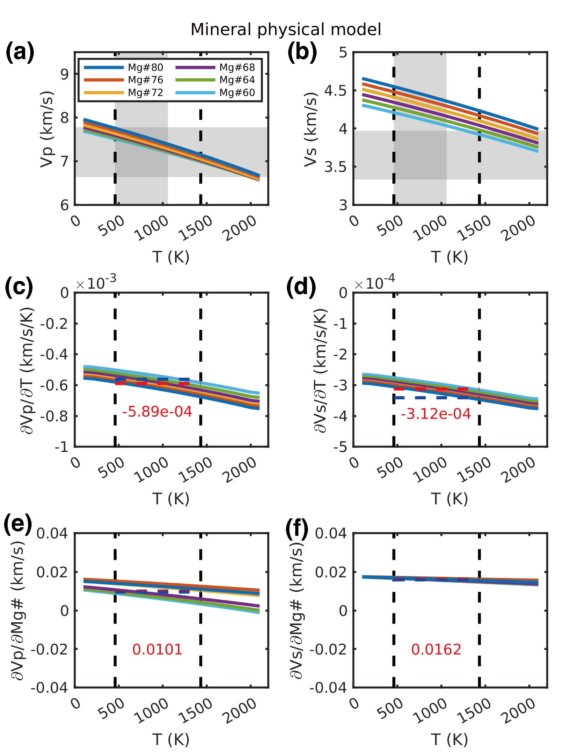
Supplementary Fig. 53 | Vp, Vs, and their temperature and Mg# derivatives calculated from mineral physical model. Figure captions are same as in Supplementary Figs. 50–51. Horizontal red dashed lines in (c)–(f) denote the average derivatives from mineral physical model, while horizontal blue dashed lines denote results from Perple_X calculations.

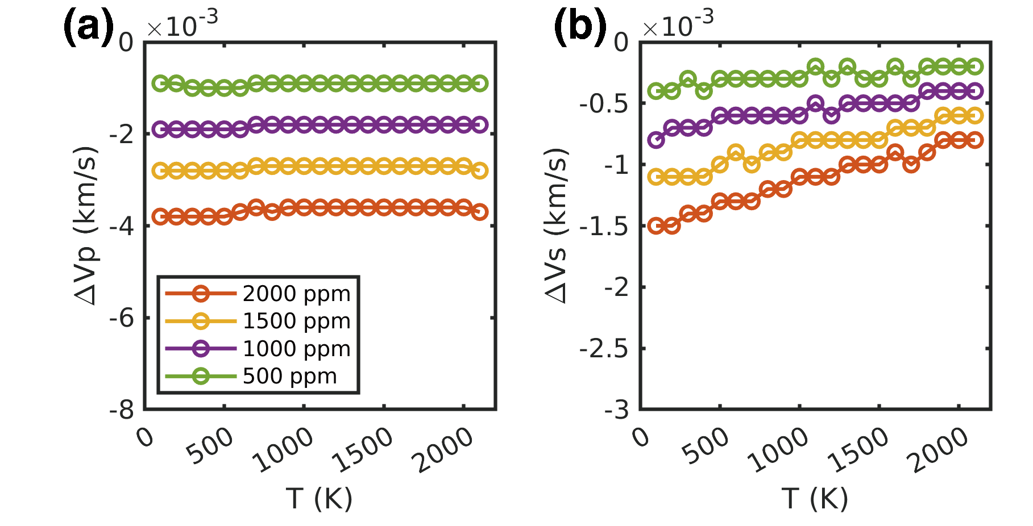
Supplementary Fig. 54 | Variations of (a) Vp and (b) Vs with different bulk water contents.

8. Martian mantle solidus and geotherm

8.1. Dry solidus and its variation with Mg#
The Martian mantle solidus is believed to be lower than that of Earth at equivalent pressures, as the Martian mantle is thought to be enriched in Na and K and have a lower Mg#⁸⁰. Experimental studies have modeled Martian mantle solidus as quadratic or cubic functions of pressure⁸⁵⁻⁸⁹. Although the applicable pressure ranges differ across these studies, these models yield consistent melting temperatures at ~0.8–1.0 GPa (Supplementary Fig. 52). In this study, we adopt the solidus ($T_{solidus}$) equation provided by ref. ⁸⁵, valid for 0.5–2.2 GPa:
$T_{solidus}(K)=1306.15+168.1P(GPa)-14.22P^{2}(GPa)$. (27)
The content of major elements in peridotite, such as Na, K, Ca, Mg, and Fe, significantly affects the mantle solidus¹⁰⁰. Ref. ⁸⁸ provides a composition dependent parameterization at 1 GPa:
$T_{solidus}\left(K\right)=1370.15+1.6Mg\#-47.6\left({Na}_{2}O+K_{2}O\right)\left(wt\%\right)+5.7CaO\left(wt\%\right)$. (28)
Since we use Mg# as a proxy for composition variation (Methods, Equation 3), we focus on the derivative of solidus with respect to Mg#. As shown in Supplementary Fig. 48, our parameterization of the bulk Martian mantle composition indicates a linear relationship between Na₂O/CaO and Mg#. Thus, it is straightforward to replace the other parameters in the previous solidus equation with Mg#. Subsequently, we derive $\frac{{∂T}_{solidus}}{∂Mg\#}=1.4867(K)$, which is used in equation (5) of Methods.

8.2. Hydrous solidus
Ref. ¹⁰¹ proposed a parameterization of hydrous mantle melting based on thermodynamic modeling and experimental investigations. The hydrous mantle solidus is expressed as
$T_{solidus}^{hydrous}\left(P,X_{H_{2}O}\right)=T_{solidus}^{dry}\left(P\right)-∆T_{solidus}(X_{H_{2}O})$, (29)
where $X_{H_{2}O}$ is the weight fraction of water in the melt. The reduction in solidus temperature due to water content is defined as:
$∆T_{solidus}\left(X_{H_{2}O}\right)=\left\{\begin{aligned}KX_{H_{2}O}^{γ}, if X_{H_{2}O}≤X_{H_{2}O}^{sat} \\ ∆T_{solidus}\left(X_{H_{2}O}^{sat}\right), if X_{H_{2}O}>X_{H_{2}O}^{sat}\end{aligned}\right.$. (30)
$X_{H_{2}O}^{sat}$ is the weight fraction of water in the saturated melt and is pressure-dependent:
$X_{H_{2}O}^{sat}\left(P\right)=χ_{1}P^{λ}+χ_{2}P$. (31)
Additional water beyond saturation does not further lower the solidus. The fraction of water in the melt is determined by the bulk water content and the partition coefficient of hydrogen between peridotite and melt:
$X_{H_{2}O}=\frac{X_{H_{2}O}^{bulk}}{D_{H}^{peridotite/melt}}$, (32)
where $D_{H}^{peridotite/melt}$ is taken as 0.009¹⁰². Other parameters used in equations (30)–(31) are referred to ref. ¹⁰¹.
An alternative method, cryoscopic relation¹⁰³, is also tested to estimate the effect of water on mantle melting. This method accounts for the freezing point depression caused by an ideal diluent (e.g. water here) as:
$\frac{1}{T_{solidus}^{hydrous}}=\frac{1}{T_{solidus}^{dry}}-\frac{R}{{∆H}_{peridotite}^{fusion}}ln⁡(1-X_{{OH}^{-}})$, (33)
where $X_{{OH}^{-}}$ is the mole fraction of hydroxyl in the melt at the solidus and can be derived from $X_{H_{2}O}$, ${∆H}_{peridotite}^{fusion}$ is the enthalpy of fusion of peridotite and is linearly extrapolated with pressure based on ref. ¹⁰⁴, and R is the gas constant.
In Supplementary Fig. 55d, we compare the hydrous solidus results from two methods. For bulk water content below saturated conditions (< 0.107 wt%), both methods yield consistent solidus temperatures of ~1200–1400 K at 0.8 GPa, still higher than thermal model predicted temperatures for this depth⁸⁴. Therefore, the upper mantle beneath Elysium Planitia likely requires elevated temperatures, supporting the presence of a mantle plume in this region¹¹.

8.3. Upper mantle geotherms
Given that the LVZs are caused by partial melting, the depths of their top and bottom boundaries, along with the mantle solidus, can be used to derive the geotherm beneath Elysium Planitia. Following ref. ³⁹, we model the geotherm as
$T\left(z\right)=T_{0}+T_{m}erf\left(\frac{z}{\sqrt{κt}}\right)+z{\left(\frac{dT}{dz}\right)}_{adiabatic}$, (34)
where $T_{0}$ is the surface temperature, t is the thermal age, $κ$ is the thermal diffusivity, and ${\left(\frac{dT}{dz}\right)}_{adiabatic}$ is the adiabatic thermal gradient. The error function term represents the lithospheric temperature profile above the LVZ, while the linear term accounts for the adiabatic temperature increasing with depth.
We fix $T_{0}$ and t to be 205 K and 4.25$×$10⁹ y, same as in ref. ³⁹. The values of $T_{m}$, $κ$, and ${\left(\frac{dT}{dz}\right)}_{adiabatic}$ are optimized with equation (34) to ensure the geotherm intersects the solidus at depths of 70 km and 120 km, corresponding to the top and bottom boundaries of the LVZ. We examine bulk water contents of 0, 0.05 wt%, and 0.1 wt% for solidus. The resulting geotherms show a steep temperature increase from 205 K at surface to ~1200–1400 K at ~70 km depth (Supplementary Fig. 55c).

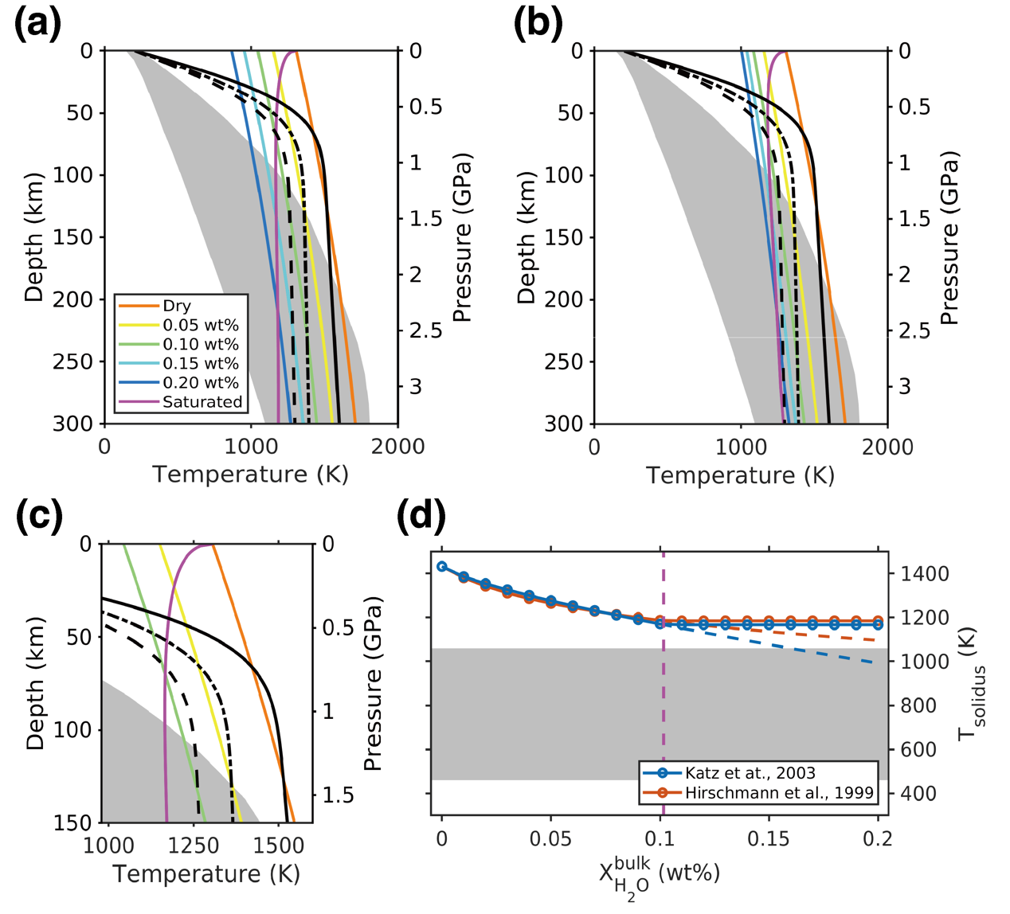
Supplementary Fig. 55 | Hydrous solidi and possible geotherms in the Martian upper mantle beneath Elysium Planitia. (a) Comparison of geotherms and hydrous solidi calculated with the method in ref. ¹⁰¹. (b) Comparison of geotherms and hydrous solidi calculated with the method in ref. ¹⁰³. (c) Enlarged view of (a) focused on the top 150 km depth. Colored curves in (a–c) denote the hydrous mantle solidi with different water contents. Purple curves represent the mantle solidi with saturated water in the melt. Grey shaded areas denote the range of temperature profiles provided in ref. ⁸⁴ with medium crustal HPE enrichment. Solid and dashed black curves denote our calculated geotherms based on the depth and thickness of LVZ and the hydrous solidi with water contents of 0, 0.05 wt%, and 0.10 wt%, respectively. (d) Hydrous solidus temperatures at 80 km depth with different bulk water contents. Solid curves denote the solidi with saturation constraint, while dashed curves stand for those with saturation constraint. Vertical dashed line denotes the saturation state, where bulk water content is 0.107 wt%. Additional water content beyond saturation does not further lower the solidus temperature. Grey shaded areas denote the range of temperature profiles at this depth provided in ref. ⁸⁴ with medium crustal HPE enrichment.

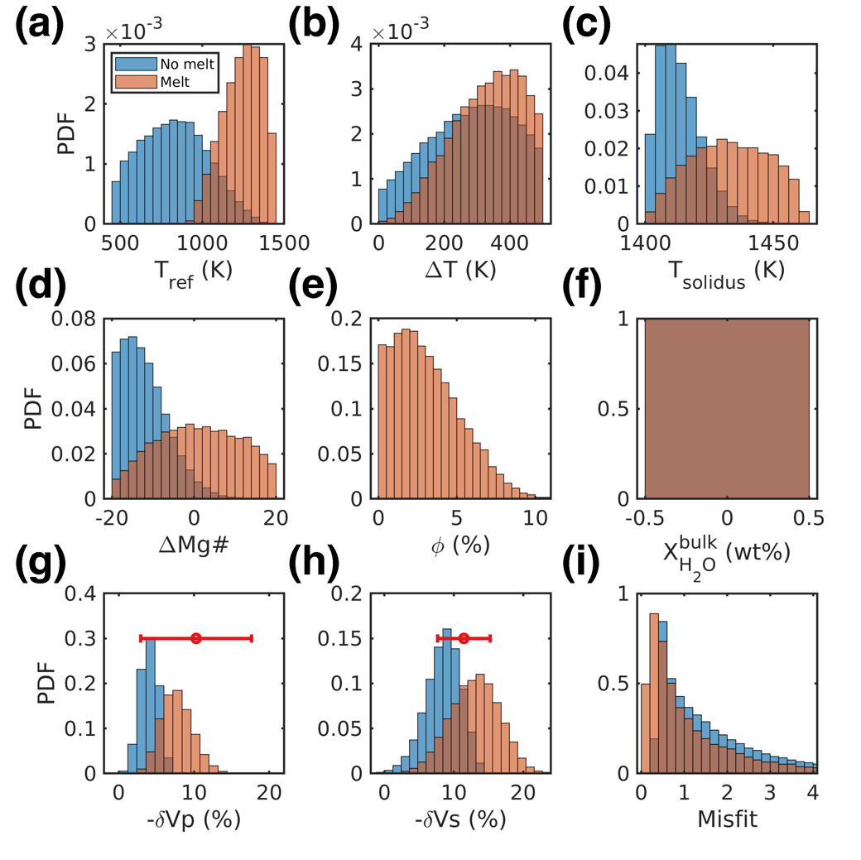
Supplementary Fig. 56 | Modeling results for fitting the LVZ velocity reductions beneath InSight under the dry mantle assumption. From (a) to (i) are probability distribution functions of reference mantle temperature, temperature anomaly, mantle solidus, variation of Mg#, melt fraction, bulk water content, Vp perturbation, Vs perturbation and misfit function. Bulk water content is fixed as 0 in the simulation.

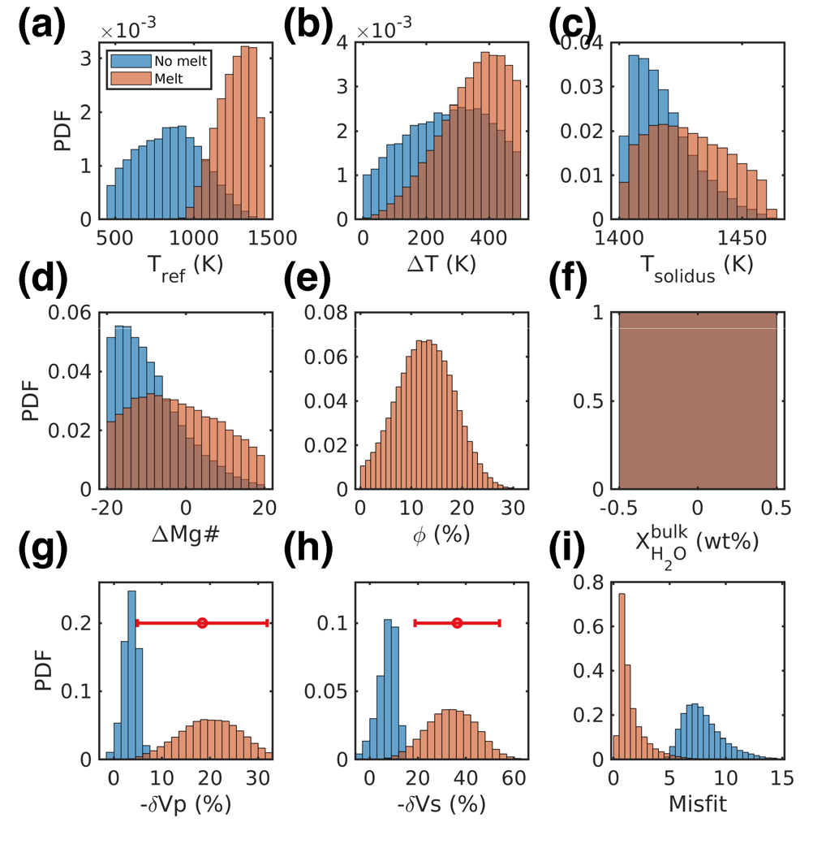
Supplementary Fig. 57 | Modeling results for fitting the LVZ velocity reductions beneath the southern edge of AP under the dry mantle assumption. Detailed figure captions are same as in Extended Data Fig. 6.

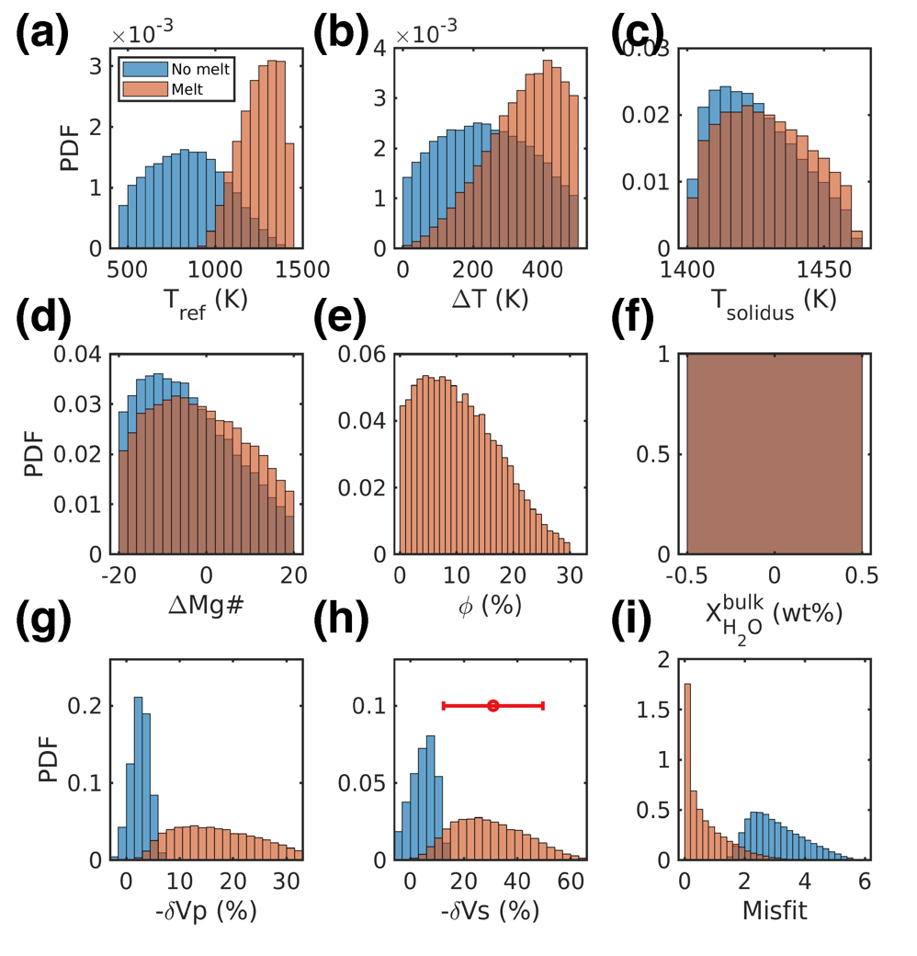
Supplementary Fig. 58 | Modeling results for fitting the LVZ velocity reductions beneath the eastern CF under the dry mantle assumption. Detailed figure captions are same as in Extended Data Fig. 7. Note that no Vp information is obtained in the inversion (g) since there is no observation of PP or PP precursor in the waveform of S1153a.

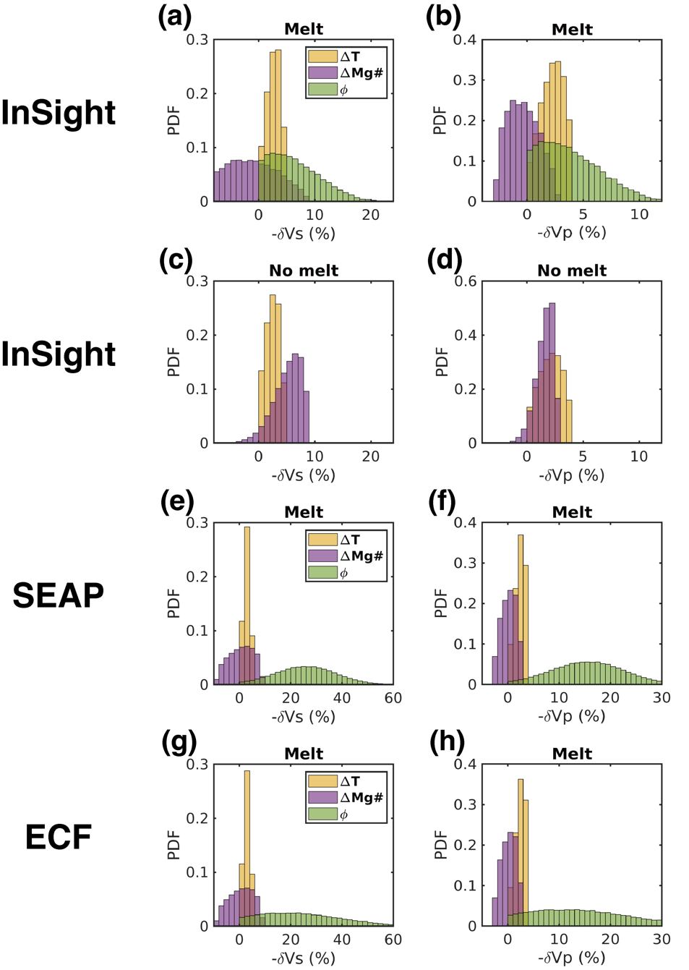
Supplementary Fig. 59 | Contributions of each factor to velocity perturbations. Left and right panels show the distributions of reductions in Vs and Vp, respectively, which are calculated by individual mechanisms in different simulations. Partial melting accounts for the largest fraction of the velocity reduction, while the effects of variations in temperature and Mg# are minor.

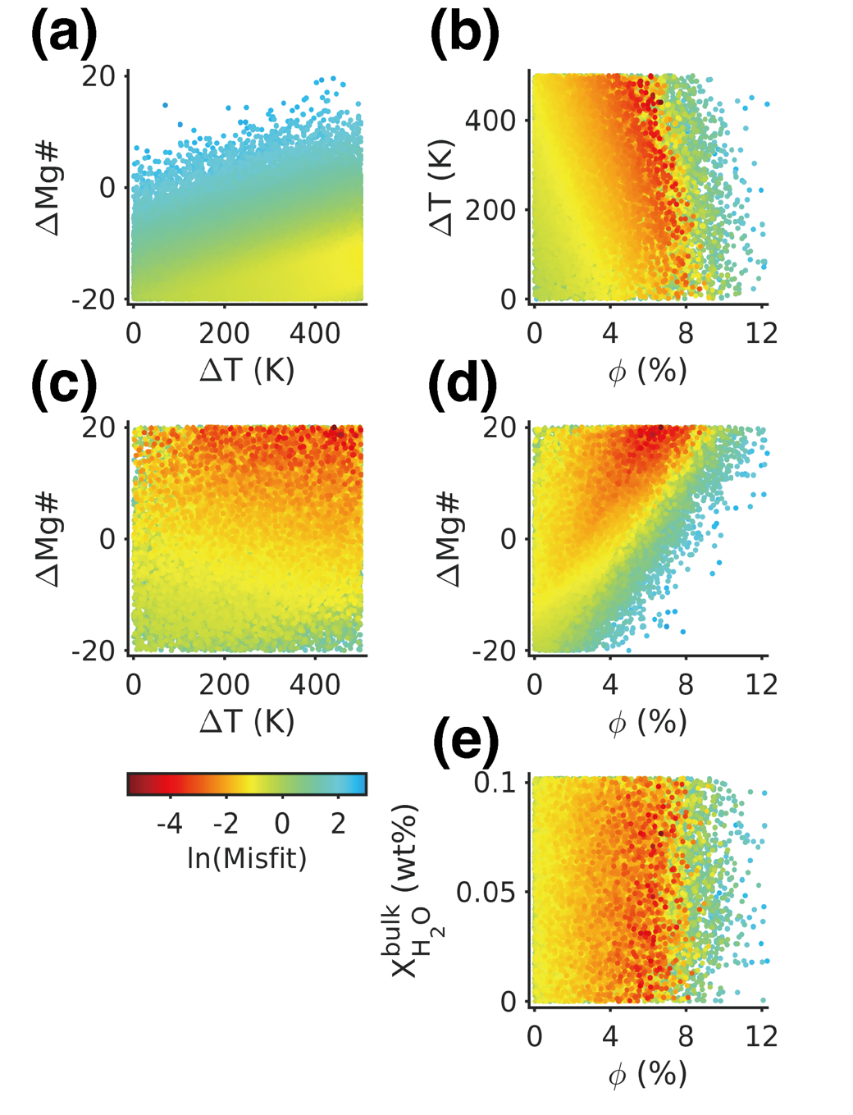
Supplementary Fig. 60 | Distributions of misfits versus LVZ features from the modeling for fitting the LVZ velocity reductions beneath InSight under the hydrous mantle assumption. (a) shows the results without melts in the LVZ. (b)–(e) show the result with melts in the LVZ. Colors of dots stand for the misfit values.

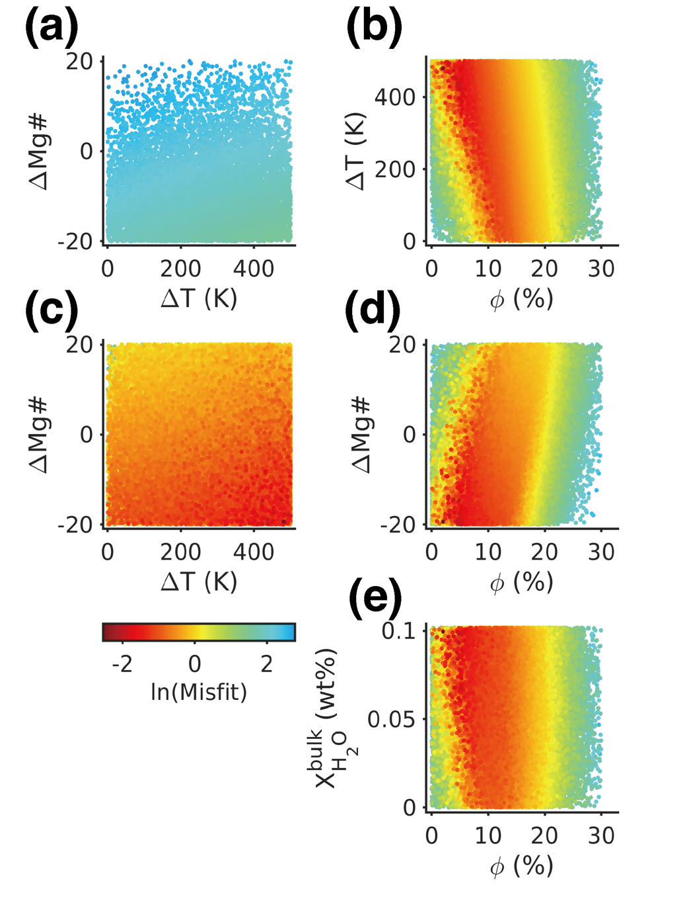
Supplementary Fig. 61 | Similar to Supplementary Fig. 60 but for the LVZ beneath the southern edge of AP.

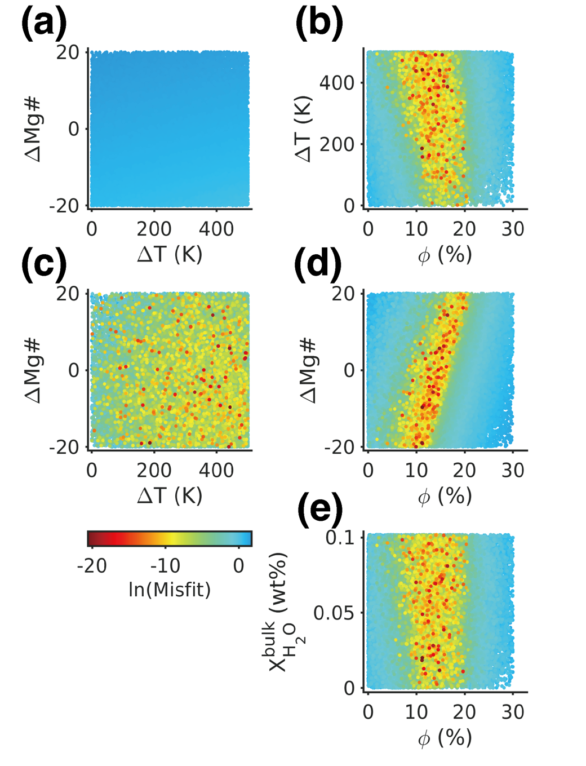
Supplementary Fig. 62 | Similar to Supplementary Fig. 60 but for the LVZ beneath the eastern CF.

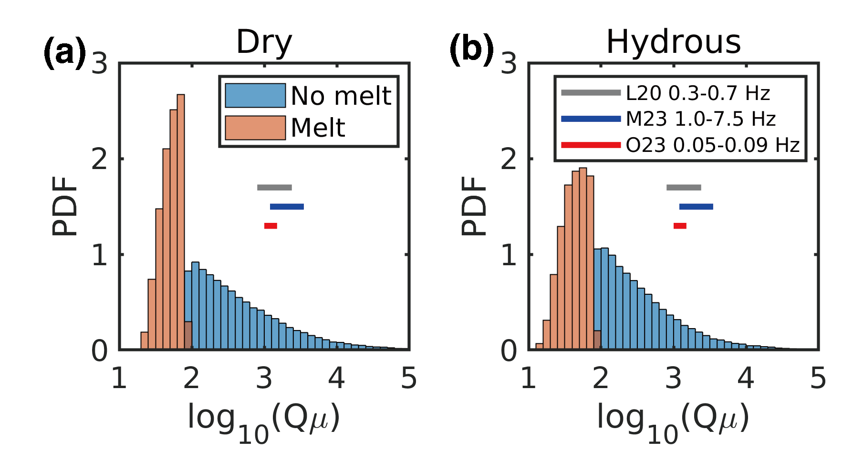
Supplementary Fig. 63 | Distribution of intrinsic attenuation factor (Qμ) in the modeling of LVZ velocity reductions beneath InSight. (a) shows the results for the dry mantle case, while (b) is for the hydrous mantle case. Values of Qμ are calculated by equation (4) in the Methods. Horizontal line segments denote the ranges of Qμ from previous studies. If melts exist in the LVZ, the calculated Qμ values are below 100, significantly lower than those derived from previous studies¹⁰⁵⁻¹⁰⁷. L20: Lognonne et al., 2020 (ref. ¹⁰⁵) (Qμ = 800–2400 from S0173a and S0235b at ~0.3–0.7 Hz). M23: Menina et al., 2023 (ref. ¹⁰⁶) (Qμ = 1200–3500 from near impacts, VF events, and S1222a at ~7.5 Hz). O23: Onodera et al., 2023 (ref. ¹⁰⁷) (Qμ = 1000–1500 from surface waves of S1222a at 0.05–0.09 Hz).

Supplementary Tab. 1 | Information of marsquake events used in this study
Method | Name | Quality | Distance (°)* | Back azimuth (°)# | Bandpass f₁ (Hz) | Bandpass f₂ (Hz) | Subsequent process | Remark
P-wave RF | S0173a | A | 30.0 ± 1.0 | 86.57 ± 1.45 | 0.05 | 0.9 | Bandpass filter into 0.15–0.85 Hz after deconvolution | CF events used in the RF inversion
P-wave RF | S0235b | A | 28.7 ± 1.1 | 76.93 ± 2.94 | 0.05 | 0.9 | Bandpass filter into 0.15–0.85 Hz after deconvolution | CF events used in the RF inversion
P-wave RF | S0809a | A | 29.8 ± 1.4 | 85.41 ± 2.17 | 0.05 | 0.9 | Bandpass filter into 0.15–0.85 Hz after deconvolution | CF events used in the RF inversion
P-wave RF | S0820a | A | 30.2 ± 1.7 | 93.78 ± 9.27 | 0.05 | 0.9 | Bandpass filter into 0.15–0.85 Hz after deconvolution | CF events used in the RF inversion
P-wave RF | S1048d | A | 30.2 ± 0.9 | 77.85 ± 21.89 | 0.05 | 0.9 | Bandpass filter into 0.15–0.85 Hz after deconvolution | CF events used in the RF inversion
P-wave RF | S1133c | A | 30.2 ± 0.9 | 86.39 ± 2.31 | 0.05 | 0.9 | Bandpass filter into 0.15–0.85 Hz after deconvolution | CF events used in the RF inversion
P-wave RF | S0802a | B | 30.0 ± 2.5 | 70.93 ± 12.58 | 0.05 | 0.9 | Bandpass filter into 0.15–0.85 Hz after deconvolution | CF events not used in the RF inversion
P-wave RF | S1022a | A | 30.7 ± 1.5 | 80.62 ± 9.66 | 0.05 | 0.9 | Bandpass filter into 0.15–0.85 Hz after deconvolution | CF events not used in the RF inversion
P-wave RF | S0484b | B | 31.8 ± 4.2 | 70.99 ± 3.75 | 0.05 | 0.9 | Bandpass filter into 0.15–0.85 Hz after deconvolution | CF events not used in the RF inversion
P-wave RF | S0864a | A | 28.7 ± 2.4 | 94.52 ± 6.57 | 0.05 | 0.9 | Bandpass filter into 0.15–0.85 Hz after deconvolution | CF events not used in the RF inversion
P-wave RF | S0407a | B | 29.3 ± 1.5 | 74.54 ± 12.44 | 0.05 | 0.9 | Bandpass filter into 0.15–0.85 Hz after deconvolution | CF events not used in the RF inversion
P-wave RF | S1015f | A | 27.5 ± 1.5 | 85.09 ± 4.76 | 0.05 | 0.9 | Bandpass filter into 0.15–0.85 Hz after deconvolution | CF events not used in the RF inversion
P-wave RF | S1222a | A | 37.0 ± 1.1 | 110.42 ± 3.99 | 0.05 | 0.9 | Bandpass filter into 0.15–0.85 Hz (HF) and 0.1–0.4 Hz (LF) after deconvolution | Largest detected marsquake
S-wave RF | S1153a | B | 84.8 ± 7.7 | 87.17 ± 5.20 | 0.05 | 0.9 | Bandpass filter into 0.15–0.85 Hz after deconvolution | Distant events
S-wave RF | S1415a | B | 88.2 ± 7.4 | 115.39 ± 11.09 | 0.05 | 0.9 | Bandpass filter into 0.15–0.85 Hz after deconvolution | Distant events
PP precursor | S0976a | A | 146.3 ± 5.2 | 97.62 ± 2.18 | 0.125–0.167 | 0.33–0.50 | Polarization filter | Distant events
SS precursor | S0976a | A | 146.3 ± 5.2 | 97.62 ± 2.18 | 0.118–0.154 | 0.25–0.33 | Polarization filter | Distant events
SS precursor | S1153a | B | 84.8 ± 7.7 | 87.17 ± 5.20 | 0.133–0.250 | 0.67–1.00 | Polarization filter | Distant events
*Epicentral distances and their 1σ uncertainty ranges are from MQS V14 catalogue².
#Back azimuths and their 1σ uncertainty ranges are from ref. ⁵.

Supplementary Tab. 2 | Prior ranges of model parameters in RF inversion
Parameter |  | Range
Crust layer 1 | Vs₀ | 0.9–1.7 km/s
Crust layer 1 | R₀ | 1.5–2.1
Crust layer 1 | H₁ | 1.5–5.5 km
Crust layer 2 | Vs₁ | 1.3–2.3 km/s
Crust layer 2 | R₁ | 1.5–2.1
Crust layer 2 | H₂ | 6–12 km
Crust layer 3 | Vs₂ | 2.0–3.2 km/s
Crust layer 3 | R₂ | 1.5–2.1
Crust layer 3 | H₃ | 14–30 km
Crust layer 4 | Vs₃ | 2.5–4.0 km/s
Crust layer 4 | R₃ | 1.5–2.1
Crust layer 4 | H₄ | 30–55 km
Uppermost mantle above the LVZ | Vs₄ | 2.8–4.6 km/s
Uppermost mantle above the LVZ | R₄ | 1.5–2.1
Uppermost mantle above the LVZ | H₅ | 50–90 km
Upper mantle LVZ | Vs₅ | 2.0–4.0 km/s
Upper mantle LVZ | R₅ | 1.5–2.7

Supplementary Tab. 3 | Prior ranges of model parameters in PP/SS precursor inversions
Parameter |  | Range
Crust layer 1 | Vs₁ | 1.0–3.5 km/s
Crust layer 1 | Vp₁ | 2.0–6.0 km/s
Crust layer 1 | ρ₁ | 0–4.2 g/cm³
Crust layer 1 | H₂ | 10–40 km
Crust layer 2 and uppermost mantle above the LVZ | Vs₂ | 2.0–4.5 km/s
Crust layer 2 and uppermost mantle above the LVZ | Vp₂ | 4.0–8.0 km/s
Crust layer 2 and uppermost mantle above the LVZ | ρ₂ | 0–4.2 g/cm³
Crust layer 2 and uppermost mantle above the LVZ | H₂ | 40–120 km
Upper mantle LVZ | Vs₃ | 1.0–4.5 km/s
Upper mantle LVZ | Vp₃ | 2.0–8.0 km/s
Upper mantle LVZ | ρ₃ | 0–4.2 g/cm³

References
1 Stähler, S. C. et al. Seismic detection of the martian core. Science 373, 443-448 (2021). https://doi.org/10.1126/science.abi7730
2 InSight Marsquake Service. (ETHZ, IPGP, JPL, ICL, Univ. Bristol, 2023).
3 Zenhäusern, G. et al. Low‐Frequency Marsquakes and Where to Find Them: Back Azimuth Determination Using a Polarization Analysis Approach. Bulletin of the Seismological Society of America 112, 1787-1805 (2022). https://doi.org/10.1785/0120220019
4 Ceylan, S. et al. Mapping the Seismicity of Mars With InSight. Journal of Geophysical Research: Planets 128, e2023JE007826 (2023). https://doi.org/10.1029/2023JE007826
5 Wang, X., Chen, L. & Wang, X. Renewed Epicentral Distribution of Low Frequency Marsquakes by Varying-Parameter Polarization Analysis of InSight Data. Geophysical Research Letters 50, e2023GL103896 (2023). https://doi.org/10.1029/2023GL103896
6 Brinkman, N. et al. First Focal Mechanisms of Marsquakes. Journal of Geophysical Research: Planets 126, e2020JE006546 (2021). https://doi.org/10.1029/2020JE006546
7 Kedar, S. et al. Analyzing Low Frequency Seismic Events at Cerberus Fossae as Long Period Volcanic Quakes. Journal of Geophysical Research: Planets 126, e2020JE006518 (2021). https://doi.org/10.1029/2020JE006518
8 Perrin, C. et al. Geometry and Segmentation of Cerberus Fossae, Mars: Implications for Marsquake Properties. Journal of Geophysical Research: Planets 127, e2021JE007118 (2022). https://doi.org/10.1029/2021JE007118
9 Stähler, S. C. et al. Tectonics of Cerberus Fossae unveiled by marsquakes. Nature Astronomy 6, 1376-1386 (2022). https://doi.org/10.1038/s41550-022-01803-y
10 Jacob, A. et al. Seismic sources of InSight marsquakes and seismotectonic context of Elysium Planitia, Mars. Tectonophysics 837, 229434 (2022). https://doi.org/10.1016/j.tecto.2022.229434
11 Broquet, A. & Andrews-Hanna, J. C. Geophysical evidence for an active mantle plume underneath Elysium Planitia on Mars. Nature Astronomy 7, 160-169 (2023). https://doi.org/10.1038/s41550-022-01836-3
12 Giardini, D. et al. The seismicity of Mars. Nature Geoscience 13, 205-212 (2020). https://doi.org/10.1038/s41561-020-0539-8
13 Tanaka, K. L. et al. Geologic map of Mars. Report No. 3292, 48 (Reston, VA, 2014).
14 Montalbetti, J. F. & Kanasewich, E. R. Enhancement of Teleseismic Body Phases with a Polarization Filter. Geophysical Journal International 21, 119-129 (1970). https://doi.org/10.1111/j.1365-246X.1970.tb01771.x
15 Shi, J. et al. High-Frequency Receiver Functions With Event S1222a Reveal a Discontinuity in the Martian Shallow Crust. Geophysical Research Letters 50, e2022GL101627 (2023). https://doi.org/10.1029/2022GL101627
16 Zhang, J., Chen, L. & Wang, X. Crustal structure study based on principal component analysis of receiver functions. Science China Earth Sciences 62, 1110-1124 (2019). https://doi.org/10.1007/s11430-018-9341-9
17 Beghein, C. et al. Crustal Anisotropy in the Martian Lowlands From Surface Waves. Geophysical Research Letters 49, e2022GL101508 (2022). https://doi.org/10.1029/2022GL101508
18 Li, J. et al. Evidence for crustal seismic anisotropy at the InSight lander site. Earth and Planetary Science Letters 593, 117654 (2022). https://doi.org/10.1016/j.epsl.2022.117654
19 Ceylan, S. et al. Companion guide to the marsquake catalog from InSight, Sols 0–478: Data content and non-seismic events. Physics of the Earth and Planetary Interiors 310, 106597 (2021). https://doi.org/10.1016/j.pepi.2020.106597
20 Dahmen, N. L. et al. Resonances and Lander Modes Observed by InSight on Mars (1–9 Hz). Bulletin of the Seismological Society of America 111, 2924-2950 (2021). https://doi.org/10.1785/0120210056
21 Ligorría, J. P. & Ammon, C. J. Iterative deconvolution and receiver-function estimation. Bulletin of the Seismological Society of America 89, 1395-1400 (1999).
22 Joshi, R. et al. Joint Inversion of Receiver Functions and Apparent Incidence Angles to Determine the Crustal Structure of Mars. Geophysical Research Letters 50, e2022GL100469 (2023). https://doi.org/10.1029/2022GL100469
23 Kim, D. et al. Improving Constraints on Planetary Interiors With PPs Receiver Functions. Journal of Geophysical Research: Planets 126, e2021JE006983 (2021). https://doi.org/10.1029/2021JE006983
24 Dai, M. & Sun, D. Martian Crustal Model From a Joint Inversion of Receiver Functions and Apparent Shear Wave Velocity. Journal of Geophysical Research: Planets 128, e2022JE007702 (2023). https://doi.org/10.1029/2022JE007702
25 Knapmeyer-Endrun, B. et al. Thickness and structure of the martian crust from InSight seismic data. Science 373, 438-443 (2021). https://doi.org/10.1126/science.abf8966
26 Shi, J. et al. Differences in Scattering Properties of the Shallow Crusts of Earth, Mars, and the Moon Revealed by P-Wave Receiver Functions. Journal of Geophysical Research: Planets 128, e2022JE007676 (2023). https://doi.org/10.1029/2022JE007676
27 Gavish, M. & Donoho, D. L. The Optimal Hard Threshold for Singular Values is $4/\sqrt {3}$. IEEE Transactions on Information Theory 60, 5040-5053 (2014). https://doi.org/10.1109/TIT.2014.2323359
28 Durán, C. et al. Seismology on Mars: An analysis of direct, reflected, and converted seismic body waves with implications for interior structure. Physics of the Earth and Planetary Interiors 325, 106851 (2022). https://doi.org/10.1016/j.pepi.2022.106851
29 Carrasco, S. et al. Constraints for the Martian Crustal Structure From Rayleigh Waves Ellipticity of Large Seismic Events. Geophysical Research Letters 50, e2023GL104816 (2023). https://doi.org/10.1029/2023GL104816
30 Drilleau, M. et al. Structure of the Martian Crust Below InSight From Surface Waves and Body Waves Generated by Nearby Meteoroid Impacts. Geophysical Research Letters 50, e2023GL104601 (2023). https://doi.org/10.1029/2023GL104601
31 Li, J. et al. Constraints on the martian crust away from the InSight landing site. Nature Communications 13, 7950 (2022). https://doi.org/10.1038/s41467-022-35662-y
32 Choy, G. L. & Richards, P. G. Pulse distortion and Hilbert transformation in multiply reflected and refracted body waves. Bulletin of the Seismological Society of America 65, 55-70 (1975). https://doi.org/10.1785/bssa0650010055
33 Khan, A. et al. Upper mantle structure of Mars from InSight seismic data. Science 373, 434-438 (2021). https://doi.org/10.1126/science.abf2966
34 Drilleau, M. et al. Marsquake Locations and 1-D Seismic Models for Mars From InSight Data. Journal of Geophysical Research: Planets 127, e2021JE007067 (2022). https://doi.org/10.1029/2021JE007067
35 Durán, C. et al. (IPGP Research Collection, 2022).
36 Charalambous, C. et al. A Comodulation Analysis of Atmospheric Energy Injection Into the Ground Motion at InSight, Mars. Journal of Geophysical Research: Planets 126, e2020JE006538 (2021). https://doi.org/10.1029/2020JE006538
37 Ceylan, S. et al. The marsquake catalogue from InSight, sols 0–1011. Physics of the Earth and Planetary Interiors 333, 106943 (2022). https://doi.org/10.1016/j.pepi.2022.106943
38 Durán, C. et al. Observation of a Core-Diffracted P-Wave From a Farside Impact With Implications for the Lower-Mantle Structure of Mars. Geophysical Research Letters 49, e2022GL100887 (2022). https://doi.org/10.1029/2022GL100887
39 Huang, Q. et al. Seismic detection of a deep mantle discontinuity within Mars by InSight. Proceedings of the National Academy of Sciences 119, e2204474119 (2022). https://doi.org/10.1073/pnas.2204474119
40 Wang, X., Chen, L. & Wang, X. Uncovering Shallow Crustal Structures of Mars Beneath the InSight Landing Site Using P-Wave Particle Motions. Journal of Geophysical Research: Planets 130, e2024JE008927 (2025). https://doi.org/10.1029/2024JE008927
41 Ammon, C. J., Randall, G. E. & Zandt, G. On the nonuniqueness of receiver function inversions. Journal of Geophysical Research: Solid Earth 95, 15303-15318 (1990). https://doi.org/10.1029/JB095iB10p15303
42 Akaike, H. A new look at the statistical model identification. IEEE Transactions on Automatic Control 19, 716-723 (1974). https://doi.org/10.1109/TAC.1974.1100705
43 Schwarz, G. Estimating the Dimension of a Model. The Annals of Statistics 6, 461-464 (1978). https://doi.org/10.1214/aos/1176344136
44 Li, J. et al. Different Martian Crustal Seismic Velocities Across the Dichotomy Boundary From Multi-Orbiting Surface Waves. Geophysical Research Letters 50, e2022GL101243 (2023). https://doi.org/10.1029/2022GL101243
45 Aki, K. & Richards, P. G. Quantitative seismology. (2002).
46 Wieczorek, M. A. et al. InSight Constraints on the Global Character of the Martian Crust. Journal of Geophysical Research: Planets 127, e2022JE007298 (2022). https://doi.org/10.1029/2022JE007298
47 Park, J. J., Levin, V. L. & Rye, D. M. in AGU Fall Meeting Abstracts Vol. 2023 P41J-3301 (San Francisco, CA, 2023).
48 Caress, D. W., McNutt, M. K., Detrick, R. S. & Mutter, J. C. Seismic imaging of hotspot-related crustal underplating beneath the Marquesas Islands. Nature 373, 600-603 (1995). https://doi.org/10.1038/373600a0
49 Park, J. & Rye, D. M. Broader Impacts of the Metasomatic Underplating Hypothesis. Geochemistry, Geophysics, Geosystems 20, 4810-4829 (2019). https://doi.org/10.1029/2019GC008493
50 Ortega-Ramos, V. et al. Evidence of a Low-Velocity Zone in the Upper Mantle Beneath Cumbre Vieja Volcano (Canary Islands) Through Receiver Functions Analysis. Geophysical Research Letters 51, e2023GL105487 (2024). https://doi.org/10.1029/2023GL105487
51 Grott, M. et al. Long-Term Evolution of the Martian Crust-Mantle System. Space Science Reviews 174, 49-111 (2013). https://doi.org/10.1007/s11214-012-9948-3
52 Hauber, E., Brož, P., Jagert, F., Jodłowski, P. & Platz, T. Very recent and wide-spread basaltic volcanism on Mars. Geophysical Research Letters 38 (2011). https://doi.org/10.1029/2011GL047310
53 Andrews-Hanna, J. C., Zuber, M. T. & Banerdt, W. B. The Borealis basin and the origin of the martian crustal dichotomy. Nature 453, 1212-1215 (2008). https://doi.org/10.1038/nature07011
54 Kawamura, T. et al. S1222a - the largest Marsquake detected by InSight. Geophysical Research Letters 49, e2022GL101543 (2022). https://doi.org/10.1029/2022GL101543
55 Golombek, M. P. et al. Geology of the InSight landing site on Mars. Nat Commun 11, 1014 (2020). https://doi.org/10.1038/s41467-020-14679-1
56 Chen, K.-X., Forsyth, D. W. & Fischer, K. M. A Mid-Lithospheric Discontinuity Detected Beneath 155 Ma Western Pacific Seafloor Using Sp Receiver Functions. Geophysical Research Letters 51, e2024GL108347 (2024). https://doi.org/10.1029/2024GL108347
57 Farra, V. & Vinnik, L. Upper mantle stratification by P and S receiver functions. Geophysical Journal International 141, 699-712 (2000). https://doi.org/10.1046/j.1365-246x.2000.00118.x
58 Zhou, L., Chen, W.-P. & Özalaybey, S. Seismic Properties of the Central Indian Shield. Bulletin of the Seismological Society of America 90, 1295-1304 (2000). https://doi.org/10.1785/0119990039
59 Kind, R., Yuan, X. & Kumar, P. Seismic receiver functions and the lithosphere–asthenosphere boundary. Tectonophysics 536-537, 25-43 (2012). https://doi.org/10.1016/j.tecto.2012.03.005
60 Bissig, F. et al. Multifrequency Inversion of Ps and Sp Receiver Functions: Methodology and Application to USArray Data. Journal of Geophysical Research: Solid Earth 126, e2020JB020350 (2021). https://doi.org/10.1029/2020JB020350
61 Drilleau, M. et al. Constraints on Lateral Variations of Martian Crustal Thickness From Seismological and Gravity Field Measurements. Geophysical Research Letters 51, e2023GL105701 (2024). https://doi.org/10.1029/2023GL105701
62 Compaire, N. et al. Autocorrelation of the Ground Vibrations Recorded by the SEIS-InSight Seismometer on Mars. Journal of Geophysical Research: Planets 126, e2020JE006498 (2021). https://doi.org/10.1029/2020JE006498
63 Deng, S. & Levander, A. Autocorrelation Reflectivity of Mars. Geophysical Research Letters 47 (2020). https://doi.org/10.1029/2020gl089630
64 Schimmel, M. et al. Seismic Noise Autocorrelations on Mars. Earth and Space Science 8, e2021EA001755 (2021). https://doi.org/10.1029/2021EA001755
65 Muller, G. The reflectivity method: a tutorial. Journal of Geophysics 58, 153-174 (1985).
66 Dahmen, N. et al. Revisiting Martian seismicity with deep learning-based denoising. Geophysical Journal International 239, 434-454 (2024). https://doi.org/10.1093/gji/ggae279
67 Zhu, L. & Rivera, L. A. A note on the dynamic and static displacements from a point source in multilayered media. Geophysical Journal International 148, 619-627 (2002). https://doi.org/10.1046/j.1365-246X.2002.01610.x
68 Shi, J. et al. Martian seismic anisotropy underneath Elysium Planitia revealed by direct S wave splitting. Earth and Planetary Science Letters 647, 119047 (2024). https://doi.org/10.1016/j.epsl.2024.119047
69 Crotwell, H. P., Owens, T. J. & Ritsema, J. The TauP Toolkit: Flexible Seismic Travel-time and Ray-path Utilities. Seismological Research Letters 70, 154-160 (1999). https://doi.org/10.1785/gssrl.70.2.154
70 Panning, M. P. et al. Locating the Largest Event Observed on Mars With Multi-Orbit Surface Waves. Geophysical Research Letters 50, e2022GL101270 (2023). https://doi.org/10.1029/2022GL101270
71 Kim, D. et al. Surface waves and crustal structure on Mars. Science 378, 417-421 (2022). https://doi.org/10.1126/science.abq7157
72 Xu, Z. et al. Investigation of Martian Regional Crustal Structure Near the Dichotomy Using S1222a Surface-Wave Group Velocities. Geophysical Research Letters 50, e2023GL103136 (2023). https://doi.org/10.1029/2023GL103136
73 Kim, D. et al. Structure Along the Martian Dichotomy Constrained by Rayleigh and Love Waves and their Overtones. Geophysical Research Letters 49, e2022GL101666 (2022). https://doi.org/10.1029/2022GL101666
74 Kim, D. et al. Global Crustal Thickness Revealed by Surface Waves Orbiting Mars. Geophysical Research Letters 50, e2023GL103482 (2023). https://doi.org/10.1029/2023GL103482
75 Deng, S. & Levander, A. Autocorrelation R2 on Mars. Geophysical Research Letters 49, e2022GL099580 (2022). https://doi.org/10.1029/2022GL099580
76 Masters, G., Woodhouse, J. H. & Freeman, G. Mineos v1.0.2 [software]. Computational Infrastructure for Geodynamics (2011).
77 Connolly, J. A. D. Computation of phase equilibria by linear programming: A tool for geodynamic modeling and its application to subduction zone decarbonation. Earth and Planetary Science Letters 236, 524-541 (2005). https://doi.org/10.1016/j.epsl.2005.04.033
78 Stixrude, L. & Lithgow-Bertelloni, C. Thermodynamics of mantle minerals – II. Phase equilibria. Geophysical Journal International 184, 1180-1213 (2011). https://doi.org/10.1111/j.1365-246X.2010.04890.x
79 Wasson, J. T., Kallemeyn, G. W., Runcorn, S. K., Turner, G. & Woolfson, M. M. Compositions of chondrites. Philosophical Transactions of the Royal Society of London. Series A, Mathematical and Physical Sciences 325, 535-544 (1988). https://doi.org/10.1098/rsta.1988.0066
80 Dreibus, G. & Wanke, H. Mars, a Volatile-Rich Planet. Meteoritics 20, 367 (1985).
81 Sanloup, C., Jambon, A. & Gillet, P. A simple chondritic model of Mars. Physics of the Earth and Planetary Interiors 112, 43-54 (1999). https://doi.org/10.1016/S0031-9201(98)00175-7
82 Irving, J. C. E. et al. First observations of core-transiting seismic phases on Mars. Proceedings of the National Academy of Sciences 120, e2217090120 (2023). https://doi.org/10.1073/pnas.2217090120
83 Baratoux, D., Toplis, M. J., Monnereau, M. & Gasnault, O. Thermal history of Mars inferred from orbital geochemistry of volcanic provinces. Nature 472, 338-341 (2011). https://doi.org/10.1038/nature09903
84 Plesa, A.-C. et al. Seismic Velocity Variations in a 3D Martian Mantle: Implications for the InSight Measurements. Journal of Geophysical Research: Planets 126, e2020JE006755 (2021). https://doi.org/10.1029/2020JE006755
85 Collinet, M., Médard, E., Charlier, B., Vander Auwera, J. & Grove, T. L. Melting of the primitive martian mantle at 0.5–2.2 GPa and the origin of basalts and alkaline rocks on Mars. Earth and Planetary Science Letters 427, 83-94 (2015). https://doi.org/10.1016/j.epsl.2015.06.056
86 Ding, S., Dasgupta, R. & Tsuno, K. The Solidus and Melt Productivity of Nominally Anhydrous Martian Mantle Constrained by New High Pressure-Temperature Experiments—Implications for Crustal Production and Mantle Source Evolution. Journal of Geophysical Research: Planets 125, e2019JE006078 (2020). https://doi.org/10.1029/2019JE006078
87 Duncan, M. S., Schmerr, N. C., Bertka, C. M. & Fei, Y. Extending the Solidus for a Model Iron-Rich Martian Mantle Composition to 25 GPa. Geophysical Research Letters 45, 10,211-210,220 (2018). https://doi.org/10.1029/2018GL078182
88 Kiefer, W. S., Filiberto, J., Sandu, C. & Li, Q. The effects of mantle composition on the peridotite solidus: Implications for the magmatic history of Mars. Geochimica et Cosmochimica Acta 162, 247-258 (2015). https://doi.org/10.1016/j.gca.2015.02.010
89 Ruedas, T. & Breuer, D. On the relative importance of thermal and chemical buoyancy in regular and impact-induced melting in a Mars-like planet. Journal of Geophysical Research: Planets 122, 1554-1579 (2017). https://doi.org/10.1002/2016JE005221
90 Yoshizaki, T. & McDonough, W. F. The composition of Mars. Geochimica et Cosmochimica Acta 273, 137-162 (2020). https://doi.org/10.1016/j.gca.2020.01.011
91 Cottaar, S., Heister, T., Rose, I. & Unterborn, C. BurnMan: A lower mantle mineral physics toolkit. Geochemistry, Geophysics, Geosystems 15, 1164-1179 (2014). https://doi.org/10.1002/2013GC005122
92 Birch, F. Elasticity and constitution of the Earth's interior. Journal of Geophysical Research (1896-1977) 57, 227-286 (1952). https://doi.org/10.1029/JZ057i002p00227
93 Stixrude, L. & Lithgow-Bertelloni, C. Thermodynamics of mantle minerals — I. Physical properties. Geophysical Journal International 162, 610-632 (2005). https://doi.org/10.1111/j.1365-246X.2005.02642.x
94 Mao, Z. et al. Elasticity of single-crystal olivine at high pressures and temperatures. Earth and Planetary Science Letters 426, 204-215 (2015). https://doi.org/10.1016/j.epsl.2015.06.045
95 Liu, W. & Li, B. Thermal equation of state of (Mg0.9Fe0.1)2SiO4 olivine. Physics of the Earth and Planetary Interiors 157, 188-195 (2006). https://doi.org/10.1016/j.pepi.2006.04.003
96 Li, B. & Neuville, D. R. Elasticity of diopside to 8GPa and 1073K and implications for the upper mantle. Physics of the Earth and Planetary Interiors 183, 398-403 (2010). https://doi.org/10.1016/j.pepi.2010.08.009
97 Sang, L. & Bass, J. D. Single-crystal elasticity of diopside to 14GPa by Brillouin scattering. Physics of the Earth and Planetary Interiors 228, 75-79 (2014). https://doi.org/10.1016/j.pepi.2013.12.011
98 Jackson, J. M., Sinogeikin, S. V. & Bass, J. D. Sound velocities and single-crystal elasticity of orthoenstatite to 1073K at ambient pressure. Physics of the Earth and Planetary Interiors 161, 1-12 (2007). https://doi.org/10.1016/j.pepi.2006.11.002
99 Cline Ii, C. J., Faul, U. H., David, E. C., Berry, A. J. & Jackson, I. Redox-influenced seismic properties of upper-mantle olivine. Nature 555, 355-358 (2018). https://doi.org/10.1038/nature25764
100 Hirschmann, M. M. Mantle solidus: Experimental constraints and the effects of peridotite composition. Geochemistry, Geophysics, Geosystems 1 (2000). https://doi.org/10.1029/2000GC000070
101 Katz, R. F., Spiegelman, M. & Langmuir, C. H. A new parameterization of hydrous mantle melting. Geochemistry, Geophysics, Geosystems 4 (2003). https://doi.org/10.1029/2002GC000433
102 Aubaud, C., Hauri, E. H. & Hirschmann, M. M. Hydrogen partition coefficients between nominally anhydrous minerals and basaltic melts. Geophysical Research Letters 31 (2004). https://doi.org/10.1029/2004GL021341
103 Hirschmann, M. M., Asimow, P. D., Ghiorso, M. S. & Stolper, E. M. Calculation of Peridotite Partial Melting from Thermodynamic Models of Minerals and Melts. III. Controls on Isobaric Melt Production and the Effect of Water on Melt Production. Journal of Petrology 40, 831-851 (1999). https://doi.org/10.1093/petroj/40.5.831
104 Kojitani, H. & Akaogi, M. Melting enthalpies of mantle peridotite: calorimetric determinations in the system CaO-MgO-Al2O3-SiO2 and application to magma generation. Earth and Planetary Science Letters 153, 209-222 (1997). https://doi.org/10.1016/S0012-821X(97)00186-6
105 Lognonné, P. et al. Constraints on the shallow elastic and anelastic structure of Mars from InSight seismic data. Nature Geoscience 13, 213-220 (2020). https://doi.org/10.1038/s41561-020-0536-y
106 Menina, S. et al. Stratification of Heterogeneity in the Lithosphere of Mars From Envelope Modeling of Event S1222a and Near Impacts: Interpretation and Implications for Very-High-Frequency Events. Geophysical Research Letters 50, e2023GL103202 (2023). https://doi.org/10.1029/2023GL103202
107 Onodera, K. et al. Seismic Scattering and Absorption Properties of Mars Estimated Through Coda Analysis on a Long-Period Surface Wave of S1222a Marsquake. Geophysical Research Letters 50, e2022GL102716 (2023). https://doi.org/10.1029/2022GL102716

