Figure 4A

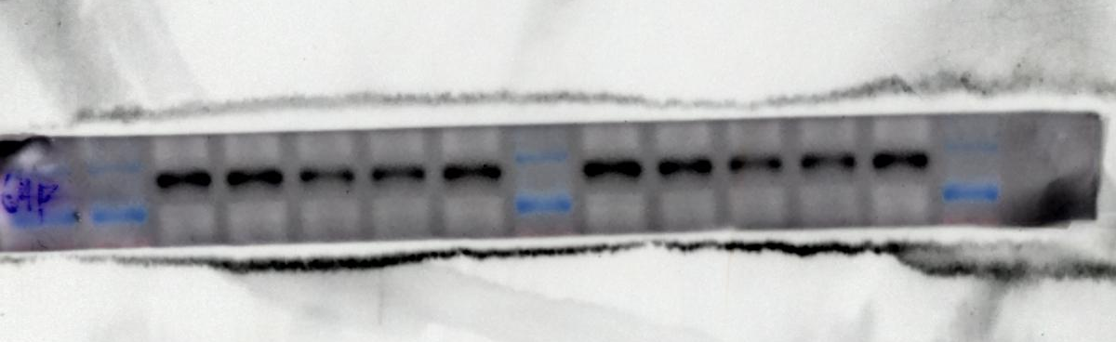
APP 110KDa

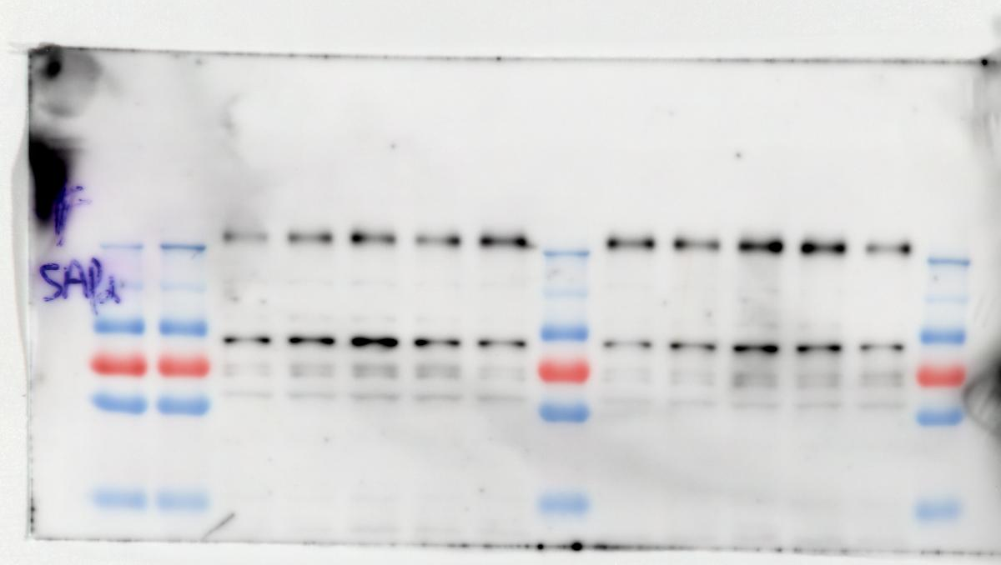

sAPPα 97KDa

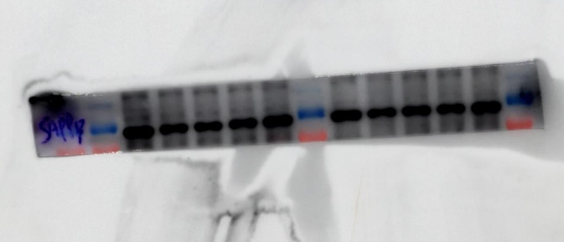

sAPP_{β} 97KDa

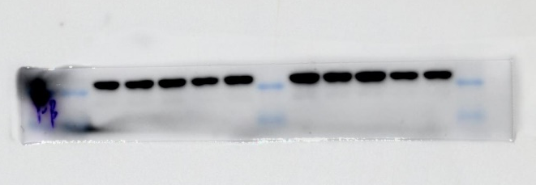

β-actin 42KDa

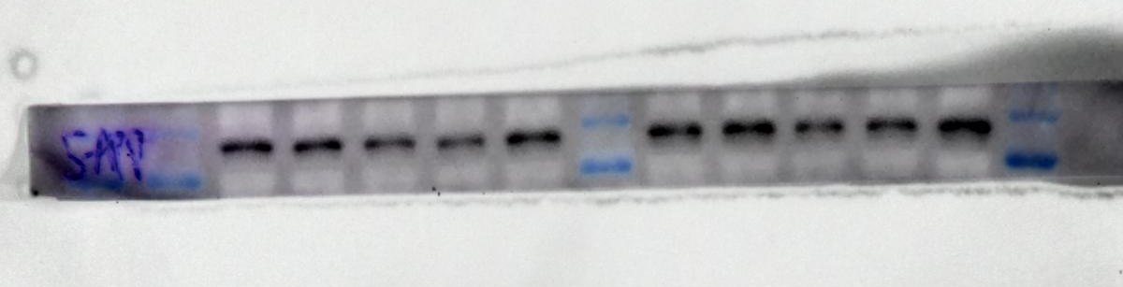
APP 110KDa
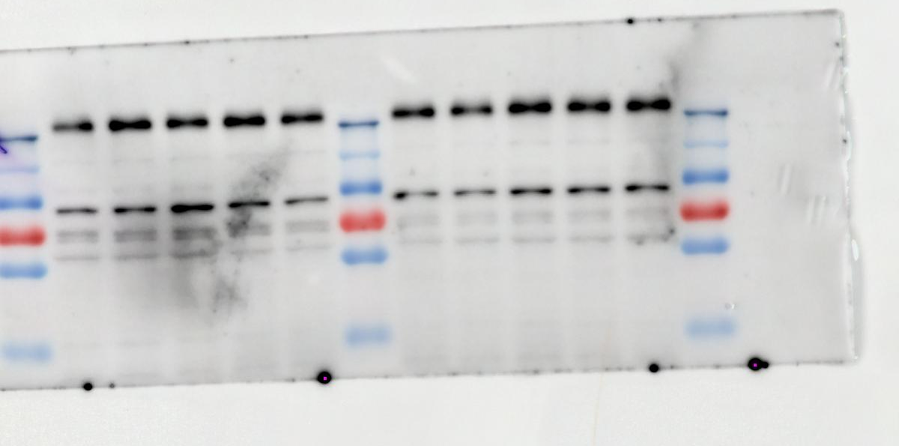
sAPPα 97KDa

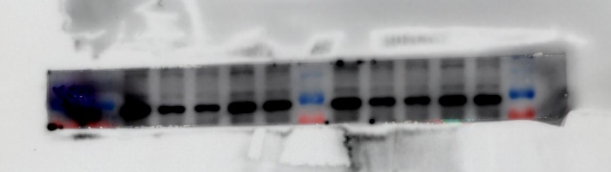
sAPP_{β} 97KDa

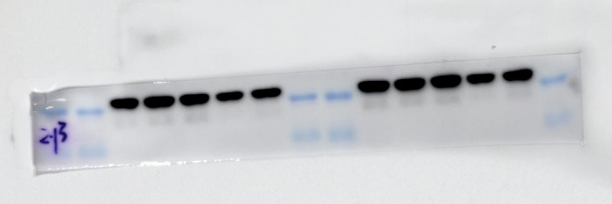

β-actin 42KDa

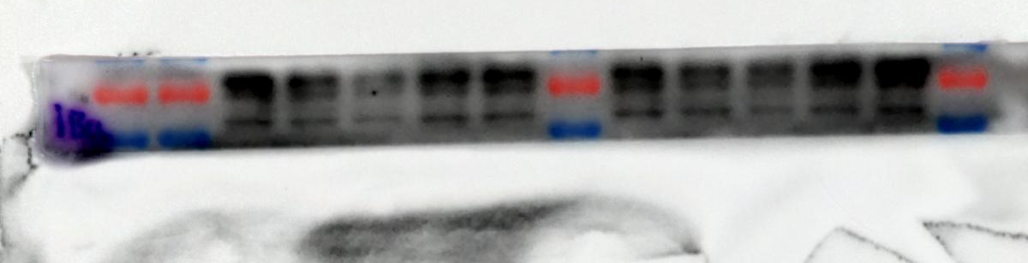
BACE1 70KDa

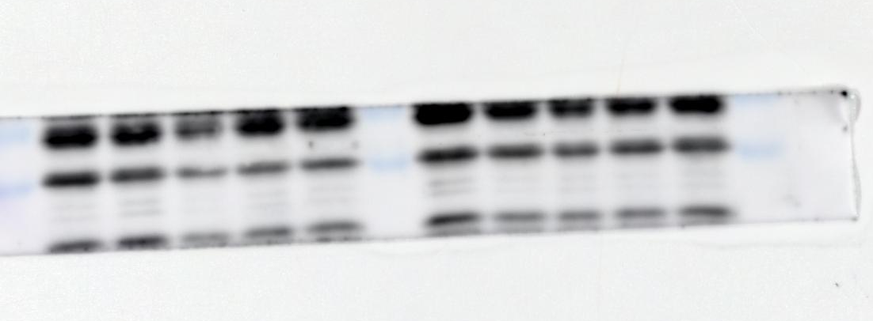
PS1 22KDa

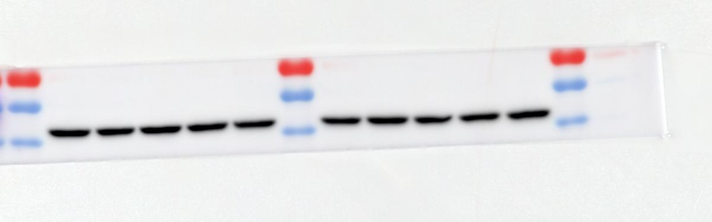
β-actin 42KDa

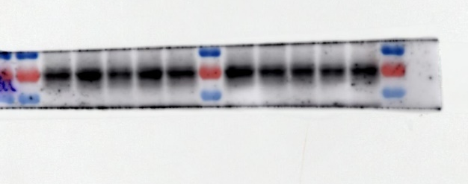
BACE1 70KDa
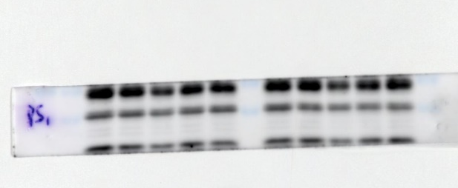
PS1 22KDa

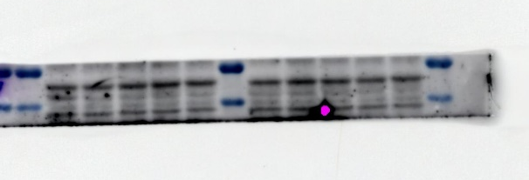
β-actin 42KDa

Figure 4. The treatment of ARC-18 reduced Aβ production in N2a/APPswe cells by regulating the APP processing pathways. (A) Original strip of western blot in APP processing pathways. Please refer to the manuscript for specific grouping and experimental conditions (n=4).

